Cycle 0
LOOP: subi r1, r1, 1 | Fetch
muld f0, f1, f1
addd f0, f2, f2
bne r1, r0, LOOP
addd f1, f2, f3

   | Tag | Value | Valid
  f0 |  | 0 | 1
  f1 |  | 1 | 1
  f2 |  | 2 | 1
  f3 |  | 3 | 1
   | Tag | Value | Valid
  r0 |  | 0 | 1
  r1 |  | 2 | 1
   | Inst | Reg | Value | Valid
  A | - | - | - | 0
  B | - | - | - | 0
  C | - | - | - | 0
  D | - | - | - | 0
  E | - | - | - | 0
  …
  ROB
  Tag | Value | Valid | Tag | Value | Valid | ROB
  - | - | 0 | - | - | 0 | -
  - | - | 0 | - | - | 0 | -
  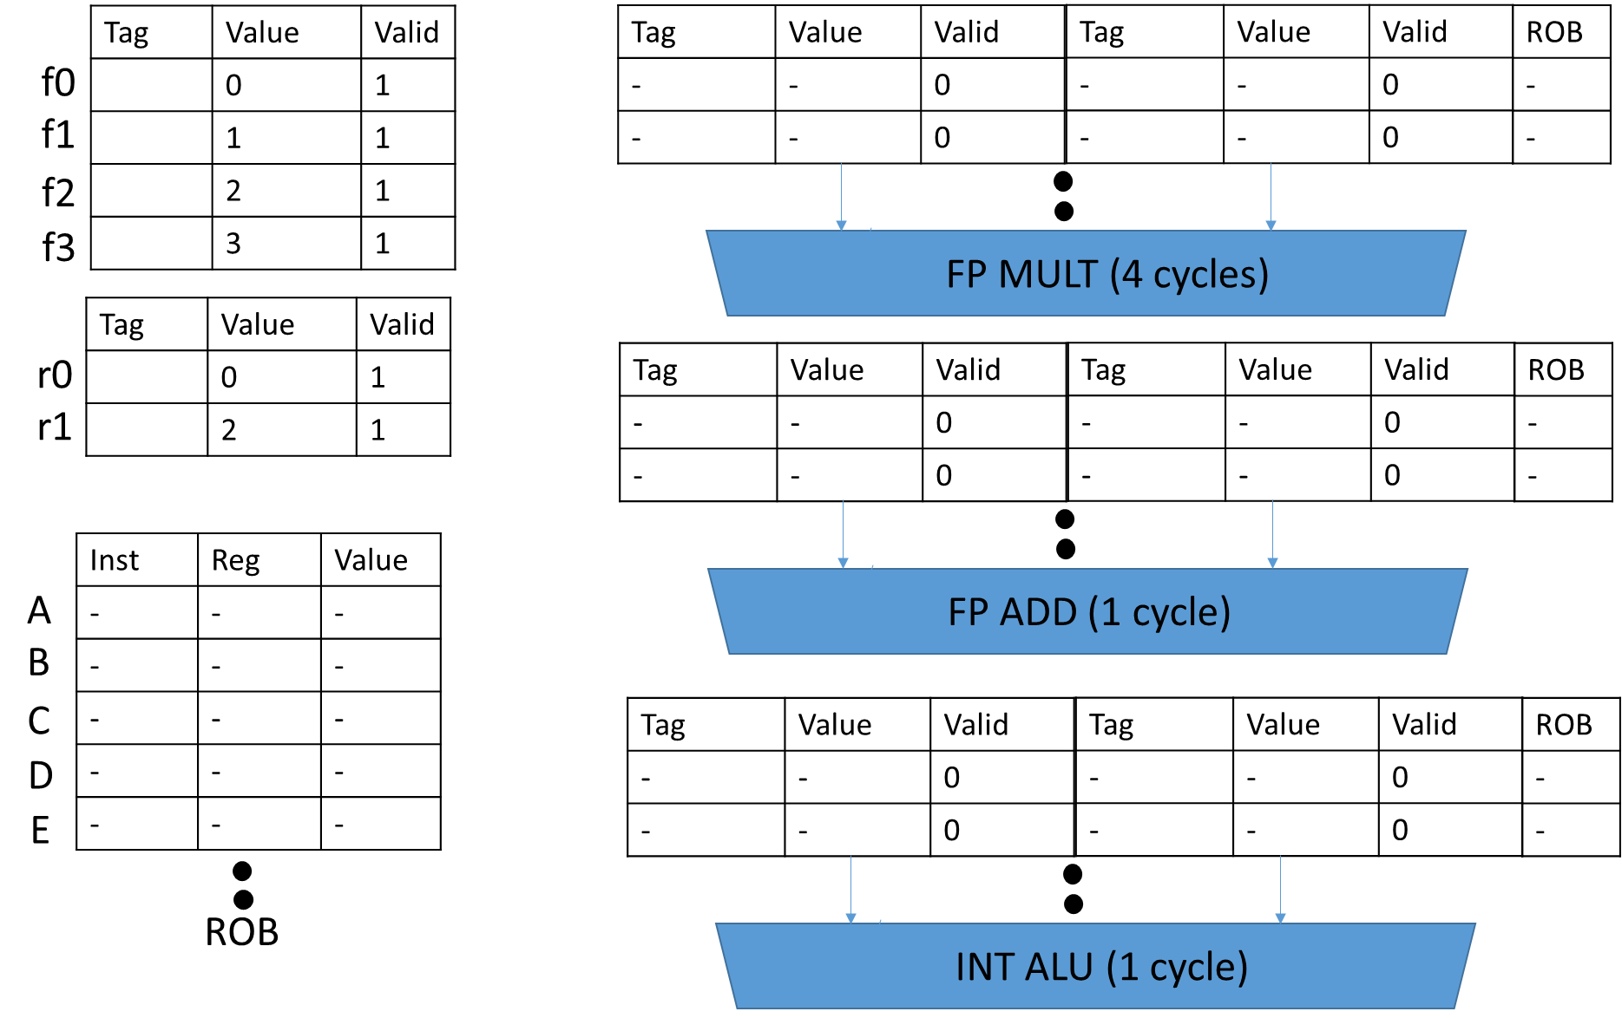
  Tag | Value | Valid | Tag | Value | Valid | ROB
  - | - | 0 | - | - | 0 | -
  - | - | 0 | - | - | 0 | -
  Tag | Value | Valid | Tag | Value | Valid | ROB
  - | - | 0 | - | - | 0 | -
  - | - | 0 | - | - | 0 | -

Cycle 1
LOOP: subi r1, r1, 1 | Dispatch
muld f0, f1, f1 | Fetch
addd f0, f2, f2
bne r1, r0, LOOP
addd f1, f2, f3

   | Tag | Value | Valid
  f0 |  | 0 | 1
  f1 |  | 1 | 1
  f2 |  | 2 | 1
  f3 |  | 3 | 1
   | Tag | Value | Valid
  r0 |  | 0 | 1
  r1 | A | 2 | 0
   | Inst | Reg | Value | Valid
  A | subi | r1 | - | 0
  B | - | - | - | 0
  C | - | - | - | 0
  D | - | - | - | 0
  E | - | - | - | 0
  …
  ROB
  Tag | Value | Valid | Tag | Value | Valid | ROB
  - | - | 0 | - | - | 0 | -
  - | - | 0 | - | - | 0 | -
  Tag | Value | Valid | Tag | Value | Valid | ROB
  - | - | 0 | - | - | 0 | -
  - | - | 0 | - | - | 0 | -
  Tag | Value | Valid | Tag | Value | Valid | ROB
  - | 2 | 1 | - | - | 0 | A
  - | - | 0 | - | - | 0 | -

Cycle 2
LOOP: subi r1, r1, 1 | Issue (E1)
muld f0, f1, f1 | Dispatch
addd f0, f2, f2 | Fetch
bne r1, r0, LOOP
addd f1, f2, f3

   | Tag | Value | Valid
  f0 |  | 0 | 1
  f1 | B | 1 | 0
  f2 |  | 2 | 1
  f3 |  | 3 | 1
   | Tag | Value | Valid
  r0 |  | 0 | 1
  r1 | A | 2 | 0
   | Inst | Reg | Value | Valid
  A | subi | r1 | - | 0
  B | muld | f1 | - | 0
  C | - | - | - | 0
  D | - | - | - | 0
  E | - | - | - | 0
  …
  ROB
  Tag | Value | Valid | Tag | Value | Valid | ROB
  - | 0 | 1 | - | 1 | 1 | B
  - | - | 0 | - | - | 0 | -
  Tag | Value | Valid | Tag | Value | Valid | ROB
  - | - | 0 | - | - | 0 | -
  - | - | 0 | - | - | 0 | -
  Tag | Value | Valid | Tag | Value | Valid | ROB
  - | 2 | 1 | - | - | 0 | A
  - | - | 0 | - | - | 0 | -

Cycle 3
LOOP: subi r1, r1, 1 | WB
muld f0, f1, f1 | Issue (E1)
addd f0, f2, f2 | Dispatch
bne r1, r0, LOOP | Fetch (and predict as Taken)
addd f1, f2, f3

   | Tag | Value | Valid
  f0 |  | 0 | 1
  f1 | B | 1 | 0
  f2 | C | 2 | 0
  f3 |  | 3 | 1
   | Tag | Value | Valid
  r0 |  | 0 | 1
  r1 | A | 2 | 0
   | Inst | Reg | Value | Valid
  A | subi | r1 | 1 | 1
  B | muld | f1 | - | 0
  C | addd | f2 | - | 0
  D | - | - | - | 0
  E | - | - | - | 0
  …
  ROB
  Tag | Value | Valid | Tag | Value | Valid | ROB
  - | 0 | 1 | - | 1 | 1 | B
  - | - | 0 | - | - | 0 | -
  Tag | Value | Valid | Tag | Value | Valid | ROB
  - | 0 | 1 | - | 2 | 1 | C
  - | - | 0 | - | - | 0 | -
  Tag | Value | Valid | Tag | Value | Valid | ROB
  - | - | 0 | - | - | 0 | -
  - | - | 0 | - | - | 0 | -

Cycle 4
LOOP: subi r1, r1, 1 | Commit
muld f0, f1, f1 | Issue (E2)
addd f0, f2, f2 | Issue (E1)
bne r1, r0, LOOP | Dispatch
LOOP: subi r1, r1, 1 | Fetch

   | Tag | Value | Valid
  f0 |  | 0 | 1
  f1 | B | 1 | 0
  f2 | C | 2 | 0
  f3 |  | 3 | 1
   | Tag | Value | Valid
  r0 |  | 0 | 1
  r1 | - | 1 | 1
   | Inst | Reg | Value | Valid | T/NT
  A | - | - | - | 0 | 0
  B | muld | f1 | - | 0 | 0
  C | addd | f2 | - | 0 | 0
  D | bne | - | - | 0 | T
  E | - | - | - | 0
  …
  ROB
  Tag | Value | Valid | Tag | Value | Valid | ROB
  - | 0 | 1 | - | 1 | 1 | B
  - | - | 0 | - | - | 0 | -
  Tag | Value | Valid | Tag | Value | Valid | ROB
  - | 0 | 1 | - | 2 | 1 | C
  - | - | 0 | - | - | 0 | -
  Tag | Value | Valid | Tag | Value | Valid | ROB
  - | - | 0 | - | - | 0 | -
  - | - | 0 | - | - | 0 | -

Cycle 5
LOOP: subi r1, r1, 1
muld f0, f1, f1 | Issue (E3)
addd f0, f2, f2 | WB
bne r1, r0, LOOP | Issue (E1)
LOOP: subi r1, r1, 1 | Dispatch
muld f0, f1, f1 | Fetch

   | Tag | Value | Valid
  f0 |  | 0 | 1
  f1 | B | 1 | 0
  f2 | C | 2 | 0
  f3 |  | 3 | 1
   | Tag | Value | Valid
  r0 |  | 0 | 1
  r1 | E | 1 | 0
   | Inst | Reg | Value | Valid | T/NT
  A | - | - | - | 0 | 0
  B | muld | f1 | - | 0 | 0
  C | addd | f2 | 2 | 1 | 0
  D | bne | - | - | 0 | T
  E | subi | r1 | - | 0 | 0
  …
  ROB
  Tag | Value | Valid | Tag | Value | Valid | ROB
  - | 0 | 1 | - | 1 | 1 | B
  - | - | 0 | - | - | 0 | -
  Tag | Value | Valid | Tag | Value | Valid | ROB
  - | - | 0 | - | - | 0 | -
  - | - | 0 | - | - | 0 | -
  Tag | Value | Valid | Tag | Value | Valid | ROB
  - | 1 | 1 | - | - | 0 | E
  - | - | 0 | - | - | 0 | -

Cycle 6
LOOP: subi r1, r1, 1
muld f0, f1, f1 | Issue (E4)
addd f0, f2, f2 | Commit
bne r1, r0, LOOP | Taken
LOOP: subi r1, r1, 1 | Issue (E1)
muld f0, f1, f1 | Dispatch
addd f0, f2, f2 | Fetch

   | Tag | Value | Valid
  f0 |  | 0 | 1
  f1 | B | 1 | 0
  f2 | - | 2 | 1
  f3 |  | 3 | 1
   | Tag | Value | Valid
  r0 |  | 0 | 1
  r1 | E | 1 | 0
   | Inst | Reg | Value | Valid | T/NT
  A | - | - | - | 0 | 0
  B | muld | f1 | - | 0 | 0
  C | - | - | - | 0 | 0
  D | bne | - | - | 0 | T
  E | subi | r1 | - | 0 | 0
  F | muld | f1 | - | 0 | 0
  …
  ROB
  Tag | Value | Valid | Tag | Value | Valid | ROB
  - | 0 | 1 | - | 1 | 1 | B
  - | 0 | 1 | B | - | 0 | F
  Tag | Value | Valid | Tag | Value | Valid | ROB
  - | - | 0 | - | - | 0 | -
  - | - | 0 | - | - | 0 | -
  Tag | Value | Valid | Tag | Value | Valid | ROB
  - | 1 | 1 | - | - | 0 | E
  - | - | 0 | - | - | 0 | -

