PROJECT REPORT

**Submitted By:**

Tianyu Gu tg1553

Fengyang Jiang fj483

Yingqi Huang yh1990

Junlun Xiao jx755

Yiren Dai yd1257

Lin Lu ll3374

NEW YORK UNIVERSITY

TANDON SCHOOL OF

ENGINEERING

DEPARTMENT OF ELECTRICAL AND COMPUTER ENGINEERING

1. Abstract 4

2. Processor Design and Test 4

2.1 Summary 4

2.2 Component Design and Test 5

2.2.1 Program Counter (PC) Register 5

2.2.2 Instruction Memory & Data Memory 9

2.2.3 Register file 11

2.2.4 Control unit 14

2.2.5 ALU 16

2.2.6 Debouncer 18

2.2.7 Seg_led 19

2.3 Processor Desgin and test 19

2.3.1 Assmebly comiler 19

2.3.2 Correctness of the Processor Design 20

2.3.3 Functional simulation 21

2.3.4 Timing simulation 22

2.3.5 Timing Analysis and Optimization 23

3. RC5 Implementation 24

3.1 Assmebly code 24

3.1.1 FSM diagram 24

3.1.2 Time complexity analysis 25

3.1.3 ROTATE optimization 26

3.1.4 XOR optimization 27

3.2 Testbench 27

3.3 Functional simulation 28

3.4 Timing simulation 30

4. FPGA Implementation 31

4.1 Clock Configuration 31

4.2 Board Test 32

5. Summary 34

5.1 Specifications 34

5.2 Deliverables 34

# Abstract

The main objective of this project is to design a single cycle 32-bit MIPS RISC processor using VHDL, and implementing it on an FPGA with on-board input/output interface to input data and get results on-the-fly. To show whether it works properly for these instructions, we wrote a RC5 assembly code using only the supported instructions supported, converted the assembly code into machine code and ran it on FPGA.

The highest frequency of our processor is **76.8 MHz** according to timing summary. However, on FPGA, our processor can run at **135 MHz** stably. Details about timing analysis and how we multiple the sys_clk will be discussed in section 2.3.5.1 and 4.1. The FPGA resource utilization is **3.28%**, which is discussed in section 2.3.5.2.

Our RC5 assembly code is optimized to be efficient. It can run encryption/decryption in **513 cycles**, round key generation in **2574 cycles**. Details about how we achieved it will be discussed in section 3.1.2, 3.1.3 and 3.1.4. And in section 3.2, 3.3 and 3.4, we ran **4000 cases** in functional simulation and **35 cases** in timing simulation, to verify the processor as well as the RC5 code.

# Processor Design and Test

## Summary

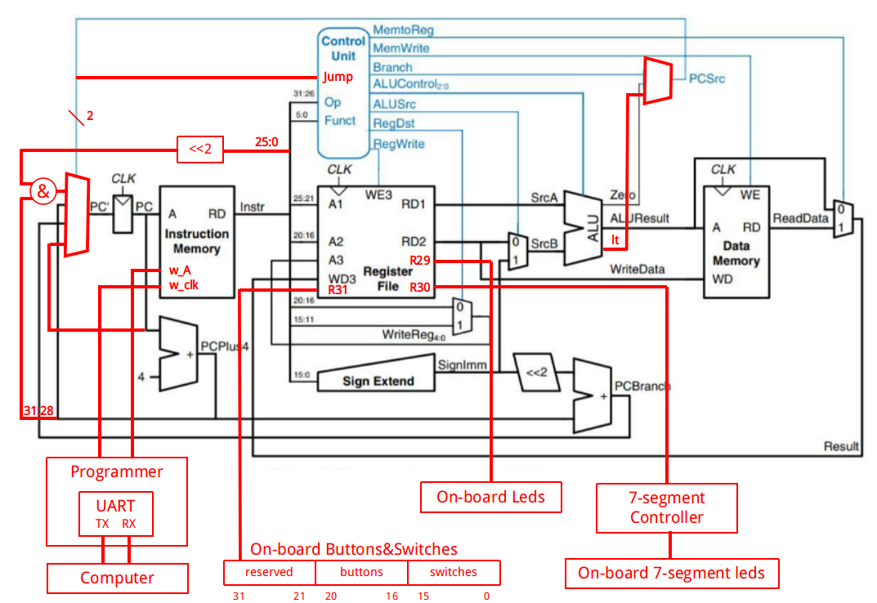

Figure 2.1 Processor block diagram

Above is the block diagram of our processor. The red parts are what we added to the original design, to fix the mistakes or add some new features. Minor changes (like renaming the ports) are not shown in this diagram.

We added 3 new port to the register file, in order to provide an input/output to the processor, where r31 is always connected to the on-board buttons and switches; r29 is always connected to on-board leds; r30 is always connected to a 7-segment controller. In this way, the processor could get the input from buttons and switches by reading the REG[31] and show output by writing to REG[29] or REG[30].

In the next section we will introduce each modules in detail and describe how we design and test them.

## Component Design and Test

### Program Counter (PC) Register

#### Implementation of PC

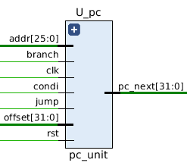

Signal list:

in clk: clock signal

in rst: reset signal, active-high

in jump: pc_src select signal for JMP, active-high

in addr: address to jump

in branch: pc_src select signal for BXX, active-high

in condi: branch condition signal, active-high

in offset: offset to branch

out pc_next: address of next instruction

This is a 32-bit register that contain the address of the next instruction to be executed. pc_next will be updated synchronously under 4 different conditions, as show below:

|  |  |  |
| --- | --- | --- |
| Type | PC_next | Condition |
| Continuously | PC + 4 | jump=0 & branch=0 * |
| Branch | PC + 4 + offset*4 | jump=0 & branch=1 & condi=1 |
| Jump | (PC+4)[31:28] & addr & “00” | jump=1 & branch=0 |
| Halt | PC | jump=1 & branch=1 |

*\* full logic should be jump=0 & (branch=0 | (branch=1 and condi=0))*

#### Testbench

For each condition, I tested the PC unit on 1000 random cases and used ‘assert’ statement to check the output automatically (see tb_pc.vhd for details). The stage signal would change to FINISH only when all test cases passed, otherwise, the simulation would stop with severity level ‘failure’.

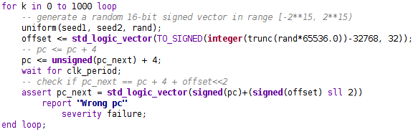

Figure 2.2 This is an example code of checking the branch condition

#### Functional simulation

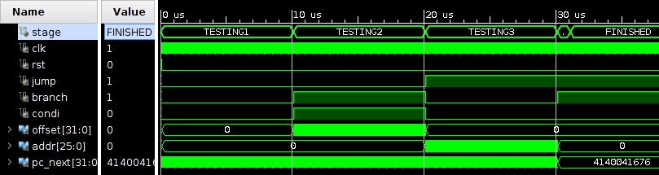

Figure 2.3 An overview. All cases passed.

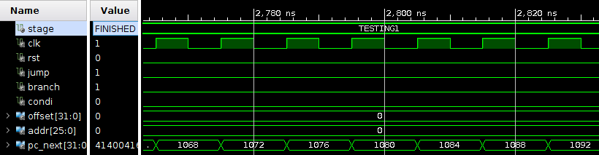

Figure 2.4 Testing continuously increment condition.

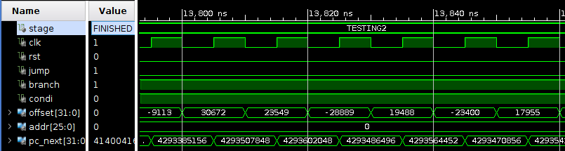

Figure 2.5 Testing branch condition.

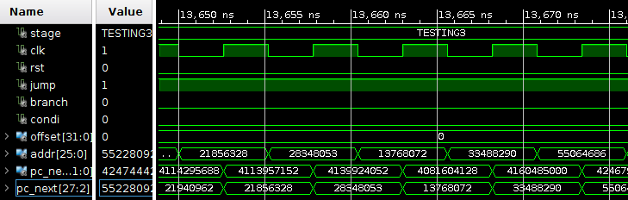

Figure 2.6 Testing jump condition

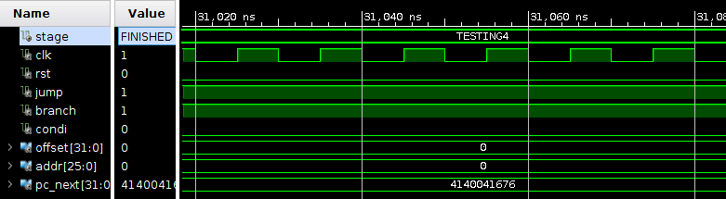

Figure 2.7 Testing halt condition

#### Timing simulation

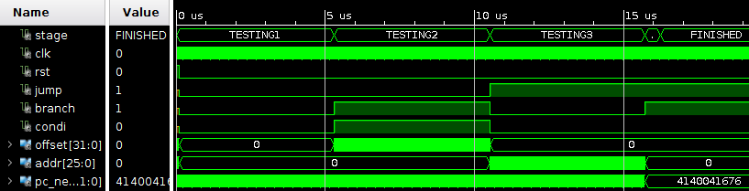

Figure 2.8 An overview. All cases passed.

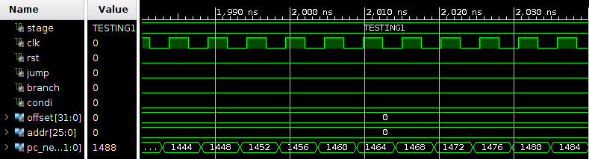

Figure 2.9 Testing continuously increment condition.

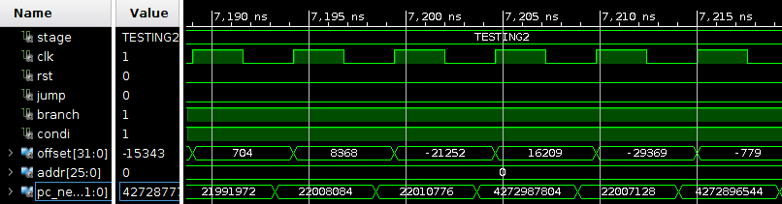

Figure 2.10 Testing branch condition

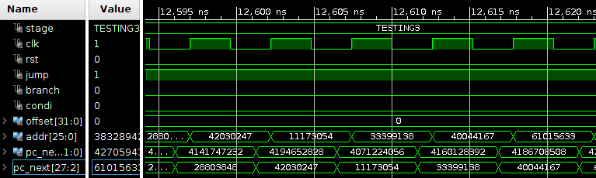

Figure 2.11 Testing jump condition

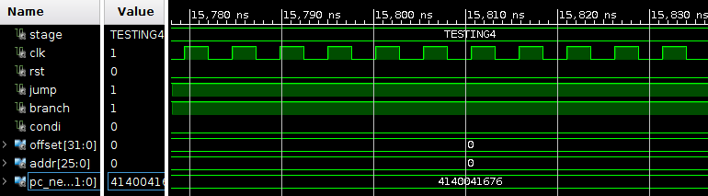

Figure 2.12 Testing halt condition

### Instruction Memory & Data Memory

#### Implementation of INS_MEM & DATA_MEM

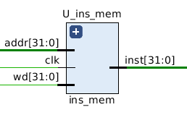 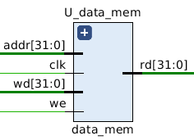

Signal list:

in addr: 32-bit address

in clk: write clock signal

in wd: 32-bits value we want to write in the instruction memory

in we: write-enable signal; active-high; only in data_mem

out inst: the result 32-bit instruction.

Instruction Memory and Data Memory are almost identical, except that data memory has a active-high write enable signal. So we introduce them together in this section

Each instruction/data has its own address, marked by a 32-bit address. The following considerations have to be taken into account during designing:

* Each instruction/data is one word long (32 bits).
* Each instruction/data is addressed by a multiple of 4 bytes (1 word).
* Each instruction/data lies at a multiple of 4 bytes. By contrast, the address in terms of bytes. Lowest 2 bits of the address is ignored.
* Read is asynchronous.
* Writing is synchronous.

#### Testbench

Randomly generate 1000 test cases using the same random vector generator in 2.2.1.2.

* Generate random vector to change addr and random variable to change wd
* When stage equals to finished, all the test case passed.

#### Functional Simulation

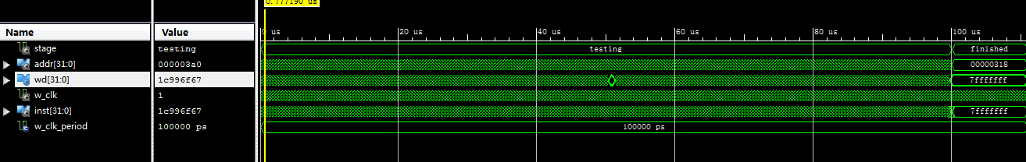

Figure 2.13 The stage is finished, which means all test cases passed.

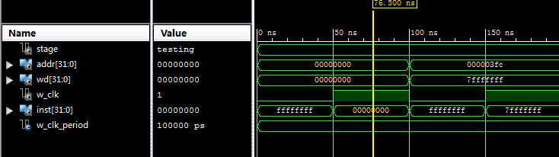

Figure 2.14 Example1: the output instruction is the same as the wd value we wrote in.

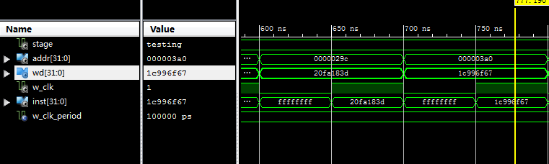

Figure 2.15 example2: the output instruction is the same as the wd value we wrote in.

#### Timing Simulation

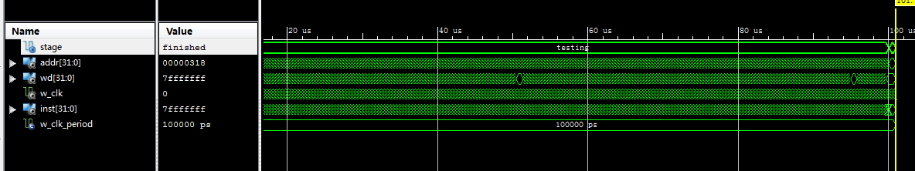

Figure 2.16 The stage is finished, which means all test cases passed.

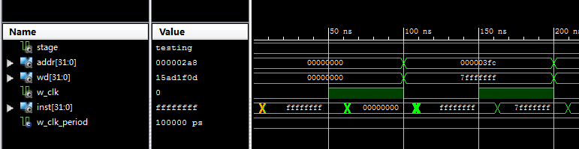

Figure 2.17 timing simulation for first example.

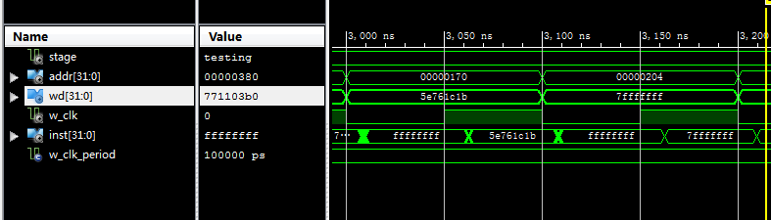

Figure 2.18 timing simulation for second example.

### Register file

#### Implementation

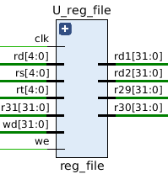

Signal list:

in clk: clock signal

in rs, rt, rd: 5-bit address

in wd: 32-bit data that should be written into reg(rd)

in we: write-enable signal, active-high

in r31: input interface for BTN & SW; read-only

out r29: output interface for LED Display

out r30: output interface for 7-Segment Display

out rd1, rd2: 32-bit data read from reg(rs) and reg(rt)

This component (Register File) is used to stage data between memory and the functional units in CPU. The main functions of Reg_File include:

* Asynchronous read: rd1 = REG[rs]; rd2 = REG[rt]; r29 = REG[29]; r30 = REG[30]
* Synchronous write: REG[rd] = wd @ rising_edge(clk)
* Input/Output interface: r31, r29 and r30

#### Testbench

For each register, we generated 1000 random vectors to do write operation, and then check if the read values are equal to the written values in all the 1000 cases. So there are totally 31*1000 = 31000 cases (r31 is read-only) being checked in this testbench. Assertion statement was used to check the output automatically. If anything goes wrong, the simulation will stop and raise a ‘failure’ exception. If all cases pass, stage signal will be set to “Finished”.

#### Functional Simulation

Based on the test bench described above, we can run functional simulation now.

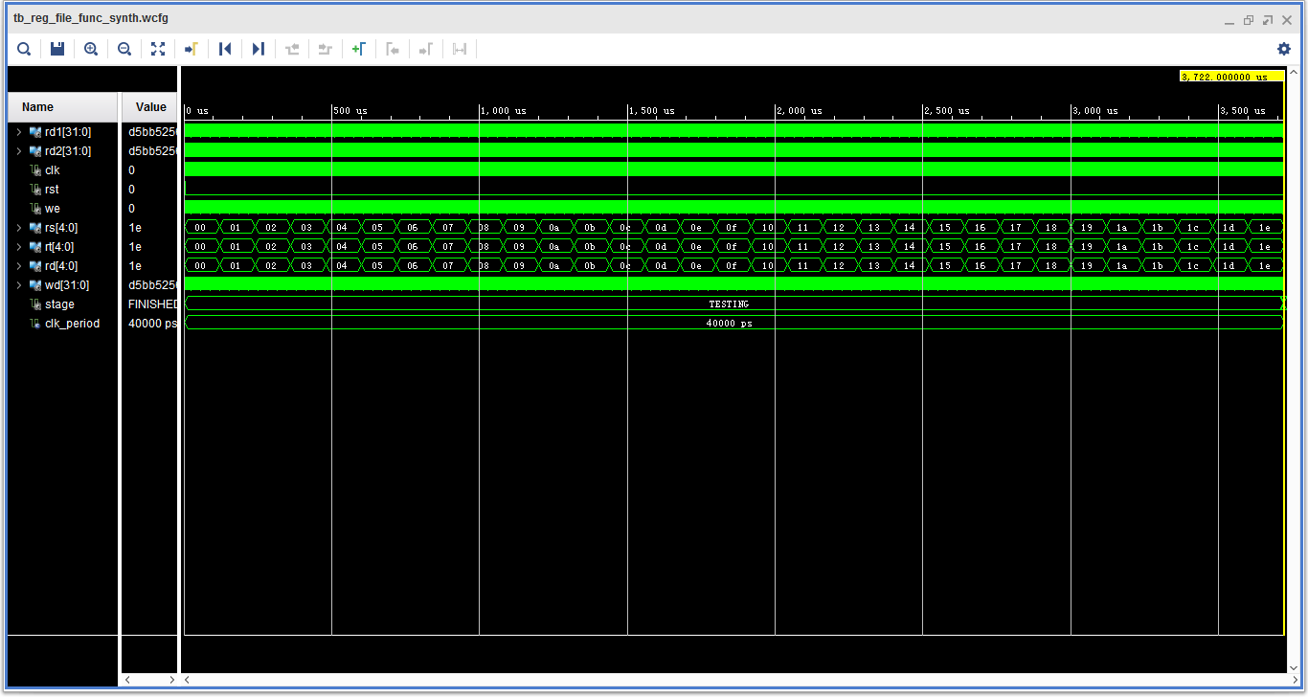

Figure 2.19 The whole simulation.

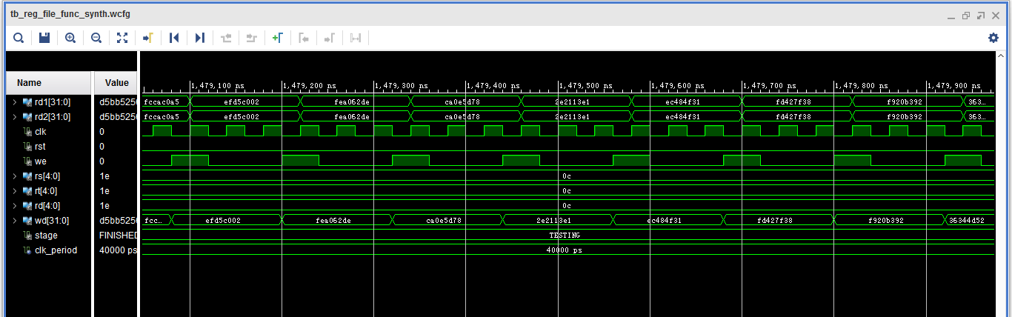

Figure 2.20 Some cases in detail. We can see that rd = wd @ risingede(clk)&we=1

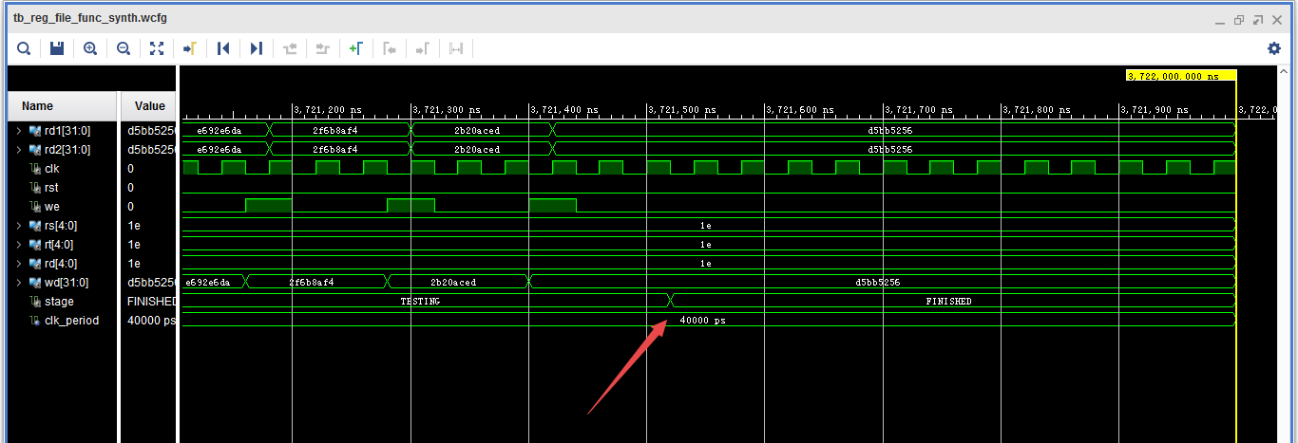

Figure 2.21 The last few cases. Stage signal changes to FINISHED when all cases have passed.

#### **Timing Simulation**

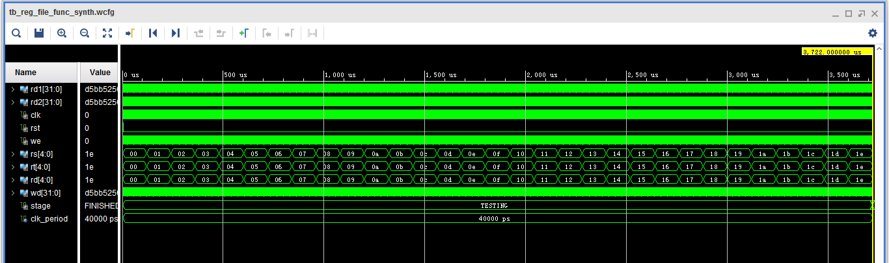

Figure 2.22 The whole simulation

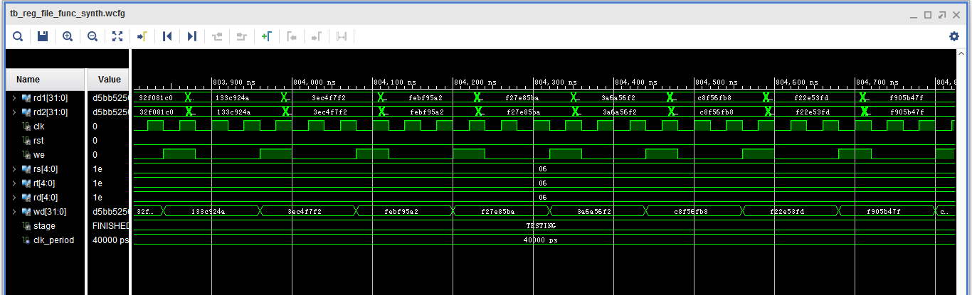

Figure 2.23 A few cases during the simulation

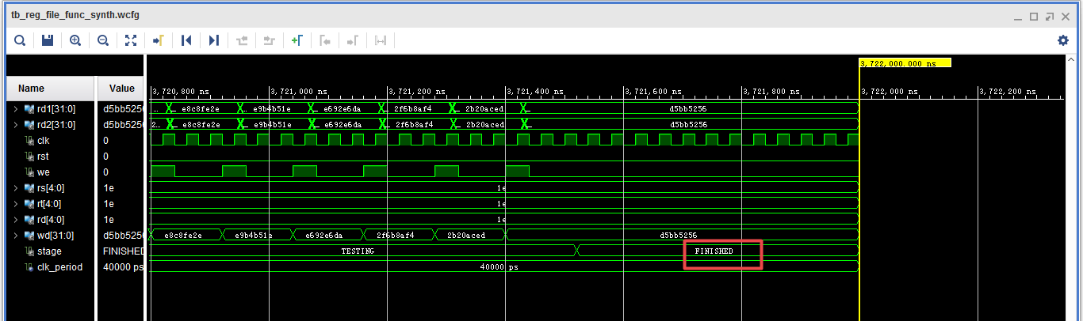

Figure 2.24 Last few cases. After all the cases finish, the state becomes “FINISHED”.

### Control unit

#### Implementation

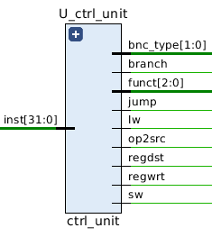

Signal list:

in inst: 32-bit instruction

out lw: write back source selector signal for reg_file

out sw: write-enable signal for data memory

out branch: branch indicator

out bnc_type: branch type indicator

out jump: jump indicator

out funct: operation selector signal for ALU

out op2src: op2 source selector signal for ALU

out regdst: register destination selector signal for reg_file

out regwrt: write-enable signal for file

The control unit of the block diagram examines the instruction opcode bits [31 – 26] and decodes the instruction to generate control signals to be used in the additional modules.

#### Testbench

For each condition, I created one instruction to test correctness(bits unused is set to be zero) and used ‘assert’ statement to check the output automatically (see tb_ctrl_unit.vhd for details). The stage signal would change to FINISH only when all test cases passed, otherwise, the simulation would stop with severity level ‘failure’.

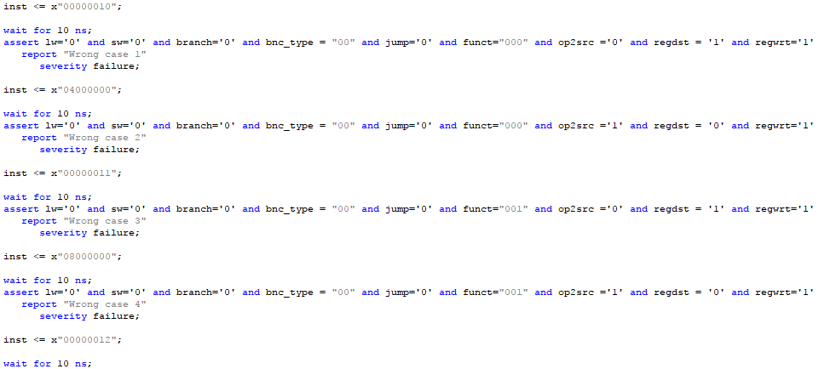

#### Functional Simulation

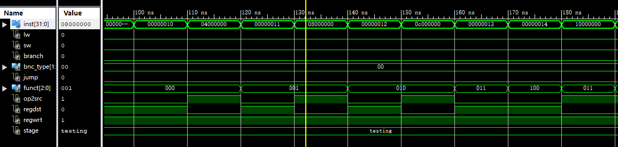

Figure 2.25 Testing first 9 conditions

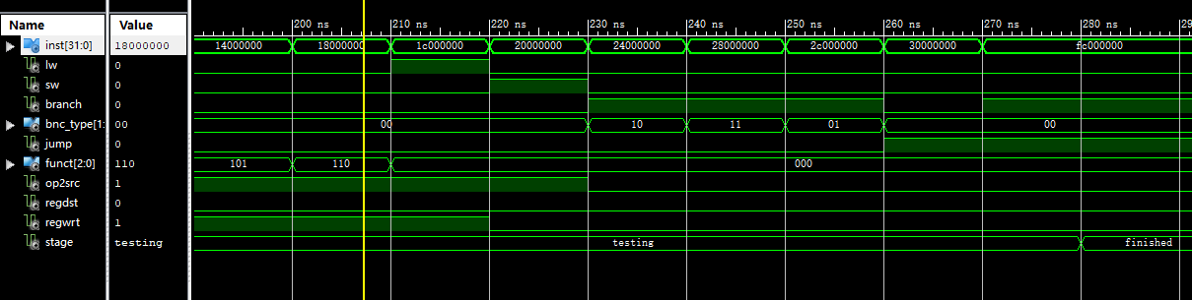

Figure 2.26 Testing latter 9 conditions

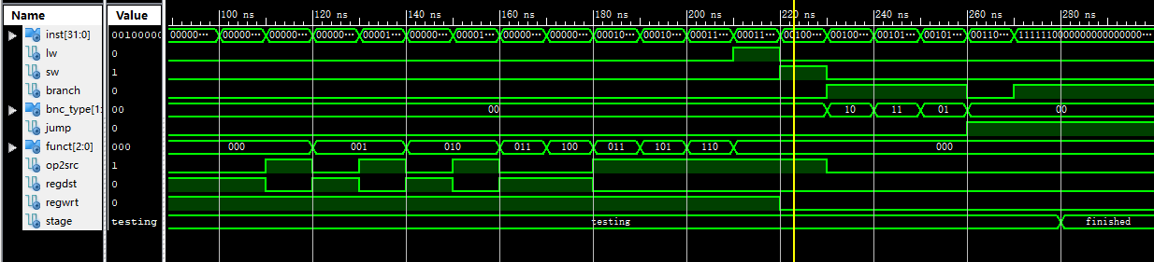

Figure 2.27 An overview with all cases passed.

#### Timing Simulation

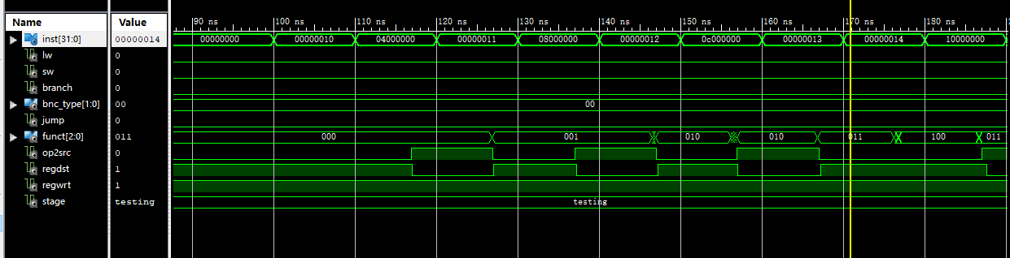

Figure 2.28 Testing first 9 conditions

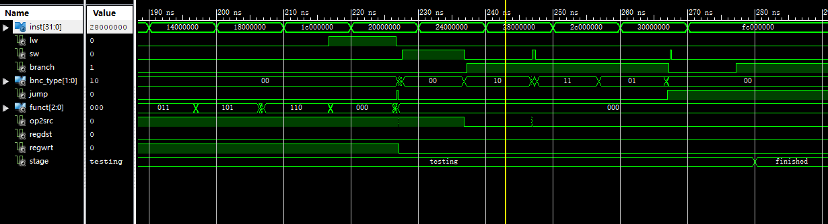

Figure 2.29 Testing latter 9 conditions

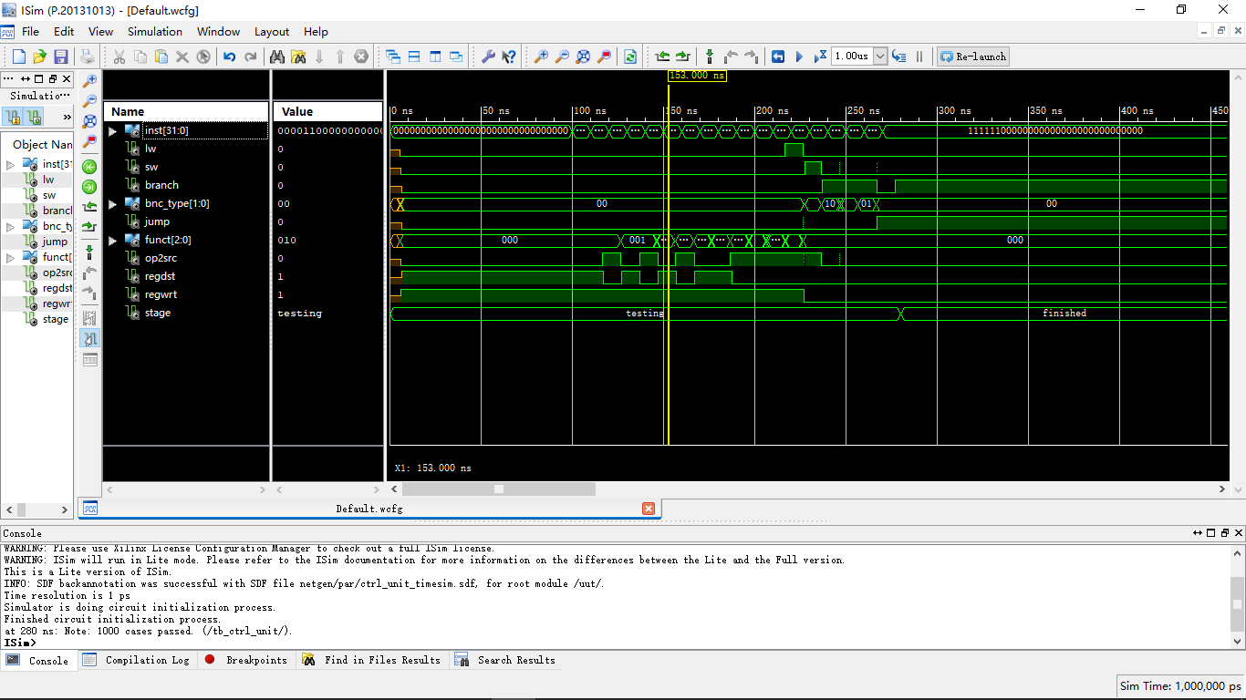

Figure 2.30 An overview with all cases passed.

### ALU

#### Implementation

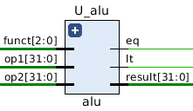

Signal list:

in op1: operand1

in op2: operand2

in funct: function selection

out eq: HIGH when op1 == op2, otherwise LOW

out lt: HIGH when op1 < op2, otherwise LOW

out result: function result

ALU operations based on funct signal:

0: do result = op1 + op2

1: do result = op1 - op2

2: do result = op1 & op2

3: do result = op1 | op2

4: do result = !(op1 | op2)

5: do result = op1 << op2

6: do result = op1 >> op2

#### Testbench

For testbench, I tested the ALU unit on 1000 random op1 and op2 for all the functions and used ‘assert’ statement to check the status automatically. The testbench would finish and show “1000 cases passed” only if all cases passed.

#### Functional Simulation

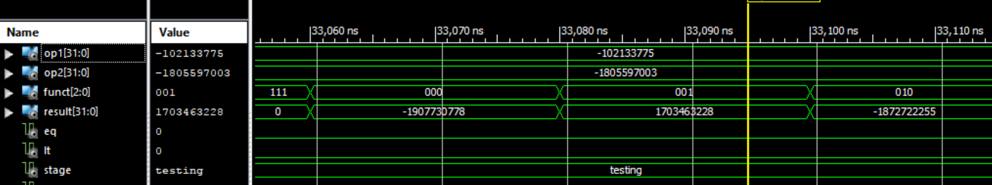

Figure 2.31 case “+” and “-” showed on decimal

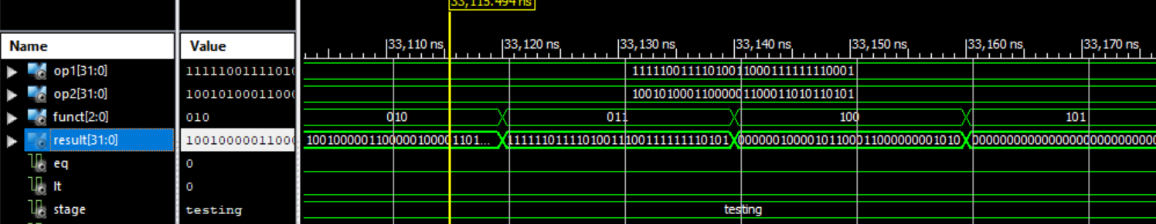

Figure 2.32 bit operation case showed on bits

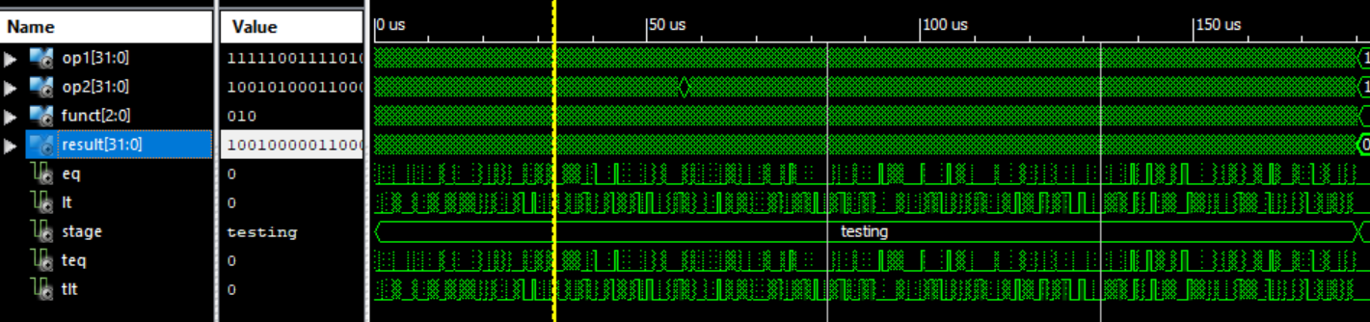

Figure 2.33 An overview. All cases passed

#### Timing Simulation

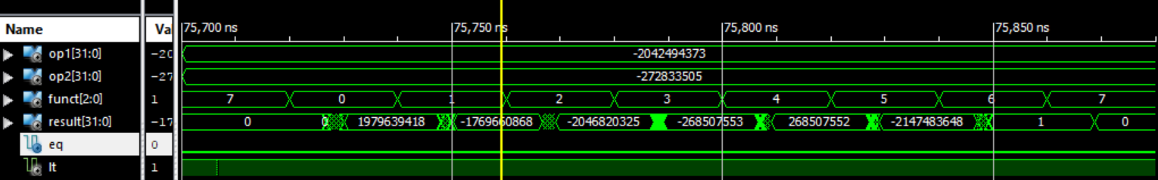

Figure 2.34 case “+” and “-” showed on decimal

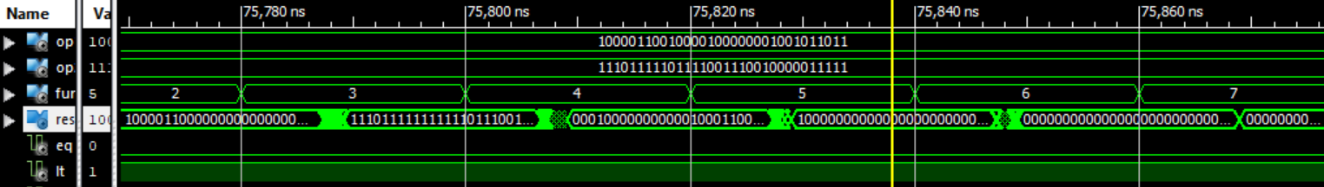

Figure 2.35 bit operation case showed on bits

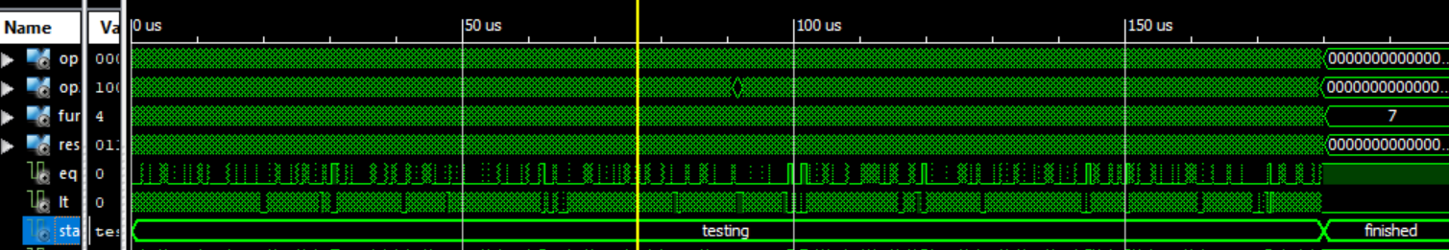

Figure 2.36 Overview. All cases passed

### Debouncer

#### Implementation

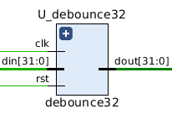

Signal list:

in clk: clock signal

in rst: reset signal, active-high

in din: input data

out dout: output data

This is a unit for buttons and switches input debouncing. It uses a 3-state FSM to achieve debounce. It gets the data only when the state is idle. When pressing and releasing are not stable, the machine will keep in the “pressing” or “releaseing” state and will not send the signal to output.

### Seg_led

#### Implementation

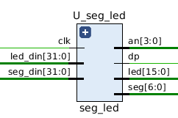

Signal list:

in clk: clock signal

in led_din: 32-bit input for led

in seg_din: 32-bit input for 7-segment display

out an: 7-segment display digit selector signal

out dp: 7-segment display dp control signal

out seg: 7-segment display seg control signal

out led: LED output

This is a controller for on-board led and 7-segment display, used to show the value of two special register. The led will show the lower 16 bits of led_din signal, which is connected to r29. And 7-segment will show the value of seg_din in hexadecimal format, which is connected to r30.

With this design, we can output the internal value of the CPU on FPGA, simply by writing it into r29 (binary display) or r30 (hex display).

## Processor Desgin and test

### Assmebly comiler

We wrote out instructions in assembly and used a simple compiler written in python (load_instructions.py) to help convert assembly to machine code (*.binary), which can be conducted directly on the FPGA board.

Our compiler contains three main stages: trimming, compiling and writing-back.

During the trimming, all comment, blank line, extra white space or any other useless parts will be removed, to make the compiling easier. In addition, in our assembly labels are used to help mark the lines for branch and jump instructions. So in this stages, a label-to-address table will be created for compiling stages.

In the compiling stage, we use a decoding table and three separate parser for each of I/R/J type instruction, to convert assembly code to machine code.

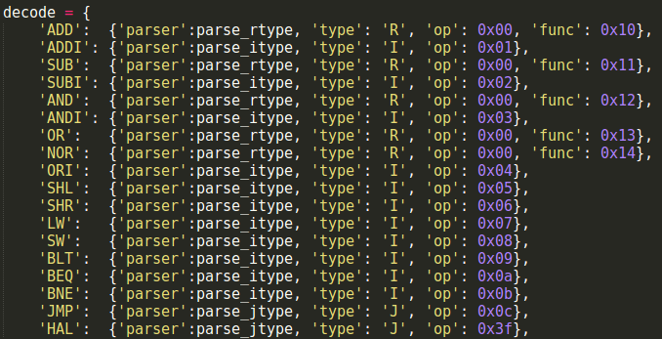

Finally in the writing-back stage, the machine code will be written back to instruction memory (ins_mem.vhd). Please see our code (load_instructions.py) for more detail. It’s well commented for reviewing.

### Correctness of the Processor Design

The processor is tested with the sample code provided in the project description. We first hand calculate the expected results:

**Sample code 1:**

ADDI R1, R0, 7 // R1 = 7

ADDI R2, R0, 8 // R2 = 8

ADD R3, R1, R2 // R3 = R1 + R2 =15

HAL // HALT

Here, the instruction is to add the immediate value 7 and R0 and store it in R1. As we can see from the above screenshot, R1 is 7. Similarly, R2 is 8. Then we add the value of R1 and R2 and store the result in R3. It’s easy to get that R3 should be 15. The following table show the state of all related registers after each line of code:

|  |  |  |  |  |
| --- | --- | --- | --- | --- |
| register | Line 1 | Line 2 | Line 3 | Line 4 |
| R1 | 0 | 0 | 0 | 0 |
| R2 | 7 | 7 | 7 | 7 |
| R3 | 0 | 8 | 8 | 8 |
| R4 | 0 | 0 | 15 | 15 |

**Sample code 2:**

*Too long to be show here*

The code is too long, here we just show the excepted results after each line of code:

|  |  |  |  |  |  |  |  |  |  |  |  |  |  |  |  |  |
| --- | --- | --- | --- | --- | --- | --- | --- | --- | --- | --- | --- | --- | --- | --- | --- | --- |
|  | 1 | 2 | 3 | 4 | 5 | 6 | 7 | 8 | 9 | 10 | 11 | 12 | 13 | 14 | 15 | 16 |
| R0 | 0 | 0 | 0 | 0 | 0 | 0 | 0 | 0 | 0 | 0 | 0 | 0 | 0 | 0 | 0 | 0 |
| R1 | 2 | 2 | 2 | 2 | 2 | 2 | 2 | 2 | 2 | 2 | 2 | 2 | 2 | 2 | 2 | 2 |
| R2 | 0 | 0 | 0 | 0 | 0 | 0 | 0 | 0 | 0 | 0 | 0 | 10 | 10 | 10 | 10 | 10 |
| R4 | 0 | 10 | 10 | 10 | 10 | 10 | 10 | 10 | 10 | 10 | 10 | 10 | 10 | 10 | 10 | 10 |
| R4 | 0 | 0 | 14 | 14 | 14 | 14 | 4 | -1 | 0 | 10 | 10 | 10 | 10 | -11 | * | 0 |
| R5 | 0 | 0 | 0 | 2 | 2 | 2 | 2 | 2 | 2 | 2 | 2 | 2 | 2 | 2 | 2 | 2 |
| MEM[12] | 0 | 0 | 0 | 0 | 14 | 14 | 14 | 14 | 14 | 14 | 14 | 14 | 14 | 14 | 14 | 14 |
| MEM[11] | 0 | 0 | 0 | 0 | 0 | 10 | 10 | 10 | 10 | 10 | 10 | 10 | 10 | 10 | 10 | 10 |

* 10240

17 BEQ R5, R0, -2: R5=2 is not equal to R4=0. Go next line.

18 BLT R5, R4, 0: R5=2 is not less than R4=0. Go next line.

19 BNE R5, R4, 0: R5=2 is not equal to R4=0. Jump to pc+4+0 which is the next line.

20 JMP 20: It will jump to itself, which leads to an infinite loop.

### Functional simulation

**Sample code 1:** The operations of this code are described in 2.3.2. Now we run a functional simulation to verify it.

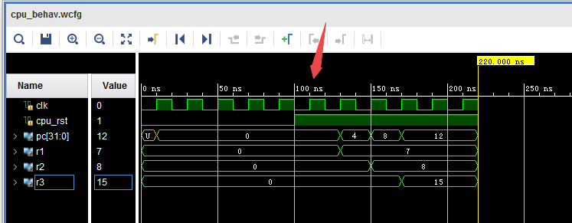

We can see that after the cpu_rst becomes high, the instructions in the inst_mem are executed one by one. Then 7 is written to r1, 8 is written to r2, and their sum 15 is written to r3, which is the same as expected.

**Sample code 2:** The operations of this code are described in 2.3.2, too. Now we run a functional simulation to verify it.

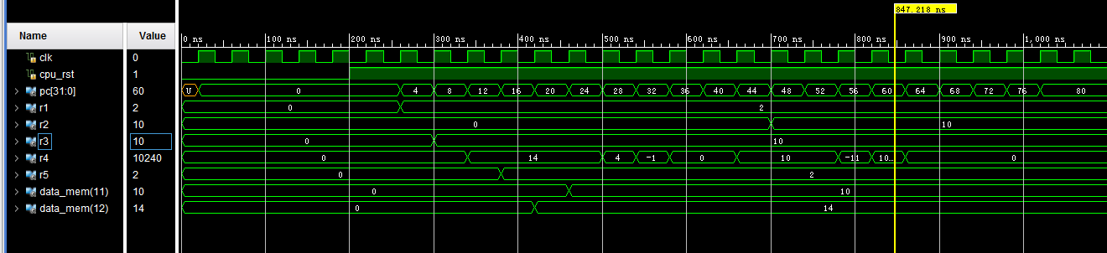

Compared to the description in 2.3.2, we find that the simulation results are correct.

### Timing simulation

**Sample code 1:** Now we should check the timing simulation of this code. The sequence of the signals is the same as 2.3.3.

Notice that here we doesn’t show the two least significant bits of pc (program counter), so the values it gives represent the sequence number of the instructions being executed instead of the addresses (0, 1, 2, 3… instead of 0, 4, 8, 12…)

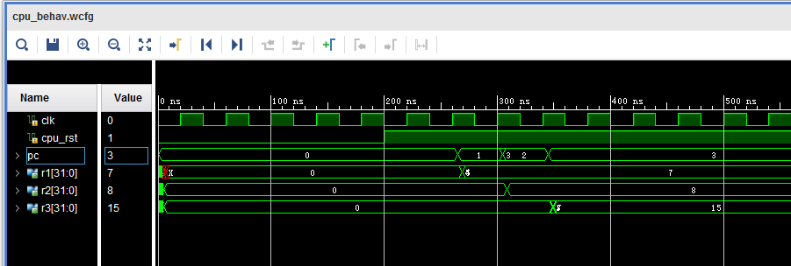

We get the same results as the functional simulation. Notice that there are glitches at the time when the signals change, because of the race condition

**Sample code 2:** The configurations are the same with 2.3.3

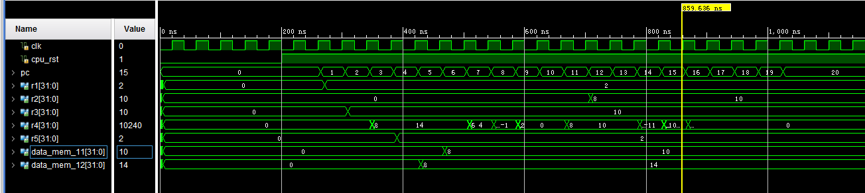

Similarly to 2.3.4 (1), this timing simulation is in correspondence with its functional simulation. And we can also see delays and glitches in the wave form.

### Timing Analysis and Optimization

* + - 1. **Critical path**

The Figure 2.37 below shows the critical path of our original design. We can see that the longest delay happens when we do the LW operation. The data memory have to wait for the ALU calculating the address. Actually the address can be calculated directly without passing through the ALU, which can eliminate the extra delay occurs on those two multiplexers. So we change our original design into a new one as shown in the next picture, where the ALU is bypassed when doing LW/SW operation.

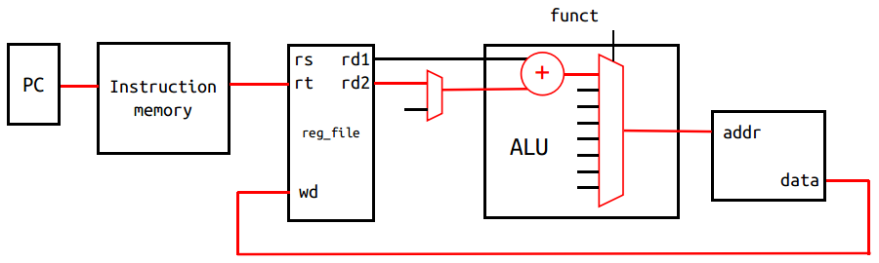

Figure 2.37 The critical path of the orignal design. Extra delay occurs in ALU.

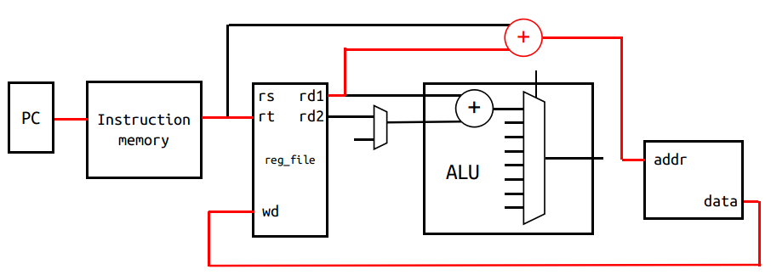

Figure 2.38 Optimized design where ALU is bypassed.

This change saves around 2 ns of delay, which reduce our total delay to **13.021ns**. Thus the highest frequency now can be **76.8MHz**.

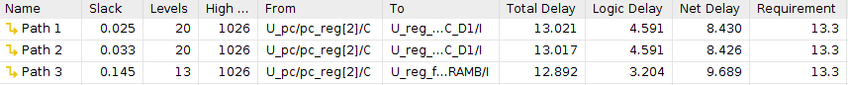

* + - 1. Resource Utilization

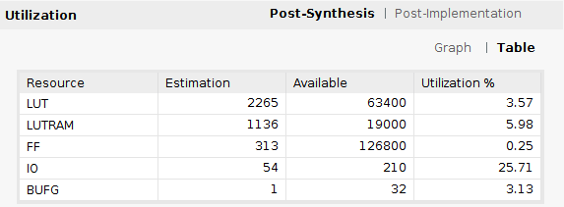 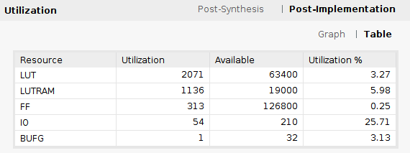

Our implementation takes **3.27%** of the LUTs. We can reduce it by setting the optimization level to HIGH when synthesize and implement the design. However, it will increase the critical path delay. So in our case, we choose higher clock frequency rather than low resource utilization.

# RC5 Implementation

## Assmebly code

### FSM diagram

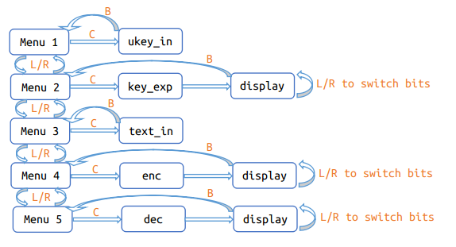

This picture shows the diagram of our RC5 code. Thanks to the input/output interface of the processor, our program supports changing ‘ukey’ and ‘din’ on-the-fly. We wrote an FSM in our RC5 code, to let the user choose which subprogram to run independently. There are 4 buttons: LEFT(L), RIGHT(R), CONFIRM(C) and BACK(B). After power-on, the program will be in Menu 1. User can use L/R to switch between different menus and C to execute the subprogram.

**UKEY_IN**: This is the subprogram for sending 128-bit ukey. We can use switches and btnC to input 16-bit at a time and use L/R btn to switch between different bits. The ukey will be stored into data memory [50 to 53] in little-endian.

**KEY_EXP:** This is the key expansion function. Round-key will be generated based on the ukey in the data memory. The expanded round-key will be stored into data memory [0 to 25].

**TEXT_IN:** This is the subprogram for sending 64-bit input-text. We can use switches and btnC to input 16-bit at a time and use L/R btn to switch between different bits. The input-text will be stored into data memory [54 to 55] in little-endian.

**ENCRYPTION:** This is the encryption function. 64-bit Cypher-text encrypted from input-text will be stored into data memory [30 to 31] in little-endian.

**DECRYPTION:**This is the decryption function. 64-bit Plain-text decrypted from input-text will be stored into data memory [32 to 33] in little-endian.

**DISPLAY:** This subprogram will show the output-text on the 7-segment display. User can use L/R to switch from different bits.

Please check the source ‘rc5_optimized.asm’ for more details about how we implement the RC5 algorithm in assembly. Our source code is well commented for reviewing. Also in the next few sections, we will talk about the assembly implementation of rotation and XOR.

### Time complexity analysis

The critical part in the RC5 implementation is how fast we can run the key expansion, encryption and decryption in terms of cycles. So in this section we will briefly analyze the time complexity of rc5.

The running cycles of **key expansion** is **O(TL + TS + (Trot + Cexp)*78 + C0)**, where TL is for L-Initialization, TS is for S-Initialization, Trot + Cexp is for one round of skey-Expansion, C0 is for other constant time operations.

The running cycles of **encryption/decryption** is **O((Trot + Txor + C1)*2*12 + C0)**, where (Trot + Txor + C1)*2 is for one round of encryption/decryption, C0 is for other constant time operations.

Notice that the constant factors 78 and 24 are relatively large, so reducing the cycles spend on rotation(Trot) and XOR(Txor) operation will be very helpful to reduce the total running cycles.

### ROTATE optimization

In this project, we only have I-type shift instructions, which is a huge limitation.

A trivial solution to implement left rotation using I-type shift is:

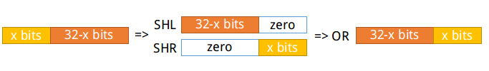

Suppose the rotation amount[1] is x, we can recursively shift left by 1 for x times. Then right shift by 1 for 32-x times. Finally combine them together using OR operation. This method will take at least 32*3=96 cycles per rotation. Below is an example code of rotl.

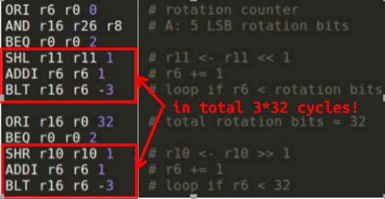

A smarter way is sequentially comparing the rotation amount with 0 to 31 and shifting the register by required amount directly. Because we don’t have instructions to compare a register with an immediate number, so each comparison will take 2 cycle. Thus, the running time per rotation in average is 2*16+4=36 cycles.

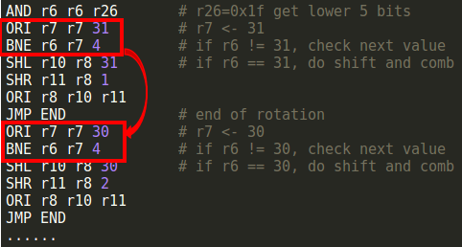

An optimal way to do the rotation is using binary search, which takes only 13 cycles per rotation! We know that the rotation amount is a 5-bit number, so we can determine whether it’s in [0,15] or [16,31] by checking its 5th bit. Then use 4th bit to reduce the range again, so on and so forth. Picking 1 bit (AND) and branch if it’s 1 (BEQ) takes only 2 cycles. So the total running time is 2*log(32)+4=14 cycles. The assembly code to implement a binary search rotation is similar to the sequential comparison, but much longer (150+ lines). Please check our source code as it’s too long to be shown here.

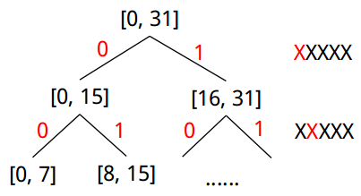

### XOR optimization

We don’t have XOR instruction, so we have to implement it using AND, OR, NOR. If we looking at the truth table of them, we can easily find an efficient solution: **A XOR B = (A NOR B) NOR (A AND B),** which takes only 3 cycles.

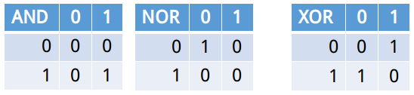

## Testbench

To meet the requirement, we tested 1000 random cases for each of key_expansion, encryption and decryption. We also tested another 10 random ukey, each with 100 cases of encryption and decrpytion. So there were in total 4000 cases tested in our testbench.

The random cases along with their expected result were generated from a python script (rc5.py), and stored in a text file for testbench to read. Assertion statement was used in the testbench for automatically checking.

The testbench for the timing simulation is similar, except that the number of cases is reduced. We tested 5 random cases for each of key_expansion, encryption and decryption. Then tested another 2 random ukey, each with 5 cases of encryption and decrpytion.

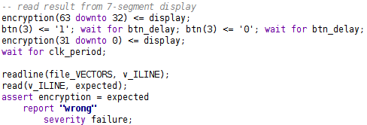

## Functional simulation

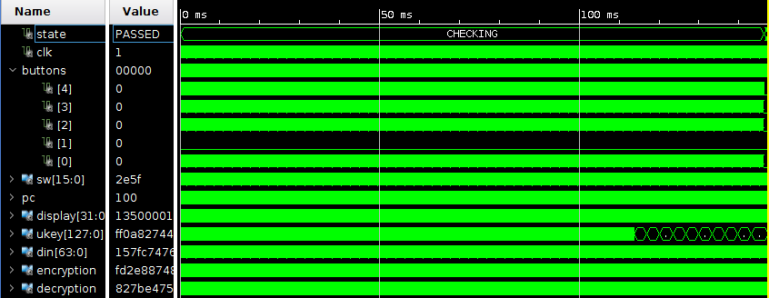

Figure 3.1 All 4000 cases. 0 to 110ms is 3*1000 cases for each of key expansion, encryption and decryption. After 110ms is the wave of 10 different ukeys each with 100 dins.

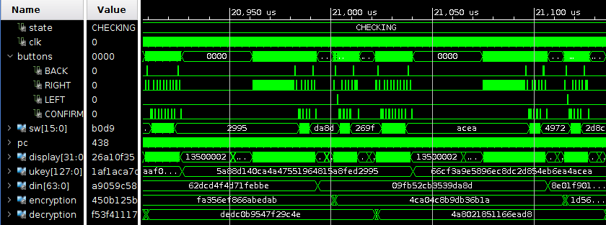

**din**

**din**

**din**

**din**

**ukey_in**

**ukey_in**

Figure 3.2 This screenshot shows 2 random ukey each with 1 din for encryption and 1 din for decryption. The red box shows how the testbench input data using buttons and switches.

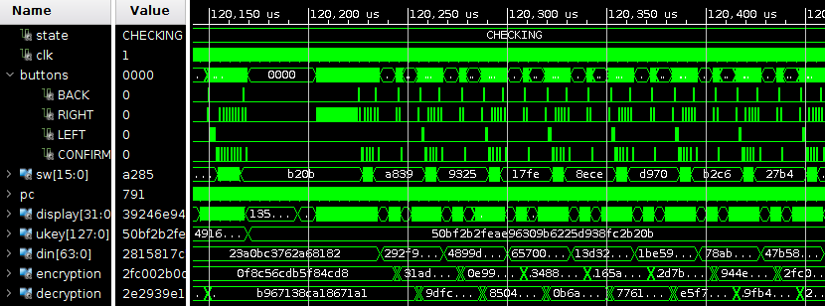

Figure 3.3 Screenshot of 1 ukey followed by 100 din for each encryption and decryption.

Now let’s figure out how much cycles does it take to do the key_expansion, encryption and decryption. Note that the clock period is 10 ns.

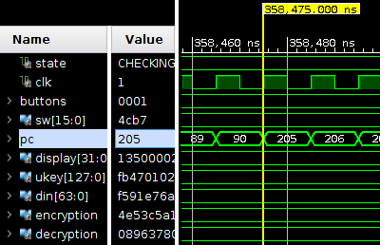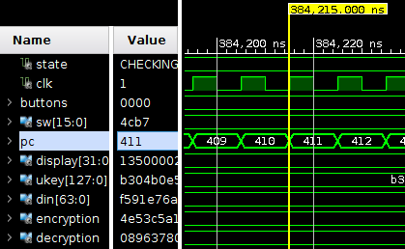

Figure 3.4 Key_expansion starts at line 205 and ends before line 411.

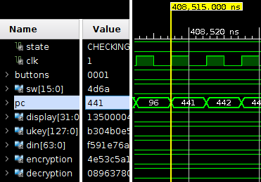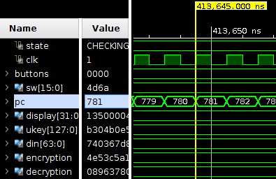

Figure 3.5 Encryption starts at line 441 and ends before line 781.

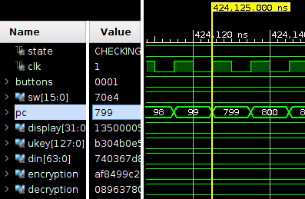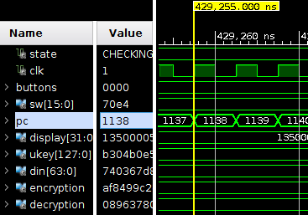

Figure 3.6 Decryption starts at line 799 and ends before line 1138.

Then we can get the following table:

|  |  |  |  |
| --- | --- | --- | --- |
| function | Start at | End at | Cycles |
| key_expansion | 358475 | 384215 | 2574 |
| encryption | 408515 | 413645 | 513 |
| decryption | 424125 | 429255 | 513 |

Thanks to the optimization of rotation operation, our RC5 implementation is very efficient.

## Timing simulation

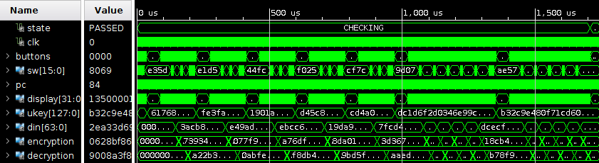

Figure 3.7 All 25 cases. The red arrow shows 5 ukey each followed by 1 encryption and 1 decryption. The yellow arrow shows 2 ukey each followed by 5 encryption and decryption.

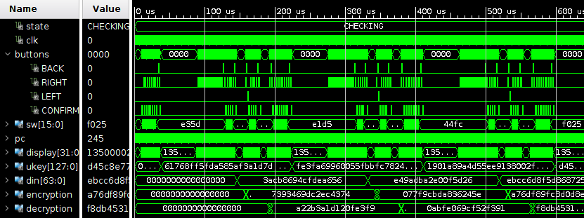

Figure 3.8 1 One ukey followed by 1 encryption and 1 different decryption.

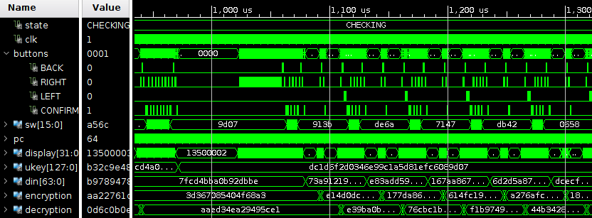

Figure 3.9 One ukey followed by 5 encryption and decryption.

# FPGA Implementation

* 1. **Clock Configuration**

The timing analysis show that our processor can run at 76.8MHz, but we can only divide the system clock by 2 to get 50 MHz at most. Fortunately, we find a way to generate whatever clock frequency we want in the design, that is using the MMCM module on the FPGA.

The Mixed-Mode Clock Manager (MMCM) Module is used to generate multiple clocks with defined phase and frequency relationships to a given input clock. It’s similar to the PLL. And using it is very simple in Vivado:

Click the ‘IP Catalog’ in PROJECT MANAGER. In the pop-up tab, double click the ‘Clocking Wizard’ under ‘FPGA Feature and Design/Clocking’.

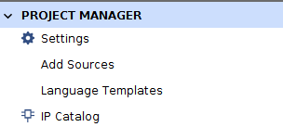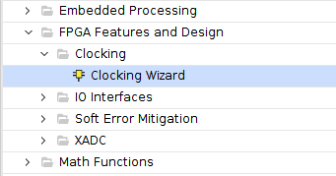

Then a configuration window will show up. In the ‘Output Clocks’ tab, we can set the desired frequency of clk_out1. Below that table, we can also select other output signal that we want (in our case, we unselected the locked signal). We can check the port of the module on the left side. Click OK if done with setting.

The generated MMCM module will show up in Sources window. We can use it as an component as we always do. The following figure shows how we use this module in our code.

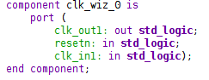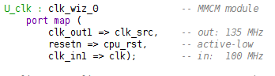

Now we can set our processor to run at any clock frequency we want. The following figure shows the simulation result of our new clock at 135 MHz.



Figure 4.1 clk: 100MHz system clock signal, clk_src: new clock from MMCM at 135MHz

* 1. **Board Test**

Section 3.1.1 described how other RC5 program works. When the RC5 is running on the FPGA, we can use buttons to switch from different menus, and do input, key expansion, encryption, decryption independently as we want. The output will show on the 7-segment display.

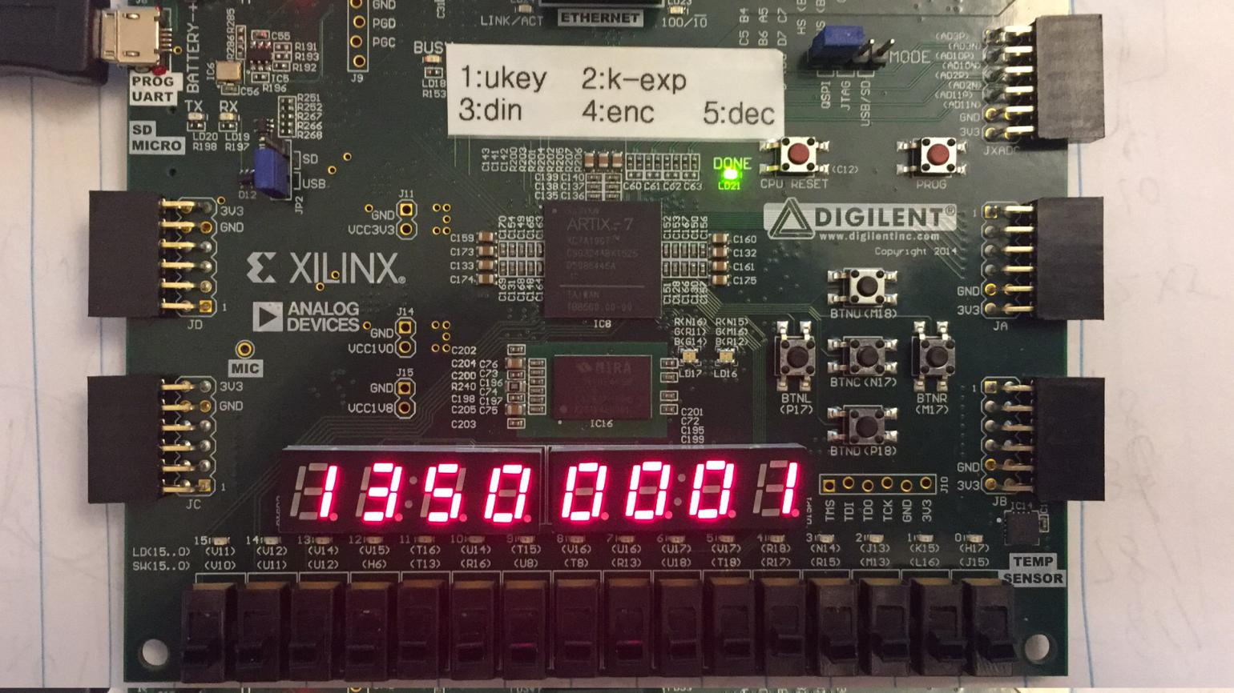

Figure 4.2 Right 7-segment display shows the menu index; Left shows the current clock frequency.

We started from 75 MHz, and tested 2 ukey each with 5 encryption and decryption to verify if the FPGA worked properly. Then we increased the frequency by 5 MHz at a time, until the FPGA couldn’t passed the cases. Note that when we changed the frequency, we also changed our RC5 code to show up the current frequency on the main menu, in order to make sure that the downloaded bitstream was correct.

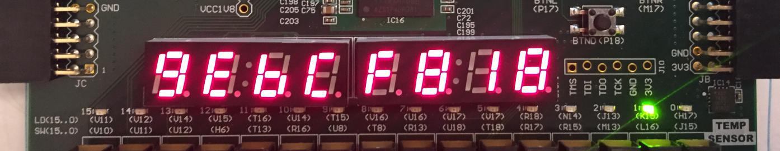At the end, we found that the FPGA can stably run at **135 MHz**! The following figures shows the result of the given test case on our board at 135 MHz.

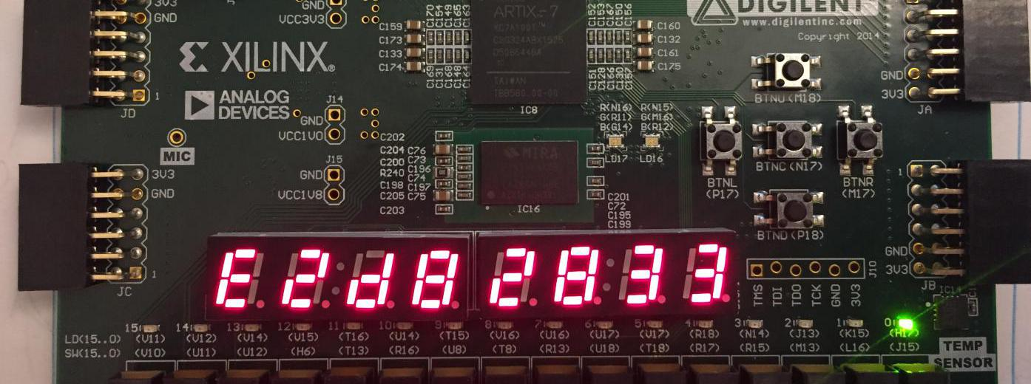

Figure 4.3 Encryption result: 0x9ebcf818 e2d82833 which is as expected

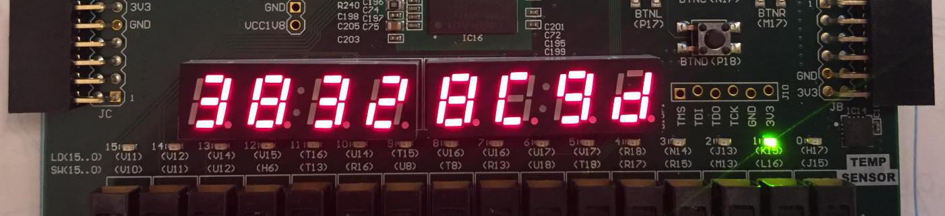

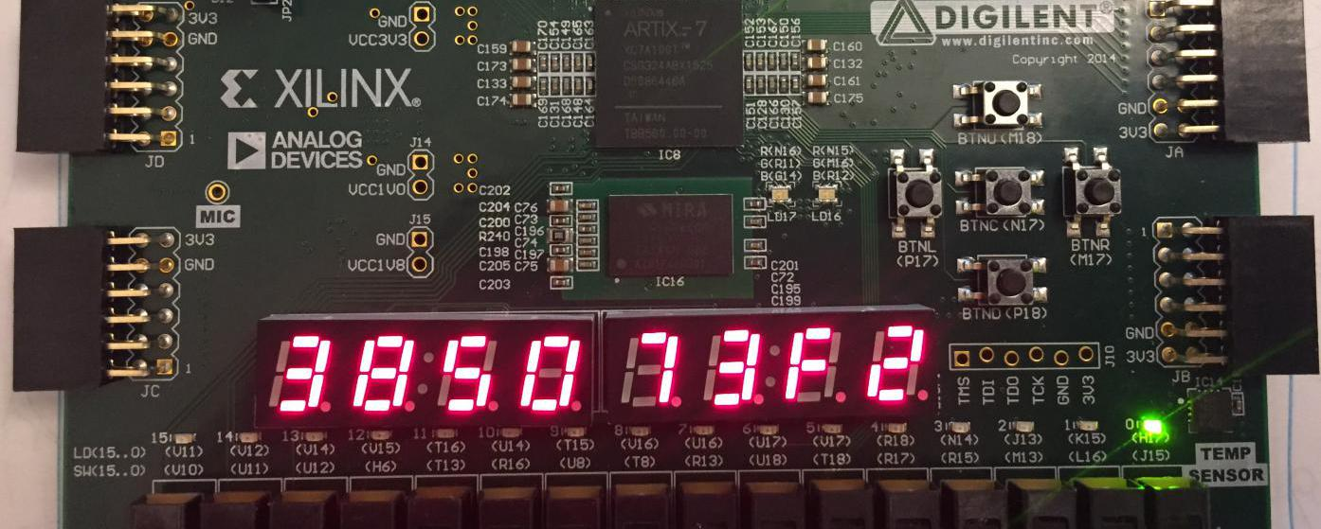

Figure 4.4 Decryption result: 0x38328c9d 385073f2 which is as expected

# Summary

* 1. **Specifications**

Number of clock cycles to perform Encryption/Decryption: **513 cycles**

Number of clock cycles to perform Round Key Generation: **2574 cycles**

Clock frequency of the processor: **135MHz on FPGA (76.8MHz in timing summary)**

FPGA utilization (LUTs): **3.27%**

Number of test vectors for functional simulation: **1000*3 + 1000 random cases**

Number of test vectors for timing simulation: **5*3 + 10 random cases**

* 1. **Deliverables**

Github: **https://github.com/Kooscii/ahd_processor_design**

Design block diagram: **Section 2.1**

Simulation screenshots: **Section 3.3 and 3.4**

Performance and area analysis of design: **Section 2.3.5.1 and 2.3.5.2**

Description of RC5 implementation in assembly: **Section 3.1**

Description of processor interfaces: **Section 2.1, 2.2.3, 2.2.7 and 3.1.1**

Details about how you verified your overall design: **Section 2.3 and 4.2**

Demo video: https://youtu.be/XHvZEeUGkEw

1. The rotation amount is the lower 5 bits of the operand, so it’s in range from 0 to 31.