Kholofelo Robyn Rababalela  Full-Stack Frontend Engineer  Based in Cape Town, South Africa  Originally from Ga-Kgapane, Tzaneen, Limpopo and relocated to Cape Town in 2012 for education and opportunity. | 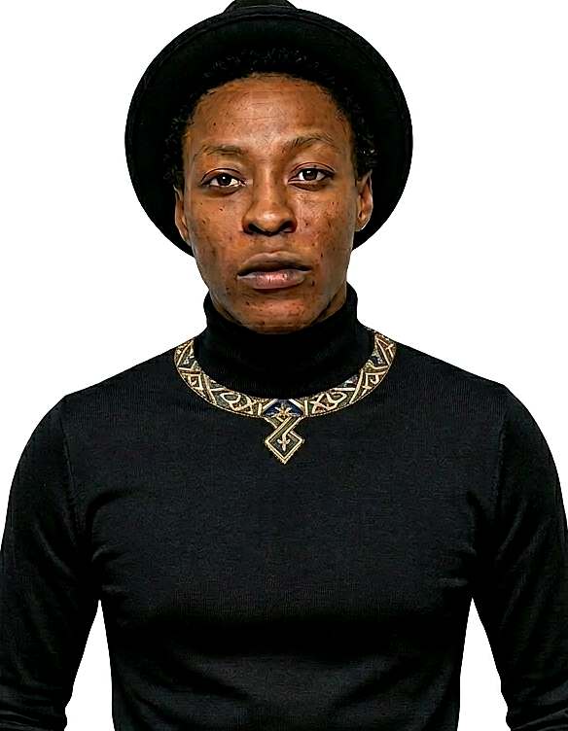
Email | rkholofelo@gmail.com
Portfolio | kholofelorababalela.vercel.app
LinkedIn | linkedin.com/in/kholofelo-robyn-rababalela-7a26273b6
GitHub | github.com/RobynAwesome

PROFESSIONAL SUMMARY
Originally from Ga-Kgapane, Tzaneen, Limpopo and now based in Cape Town after relocating in 2012 for education and opportunity, I build production web products with React, TypeScript, Next.js, Node.js, Express.js, and MongoDB. My work focuses on scalable frontend experiences, strong server-side logic, authentication, SSR-aware delivery, and performant interfaces for real users.
TECHNICAL SKILLS
Languages | JavaScript, TypeScript, HTML, CSS, Python, Java
Frontend | React, Next.js, Tailwind CSS, Framer Motion, responsive UI development, PWAs
Backend & APIs | Node.js, Express.js, REST APIs, JWT auth, NextAuth, RBAC
Data | MongoDB, Mongoose, database modeling, content, booking, and marketplace workflows
Tools & Platforms | Git, GitHub, Vercel, Vite, Docker (working knowledge), Azure fundamentals
AI & Learning | MCP, AI-assisted development workflows, cloud and cybersecurity fundamentals
Concepts | SSR, server-driven UI, Agile/Scrum collaboration, performance optimization, testing fundamentals

PROFESSIONAL EXPERIENCE
Founder & Full-Stack Engineer | Kopano Labs | Cape Town, South Africa | 2026 - Present
- Architect and build full-stack web applications with React and Next.js frontends, backed by Node.js and Express services for production-ready workflows.
- Design secure authentication, API contracts, and MongoDB data models supporting booking, content, and user management use cases.
Director & Full-Stack Developer | AMAPHU (Pty) Ltd | Cape Town, South Africa | 2021 - Present
- Lead client and product delivery through AMAPHU, translating business needs into shipped web platforms and polished user experiences.
- Delivered work for Hellenic FC / 5's Arena and other clients using React, Next.js, Node.js, and modern frontend tooling.
SELECTED PROJECTS
Bookit - 5's Arena | Next.js, React, Node.js, MongoDB
Built for: Hellenic FC / 5's Arena. A full-stack court booking and arena management platform with streamlined reservations and admin workflows.
Live product: fivesarena.com GitHub repository: github.com/RobynAwesome/Bookit-5s-Arena
5's Arena Blog | React, Node.js, Express.js, MongoDB
Built for: 5's Arena football community. A media and publishing platform with authentication, RBAC, image uploads, and content management.
Live product: blog.fivesarena.com GitHub repository: github.com/RobynAwesome/5s-Arena-Blog
KasiLink | Next.js, React, TypeScript, PWA
Built for: Township job seekers, informal businesses, and local gig providers. A mobile-first platform for trusted local services and opportunities.
Live product: kasilink.com GitHub repository: github.com/RobynAwesome/KasiLink
Cape Compass | Next.js, Framer Motion, PWA
Built for: Western Cape visitors and local explorers. A mobile-first tourism and discovery experience for heritage walks, guided trails, and local experiences.
Live product: github.com/RobynAwesome/cape-campass GitHub repository: github.com/RobynAwesome/cape-campass
Harvest 4 All | React, Vite, Tailwind CSS
Built for: MICT SETA Hackathon 2026. A sustainability platform supporting township residents, students, and families with food-growing and local trading tools.
Live product: www.cxia4irhack.co.za GitHub repository: github.com/RobynAwesome/Harvest-4-All
Portfolio-MBR | React, TypeScript, Vite
Built for: Mashoto Bayne Rababalela. A custom professional portfolio showcasing engineering, consulting, and business work.
Live product: mashoto.vercel.app GitHub repository: github.com/RobynAwesome/Portfolio-MBR
Portfolio Website | React, TypeScript, Vite, Framer Motion
Built for: My own professional brand and recruiter-facing showcase. A multi-page portfolio presenting projects, certifications, and technical narrative with strong motion design and responsive layout.
Live product: kholofelorababalela.vercel.app GitHub repository: github.com/RobynAwesome/Portfolio
EDUCATION
Bachelor of Engineering Technology (BEng Tech), Computer Engineering | Cape Peninsula University of Technology (CPUT) | 2025 - Present
Current studies focused on software engineering principles, modern computing systems, and engineering problem-solving.
ACHIEVEMENTS & CERTIFICATIONS
- National Round Finalist, CHPC Student Cluster Competition: Represented CPUT as part of Team #Runtime #Blinders in high-performance computing and distributed systems (December 2025).
- Cyber Security Participant: Completed the SANCS26 Southern Africa Netherlands Cyber Security School (March 2026).
- HackerRank: Frontend Developer (React), React (Basic), Node.js (Basic), CSS (Basic), and Java (Basic) (March 2026).
- Anthropic & LinkedIn Learning: AI Fluency, Introduction to Model Context Protocol, Azure Cloud Fundamentals, Generative AI in Cloud Computing, and AI for Cybersecurity (March 2026).

