**Kopeftache**

**The WebBrowser of the future!**

- O.S. Project –

Copetchi Stefan-Dragos

Dimoftache Serban

1222A – FILS

**Table of contents:**

1. Introduction

* a small welcome into the future with the Kopeftache WebSurfer

1. Functionality

* explaining the usages of the WebSurfer

1. Elements of the WebBrowser

* description of the elements and buttons of the WebBrowser

1. Usability of the PictureBox

* description of the components and the usability of the PictureBox

**Introduction:**

Kopeftache is new WebBrowser looking forward to evolve the market when it comes to „Surfing the Internet”.

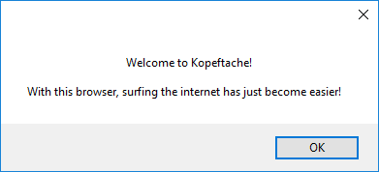

With it’s simple and efficient structure that can reach incredible download speeds, Kopeftache is the next step towards a faster access to information, not only by speed but also by efficiency.

The efficiency of the browser is stated in the possibilties of saving the information in your browser in just a few clicks and drags.

Goodbye Gyazo and goodbye dear old Snipping Tool and welcome the new sensation in town : Kopeftache!

**Functionality:**

Kopeftache has the basic components of a web-browser like navigation and status, but it also has a new photo-editing feature included.

You can surf the internet, go to your favorite websites, move easily between pages with Back and Forward buttons and you can directly use the Google search engine to find what you are looking for in a matter of seconds.

Although, the true innovation that Kopeftache brings is the possibility to save screenshots from any web-page you are surfing on.

The new PictureBox feature has multiple options of editing, saving and printing the web-page you are surfing on.

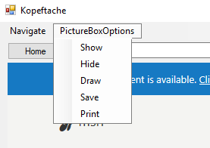

We will talk about these features in the next chapters.

**Elements of the WebBrowser:**

The WebBrowser component first has the basic elements of a classic web-browser:

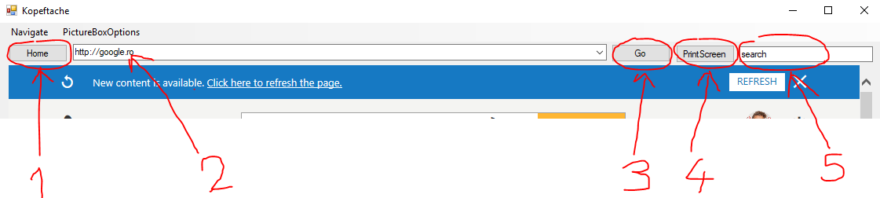

1 – „Home” button : redirects towards the home page of the web-browser

2 – Address bar : this is where you insert addresses with „http://” protocol

3 – „Go” button : redirects towards the link inserted in the Address bar(2)

4 – „PrintScreen” button : this button saves a screenshot of your current window and opens the PictureBox for you to further edit that screenshot

5 – Google search engine

The status bar of the loading page is also displayed in the bottom-left of the window:



And also, the most important navigation feature, the Navigation menu :

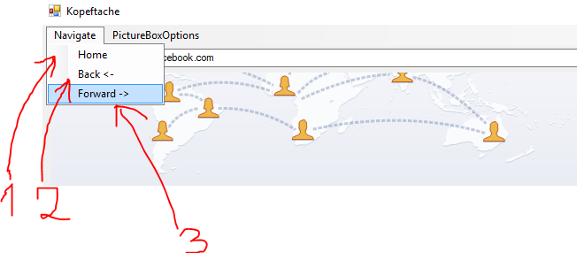

1 – Another „Home” button : redirects towards the home page of the WebBrowser

2 – „Back” button : redirects to the last visited web-pages in a reverse direction

3 – „Forward” button : redirects to the last visited web-pages in a forward direction

**Usability of the PictureBox:**

After clicking the „PrintScreen” button, a PictureBox will appear with the screenshot that has been captured.

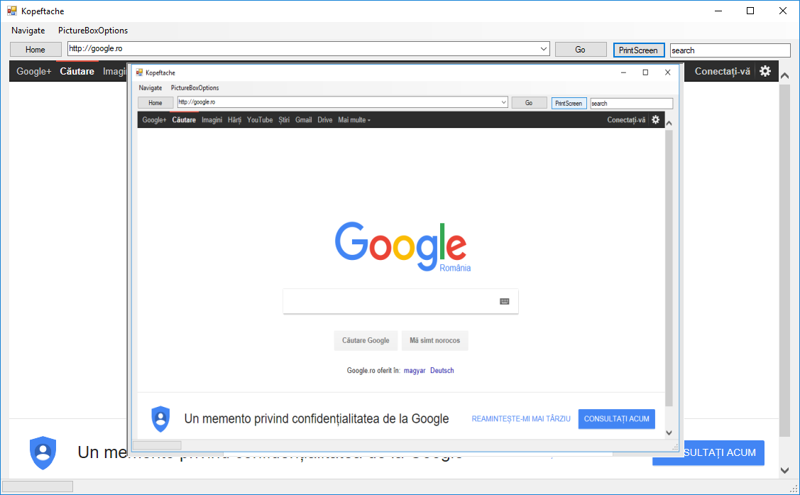

The PictureBox will be placed in front of the browser and the user can use some tools that can be applied on it. These tools are found in the „PictureBoxOptions” menu, located in the top-left of the WebBrowser.

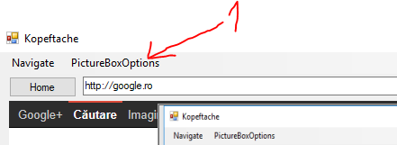

Clicking on the „PictureBoxOptions” menu will give you a list of tools that can be applied on the PictureBox you have just opened.

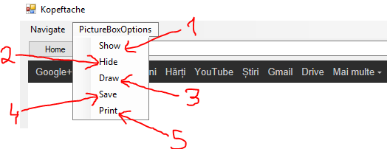

1 – „Show” button : Reveals the PictureBox with the last screenshot that has been taken

2 – „Hide” button : Hides the PictureBox in case the user wants to continue surfing the internet

3 – „Draw” button : Enables to the user the possibility of drawing with a red pen over the surface of the PictureBox

4 – „Save” button : Saves the edited image inside the PictureBox to your computer as a .jpg format

5 – „Print” button : Converts the image from inside the PictureBox into a pdf document ready to be printed and saves it onto your computer, on the user’s desired location