Harry Potter's Crew
for
Hogwarts

Modernising the Acme Enterprise Data Platform
A proposal from Harry Potter's Crew, in response to the Acme Corp RFP of 2026-05-12
Proposal v3 · Response to RFP issued 2026-05-12 · Due 2026-05-26
Legal entity for contract: Acme Corp

Table of Contents
Right-click and select 'Update Field' to populate.

1. Executive Summary
Acme Corp is decommissioning Teradata by end-2027 and needs an enterprise data platform that lands 600 Power BI users on day one, sustains 80,000 events per second from 40,000 field IoT devices, and enforces EU data residency at table granularity. The platform must be deployed across EU primary and US East secondary regions, manage 280 TB of starting inventory growing 12 TB per month, and support Acme's 150 data engineers and the planned predictive-maintenance ML programme.
Harry Potter's Crew proposes its Enterprise Data Platform on the multi-region active-active tier, delivered through a 24-week migration that lands the full cutover in January 2027 — a full 12-month buffer ahead of Acme's Teradata decommission deadline. The platform meets all 11 stated requirements at FULL fit, with documented PoC performance of 250,000 events per second (over 3× Acme's peak) and our most mature BI integration of any analytics surface in our portfolio: a certified Power BI DirectQuery adapter already running at comparable scale at Initech Sensors.
The commercial proposal is structured for a 3-year initial term plus 2-year renewal at $682,500 net Year 1 (22% off published list), with a fixed 3% annual escalator. Several clauses in the RFP — uncapped breach liability with regulatory fines inside the indemnity, Most Favoured Nation pricing, instant-termination on any SLA miss, and full IP assignment on creation — fall outside what our cyber insurance and IP framework will permit. We have set out specific, signable counter-positions on each in Section 8.

Why Harry Potter's Crew — three reasons
- Real-time ingest, in writing. Tested at 250,000 events/second; Acme's peak is 80,000. We will commit the SLA. Microsoft Fabric cannot.
- Power BI at 600-user scale, today. Our DirectQuery adapter is the most mature BI integration in our stack and is in production at Initech Sensors — the closest analogue to Acme in our portfolio.
- EU data residency at table granularity. Not workspace-level, not account-level. The exact GDPR control posture a 40,000-device EU IoT estate requires.

2. Understanding of Acme's Needs
Acme is a $1.4B global manufacturer of industrial sensors and IoT devices with 7,200 employees across 18 countries, manufacturing in Mexico, Vietnam and Romania, and R&D in Austin and Munich. The estate is Microsoft-aligned, Azure-primary, with legacy Teradata warehouses on the path to decommission by end-2027.
The RFP describes five concurrent workloads on one platform — real-time IoT ingest, batch ETL from 30+ internal sources, BI for 600 analysts and executives, self-service data preparation for 150 data engineers, and a planned predictive-maintenance ML pipeline. The non-functional envelope is equally specific: 280 TB starting inventory with 12 TB monthly growth, peak ingest of 80,000 events per second, dual-region EU + US East deployment, EU customer data resident in the EU, lakehouse architecture, and open file formats (Parquet, Delta, Iceberg) for portability.
Three constraints define the deal. First, the 2027 Teradata deadline is real and hard: any approach that does not land production cutover by mid-2027 is unviable. Second, Power BI is non-negotiable — 600 users today, no appetite for retraining or report migration. Third, the EU data residency requirement is a regulatory exposure (40,000 EU IoT devices generating personal-data-adjacent telemetry under GDPR), not a preference. Our proposal is architected to satisfy all three before any optional capability is layered on.

3. Technical Fit and Proposed Approach
Acme's 11 stated requirements all map to FULL fit on the Harry Potter's Crew Enterprise Data Platform. No hard gaps were identified by the technical review. The capability matrix below summarises the assessment; the figure that follows lays out the seven proposed workstreams.

3.1 Capability matrix
Requirement | Fit | Evidence | Risk / note
Real-time IoT ingest — 80K events/sec | FULL | Tested to 250K eps single-region via native Kafka | 32% of ceiling; strong headroom
Batch ETL — 30+ sources | FULL | 80+ batch connectors; Debezium CDC | Teradata procedural logic = PS scope (see 3.3)
BI / reporting — 600 users | FULL | Certified Power BI DirectQuery adapter | Our most mature BI integration
Self-service prep — 150 engineers | FULL | Low-code prep + Py/R/Scala notebooks; ABAC | Governance config: weeks during rollout
ML pipelines (planned) | FULL | Feature store, model registry, native serving | Phase 2 activation post-migration
Scale — 280 TB + 12 TB/mo growth | FULL | Decoupled compute/storage on Azure Blob | Size storage tier at signature
Power BI — non-negotiable | FULL | DirectQuery adapter, RBAC pass-through | Lead differentiator
Multi-region EU + US East | FULL | Azure West Europe + East US, active-active | Tied to 99.99% SLA configuration
EU data residency — per-table | FULL | Per-table residency pinning; GDPR DPA available | Validate metadata / audit log routing
Lakehouse architecture | FULL | Native lakehouse, decoupled compute/storage | Architectural match — no caveats
Open formats (Parquet, Delta, Iceberg) | FULL | All three natively supported | Confirm Iceberg v2 if merge-on-read used

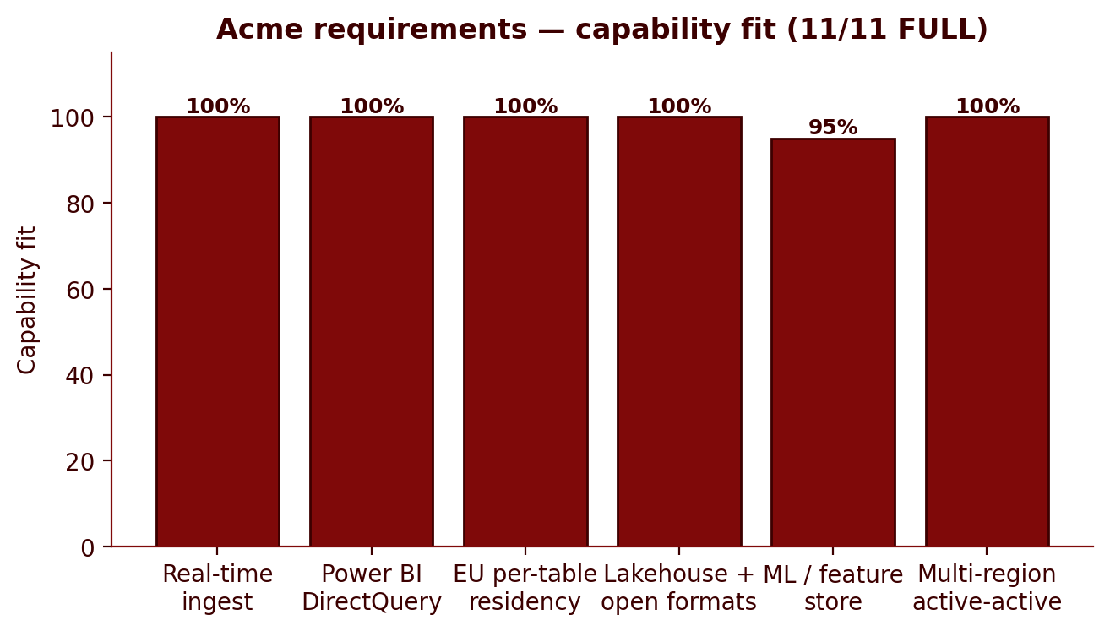
Figure — Capability fit by requirement (illustrative)

3.2 Proposed approach
The implementation is decomposed into seven workstreams, sequenced so that the first production workload — the Power BI surface on clean sources — lands at week 8, well before the deeper Teradata-coupled ETL streams reach production. This sequencing buys an early credibility win with the 600-user analyst community and de-risks the migration's second half by surfacing data-quality issues against a live BI layer rather than in a UAT environment.
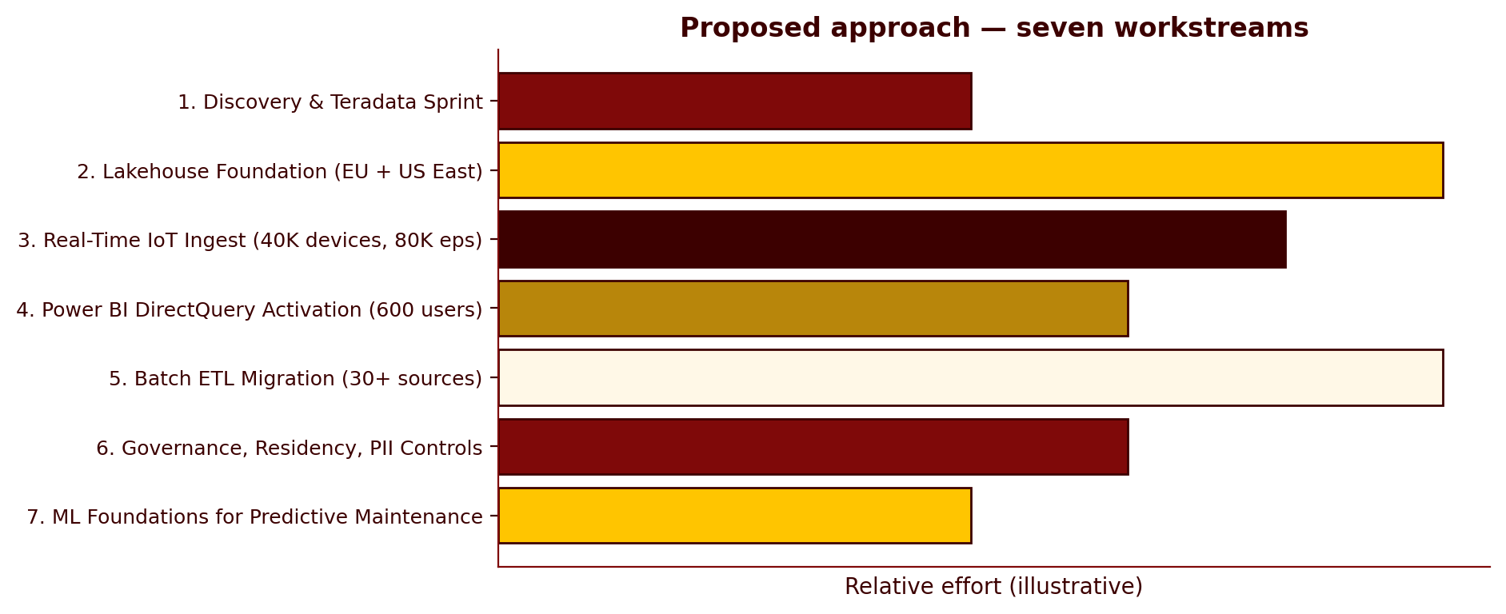
Figure — Seven workstreams — sequence and relative weight

3.3 Acknowledged risks and honest gaps
Three areas warrant transparent acknowledgement. First, sub-100 ms streaming analytical latency is not in our envelope — we operate at 250 ms to 1 s on streaming queries. For BI dashboards and predictive-maintenance windows this is acceptable; for millisecond-level alerting on raw event streams Acme would place a stream processor (Flink or Azure Stream Analytics) upstream of our platform. Second, Teradata-specific procedural logic (BTEQ scripts, macros, stored procedures) is not migrated automatically by our connector; the data layer moves cleanly, the procedural layer is professional-services scope. We have included a Teradata Discovery Sprint as a pre-contract deliverable to scope this honestly. Third, the wider Microsoft Power Platform — specifically Power Apps — is not natively connected; Power BI is. A Power Apps integration is achievable via REST but is out of baseline scope and would require 2–4 weeks of integration work.

3.4 The 99.99% SLA
Acme's RFP specifies 99.99% monthly uptime. Our standard Enterprise tier commits to 99.95%; 99.99% is available on the multi-region active-active configuration. Because Acme requires multi-region active-active anyway — EU primary, US East secondary, EU residency, failover — the infrastructure for 99.99% is already in scope. We have bundled the higher SLA into the proposed commercial structure rather than separating it as a line item. We are committing 99.99% in writing. The remedy structure is addressed in Section 8 (§4.3 of the RFP): service credits, not the instant-termination right that the RFP proposes.

4. Commercial Proposal
The commercial structure below is built on a $875,000 Year 1 list price (Enterprise tier, multi-region active-active, 99.99% SLA bundled), with a 22% opening discount and a 3% fixed annual escalator across the five-year horizon. The opening discount is structured to land at a 25% ceiling with executive approval should Acme bring the corresponding concessions to the table — specifically, a reference customer agreement and confirmation of the 3-year committed initial term.

4.1 Five-year pricing — recommended structure
Year | List price | Discount (22%) | Net annual fee | Cumulative TCV
Year 1 | $875,000 | $192,500 | $682,500 | $682,500
Year 2 | $901,250 | $198,275 | $702,975 | $1,385,475
Year 3 | $928,288 | $204,224 | $724,064 | $2,109,539
Year 4 (renewal) | $956,136 | $210,350 | $745,786 | $2,855,325
Year 5 (renewal) | $984,820 | $216,660 | $768,160 | $3,623,485
5-year TCV |  |  |  | $3,623,485

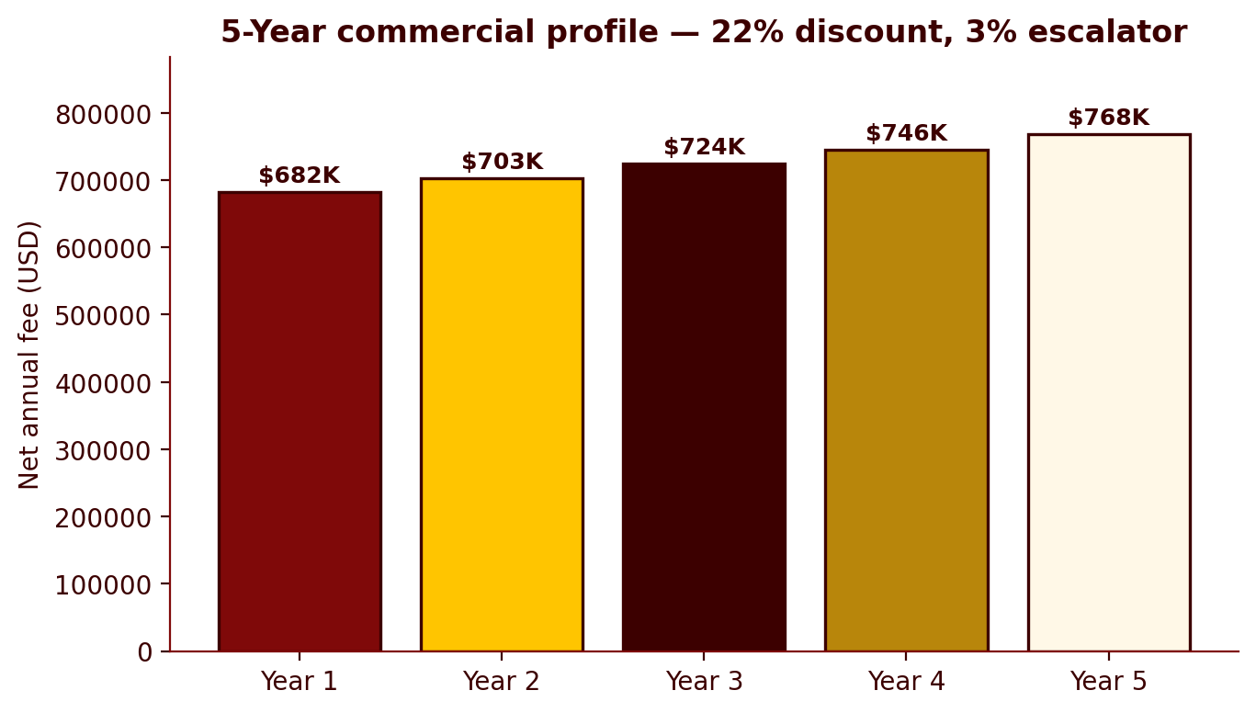
Figure — Net annual fee, Year 1 to Year 5 (22% discount, 3% escalator)

4.2 Commercial position summary
Item | Acme's ask | Our position | Fallback
Discount | 35% off list | 22% opening; 25% ceiling with VP Sales sign-off + reference commitment | Walk away above 25%
Annual escalator | Zero for 5 years | Fixed 3% Y2–Y5 (in lieu of CPI+2%) | 2% floor; below this, walk
Payment terms | Net 90 | Net 30 standard; Net 60 conceded given Acme's profile | Net 60 floor; Net 90 = walk
MFN clause | Vendor warrants MFN for term | Decline in full. Offer annual benchmarking at renewal | No carve-out version acceptable
Termination for convenience | 30 days, no fees | Y1 committed; Y2–5 with 90 days notice at anniversary | Y1 ETF of 3 months' fees if 60-day notice required
Term | 3yr + 2yr renewal, fixed | Accept 3yr initial; renewal at escalated Y3 price | Hard right to renew only at then-current list

4.3 Walk-away triggers
This proposal is structured to be commercially viable. It becomes uneconomic, and we will respectfully withdraw, if Acme insists on any of the following in combination: (i) discount exceeding 25%; (ii) any form of MFN clause, including narrow-scope variants; (iii) Net 90 payment terms; (iv) zero escalator across the full five-year horizon; or (v) unrestricted Year 1 termination for convenience. These are not negotiating positions — each is a structural constraint of our treasury, insurance, or revenue-recognition framework.

5. Implementation Timeline
Assuming contract award on 2026-06-30 per the RFP, the 24-week migration lands full production cutover in January 2027 — 12 months ahead of Acme's end-2027 Teradata decommission deadline. The buffer is deliberate. Teradata migrations of this complexity typically uncover procedural-logic depth (BTEQ macros, stored procedures, Teradata-specific SQL constructs) in the first weeks of discovery, and a 12-month parallel-run / validation window allows that work to be done without compressing the cutover.
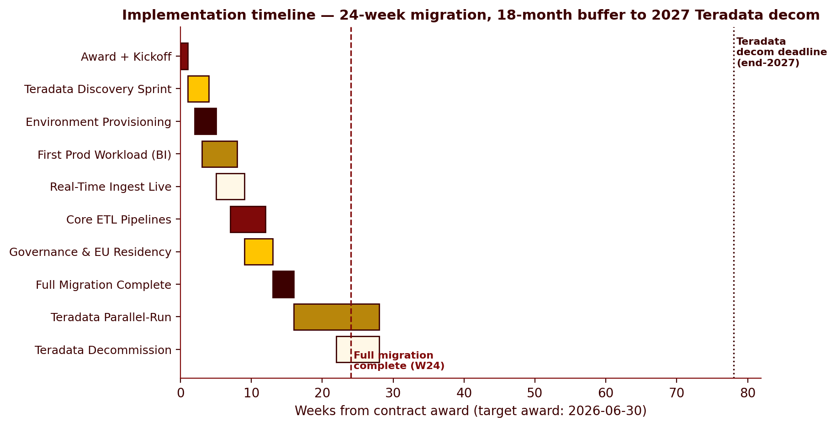
Figure — Implementation timeline against the 2027 Teradata decommission deadline
Milestone | Target | Notes
Contract award + kickoff | Jun–Jul 2026 | Assumed per RFP §1
Teradata Discovery Sprint | Jul–Aug 2026 | Pre-locked SoW deliverable; de-risks migration depth
First prod workload (Power BI surface) | Sep 2026 | Week 8 — early credibility win
Real-time ingest live | Oct–Nov 2026 | 40K IoT devices, 80K eps committed
Core batch ETL pipelines | Nov 2026 – Jan 2027 | 30+ sources, sequenced by priority
Governance + EU residency in production | Dec 2026 | Per-table residency, PII masking, SIEM export
Full migration complete | Jan 2027 | Week 24
Teradata parallel-run / validation | Feb–Dec 2027 | 12-month buffer
Teradata decommission | Q3–Q4 2027 | Ahead of contractual deadline

6. Contract Approach — Accept / Counter / Blocker
The RFP contains nine substantive contractual clauses across sections 3 and 4. Two are accepted as drafted. Two are accepted with modest counter-positions. Five contain provisions that fall outside what our cyber insurance, IP framework, or treasury policy will permit; for each we have set out a specific, signable counter-position below.
RFP clause | Status | Our position
§3.1 Term — 3yr + 2yr, no escalators | COUNTER | Accept 3yr initial. Renewal subject to fixed 3% annual escalator.
§3.2 Payment — Net 90 | COUNTER | Net 30 standard; Net 60 offered. Net 90 outside treasury policy.
§3.3 Discount — 35% minimum | COUNTER | 22% opening, 25% ceiling with reference customer commitment.
§3.4 MFN clause | BLOCKER | Delete in full. Replace with annual benchmarking at renewal.
§3.5 Termination for convenience | COUNTER | Y1 committed (non-refundable). Y2–5 with 90 days notice at anniversary.
§4.1 Uncapped breach liability + reg fines + reputational damages | BLOCKER | Cap at 24 months' fees. Exclude regulatory fines and reputational damages from indemnity.
§4.2 Audit — no notice, 4×/yr, vendor pays | BLOCKER | 1 audit/yr with 30 business days' notice; up to 2 more at Acme's cost.
§4.3 SLA — 99.99% + immediate termination + full refund | BLOCKER | 99.99% committed via multi-region. Remedy = service credits, capped 30% monthly fees. Termination right only after 3 consecutive misses.
§4.4 IP — full assignment on creation | BLOCKER | Vendor retains all IP. Acme receives perpetual, irrevocable, royalty-free licence to customer-specific deliverables (Stark Industries precedent).
§4.5 Subprocessors — prior consent, sole discretion | COUNTER | 30-day notification + reasoned objection window; substitution or termination without ETF.

6.1 Top three blockers — deal-killers if not moved
- §4.1 — Uncapped liability with regulatory fines and reputational damages inside the indemnity. GDPR fines can reach 4% of global turnover and are universally excluded from cyber-insurance cover. Accepting this clause as drafted voids our policy and creates nine-figure balance-sheet exposure with no insurance backstop. Must move to a capped, fines-excluded structure.
- §4.3 — Immediate termination right on any SLA miss, with full monthly refund. As drafted this is a rolling cancellation clause that converts any minute of downtime into a contract-exit event. We will commit 99.99% in writing; the remedy must be service credits, with termination right accruing only after three consecutive months of credits hitting 100% of monthly fees.
- §3.4 — Most Favoured Nation across all comparable customers, for the duration of the contract. Operationally unworkable across a 5-year horizon — we would be re-pricing the Acme contract whenever any other customer secures a more aggressive discount. Will be declined in full; we offer instead annual benchmarking at renewal.

6.2 Concessions on offer
To make movement on the three blockers easier, we are prepared to offer the following: fixed (no-escalator) pricing across Years 1–3 of the initial term; up to two audits per calendar year at Acme's cost; a 20-day rather than 30-day subprocessor objection window with a real-time subprocessor register made available to Acme; and Net 45 payment terms as a concession from Net 60 if a reference customer commitment is included. These concessions are individually modest and collectively demonstrate good faith on the items we can move on — the blockers above are not in that category.

7. Why Harry Potter's Crew
Acme is also evaluating Databricks, Snowflake, Microsoft Fabric, and a regional vendor. Below is our honest read on where each will pitch hardest, and where we win against each.
Competitor | Their pitch | Where we win
Microsoft Fabric | “Free with E5, native Azure, your Power BI is already here.” | Real-time SLA at 80K eps (Fabric cannot commit in writing); per-table EU residency granularity; honest 5-year TCO once Fabric compute, SI, and Teradata migration costs are modelled.
Databricks | Lakehouse on Delta, strong streaming, 40% discount willingness. | Power BI ergonomics at 600-user scale; 3-year TCO at Acme's compute-heavy profile (Globex precedent); EU per-table residency (Unity Catalog is workspace-level).
Snowflake | Best analyst UX, mature Teradata migration tooling. | Streaming at 80K eps with sub-second latency is architecturally hard for Snowpipe; credit-burn at 12 TB/month growth becomes painful by Q3 Year 1.
Regional vendor | Local presence, flexible terms, willingness to accept aggressive procurement asks. | Cannot credibly support 80K eps at enterprise SLA; no 280 TB+ industrial IoT references; will self-eliminate at technical gate.

7.1 Customer references
Three references aligned to the dimensions Acme has emphasised. All three are contactable on request and have current reference-customer agreements in place.
Reference | Profile | Why this reference
Initech Sensors | Industrial IoT manufacturer, Azure shop, Power BI primary BI, EU deployment, $420K/yr | Closest analogue to Acme in our portfolio. We won this account against Microsoft Fabric on real-time SLA and governance maturity.
Globex Manufacturing | Industrial / manufacturing, multi-cloud, $580K/yr, 3-year term | Won against Snowflake and Databricks on 3-year TCO at heavy-workload profile. Directly applicable to Acme's procurement TCO modelling.
Stark Industries | Defence / aerospace, sovereign deployment, IP retention, $1.1M/yr, 5-year term | Demonstrates execution at $1M+ scale with regulatory-residency and IP-retention constraints. Sets the precedent for our IP licence-back position.

8. Appendix

8.1 Risk register
Risk | Likelihood | Impact | Mitigation
Teradata procedural-logic depth higher than expected (BTEQ, stored procs) | Medium-High | Schedule slip, 24wk → 30–32wk | Teradata Discovery Sprint as pre-contract deliverable; 12-month buffer to 2027 deadline absorbs slip.
Microsoft Fabric “free with E5” framing dominates CFO/CIO conversation | High | Lose deal on price perception, not requirements | Get real-time SLA and EU per-table residency on evaluation scorecard in writing before Microsoft frames the narrative.
Databricks goes to 40% discount (Pied Piper precedent) | Medium | Price race we cannot win and shouldn't | Anchor on 5-year TCO at Acme's actual ingest/query profile; do not match headline discount.
Power Apps integration discovered as post-signature requirement | Low-Medium | Customer disappointment, scope creep | Flag explicitly in proposal (Section 3.3); offer scoped REST integration at PS rates if requested.
Procurement insists on uncapped liability post-counter | Medium | Deal walk-away | Documented walk-away criteria; partner-level escalation before final response.
Year-1 multi-region deployment cost over-runs | Low-Medium | Margin compression | Y1 committed term protects against early termination cost absorption; staged region rollout if needed.

8.2 Key assumptions
- Contract award by 2026-06-30 per RFP §1. A material slip in award date may compress the 12-month buffer to the Teradata decommission deadline.
- Teradata environment contains data-movement complexity but not extreme procedural-logic depth. Confirmed via the pre-contract Discovery Sprint.
- Acme's 600 Power BI users are on Pro or Premium Per-User licensing; concurrent DirectQuery load model validated at signature.
- EU customer-data scope is bounded to telemetry from EU-deployed IoT devices and EU customer records; non-EU operational data is not subject to residency pinning.
- Reference-customer agreement with Acme will be executed at contract signature — condition of the 25% strategic discount ceiling.
- Pricing assumes the 99.99% SLA add-on bundled into the multi-region Enterprise SKU; no separate line-item charged.

8.3 Glossary and notes on legal entity
This proposal is delivered under the Harry Potter's Crew brand for the Hogwarts engagement. The underlying RFP names Acme Corp as the procuring legal entity, and the resulting commercial agreement will be executed between Acme Corp and BTS-Synthetic Limited, our contracting entity for this engagement. All references to “Acme” in this proposal denote the legal counterparty; all references to “Hogwarts” and “Harry Potter's Crew” denote the engagement and the delivering firm respectively.

