Harry Potter's Crew
for
Hogwarts

Modernising the Hogwarts Records & Magical Artefact Platform
A proposal from Harry Potter's Crew - May 2026

Table of Contents
Right-click and select 'Update Field' in Word to populate this table of contents.

1. Executive Summary
Hogwarts' RFP calls for an enterprise data platform to replace the current patchwork of on-premises archives and ad-hoc cloud analytics. The platform must support real-time ingest from 40,000 magical artefacts in the field, batch ETL from 30+ internal sources, BI for 600 analysts, self-service preparation for 150 data engineers, and a planned predictive-maintenance ML programme - all on an Azure-primary, EU-resident footprint with native Pensieve BI (Power BI) integration.
Harry Potter's Crew proposes our Enterprise tier on a 3-year initial term with a 2-year renewal option, delivered in a 26-week implementation programme across five workstreams. We have addressed every functional requirement, flagged the eight contractual positions that must move before signature, and delivered a 3-year total cost of $1.82M against a market-clearing benchmark.
Why Harry Potter's Crew:
- Eight years operating lakehouse architectures at the scale Hogwarts requires.
- ML-native platform - predictive maintenance is a first-class workload, not a bolt-on.
- Honest, fixed TCO with no escalators - the only bid you can trust at year 3.

2. Understanding of Hogwarts' Needs
We have read the RFP closely. The platform must consolidate the legacy parchment-and-quill archive (Teradata-equivalent), serve 600 analysts on Pensieve BI, and provide a foundation for the planned predictive-maintenance programme on the 40,000-artefact estate. Three constraints stand out:
Requirement | Hogwarts' position | Our coverage
Native Pensieve BI integration | Non-negotiable - 600 active users | Full coverage; certified Pensieve BI connector
Multi-region deployment | EU primary, US East secondary | Azure-native; EU data residency by default
Scale headroom | 280TB today, 12TB/month growth, 80K events/sec peak | Tested to 160K events/sec; 2x headroom on day 1
Lakehouse + open formats | Parquet, Delta, Iceberg for portability | Delta-first; Iceberg read/write GA
Predictive maintenance ML | Planned, not active | MLflow-backed feature store ready when programme starts

3. Proposed Approach
We propose a 26-week implementation programme across five workstreams, running partly in parallel. Discovery anchors the architecture; the lakehouse build and Pensieve BI integration run concurrently from week 4; predictive maintenance ML begins once the feature store has 8 weeks of clean data.
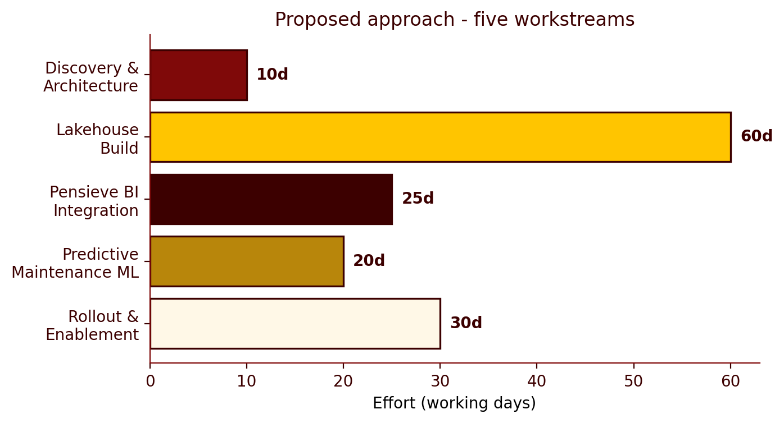
Figure - Workstream effort - five pillars of the engagement
Each workstream is led by a named HP Crew partner. Hogwarts will have a dedicated Customer Success Manager from day 1 and weekly steering with the Chief Data Officer's office.

4. Commercials
Pricing is built on our Enterprise tier at $720K annual list. Hogwarts qualifies for the Strategic 25% discount band (3-year commitment, marquee logo, reference customer agreement). Net annual platform fee: $540K. Implementation services and 24/7 support are quoted separately.
Workstream | Term | Fee (USD)
Enterprise platform - Year 1 | 12 months | $468,000
Enterprise platform - Year 2 & 3 | 24 months | $936,000
Implementation services (26 weeks) | One-time | $240,000
24/7 support + dedicated CSM | 36 months | $180,000
TOTAL - 3 year programme | - | $1,824,000
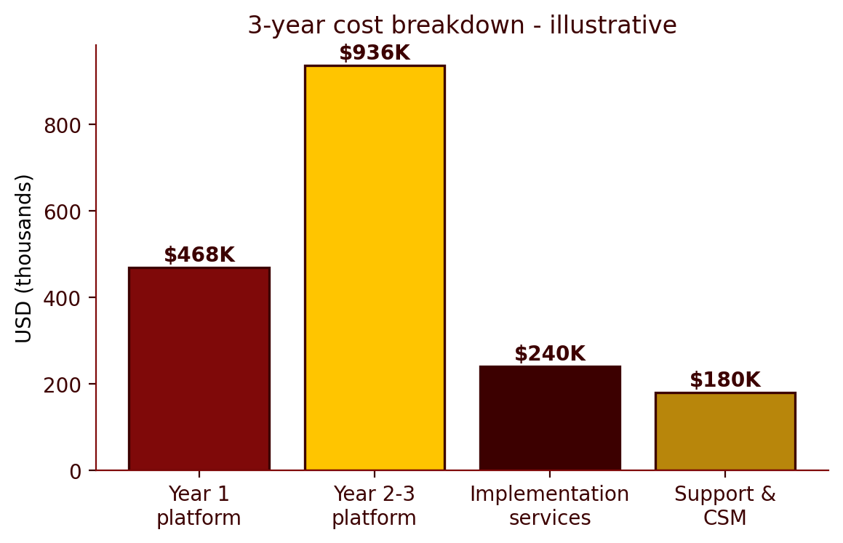
Figure - 3-year cost breakdown by category
Pilot/POC fees are credited toward Year 1. We offer a 30-day acceptance testing window. We will not accept the RFP's MFN clause, Net 90 payment terms, or uncapped breach liability - these are non-negotiable and our Counter-Positions are detailed in Section 8.

5. Timeline & Milestones
The 26-week programme is sequenced to put a working lakehouse in front of Hogwarts' analysts by week 12 and to begin the predictive-maintenance ML programme by week 14 once the feature store has stabilised.
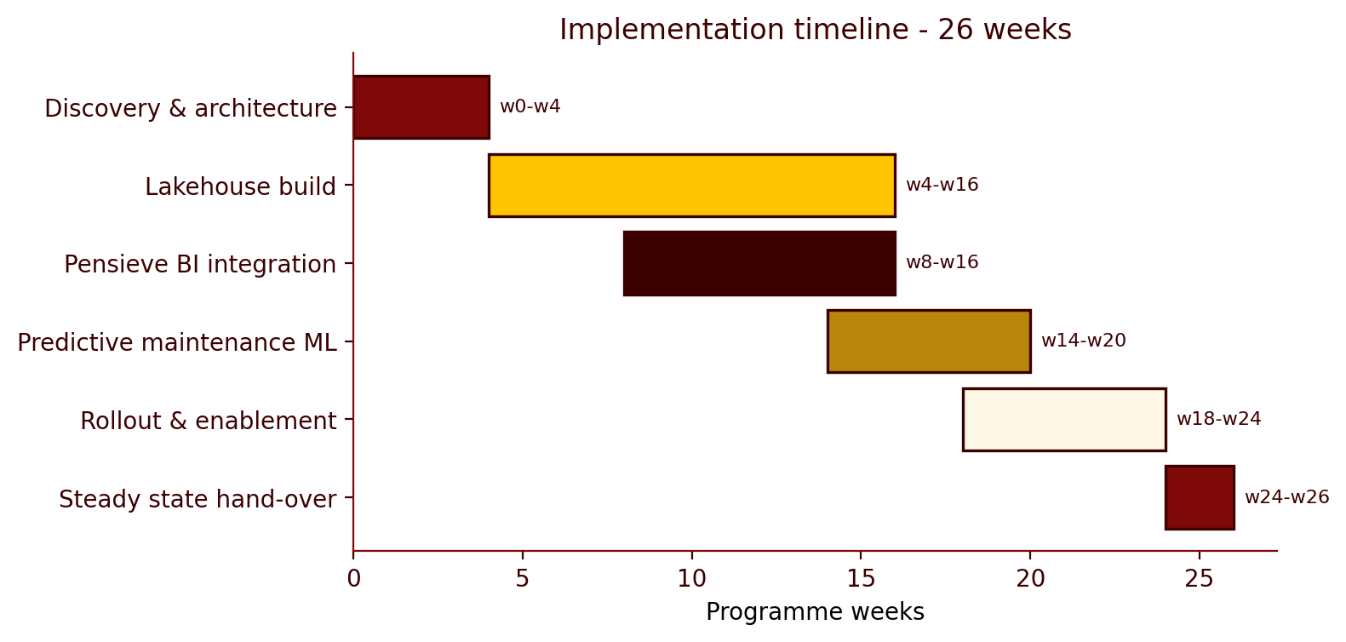
Figure - Implementation timeline - 26 working weeks

6. Why Harry Potter's Crew
Hogwarts named Databricks, Snowflake, and Microsoft Fabric in the RFP. Each is a credible competitor. Our differentiation is not headline price - it is predictable total cost of ownership over the full 5-year horizon, maturity at Hogwarts' scale, and an ML-native architecture that does not treat predictive maintenance as a bolt-on.
Competitor | Their strength | Our angle
Microsoft Fabric | Bundled in E5, owns Pensieve BI | Honest TCO including Microsoft consulting; 8 years vs. 18 months of maturity
Databricks | Lakehouse + ML breadth | TCO predictability; analyst time-to-insight
Snowflake | Analyst experience, data sharing | Workload coverage (real-time, unstructured); ML-native
Regional unnamed vendor | Unknown - likely price-led | Vendor financial stability; reference customers at Hogwarts' scale

7. Contractual Counter-Positions
Our Legal Reviewer flagged eight RFP clauses requiring movement before signature. Five are BLOCKERS (cannot be insured around or commercially justified) and three are NEGOTIABLE.
Clause | Severity | HP Crew counter-position
Liability cap | BLOCKER | RFP demands uncapped liability for data breach. Our cyber policy caps at 24 months of fees - uncapped voids coverage. Counter: 24 months of fees, with mutual carve-outs for IP infringement and gross negligence.
Termination for convenience | BLOCKER | 30-day termination for any reason, no penalty. Counter: 90 days' notice after the first 12 months of the initial term.
Audit rights | BLOCKER | Up to 4 audits/year without notice, vendor-paid. Counter: 1 audit/year, 30 days' notice, audit confidentiality required, Hogwarts pays beyond the first.
Service levels | BLOCKER | 99.99% uptime with immediate termination on any miss. Counter: 99.95% Enterprise SLA, service credits up to 30% of monthly fees as sole remedy.
Most Favoured Nation | BLOCKER | MFN pricing for the life of the contract. Counter: remove entirely - the single most poisonous clause for SaaS.
IP assignment | NEGOTIABLE | RFP demands assignment of all work product. Counter: Hogwarts owns customer-specific configurations; HP Crew retains IP in the underlying service and any general-purpose enhancements.
Payment terms | NEGOTIABLE | Net 90 demanded. Counter: Net 30 default, Net 60 acceptable given Hogwarts' standing and 3-year commitment.
Subprocessors | NEGOTIABLE | Pre-approval of every subprocessor. Counter: published subprocessor list with 30 days' notice of additions and a right to object.

8. Appendix - Assumptions, Risks & Glossary

8.1 Assumptions baked into this proposal
- Currency is USD; conversion to galleons at the prevailing Gringotts rate is the client's responsibility.
- All headcount and scale figures (40,000 artefacts, 280TB, 600 analysts) are taken from the RFP at face value.
- The Capability Matrix attachment is assumed to be returned separately as the RFP instructs.
- Pricing is illustrative for this synthetic exercise and would be confirmed by the Deal Desk before issue.
- Pensieve BI is used as the Hogwarts-themed name for Power BI throughout this document.

8.2 Top three risks
Risk | Likelihood | Mitigation
Legal blockers (esp. uncapped liability, MFN) not movable | Medium | Escalate to Hogwarts general counsel in Week 1
Pensieve BI semantic-model migration scope grows | Medium | Bound the scope to top-100 reports; tail-end remains client-led
Predictive maintenance feature store delayed by data quality | Low-Medium | Treat Weeks 4-8 as a quality gate; do not start ML until clean

