
SINGAPORE UNIVERSITY OF TECHNOLOGY AND DESIGN

2026 MAY TERM

Elements of Software Construction (50.003)
Final Report on Web Development of Sprout
A Web-First Web Platform for Nature-Based Gamification with Mobiel App Companion

Submitted To:
Dr Lu Zhuo Ming (Kenny)
Senior Lecturer, ISTD Pillar
Dr Mahamarakkalage Dileepa Yasas Fernando
Lecturer, ISTD Pillar

Submitted By:
Team Sprout (CH03, Team 02)
Andrina Morrison (1009347)
Chia Zhi Feng (1009327)
Nathaniel Sim (1009068)
Ng Li Xiang (1009043)
Omar Fayaz (1008838)
Justin Teh (1009252)

Contents
Important Notes 7
Auxiliary Resources 7
1. Introduction 8
1.1 User Research 8
1.2 Problem Statement 9
1.3 Scope and Assumptions 9
1.4 Features Not Implemented 9
2. Requirement (Use Case) 10
2.1 Modelling Conventions 10
2.3 Common Requirements 12
2.4 Use Cases 13
2.4.1 Use Case Diagram 14
2.5 Misuse Cases 14
2.5.1 Misuse Case Diagram: Hostile 15
2.5.2 Misuse Case Diagram: Non-Malicious 16
3. Design (Class, Solution & Sequence) 17
3.1 Domain Class Diagram 17
3.2 Solution Diagram 18
3.3 Sequence Diagrams 18
4. Cloud Native Design and Architecture Rationale and Resiliency 20
4.1 Twelve-factor audit 20
4.2 Why containerize 20
4.3 Liveness and readiness are deliberately separate 21
4.4 Measured evidence 21
4.5 Resiliency inventory 23
5. Implementation Challenges 23
5.1 Algorithmic 24
5.2 Engineering 24
5.3 Testing challenges 29
6. Testing 31
6.1 Objectives 31
6.2 Testing Strategy 31
6.3 Continuous Integration 33
6.4 Mapping of Test to Requirements & Design 33
6.5 Input Domains and Data Types 35
6.6 Unit Test Examples 36
6.7 Integration Test Examples 38
6.8 Robustness: Fuzzing the Ingest Gate 39
6.9 System End-to-End Testing 40
6.9.1 Automated End-to-End Test (Playwright) 40
6.9.2 Manual End to End Testing 41
6.9.2.1 Rationale 41
6.9.2.2 Paths Exercised 42
6.9.2.3 Findings and Remediation 42
6.9.3 Risks and Mitigation 43
7. Feature Progress and Workload Distribution 46
7.1 Outstanding Work 47
7.2 Pull Request Tracking 47
9. Sustainability, Diversity and Inclusion 55
9.1 Sustainability 55
9.1.1 Environmental Purpose 55
9.1.2 Computational Sustainability 55
9.1.3 Operational and Social Sustainability 55
9.2 Diversity and Inclusion 55
9.2.1 Accessibility for users with disabilities 56
9.2.2 Access across demographic and economic groups 56
9.2.3 Cultural and linguistic representation 56
9.3 Contribution to the UN Sustainable Development Goals 57
10. UX/UI Improvements 58
10.1 Frontend Refinement of the Landing, Sign Up, Log In and Contact Pages 58
10.2 Streamlining the User Experience 58
10.3 Interface Interactivity 60
11. Conclusion 62
11.1 Summary of Deliveables 62
11.2 Takeaways 62
12. References 63
Appendix 64
Appendix 1: Use Case Description 64
Legends 64
Appendix 2: Misuse Cases 82
Hostile misuse 82
Non-malicious misuse 83
Appendix 3: Sequence diagrams 85
UC1: Signup 85
UC2: Login 86
UC3: Reset Password 87
UC4: Browse Plant Avatar Archival 88
UC5: Join PVE Battle 89
UC6: Upload Plant Picture 90
Appendix 3.1: GenAI Pipeline Features and Non-functional Requirements 92
UC8: Submit Query Ticket 94
Appendix 4: Test Case Tables (Full Value Set) 95
Appendix 5. Summary of CI Command Groups 105

List of figures
Figure 1. Erroneous Conventions of Use Case Diagram Drawings. 9
Figure 2. Primary actors sit left of the system boundary and secondary actors right, per the convention in the course notes. The shape legend is inside the diagram. 13
Figure 3. Hostile Misuse Case Diagram 14
Figure 4. Non-Malicious Misuse Case Diagram 15
Figure 5. Domain class diagram (Sprout-class-diagram-pm3.png). 17
Figure 6. The production readiness endpoint answering live: GET /api/health/ready on sprout-backend-gyvk.onrender.com returns 200 ready with both probes ok (firestore round trip 105 ms). Captured 7 August 2026, after the roughly one-minute cold start of the sleeping free-tier instance described at the start of this section. 21
Figure 7. Resend domain verification requirement (Screenshot 2026-07-25 183754.png). 24
Figure 8. Resend dashboard showing no delivered messages (Screenshot 2026-07-25 214021.png). This is why the report does not claim UC1 and UC8 email delivery as working. 24
Figure 9. Repeated 401 responses on the deployed archive (Screenshot 2026-07-25 172723.png). 25
Figure 10. Vercel environment variables after correction (Screenshot 2026-07-25 163016.png). 25
Figure 11. Render environment reduced to four variables after the import (Screenshot 2026-07-25 173952.png). 26
Figure 12. The failing CI run that exposed the version conflict (Screenshot 2026-07-25 213844.png). 27
Figure 13. Pull request #5 merged with four required checks passing (Screenshot 2026-07-25 214241.png). 43
Figure 14. Both CI jobs green on main in 2m 1s (Screenshot 2026-07-25 214203.png). 43
Figure 15. The landing page, as refined. 59
Figure 16. The contact page, as refined. 60
Figure 16. UC1 Signup sequence diagram. 84
Figure 17. UC2 Login sequence diagram. 85
Figure 18. UC3 Reset Password sequence diagram. 86
Figure 19. UC4 Browse Plant Avatar Archival sequence diagram. 87
Figure 20. UC5 Join PVE Battle sequence diagram. 88
Figure 21. UC6 Upload Plant Picture (Scan) sequence diagram. 89
Figure 22. UC8 Submit Query Ticket sequence diagram. 93

List of tables
Table 1. The four modelled primary actors, their definitions, and their associations. Inherited associations are stated rather than drawn twice, which is the economy the generalisation buys. 10
Table 2. The six secondary actors. The final four constitute the generative AI pipeline. Where two providers are listed, they fill one role as primary and fallback rather than acting as two separate actors. 10
Table 3. Summary of Access Path for respective Primary Actors. 11
Table 4. Summary of Common Requirements (Use Cases with Shared Preconditions) 11
Table 5. Summary of Base Use Case for Web Application 12
Table 6. Summary of Sub Use Case for Web Application 12
Table 7. The two misuse case families. The full listing, with each misuse case mapped to the alternative flow that mitigates it, is given in the use case documentation. 14
Table 8. Summary of Sequence Diagram based on use case defined 17
Table 9. Twelve-factor audit of the deployed system, graded against the factors as defined in (Wiggins, 2011). 19
Table 10. Cloud native claims and evidence for each. 21
Table 11. Resiliency properties and the failure each one prevents. 22
Table 12. Test levels, what each cover and where the suites live. 31
Table 13. Test Environment and Tooling Levels. 31
Table 14. Traceability from use case to sequence diagram, suites and test cases. 33
Table 15. Executed test case counts by tier (9 August 2026, commit b184b62). 34
Table 16. Input domains, data types and their source of truth. 35
Table 17. Valid and invalid input taxonomy across the image ingest gate and the text validators. The eight image rejection reasons are the gate's discriminated results; the Fuzzer asserts that every mutated input lands in one of them. 35
Table 18. UC1 Signup — representative cases. Full set: Appendix Table A1. 35
Table 19. UC3 Reset Password — representative cases. Full set: Appendix Table A3. 36
Table 20. UC4 Browse Plant Avatar Archival — representative cases. Full set: Appendix Table A4. 36
Table 21. UC5 Join PVE Battle — representative cases. Full set: Appendix Table A5. 36
Table 22. UC6 Upload Plant Picture (Scan) — representative cases. Full set: Appendix Table A6. 36
Table 23. UC8 Submit Query Ticket — representative cases. Full set: Appendix Table A7. 36
Table 24. Cross-cutting test cases — representative cases. Full set: Appendix Table A8. 37
Table 25. Integration test cases, representative set. Full set: Appendix Table A1 to Table A8. 38
Table 26. Mutation strategies and the verdict each one should produce. 38
Table 27. Known gaps, their effect and the mitigation in place. 42
Table 28. Delivery status of all sixteen use cases at submission 46
Table 29. Summary of Workload Distribution and Task Completed 53
Table 30. Summary of UN SGD Contributions 56

Table A1. UC1 Signup — full test case set. 95
Table A2. UC2 Login — full test case set. 96
Table A3. UC3 Reset Password — full test case set. 97
Table A4. UC4 Browse Plant Avatar Archival — full test case set. 98
Table A5. UC5 Join PVE Battle — full test case set. 99
Table A6. UC6 Upload Plant Picture (Scan) — full test case set. 100
Table A7. UC8 Submit Query Ticket — full test case set. 101
Table A8. Cross-cutting cases — full test case set. 102
Table A9. CI Command Groups and Emulator Requirement. 105

Important Notes
Use and Misuse Case Descriptions are in Appendix 1 and 2 respectively, and all Sequence Diagrams are in Appendix 2, at the end of the report.
Appendix 3.1 discusses the GenAI Pipeline Features and Non-functional Requirements for Sprout. Appendix 4 provides 90 Test Case Tables (Full Value Set). Appendix 6 provides a summary of CI Command Groups.
Section 6.3 Continuous Integration's Table 14 provides the traceability and linking of our respective Test Coverage to their respective use case and sequence diagrams.

Auxiliary Resources
  C3T2 Private GitHub Repository Link: https://github.com/Kopi-O-Kosong-Beng/sprout-web-app |   C3T2 Final Presentation on 11 August 2026: https://www.youtube.com/watch?v=vxvBAKq0G6Y
  C3T2 30s Demo: https://youtu.be/SFZRiLCGQro |   C3T2 Pitch Video: https://youtu.be/F1EaFMxepHM

1. Introduction
Sprout is a web platform for nature-based gamification, developed by our team as a continuation of the team’s earlier Baby Shark project. Users scan a plant, receive a pixel-art creature called a "Plantemon" generated from that species, collect it, and take it into turn-based battle. The aim is to attach a game loop to botanical learning so that a garden visit produces lasting knowledge rather than a forgotten photo.

1.1 User Research
Gardens By the Bay (GBTB) welcomed 16 million visitors in 2025. That volume is not matched by lasting engagement. Three gaps recurred across our research:
- Low digital usage – existing digital features are not engaging enough to hold attention, despite roughly 70% of theme-park guests using their phones regularly during a visit. The devices are already in hand; the experiences are not compelling.
- Information is not sticky – visitors read an information plaque once and retain almost nothing afterwards.
- No imperative action – nothing invites visitors to apply what they have learned, so knowledge retention decays further.
Visitor profiling identified three groups at GBTB: foreign tourists, families with children, and VIPs or delegates. We selected families with children as the target audience, as they visit for excursions, learning journeys and educational programmes. Many of them also treat the gardens as a regular weekend outing; that is a repeat-visit pattern that a collection-based game can build on.
We built a mobile prototype and tested it in two rounds: first at our Term 4 ISTD Showcase, and then on-site at GBTB, where visitors from mainland China, Europe, the Americas, the Middle East and Southeast Asia confirmed the international visitor mix the earlier profiling had assumed. Feedback across both rounds was strongly positive on visual design ("cute," "colourful" and "aesthetic" were the most prominent terms in an aggregated analysis of user comments) and validated the core scan-and-collect game methodology as engaging. It also surfaced two concrete changes: colour-highlighting for key on-screen text, and replacing raw pipeline status messages with a loading animation, since children disengaged while waiting for the AI pipeline to return a result. A recurring criticism was text density, with users describing parts of the interface as "wordy," direct evidence for the "information is not sticky" gap identified above.
This testing also surfaced a limitation in the mobile-only design: a phone app can only scan a plant that is physically present. Two considerations motivated a shift to a companion web application. The first was accessibility of learning: users wanted a way to research a plant before encountering it in person, so that a future visit could be more deliberate and observant rather than incidental. The web application addresses this by letting a user upload a photo and receive the same species identification and Plantemon generation as an in-person scan, without requiring physical presence at a nature park. This Plantemon is deliberately temporary (it expires after 24 hours and is never added to the user's permanent collection), so the feature streamlines learning without displacing the core incentive to visit and scan a plant in person. The second consideration was operational: a production system requires a way to manage plant data, monitor the AI pipeline and administer user accounts, none of which are mobile-appropriate tasks.
The resulting web prototype was tested with secondary and IB-level students at Anglo-Chinese School (Independent) and at Victoria Junior College. This round validated a design hypothesis directly: a cleaner interface that supported constant engagement was preferred over a more text-heavy, story-driven one, provided the core scan-and-collect loop remained freely accessible rather than gated behind a narrative sequence.

1.2 Problem Statement
How might we shift high foot traffic into lasting environmental awareness, rather than just Instagram-able moments?

1.3 Scope and Assumptions
Three assumptions were made before the development of our software development documentations of requirements and design.
1. The database is shared with the mobile application. The web platform and the mobile companion read and write the same account store, so the two clients are two faces of one system rather than two systems that exchange data. This matters to the model because it means the cross-platform sharing point is a backend call and not the database itself.
2. All notifications are delivered by email; Verification links, password reset codes and enquiry confirmations.
3. Internal components are not actors. A secondary actor is a party outside the system boundary that the system collaborates with in order to complete a goal. A component we wrote, deploy and can change ourselves sits inside that boundary. On this reading the database, the gameplay mechanism and the image pre-processing step are components rather than actors, and they were removed from the secondary actor column entirely.
Three features were scoped out and are therefore absent from the documentation in later sections. PVP Battle, the business-to-business advertisement placement service, and the business-to-business dashboard.

1.4 Features Not Implemented
A use case diagram is a statement about what the system does, so including unbuilt features would have overstated the delivery. Where a removed feature would have introduced an actor, that actor was removed with it.

2. Requirement (Use Case)
Brief introduction to our project before talking about use cases. Talk about what we want the user to be able to do, then break it down into the use cases derived from this.

2.1 Modelling Conventions
The conventions below were drawn partly from the course notes and partly from the corrections we received at the first project meeting. They are listed as rules because we applied them uniformly across all sixteen use cases rather than case by case, which is what makes the model internally consistent and reviewable.
1. Actors are defined by session state, not by job title. A person is a Visitor because they hold no session, and a User because they hold a verified one. Defining actors this way means the association between an actor and a use case is a claim that can be checked against the implementation, since the implementation also decides what to offer based on session state.
2. Use cases are named as a verb followed by a noun. Sign Up, Reset Password and Upload Plant Picture describe an actor goal. Naming a use case after a screen or a button would tie the requirement to an interface that is free to change.
3. Preconditions are weakened to NIL wherever a person who fails the condition can still reach the flow. A precondition asserts a state that must already hold before the interaction begins. If somebody who does not meet it can nonetheless start the flow, the system still has to answer them, and that answer belongs in an alternative flow. Applying this test moved the condition out of the precondition field in thirteen of our sixteen use cases.
4. Preconditions shared across a group of use cases are lifted into common requirements. Restating the same condition in every use case that carries it is duplication, and duplicated text drifts. We defined two common requirements: one for an active and verified session, and one for the operator's grant. Each remains visible in the error states of every use case that carries it and is answered by an alternative flow where the flow can be reached without it.
5. Every operational flow begins with the actor. A use case records an actor pursuing a goal, so the first step is the actor initiating it. A step of the form "the system displays the page" describes the interface rather than the interaction, and it never opens a flow in our model.
6. Three relationship shapes are excluded by construction. Two base use cases are never joined to one another, because each base use case is an independent actor goal, and joining them would model a sequence rather than a requirement. An actor is never joined to a sub use case, because a sub use case is reached only through the base that includes or extends it. A sub use case is never joined to another sub use case, so every chain terminates a base use case.
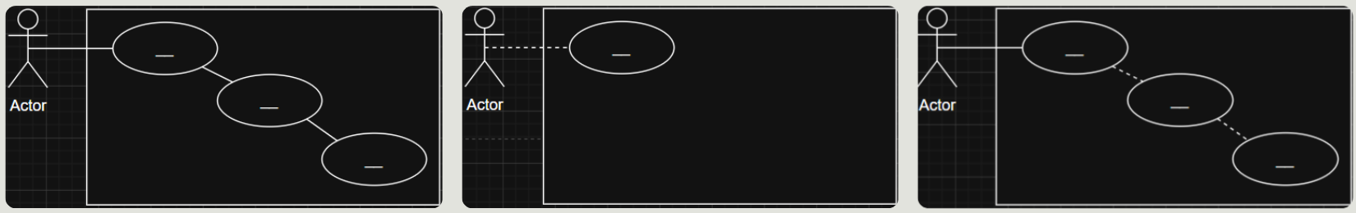Figure 1. Erroneous Conventions of Use Case Diagram Drawings.
2.2 Actors
The model has twelve actors in total, six primary and six secondaries. Four of the six primary actors participate in the use case model properly. The remaining two exist only in the misuse case model and are introduced in Section 1.4.
The four modelled primary actors are related by generalisation rather than listed flats. All is the base actor, meaning anyone who reaches the platform. Visitor and User each specialise All, and Superadmin specialises User. The arrow in the diagram points from the specialised actor to the more general one, and inheritance runs in the opposite direction, so a child actor holds every association its parent holds.
The reason for placing Superadmin beneath User rather than beneath All is that an operator is also a player. An operator holds a collection and can battle, so attaching Superadmin directly to All would have asserted that operators cannot scan or battle, which the implementation contradicts. Equally, Visitor is a sibling of User and not an ancestor of it, so a Superadmin does not inherit Sign Up, Log In or Reset Password. Those three belong to Visitor precisely because none of them is reachable once a session exists.
Primary Actor | Definition | Associated use cases
All | Anyone who reaches the platform. The base actor. | Submit Query Ticket, Check Query Ticket Status, View Ranking Leaderboard
Visitor | A person with no active session. Specialises All. | Sign Up, Log In, Reset Password, and everything All holds
User | A person with an active, verified session. Specialises All. | Log Out, Browse Plantemon Collection, Start PVE Battle, Upload Plant Picture, and everything All holds
Superadmin | A User who additionally holds the operator grant. Specialises User. | Manage User Accounts, Operate Pipeline Studio, Verify Backend API Health, Manage Query Tickets, and everything User holds
Table 1. The four modelled primary actors, their definitions, and their associations. Inherited associations are stated rather than drawn twice, which is the economy the generalisation buys.
The six secondary actors are named by the role they play, with the current provider given in brackets. The role is the part the requirement fixes, whereas the provider is an implementation choice that has already changed once during the project and may change again. Naming them this way means a provider substitution does not invalidate the diagram.
Secondary actor | Provider | Purpose
Identity Provider | Firebase Authentication | Creates identities and verifies session tokens
Email Delivery | Resend | Verification links, reset codes and ticket correspondence
Plant Identification | Plant.id | Returns species, taxonomy and a confidence score
Prompt Generation | NVIDIA or Gemini | Turns species data into a structured sprite prompt
Image Generation | FLUX or Gemini | Renders the sprite from the prompt
Background Removal | withoutBG | Returns the rendered sprite on a transparent background
Table 2. The six secondary actors. The final four constitute the generative AI pipeline. Where two providers are listed, they fill one role as primary and fallback rather than acting as two separate actors.
The table below summarises the web pages (frontend) and the use cases (actor goals) for our three distinct primary actor groups.
Actor | Pages the implementation admits | Use cases associated in the diagram
Visitor  (no session) | Home, Ranking, Contact.  Scan, Archive and PVE Battle are rendered greyed out and are not clickable. | UC1 Sign Up, UC2 Log In, UC3 Reset Password.  By inheritance from All: UC7, UC8, UC9.
User  (verified session) | Home, Scan, Archive, PVE Battle, Ranking, Contact. | UC4, UC5, UC6, UC10.  By inheritance from All: UC7, UC8, UC9.  Not UC1, UC2 or UC3: the implementation redirects an authenticated person away from all three.
Superadmin | Every page: the six above, plus Admin, Studio, API Test and Ticket Manager. | UC11, UC12, UC13, UC14.  By inheritance from User: everything a User can reach.
Table 3. Summary of Access Path for respective Primary Actors.

2.3 Common Requirements
From the course notes, a precondition is defined as
- "a list of mandatory criteria / system state that must be met before this user-system interaction is initiated"
- "and if a precondition is common to a set of use cases, we convert it into a common requirement field"
In our project, two conditions are common to groups of use cases, but they are still listed in the error states of every use case that has them and represented in an alternative flow where required.
From Project Meeting 1 consultation, this is because a person who does not meet the condition can still reach the flow, and the system must answer them. The common requirements therefore reconcile the need to weaken preconditions with the need to handle invalid people in the alternative flows.
ID | Common requirement | Applies to | If it is not met
CR1 | The actor holds an active session, and that session's email address has been verified. | UC4, UC6, UC11, UC12, UC13, UC14.  Not UC5 (see its precondition), and not UC10, which retains the weaker precondition of a session alone: ending a session does not require the address on it to have been verified. | The actor is prompted to log in or to complete verification, and the requested destination is retained so the flow resumes once the condition is met. See alternative flow 2a/3a of each use case.
CR2 | The actor holds the operator grant; referring to the account flag, or the break-glass allowlist from deployment configuration. | UC11, UC12, UC13, UC14 | The system refuses in exactly the same terms it uses for any other refusal, so the existence of the grant is never disclosed, and returns the actor to the public area. Modelled as the sub use case UC15 Authorise Operator.
Table 4. Summary of Common Requirements (Use Cases with Shared Preconditions)

2.4 Use Cases
Base use cases associate directly with a primary actor, and are named in the <verb> + <noun> format the notes prescribe, with Sign Up, Log In and Log Out kept as bare verbs under the exception the notes make for Login.
ID | Use Case | Primary Actor | Secondary Actors
UC1 | Sign Up | Visitor | Identity Provider, Email Delivery Service
UC2 | Log In | Visitor | Identity Provider
UC3 | Reset Password | Visitor | Identity Provider, Email Delivery Service
UC4 | Browse Plantemon Collection | User | NIL
UC5 | Start PVE Battle | User | NIL
UC6 | Upload Plant Picture | User | Plant Identification Service, Prompt Generation Service,  Image Generation Service, Background Removal Service
UC7 | Submit Query Ticket | All | Email Delivery Service
UC8 | Check Query Ticket Status | All | NIL
UC9 | View Ranking Leaderboard | All | NIL
UC10 | Log Out | User | Identity Provider
UC11 | Manage User Accounts  (Admin Dashboard) | Superadmin | Identity Provider
UC12 | Operate Pipeline Studio  (Studio Dashboard) | Superadmin | Plant Identification Service, Prompt Generation Service,  Image Generation Service, Background Removal Service
UC13 | Verify Backend API Health  (API Test Dashboard) | Superadmin | Identity Provider, Email Delivery Service
UC14 | Manage Query Tickets  (Ticket Manager Dashboard) | Superadmin | NIL
Table 5. Summary of Base Use Case for Web Application
Sub use cases are reachable only through a base use case, as an «include» or an «extend», and therefore carry no actor association of their own. From the course notes, primary actors cannot access sub use cases directly.
ID | Sub Use Case | Relationship | Secondary Actors
UC15 | Authorise Operator | «include», included by UC11, UC12, UC13 and UC14 | NIL
UC16 | Resend Verification Email | «extend», extends UC1 and UC2 | Identity Provider, Email Delivery Service
Table 6. Summary of Sub Use Case for Web Application

2.4.1 Use Case Diagram
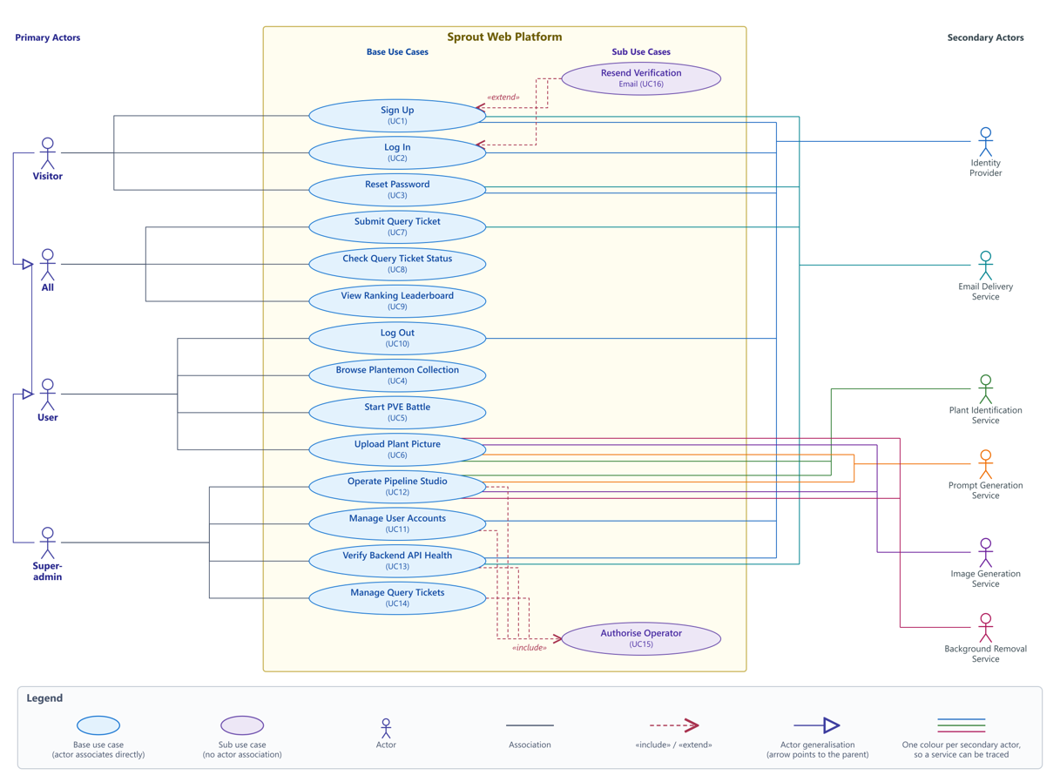Figure 2. Primary actors sit left of the system boundary and secondary actors right, per the convention in the course notes. The shape legend is inside the diagram.
Please find the detailed Use Case Descriptions in Appendix 1 at the end of the report.

2.5 Misuse Cases
A misuse case is a goal pursued against the system rather than through it. We documented sixteen of them, split into two families, because the two families call for different controls. Hostile misuse is deliberate and the correct control is refusal. Non-malicious misuse is committed by a legitimate person with no hostile intent, and refusal is the wrong answer there, since refusing a careless customer is still refusing a customer. The control in that case has to make the mistake cheap, reversible, or difficult to make by accident.
This distinction is also why the misuse model introduces two further primary actors. Misuser is the hostile party, defined by intent rather than by session state, which is why it is deliberately not modelled as a specialisation of All. Careless User is the non-malicious counterpart, and may be any legitimate Visitor, User or Superadmin.
Family | Count | Threatened use cases | Control
Hostile | 9 | Log In, Reset Password, Browse Plantemon Collection, Start PVE Battle, Upload Plant Picture, Submit Query Ticket, Check Query Ticket Status, the operator dashboards | Refusal
Non-malicious | 7 | Sign Up, Log In, Reset Password, Start PVE Battle, Upload Plant Picture, Submit Query Ticket, Manage User Accounts, Verify Backend API Health | Make the mistake cheap or reversible
Table 7. The two misuse case families. The full listing, with each misuse case mapped to the alternative flow that mitigates it, is given in the use case documentation.
The property that ties the two halves of the model together is that every control we claim is an alternative flow that is actually implemented, rather than a measure we intend to add. There is exactly one exception, and we state it rather than hide it: the control for repeated rescanning of the same plant is not an alternative flow at all but the main flow of Upload Plant Picture, which reuses the canonical sprite already held for that species. Recording the exception matters more than a tidy generalisation would, because a reader can otherwise check the claim and find it false.

2.5.1 Misuse Case Diagram: Hostile
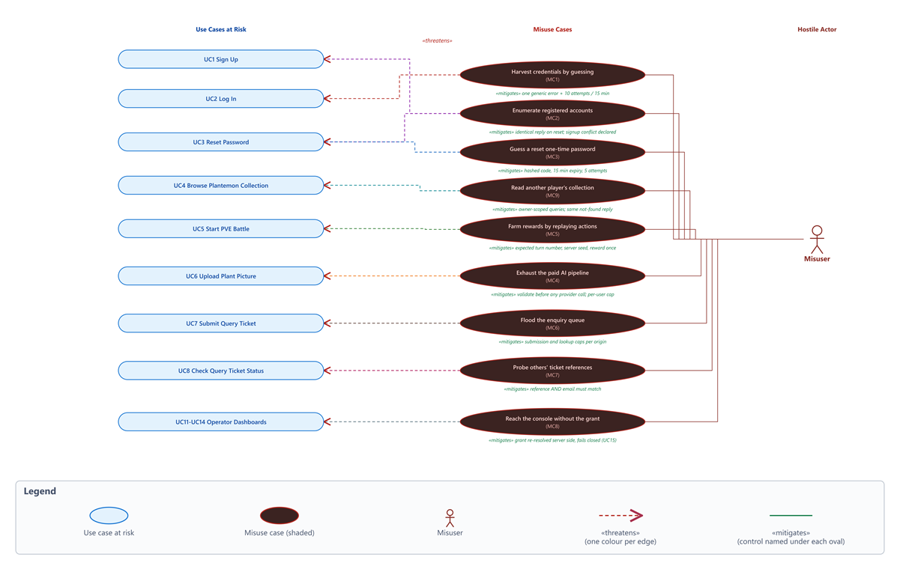
Figure 3. Hostile Misuse Case Diagram
Read right to left: the Misuser pursues a misuse case, which «threatens» a use case; the green line beneath each misuse case is the implemented control that «mitigates» it.

2.5.2 Misuse Case Diagram: Non-Malicious
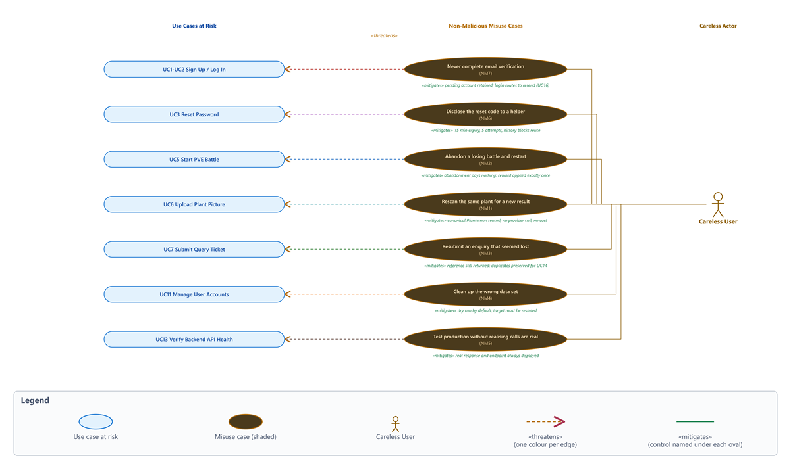
Figure 4. Non-Malicious Misuse Case Diagram
The Careless User has no hostile intent, so each control makes the mistake cheap, reversible, or impossible to make by accident rather than refusing it. Full detail, including the six gaps that are declared rather than closed, is in the Misuse Cases tables.
Please find the detailed Misuse Case Descriptions in Appendix 2 at the end of the report.

3. Design (Class, Solution & Sequence)
The following section documents our Domain Class, Solution, and Sequence diagrams for the respective Use Cases identified in Section 2.
Please note that we did not implement PVP and B2B features, hence, while they were initially planned, they will not be documented in the following sections of the report.

3.1 Domain Class Diagram
The domain class diagram is our analysis model: it captures the entities of the Sprout problem domain with their attributes and the relationships between them, and deliberately carries no methods, no controllers and no layering. Its purpose is to fix the vocabulary and the structural rules that the sixteen use cases operate on, and to be checkable for consistency against the use case diagram.
Account is the central entity and demonstrates the three whole-part relationship types. It composes exactly one GameStats record (the filled diamond) which is an exclusive part with no independent existence, holding the battle experience and first-discovery counts that the ranking boards are built from. It aggregates its Sessions and its PlantemonEntry collection (the hollow diamond) which is a weaker whole-part link, because a collected Plantemon has its own lifecycle and is not destroyed with the account in the model. The remaining links are plain associations carrying explicit multiplicity, demonstrated as such: each PlantemonEntry is classified as exactly one Species (0..* to 1), and each Species composes its single canonical Sprite, reflecting the report's rule that a species has one canonical pixel-art sprite reused across all discoverers.
Two association classes model relationships whose data belongs to neither participant alone. RewardResult is the reified association between Account and Battle: the win/loss/abandonment outcome and the experience change are properties of playing a battle, not of the account or the battle in isolation, so they are lifted into their own class. DiscoveryRecord similarly captures first-discovery attribution per species (who discovered it first and the running discovery count) which is the data UC9's discovery leaderboard ranks by. Battle also composes one or more BattleActions, one per resolved turn, and is fought with one PlantemonEntry. Finally, LeaderboardEntry is modelled as a read projection over Account rather than as stored state, consistent with UC9 computing both boards on request.
Two design decisions are visible here for consistency with the finalised scope. PVP was not implemented, so Battle is a single flattened class rather than a PVE/PVP hierarchy, and its result multiplicity collapses to exactly one. The DiscoveryRecord, the ticket status/resolvedAt fields, and the Account.isOperator grant were added to support UC9 (Ranking), UC14 (Ticket Manager) and the four Superadmin dashboards respectively.
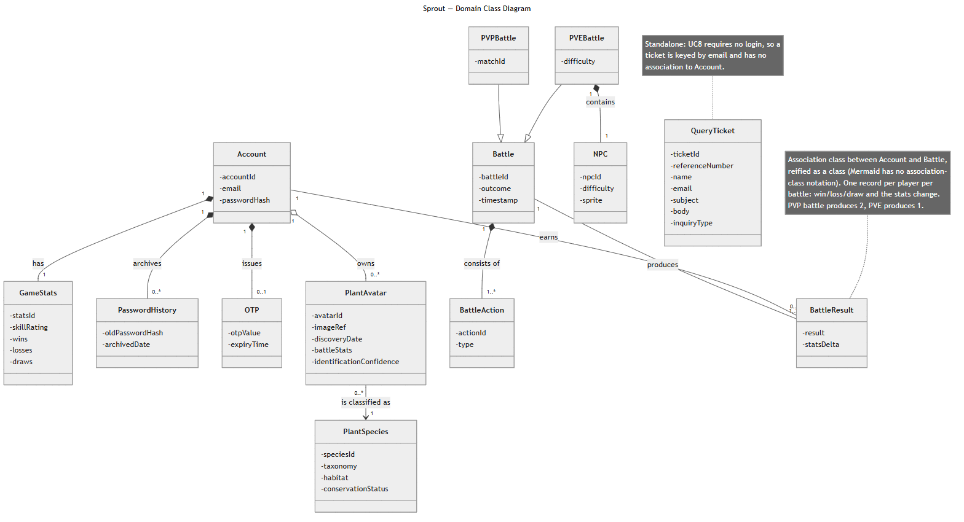
Figure 5. Domain class diagram (Sprout-class-diagram-pm3.png).

3.2 Solution Diagram
d

3.3 Sequence Diagrams
Nine sequence diagrams cover the operation of flows, including alternative and error paths. Please find the detailed Sequence Diagrams in Appendix 3 at the end of the report (detailed in Reference Column below).
Reference | Use case | File
Figure | UC1 Signup | UC1-signup-seq.png
Figure | UC2 Login | UC2-login-seq.png
Figure | UC3 Reset Password | UC3-reset-password-seq.png
Figure | UC4 Browse Archive | UC4-archive-seq.png
Figure | UC5 PVE Battle | UC5-pve-seq.png
Figure | UC6 Upload Plant Picture | UC6-upload-seq.png
not in appendix | UC7 PVP Battle, main flow | UC7a-pvp-seq.png
not in appendix | UC7 PVP Battle, failure paths | UC7b-pvp-failures-seq.png
Figure | UC8 Submit Query Ticket | UC8-query-ticket-seq.png
Table 8. Summary of Sequence Diagram based on use case defined
Two design rules are applied consistently throughout all the diagrams.
- Every flow ends with a response back to the initiating actor, and;
- Every external call has a defined failure branch rather than an assumed success.

4. Cloud Native Design and Architecture Rationale and Resiliency
Cloud native here means what the Cloud Native Computing Foundation (CNCF) means by it (CNCF, n.d.): a service built to run on a platform it does not own, and to keep working while that platform moves underneath it. Sprout does that on a single free-tier Render instance, so the limits come first. The instance sleeps when idle and takes about a minute to wake. Rate-limit counters live in process memory, so a second instance would need a shared store such as Redis. There is no distributed tracing; API metrics are in-process only, on the studio observability page, and they reset on every restart. Nothing is orchestrated, so there is no Kubernetes and no autoscaling. The one part of the system that would earn its own container is server/pipeline/, which does CPU-bound sharp work, accepts 20 MB request bodies, holds server-sent event streams open and calls five third-party providers; splitting it out is a proposal, not something we deployed. Inside those limits, every claim below is either measured or asserted in CI, and Error! Reference source not found. records which.

4.1 Twelve-factor audit
We audited the deployment against the twelve-factor methodology (Wiggins, 2011), the checklist Adam Wiggins published in 2011 for services that run on a platform instead of a machine the team owns. We used an external checklist on purpose: it asks the same twelve questions of every deployment, so we could not quietly grade ourselves on the parts we happened to do well. Eleven factors pass. Concurrency (VIII) is partial, since the process is stateless and the property holds, but only one instance runs today. Disposability (IX) was our one outright failure and is now fixed; the defect and the fix are Engineering challenge 7 in the next section.
Factor | State
I Codebase | Pass. One repo, one app
II Dependencies | Pass. npm ci against package-lock.json
III Config in environment | Pass. render.yaml plus Vercel; secrets declared sync: false
IV Backing services attached | Pass. Emulator vs managed Firestore is an environment variable
V Build/release/run separated | Pass, and now image vs container as well
VI Stateless processes | Pass. All state lives in Firestore
VII Port binding | Pass. process.env.PORT with a 3001 default
VIII Concurrency | Partial. Stateless, so the property holds; one instance today
IX Disposability | Now pass. Was the single outright failure; see Engineering challenge 7
X Dev/prod parity | Pass. Emulator plus USE_MOCK_APIS; the compose stack strengthens it
XI Logs as event streams | Pass. stdout/stderr, captured by the platform
XII Admin processes | Pass. seed:firestore, seed:admin, check:storage
Table 9. Twelve-factor audit of the deployed system, graded against the factors as defined in (Wiggins, 2011).

4.2 Why containerize
Render has always run this service in a container. Before we wrote a Dockerfile it built one from our source with a buildpack we never saw and could not change, so writing our own did not introduce containers to the project. What it changed is ownership. The build recipe is now ours: explicit, in version control, and reproducible off the platform.
Native binaries are why we bothered. sharp (libvips) and bcrypt install per-platform prebuilt binaries, so our Windows and macOS machines and Render's Linux hosts each ran a different compiled artefact under the same version number in package.json. A green suite on a laptop therefore said nothing about the binary production actually runs. Building the dependency tree once inside a Debian-slim image, with npm ci against package-lock.json, makes the Linux build the only build. The second reason is smaller but saves every new member an afternoon: the Firestore emulator is a Java program that package.json does not record as a dependency, and docker compose up removes that hand-installed step from setup.

4.3 Liveness and readiness are deliberately separate
Two endpoints answer two different questions. GET /api/health answers "is the process alive": 200 every time, and it touches nothing outside the process. GET /api/health/ready answers "can this instance serve traffic right now": 200 or 503, with a named line per dependency. The Firestore line is a real listCollections() round trip against the configured project, bounded by its own 2.5 s timeout so a hanging dependency cannot hang the probe; the live check in Figure came back in 105 ms. The storage line is a configuration check only, and the response says so rather than implying a round trip we do not make.
Keeping liveness dependency-free is the point of having two endpoints. A platform restarts whatever fails its health check, so wiring that check to Firestore would mean one slow minute at the database restarts every instance at once, and each replacement then fails the same check while it boots. A dependency blip becomes a restart loop, and the restarts make recovery slower, not faster. Readiness answers 503 rather than 500 for the same reason: nothing is wrong with the process, a dependency it needs is unavailable, and 503 is the status that tells a load balancer to route around this instance and retry later (Fielding, Nottingham and Reschke, 2022). Kubernetes draws the same line between livenessProbe and readinessProbe (Kubernetes, n.d.). We implement the split without running a cluster, which is worth being precise about: on Render the readiness endpoint is evidence we read and CI asserts, not a signal an orchestrator acts on. The design is in place for the day it is, and Engineering challenge 8 is what happened the first time we wrote the readiness probe without thinking about what it touches.

4.4 Measured evidence
Each claim carries the evidence behind it. The container CI run referenced below is run 31097344997 (commit 05fb060, 6 August 2026, all jobs green).

Claim | Proof | Status
API image builds on Linux; size 464 MB | .github/workflows/docker.yml, server-image job | PASS (CI, 6 Aug 2026)
Image runs as non-root (Config.User = node) | docker.yml assertion | PASS (CI, 6 Aug 2026)
Container serves /api/health with no credentials configured | docker.yml: healthy after 2 s | PASS (CI, 6 Aug 2026)
Readiness reports per-dependency status and does not 500 | docker.yml: HTTP 503, both probes named | PASS (CI, 6 Aug 2026)
Container stops on SIGTERM, exit code 0, "drained cleanly" logged | docker.yml: stopped in 1 s | PASS (CI, 6 Aug 2026)
API and Firestore emulator communicate over the compose network | docker.yml, compose-stack job | PASS (CI, 6 Aug 2026)
Image published and pullable | ghcr.io/kopi-o-kosong-beng/sprout-web-app-server:latest | PASS (6 Aug 2026)
Production runs our own image (runtime: docker) | render.yaml; Render dashboard checked 6 Aug 2026 | PASS (confirmed)
Production dependencies healthy | Live GET /api/health/ready returned 200, firestore ok; re-verified 7 Aug (Figure ) | PASS (6 Aug 2026)
Table 10. Cloud native claims and evidence for each.
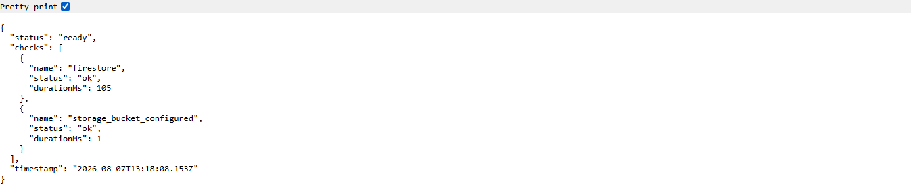
Figure 6. The production readiness endpoint answering live: GET /api/health/ready on sprout-backend-gyvk.onrender.com returns 200 ready with both probes ok (firestore round trip 105 ms). Captured 7 August 2026, after the roughly one-minute cold start of the sleeping free-tier instance described at the start of this section.
Build and delivery, measured on 10 August 2026 on main. The published image is 423 MB uncompressed, down from the 464 MB in Error! Reference source not found. after we tightened .dockerignore and pruned dependencies. It builds in three stages (deps, builder, runtime), so nothing that compiles code ships in the runtime image; it runs as non-root, which CI asserts on every build and fails the build if it is not true; and no secret is baked into it, since all configuration is injected at runtime. The Dockerfile copies package.json and package-lock.json before the source, and the effect is measurable: the same image job finishes in 37 s when the npm ci layer is a cache hit and 158 s when a manifest change invalidates it, a 4.3 times difference. The whole container pipeline takes about three minutes across four largely parallel jobs. The last nine container runs and the last twenty test runs on main were green. Per-pull-request CI needs zero secrets and makes zero paid API calls, because Firestore, Auth and Storage run as Google's emulators and the four paid providers are replaced by the server's own USE_MOCK_APIS fixtures. Every merge to main publishes an image tagged with the commit SHA and triggers a deploy, so deployment frequency is merge frequency: 39 deploys in 32 days, with a mean of 3.5 h from pull request opened to merged.
Three things we did not measure, and so do not claim: the compressed pull size of the image, because the CI step prints the uncompressed size and no Docker daemon runs on our development machines; the container's memory footprint at rest; and Render's cold-start time on the free tier, which we have watched take about a minute but never instrumented.

4.5 Resiliency inventory
Property | Failure Prevention
Stateless process; all state in Firestore | A crash or restart loses no user data, because the server keeps nothing important in its own memory. Running several copies would need no redesign.
Replay-verified battle engine | A corrupted or hand-edited battle record is caught instead of trusted. Every battle is recomputed from its stored move history when it is read, then compared with the stored state.
Graceful shutdown (server/lifecycle.ts) | A redeploy does not cut off requests in flight. The server stops accepting new connections, finishes the ones it is already serving, and then exits.
Liveness/readiness split | A database blip routes traffic away from the instance instead of restarting every instance at once.
Fail-closed auth allowlists | A missing admin allowlist gives nobody admin access, rather than everybody.
Per-route rate limiting | One abusive client cannot spend the shared free tier, because each sensitive route has its own request budget.
Image ingest gate plus mutation fuzzer | A malformed or hostile image cannot spend Plant.id quota or crash the pipeline. Uploads are validated on the server before any paid call, and a fuzzer attacks that validator in CI.
Email fallback chain: console, then SMTP, then Resend HTTPS | A blocked transport does not stop verification email. Delivery falls back from console to SMTP to the Resend HTTPS API; the third exists because Render's free tier silently drops outbound SMTP.
CI gates every merge | A broken commit cannot reach production, which is what makes deploy-on-merge safe.
Declarative render.yaml | The production environment can be rebuilt from a file in version control, and changes to it are reviewed like code.
Table 11. Resiliency properties and the failure each one prevents.
The email row is the one case where a limitation of the cloud platform itself forced us to change the architecture instead of the code around it. How we found it and what we did are recorded as Engineering challenges 1 and 2 in the next section.

5. Implementation Challenges
The challenges are grouped as algorithmic, engineering and testing. Each entry says what broke, how we found it, and what we changed. Where a proper fix was out of scope, it says what we did instead and what is still not true.

5.1 Algorithmic
1. Battle stats were not reproducible. The sprite pipeline handed us numbers we could not build a battle on. Every species came out with maxHealth: 100, and speed was drawn from Math.random(), so all plants were mechanically identical on health while their speed changed on every machine and every run, including between a live demo and the report describing it. A stat that is re-rolled whenever it is read cannot anchor a fight: the same plant fights differently depending on when the server last computed it, and no result can be checked after the fact. We now derive hp, attack, defense and speed from the species key with a pure hash. Different species hash to different numbers, so the differentiation is real, and the same species hashes to the same numbers on every machine, so a stat printed in this report is the stat seen in the demo (server/tests/species-stats.test.ts).

5.2 Engineering
1. The host blocks outbound SMTP. Signup verification emails never arrived, and each request hung for exactly two minutes before failing. The Gmail App Password worked from our own machines, which ruled out credentials, and the timeout pointed at the network rather than the provider: Render's free tier blocks outbound connections on port 587. We replaced SMTP with the Resend HTTPS API on port 443, added as a third EMAIL_MODE alongside the existing console and SMTP modes, so the transport that production uses is one the host allows.
2. Email delivery is still not proven. Resend will only send to arbitrary recipients from a verified domain. Without one, the shared sandbox sender can reach the account owner's own address and nothing else, so no test message ever landed in the team inbox. Verifying a domain means buying one and configuring MX records, which was out of scope for a course project. The limit is therefore exactly this: signup verification and reset OTP email deliver to one specific address. That path works end to end for that inbox, and nowhere in this report do we claim more than that.
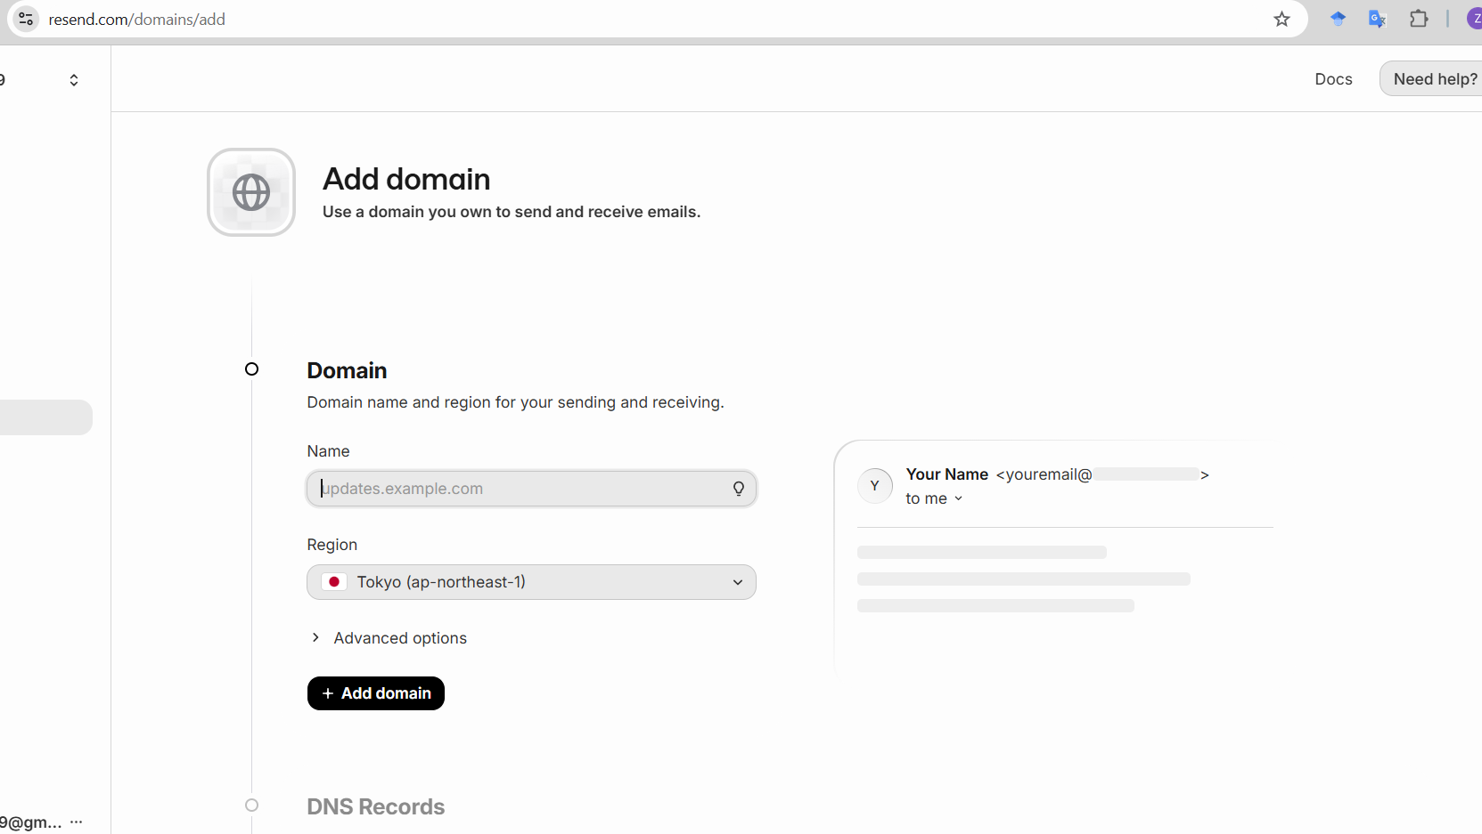
Figure 7. Resend domain verification requirement (Screenshot 2026-07-25 183754.png).
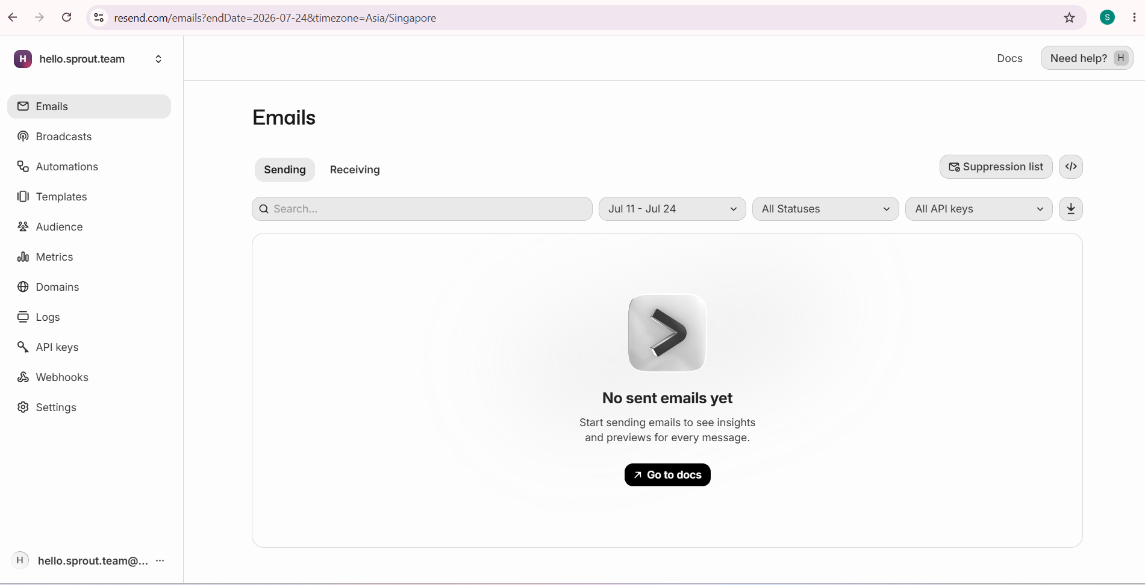
Figure 8. Resend dashboard showing no delivered messages (Screenshot 2026-07-25 214021.png). This is why the report does not claim UC1 and UC8 email delivery as working.
3. Authentication passed every local and CI check yet failed in production. Signed-in users got 401 on the archive and logout broke, with every automated check green. The 401 came from verifyIdToken, so we spent the first hour on the server: project settings, key scoping, token expiry. Nothing there. The cause was in the client build. Our .env wrapped Firebase values in double quotes; Vite strips those when reading a file, so every developer machine built correctly. Vercel passes the value through literally, so the deployed client built a broken config and issued tokens the server couldn't verify. Removing the quotes in the Vercel dashboard fixed it. Two environments parsed the same config differently, so no suite that runs in only one of them could have caught it. This is what a Factor X dev/prod parity gap actually looks like
.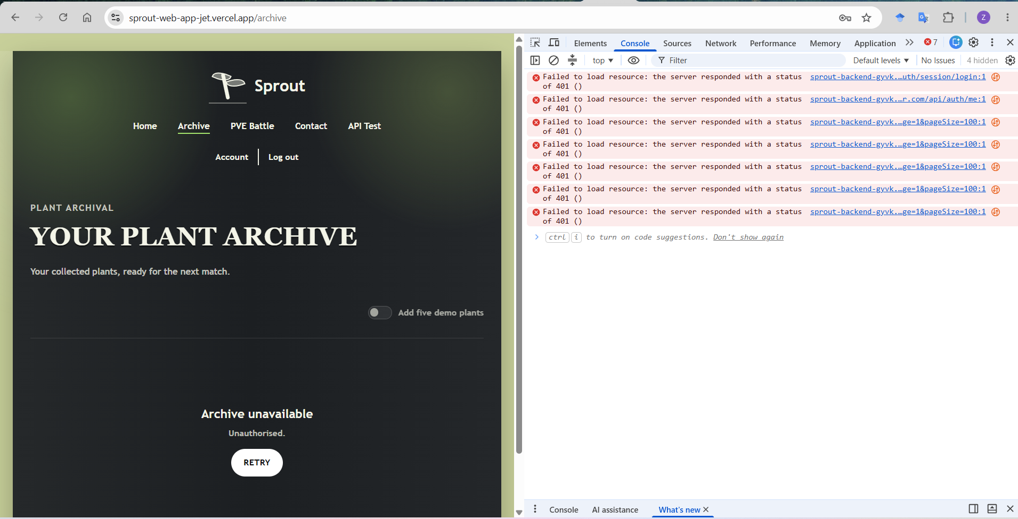
Figure 9. Repeated 401 responses on the deployed archive (Screenshot 2026-07-25 172723.png).
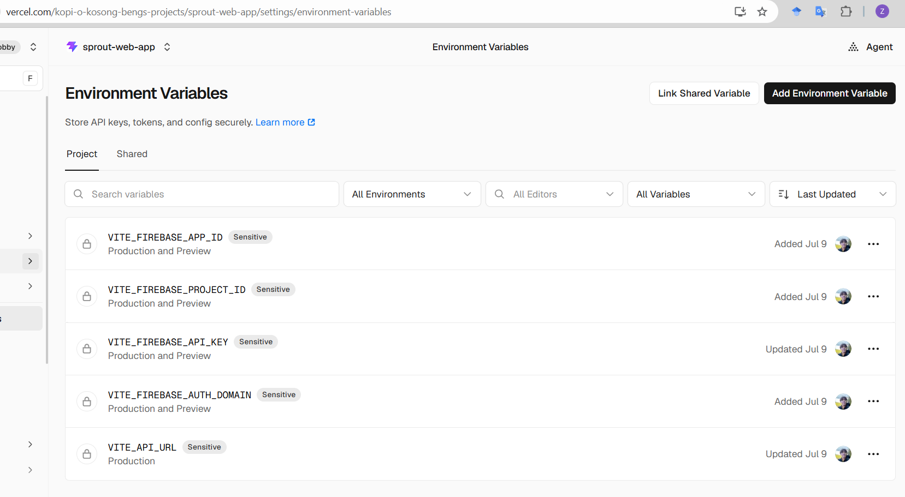
Figure 10. Vercel environment variables after correction (Screenshot 2026-07-25 163016.png).
4. Importing environment variables replaced them instead of merging them. Render's dashboard offers a bulk import for environment variables. We imported a partial file expecting it to merge with what was already set, and it replaced the entire set instead: every variable not present in that file was deleted, FIREBASE_SERVICE_ACCOUNT_JSON among them, and the backend was down until we worked out why. Recovery was to rebuild the complete twenty-variable file and import that. It took ten minutes rather than an afternoon because render.yaml declares every variable the service expects, with secrets marked sync: false so their values stay in the dashboard and out of the repository. The file could not give the values back, but it told us exactly which twenty had to exist. The measure we took from it is to treat the environment as one artefact, imported whole and checked against render.yaml, rather than as individual keys to patch.
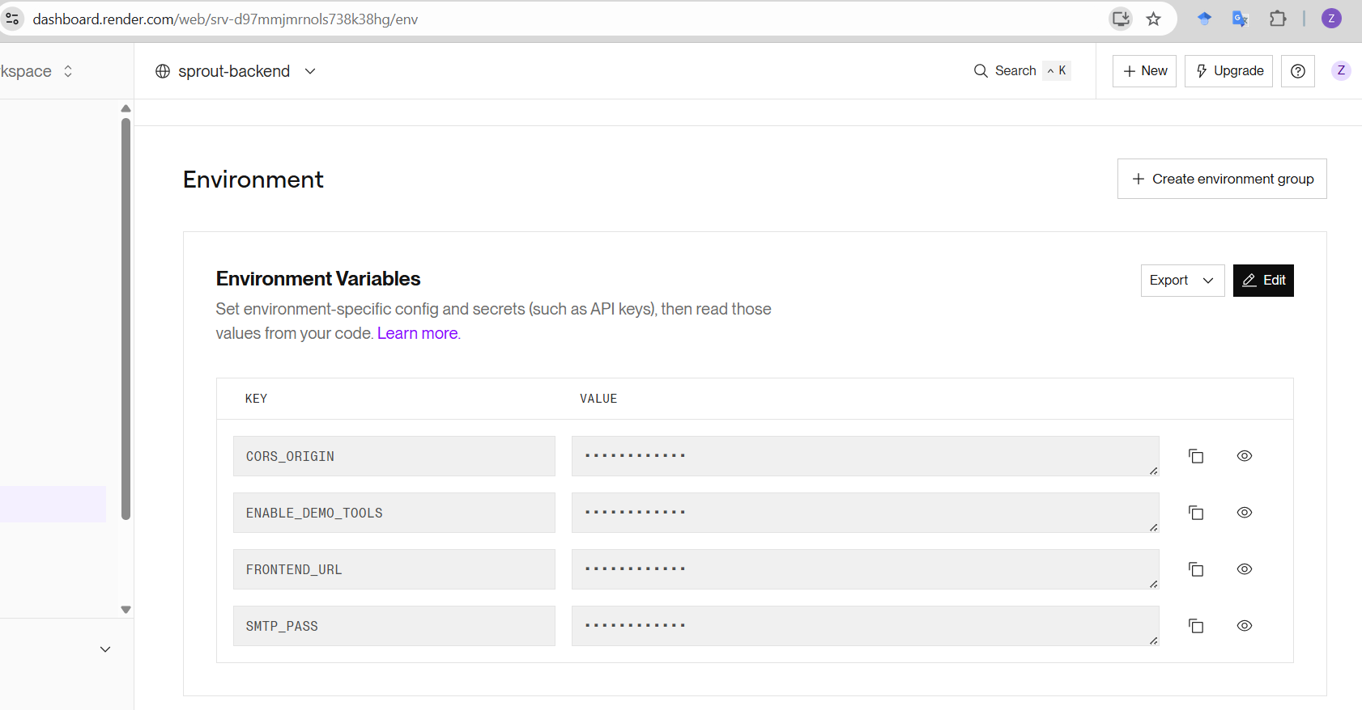
Figure 11. Render environment reduced to four variables after the import (Screenshot 2026-07-25 173952.png).
5. Two copies of Jest in one workspace broke CI. The server suites passed on our machines and failed on GitHub Actions with TypeError: this._moduleMocker.clearMocksOnScope is not a function, a message that points nowhere near the actual cause. The workspace held two installations of Jest: ts-jest lists Jest 30 as a peer dependency, so npm placed it at the repository root, while the server package pins Jest 29 for its own suites. Typing jest runs whatever the shortcut at node_modules/.bin/jest points to, and that resolved to the pinned copy on our machines and to the root copy on the Linux runner. The error is what that mismatch looks like from the inside: Jest 30's runner calling a method on Jest 29's mocking module, which does not have one. The fix is to stop depending on the shortcut. The suites now invoke the pinned binary by path, node node_modules/jest/bin/jest.js, so every machine runs the same Jest.
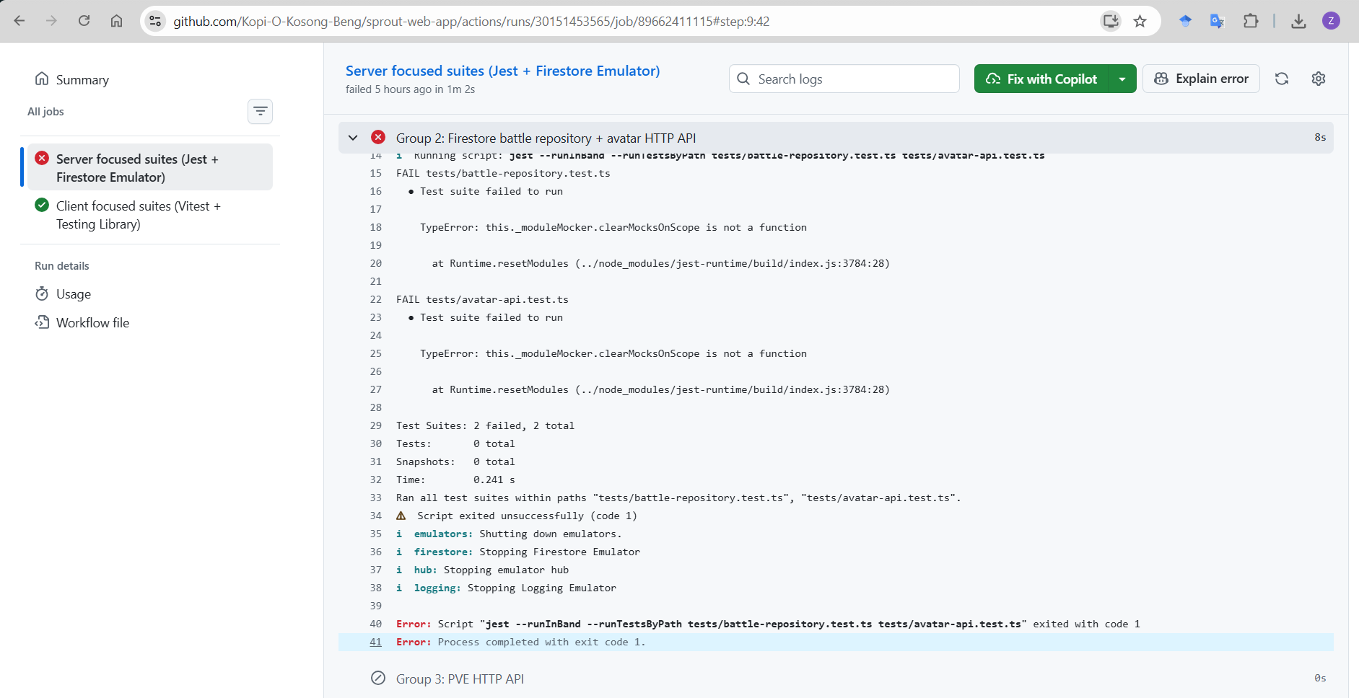
Figure 12. The failing CI run that exposed the version conflict (Screenshot 2026-07-25 213844.png).
6. The same dependency was three different native binaries. sharp and bcrypt ship per-platform prebuilt binaries, so the team's Windows and macOS machines and Render's Linux hosts each ran a different compiled artefact under one version number. A green local suite was therefore not evidence about production. We addressed it by building the dependency tree once inside a Debian-slim Linux container image (server/Dockerfile), installed with npm ci against package-lock.json, so the Linux build is the only build. We evaluated Alpine and rejected it: Alpine is musl-libc while the prebuilds target glibc, so an Alpine base either compiles sharp from source on every build or fails outright.
7. The service ignored the only stop signal its platform can send. Container platforms shut a process down in exactly one way: send SIGTERM, wait out a grace period, then kill what is left. Render does this on every redeploy. server.ts had no handler for that signal, and Node's default on SIGTERM is to exit immediately, so each deploy dropped whatever requests were in flight. The twelve-factor methodology calls this property disposability, Factor IX: a process should start quickly and stop cleanly on demand, because the platform will stop it whenever it wants. It was the one factor we outright failed. The fix is a shutdown handler in server/lifecycle.ts. On SIGTERM it stops accepting new connections, lets the requests already running finish, then exits, bounded by a ten-second timer so a single stuck connection cannot hold the container open, and written to be idempotent so a repeated signal changes nothing. The container's CMD uses exec form, which keeps our process as PID 1 and delivers the signal to it directly instead of to a shell that would swallow it. Five unit tests cover the clean drain, the forced exit, timer cleanup, repeat signals and a close error, and CI asserts it on the real container: it stops in 1 s with exit code 0 (.github/workflows/docker.yml).
8. The readiness probe crashed the server it was meant to report on. Our first Firestore check simply called listCollections(), which looks harmless. Underneath, the Firestore client builds its gRPC connection the first time it is used, and the library attaches its own error handler to that connection's promise, a promise our code never receives. With no credentials configured, that internal promise rejects; because nothing in our code is holding it, Node treats it as an unhandled rejection and terminates the process. await did not catch it, .catch() did not catch it, and the service's own error wrapper did not catch it, because the failure was never on the promise we were waiting for. What we had was a readiness endpoint that killed a healthy server, in precisely the misconfigured-deploy situation where somebody would call it. Every local test passed, because the suites run against the emulator and the emulator needs no credentials. The container smoke test in CI caught it, because that one starts the image deliberately without credentials. Two fixes followed. The probe now confirms a credential source exists before making the call, so with none it reports an ordinary failure instead of triggering the crash; and server.ts registers a process-level unhandledRejection handler that logs and keeps serving, because a rejection inside a background client has interrupted no request and every piece of durable state lives in Firestore. uncaughtException stays fatal on purpose: that one means an operation unwound mid-flight, and the process should end.

5.3 Testing challenges
1. Two end-to-end drafts passed without being able to fail. The spec takes a plant from the archive into a battle. The first draft asserted only that the page was not blank, and since every route in the app renders a layout, that held whether or not the archive contained anything. The second looked for the text "PVE Battle", which is the label on a navigation link present in the header of every page, so it matched without the archive's battle button existing at all. Both drafts were green, and neither could have gone red for the right reason. What makes this a testing challenge rather than a bug is that nothing in the run tells you: a false pass looks exactly like a real one. The spec now asserts the absence of the empty state, "No battle plants yet", which is only possible once plants have genuinely loaded, and its selectors are scoped to the main region so header links cannot satisfy them. Both drafts are kept in comments at the top of e2e/archive-to-battle.spec.ts, because the useful artefact is the pair, not the fix: a passing test is evidence only if it could have failed.
2. The end-to-end suite found a defect that unit and integration tests structurally could not. The app accepts two kinds of sign-in, a Firebase token and a dev session, and apiClient sends the right credential for either. Scanning cannot go through apiClient, because streaming progress back to the browser needs its own fetch call, so client/src/services/pipelineStream.ts was written separately and implemented only the token path. The effect was invisible from every other angle: a dev-session user could browse the archive and fight battles, both of which go through apiClient, while every scan returned 401. Manual testing missed it because we were all signed in with real accounts, and no unit test could catch it because each half was correct on its own; the defect lived in the gap between them. It surfaced the first time the E2E suite, which signs in with a dev session, drove a full scan. The dev-session branch was copied from apiClient into the stream client with the same production fencing so the two cannot drift apart again, and scan-to-archive.spec.ts now runs against the real ingest gate and the Storage emulator.
3. The fuzzer's first findings were all false, and the harness was at fault. Its opening run reported 38 findings against the ingest gate. Every one was wrong: the runner decided what each mutant should produce from the name of the strategy that made it, so anything from bitflip or format_confusion counted as hostile, when a bitflip deep in JPEG pixel data still yields a valid image and format_confusion choosing WebP produces a format that is on the allow-list. The gate had been right 38 times and the oracle had been wrong. This is the failure mode that matters most in fuzzing, because a fuzzer that cries wolf gets ignored and then gets deleted. Each mutant now declares its own expected verdict at the point it is built, since only the mutation knows what it actually produced. The full account is under Robustness below.

6. Testing
For our web development, we implemented a total of 1,093 test cases across 5 distinct test levels (unit, integration, robustness, system end-to-end, others; non-functional).
Please find 90 of the 1,093 test case examples in Appendix 4 at the end of the report.

6.1 Objectives
- Each use case behaves as its description and sequence diagram say, including the alternative and error flows, not only the happy path.
- Security boundaries hold. A user cannot read another user's data and an unverified account cannot reach protected gameplay.
- Failures in external services degrade safely rather than corrupting stored state.
- Malformed or hostile input is refused safely, and refused before it costs money: the image ingest gate is the boundary between bytes a stranger controls and the paid identification chain behind it.
- Every result quoted in this section is reproducible from the report: a named commit, runner-reported totals, and a fuzzer whose seed is injected and printed rather than left to chance.

6.2 Testing Strategy
- Backend: call graph bottom up. The server is a layered call graph where routes call services, and services call repositories. Testing bottom up means the battle engine and the Firestore repositories are proven first, then the HTTP routes that depend on them. By the time a route is tested, everything beneath it is already trusted, so a route failure points at the route. Repository tests run against the Firestore Emulator rather than a mock, because the behaviour that matters most, transactions and atomic writes, is exactly what a mock would fake.
- Frontend: top down from the caller side. React pages are driven by user events, not by being called from below, so bottom up has little meaning. Pages are rendered whole with a real router and real child components, and only the network boundary is stubbed. This proves the integration between page, router, and context, which is where defects actually appeared.
- Battle engine: property based testing. The engine has invariants that no finite example set can express, such as damage never being negative and health never exceeding its maximum, so fast-check generates cases instead of enumerating them. This was chosen after a real defect where a negative damage value healed the opponent.
- Ingest gate: mutation fuzzing against a declared oracle. The gate is the one component that reads bytes chosen by someone outside the system, so example-based tests are the wrong instrument: we cannot enumerate what a stranger will send. A seeded fuzzer mutates a corpus of real photographs with eight strategies and checks the gate's contract rather than any single verdict, which is that it never throws and every outcome is one of eight discriminated rejection reasons. Two of the eight strategies are expected to be accepted, not rejected, which is what stops the suite from mistaking strictness for correctness. A purely random generator runs alongside as a baseline, to show how little of the input space random bytes actually reach. The strategies, the seeding and what the fuzzer has and has not caught are set out under Robustness below.
Level | Types | What it covers | Where
Unit | Standard | Pure logic: battle engine, catalog, eligibility rules | battle-engine, battle-catalog, battle-eligibility
 | Property-Based | Engine invariants under generated input | battle-engine.property
Integration | Server-Side | Route through service to repository, against the emulator | auth, query, battle-api, avatar-api, admin-api
 | Client-Side | Page with real router and context, network stubbed | BattlePage, ArchivePage, LoginPage, AdminPage
Robustness | Image & Text Fuzzing | Mutation fuzzing of the image ingest gate, deterministic by injected seed; random baseline and text validators | imageIngest, imageIngest.fuzz, fuzzRunner.test, platform-fuzz-api.test, baseline.test, textFuzz.test
System End-to-End | Playwright | Complete user journeys in a real browser against the real server and emulators | e2e/*.spec.ts (6 files, 13 journeys)
 | Manual | Edge cases not anticipated in a manually written test suite. | Documented in Section 10
Others  (Non-Functional) | Configuration | Runtime guards, for example that no SQL path can load | firestore-only-runtime, app-config
Table 12. Test levels, what each cover and where the suites live.
Tier | Tools
Server | Jest, Supertest, Firebase Firestore Emulator, fast-check
Client | Vitest, React Testing Library, jsdom
Pipeline | Vitest, sharp, seeded mutation fuzzer
End-to-End | Playwright, Chromium, Firestore + Auth + Storage emulators, scripts/e2e-stack.mjs
CI | GitHub Actions, Ubuntu runner, Node 22
Table 13. Test Environment and Tooling Levels.
Tests never touch the production of Firestore project. Server suites run against the emulator under project id sprout-test. Environment variables are reset in tests/setup-env.ts so that a developer's local .env cannot change a result, a defect that was found and fixed during this checkoff.
Test Data: Data is created per test rather than shared, so suites do not depend on execution order. Battle randomness is seeded, so a battle test that passes once every time. Demo archive records are generated from a fixed template set of five species, which lets the archive tests assert exact counts.

6.3 Continuous Integration
.github/workflows/tests.yml runs ten focused command groups on every push and every pull request to main, split across a server job and a client job, plus an end-to-end job that boots the full emulated stack and runs the thirteen Playwright journeys. A second workflow, .github/workflows/docker.yml, builds both container images on every pull request, smoke-tests the API container (liveness with no credentials, per-dependency readiness, a clean SIGTERM stop) and the compose stack, and publishes the API image to GHCR on merge to main. The only suite that is not automatic is the live fuzzer (fuzz-live.yml), which spends paid API credits and is manual-only.
The ten groups, and which of them need an emulator, are listed in Appendix Table A9. They run the same commands locally and in CI, so a group that passes on a laptop passes for the same reason on the runner. What CI does not do is run everything. The ten groups cover roughly twenty of the forty-six server files and seven of the twenty-eight client files, picked as the evidence groups for the properties this report claims, and the end-to-end job runs the complete tier of thirteen journeys. The totals in Table 8 come from full-suite runs performed locally. Both statements are true and they are not the same statement: CI proves the evidence groups plus all of end-to-end on every pull request, not 1,101 tests.

6.4 Mapping of Test to Requirements & Design
Entry criteria. Code compiles, TypeScript check passes. Exit criteria. All jobs green: the ten focused groups, the end-to-end job, and the container jobs. A merge to main is blocked otherwise.
Use Case | Sequence Diagram | Server and Pipeline Suites | Client Suites | End-to-End Journey
UC1 Signup  TC-UC1-01 to 11 (Table A1) | UC1 signup | auth.test.ts (signup, resend limits) | SignupPage, validation | signup-and-contact.spec.ts: real endpoint, account created in the Auth emulator
UC2 Login  TC-UC2-01 to 10 (Table A2) | UC2 login | auth.test.ts, auth-user-repo-firestore.test.ts | LoginPage | archive-to-battle.spec.ts: form sign-in establishing a session
UC3 Reset Password  TC-UC3-01 to 10 (Table A3) | UC3 reset | auth.test.ts (OTP flow), password-policy.test.ts | LoginPage | Deliberately not automated: crosses an email inbox; manual walkthrough
UC4 Browse Archive  TC-UC4-01 to 11 (Table A4) | UC4 archive | avatar-upsert.test.ts, avatar-api.test.ts, avatar-discovery-api.test.ts | ArchivePage | archive-to-battle.spec.ts: listing plus the A3 battle shortcut
UC5 PVE Battle  TC-UC5-01 to 16 (Table A5) | UC5 PVE | battle-engine.test.ts (+property), battle-repository.test.ts, battle-api.test.ts | BattlePage | battle-turn.spec.ts: a committed move advances the server's turn counter
UC6 Upload Plant Picture  TC-UC6-01 to 11 (Table A6) | UC6 upload | imageIngest.test.ts, imageIngest.fuzz.test.ts, six stage suites, scan-persistence.test.ts, sprite-storage.test.ts, pipeline-auth.test.ts, pipeline-complete-event.test.ts | ScanPage | scan-to-archive.spec.ts: a real JPEG persisted via the Storage emulator, found in the archive
UC7 PVP Battle  No test cases: design only | UC7a, UC7b | Designed only; no automated suite claims it | None | None
UC8 Query Ticket  TC-UC8-01 to 12 (Table A7) | UC8 ticket | query.test.ts, ticket-repo-firestore.test.ts | ContactPage | signup-and-contact.spec.ts: a visitor submits a ticket without an account
Cross-cutting  TC-XC-01 to 09 (Table A8) | Not applicable | admin-api.test.ts (authorisation matrix), leaderboard suites, readiness.test.ts, lifecycle.test.ts, spriteAssets.test.ts | AppHeader navigation lock, AdminPage | public-access.spec.ts: almanac open, archive and admin guarded
Table 14. Traceability from use case to sequence diagram, suites and test cases.
Every row links to the sequence diagram it verifies in the appendix and to the full test case table for that use case, so a suite named here can be followed in either direction. We keep the same mapping in the repository at docs/TEST_TRACEABILITY.md.
Counts are read from each runner's own reported total, measured on 9 August 2026 at commit b184b62, the tip of main that day, and not by counting it() declarations in source. Parameterised cases expand at runtime, so a static count of the server suite returns roughly 416 where the Jest runner executes 624. These totals come from full-suite runs on a local machine; what continuous integration executes on each pull request is a subset, described under Continuous Integration above.
Tier | Test Files | Test Cases
Server Integration and API (Jest + Supertest, Firestore emulator) | 46 | 624
Client components and routing (Vitest + React Testing Library) | 28 | 309
Pipeline and fuzzing (Vitest) | 18 | 155
System End-to-end journeys (Playwright, Chromium) | 6 | 13
Total | 98 | 1101
Table 15. Executed test case counts by tier (9 August 2026, commit b184b62).
Test case format. Each table carries the CE10 field set in one place: the ID, the target unit (a single class or component: UI, controller, or service), the scenario, the inputs together with any mocked input/output pairs, the expected output, and the result. Literal values are stated where a boundary defines the case; other inputs state their class, and the domain and data type of every named input is in Error! Reference source not found.. Server rows run against the Firestore emulator with only the Firebase Admin token boundary mocked; UI rows run with sproutApi mocked at the network boundary; rows marked E2E run in a real browser against the emulated stack. Pass means green in the full-suite run at commit b184b62, the tip of main on 9 August 2026. Continuous integration re-runs the focused evidence groups plus the whole end-to-end tier on every pull request. Error! Reference source not found. to Error! Reference source not found. below show representative cases per use case, chosen so that each one demonstrates a boundary, a security rule or a failure path. The complete value set for every case is in Appendix Table A1 to Table A8, and the executable version is in the test files named in Error! Reference source not found..

6.5 Input Domains and Data Types
Every input named below draws from these documented domains.
Input | Data type | Domain | Source
Image payload | bytes (decoded from base64) | 0 to 15,728,640 bytes (15 MB) | server/pipeline/ingest/imageIngest.ts (MAX_IMAGE_BYTES)
Image edge | integer (pixels) | at least 16 px per edge | imageIngest.ts (MIN_IMAGE_EDGE)
Declared image pixels | integer | width times height at most 40,000,000 | imageIngest.ts (MAX_IMAGE_PIXELS)
Image format | enumeration | {jpeg, png, webp} | imageIngest.ts (ALLOWED_IMAGE_FORMATS)
Password | string | at least 8 characters and at most 72 UTF-8 bytes; bcrypt truncates at 72 bytes | client/src/utils/validation.ts, mirroring the server policy
Display name | string | 1 to 50 characters | TC-UC1-06
Ticket message | string | 1 to 2,000 characters | TC-UC8-08
Table 16. Input domains, data types and their source of truth.
Valid and invalid input taxonomy. Error! Reference source not found. sorts every named input into its valid domain and the invalid classes that sit outside it, so the equivalence classes behind Error! Reference source not found. to Error! Reference source not found. can be derived from the report alone. The image rows are the ones the fuzzer attacks: the ingest gate sorts every rejection into one of eight discriminated reasons and never throws, so each invalid class below is an outcome a test can assert on. The header pass (0.15 ms) rejects on format and declared dimensions before the decode that a decompression bomb needs; the decode pass (2.10 ms) catches what a header cannot show, such as a file truncated behind a valid header.
Input | Valid domain (Accepted) | Invalid Classes & Outputs
Image payload | A base64 string that decodes to bytes | Absent: missing. Not decodable as base64: not_base64
Payload size | 1 to 15,728,640 bytes (15 MB) | Above 15,728,640 bytes: too_large
Declared pixels | width × height at most 40,000,000 | Above 40,000,000: too_many_pixels, rejected on the header pass before any pixel is decoded
Image edge | At least 16 px on each edge | Below 16 px on either edge: too_small
Image format | jpeg, png, webp | Any other format: unsupported_format
Decoded bytes | Decode completes under the bound | Decode fails: unreadable. File cut behind a valid header: truncated
Password | At least 8 characters, at most 72 UTF-8 bytes | Below 8 characters: rejected. Above 72 bytes, where bcrypt truncates: rejected
Display name | 1 to 50 characters | Empty, or above 50 characters: 400
Ticket message | 1 to 2,000 characters | Empty, or above 2,000 characters: 400
Table 17. Valid and invalid input taxonomy across the image ingest gate and the text validators. The eight image rejection reasons are the gate's discriminated results; the Fuzzer asserts that every mutated input lands in one of them.

6.6 Unit Test Examples
ID | Target unit | Test case | Inputs and Mocked pairs | Expected | Result
TC-UC1-06 | Request validation | Display name at the 50-character boundary | displayName = 50 characters "a", then 51 (string, 1 to 50) | Accepted at 50, rejected beyond | Pass
TC-UC1-10 | Resend rate limiter (per-IP bucket) | Unauthenticated resend abuse, 21 requests per IP | 21 requests from one IP inside 15 minutes (cap 20) | Capped at 20 per 15 minutes | Pass
Table 18. UC1 Signup — representative cases. Full set: Appendix Table A1.
ID | Target unit | Test case | Inputs and Mocked Pairs | Expected | Result
TC-UC3-03 | Reset flow (service + repository) | Reset with a valid OTP | The issued OTP and a policy-passing new password | Password changed, OTP cleared | Pass
TC-UC3-05 | Reset flow | Five wrong OTP attempts | Five wrong OTP values against one issuance (limit 5) | OTP invalidated after the fifth | Pass
TC-UC3-09 | Reset flow | Firebase update fails after OTP claim | A valid OTP. Mocked: the Firebase password update throws | OTP stays consumed, no silent retry window | Pass
Table 19. UC3 Reset Password — representative cases. Full set: Appendix Table A3.
ID | Target Unit | Test Case | Inputs and Mock Pairs | Expected | Result
TC-UC4-05 | Avatar repository paging | Archive with more than 100 records | An account holding over 100 records (page-size boundary) | All owned avatars loaded across pages | Pass
Table 20. UC4 Browse Plant Avatar Archival — representative cases. Full set: Appendix Table A4.
ID | Target Unit | Test Case | Inputs and Mocked Pairs | Expected | Result
TC-UC5-03 | Battle service | Start with a foreign or expired avatar | An avatar owned by another uid; an expired temporary avatar | Same 404 for missing, foreign, and expired | Pass
TC-UC5-10 | Battle engine (property test) | Engine invariants under generated input | fast-check generated battle states and moves over the seeded RNG | Damage never negative, health never above maximum | Pass
Table 21. UC5 Join PVE Battle — representative cases. Full set: Appendix Table A5.
ID | Target unit | Test case | Inputs and Mocked pairs | Expected | Result
TC-UC6-03 | Ingest gate | Payload over 15,728,640 bytes | A payload of 15,728,641 bytes (domain 0 to 15,728,640) | Rejected: too_large | Pass
TC-UC6-05 | Ingest gate | Header declaring more than 40,000,000 pixels | A header declaring 7000 by 6000 px, which is 42,000,000 declared pixels | Rejected: too_many_pixels, before any pixel is decoded | Pass
TC-UC6-08 | Ingest gate under the mutation fuzzer | Fuzzing with the eight mutation strategies | The real-photo seed corpus, mutated; deterministic by injected seed | The gate never throws; every outcome is a discriminated result | Pass
Table 22. UC6 Upload Plant Picture (Scan) — representative cases. Full set: Appendix Table A6.
ID | Target unit | Test case | Inputs and Mocked pairs | Expected | Result
TC-UC8-08 | Request validation | Message over 2000 characters | message = 2,001 letters "m" (string, 1 to 2,000) | 400 | Pass
TC-UC8-10 | Ticket service (persist-first) | Email delivery fails (alt flow 5a) | A valid ticket. Mocked: transport throws a provider error | Still 201, ticket still persisted | Pass
TC-UC8-11 | Ticket and email service logging | Provider rejection text contains a secret | Mocked provider rejection whose message embeds a secret string | Secret never persisted or logged | Pass
Table 23. UC8 Submit Query Ticket — representative cases. Full set: Appendix Table A7.
These protect properties that belong to no single use case; they map to the cross-cutting row of the traceability table.
ID | Target unit | Test case | Inputs and Mocked pairs | Expected | Result
TC-XC-02 | Operator allowlist | Missing allowlist locks everyone out (fail-closed) | SUPER_ADMIN_EMAILS unset in the environment | Everyone is denied, including admin-badge accounts; nothing defaults open | Pass
TC-XC-05 | Graceful shutdown (lifecycle.test.ts, 5 cases) | Drain behaviour on SIGTERM and SIGINT | An injected fake server and timers: clean close, a hung connection, repeated signals, a close error | Clean drain exits 0; a hung drain is forced non-zero at 10 s; the timer is cleaned up; repeat signals are ignored | Pass
Table 24. Cross-cutting test cases — representative cases. Full set: Appendix Table A8.

6.7 Integration Test Examples
Integration testing in this project means proving that separately tested units still hold together across a real boundary. On the server, a request travels route to service to repository, running against the Firebase Firestore Emulator rather than a mock, because the behaviour that matters most, transactions and atomic writes, is exactly what a mock would fake. The only boundary mocked on the server is the Firebase Admin token. On the client, a page is rendered whole with a real router and real child components, and only the network boundary is stubbed, which proves the integration between page, router and context, where defects actually appeared. The server integration suites are auth, query, battle-api, avatar-api and admin-api; the client integration suites are BattlePage, ArchivePage, LoginPage and AdminPage.
ID | Target unit | Test case | Inputs and Mocked pairs | Expected | Result
TC-UC1-01 | Auth controller: POST /api/auth/signup | Sign up with valid details | Unused email; displayName (string, 1 to 50); password meeting all six policy criteria. Mocked: createUser returns a new uid; email transport reports success | Firebase user, local profile, and verification email payload created | Pass
TC-UC2-01 | Auth middleware + GET /api/auth/me | Load profile with a valid verified ID token | Authorization: Bearer <token>. Mocked: verifyIdToken returns { uid: "user-1", email_verified: true } | Profile returned, last login recorded | Pass
TC-UC2-02 | Auth middleware | Request with missing, invalid, or unverified token | No header; a malformed token; a token whose mocked verification returns email_verified: false | Rejected in all three cases | Pass
TC-UC2-05 | Auth middleware (demo fence) | Send x-dev-uid while DEMO_AUTH_BYPASS is on | Header x-dev-uid with DEMO_AUTH_BYPASS enabled | Rejected | Pass
TC-UC4-03 | Avatar repository query | Load archive containing another user's records | Caller uid "user-A"; emulator seeded with records owned by A and B | Only caller-owned avatars listed | Pass
TC-UC5-05 | Battle repository transaction | Two requests for the same turn | Two submissions with expectedTurn = 1 (real emulator transaction) | One resolves, other gets a redacted stale snapshot | Pass
TC-XC-01 | Admin API (admin-api.test.ts, emulator) | Authorisation matrix over /api/admin and /api/platform | Requests as anonymous, ordinary user, admin-badge account, and super-admin | The full 401/403/200 grid holds: anonymous 401, non-operator 403, super-admin 200, on every route | Pass
TC-UC4-08 | ArchivePage (UI) | Sprite image fails to load | Mocked record with an unloadable spriteUrl; the image error event fires | Falls back to the CSS rendered plant | Pass
Table 25. Integration test cases, representative set. Full set: Appendix Table A1 to Table A8.
The complete integration case list is in Appendix 4, Table A1 to Table A8, identified by the Level column.

6.8 Robustness: Fuzzing the Ingest Gate
The fuzzing target is the image ingest gate (server/pipeline/ingest/imageIngest.ts), because it is the one place where bytes stranger controls meet money we pay: everything past it costs a Plant.id call. The harness mutates a seed corpus of real photographs with eight strategies and asserts the gate's contract, which is that it never throws and every outcome is one of the eight discriminated rejection reasons in Error! Reference source not found..
Strategy | What it Mutates | Verdict the Harness Expects
bitflip | Flips bits at any offset in the file | Either. A flip deep in entropy-coded JPEG data still decodes; the same flip in the header does not. This one hunts crashes and hangs, not a fixed verdict
truncate | Cuts the file short | Reject: truncated
header_corrupt | Damages header bytes | Reject: unreadable or unsupported_format
format_confusion | Re-encodes into a different container | Accept when it picks WebP, which is on the allow-list; otherwise reject: unsupported_format
extreme_resize | Declares extreme dimensions | Reject: too_many_pixels or too_small
pixel_noise | Perturbs pixel data only | Accept: the file is still a valid image
exif_abuse | Abuses EXIF metadata | Accept: unusual metadata is not grounds for refusal
not_an_image | Substitutes non-image bytes | Reject: not_base64 or unreadable
Table 26. Mutation strategies and the verdict each one should produce.
Two more generators, random_bytes and random_printable, sit outside that set in fuzz/baseline.ts. They are the random-testing baseline, and their job is to report how many purely random inputs get past the gate at all. Of the eight rejection reasons, missing and too_large are covered by the unit suite rather than by a mutation, because neither needs a mutated image to reach.
Reproducibility. Randomness is injected, never ambient: every mutator takes an rng built from a seed, and when no seed is supplied the run picks one and prints it, so any finding replays byte for byte from its log. CI pins the seed at 42 and executes 300 iterations per run; the live runner, which spends real provider credits and is manual-only, defaults to 10 and takes --runs N.
Findings. The fuzzer has not found a defect in the ingest gate. Every run since the gate landed has been green, and we would rather report that than dress up a finding that collapses under one question. What it did catch was a defect in its own oracle, and that is worth the space. The first run reported 38 findings, and all 38 were harness bugs. The runner classified each mutant's expected verdict by strategy name, so bitflip and format_confusion were both marked hostile, when in fact a bitflip in JPEG pixel data still produces a valid image and format_confusion choosing WebP produces a format that is genuinely on the allow-list. The gate had been right 38 times and the harness had been wrong. Each mutant now declares its own expectation at the point it is built, because only the mutation knows what it actually produced. The lesson we took is that when a fuzzer reports a finding, you confirm the oracle before you confirm the bug.
The gate itself came out of this work, and the honest attribution is that inspection found it, not fuzzing. Before the gate existed, POST /api/pipeline/run-stream took imageBase64 from a JSON body, checked only that it was truthy, stripped the data-URL prefix with a regular expression and posted the string to Plant.id. Every decode, resize and format decision happened in the browser, which is exactly the part of the path an attacker skips by posting to the endpoint directly. We found it because the fuzzer needed a real target to point at.
What the fuzzer cannot do. The runner takes an iteration count, not a duration. There is no deadline, no graceful stop, and no way to know in advance which count fills a given period, so we cannot claim the long-running capability the brief describes. Adding a duration option to that one loop is a small change and it is not made yet.

6.9 System End-to-End Testing
End-to-end here means what the course means by it: a journey that starts from the user and ends with the user. A real Chromium, driven by Playwright, operates the real React build, which calls the real Express server, which reads and writes Google's official Firestore, Auth and Storage emulators, the same client libraries and query semantics as production. Nothing between the click and the database is substituted.
One seam is substituted, and we would rather say so here than have a reader find it in the code: the four paid providers behind the sprite pipeline (Plant.id, Gemini, remove.bg, and the mail transport) are replaced by the server's own USE_MOCK_APIS fixtures. There are two reasons. Every real run costs money, and a suite that bills us per execution is a suite nobody runs. The providers' output is also not deterministic, so asserting on a genuinely generated image means asserting on something that is allowed to differ every run. Every result reported from a mocked run is marked as such in the case tables.

6.9.1 Automated End-to-End Test (Playwright)
Thirteen journeys across six spec files (e2e/):
- UC1 signup against the real endpoint: the account is genuinely created in the Auth emulator and the success screen renders only on the server's confirmation; plus the mismatched-confirmation alternative flow, rejected client-side before any request (signup-and-contact.spec.ts).
- UC8: a visitor submits a query ticket without an account and sees success feedback (signup-and-contact.spec.ts).
- UC2 sign-out: sign in, click the real Log out control, then three independent checks rather than one: the header flips, the stored session record is genuinely removed from real browser storage, and a protected route bounces back to /login; a second journey proves the signed-out state survives a reload (logout.spec.ts).
- UC4: the archive lists the seeded creatures and the A3 "Battle with this avatar" shortcut carries one into UC5; plus the brand-new-account empty state, and the leaderboard rendering for a signed-in player (archive-to-battle.spec.ts).
- UC5: a match starts and a committed move advances the server's own turn counter. "Turn 2" can only appear when the round trip genuinely completed (battle-turn.spec.ts).
- UC6 to UC4: a real JPEG travels through the real ingest gate and the six streamed stages, is persisted through the Storage emulator, and is found in the archive after navigation (scan-to-archive.spec.ts).
- Public-route posture: the landing page is open and console-error-free, and the archive and operator dashboard redirect an anonymous visitor away (public-access.spec.ts).
The suite runs on every pull request, in about two minutes including stack boot, and needs zero secrets: Firestore, Auth and Storage are emulators that authenticate nobody, USE_MOCK_APIS means no billable call, and the dev-session identity is fenced on the server outside production. The zero-secrets property matters: a suite that depends on a secret cannot run on a fork, skips silently when the secret is missing, and reports green for having done nothing.
The suite is deliberately serial: one worker against one shared emulator, so a failure says something about the application rather than about two tests racing each other. CI allows a single retry to absorb browser flake, and the run fails if a spec is accidentally left focused, because a green tick that ran one test is worse than a red one.
Two journeys stop short of automation on purpose. UC3 reset password crosses an email inbox, which the stack does not emulate, so it is documented as a manual walkthrough instead. UC7 PVP is not implemented on the web client, and no suite pretends otherwise.

6.9.2 Manual End to End Testing

6.9.2.1 Rationale
We did not rely on the automated end to end suite alone. An automated journey passes when its assertions pass, and an assertion can only encode a fault somebody anticipated well enough to write down. That makes the automated suite excellent at catching regressions in behaviour we already understood, and structurally incapable of noticing that a screen is confusing, that a message is technically true but useless, or that two features contradict one another in a way no single journey visits.
The manual pass was therefore scripted rather than exploratory in the loose sense. One person walked every journey end to end against the deployed build, beginning at the landing page, then following each alternative path away from it, and then the nested paths available within each core feature. Working against the deployed build rather than a local one was deliberate, since several of the defects we found depended on real provider behaviour that a local stub would have hidden.

6.9.2.2 Paths Exercised
The paths below are representative rather than exhaustive. Each was followed to its terminal state and then back out through every branch it offered.
- Landing to Sign Up to Play
- Landing to Login to Play
- Landing to Login to Reset Password to Reset Successful to Landing or Login
- Landing to Contact Us to Submit Successful to Submit Another
- Landing to Login to Archive to Battle
- Landing to Login to Scan to Upload to Drag and Drop to Generate Sprite, then onward to Battle, Generate Another, Archive or Download

6.9.2.3 Findings and Remediation
The pass found seven defects, none of which the automated suite had reported. They fall into five areas, and all seven were fixed before submission.
- Duplicate identity. Signing up through the form and then signing in with Google on the same address left a stale record in Firestore, and the person was locked out with nothing more informative than an invalid credentials message. This was the most serious of the seven, because every automated test involved passed: each asserted its own path correctly, and no single path crossed both registration routes on one address. The fix makes the Google identity authoritative, so a Google-owned address is detected at login and the person is directed to continue with Google.
- Role-based navigation. The navigation bar offered every tab regardless of who was signed in. Capabilities were still refused correctly on the server, so nothing was exposed, but presenting a person with entry points they cannot use is a defect in its own right. The navigation bar is now driven by the account flag.
- Ticket follow-up. A person could file an enquiry and receive a reference number, but had no way to ask what had become of it. We added a status check on the contact page, which takes the reference number together with the address the enquiry was filed with.
- Content standardisation and interface consistency. Interface copy carried implementation detail that meant nothing to a reader, and control placement and padding were inconsistent between screens. We rewrote the copy in plain language and standardised the positions, spacing and link treatments.
- File validation on upload. Validation of the uploaded image was being skipped during the upload process. This was the finding with the largest cost attached, since the validation gate is what stands between an arbitrary upload and a sequence of paid provider calls. Validation now runs before any provider is contacted.
The general lesson we drew is recorded in Section 5.2, but it is worth stating here in its narrow form. The seven defects were not failures of test coverage. They were failures of a kind that coverage does not measure, because each one required somebody to form a judgement about whether the observed behaviour was reasonable, and judgement is precisely what an assertion cannot hold.

6.9.3 Risks and Mitigation
Gap | Effect | Mitigation
Live email delivery is scope-constrained | Without a purchased domain and MX configuration, verification and reset OTP mail deliver to one specific address only | Declared in Engineering challenge 2; delivery-failure paths are tested and the app survives them
UC3 crosses an email inbox | The reset journey cannot be automated end to end | Manual walkthrough; the OTP logic itself is integration-tested (TC-UC3-01 to TC-UC3-10)
UC7 PVP is design only | The use case carries diagrams but no implementation | Declared as not implemented; no suite pretends otherwise
Single Firestore emulator port | Suites cannot run in parallel locally | CI runs groups sequentially with --runInBand; the E2E suite is deliberately serial (one worker)
The fuzzer takes an iteration count, not a duration | It cannot be told to run for a fixed period such as 24 hours, so we do not claim long-run capability | CI runs 300 seeded iterations per pull request; adding a duration option to the runner loop is a small, scoped change we have not made
End-to-end cold-start flake | archive-to-battle.spec.ts timed out on the first navigation to /archive in two of four cold local runs, passing on retry both times | Traced to the Vite dev server compiling that route on a cold start, not to product code; CI has never reproduced it
Table 27. Known gaps, their effect and the mitigation in place.
Merges are gated on all those checks passing, and the screenshots below are the gate doing its job on real pull requests.
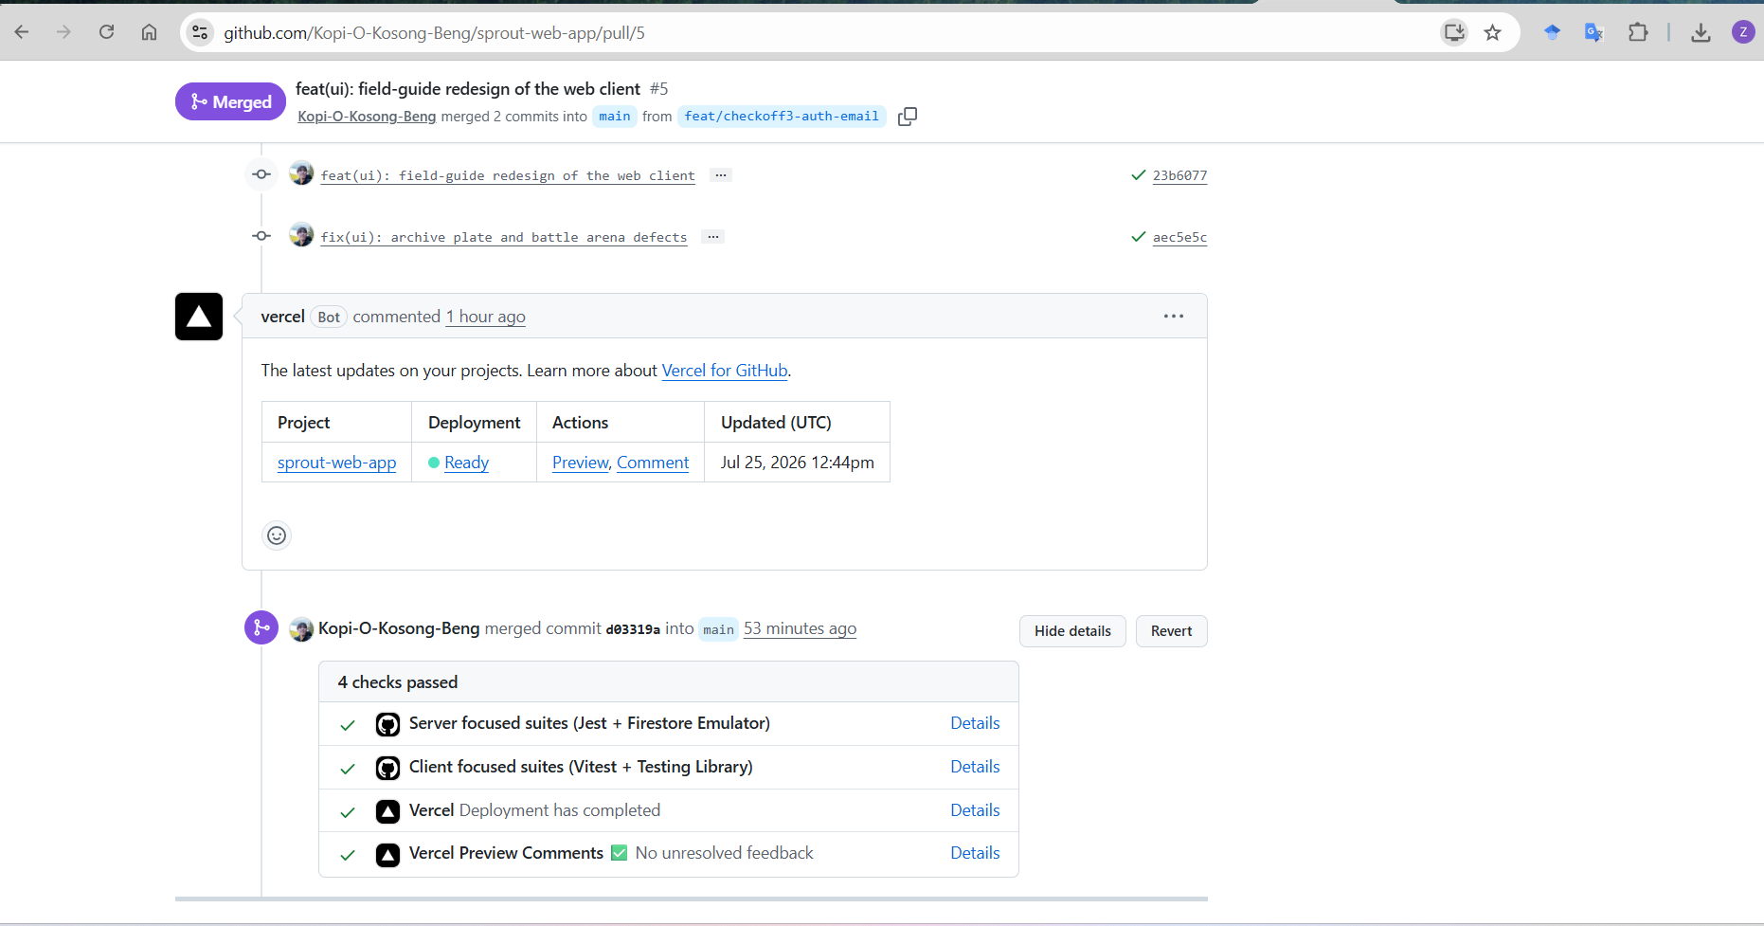
Figure 13. Pull request #5 merged with four required checks passing (Screenshot 2026-07-25 214241.png).
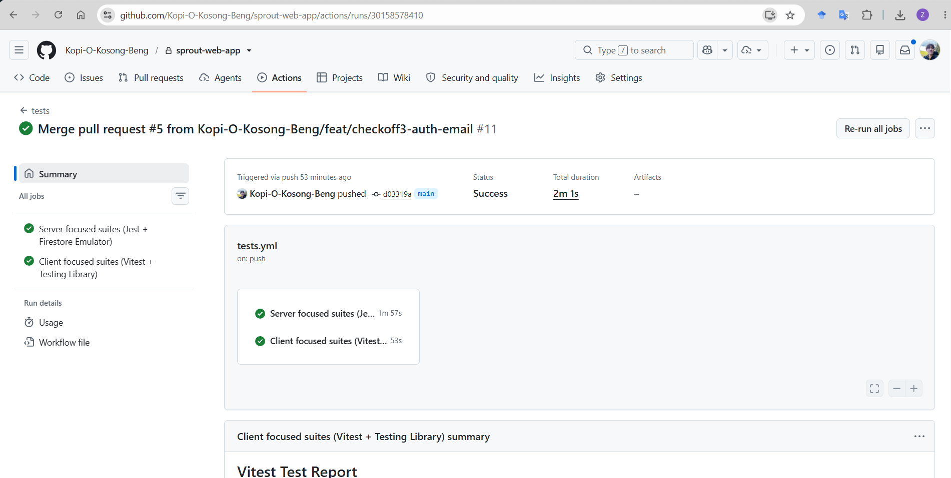
Figure 14. Both CI jobs green on main in 2m 1s (Screenshot 2026-07-25 214203.png).
Figure and Figure together are the useful pair: a real failure, diagnosed, then green.
Current results. All four suites are green at commit b184b62, the tip of main on 9 August 2026: server 624 of 624, client 309 of 309, pipeline 155 of 155, and end-to-end 13 of 13. The PM3 snapshot previously recorded here (76 of 76 client cases, 25 July 2026) is superseded by those figures. One honest qualification on the end-to-end tier: archive-to-battle.spec.ts timed out on the first navigation to /archive in two of four cold local runs and passed on retry both times, which is the Vite dev server compiling that route for the first time rather than a product defect. CI has never hit it. Figure records the PM3-era CI evidence.
Not proven. These are the things we do not claim coverage of:
- Live email delivery to an arbitrary external inbox, for the reason in Engineering Challenge 2: without a purchased domain and MX configuration, verification and reset OTP mail deliver to one specific address only.
- UC7 PVP, which is designed only.
- UC3 as a browser journey: the inbox hop is not automated; the flow is verified by integration tests and a manual walkthrough.

7. Feature Progress and Workload Distribution
This section reports where each of the sixteen use cases stands at the point of submission. We record the stage reached rather than a percentage, because a percentage invites the reader to average figures that do not average. Three stages are used, and the difference between them is what evidence exists, not how much code was written.
- Delivered and covered. The operational flow and its alternative flows are implemented, and the feature is exercised by automated tests at more than one level, meaning a regression would be caught by the suite rather than by a person.
- Delivered, bounded. Implemented and exercised, but subject to a constraint outside the system that we cannot remove and therefore declare. In every case, here the constraint is the same one.
- Delivered, test gap. Implemented and verified by hand during the manual pass, but without automated coverage at one or more levels. The behaviour works; what is missing is the guarantee that it will keep working.
UC | Feature | Where it is delivered | Automated coverage | Stage
1 | Sign Up | POST /api/auth/signup, Sign Up page | Unit, integration, E2E | Delivered, bounded
2 | Log In | POST /api/auth/session/login and /sign-in-method, Log In page | Unit, integration, E2E | Delivered and covered
3 | Reset Password | POST /api/auth/request-reset and /verify-reset, auth panel on the Log In page | Unit, integration | Delivered, test gap
4 | Browse Plantemon Collection | GET /api/avatar and /api/almanac, Archive page | Unit, integration, E2E | Delivered and covered
5 | Start PVE Battle | POST /api/battle/pve, Battle page | Unit, property, integration, E2E | Delivered and covered
6 | Upload Plant Picture | POST /api/pipeline, Scan page | Unit, fuzzing, integration, E2E | Delivered and covered
7 | Submit Query Ticket | POST /api/query/submit, Contact page | Unit, integration, E2E | Delivered, bounded
8 | Check Query Ticket Status | POST /api/query/status, Contact page panel | Unit, integration | Delivered, test gap
9 | View Ranking Leaderboard | GET /api/leaderboard, Leaderboard page | Unit, integration, E2E | Delivered and covered
10 | Log Out | POST /api/auth/session/logout, navigation bar | Unit, integration, E2E | Delivered and covered
11 | Manage User Accounts | GET and DELETE /api/admin/users, Admin dashboard | Unit, integration, E2E refusal | Delivered and covered
12 | Operate Pipeline Studio | POST /api/pipeline/run-stream and /run-stage2c, Studio dashboard | Unit, integration | Delivered, test gap
13 | Verify Backend API Health | GET /api/platform and health routes, API Test dashboard | Unit, integration | Delivered, test gap
14 | Manage Query Tickets | GET /api/admin/tickets, PATCH /tickets/:id/status, Ticket Manager dashboard | Unit, integration | Delivered and covered
15 | Authorise Operator (sub) | Superadmin flag check in the admin middleware, included by UC11 to UC14 | Unit, integration, E2E refusal | Delivered and covered
16 | Resend Verification Email (sub) | POST /api/auth/resend-verification, Verify Email page | Unit, integration | Delivered, bounded
Table 28. Delivery status of all sixteen use cases at submission
Every one of the sixteen is implemented and reachable in the deployed build. Nine are delivered and covered; three are bounded by a single external constraint, and four carry a test gap. No use case is unimplemented, and none was dropped from the model after being written, which is a consequence of the ordering described in Section 4.1 rather than good fortune.

7.1 Outstanding Work
Four items remain. We list them because a status report that records only what is finished is not a status report.
- Email delivery to arbitrary inboxes is unproven. This is the single constraint behind all three bounded entries, and it affects sign up, password reset, ticket confirmation and verification resend. Without a purchased sending domain, our provider will not deliver reliably to addresses outside the sender allowlist. The code path is complete and tested against the provider's interface, so what is unproven is delivery rather than logic. Remedy is procurement, not engineering.
- Two operator pages have no component test. Thirteen of the fifteen client pages carry a test file. The Studio and API Test pages do not, which is why UC12 and UC13 sit at a test gap. Both are operator-facing, and both were walked by hand, but neither is protected against regression.
- Three flows have no automated journey. Password reset, ticket status and verification resend are covered at the unit and integration levels but by no Playwright journey. Password reset is the one that matters most, since it is the only flow of the three that changes a credential, and a defect there would be both severe and silent. It is the first spec we would write given more time.
- The operator dashboards are proven negatively. The automated suite proves that an unauthorised caller is refused at every dashboard, which is the security-critical half. It does not prove that an authorised operator can complete the task, which is currently established only by the manual pass. The gap is a seeded superadmin fixture in the Playwright setup.
None of the four is a defect. Each is a known absence of evidence rather than a known fault, and we would rather state where the suite stops than let a green run imply a guarantee it does not give. That distinction is the same one drawn in Section 2.1, applied to our own reporting.

7.2 Pull Request Tracking
Final-phase work landed as one reviewed pull request per feature: branch protection on main, no direct pushes, every merge gated on CI. Each row below points at verifiable artefacts (pull request numbers and file paths) so the claim can be checked against the repository. Rows marked as placeholders are for the named member to fill in before submission.
Member | Feature | Evidence (pull requests, files, tests)
Zhi Feng | Backend database and email server  The API's Firestore data layer and the email system behind signup verification, password reset and ticket notifications. | PRs #1 and #2 (PM3 phase)  server/services/auth.service.ts, email.service.ts, repositories  Email fallback chain: console, then SMTP, then Resend HTTPS, adopted after Render blackholed outbound SMTP (render.yaml)
Zhi Feng | Scan-to-archive persistence (UC6 to UC4)  A completed scan now writes the creature into the player's archive with deterministic battle stats, closing the product's core loop. | PR #8  server/services/scan-persistence.ts, sprite-storage.ts, avatar repository upsert  Tests: scan-persistence.test.ts, sprite-storage.test.ts
Zhi Feng | Leaderboards  XP and first-discovery rankings, read-only projections of battle and dex data. | PR #10  server/services/leaderboard.service.ts, /leaderboard page  Tests: leaderboard-api.test.ts
Zhi Feng | Battle client and turn cinematic  The battle screen a player uses: arena layout, turn feedback, sequential turn cinematic, mid-battle session resume. | PRs #10 and #11, plus the 5 Aug battle/design PR  client/src/pages/BattlePage.tsx across three iterations  Tests: BattlePage.test.tsx
Zhi Feng | Auth hardening (client)  Fixed the Google sign-in redirect race, made login survive audit failures, diagnosed the hanging verification email. | PR #11  client/src/pages/LoginPage.tsx  Tests: LoginPage.test.tsx (the race regression was made to fail before the fix, then pass)
Zhi Feng | Super-admin operator tier  A separate operator role for the accounts dashboard and pipeline studio, enforced by fail-closed server-side allowlists. | 5 Aug PR  Middleware and route gating on /api/admin and /api/platform  Tests: admin-api.test.ts authorisation matrix (401/403/200)
Zhi Feng | Sprite pipeline completion  Replaced the empty-pot placeholders: demo species rendered through the real pipeline and committed, with a drawn fallback. | 5 Aug  Committed sprite assets; one shared sprites:generate generator  Tests: spriteAssets.test.ts, which fails the build if a seeded sprite URL has no file on disk
Zhi Feng | Deployment  Owns the deployed stack: Vercel frontend, Render backend, Firebase. Recovered the production outages recorded in the challenges. | render.yaml, vercel.json, environment configuration  Production readiness verified live on 7 Aug 2026 (Figure )
Zhi Feng | Containerization, cloud-native and resiliency  The Cloud Native section end to end: images, compose stack, graceful shutdown, readiness probes, CI smoke tests, production on runtime: docker. | PR #23  server/Dockerfile, client/Dockerfile + nginx.conf, docker-compose.yml, docker/firestore-emulator/  server/lifecycle.ts, server/services/readiness.service.ts, .github/workflows/docker.yml  Tests: lifecycle.test.ts, readiness.test.ts, plus the CI container assertions; image published to GHCR
Zhi Feng | End-to-end suite and traceability  The Playwright tier: thirteen browser journeys on every pull request, and the use-case-to-suite mapping. | PR #24; the sign-out journey added 9 Aug 2026  e2e/ (6 specs), playwright.config.ts, scripts/e2e-stack.mjs, the E2E job in tests.yml  docs/TEST_TRACEABILITY.md
Zhi Feng | Final review and merge  Reviewer and merger of every final-phase pull request; keeper of branch protection and the deployment configuration. | PRs #7 to #30 reviewed and merged  Branch protection on main; Vercel and Render configuration ownership
Justin | Account identity and Google-priority sign-in. The duplicate identity defect: form signup followed by Google sign-in on the same address left a stale Firestore record and a generic credentials error. Made the Google identity authoritative and added a pre-flight method check so the person is directed to Google instead of refused. | PR #18 (feature/frontendpart1), commit 179990e. server/services/auth.service.ts, auth.controller.ts, routes/auth.routes.ts (new POST /api/auth/sign-in-method), repositories/auth-users.ts, models/auth.ts.
Justin | Landing, Sign Up, Log In and Reset Password refinement. Reading-order swap and 20px inset on the top-right controls, Start Scanning (Sign Up) labelling, rewritten plain-language copy with PVE Battle linked, sign-up success screen cleanup, and unverified sessions routed to verification rather than left on a login form they cannot pass. | PR #18, commit 179990e. client/src/pages/LandingPage.tsx, SignupPage.tsx, LoginPage.tsx and all three .test.tsx
Justin | Role-based navigation and operator authorisation (UC15). Navbar previously offered every tab to everybody. Now driven by the account flag: visitor sees three live and three greyed, user six, superadmin all ten with a divider before the operator group. Introduced the superadmin tier and its server-side gate. | PR #18, commit 179990e. components/common/AppHeader.tsx with three dedicated tests (AppHeader.audiences.test.tsx, .admin-link.test.tsx, .logout.test.tsx), SuperAdminRoute.tsx, App.tsx, BackButton.tsx.
Justin | Contact Us and the ticket lifecycle (UC7, UC8, UC14). Live character counters, red asterisks on mandatory fields, Inquiry type raised above Subject, guidance moved above the form, and the Check Feedback Status panel that closes the loop on a submitted ticket using reference number plus filing address. | PR #18, commit 179990e. client/src/pages/ContactPage.tsx + test (Message ({message.length}/{MAX_MESSAGE_LENGTH})), TicketManagerPage.tsx + test. Server: services/ticket.service.ts, controllers/query.controller.ts, routes/query.routes.ts (POST /api/query/status), repositories/tickets.ts, models/ticket.ts, tests/query.test.ts, ticket-repo-firestore.test.ts
Justin | Console-first auth and query groundwork. Early signup, login and query path with console-based auth, before the email provider chain existed.
Justin | Requirements model: 16 use cases, misuse cases and the use case diagram. Fourteen base and two sub use cases, nine hostile and seven non-malicious misuse cases, each tied to the alternative flow that mitigates it. Four post-PM1 refinements including the uniform precondition test applied to thirteen cases. | Not in the app repo. UseCase/v5/uc_content.py, UseCase/v6/build_diagram.py, C3T2_UC_v5.pdf, UseCaseDiagram_v6.png
Justin | Project and milestone plan, PM1 and PM2 documentation. Each milestone tied to a named artefact, so requirements were due at PM1, design at PM2, tests at PM3. | Not in the app repo. PM1/PM2 submission documents
Justin | Scripted manual end to end testing. Six journeys walked to terminal state and back out through every branch. Found seven defects the automated suite had not reported. | Findings landed as the 179990e changes above. Written up in Report/C3T2_Report_Justin.docx §2.3
Nat | (placeholder, to be completed by Nat) | To be added
Andrina | Use case requirements and user flow design | Not in the app repo. PM1/PM2/PM3 submission documents.
Andrina | Video submissions: Collating everyone’s work and summarising into video presentation. Prepared slide decks and scripts. | PM1 video, PM2 video, PM3 video.
Andrina | Checkoff documentations: PM1/PM2/PM3 reports. Collating everyone’s work for the report documentation, conduct overall review on system design, features, and ensure that design and implementation matches. | PM1 report, PM2 report, PM3 report.
Omar | (placeholder, to be completed by Omar) | To be added
Li Xiang | (placeholder, to be completed by Li Xiang) | To be added
Table 29. Summary of Workload Distribution and Task Completed

9. Sustainability, Diversity and Inclusion

9.1 Sustainability

9.1.1 Environmental Purpose
The core problem Sprout addresses is a sustainability problem: gardens and nature parks draw enormous foot traffic, yet that attention rarely converts into lasting environmental awareness. Visitors take a few photos and move on. Sprout's premise is that gamified, repeated engagement with real local plants turns a shallow visit into durable familiarity with biodiversity. Because the almanac is built from 200 genuinely local Singapore species, sourced from the NUS Raffles Museum of Biodiversity Research flora checklist rather than invented, a player is learning about the plants actually growing around them, including their family, native-or-exotic origin, and growth form. This way, visitors actually become more environmentally aware and sustain their knowledge.

9.1.2 Computational Sustainability
Generative-AI features carry a real and often-ignored environmental cost: every image generated consumes energy in a data center. Sprout was designed to treat that cost as something to conserve, not spend freely:
- One plantemon per species, not per user. Generated plantemons are stored globally, keyed by species. The second person to scan a given fern reuses the first person's plantemon instead of triggering a fresh generation. Across a growing user base this collapses what would be thousands of redundant image generations into one per species, a direct, measurable reduction in AI computation and storage.
- Long-lived immutable caching. Plantemon assets are served with a one-year immutable cache header, so once a species is rendered it is not regenerated or repeatedly re-fetched from origin.
- A bounded, curated species set. The almanac is a fixed set of 200 species rather than an open-ended generate-anything system, which caps the total generation workload the product can ever incur and makes its resource ceiling predictable.
- Fail-safe pipeline design. The identification-to-generation pipeline validates and short-circuits early (for example, a low-confidence identification is rejected before any image is generated), so compute is not spent on inputs that cannot yield a usable result.

9.1.3 Operational and Social Sustainability
Sprout is a Baby Shark seed-round project with grant funding as a financial fallback, and its public-facing nature is treated as a quality obligation rather than a throwaway prototype. Our main identified risk was over-scoping, mitigated by strict P0 to P2 prioritisation, a discipline that is itself a form of sustainable engineering: shipping a smaller, well-tested surface that can be maintained, rather than a broad, fragile one that cannot. A continuous-integration pipeline gates every change, keeping the codebase in a continuously shippable, maintainable state.

9.2 Diversity and Inclusion
Sprout’s inclusion considerations fall into 3 areas: accessibility, access across demographic and economic groups, and cultural and linguistic representation.

9.2.1 Accessibility for users with disabilities
Accessibility is a first-class design principle in the product specification (WCAG 2.1 AA) and is implemented throughout the interface:
- Contrast and colour independence. Body text meets a 4.5:1 contrast ratio and large text 3:1. Crucially, colour is never the sole carrier of meaning: battle outcomes, account-verification status, and email-delivery states each pair colour with text or shape, so colour-blind users are never excluded from information.
- Reduced-motion support. Every animation has a prefers-reduced-motion alternative, honouring the operating-system setting used by people with vestibular disorders or motion sensitivity.
- Keyboard and screen-reader operability. Interactive elements expose ARIA roles and labels and provide visible focus states, so the app is navigable without a mouse and legible to assistive technology.
- Touch and small-screen inclusivity. Interactive targets are at least 44px, and the archive grid stays operable and readable down to a 320px viewport, meaning the product works on small, older, and low-cost phones, not only flagship devices.

9.2.2 Access across demographic and economic groups
- Low-barrier entry for casual and non-expert users. The whole product is designed so that a tourist or student with a few minutes of attention can go from landing page to a finished battle without instruction. Plant learning is delivered as play rather than as a lecture, which reaches people who would never engage with a formal field guide.
- No account is required to explore. The public almanac and landing page are fully browsable by unauthenticated visitors, meaning anyone can see which species exist and have been discovered without signing up, lowering the barrier for casual, first-time, or privacy-cautious users.
- Web reach beyond a single platform. Extending the original Android app to the web deliberately widens access to anyone with a browser, including desktop and non-Android users who were previously excluded.

9.2.3 Cultural and linguistic representation
- Locally rooted content. The species set is specific to Singapore's actual flora and drawn from an authoritative local scientific source, so the product reflects the biodiversity of its own community rather than importing a generic Western plant set.
- Vernacular names, honestly handled. Alongside each scientific binomial, the almanac shows the plant's everyday common name where a well-established one exists, including Malay names such as Pegaga (Centella asiatica), not only English ones such as Sea holly (Acanthus ilicifolius). This reflects how plants are actually named across Singapore's cultures rather than defaulting to English alone. Critically, the source checklist contains no common names, so these were added by hand. Of the 200 species, only 68 have an established common name. For the remaining 132, the field is deliberately left blank rather than inventing a name to fill it. Fabricating names, especially forcing a plant into English words no one uses, would misrepresent it, leaving it blank is the honest and culturally respectful choice.

9.3 Contribution to the UN Sustainable Development Goals
Sprout maps most directly to SDG 15 (Life on Land), with meaningful secondary contributions to SDGs 4, 11 and 12.
UN SDG | How Sprout Contributes
SDG 15  Life on Land (primary) | The almanac is 200 real Singapore plant species drawn from the NUS Raffles Museum vascular-flora checklist (Chong, Tan & Corlett, 2009), each carrying family, origin (native / exotic / weed) and growth form. Turning identification and collection into a game builds species-level awareness of local biodiversity, directly supporting the target of halting biodiversity loss through awareness and appreciation.
SDG 4  Quality Education | Sprout reframes plant education as play. Real taxonomy, provenance and species records sit inside a game loop, so informal learning happens for a casual visitor who would never open a field guide — a low-barrier, lifelong-learning tool available on any phone or laptop.
SDG 11  Sustainable Cities & Communities | The product is designed around high-footfall urban green spaces such as Gardens by the Bay. It deepens the value residents and tourists get from public parks, strengthening the case for green public space as shared civic infrastructure rather than passive scenery.
SDG 12  Responsible Consumption & Production | Plantemon generation is engineered to minimise wasted compute (see below): one AI-generated plantemon is produced and cached per species for the whole user base, not per user, so the second person to scan a fern reuses the first person's result.
Table 30. Summary of UN SGD Contributions
In summary, Sprout's primary contribution is to environmental awareness and biodiversity education (SDG 15 and 4), delivered through public urban green spaces (SDG 11), and engineered so that the AI features powering it stay resource-conscious rather than wasteful (SDG 12).

10. UX/UI Improvements

10.1 Frontend Refinement of the Landing, Sign Up, Log In and Contact Pages
The manual pass produced two lists rather than one. The first was the defect list given in Section 2.3, where the build did something incorrect. The second was longer and consisted of points where the build did nothing incorrect but still made the person using it work harder than necessary. We wrote that second list up as a frontend refinement specification and worked through its page by page. This section records it, because friction of this kind is invisible to a test suite and would otherwise leave no trace in the documentation at all.

10.2 Streamlining the User Experience
One principle runs through the refinements below. A person should not have to hold anything in their head on the screen could simply show them. Applied to navigation, this means the interface states where you are and what you may do; applied to copy it means the interface states what a control will do before you press it. The changes fall into three groups.
Navigation and vocabulary.
- One name for the creature. User-facing copy used sprite, creature and Plantemon interchangeably for the same object. All of it now says Plantemon. Sprite survives only as an internal rendering term, where it genuinely means the 192 by 192 image rather than the creature it depicts.
- Navigation present on every page. The Play page was retired by removing it from every user flow rather than deleting it, so no route breaks and the code remains available for reference. Scan was promoted to a top level tab, the navigation bar now renders on every subpage including Studio, and the tab for the current page is highlighted. A successful login therefore lands on the home page rather than on a dedicated post-login screen, which removes a page whose only purpose was to exist between the login form and the rest of the product.
- Navigation scoped to the account. A visitor sees Home, Ranking and Contact as live tabs, with Scan, Archive and PVE Battle greyed rather than hidden. Hiding them would have been easier, but greying them is more informative, since it shows a visitor what an account is worth before asking them to create one. A signed-in user sees six live tabs. A superadmin sees all ten, ordered so that the six player tabs come first and a divider separates them from Admin, Studio, API Test and Ticket Manager.
Landing page.
- Reading order made consistent. Sign Up and Log In were swapped in the top right so that their left to right order matches the two calls to action in the middle of the page, where Start Scanning sits on the left and I have an account sits on the right. A reader who has already decided which of the two they are should not have to re-read the pair in a different order.
- Controls moved off the corner. The same two controls were inset by twenty pixels from the top right corner. A control flush against a screen edge is cheap to hit only when the edge itself is clickable, and here it was not, so the previous placement asked for a full corner drag and then a correction back.
- Consequence stated before the click. Start Scanning became Start Scanning (Sign Up). The original label promised the scanner and delivered a registration form, which is a small betrayal repeated on every first visit.
- Copy rewritten in plain language. The description now reads point your phone camera rather than point your camera, since the capture path is the mobile companion and the web client cannot do it. Availability is spelled out in three lines covering price, where capture happens and what can be tried immediately on the web, and PVE Battle in that last line is a working link that routes a signed-out visitor to the login page rather than to a refusal.
Sign up and Contact.
- A success screen that reports only success. The sign up result now reads Your account is created, followed by Proceed to Login to verify your account. We removed a message that appeared on the same screen reporting that the verification email could not be sent. It named a problem the reader could not act on at that moment, on the one screen whose job is to confirm that something worked, and the resend path already covers the case properly.
- Implementation detail removed from the contact page. The form previously described itself by naming the endpoint it posts to. It now says that feedback and enquiries are sent through the online form, which is the same statement expressed in terms the reader can use.
- Obligation marked before it is enforced. Mandatory fields carry a red asterisk in the label. Previously the only way to discover that a field was required was to submit without it.
- Fields ordered by dependence. Inquiry type was raised above Subject, because the type constrains what a useful subject looks like, and asking for the specific before the general forces a rewrite.
- Guidance placed before the fields. The note explaining what detail helps us answer faster was moved from below the form to above it. Guidance printed after the fields is guidance the reader has already skipped.
- Confirmation that commits to something. The ticket confirmation previously reported that notification delivery had been attempted, which is a statement about our infrastructure rather than an answer to the reader's actual question. It now gives the reference number and a reply window of three working days.
- A way to follow the ticket up. A Check Feedback Status panel takes the reference number together with the address the enquiry was filed with. When an operator marks a ticket resolved, the reply timestamp is recorded, so the status answer names the date Sprout replied and points the reader at their email, rather than returning a bare status word.
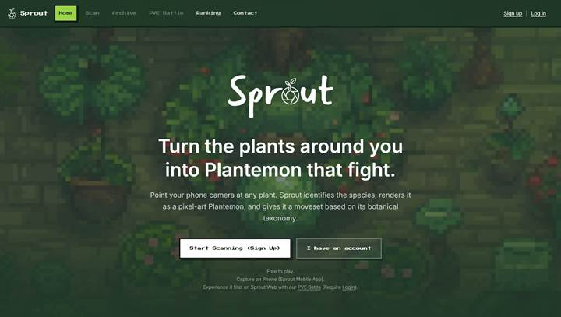
Figure 15. The landing page, as refined.

10.3 Interface Interactivity
The second half of the work concerns feedback rather than layout. An interface that moves in response to input confirms that the input is registered, which is information the reader would otherwise have to infer. Four additions carry that load.
- A live character counts on the contact form. The label itself carries the count, so the message field reads Message followed by the current length against the two-thousand-character limit, and it updates every keystroke. Placing the count in the label rather than beneath the field means the limit is legible before typing starts instead of only after it has been exceeded. The name, organisation and subject fields carry the same treatment. One defect here is worth recording because it is the kind only manual use finds: returning to the form through the browser back button restored the text into the field while leaving the counter reading zero, since the count was derived from application state that the browser restore path never touched. The count is now read from the field's own value.
- A bobbing animation when an avatar is picked. Hovering a pot in the archive lifts the Plantemon through a short hop lasting 450 milliseconds and settling with a second smaller rise, so the motion reads as weight rather than as a slide. The same animation is bound to keyboard focus and not to hover alone, which means a reader moving through the grid with the tab key gets the identical confirmation that a mouse user gets.
- A glow on the selected avatar. Hovering a pot brightens its ring with a green halo, and the specimen currently open in the detail panel carries a slow three second pulse behind the sprite. The distinction is deliberate. The hover glow fires once and stops, because it marks an event, while the selection glow repeats indefinitely, because it marks a state that persists whether the pointer is still there.
- A green response on every button hover. Buttons across the product resolve to one green on hover, drawn from the same variable that colours a healthy Plantemon, and lift by a pixel while their shadow deepens. Using a single token rather than a per-page colour means the answer to what this does is the same everywhere, and changing it later is one edit.
Three constraints held across all four. Every animation is wrapped in a reduced motion query and disabled for readers who have asked their operating system for less movement, which is only safe because motion is never the sole signal; the glow, the colour change and the count each stand on their own. Every interactive control keeps a minimum height of forty-four pixels so that it remains a comfortable touch target on the mobile companion. Finally, we measured the button contrast rather than assuming it: white text on the hover green comes to 2.78 to 1, well under the 4.5 to 1 threshold, so the hover state carries dark ink on green instead. The measurement is recorded in the stylesheet next to the rule, so the next person to reach for white there finds the reason it is not used.
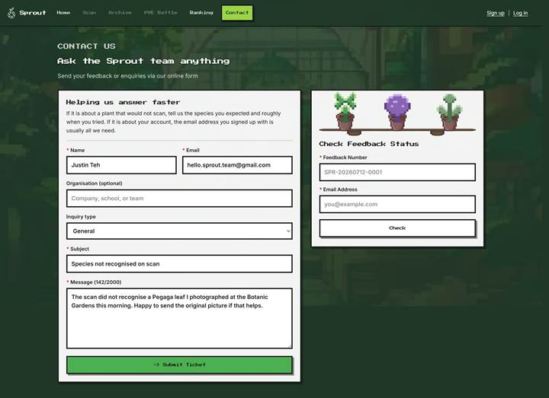
Figure 16. The contact page, as refined.

11. Conclusion

11.1 Summary of Deliveables
We delivered a complete end to end web application comprising a frontend, a backend, a native game engine, generative AI services, a serverless database, and hosting on Vercel and Render with continuous integration and deployment configured.
The documentation and the implementation were developed against one another rather than in sequence. Sixteen use cases produced the class, solution and sequence diagrams, and those in turn produced the test suite, which finished at 1,093 passing test cases across 95 files. The value of that chain is that each artefact can be checked against its neighbour: every controller answers to exactly one use case, and every alternative flow has a test that exercises it.

11.2 Takeaways
1. Documentation earns its cost when it is written to be checked. Specification-driven development was not simply a matter of writing the documents first. The documents were only useful because they were written precisely enough to disagree with the code, and several of our corrections came from noticing exactly such a disagreement.
2. An alternative flow and a misuse case answer different questions. An alternative flow states what the system does when the expected path does not hold, and it is verified by a test. A misuse case states what somebody is trying to achieve against the system, and it is answered by a mitigation. Keeping the two separate stopped us from assuming that a tested branch was also a defended one.
3. Manual end to end testing reveals what the alternative flows do not. This was the least expected of the three. Our automated suite was comprehensive and green, and it was still a person walking the whole journey who found seven real defects. The reason is structural rather than a shortcoming of the suite: an alternative flow can only describe a failure somebody thought of, so the faults that survive into a finished build are disproportionately the ones nobody thought to write down.

12. References
Cloud Native Computing Foundation (CNCF) (n.d.) CNCF cloud native definition v1.1. Available at: https://github.com/cncf/toc/blob/main/DEFINITION.md (Accessed: 11 August 2026).
Fielding, R., Nottingham, M. and Reschke, J. (eds.) (2022) HTTP semantics. RFC 9110, section 15.6.4. Internet Engineering Task Force. Available at: https://www.rfc-editor.org/rfc/rfc9110 (Accessed: 11 August 2026).
Kubernetes (n.d.) Configure liveness, readiness and startup probes. Kubernetes documentation. Available at: https://kubernetes.io/docs/tasks/configure-pod-container/configure-liveness-readiness-startup-probes/ (Accessed: 11 August 2026).
Wiggins, A. (2011) The twelve-factor app. Available at: https://12factor.net/ (Accessed: 11 August 2026).

Appendix

Appendix 1: Use Case Description
Every flow ends with Sprout responding to the actor who started it. Three conventions are applied consistently across all sixteen use cases:
- Every flow opens with the actor, never with the system. A use case records an actor's goal, so the first step is always the actor initiating it. A step such as "System displays the page" describes the interface rather than the interaction and never opens a flow.
- One input step, then one submit step. Everything the actor supplies in a single exchange is one atomic step, and committing it is the next. Atomicity is per interaction, not per field: listing each field separately would number the layout of a form rather than the interaction, and the form is an implementation choice. The system's own work stays split one action per step, which is what the Project Meeting 1 note on the UC3 one-time password asked for.
- An alternative flow states where it rejoins only when the system actually resumes it. Where the system retains state and carries the actor back to a specific step, that step is named. Where the system merely reports the outcome and the actor is free to correct it, retry, or leave, the alternative flow ends at its last stated effect. Asserting a return would claim the system compels a continuation it does not compel.
Each Trigger names the entry points the current implementation happens to offer, as examples only. They illustrate the trigger; they do not constrain it, and a future entry point reaching the same actor goal is the same use case. The operation and alternative flows carry no interface detail at all.

Legends
The legend scheme follows our submitted Use Case Report from Project Meeting 1, so the interpretation is unchanged. One entry is new: consultation notes and direct quotes from the Project Meeting sessions are marked in red on yellow wherever they appear in this document.
Purpose | Example
Project Meeting Consultation Notes | "anyone can click that button"
Actors | User, Identity Provider
Checks and validation | System validates the credentials
Backend operation | System stores the ticket
Happy path | System returns the reference number
Error path | 3a) Email format is invalid
Async action by the actor (outside the system's control) | Actor opens the link from their email (ASYNC ACTION)

UC1: Sign Up
Description | A person without an account creates a Sprout account and completes email verification. Signing up through the federated Google option is the same use case: the Identity Provider satisfies the credential and verification steps.
Actors | Primary: Visitor  Secondary: Identity Provider, Email Delivery Service
Trigger | Visitor requests to create an account.  Three entry points:  - the Sign up control in the site header  - the Start Scanning (Sign Up) action in the public landing area  - the create an account link on the login screen
Precondition | NIL. Anyone may request an account; an address that is already registered is handled in an alternative flow, not excluded here.
Postcondition | An identity and a matching Sprout profile exist, and the profile is marked verified once the verification link has been applied.
Error States | Invalid email; invalid display name; password fails policy; email already registered; identity creation failure; profile creation failure; verification email delivery failure; invalid or expired verification link; resend limit exceeded.
Operation Flow | 1) Visitor enters an email address, a display name and a password.  2) Visitor submits the registration request.  3) System validates the email format, the display name and the password policy.  4) System requests the Identity Provider to create an unverified identity.  5) Identity Provider returns the created identity.  6) System creates the matching Sprout profile.  7) System requests a verification action link from the Identity Provider.  8) System requests the Email Delivery Service to deliver the verification link.  9) System confirms the account is pending verification and leaves the actor holding an authenticated but unverified session, which is what makes the resend reachable.  10) Visitor opens the verification link from their email (ASYNC ACTION)  11) System applies the verification action code.  12) System synchronises the verified state onto the profile.  13) System confirms the account is verified and grants access as a User.
Alternative Flow | 3a) Email format is invalid  - System returns a field-specific error  - No identity is created  3b) Display name is empty, too long, already taken, or uses disallowed characters  - System returns a field-specific error  - No identity is created  3c) Password does not meet the policy (at least eight characters, with an uppercase letter, a lowercase letter, a number and a symbol)  - System returns the criteria that were not met  - No identity is created  4a) Email address is already registered  - System reports the conflict and offers to log in instead, or to resend verification  - No second profile is created  5a) Identity creation fails  - System reports a service error  - No profile is created  6a) Profile creation fails  - System records a recoverable provisioning state  - System does not report a completed signup  8a) Verification email cannot be delivered, or does not arrive  - System retains the pending account and records the delivery failure  - The failure is deliberately not raised to the actor on an otherwise successful signup, because it is not actionable there; the resend is where it is answered  - Extension point: the actor may optionally invoke UC16 (Resend Verification Email) here. UC1 completes with or without it, which is why UC16 «extend»s rather than is included  - A retry must never create a second identity  10a) Verification code is invalid or has expired  - System reports the failure and offers a fresh verification email  12a) Visitor signs up through the federated Google option  - The Identity Provider asserts an already-verified email  - Steps 7 to 11 are not performed  - Continue at Step 12

UC2: Log In
Description | A person without a session authenticates and is granted a verified session, with their profile, Plantemon collection and game statistics synchronised from the Database so that the web platform shows what the mobile app shows.
Actors | Primary: Visitor  Secondary: Identity Provider
Trigger | Visitor requests to log in.  Four entry points:  - the Log in control in the site header  - the I have an account action in the landing area  - the Login hyperlink in the landing area  - an automatic redirect when a protected capability (a User or Superadmin use case) is requested without a session, which carries the requested destination with it
Precondition | NIL. No account is assumed. An unknown account, wrong credentials and an unverified email are all alternative flows, so nothing about the requester is asserted before the flow begins.
Postcondition | A verified session is active and the actor's profile and collection data are available on this platform.
Error States | Invalid credentials; unknown account; too many attempts; invalid, expired or tampered session token; email not yet verified; profile or collection data unavailable.
Operation Flow | 1) Visitor enters an email address and a password.  2) Visitor submits the login request.  3) System requests the Identity Provider to authenticate the credentials.  4) Identity Provider returns an authenticated identity and a session token.  5) System verifies the session token.  6) System records the login against the actor's profile.  7) System synchronises the verified state, profile, Plantemon collection and game statistics.  8) System grants access as a User.
Alternative Flow | 3a) Credentials are wrong, or the account is unknown  - System returns one generic authentication error and does not reveal which field was wrong  - No session is granted  3b) Too many attempts within the configured window  - System refuses further attempts until the window elapses  5a) Session token is invalid, expired or tampered with  - System refuses the session and clears any local session state  6a) Email address is not yet verified  - System withholds the verified session  - System directs the actor to the verification screen  - Extension point: the actor may optionally invoke UC16 (Resend Verification Email) here. UC2 is refused with or without it, which is why UC16 «extend»s rather than is included  - Protected capabilities remain blocked  7a) Profile or collection data is unavailable  - System reports a retriable error  - System does not present an empty collection as a successful synchronisation  1a) Visitor chooses the federated Google option  - Steps 1 and 2 are satisfied by the Identity Provider  - Continue at Step 4

UC3: Reset Password (separate base use case)
Description | A person who may hold an account requests a one-time password by email and sets a new password. The system never reveals whether the address belongs to an account.
Actors | Primary: Visitor  Secondary: Identity Provider, Email Delivery Service
Trigger | Visitor requests a password reset.  One entry point: the forgotten password option on the login screen, which switches that screen into reset mode rather than opening a separate destination.
Precondition | NIL. No registered account and no existing password is assumed, per the Project Meeting 1 correction that "anyone can click that button". An address with no account is handled in alternative flow 4a.
Postcondition | For a valid account and a valid one-time password, the password is updated, the previous password is recorded in the recent-password history, and the one-time password is invalidated.
Error States | Invalid email format; delivery failure; incorrect one-time password; expired one-time password; attempt limit reached; new password fails the policy; new password recently used; update failure.
Operation Flow | 1) Visitor enters an email address.  2) Visitor submits the reset request.  3) System validates the email format.  4) System generates a six-digit one-time password.  5) System stores the hashed one-time password with a fifteen-minute expiry and a zero failed-attempt count.  6) System requests the Email Delivery Service to deliver the one-time password.  7) System returns the same generic acknowledgement whether or not the account exists.  8) Visitor retrieves the one-time password from their email (ASYNC ACTION)  9) Visitor enters the one-time password, a new password and its confirmation.  10) Visitor submits the reset.  11) System checks that the one-time password has not expired.  12) System validates the one-time password against the stored hash. The failed-attempt count is a consequence of this check rather than a step of its own: it is incremented only when the comparison fails, and the fifth failure invalidates the code.  13) System validates the new password against the password policy.  14) System checks the new password against the recent-password history.  15) System invalidates the one-time password, claiming it before the password is written so that one code can complete at most one reset.  16) System updates the password through the Identity Provider.  17) System records the previous password in the recent-password history.  18) System confirms the reset was successful.
Alternative Flow | 3a) Email format is invalid  - System returns a field error  - No one-time password is generated  4a) The requester has no account: a Visitor who never signed up, a mistyped address, or an address belonging to nobody  - System stores and sends nothing. A one-time password is still generated and hashed, deliberately, so that the work done for an unregistered address matches the work done for a registered one and the response cannot be told apart by how long it took  - System returns the same acknowledgement as Step 7, word for word, so a requester cannot distinguish a registered address from an unregistered one  - No email is sent, so an unregistered person is never told that an account was looked for  - Nothing the requester subsequently enters at Step 9 can validate, because no one-time password was ever issued for that address  6a) One-time password cannot be delivered for a known account  - System records the failure internally  - System returns the same generic acknowledgement and allows a fresh request  11a) One-time password has expired  - System invalidates it and requires a fresh request  - Expiry is tested before the code itself, so an expired code is reported as expired whether or not it was also the wrong code  - Return to Step 1  12a) One-time password is incorrect  - System increments the failed-attempt count  - System returns a generic invalid-code error  - The issued one-time password remains valid until it expires or the attempt limit is reached, so the actor may re-enter it at Step 9  12b) Five failed attempts have been made  - System invalidates the issued one-time password and requires a fresh request  - Return to Step 1  13a) New password does not meet the policy  - System returns the criteria that were not met  - The one-time password is not yet consumed, so the actor may re-enter at Step 9  14a) New password matches a recently used password  - System requires a different password  - The one-time password is not yet consumed, so the actor may re-enter at Step 9  15a) The one-time password has already been claimed by a concurrent reset  - System refuses and requires a fresh request, so one code completes exactly one reset  16a) Password update fails  - System does not report success  - The one-time password was consumed at Step 15, so the actor requests a fresh one rather than retrying with the same code  - Nothing has been written to the password history, so it is not left partly written

UC4: Browse Plantemon Collection
Description | A player browses their own collection of discovered species. Each entry carries its canonical sprite, species information, when it was first and last seen, and its battle statistics.
Actors | Primary: User
Trigger | User requests their Plantemon collection.  One entry point: the Archive tab in the site header, which is live only for a verified session and inert otherwise.
Precondition | CR1, an active, verified session. Nothing else is assumed.
Postcondition | The actor's own collection is displayed, and no other player's private data is exposed.
Error States | No active session; email not verified; persistence unavailable; canonical sprite missing; collection empty; entry belongs to another player; discovery attribution unavailable.
Operation Flow | 1) User requests their Plantemon collection.  2) System confirms an active verified session.  3) System retrieves the collection entries owned by the actor.  4) System resolves each entry to its species metadata and canonical Plantemon sprite.  5) System returns the collection.  6) System displays each entry with its status, species name, sprite, first and last seen dates, and battle statistics.  7) User selects an entry to view its detail.  8) System displays the species detail, the discovery provenance, and the display name of the player who first discovered that species.
Alternative Flow | 2a) No active session  - System prompts the actor to log in, retaining the requested destination  - On a verified session, continue at Step 3  2b) Session exists but the email is not verified  - System directs the actor to complete verification  - No collection data is returned  3a) User has no entries yet  - System shows an empty-collection state and offers the upload action (UC6)  3b) Persistence is unavailable  - System reports a retriable error rather than presenting an empty collection as the truth  4a) A canonical Plantemon sprite is missing  - System shows an explicit placeholder and records the broken reference  - The rest of the request still succeeds  7a) User requests an entry that is not theirs  - System reports that the entry was not found, without disclosing that it belongs to another player  8a) Discovery attribution is unavailable  - System shows the entry with no discoverer named rather than failing the request  8b) User chooses to battle with this plant  - System starts UC5 with that plant already selected  - If the entry is not eligible for battle, the action is unavailable and the reason is shown, rather than failing afterwards

UC5: Start PVE Battle
Description | A player fights a system-controlled opponent with one of their collected plants, in an alternating turn-based battle that the system resolves authoritatively. The plant is chosen from the collection the player already holds; battle setup does not upload.
Actors | Primary: User  The opponent and the battle engine are internal Sprout components, not actors.
Trigger | User requests a PVE battle.  Three entry points:  - the PVE Battle tab in the site header, live only for a verified session  - the PVE Battle hyperlink in the landing area, shown to anyone  - the Battle with this Plantemon action on an open collection entry, which arrives with the Plantemon already chosen
Precondition | NIL. Login is conditionally triggered here rather than mandatory: the landing area deliberately offers the PVE hyperlink to anyone, and the system carries them back to the battle once they log in. By the Project Meeting 1 test, "handle invalid people in the alternative flow", that belongs in an alternative flow (2a) and not in the precondition. Note that this is the opposite conclusion from UC6, for the opposite reason. Holding a plant is not assumed either; an empty collection is alternative flow 3a.
Postcondition | The battle ends in a win, a loss or an abandonment, and exactly one reward result is recorded.
Error States | No active session; email not verified; no eligible Plantemon; invalid or foreign battle session; invalid move; stale or replayed turn; round resolution failure; persistence failure.
Operation Flow | 1) User requests a PVE battle.  2) System confirms an active verified session.  3) System presents the actor's plants that are eligible for battle.  4) User selects one plant.  5) System creates a battle session with a versioned opponent preset, starting health and a stored random seed.  6) System returns the opening battle state and the current turn number.  7) User selects a battle action for the current turn.  8) User submits the action together with the expected turn number.  9) System validates the action and the turn number.  10) System selects the opponent's action using the stored seed.  11) System resolves the round and appends the action log.  12) System checks whether either side has been defeated.  13) System increments the turn and returns to Step 7 while both sides remain active.  14) System marks the battle complete once one side is defeated.  15) System applies the reward exactly once.  16) System displays the battle summary and the experience awarded.
Alternative Flow | 2a) No active session  - System prompts the actor to log in, retaining the requested destination  - On a verified session, continue at Step 3  2b) Session exists but the email is not verified  - System directs the actor to complete verification  - No battle is started  3a) User has no eligible Plantemon  - System directs the actor to add one first, which they do by pursuing UC6 (Upload Plant Picture), a separate base use case with its own goal, not a step inserted into this flow  - No empty battle session is created  4a) User arrives with a plant already chosen from their collection (UC4)  - The plant is preselected and Steps 3 and 4 are already satisfied  - Continue at Step 5  9a) The submitted action is not valid  - System rejects it without advancing the turn  - Return to Step 7  9b) The turn number is stale, or the action is a repeat  - System returns the current state without applying the effect a second time  11a) Round resolution fails  - System keeps the last valid state and reports a retriable error  - Return to Step 7  15a) The reward has already been applied  - System returns the original result rather than awarding experience twice  16a) User leaves the battle before it ends  - System marks the battle abandoned  - No reward is applied  16b) User chooses to battle again  - Return to Step 3

UC6: Upload Plant Picture
Description | A player submits a photograph of a real plant. The system identifies the species, reuses or creates the one canonical pixel-art sprite for that species, and records the species in the player's collection. It is pursued as a goal in its own right and completes with no battle involved; a plant it adds is available to UC5 afterwards, like any other collected plant.
Actors | Primary: User  Secondary: Plant Identification Service, Prompt Generation Service, Image Generation Service, Background Removal Service
Trigger | User submits a plant photograph.  Entry points: the Scan tab in the site header and the Open Sprout action in the landing area. Both are offered only to a verified session, as the precondition explains.
Precondition | CR1, an active, verified session. Checked against the Project Meeting 1 condition rather than assumed: the upload has no entry point offered to a person without a session, since the header tab is inert and the landing area sends them to sign up instead, so login here is genuinely mandatory and deleting it would misdescribe the system. Alternative flow 3a covers the one way in without it, a directly entered address.
Postcondition | The species is recorded in the actor's collection, a completed canonical sprite exists for that species, and first-discovery attribution has been recorded.
Error States | No active session; email not verified; unsupported or malformed image; image over the size limit; upload rate exceeded; confidence below the configured threshold; identification unavailable; generation failure; background removal failure; storage failure; collection save failure.
Operation Flow | 1) User selects or captures a plant photograph.  2) User submits the image.  3) System confirms an active verified session.  4) System validates the file type by its magic bytes, its size, and the actor's upload rate.  5) System sends the image to the Plant Identification Service.  6) Plant Identification Service returns a stable species identifier, names, taxonomy and a confidence score.  7) System checks that the confidence is greater than or equal to the configured threshold.  8) System records the species metadata against its stable identifier.  9) System looks for an existing canonical Plantemon sprite for that species and generation recipe version.  10) System reuses the existing sprite when one is already complete; otherwise it continues to Step 11.  11) System sends the species data to the Prompt Generation Service.  12) Prompt Generation Service returns a versioned, structured sprite prompt.  13) System sends the prompt to the Image Generation Service.  14) Image Generation Service returns the rendered source image.  15) System sends the rendered image to the Background Removal Service.  16) Background Removal Service returns the image with a transparent background.  17) System normalises the image to the fixed sprite size and locks it to the fixed palette.  18) System stores the Plantemon sprite as the one canonical object for that species.  19) System records the species in the actor's collection, keeping the original discovery date on a repeat scan and updating the last-seen date.  20) System records first-discovery attribution for the species and increments its discovery count.  21) System returns the species information, the Plantemon sprite and the collection result.  22) System makes the species available in the actor's collection (UC4).
Alternative Flow | 3a) No active session  - System prompts the actor to log in, retaining the requested destination  - On a verified session, continue at Step 4  3b) Session exists but the email is not verified  - System directs the actor to complete verification  - No external service is called  4a) File is not an accepted image type  - System reports the accepted formats  - No external service is called  - No collection entry is created  4b) File is over the size limit  - System reports the limit  - No external service is called  - No collection entry is created  4c) User has exceeded the upload rate  - System refuses the upload until the window elapses  5a) Identification is unavailable or times out  - System reports that identification could not be completed and offers a retry  - No collection entry is created  7a) Confidence is below the configured threshold  - System reports that the plant could not be identified confidently  - System suggests a clearer photograph  - No collection entry is created  13a) Image generation fails  - System marks the recipe retriable and reports a generation failure  - No canonical Plantemon sprite is stored  15a) Background removal fails  - System continues with the rendered image and records that the background was not removed, rather than failing the whole upload  17a) Normalisation fails  - System does not mark a canonical Plantemon sprite as complete  - System reports a processing failure  18a) Plantemon sprite storage fails  - System does not point collection data at a missing object  - System reports a storage failure  18b) A concurrent upload of the same species has already stored the Plantemon sprite  - System reuses the stored object rather than overwriting it  19a) Collection record cannot be saved  - System still returns the identified species and the Plantemon sprite  - System reports the save failure distinctly from a generation failure

UC7: Submit Query Ticket
Description | Anyone may submit an enquiry. The system records it, issues a reference number, confirms receipt to the submitter, and notifies the Sprout team.
Actors | Primary: All  Secondary: Email Delivery Service
Trigger | All submits an enquiry.  Entry point: the enquiry form on the Contact page, which is open to anyone.
Precondition | NIL. No session is required, and none is assumed.
Postcondition | The ticket is stored with a unique reference number, and the outcome of each notification is recorded.
Error States | Required field missing; invalid email format; message too long; persistence failure; submitter confirmation failure; team notification failure.
Operation Flow | 1) All provides the enquiry details: name, email address, organisation (optional), subject, enquiry type and message.  2) All submits the enquiry.  3) System validates the field values.  4) System stores the ticket and assigns a unique daily reference number in one atomic operation.  5) System requests the Email Delivery Service to send the submitter a confirmation carrying the reference number.  6) System separately requests the Email Delivery Service to notify the Sprout team.  7) System records the outcome of each notification.  8) System returns the reference number to the actor.
Alternative Flow | 3a) A required field is missing, or the email format is invalid  - System marks the invalid fields  - No ticket is created  - Previously entered data is preserved, so the actor may correct and resubmit  4a) Ticket cannot be stored  - System reports the failure  - No reference number is issued  5a) Confirmation email fails  - System records the failure  - Continue to Step 6  - The reference number is still returned  6a) Team notification fails  - System records the failure  - The ticket is neither rolled back nor hidden  6b) Both notifications fail  - System preserves the ticket and both failure states for a later retry

UC8: Check Query Ticket Status
Description | A submitter checks the progress of an enquiry they have already filed, using the reference number together with the email address it was filed with.
Actors | Primary: All
Trigger | All requests the status of an enquiry.  Entry point: the Check Feedback Status form on the Contact page, which is open to anyone and is a second capability on the page that hosts UC7.
Precondition | NIL. No session is required; the reference number and email are what authorise the lookup.
Postcondition | The status of the matching ticket is returned to its own submitter only.
Error States | Missing reference number or email; no ticket matches the pair; lookup rate exceeded; persistence unavailable.
Operation Flow | 1) All enters the reference number and the email address the enquiry was filed with.  2) All submits the status request.  3) System validates the input.  4) System looks for a ticket matching both the reference number and the email address.  5) System returns the ticket's status, and the date it was resolved where it has been resolved.
Alternative Flow | 3a) Either field is missing or malformed  - System reports the field error  - No lookup is performed  4a) No ticket matches the pair  - System returns the same "not found" answer it returns for a reference belonging to someone else, so reference numbers cannot be probed  4b) Too many lookups within the configured window  - System refuses further lookups until the window elapses  5a) Persistence is unavailable  - System reports a retriable error rather than reporting the ticket as missing

UC9: View Ranking Leaderboard
Description | Anyone may view the leading players, ranked by battle experience and, separately, by the number of species they were first to discover. A player who is signed in additionally sees their own standing across all players.
Actors | Primary: All
Trigger | All requests the ranking leaderboard.  Entry points: the Ranking tab in the site header, live for anyone; and a legacy address that redirects to the same destination.
Precondition | NIL. The boards are readable without a session.
Postcondition | Both ranked boards are displayed. A signed-in actor additionally sees their own standing, with their row identified.
Error States | Persistence unavailable; no ranked players yet.
Operation Flow | 1) All requests the ranking leaderboard.  2) System determines whether the request carries an active session.  3) System ranks every player by battle experience and, separately, by species first discovered.  4) System takes the leading entries of each board.  5) System returns each board with its entries and the total number of ranked players.  6) System displays both boards, showing each player's display name only.
Alternative Flow | 2a) No active session  - System returns both boards with no row marked as the actor's and no personal standing  - The public boards remain fully readable  2b) Active session  - System additionally returns the actor's true rank across all players, not merely their position within the visible entries  - System marks the actor's own row  3a) No player has any recorded experience or discovery  - System shows an empty-board state rather than an error  5a) Persistence is unavailable  - System reports a retriable error

UC10: Log Out
Description | A player ends their session, after which protected capabilities are no longer available on that device.
Actors | Primary: User  Secondary: Identity Provider
Trigger | User requests to log out.  Entry point: the Log out control beside the account name in the site header, which exists only while a session does.
Precondition | An active session exists. This is the one precondition deliberately retained: with no session there is nothing to log out of and no way to request it, so the condition does not exclude anyone who could in fact start this flow.
Postcondition | The session is ended on this device, and the logout is recorded against the actor's profile.
Error States | Logout record fails; identity sign-out fails; an operation is still being saved.
Operation Flow | 1) User requests to log out.  2) System records the logout against the actor's profile.  3) System requests the Identity Provider to end the session.  4) System discards the local session state.  5) System returns the actor to the public area as a Visitor.
Alternative Flow | 2a) Logout cannot be recorded  - System continues to Step 3 regardless, so a failed audit write cannot trap the actor inside a session  3a) Identity Provider cannot be reached  - System still discards the local session  - System reports that the session was ended on this device  1a) An operation is still being saved  - System indicates that navigation is briefly unavailable  - System completes the logout once the save settles  - Continue at Step 2

UC11: Manage User Accounts (Admin Dashboard)
Description | An operator reviews the registered accounts, grants or revokes the operator role, removes an account, runs a maintenance clean-up against a named data set, and reviews the full species index with its discovery detail.
Actors | Primary: Superadmin  Secondary: Identity Provider
Trigger | Superadmin requests the account dashboard.  One entry point: the Admin link in the site header, shown only to an account that already carries the operator flag.
Precondition | CR1 and CR2, an active, verified session and the operator grant. Both are resolved inside the flow rather than assumed by it: anyone may request the dashboard, and UC15 decides.
Postcondition | The requested account change has been applied and attributed to the operator who made it, or the request has been refused and nothing has changed.
Error States | No active session; email not verified; operator grant absent; target account not found; unsafe clean-up request; update failure.
Operation Flow | 1) Superadmin requests the account dashboard.  2) System confirms an active verified session.  3) System «include» UC15 (Authorise Operator) to establish that the actor may use this dashboard.  4) System returns every registered account with its verification state, role and activity.  5) Superadmin selects an account.  6) Superadmin grants or revokes the operator role on that account.  7) System applies the change and records who made it and in which direction.  8) System returns the updated account.
Alternative Flow | 2a) No active session  - System prompts the actor to log in, retaining the requested destination  - Continue at Step 3  2b) Session exists but the email is not verified  - System directs the actor to complete verification  - UC15 is never reached, so the operator grant is not resolved and no dashboard data is returned  3a) UC15 does not authorise the actor  - System refuses in exactly the same terms it uses for any other refusal, so the existence of the grant is never disclosed  - System returns the actor to the public area  - No dashboard data is returned  5a) Superadmin deletes an account instead  - System requires an explicit confirmation  - System removes the identity and the profile together  - System reports what was removed  5b) Superadmin runs a maintenance clean-up instead  - System performs a dry run by default and reports what would be removed  - System requires the target to be restated explicitly before anything is deleted  5c) Superadmin reviews the species index instead  - System returns the whole taxonomy with per-species discovery detail, including anything found outside the published list  6a) Target account does not exist  - System reports that the account was not found  - Nothing is changed  7a) Change cannot be applied  - System reports the failure  - The account is left unchanged

UC12: Operate Pipeline Studio (Studio Dashboard)
Description | An operator runs and inspects the Plantemon generation pipeline: running a real photograph through every stage, checking the reachability of each external service, auditing which credentials are configured, simulating the per-stage time budget, reviewing failure signatures, approving generated species for publication, and running the automated and fuzz test suites.
Actors | Primary: Superadmin  Secondary: Plant Identification Service, Prompt Generation Service, Image Generation Service, Background Removal Service
Trigger | Superadmin requests the pipeline studio.  One entry point: the Studio link in the site header, shown on the same condition.
Precondition | CR1 and CR2, an active, verified session and the operator grant. Both are resolved inside the flow rather than assumed by it: anyone may request the dashboard, and UC15 decides.
Postcondition | The requested operation has been run and its result reported.
Error States | No active session; email not verified; operator grant absent; external service unreachable; credential missing; stage exceeds its time budget; a run of the same kind is already in progress.
Operation Flow | 1) Superadmin requests the pipeline studio.  2) System confirms an active verified session.  3) System «include» UC15 (Authorise Operator) to establish that the actor may use this dashboard.  4) System presents the available operations.  5) Superadmin submits a plant photograph to the live pipeline.  6) System runs each stage in turn, reporting each stage's outcome as it resolves.  7) System reports the finished sprite together with the model, prompt and palette versions that produced it.
Alternative Flow | 2a) No active session  - System prompts the actor to log in, retaining the requested destination  - Continue at Step 3  2b) Session exists but the email is not verified  - System directs the actor to complete verification  - UC15 is never reached, so the operator grant is not resolved and no dashboard data is returned  3a) UC15 does not authorise the actor  - System refuses in exactly the same terms it uses for any other refusal, so the existence of the grant is never disclosed  - System returns the actor to the public area  - No dashboard data is returned  4a) Superadmin checks service health instead  - System probes each external service within a fixed time limit  - System reports reachability, response time and remaining credit  - A service that does not answer within the limit is reported as unreachable rather than delaying the whole report  4b) Superadmin audits credentials instead  - System reports which credentials are configured  - Each secret is shown only as a short masked preview  4c) Superadmin simulates the time budget instead  - System reports which optional stages would be dropped under the given per-stage timings  4d) Superadmin reviews failure signatures instead  - System returns the recorded error codes, safety refusals and fallback events  4e) Superadmin reviews generated species instead  - System presents the species awaiting approval  - System publishes only those the actor approves  4f) Superadmin runs the automated test suite instead  - System runs the real suite  - System reports each case with its assertion, its output and its result  4g) Superadmin runs the fuzz suite instead  - System mutates real photographs against the image validation gate offline  - No external service is called and nothing is billed  - System reports the failures found  6a) A stage's external service fails or times out  - System reports that stage as failed  - System falls back where a fallback exists  - System does not present a partial sprite as complete  6b) A run of the same kind is already in progress  - System refuses to start a second concurrent run

UC13: Verify Backend API Health (API Test Dashboard)
Description | An operator exercises the deployed backend directly, sending real requests to the authentication, collection and enquiry endpoints and reading back the real responses, to confirm that the API contracts hold end to end.
Actors | Primary: Superadmin  Secondary: Identity Provider, Email Delivery Service
Trigger | Superadmin requests the API test dashboard.  One entry point: the API Test link in the site header, shown on the same condition.
Precondition | CR1 and CR2, an active, verified session and the operator grant. Both are resolved inside the flow rather than assumed by it: anyone may request the dashboard, and UC15 decides.
Postcondition | Each exercised endpoint has returned a real response, which is displayed as returned.
Error States | No active session; email not verified; operator grant absent; backend unreachable; endpoint returns an error.
Operation Flow | 1) Superadmin requests the API test dashboard.  2) System confirms an active verified session.  3) System «include» UC15 (Authorise Operator) to establish that the actor may use this dashboard.  4) System reports whether the backend is reachable.  5) Superadmin exercises an authentication step: register, authenticate, refresh the session token, read the current profile, or end the session.  6) System performs the real request against the Identity Provider and the backend.  7) System displays the real response returned, including the endpoint that was called.
Alternative Flow | 2a) No active session  - System prompts the actor to log in, retaining the requested destination  - Continue at Step 3  2b) Session exists but the email is not verified  - System directs the actor to complete verification  - UC15 is never reached, so the operator grant is not resolved and no dashboard data is returned  3a) UC15 does not authorise the actor  - System refuses in exactly the same terms it uses for any other refusal, so the existence of the grant is never disclosed  - System returns the actor to the public area  - No dashboard data is returned  4a) Backend is unreachable  - System reports it as unavailable rather than showing a partially working dashboard  5a) Superadmin exercises the collection endpoint instead  - System returns the collection for the identifier given  - System displays the response  5b) Superadmin exercises the enquiry endpoint instead  - System submits a real enquiry, delivered by the Email Delivery Service exactly as a public submission would be  - System displays the reference number returned  6a) Endpoint returns an error  - System displays the real error response rather than presenting it as a success

UC14: Manage Query Tickets (Ticket Manager Dashboard)
Description | An operator works the enquiry queue: reads the tickets that have been submitted, filters them by state, and marks a ticket open or resolved. This is the other half of UC7 and UC8.
Actors | Primary: Superadmin
Trigger | Superadmin requests the ticket manager.  One entry point: the Ticket Manager link in the site header, shown on the same condition.
Precondition | CR1 and CR2, an active, verified session and the operator grant. Both are resolved inside the flow rather than assumed by it: anyone may request the dashboard, and UC15 decides.
Postcondition | The selected ticket carries its new state, and the time it was resolved is recorded when it is resolved.
Error States | No active session; email not verified; operator grant absent; ticket not found; unrecognised state; persistence failure.
Operation Flow | 1) Superadmin requests the ticket manager.  2) System confirms an active verified session.  3) System «include» UC15 (Authorise Operator) to establish that the actor may use this dashboard.  4) System returns the submitted tickets, presenting the unresolved ones first.  5) Superadmin filters the queue by state.  6) Superadmin selects a ticket and reads its detail.  7) Superadmin marks the ticket open or resolved.  8) System applies the new state and records the time it was resolved.  9) System returns the updated ticket.
Alternative Flow | 2a) No active session  - System prompts the actor to log in, retaining the requested destination  - Continue at Step 3  2b) Session exists but the email is not verified  - System directs the actor to complete verification  - UC15 is never reached, so the operator grant is not resolved and no dashboard data is returned  3a) UC15 does not authorise the actor  - System refuses in exactly the same terms it uses for any other refusal, so the existence of the grant is never disclosed  - System returns the actor to the public area  - No dashboard data is returned  4a) No tickets have been submitted  - System shows an empty-queue state  6a) A ticket carries an enquiry type the current form no longer offers  - System shows the stored value as it is, rather than blanking it  7a) The requested state is not one the system recognises  - System rejects the change  - The ticket is left unchanged  8a) Change cannot be saved  - System reports the failure  - The ticket is left in its previous state

UC15: Authorise Operator (sub use case, «include»d by UC11, UC12, UC13, UC14)
Description | Establishes whether the actor may use an operator dashboard, on every request rather than once per session. This is the common requirement CR2 expressed as a use case. It is a sub use case: no actor associates with it, and it is reached only through the four base use cases that include it.
Actors | Primary: Superadmin, the same primary actor as all four use cases that include it, as the notes require. No association line is drawn to it in the diagram: an actor reaches a sub use case only through its base.
Trigger | A base use case (UC11, UC12, UC13 or UC14) reaches its authorisation step.  No entry point of its own: a Superadmin never requests this directly, which is what makes it a sub use case.
Precondition | CR1, meaning the including use case has already established an active, verified session. Authorisation is layered on identity, never instead of it.
Postcondition | The including use case has an unambiguous answer: the actor is authorised, or is refused and returned to the public area.
Error States | Grant absent; grant lookup unavailable.
Operation Flow | 1) System reads the actor's identity from the verified session.  2) System checks the break-glass allowlist held in deployment configuration.  3) System checks the operator flag recorded on the actor's account when the allowlist does not already answer.  4) System reports the actor as authorised when either check grants it.  5) System returns control to the including use case.
Alternative Flow | 4a) Neither check grants the actor  - System reports the actor as not authorised  - The including use case refuses in its standard terms  - The two checks are independent, so either alone is sufficient and neither alone can be relied on  3a) The account record cannot be read  - System treats the lookup as granting nothing rather than as granting access, so a storage failure cannot open the dashboards  - The allowlist result still stands, which is what keeps the console reachable when the account store is the thing being repaired  Configuration absent  - An unset or empty allowlist grants nobody by itself  - A missing or malformed flag is not treated as authorisation

UC16: Resend Verification Email (sub use case, «extend»s UC1 and UC2)
Description | Sends the account-verification link again when the first message has not arrived. It is a sub use case: no actor associates with it, and it is reached only as an optional insertion into a base use case, which completes with or without it.  It is shared by two bases. A person who has just signed up reaches it from UC1, and a person who tries to log in before verifying reaches the same screen and the same control from UC2, because the implementation redirects an unverified session to the verification page. Factoring it out is therefore reuse rather than decoration.  Why not UC3. UC3's one-time password is a password-reset credential, not the account-verification link this use case reissues: a different artefact, a different endpoint, and a different lifetime. Asking UC3 for another code re-enters UC3's own flow at Step 1, which is a loop inside one base use case rather than an optional insertion of separate behaviour, and it is already covered by UC3 alternative flows 11a and 12b. UC16 also requires an authenticated but unverified session, which a UC3 requester does not hold. Extending UC3 would therefore fail the «extend» test and conflate two distinct credentials.
Actors | Primary: Visitor, the same primary actor as UC1 and UC2, the two use cases it extends.  Secondary: Identity Provider, Email Delivery Service  No association line is drawn: the actor reaches this only through a base use case.
Trigger | A base use case reaches its extension point and the actor asks for the link again: UC1 alternative flow 8a, or UC2 alternative flow 6a.  One entry point: the Resend verification email control on the verification screen, which appears only while the account is still unverified.
Precondition | An account exists, is pending verification, and the actor holds the authenticated but unverified session that identifies it. UC1 creates that account and UC2 encounters it; those are the only two ways this use case is reached.
Postcondition | A fresh verification link has been requested and its delivery outcome reported; the pending account is unchanged and no second identity exists.
Error States | Per-account resend limit reached; per-address resend limit reached; delivery failure; account already verified.
Operation Flow | 1) Visitor requests the verification link again.  2) System confirms the account is still pending verification.  3) System checks that the resend limits have not been reached.  4) System requests a fresh verification action link from the Identity Provider.  5) System requests the Email Delivery Service to deliver it.  6) System confirms the link has been sent again and returns control to the base use case.
Alternative Flow | 3a) More than three requests from the same account within fifteen minutes  - System refuses further requests until the window elapses  - The pending account is retained, and the base use case may still be completed with a link already sent  3b) Too many requests from the same origin within fifteen minutes  - System refuses further requests until the window elapses. This second limit exists because the per-account one alone would let a single origin cycle through many addresses  2a) The account is already verified  - System reports that no further action is needed rather than sending a link that would do nothing  5a) Delivery fails  - System reports the failure and leaves the pending account intact  - A further attempt is permitted within the limits above and must not create a second identity

Appendix 2: Misuse Cases
A misuse case is a goal pursued against the system, drawn shaded and read the same way as a use case. Two relationships connect the two halves of the model: a misuse case «threatens» a use case, and a use case or control «mitigates» a misuse case. The Final Report rubric caps the Requirement mark at the Fair band for a model that does not include them.
Sprout models two kinds, because the two need different controls. Hostile misuse is pursued deliberately, and the control is refusal. Non-malicious misuse is committed by a legitimate actor with no hostile intent, and refusal is the wrong answer there: the control has to make the honest mistake cheap, recoverable, or impossible to make by accident. Every mitigation listed is implemented rather than aspirational, and each is also the reason for an alternative flow in the use case it protects, which is what keeps the two halves consistent.

Hostile misuse
The hostile actor is Misuser: anyone interacting with Sprout to reach a goal it was not built to serve, whether an outsider, a curious player, or a script.
ID | Misuse case | Threatens | Mitigation in the system
MC1 | Harvest credentials by repeated guessing | UC2 Log In | One generic authentication error that never reveals which field was wrong (UC2 alt 3a), and a cap of ten attempts per fifteen minutes (UC2 alt 3b).
MC2 | Enumerate which email addresses hold accounts | UC3 Reset Password; UC1 Sign Up | The reset request returns the identical acknowledgement for a registered and an unregistered address, sends no email in the second case, and mutates nothing (UC3 alt 4a). Declared: the UC1 path is not closed in the same way. Signing up with an address that already holds an account is answered with an explicit conflict (UC1 alt 4a), which confirms the address is registered. That is a deliberate trade: a generic refusal on a signup form leaves a legitimate person unable to tell whether to log in instead, and the cost of that outweighs the enumeration it would prevent on a form the reset flow already protects.
MC3 | Guess a password-reset one-time password | UC3 Reset Password | The code is stored hashed, expires in fifteen minutes, and is invalidated after five failed attempts, so guessing is bounded by both time and count (UC3 alt 11a, 12a, 12b).
MC4 | Exhaust the paid AI pipeline with uploads | UC6 Upload Plant Picture | Format, magic bytes and size are validated before any provider is called at all; uploads are rate-limited per account; and one canonical Plantemon sprite per species is reused, so repeat scans of the same plant cost nothing (UC6 alt 4a, 4b, 4c and flow steps 9 to 10).
MC5 | Farm battle rewards by replaying actions | UC5 Start PVE Battle | Each action must carry the expected turn number, the opponent's moves come from a server-held seed, and a completion marker means the reward is applied exactly once (UC5 alt 9b, 15a).
MC6 | Flood the enquiry queue | UC7 Submit Query Ticket | Submissions and status lookups are each capped per origin per fifteen minutes; validation rejects malformed submissions before a ticket is created (UC7 alt 3a). The volume that does get through lands in UC14 Manage Query Tickets, which is where an operator absorbs the cost; that is a consequence of the flood rather than a second use case the misuse case threatens directly, so it is not drawn as an edge.
MC7 | Probe ticket references belonging to other people | UC8 Check Query Ticket Status | A lookup must match the reference number and the address it was filed with, and an unmatched pair returns the same answer as a reference that does not exist (UC8 alt 4a).
MC8 | Reach the operator console without the grant | UC11, UC12, UC13, UC14 (via UC15) | The grant is re-resolved on the server for every request, fails closed when configuration is absent or the account store is unreadable, and refuses in wording identical to any other refusal (UC15 alt 3a, 4a).
MC9 | Read another player's Plantemon collection | UC4 Browse Plantemon Collection | Queries are scoped to the caller; an entry belonging to someone else returns the same not-found answer as one that does not exist; and the only cross-player identity exposed anywhere is a discoverer's display name (UC4 alt 7a, flow step 8).

Non-malicious misuse
The second actor is the Careless User: a legitimate Visitor, User or Superadmin whose ordinary mistakes, impatience or misunderstanding of the system produces the same damage a Misuser would aim for. These are modelled separately because the mitigation is different in kind. Refusing a Careless User outright would refuse a customer, so each control below either removes the cost of the mistake, makes it reversible, or requires the actor to restate an irreversible intention before it is carried out.
ID | Non-malicious misuse case | Threatens | Mitigation in the system
NM1 | Rescan the same plant repeatedly, expecting a different Plantemon | UC6 Upload Plant Picture | One canonical Plantemon sprite is held per species and generation recipe, so a repeat scan is resolved from storage and costs no provider call (UC6 flow steps 9 to 10). The collection keeps the original discovery date and updates only the last-seen date (step 19), so nothing is lost by scanning again.
NM2 | Abandon a losing battle and restart it to avoid the result | UC5 Start PVE Battle | Leaving before the end marks the battle abandoned and applies no reward (UC5 alt 16a), and the completion marker means a finished battle pays out exactly once (alt 15a). The mistake is therefore neither punished nor rewarded, and the ranking in UC9 stays truthful.
NM3 | Submit the same enquiry several times because no confirmation arrived | UC7 Submit Query Ticket | A confirmation that cannot be delivered is recorded as a distinct failure and the reference number is still returned (UC7 alt 5a), so the actor is not left guessing. Duplicates that are still submitted are preserved rather than silently merged, and the operator resolves them in UC14 Manage Query Tickets; UC14 is where the mistake is absorbed rather than a second use case this misuse case threatens, which is why no edge is drawn to it. Partly declared: the submission cap limits the volume but the system does not detect that two tickets are the same enquiry.
NM4 | Run the maintenance clean-up against the wrong data set | UC11 Manage User Accounts | The clean-up performs a dry run by default and reports what would be removed, and the target must be restated explicitly before anything is deleted (UC11 alt 5b). Account deletion likewise requires an explicit confirmation and reports what was removed (alt 5a).
NM5 | Exercise the API test dashboard against production without realising the calls are real | UC13 Verify Backend API Health | Every response is displayed exactly as returned, including the endpoint that was called (UC13 flow step 7), and the enquiry test states that a real enquiry is submitted and delivered as a public submission would be (alt 5b). Declared: there is no separate sandbox, so the dashboard is honest about the consequence rather than protected from it.
NM6 | Disclose a reset one-time password to someone offering to help | UC3 Reset Password | The code expires in fifteen minutes and is invalidated after five failed attempts (UC3 alt 11a, 12b), so the window in which a disclosed code is useful is short and bounded. The previous password is recorded in the history and refused on reuse (flow steps 14, 17). Declared: no system control can prevent an actor from voluntarily handing over a valid code inside that window.
NM7 | Abandon an account by never completing email verification | UC1 Sign Up; UC2 Log In | The pending account is retained rather than discarded (UC1 alt 8a), and a later login attempt routes the actor to the verification screen instead of a dead end or a generic failure (UC2 alt 6a). Both paths reach UC16 Resend Verification Email, which is why that sub use case extends two bases rather than one.

Currently, from the Misuse Case, it has helped us identify six controls across the two tables which has gaps.
- MC2 is closed on the reset path but deliberately open on the signup path, where a duplicate address is answered with an explicit conflict.
- MC4 is bounded per account but not globally, so a population of accounts could still drive provider cost; a global budget is the intended next control.
- MC6 caps rate but does not verify the submitter's address, so the queue can still receive well-formed nuisance tickets.
- NM3 does not detect that two tickets are the same enquiry.
- NM5 has no sandbox behind the API test dashboard.
- NM6 cannot stop an actor from handing a valid code to someone else inside its fifteen-minute window.

Appendix 3: Sequence diagrams

UC1: Signup
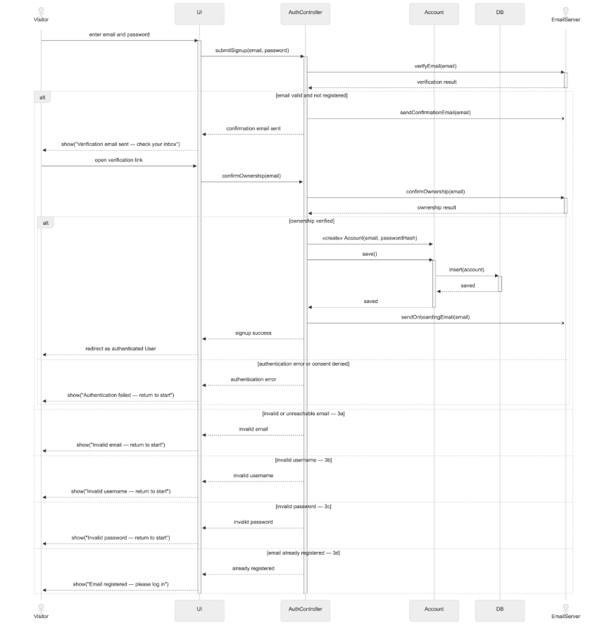
Figure 16. UC1 Signup sequence diagram.

UC2: Login
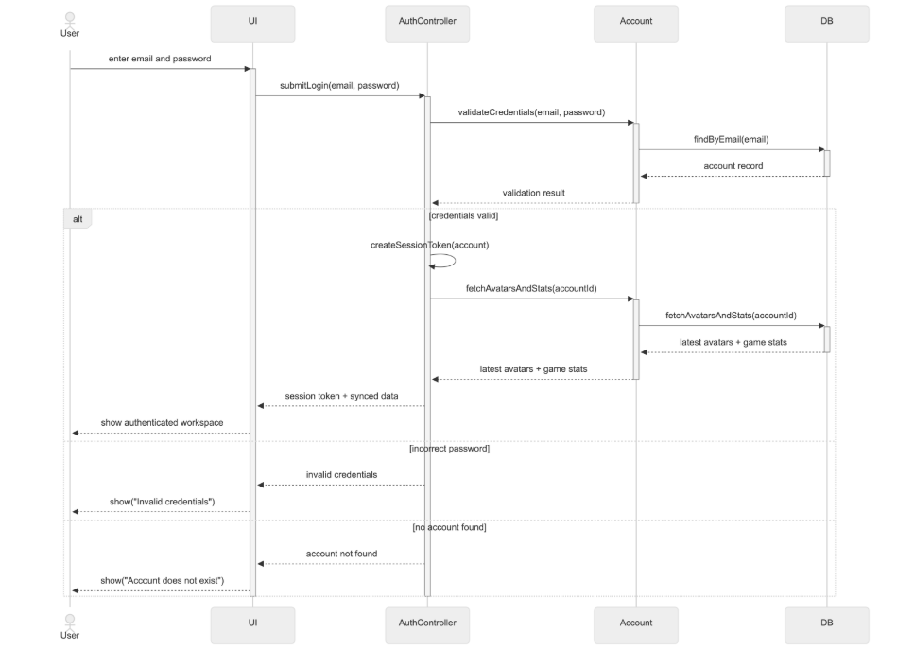
Figure 17. UC2 Login sequence diagram.

UC3: Reset Password
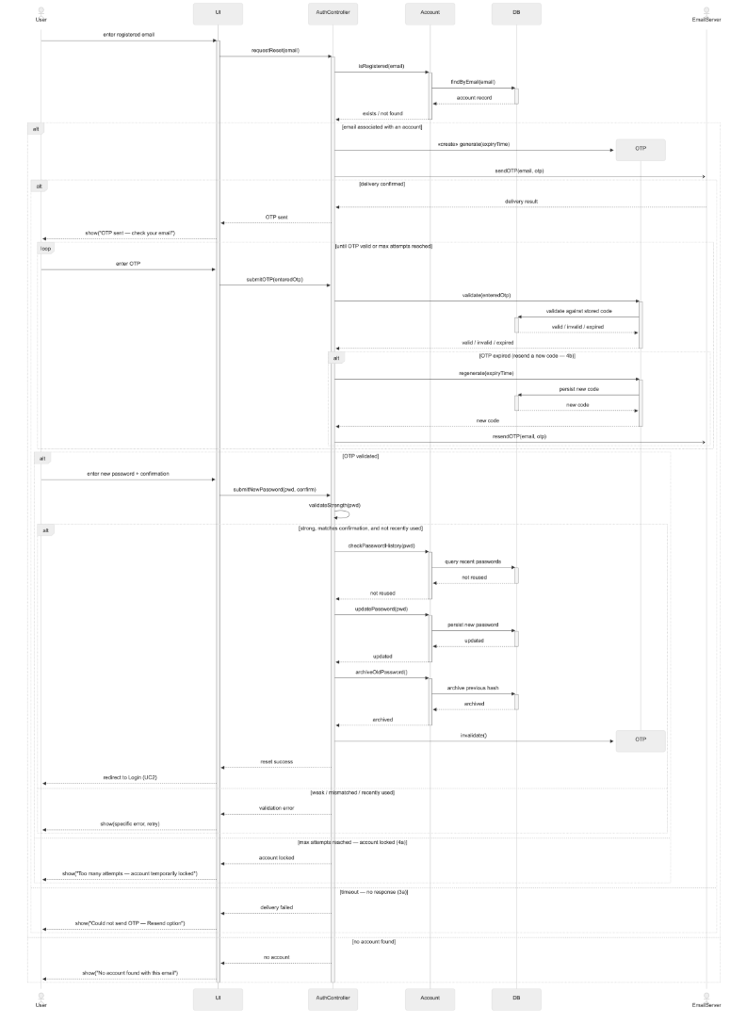
Figure 18. UC3 Reset Password sequence diagram.

UC4: Browse Plant Avatar Archival
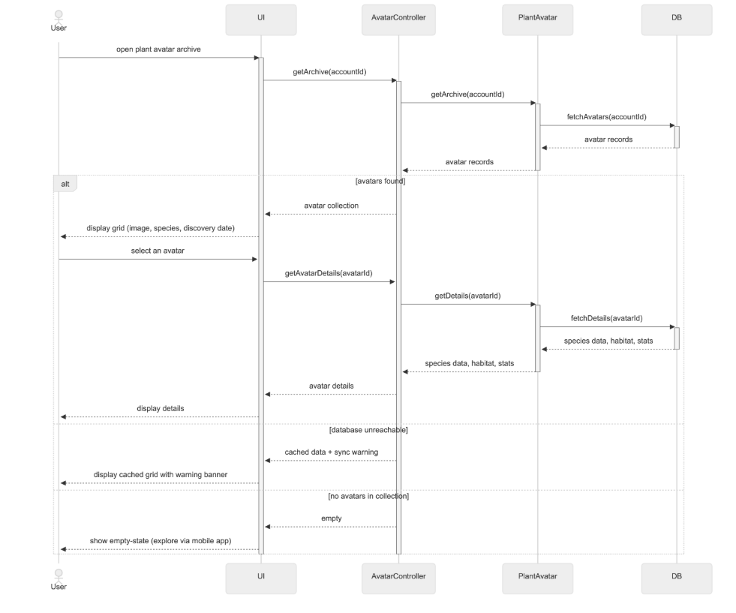
Figure 19. UC4 Browse Plant Avatar Archival sequence diagram.

UC5: Join PVE Battle
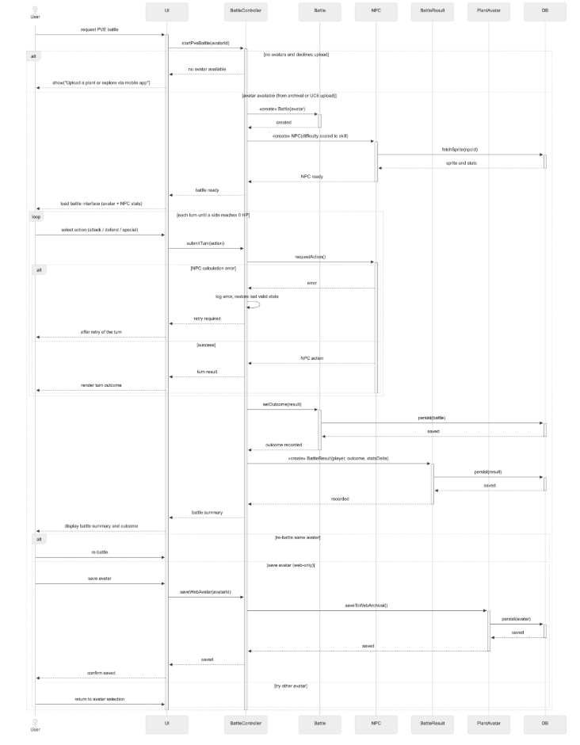
Figure 20. UC5 Join PVE Battle sequence diagram.

UC6: Upload Plant Picture
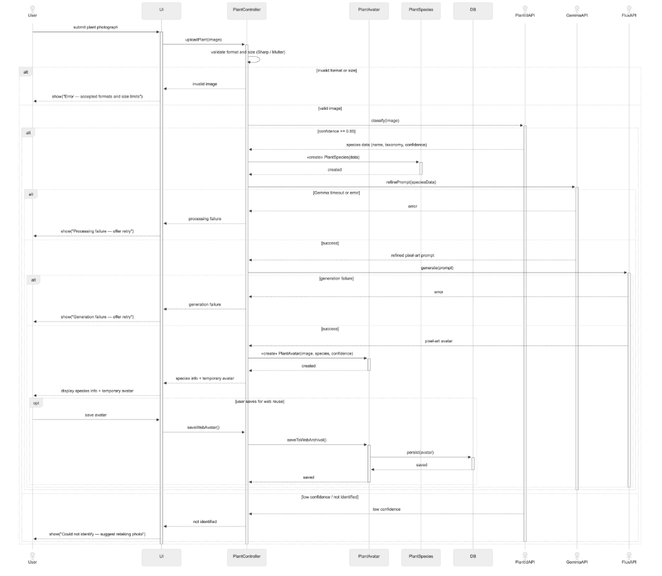Figure 21. UC6 Upload Plant Picture (Scan) sequence diagram.
UC6 covers generating sprites using generative AI, and to achieve that, we have used a series of API calls and a lot of guardrails. There are four large stages:
- Identification
- Sprite generation
- Metadata assembly
- Internal evaluations
Stage 2, sprite generation is further split into four further internal calls. These are covered by the table below in detail. Together, these calls form a total of seven stages (in server/pipeline/), with a validation gate before the first paid call and an approval gate after the last. Progress streams to the browser as server-sent events, one per stage. Two transport details follow from that. EventSource only supports GET and axios buffers whole responses, so the client reads the stream from a POST with its own fetch reader (client/src/services/pipelineStream.ts). And the photo travels as base64 inside a JSON body, so the pipeline routes mount their own 20 MB body parser instead of inheriting the app-wide one. The client resizes every photo to a 1024 px long edge before upload; the server's 15 MB ceiling is a defence, not a working size.
Stage | What happens | External call
1. Plant identification | The photo goes to Plant.id v3; the is_plant verdict and top suggestion are flattened into name, taxonomy, confidence and care details. | Plant.id
2a. Tiered prompt crafting | A vision model looks at the photo and the species data and writes a bounded creature description: two to three sentences, at most 65 words. | Gemini, then NVIDIA-hosted Gemma
2b. Sprite generation | The prompt renders a pixel-art creature. Flux leads; Gemini's image model is the automatic fallback, because the two bill on separate accounts. | NVIDIA Flux / Gemini
2c. Background cutout | The render's backdrop is removed to produce genuine transparency. Non-fatal: on failure the raw render continues, flagged removeBgOk: false. | withoutBG
2d. Finisher | The sprite is downscaled to 192×192 with nearest-neighbour sampling, disconnected islands of stray pixels are removed, every pixel is forced fully opaque or fully clear, and every opaque pixel is snapped to the locked 72-colour Spica 72 palette. | none (sharp, local)
3. Assembly | The creature receives maxHealth 100, a speed roll, and four moves selected by walking its taxonomy against a move table, with a default set when taxonomy is unknown. | none
4. Evaluation and dex gate | Two evaluation layers score the sprite and decide whether it can be auto-approved into the global dex. | Gemini (LLM-as-judge)

Appendix 3.1: GenAI Pipeline Features and Non-functional Requirements
- Ingest Gate
Before reaching Stage 1, we built an ingest gate so that uploaded images have to be checked first before any money is spent on paid API calls. This is done using validateUploadedImage (server/pipeline/ingest/imageIngest.ts) when it accepts a payload. This check is run in two passes, the first pass reads only the header: format and declared dimensions, measured at 0.15 ms. This is where the pixel ceiling is enforced - a header declaring more than 40,000,000 pixels is rejected before the decode that a decompression bomb needs. This helps us defend from adversarial images that might compromise our pipeline. The second pass decodes the image in full under a bound, measured at 2.10 ms, and catches what a header cannot show, such as a file truncated behind a valid header. The gate accepts jpeg, png and webp, requires at least 16 px per edge and at most 15 MB, and sorts every rejection into one of eight reasons (missing, not_base64, too_large, too_small, unreadable, truncated, unsupported_format, too_many_pixels). It never throws, and no decoder text reaches the user. The Robust Testing section fuzzes this gate covered in the Testing Section.
2) Failure branches
As shown in our sequence diagram, every external call has a defined failure branch instead of an assumed success path. The alternative flows planned out in our sequence diagram are important to keep our AI sprite generation flexible to the different kinds of plant pictures users may upload.
3) Budgets
This shows up in two ways, context window and latency. For image generation, our current model, Flux, limits prompts to 800 characters. Since our style claude already takes around 300 characters, our promptStyle.ts only has around 496 characters to customise the image to a new plant. We were mindful to not cut the prompt mid-word, and so will compress or trim the description if exceeding the character budget. This ensures that enforcing our fixed style is a higher priority than returning a more accurate plant, which is a step towards guaranteeing results generated are safe for kids to view.
And for latency, we use the p95 metric. Since the pipeline hard-kills any function running past 120s, we design around tail latency rather than average latency. Our per-hop caps sum to 190s. Hence, we use a shared 110s deadline that acts as a tail guardrail which does not let a single case exceed 120s and fail outright. We use min(cap,remaining) allocation and skips to degrade results gracefully, guaranteeing a useable response within a reasonable time budget.
4) Evaluation and dex gate
Similarly, we have two layers for this. The programmatic layer (eval/programmatic.ts) checks that the sprite is exactly 192×192, has some transparency, is more than 5% opaque, and has zero opaque pixels outside the palette. The judge layer (eval/judge.ts) asks Gemini to score cuteness, resemblance, edges and style from 1 to 5. Every failure path in the judge (missing key, refused prompt, network error, spent budget) returns "not scored" instead of a score.
Our dex gate is the human-in-the-loop aspect. Auto-approval into the global dex (eval/approve.ts) requires every programmatic check to pass, a successful background cut, and a cuteness score of at least 4. A missing judge score fails the gate instead of passing it; an earlier version had a default value that let unscored sprites through, and the regression test for the fix is in approve.test.ts. Sprites that fail the gate are stored as pending and wait for manual review in the studio's Dex Gate view. Admins can also use the studio to disapprove previously auto-approved sprites, ensuring human control over the pipeline in case all our automated reviews fail.
- One creature per species
After consulting Prof Kenny, Prof Dileepa, and other industry mentors, we capped our database size to the entire taxonomy of plants by setting the sprites to be saved and reused globally instead of per-user. Approved sprites are stored once per species in Cloud Storage with a one-year immutable cache header (services/sprite-storage.ts). The second user to scan a species reuses the first user's creature instead of triggering a new generation. This is how the computational-sustainability point in the Sustainability section is actually enforced: since the almanac is fixed at 200 species, there is a hard ceiling on how much generation the product can ever perform.
- Observability and mock mode
With any AI-driven system, we had to implement observability features. This is related to the Studio feature we implemented for superadmins to access.
At the very end of the sprite generation pipeline, we have

UC8: Submit Query Ticket
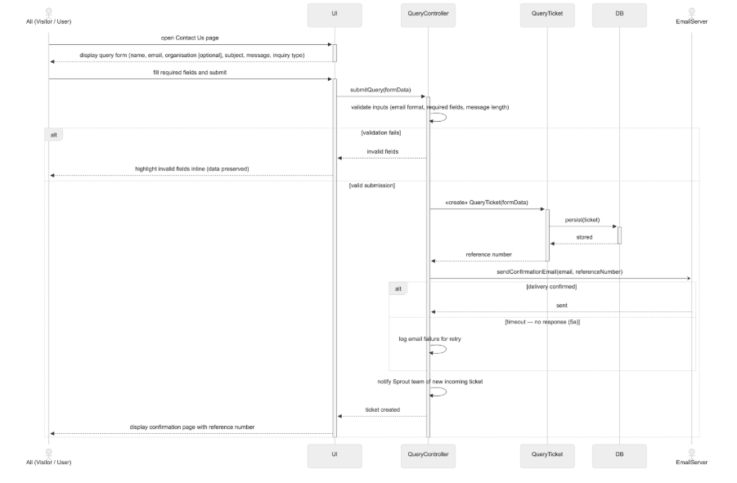
Figure 22. UC8 Submit Query Ticket sequence diagram.

Appendix 4: Test Case Tables (Full Value Set)
Every case in these tables carries the full CE10 field set. The main report shows representative cases per use case; the complete value set is here. Server rows run against the Firestore emulator with only the Firebase Admin token boundary mocked, UI rows run with sproutApi mocked at the network boundary, and rows marked E2E run in a real browser against the emulated stack.
Table A1. UC1 Signup — full test case set.
ID | Level | Target unit | Test case | Inputs and mocked pairs | Expected | Result
TC-UC1-01 | Integration (server) | Auth controller: POST /api/auth/signup | Sign up with valid details | Unused email; displayName (string, 1 to 50); password meeting all six policy criteria. Mocked: createUser returns a new uid; email transport reports success | Firebase user, local profile, and verification email payload created | Pass
TC-UC1-02 | Unit | Auth service (signup recovery path) | Sign up when email delivery fails (alt flow) | Valid field set. Mocked: email transport throws a provider error | Account is kept, recovery is reported, signup does not roll back | Pass
TC-UC1-03 | Integration (server) | Auth controller | Sign up with an already registered email | An email already registered (string). Mocked: createUser rejects with email-exists | 409 Conflict | Pass
TC-UC1-04 | Unit | Auth service (uniqueness check) | Sign up with a display name already taken | A displayName already held by another profile | 409 Conflict | Pass
TC-UC1-05 | Unit | Request validation (schema) | Sign up with malformed email and weak password | email = "not-an-email"; password = "abc" (below the 8-character minimum). No dependency reached | 400 with both violations | Pass
TC-UC1-06 | Unit | Request validation | Display name at the 50-character boundary | displayName = 50 characters "a", then 51 (string, 1 to 50) | Accepted at 50, rejected beyond | Pass
TC-UC1-07 | Unit | Resend rate limiter (per-account bucket) | Resend verification, four times in 15 minutes | Four resend requests for one account inside 15 minutes | Fourth request is rate limited | Pass
TC-UC1-08 | Unit | Resend rate limiter | Resend from one account across changing IPs | Requests for one account from different IP addresses | Quota follows the account, not the IP | Pass
TC-UC1-09 | Unit | Auth service | Resend for an already verified account | A resend request for a verified account | No send, explicit no-send response | Pass
TC-UC1-10 | Unit | Resend rate limiter (per-IP bucket) | Unauthenticated resend abuse, 21 requests per IP | 21 requests from one IP inside 15 minutes (cap 20) | Capped at 20 per 15 minutes | Pass
TC-UC1-11 | E2E | E2E: SignupPage through to the Auth emulator | A visitor signs up in a real browser, plus the mismatched-confirmation alt flow | displayName = "E2E Sprout"; run-unique e2e-<n>@example.com; password = "E2e!passw0rd" (12 chars = 12 bytes). Mocked: mail = console transport | Success screen renders only on the server response; the account exists in the Auth emulator; the mismatch is rejected before any request | Pass

Table A2. UC2 Login — full test case set.
ID | Level | Target unit | Test case | Inputs and mocked pairs | Expected | Result
TC-UC2-01 | Integration (server) | Auth middleware + GET /api/auth/me | Load profile with a valid verified ID token | Authorization: Bearer <token>. Mocked: verifyIdToken returns { uid: "user-1", email_verified: true } | Profile returned, last login recorded | Pass
TC-UC2-02 | Integration (server) | Auth middleware | Request with missing, invalid, or unverified token | No header; a malformed token; a token whose mocked verification returns email_verified: false | Rejected in all three cases | Pass
TC-UC2-03 | Unit | Auth service | Login and logout timestamps | A login then a logout for one account | Both recorded readably on the profile | Pass
TC-UC2-04 | Integration (server) | Auth middleware (dev fence) | Send x-dev-uid while AUTH_DEV_BYPASS is on | Header x-dev-uid = "dev-admin-0001" with AUTH_DEV_BYPASS enabled | Rejected, bypass header cannot authenticate | Pass
TC-UC2-05 | Integration (server) | Auth middleware (demo fence) | Send x-dev-uid while DEMO_AUTH_BYPASS is on | Header x-dev-uid with DEMO_AUTH_BYPASS enabled | Rejected | Pass
TC-UC2-06 | Integration (client) | LoginPage (UI) | Google sign-in redirect race (regression) | Mocked sign-in that settles after the redirect would fire; a fresh component tree per assertion, so the race genuinely re-runs | The redirect waits for sign-in to settle. The test failed on the unfixed code before it passed | Pass
TC-UC2-07 | Integration (client) | LoginPage (UI) | Login survives an audit-record failure | Mocked audit write that rejects during login | Login still completes; the failure is logged rather than surfaced as a login error | Pass
TC-UC2-08 | E2E | E2E: LoginPage through to a session | Sign in through the real login form | Email test@sprout.com through the form (the dev-session path; the token path is covered by the rows above) | The header reflects the session and the archive becomes reachable | Pass
TC-UC2-09 | Unit | AuthContext logout (UI unit) | logout() as a function | Mocked Firebase: the audit-then-sign-out order, the audit-failure path, the dev-session branch, unconfigured Firebase | Sign-out completes in every case; an audit failure is logged, not blocking | Pass
TC-UC2-10 | E2E | E2E: sign-out round trip (logout.spec.ts) | Signing out clears the session and re-locks protected routes; the state survives a reload | Real form sign-in; the real Log out control; a reload after signing out | The header flips; the stored session record is removed from real browser storage; /archive bounces to /login; a reload stays signed out | Pass

Table A3. UC3 Reset Password — full test case set.
ID | Level | Target unit | Test case | Inputs and mocked pairs | Expected | Result
TC-UC3-01 | Unit | Auth service (reset request) | Request reset for a known and an unknown email | "registered@example.com" and "unknown@example.com". Mocked: transport receives the OTP payload for the known account only | Identical generic 200, no account enumeration | Pass
TC-UC3-02 | Unit | Auth service | Timing of known versus unknown request | The same two requests, counting hash work | One bcrypt hash performed in both, no timing leak | Pass
TC-UC3-03 | Integration (server) | Reset flow (service + repository) | Reset with a valid OTP | The issued OTP and a policy-passing new password | Password changed, OTP cleared | Pass
TC-UC3-04 | Integration (server) | OTP repository transaction | Two parallel requests consuming one OTP | Two concurrent requests presenting the same valid OTP (real emulator transaction) | Exactly one succeeds | Pass
TC-UC3-05 | Unit | Reset flow | Five wrong OTP attempts | Five wrong OTP values against one issuance (limit 5) | OTP invalidated after the fifth | Pass
TC-UC3-06 | Integration (server) | OTP repository transaction | Five concurrent wrong attempts | Five concurrent wrong attempts on one issuance | Atomically invalidates one issuance, no double spend | Pass
TC-UC3-07 | Unit | Reset flow | Stale expired request against a freshly resent OTP | An expired reset request replayed after a fresh OTP is issued | Stale request cannot clear the new OTP | Pass
TC-UC3-08 | Unit | Password policy and history | Reuse of a recent password | A recently used password submitted as the new password | Rejected by password history | Pass
TC-UC3-09 | Unit | Reset flow | Firebase update fails after OTP claim | A valid OTP. Mocked: the Firebase password update throws | OTP stays consumed, no silent retry window | Pass
TC-UC3-10 | Unit | Email service | Email provider rejects delivery | A reset request. Mocked: transport throws a provider rejection | Generic 200 preserved, failure logged in controlled form | Pass

Table A4. UC4 Browse Plant Avatar Archival — full test case set.
ID | Level | Target unit | Test case | Inputs and mocked pairs | Expected | Result
TC-UC4-01 | Integration (server) | Avatar API route | Load archive as a new verified user | A new verified uid owning zero records (emulator) | Empty first page | Pass
TC-UC4-02 | Integration (server) | Auth middleware on /api/avatars | Load archive without authentication | No token | 401, no archive data exposed | Pass
TC-UC4-03 | Integration (server) | Avatar repository query | Load archive containing another user's records | Caller uid "user-A"; emulator seeded with records owned by A and B | Only caller-owned avatars listed | Pass
TC-UC4-04 | Integration (server) | Avatar API route | Request another user's avatar detail | uid "user-A" requesting an avatar id owned by "user-B" | Same 404 as a missing record, no existence leak | Pass
TC-UC4-05 | Integration (server) | Avatar repository paging | Archive with more than 100 records | An account holding over 100 records (page-size boundary) | All owned avatars loaded across pages | Pass
TC-UC4-06 | Integration (client) | ArchivePage (UI) | Record carrying habitat and conservation status | Mocked sproutApi returns a record with habitat and conservation fields | Both shown in the detail panel (R4) | Pass
TC-UC4-07 | Integration (client) | ArchivePage (UI) | Record without those fields | Mocked record without those fields | Facts list omitted entirely, no empty labels | Pass
TC-UC4-08 | Integration (client) | ArchivePage (UI) | Sprite image fails to load | Mocked record with an unloadable spriteUrl; the image error event fires | Falls back to the CSS rendered plant | Pass
TC-UC4-09 | Unit | Demo archive service | Remove demo plants | Remove-demo action on an account holding demo and collected plants | Collected plants preserved | Pass
TC-UC4-10 | Integration (client) | ArchivePage (UI) | Archive request fails | Mocked sproutApi rejects the request | Retry control shown | Pass
TC-UC4-11 | E2E | E2E: archive to battle | The archive lists seeded creatures and the A3 shortcut enters a battle | Seeded owner demo-user-0001; the "Battle with" button in the detail panel | The battle surface renders with the creature preselected; the page's own empty state is absent | Pass

Table A5. UC5 Join PVE Battle — full test case set.
ID | Level | Target unit | Test case | Inputs and mocked pairs | Expected | Result
TC-UC5-01 | Integration (server) | Battle API route | Start a battle without a verified token | A start request without a verified token | Rejected | Pass
TC-UC5-02 | Unit | Battle service | Start with an owned avatar | A caller-owned eligible avatar id | Session created, taxonomy preserved, opponent intent redacted | Pass
TC-UC5-03 | Unit | Battle service | Start with a foreign or expired avatar | An avatar owned by another uid; an expired temporary avatar | Same 404 for missing, foreign, and expired | Pass
TC-UC5-04 | Unit | Battle engine + service | Submit an unknown move | A move id outside the session's moveset | Rejected without advancing persisted state | Pass
TC-UC5-05 | Integration (server) | Battle repository transaction | Two requests for the same turn | Two submissions with expectedTurn = 1 (real emulator transaction) | One resolves, other gets a redacted stale snapshot | Pass
TC-UC5-06 | Integration (server) | Battle service + repository | Battle reaches a terminal state | A session played to a win | Progression and reward persisted exactly once | Pass
TC-UC5-07 | Unit | Battle service | Abandon a match | An abandon request on an active session | Abandoned once, no progression applied | Pass
TC-UC5-08 | Unit | Battle service error handling | Repository failure during a battle | Mocked: the repository throws mid-turn | Raw repository errors not exposed to the client | Pass
TC-UC5-09 | Unit | Battle rate limiter | Rate limit key isolation between users | Bursts from two uids against one route | Only accepted attempts counted, keys isolated per user | Pass
TC-UC5-10 | Unit | Battle engine (property test) | Engine invariants under generated input | fast-check generated battle states and moves over the seeded RNG | Damage never negative, health never above maximum | Pass
TC-UC5-11 | Integration (client) | BattlePage (UI) | Disabled moves state their exact reason | Mocked session where a move costs more energy than is available | The move is disabled with the specific reason shown, not greyed out silently | Pass
TC-UC5-12 | Integration (client) | BattlePage (UI) | Double-submit locking | Two rapid clicks on one move | Exactly one commit is sent; the second click cannot fire while the first is in flight | Pass
TC-UC5-13 | Integration (client) | BattlePage (UI) | Stale-turn synchronisation | Mocked stale-turn response from the server | The client resynchronises from that response without issuing extra GET requests | Pass
TC-UC5-14 | Integration (client) | BattlePage (UI) | Mid-battle session resume | An active session present on page load | The battle resumes from the persisted session instead of restarting | Pass
TC-UC5-15 | Integration (client) | BattlePage (UI) | Cinematic collapses under reduced motion | prefers-reduced-motion emulated | The turn resolves instantly with no beat-by-beat playback | Pass
TC-UC5-16 | E2E | E2E: archive shortcut to a resolved turn | A committed move advances the turn in a real browser | Seeded owner; reduced motion emulated; the first enabled move (energy rules disable some at turn 1) | "Turn 2" renders, the server's own counter, so the full round trip completed | Pass

Table A6. UC6 Upload Plant Picture (Scan) — full test case set.
ID | Level | Target unit | Test case | Inputs and mocked pairs | Expected | Result
TC-UC6-01 | Unit | validateUploadedImage (ingest gate) | Empty or absent image payload | An empty or absent payload | Rejected: missing | Pass
TC-UC6-02 | Unit | Ingest gate | Payload that is not well-formed base64 | "hello world!!" (outside the base64 alphabet); strings of length 4n+1 | Rejected: not_base64, nothing decoded | Pass
TC-UC6-03 | Unit | Ingest gate | Payload over 15,728,640 bytes | A payload of 15,728,641 bytes (domain 0 to 15,728,640) | Rejected: too_large | Pass
TC-UC6-04 | Unit | Ingest gate | Image under 16 px on either edge | A valid image 15 px on one edge (minimum 16) | Rejected: too_small | Pass
TC-UC6-05 | Unit | Ingest gate | Header declaring more than 40,000,000 pixels | A header declaring 7000 by 6000 px, which is 42,000,000 declared pixels | Rejected: too_many_pixels, before any pixel is decoded | Pass
TC-UC6-06 | Unit | Ingest gate | Format outside {jpeg, png, webp} | A decodable format outside the allow-list | Rejected: unsupported_format | Pass
TC-UC6-07 | Unit | Ingest gate | Truncated file behind a valid header | A JPEG with a valid header whose pixel data stops mid-file | Rejected: truncated, caught by the full-decode stage | Pass
TC-UC6-08 | Unit | Ingest gate under the mutation fuzzer | Fuzzing with 8 mutation strategies | The real-photo seed corpus, mutated; deterministic by injected seed | The gate never throws; every outcome is a discriminated result | Pass
TC-UC6-09 | Integration (server) | Scan persistence service (emulator) | Completed scan persists an avatar record | A completed scan for an authenticated uid; then a repeat scan of the same species | Row present with species, canonical sprite and owner; repeat updates lastSeenAt instead of duplicating | Pass
TC-UC6-10 | Integration (server) | Pipeline route auth middleware | Unauthenticated call to /api/pipeline/run-stream | A request without a token | 401, no pipeline work started | Pass
TC-UC6-11 | E2E | E2E: ScanPage through to the archive | A real photo becomes a persisted archive entry | hydrangea.jpg from the fuzzer's seed corpus. Mocked: Plant.id returns "Polygala calcarea" (0.92); placeholder sprite (USE_MOCK_APIS) | "Saved to your archive."; the species is listed in the archive after navigation | Pass

Table A7. UC8 Submit Query Ticket — full test case set.
ID | Level | Target unit | Test case | Inputs and mocked pairs | Expected | Result
TC-UC8-01 | Integration (server) | Query controller: POST /api/query/submit | Submit a valid ticket | The documented field set: name, email, subject, inquiry type, message | 201 with reference SPR-YYYYMMDD-NNNN, row persisted | Pass
TC-UC8-02 | Unit | Ticket reference generator | Submit several tickets on one day | Multiple submissions on the same day | Daily sequence increments, never duplicates | Pass
TC-UC8-03 | Unit | Request validation | Submit with a missing required field | A submission with a required field absent | 400 | Pass
TC-UC8-04 | Unit | Request validation | Submit the full UC8 field set with organisation | The full field set including the optional organisation | Accepted (R3) | Pass
TC-UC8-05 | Unit | Request validation | Submit without a subject | No subject | 400, subject is required (R3) | Pass
TC-UC8-06 | Unit | Request validation | Submit without organisation | No organisation | Accepted, organisation is optional (R3) | Pass
TC-UC8-07 | Unit | Request validation | Subject beyond the documented limit | A subject longer than the documented bound | 400 | Pass
TC-UC8-08 | Unit | Request validation | Message over 2000 characters | message = 2,001 letters "m" (string, 1 to 2,000) | 400 | Pass
TC-UC8-09 | Unit | Request validation | Invalid inquiry category | An inquiry type outside the documented set | 400 | Pass
TC-UC8-10 | Unit | Ticket service (persist-first) | Email delivery fails (alt flow 5a) | A valid ticket. Mocked: transport throws a provider error | Still 201, ticket still persisted | Pass
TC-UC8-11 | Unit | Ticket and email service logging | Provider rejection text contains a secret | Mocked provider rejection whose message embeds a secret string | Secret never persisted or logged | Pass
TC-UC8-12 | E2E | E2E: ContactPage through to a persisted ticket | A visitor submits a ticket without an account | Name, email, subject "E2E ticket" and message filled in a real browser | Success feedback renders | Pass

Table A8. Cross-cutting cases — full test case set.
ID | Level | Target unit | Test case | Inputs and mocked pairs | Expected | Result
TC-XC-01 | Integration (server) | Admin API (admin-api.test.ts, emulator) | Authorisation matrix over /api/admin and /api/platform | Requests as anonymous, ordinary user, admin-badge account, and super-admin | The full 401/403/200 grid holds: anonymous 401, non-operator 403, super-admin 200, on every route | Pass
TC-XC-02 | Unit | Operator allowlist | Missing allowlist locks everyone out (fail-closed) | SUPER_ADMIN_EMAILS unset in the environment | Everyone is denied, including admin-badge accounts; nothing defaults open | Pass
TC-XC-03 | Unit | Operator allowlist | Matching rules | A mixed-case email; a dev-bypass identity | Matching is case-insensitive; the dev bypass never grants operator access | Pass
TC-XC-04 | Integration (server) | Leaderboard API (leaderboard-api.test.ts) | XP and first-discovery projections | Battle and dex data seeded in the emulator; a player who has not battled | Boards are computed from the records; they render for a battle-less player rather than erroring | Pass
TC-XC-05 | Unit | Graceful shutdown (lifecycle.test.ts, 5 cases) | Drain behaviour on SIGTERM and SIGINT | An injected fake server and timers: clean close, a hung connection, repeated signals, a close error | Clean drain exits 0; a hung drain is forced non-zero at 10 s; the timer is cleaned up; repeat signals are ignored | Pass
TC-XC-06 | Unit | Readiness service (readiness.test.ts, 10 cases) | Probe aggregation contract | Probes that succeed, hang, and throw synchronously | Every probe is reported; a hung probe is individually timed out; the service never rejects; driver error text is hidden | Pass
TC-XC-07 | Unit | Sprite asset pact (spriteAssets.test.ts) | Seed-URL versus disk drift | The seeded sprite URLs and the files on disk | The build fails if any seeded URL points at a file that does not exist | Pass
TC-XC-08 | Integration (client) | AppHeader navigation lock (UI) | Navigation locked around a battle commit | A mocked in-flight turn commit | Navigation is locked while the commit is in flight and released after it settles | Pass
TC-XC-09 | E2E | E2E: public-route posture (public-access.spec.ts) | Public open, private guarded | An anonymous visitor at /, /archive and /admin | The landing page renders console-error-free; the archive redirects to login; the operator dashboard never renders | Pass

Appendix 5. Summary of CI Command Groups
Table A9. CI Command Groups and Emulator Requirement.
Group | Suites | Emulator
1 | battle eligibility, battle catalog, species stats, sprite storage, scan persistence, pipeline auth | No
2 | battle repository, avatar HTTP API, avatar upsert, dex repository, avatar discovery, pipeline complete event | Yes
3 | PVE HTTP API | Yes
4 | battle engine unit and property, demo archive | Yes
5 | BattlePage, AppHeader navigation lock | No
6 | ArchivePage, ScanPage | No
7 | admin API, auth, query, email | Yes
8 | Login, Signup, Admin pages | No
9 | sprite-asset pact (Vitest): seeded sprite URLs must exist on disk | No
10 | image ingest gate, its mutation fuzzer, the random baseline, text-validator fuzz, and fuzz runner (Vitest) | No
E2E Job | the 13 Playwright journeys against the emulated stack | Yes (Firestore, Auth, Storage)
Docker Jobs | image build, container smoke test, compose stack, GHCR publish on main | Yes (compose stack)

