I want to do a worship rehearsal!
For optimal results, make sure to have a sound technician here for the next time, but this is the way to get it going on a basic level.

- Follow the "Turning on the audio system" guide.
  - You can skip the "coffee shop" step.

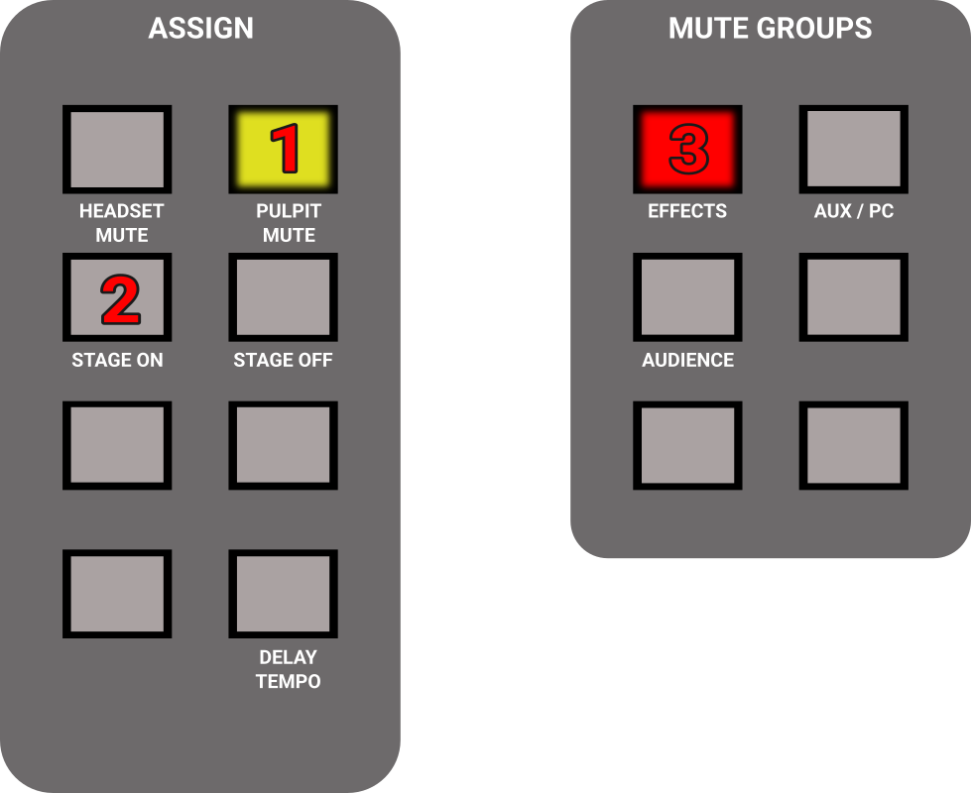
- Find the "Assign" and "Mute groups" section on the right side of the mixer, and do the following:
  - Press PULPIT MUTE if needed, to make the button glow yellow.
  - Press STAGE ON, it will not be lit, just press it once.
  - Press "Effects" if needed, to make the button glow red.

- Press CH 9-16 (left side of the mixer).
- Mute / unmute vocal mics as needed.
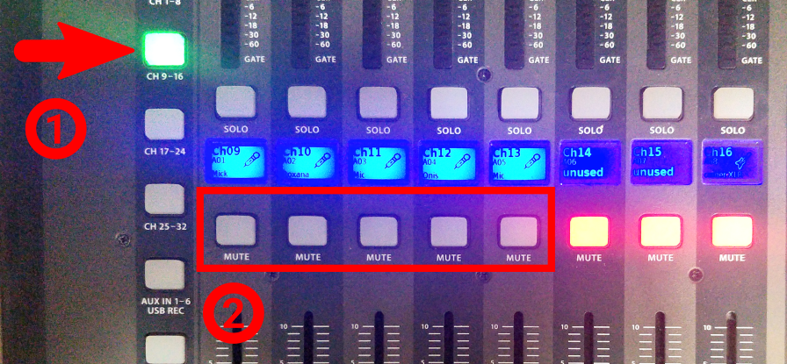
- Press CH 17-24.
- Mute / unmute instruments you are going to use (no need to mute keyboard).
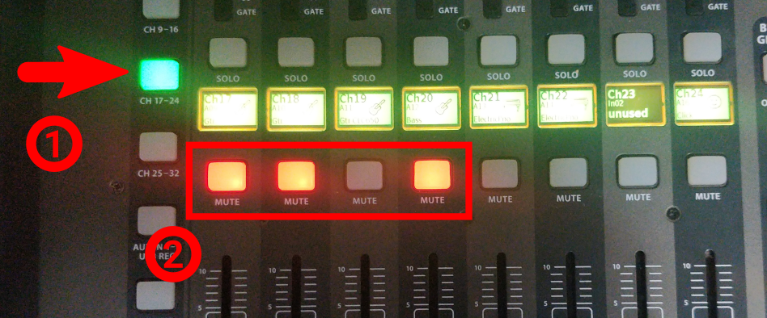
- Set the MAIN fader to its lowest position.
- Do not save this preset.
- When finished, follow the "Turning off the audio system" guide.

I want to use the pulpit!
- Follow the "Turning on the audio system" guide.
  - Skip the "stage" step.
  - You may skip the "coffee shop" step too, if you don't have people there.
- Find the "ASSIGN" section on the mixer, on the right side.
  - Press "PULPIT MUTE" if needed, to make it gray/unlit.
  - Press "STAGE OFF" it will not light up, just press it once.
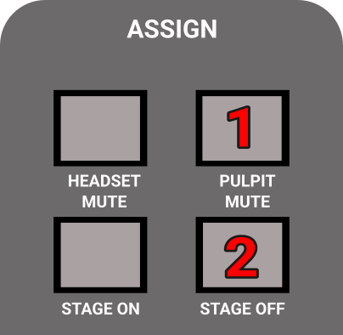
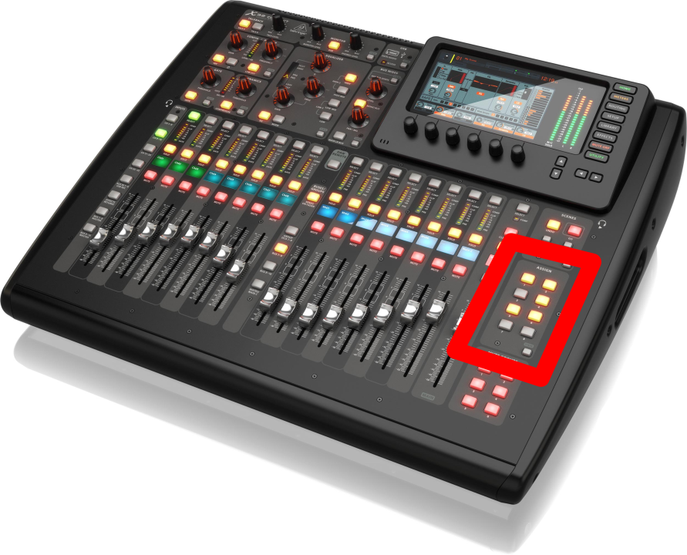
- Make sure MAIN is not muted. (Mute button should not be red.)
- Set Main fader to 0.
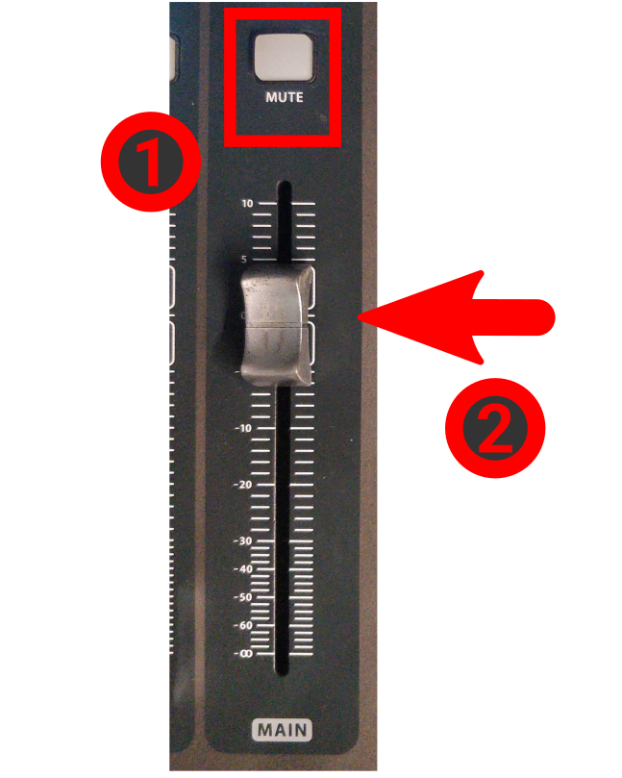
- Press CH 1-8.
- Ask someone to set the volume to something reasonable while you speak.
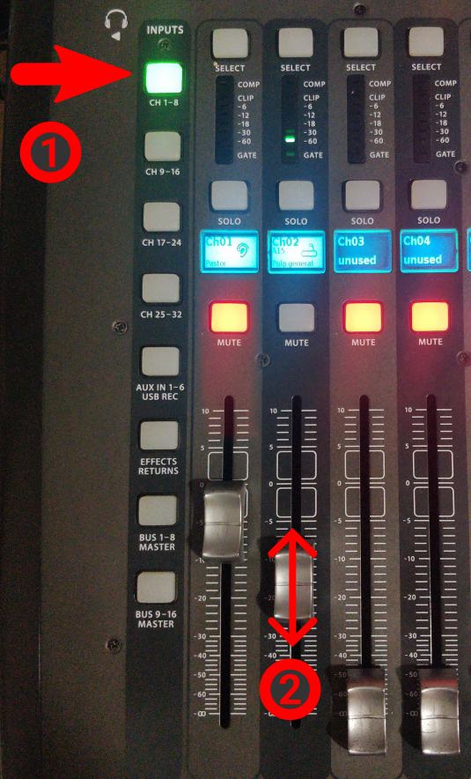
- When finished, follow the "Turning off the audio system" guide.

