TURNING ON THE BROADCAST
This TV will only get signal about 10 minutes before the service/event starts. (When you see the "We'll start soon" screen on the outside screens.)
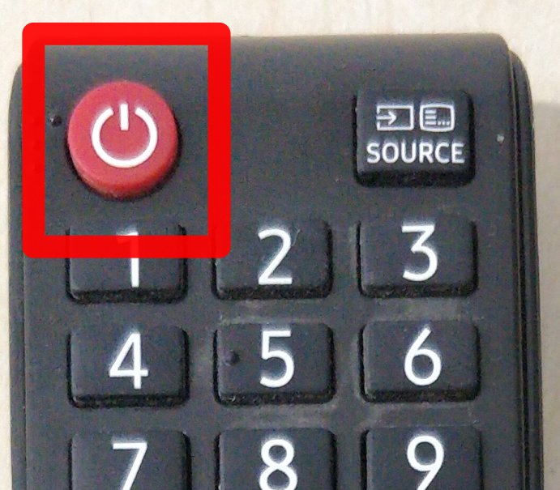
- Turn on the TV.
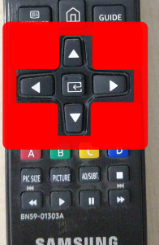
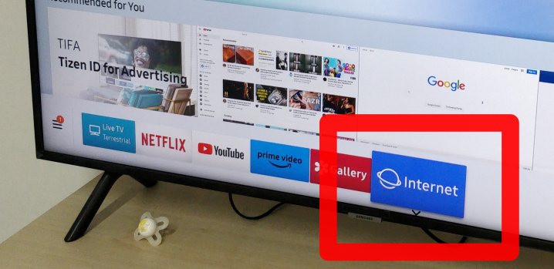
- Using the remote's ARROW KEYS navigate to INTERNET.
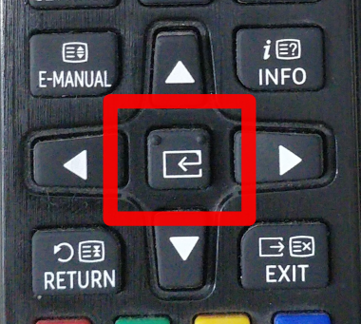
- Press the ENTER button inbetween the arrow keys on the remote.

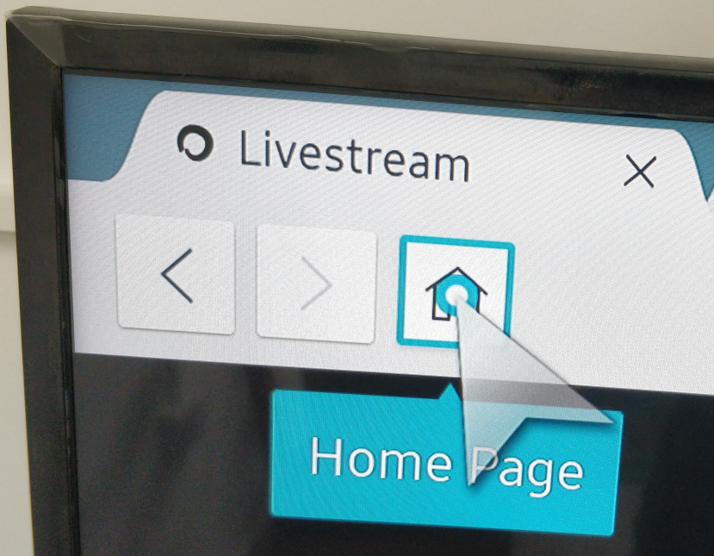
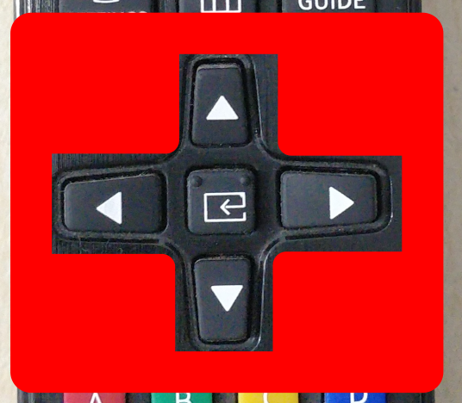
- Move the cursor to the HOME button on the browser, and press the ENTER key on the remote.

IF THE PLAYBACK STOPS
Repeat point #4 to fix it.

