TURNING ON THE LIVE STREAM
This TV will only get signal about 10 minutes before the service starts. (From when you see the countdown on the outside screens.)
- Turn on the TV.
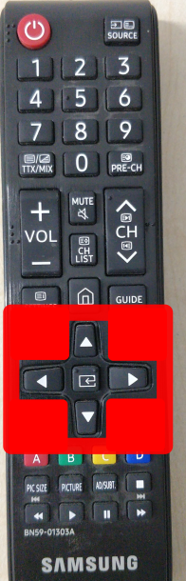
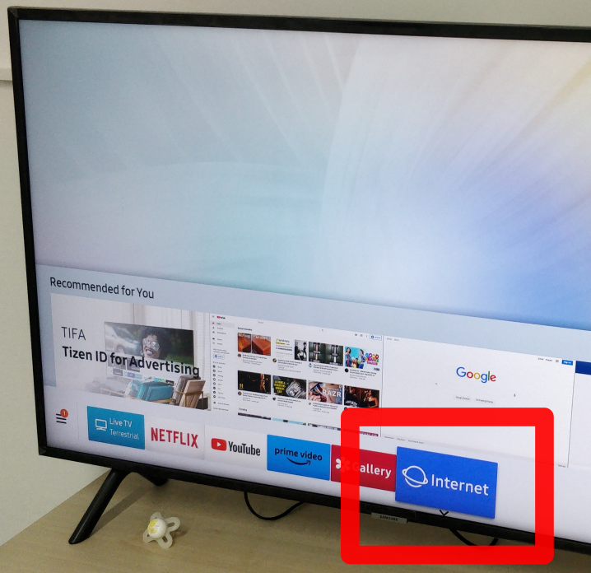
- Using the remote's ARROW KEYS (shown on the right) navigate to INTERNET.
- Press the ENTER button inbetween the arrow keys on the remote.
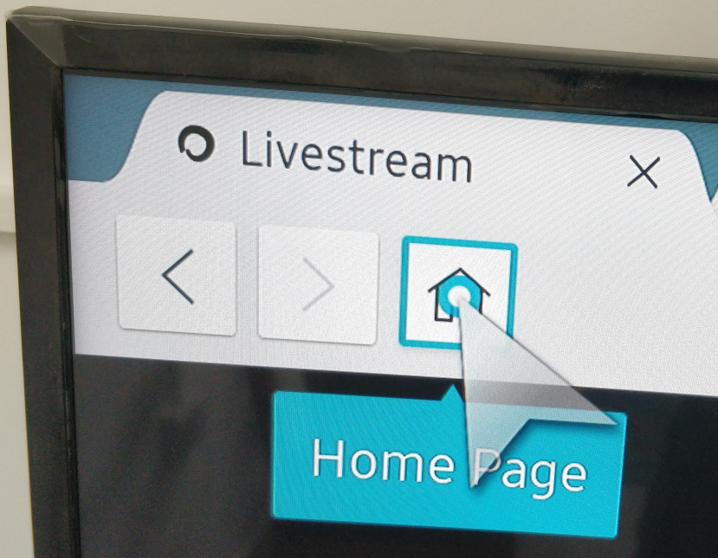
- Move the cursor to the HOME button on the browser, and press the ENTER key on the remote.
- Unmute the stream by moving the cursor to the bottom-left corner with the arrow keys.
- Press ENTER on the remote, when the cursor is above the speaker icon.
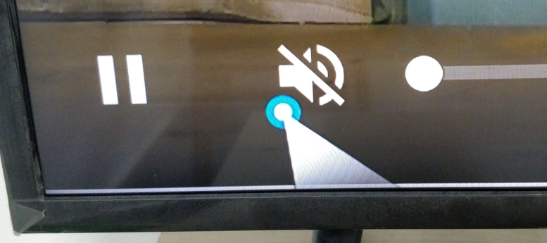
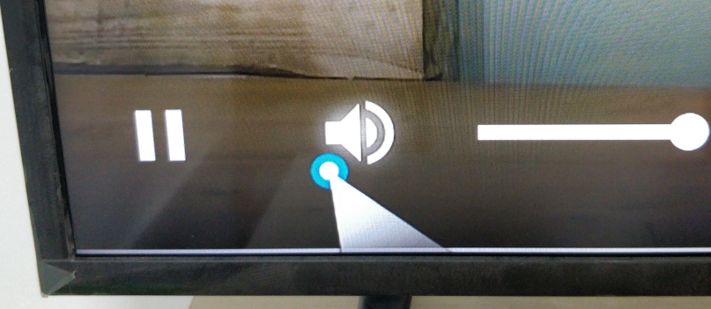

IF THE PLAYBACK STOPS

Do all the points again from #4 to fix it.

