HOW TO DO REHEARSAL WITHOUT A TECHNICIAN
For optimal results, make sure to have a sound technician here for the next time, but this is the way to get it going on a basic level.

- Follow the "Turning on the audio system" guide.
  - You can skip the "coffee shop" step.

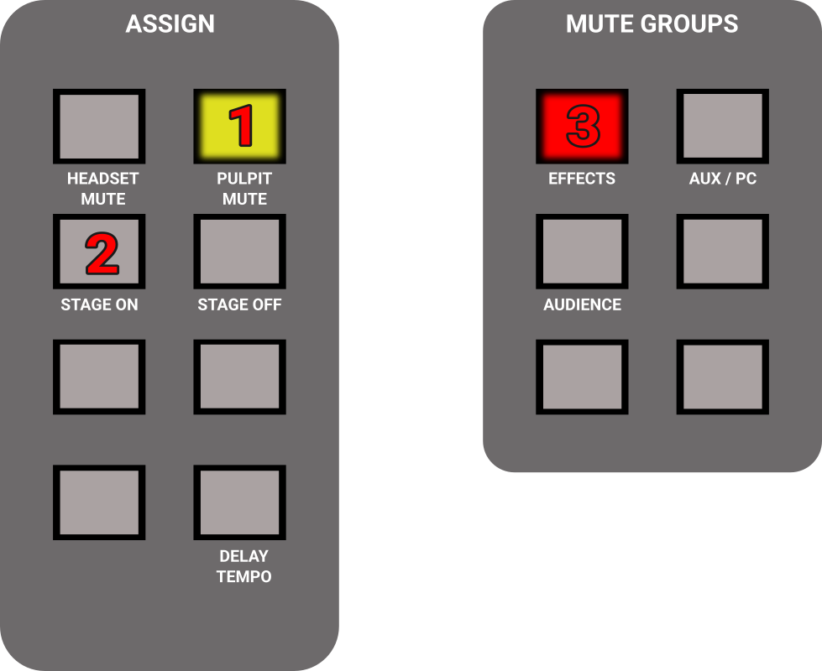
- Find the "Assign" and "Mute groups" section on the right side of the mixer, and do the following:
  - Press PULPIT MUTE if needed, to make the button glow yellow.
  - Press STAGE ON, it will not be lit, just press it once.
  - Press "Effects" if needed, to make the button glow red.

- Press CH 9-16 (left side of the mixer).
- Mute / unmute vocal mics as needed.
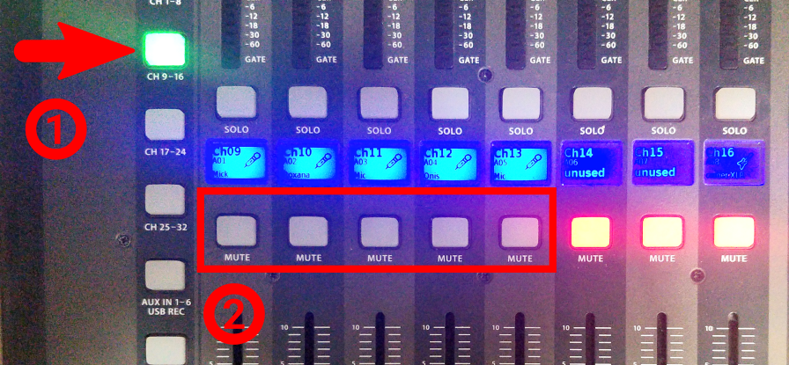
- Press CH 17-24.
- Mute / unmute instruments you are going to use (no need to mute keyboard).
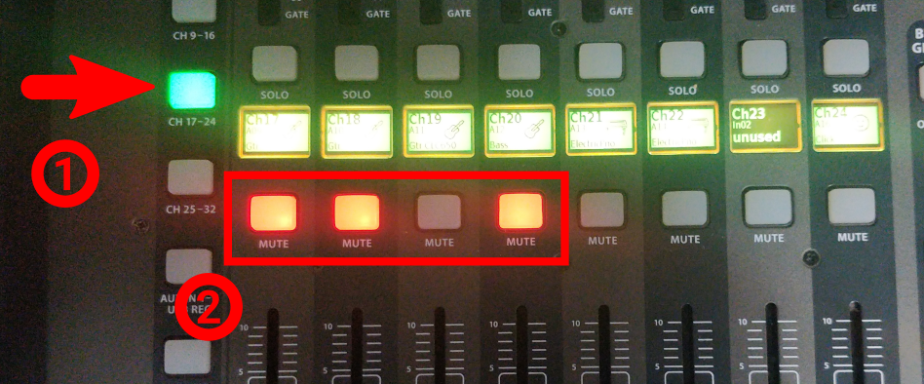
- Set the MAIN fader to its lowest position.
- Do not save this preset.
- When finished, follow the "Turning off the audio system" guide

