HOW TO USE THE PULPIT
- Follow the "Turning on the audio system" guide.
  - Skip the "stage" step.
  - You may skip the "coffee shop" step too, if you don't have people there.
- Find the "ASSIGN" section on the mixer, on the right side.
  - Press "PULPIT MUTE" if needed, to make it gray/unlit.
  - Press "STAGE OFF" it will not light up, just press it once.
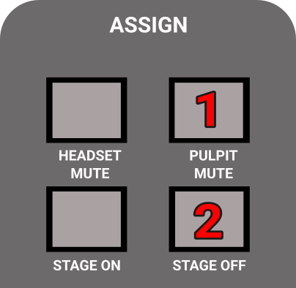
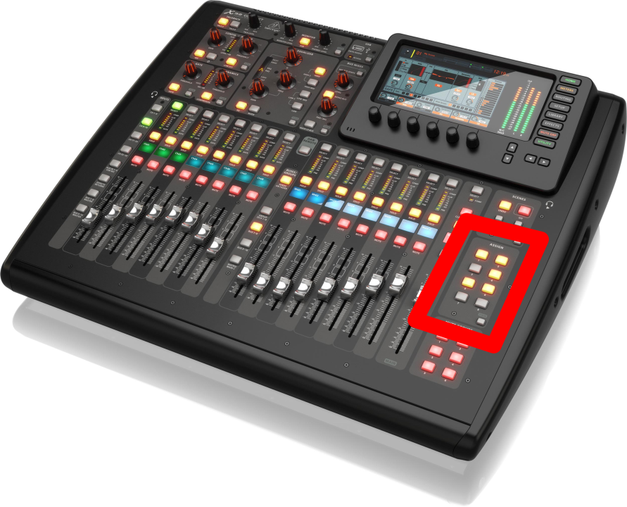
- Make sure MAIN is not muted. (Mute button should not be red, see image below.)
- Set Main fader to 0.
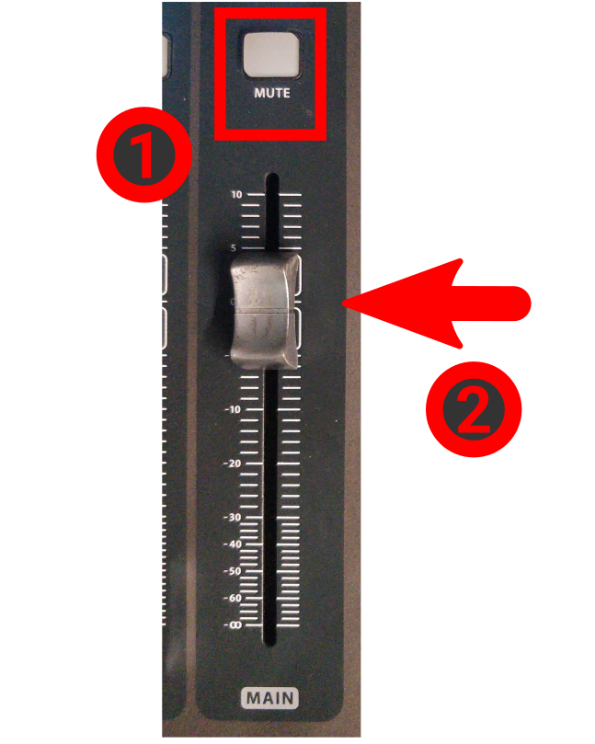
- Press "GROUP DCA 1-8" (at the middle of the console)
- Bring the "SPEAKER" group to 0. (right next to the previous step's button)
- Press CH 1-8.
- Ask someone to set the volume to something reasonable while you speak.
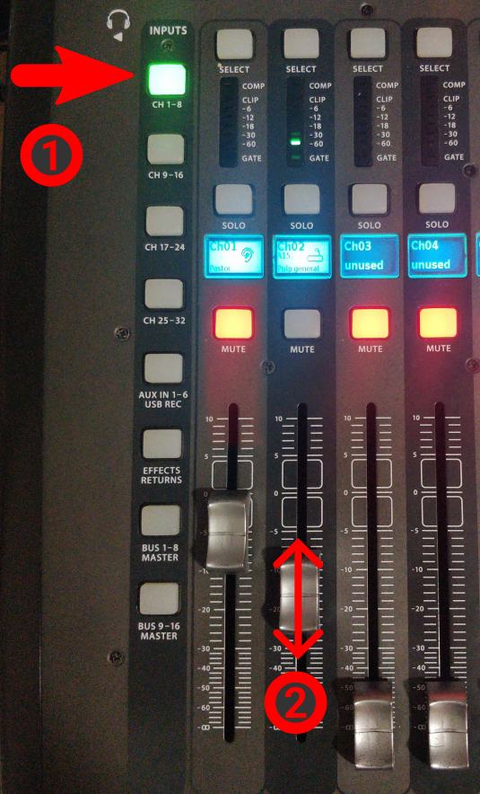
- When finished, follow the "Turning off the audio system" guide.

