HOW TO DO REHEARSAL WITHOUT A TECHNICIAN
For optimal results, make sure to have a sound technician here for the next time, but this is the way to get it going on a basic level.

- Follow the "Turning on the audio system" guide.
  - You can skip the "coffee shop" step.

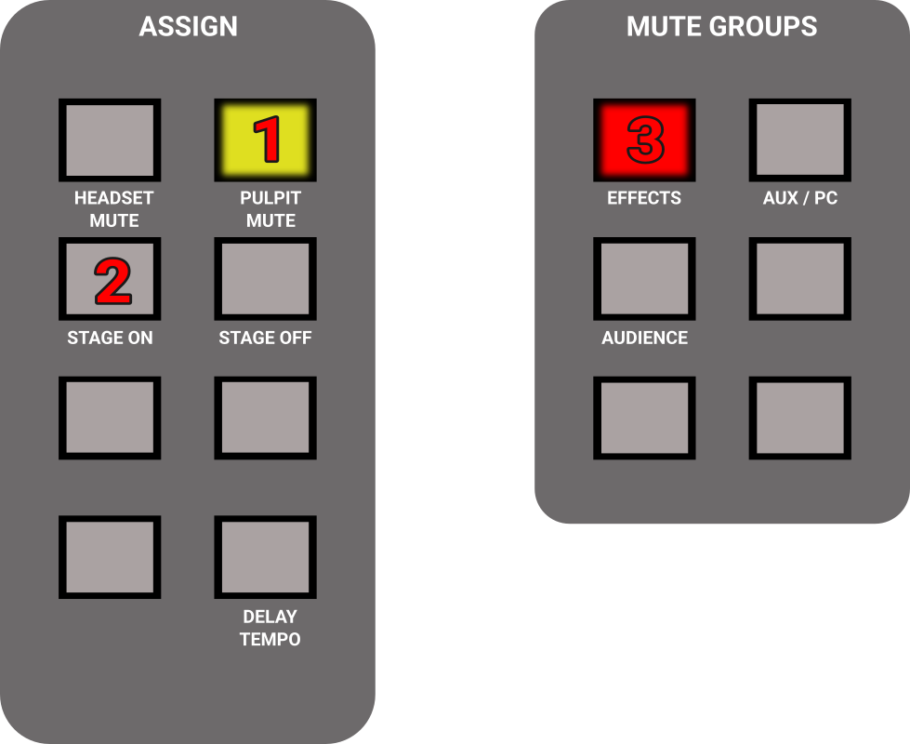
- Find the "Assign" and "Mute groups" section on the right side of the mixer, and do the following:
  - Press PULPIT MUTE if needed, to make the button glow yellow.
  - Press STAGE ON, it will not be lit, just press it once.
  - Press "Effects" if needed, to make the button glow red.

- Press CH 9-16 (left side of the mixer).
- Mute / unmute vocal mics as needed.
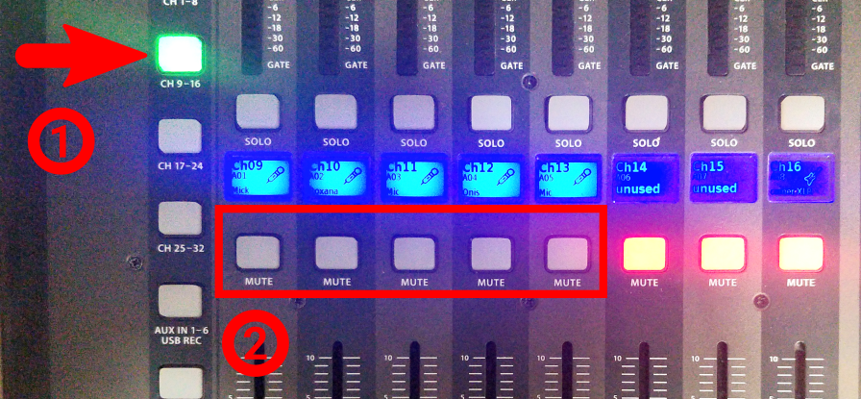
- Press CH 17-24.
- Mute / unmute instruments you are going to use (no need to mute keyboard).
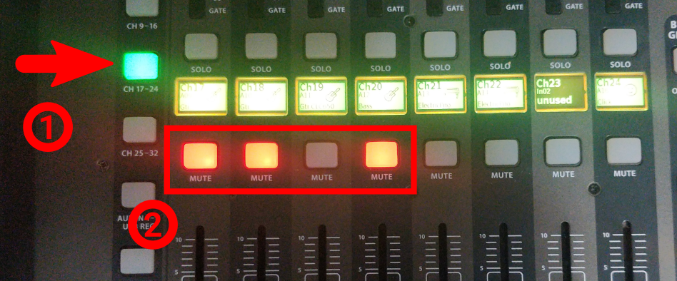
- Set the MAIN fader to its lowest position.
- Do not save this preset.
- When finished, follow the "Turning off the audio system" guide.

HOW TO USE THE PULPIT
- Follow the "Turning on the audio system" guide.
  - Skip the "stage" step.
  - You may skip the "coffee shop" step too, if you don't have people there.
- Find the "ASSIGN" section on the mixer, on the right side.
  - Press "PULPIT MUTE" if needed, to make it gray/unlit.
  - Press "STAGE OFF" it will not light up, just press it once.
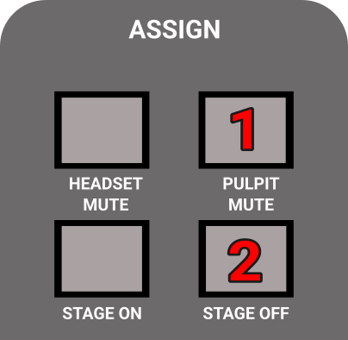
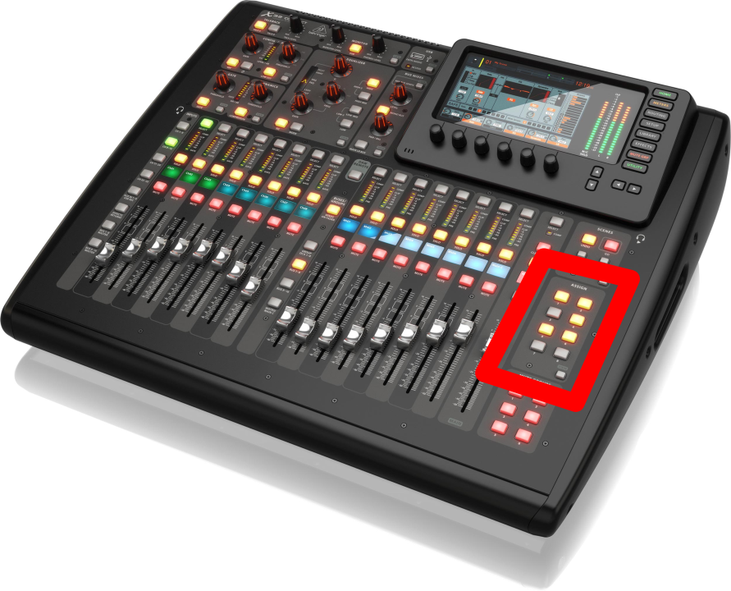
- Make sure MAIN is not muted. (Mute button should not be red, see image below.)
- Set Main fader to 0.
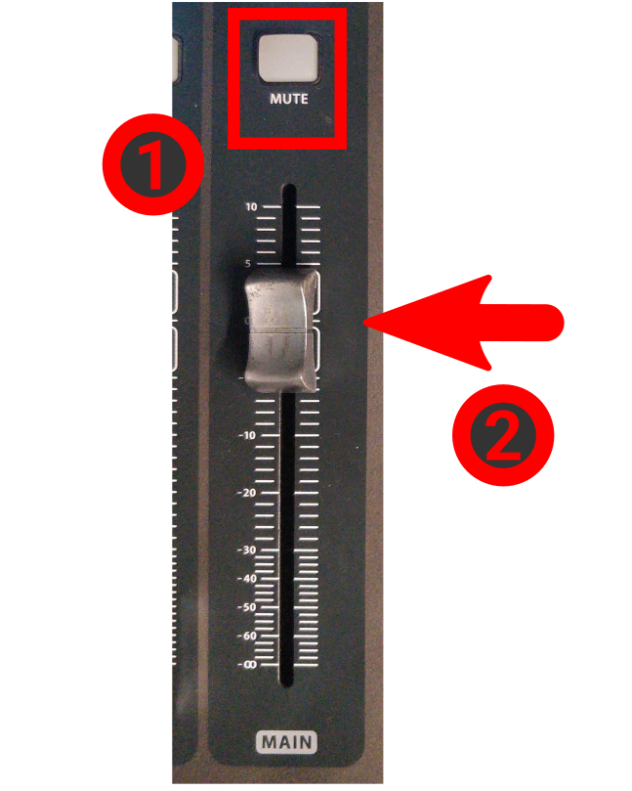
- Press "GROUP DCA 1-8" (at the middle of the console)
- Bring the "SPEAKER" group to 0. (right next to the previous step's button)
- Press CH 1-8.
- Ask someone to set the volume to something reasonable while you speak.
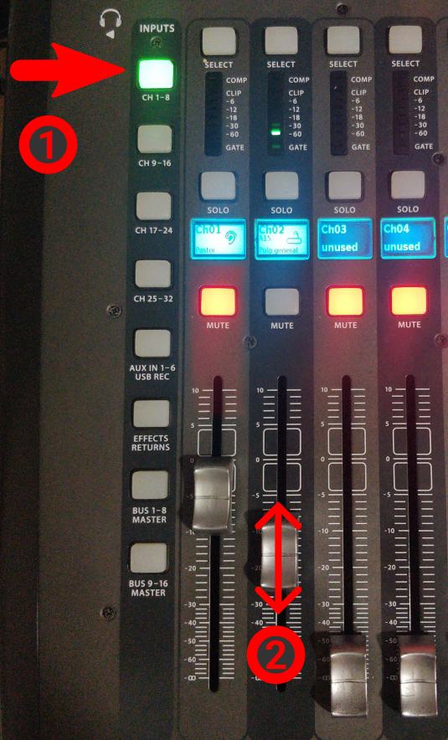
- When finished, follow the "Turning off the audio system" guide.

HOW TO DO A/V FOR BIBLESCHOOL
- Follow the "Turning on the audio system" guide.
  - You may skip the "coffee shop" step, if you don't have people there.
- Turn on the following sockets: "PC + OTHERS", "Network", "Screens" and "Screens + Sockets"

- Move the pulpit to the marked position on the floor.
- Turn on the projector & bring down the projection-screen.
- Turn on the TV on the pole, with the remote control, that is labeled "CENTURY"
- Turn on the TV in the coffeshop too, if needed.

- Connect the "FROM PULPIT" HDMI cable with the extender to the "TO PROJECTOR" cable.
- Turn on the PC
  - The power button is on the top of the PC.
- Start apps
  - Start OBS.
  - Select and make live the "BIBLESCHOOL" scene.

- Put the little keyboard (with 4 buttons) outside of the audio cave, where the person managing it (may be you:)) will sit. It is on a long extension cable for this reason.
  - Use the "Cam. Toggle" button on it, to switch between the camera and the slides.

- Put batteries into the headset
  - Based on the day, select the right pair of batteries
  - Push the button at the back of the headset and while pushing, slide down the backplate.
  - Put in batteries, close back.
  - Long press the single button at the top to turn it on.
- Load the CCP SERVICE MAIN scene in the console
  - Press VIEW at the "SCENES" section
  - Rotate the first knob under the display (labeled GO) until the selection is on CCP Service MAIN.
  - Press the first knob (labeled "GO")

- Set up the MAIN bus.
  - Mute button should not be red.
  - Set Main fader to 0 (thats not the lowest position)
- Find the "ASSIGN" section on the mixer, on the right side.
  - Make the "HEADSET MUTE" button UNLIT/GRAY, by pressing it if needed.
  - Make the "PULPIT MUTE" LIT by pressing it if needed.
  - Press "STAGE OFF": it will not light up, just press it once.
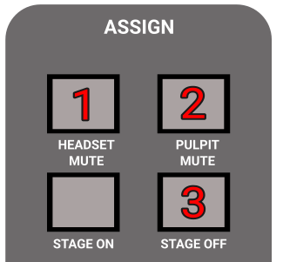

- Set the headset volume properly
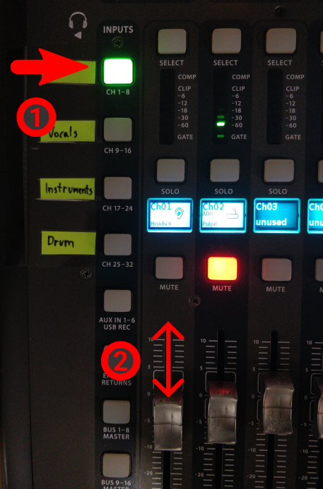
- When the class starts, press "START RECORDING" in OBS.
- When finished:
  - Press "STOP RECORDING" in OBS.
  - Turn off the projector.
  - Close back the projector-screen.
  - Put back the little keyboard.
  - Get the headset batteries out and put them back into the charger.
  - Put the headset back to the shelf.
  - Turn off the computer.
  - Restore the HDMI cables as they were (unplug, and reconnect the USB grabber)
  - And finally follow the "Turning off the audio system" guide.

TURNING ON THE LIVE STREAM
This TV will only get signal about 10 minutes before the service starts. (From when you see the countdown on the outside screens.)
- Turn on the TV.
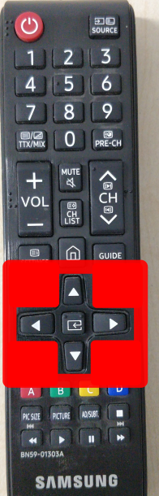
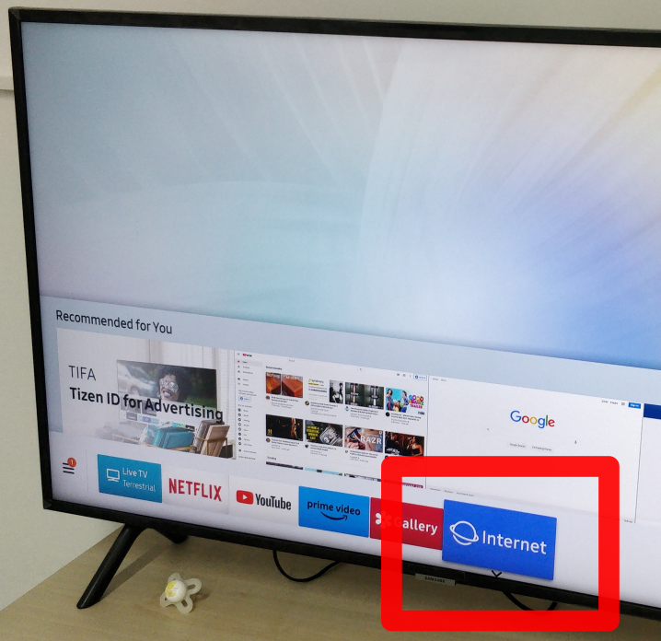
- Using the remote's ARROW KEYS (shown on the right) navigate to INTERNET.
- Press the ENTER button inbetween the arrow keys on the remote.
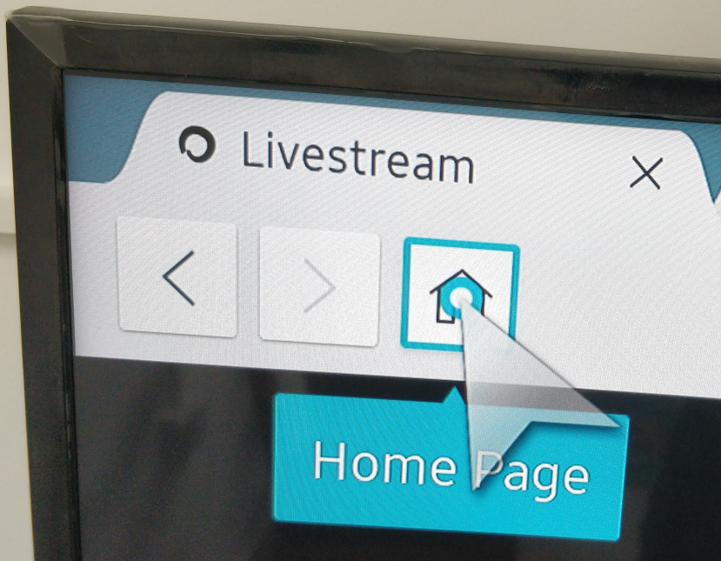
- Move the cursor to the HOME button on the browser, and press the ENTER key on the remote.
- Unmute the stream by moving the cursor to the bottom-left corner with the arrow keys.
- Press ENTER on the remote, when the cursor is above the speaker icon.
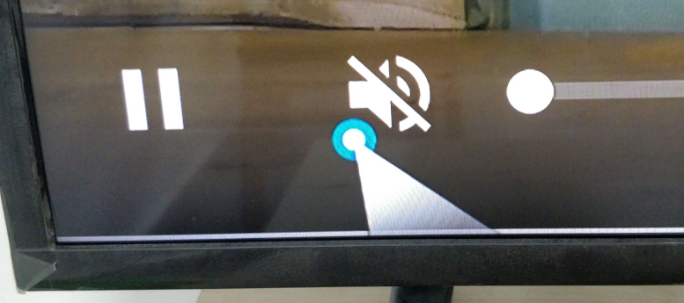
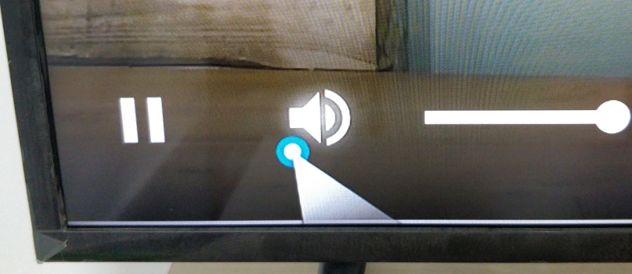

IF THE PLAYBACK STOPS

Do all the points again from #4 to fix it.

