**RAJALAKSHMIENGINEERING COLLEGE**

**RAJALAKSHMI NAGAR, THANDALAM – 602 105**



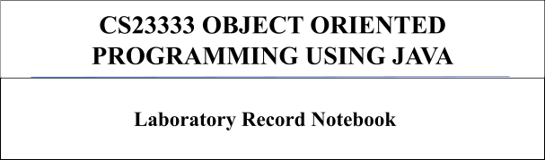

Name: S.KOPIYA

Year/Branch/Section: 2nd AIML B

University Register No: 2116231501079

College Roll No: 231501079

Semester: III

Academic Year: 2024-25

[**Lab-01-Java**](http://www.rajalakshmicolleges.org/moodle/course/section.php?id=49)[**Architecture,**](http://www.rajalakshmicolleges.org/moodle/course/section.php?id=49)[**Language**](http://www.rajalakshmicolleges.org/moodle/course/section.php?id=49)[**Basics**](http://www.rajalakshmicolleges.org/moodle/course/section.php?id=49)

1.

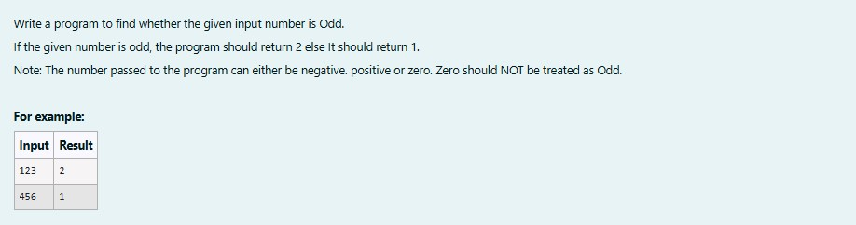

**SOLUTION :**

|  |
| --- |
| import java.util.Scanner; public class oddorEven{  public static void main(String[]args){ Scanner s=new Scanner(System.in); int number = s.nextInt(); if(number %2==0){  System.out.println(1);  }  else {  System.out.println(2);  }  }  } |

**OUTPUT :**

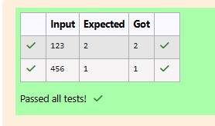

**2.**

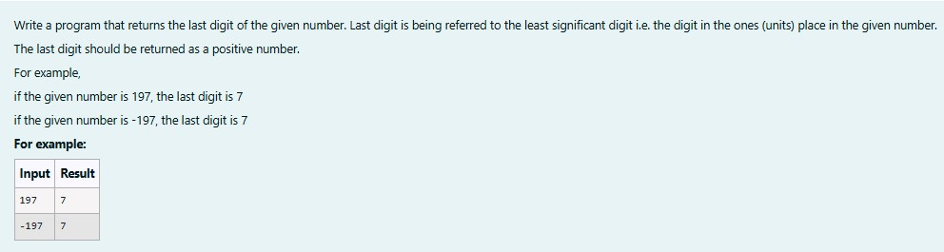

**SOLUTION :**

|  |
| --- |
| import java.util.Scanner; import java.lang.Math; public class LastDigit{ public static void main(String[]args){  Scanner s=new Scanner(System.in);  int a = s.nextInt(); int lastDigit=Math.abs(a%10); System.out.println(lastDigit);  }  } |

**OUTPUT :**

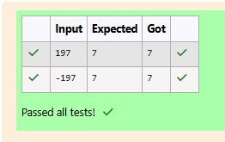

**3.**

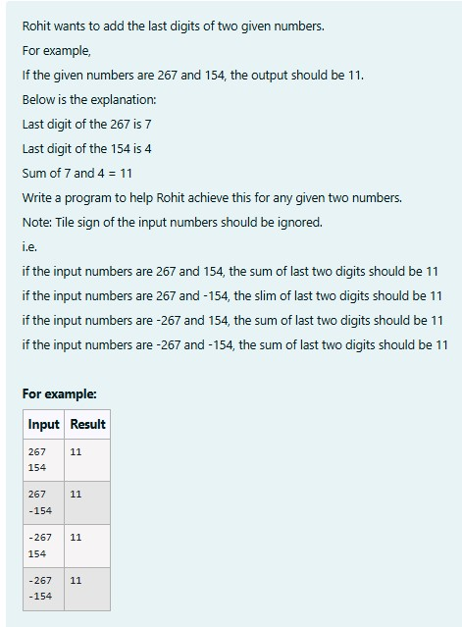

**SOLUTION :**

|  |
| --- |
| import java.util.Scanner; import java.lang.Math;  public class number{ public static void main(String[]args){  Scanner s= new Scanner(System.in);  int a = s.nextInt(); int b = s.nextInt();  System.out.println(Math.abs(a)%10+Math.abs(b)%10);  }  } |

**OUTPUT:**

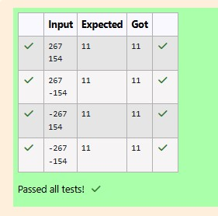

[**Lab-02-Flow**](http://www.rajalakshmicolleges.org/moodle/course/section.php?id=50)[**Control**](http://www.rajalakshmicolleges.org/moodle/course/section.php?id=50)[**Statements**](http://www.rajalakshmicolleges.org/moodle/course/section.php?id=50)

**1.**

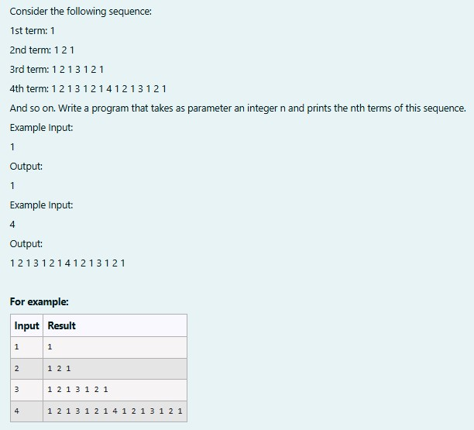

**SOLUTION :**

|  |
| --- |
| import java.util.Scanner; public class SequenceGenerator{ public static void main(String[]args){  Scanner S = new Scanner(System.in);  int n = S.nextInt();  String term = generateTerm(n);  System.out.print(term);  }  private static String generateTerm(int n){ if (n==1){ return "1";  }  String prevTerm = generateTerm (n-1);  StringBuilder currentTerm = new StringBuilder(prevTerm); |
| currentTerm.append(" " + n + " "); currentTerm.append(prevTerm);  return currentTerm.toString();  }  } |

**OUTPUT :**

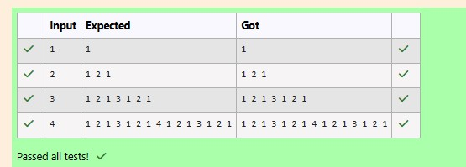

**2.**

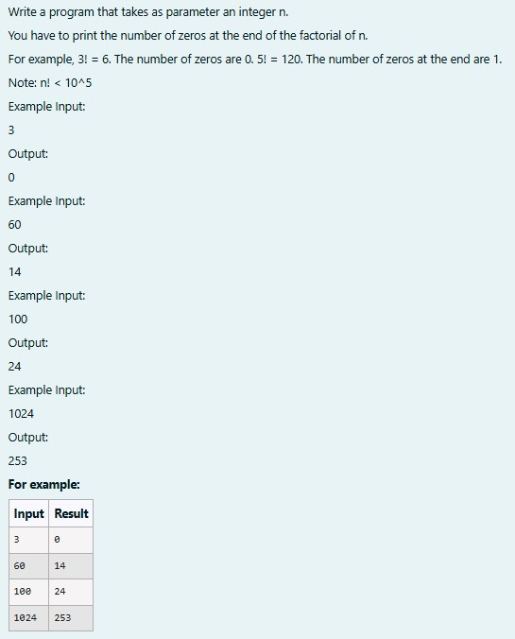

**SOLUTION :**

|  |
| --- |
| // Java program to count trailing 0s in n!  import java.io.*; import java.util.Scanner;  class prog {  // Function to return trailing // 0s in factorial of n  static int findTrailingZeros(int n)  {  if (n < 0) // Negative Number Edge Case return -1; |
| // Initialize result  int count=0;  // Keep dividing n by powers // of 5 and update count for (int i = 5; n / i >= 1; i*=5 ){ count += n / i;  }  return count;  }  // Driver Code  public static void main(String[] args)  {  Scanner sc= new Scanner(System.in); int n=sc.nextInt();  int res=findTrailingZeros(n); System.out.println(res);  }  } |

**OUTPUT :**

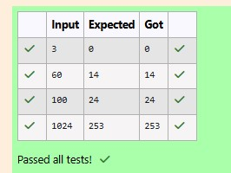

**3.**

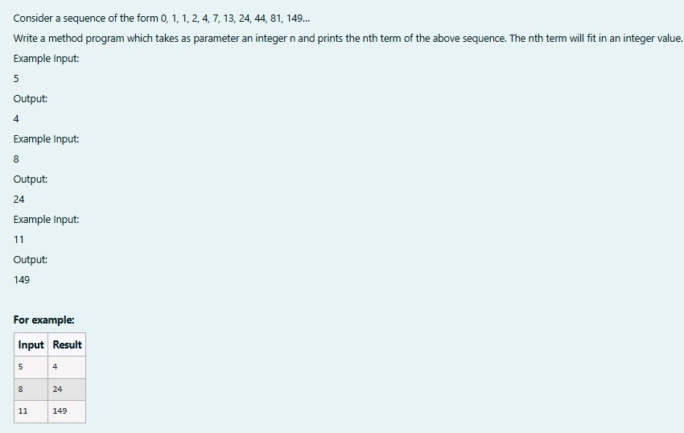

**SOLUTION :**

|  |
| --- |
| import java.util.Scanner; class fibo3{ int a; int b; int c;  fibo3(int a,int b,int c){ this.a = a; this.b = b;  this.c = c;  }  int nth(int x){ if (x == 1){ return 0;  }  else if(x == 2 && x == 3) return 1;  else{ int temp1,temp2,temp; int count = 4; while(x >= count){ temp = this.a+this.b+this.c;  temp1 = this.c; this.c = temp; temp2 = this.b; this.b = temp1; this.a = temp2;  count++;  }  return this.c;  }  }  }  public class Main{ public static void main(String[] args){  Scanner s = new Scanner(System.in); int t = s.nextInt(); fibo3 r = new fibo3(0,1,1); System.out.print(r.nth(t)); }  } |

**OUTPUT :**

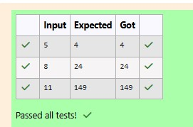

[**Lab-03-Arrays**](http://www.rajalakshmicolleges.org/moodle/course/section.php?id=51)

**1.**

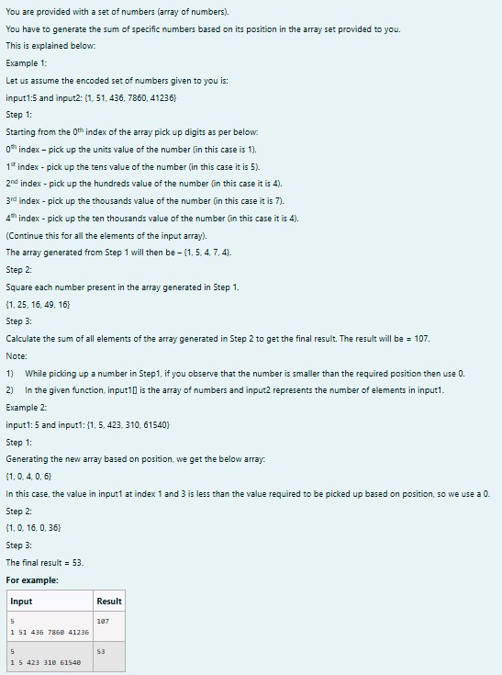

**SOLUTION :**

|  |
| --- |
| import java.util.Scanner; public class digit{ public static void main(String[]args){  Scanner scanner =new Scanner(System.in); |
| int size =scanner.nextInt(); int[]inpar=new int[size]; for(int i=0;i<size;i++){ inpar[i]=scanner.nextInt();  }  int[]dig=new int[size]; for(int i=0;i<size;i++){ int num=inpar[i]; if(i==0){  dig[i]=num%10;  }  else if (i==1){ dig[i]=(num/10)%10;  }  else if(i==2){ dig[i]=(num/100)%10;  }  else if(i==3){ dig[i]=(num/1000)%10;  }  else if(i==4){ dig[i]=(num/10000)%10;  }  else{ dig[i]=0;  }  }  int fin=0; for(int digi:dig){ fin+=digi*digi;  }  System.out.print(fin);  }  } |

**OUTPUT :**

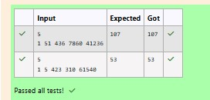

**2.**

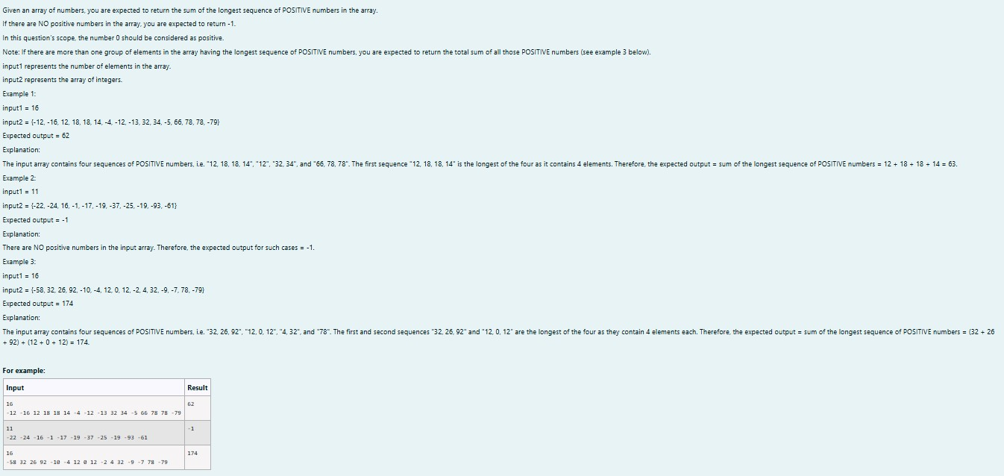

**SOLUTION :**

|  |
| --- |
| import java.util.Scanner; public class longdig{ public static void main(String[]args){  Scanner sc=new Scanner(System.in); int n=sc.nextInt();  int c = 1,v,seqtemp = 0,seq = 0,countmax = 0; int count = 0; while(c <= n){ v = sc.nextInt();  if(v >= 0){  countmax= countmax + v;  seqtemp++;  }  else{  seqtemp = 0;  countmax = 0;  }  if(seqtemp > seq ){ seq = seqtemp;  count = countmax;  }  else if (seq == seqtemp){ count = count + countmax;  }  c++;  }  if (count == 0)  System.out.print(-1); else  System.out.print(count); |
| }  } |

**OUTPUT :**

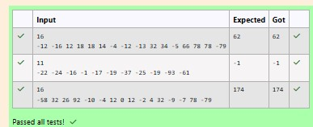

**3.**

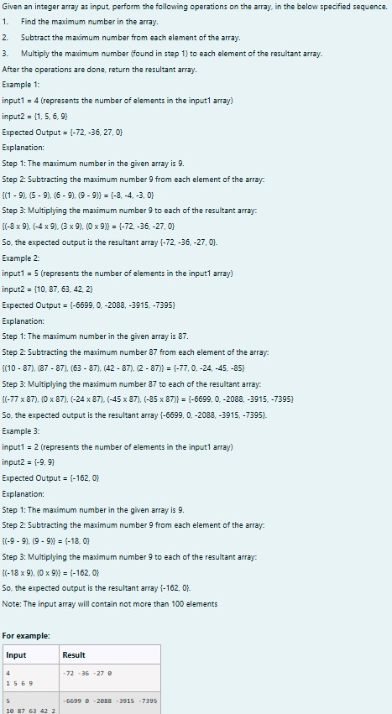

**SOLUTION :**

|  |
| --- |
| import java.util.Scanner; public class res{ public static int[]pa(int[]arr){  int maxs=Integer.MIN_VALUE;  for (int num:arr){ if(num>maxs){ maxs=num;  }  }  for(int i=0;i<arr.length;i++){ arr[i]=(arr[i]-maxs)*maxs;  }  return arr;  }  public static void main(String[]args){  Scanner scanner =new Scanner (System.in); int n=scanner.nextInt(); int[]arr=new int[n]; for(int i=0;i<n;i++){ arr[i]=scanner.nextInt();  }  int[]res=pa(arr); for(int i=0;i<n;i++){  System.out.print(res[i]+" ");  }  scanner.close();  }  } |

**OUTPUT :**

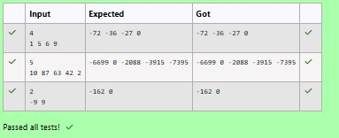

[**Lab-04-Classes**](http://www.rajalakshmicolleges.org/moodle/course/section.php?id=52)[**and**](http://www.rajalakshmicolleges.org/moodle/course/section.php?id=52)[**Objects**](http://www.rajalakshmicolleges.org/moodle/course/section.php?id=52)

**1.**

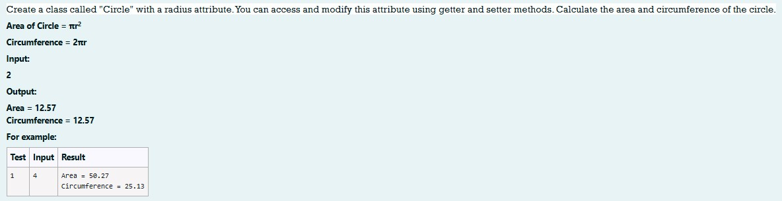

**SOLUTION :**

|  |
| --- |
| import java.io.*; import java.util.Scanner; class Circle  {  private double radius; public Circle(double radius){  // set the instance variable radius this.radius =radius;  }  public void setRadius(double radius){  // set the radius this.radius=radius;  }  public double getRadius() {  // return the radius return radius;  }  public double calculateArea() { // complete the below statement return Math.PI*radius*radius;  }  public double calculateCircumference() {  // complete the statement return 2*Math.PI*radius;  }  }  class prog{ public static void main(String[] args) { int r;  Scanner sc= new Scanner(System.in); r=sc.nextInt();  Circle c= new Circle(r);  System.out.println("Area = "+String.format("%.2f", c.calculateArea()));  // invoke the calculatecircumference method  System.out.println("Circumference = "+String.format("%.2f" ,  c.calculateCircumference()));  sc.close();  }  } |

**OUTPUT :**

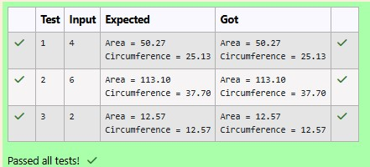

**2.**

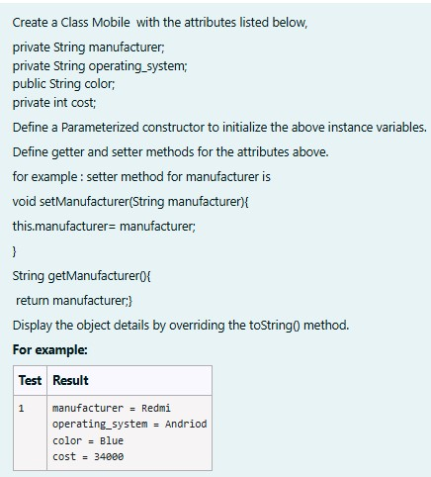

**SOLUTION :**

|  |
| --- |
| public class mobile{ private String man; private String os; public String clr; private int cost;  public mobile(String man,String os,String clr,int cost){ this.man=man; this.os=os; this.clr=clr;  this.cost=cost;  }  public String toString(){ return "manufacturer = "+man+"\n"+"operating_system = "+os+"\n"+"color = "+ clr+"\n"+"cost = "+cost;  }  public static void main(String[]args){ |
| mobile mobile=new mobile("Redmi","Andriod","Blue",34000); System.out.println(mobile);  }  } |

**OUTPUT :**

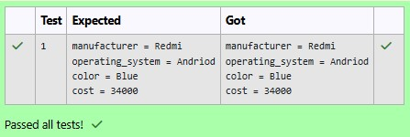

**3.**

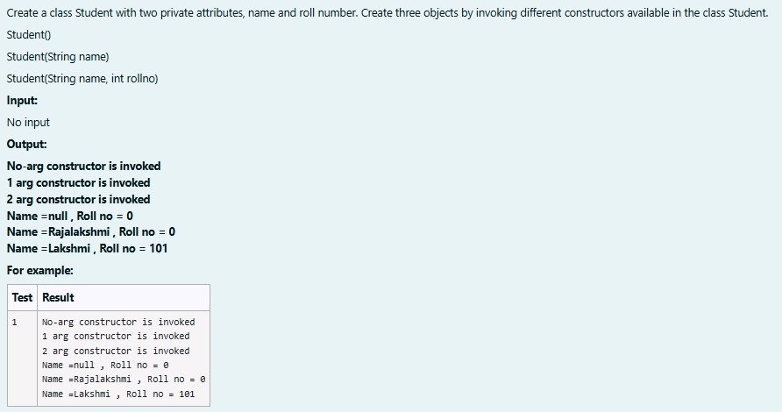

**SOLUTION :**

|  |
| --- |
| public class stud{ private String name; private int roll; public stud(){  System.out.println("No-arg constructor is invoked"); name=null; roll=0;  }  public stud(String name){  System.out.println("1 arg constructor is invoked"); this.name=name;  roll=0; |
| }  public stud(String name,int roll){  System.out.println("2 arg constructor is invoked"); this.name=name;  this.roll=roll;  }  public static void main (String[]args){  stud s1=new stud(); stud s2=new stud("Rajalakshmi"); stud s3=new stud("Lakshmi",101);  System.out.println("Name ="+s1.name+" , Roll no = "+s2.roll);  System.out.println("Name ="+s2.name+" , Roll no = "+s2.roll);  System.out.println("Name ="+s3.name+" , Roll no = "+s3.roll);  }  } |

**OUTPUT :**

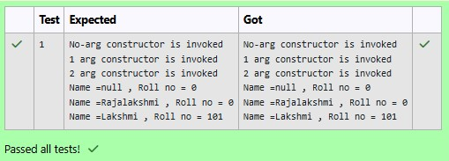

[**Lab-05-Inheritance**](http://www.rajalakshmicolleges.org/moodle/course/section.php?id=55)

**1.**

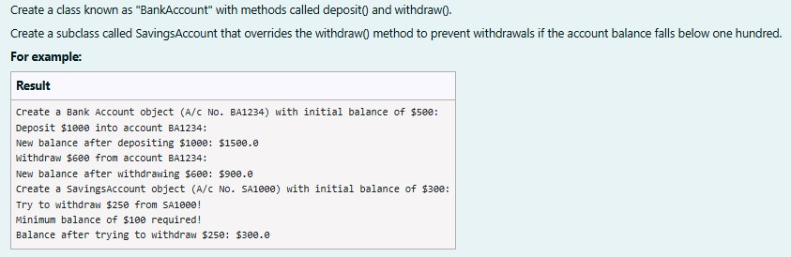

**SOLUTION :**

|  |
| --- |
| class BankAccount {  // Private field to store the account number private String accountNumber; |

|  |
| --- |
| // Private field to store the balance private double balance;  // Constructor to initialize account number and balance public BankAccount(String accountNumber,double balance){ this.accountNumber=accountNumber;  this.balance=balance;  }  // Method to deposit an amount into the account public void deposit(double amount) {  // Increase the balance by the deposit amount balance+=amount;  }  // Method to withdraw an amount from the account public void withdraw(double amount) {  // Check if the balance is sufficient for the withdrawal if (balance >= amount) {  // Decrease the balance by the withdrawal amount balance -= amount;  } else {  // Print a message if the balance is insufficient System.out.println("Insufficient balance");  }  }  // Method to get the current balance public double getBalance() { // Return the current balance  return balance;  }  public String getAccountNumber(){ return accountNumber;  }  }  class SavingsAccount extends BankAccount {  // Constructor to initialize account number and balance  public SavingsAccount(String accountNumber, double balance) {  // Call the parent class constructor  super(accountNumber,balance);  }  // Override the withdraw method from the parent class  @Override  public void withdraw(double amount) { |

|  |
| --- |
| // Check if the withdrawal would cause the balance to drop below $100 if (getBalance() - amount < 100) {  // Print a message if the minimum balance requirement is not met System.out.println("Minimum balance of $100 required!");  } else {  // Call the parent class withdraw method  super.withdraw(amount);  }  }  }  public class Main {  public static void main(String[] args) {  // Print message to indicate creation of a BankAccount object  System.out.println("Create a Bank Account object (A/c No. BA1234) with initial balance of $500:");  // Create a BankAccount object (A/c No. "BA1234") with initial balance of  $500  BankAccount BA1234 = new BankAccount("BA1234", 500);  // Print message to indicate deposit action  System.out.println("Deposit $1000 into account BA1234:");  // Deposit $1000 into account BA1234  BA1234.deposit(1000);  // Print the new balance after deposit  System.out.println("New balance after depositing $1000:  $"+BA1234.getBalance());  // Print message to indicate withdrawal action  System.out.println("Withdraw $600 from account BA1234:");  // Withdraw $600 from account BA1234  BA1234.withdraw(600);  // Print the new balance after withdrawal  System.out.println("New balance after withdrawing $600: $" + BA1234.getBalance());  // Print message to indicate creation of another SavingsAccount object  System.out.println("Create a SavingsAccount object (A/c No. SA1000) with initial balance of $300:");  // Create a SavingsAccount object (A/c No. "SA1000") with initial balance of  $300  SavingsAccount SA1000 = new SavingsAccount("SA1000", 300);  // Print message to indicate withdrawal action  System.out.println("Try to withdraw $250 from SA1000!");  // Withdraw $250 from SA1000 (balance falls below $100)  SA1000.withdraw(250);  // Print the balance after attempting to withdraw $250  System.out.println("Balance after trying to withdraw $250: $" + |
| SA1000.getBalance());  }  } |

**OUTPUT :**

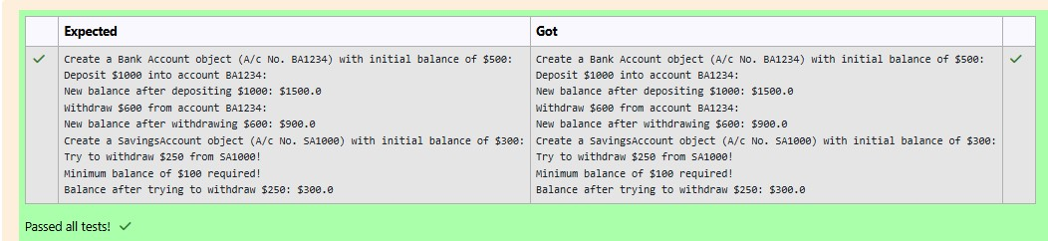

**2.**

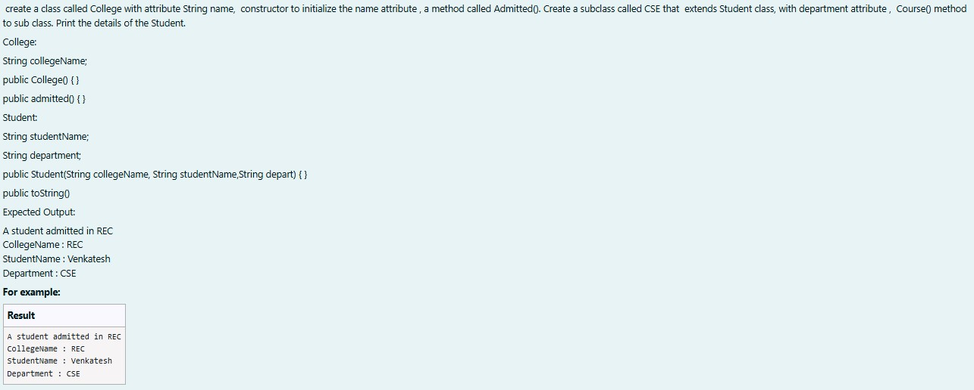

**SOLUTION :**

|  |
| --- |
| class College  {  public String collegeName;  public College(String collegeName) { // initialize the instance variables  this.collegeName=collegeName;  }  public void admitted() {  System.out.println("A student admitted in "+collegeName);  }  }  class Student extends College{  String studentName; String department; public Student(String collegeName, String studentName,String department) { |
| // initialize the instance variables super(collegeName); this.studentName=studentName; this.department=department;  }  public String toString(){  // return the details of the student return "CollegeName : "+collegeName+"\n"+"StudentName : "+studentName+"\n"+"Department : "+department;  }  }  public class Main {  public static void main (String[] args) {  Student s1 = new Student("REC","Venkatesh","CSE");  s1.admitted(); // invoke the admitted() method  System.out.println(s1.toString());  }  } |

**OUTPUT :**

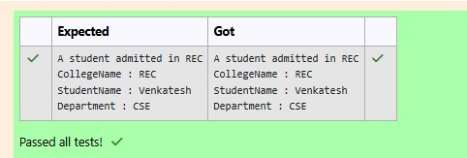

**3.**

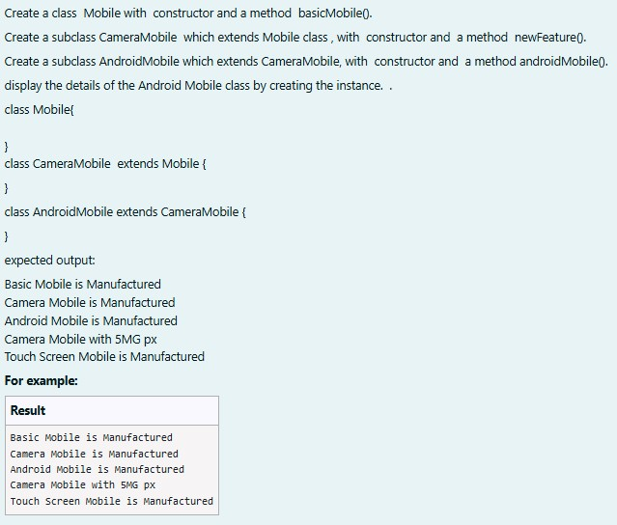

**SOLUTION :**

|  |
| --- |
| class mob{ mob(){  System.out.println("Basic Mobile is Manufactured");  }  void basmob(){  System.out.println("Basic Mobile is Manufactured");  }  }  class cam extends mob{ cam(){ super();  System.out.println("Camera Mobile is Manufactured");  }  void newm(){  System.out.println("Camera Mobile with 5MG px");  }  }  class and extends cam{ and(){ super();  System.out.println("Android Mobile is Manufactured");  }  void andmob(){  System.out.println("Touch Screen Mobile is Manufactured");  }  }  public class Main{ public static void main(String[]args){ and andmob=new and(); andmob.newm();  andmob.andmob();  }  } |

**OUTPUT :**

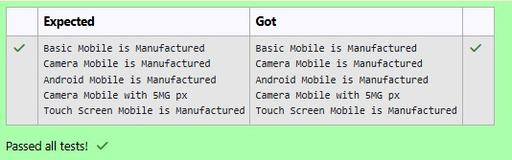

[**Lab-06-String,**](http://www.rajalakshmicolleges.org/moodle/course/section.php?id=54)[**StringBuffer**](http://www.rajalakshmicolleges.org/moodle/course/section.php?id=54)

**1.**

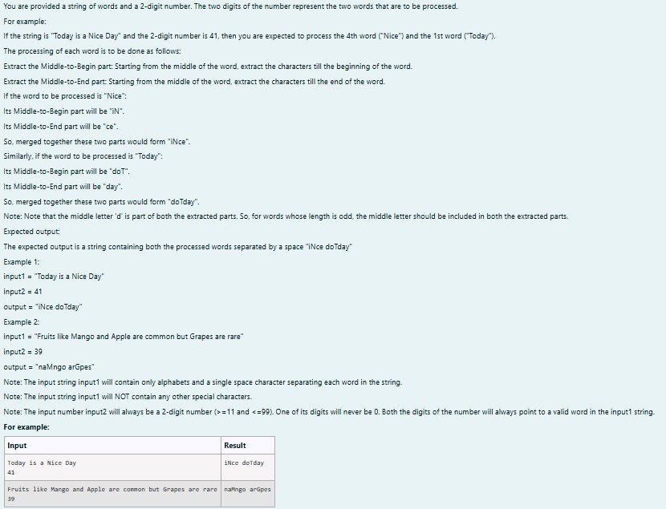

**SOLUTION :**

|  |
| --- |
| import java.util.*; public class mix{ public static void main(String[] args){  Scanner scan = new Scanner(System.in); String g = scan.nextLine(); int n = scan.nextInt(),ones,flag = 0; StringBuffer temp = new StringBuffer(); StringBuffer temp1 = new StringBuffer();  int space = 0; while (n > 0){ ones = (n %10) - 1;  for(int i = 0; i < g.length();i++){ if (g.charAt(i) == ' '){  space = space + 1;  }  else if(space == ones && flag == 0){  temp.append(Character.toString(g.charAt(i)));  }  else if(space == ones && flag == 1){ |
| temp1.append(Character.toString(g.charAt(i)));  }  }  space = 0 ; flag = 1;  n = n /10;  }  rew m = new rew();  System.out.println(m.r(temp1.toString()) + " " + m.r(temp.toString()));  }  }  class rew{  String r(String a){ int le = a.length(),n,q;  StringBuffer temp3 = new StringBuffer();  if(le % 2 == 1){  n = ((int)(le/2)); q = ((int)(le/2));  }  else{ n = ((int)(le/2)) - 1;  q = ((int)(le/2));  }  for(int i = n;i >= 0;i--){ temp3.append(Character.toString(a.charAt(i)));  }  for(int i = q;i < le;i++){ temp3.append(Character.toString(a.charAt(i)));  }  return temp3.toString();  }  } |

**OUTPUT :**

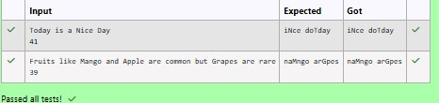

**2.**

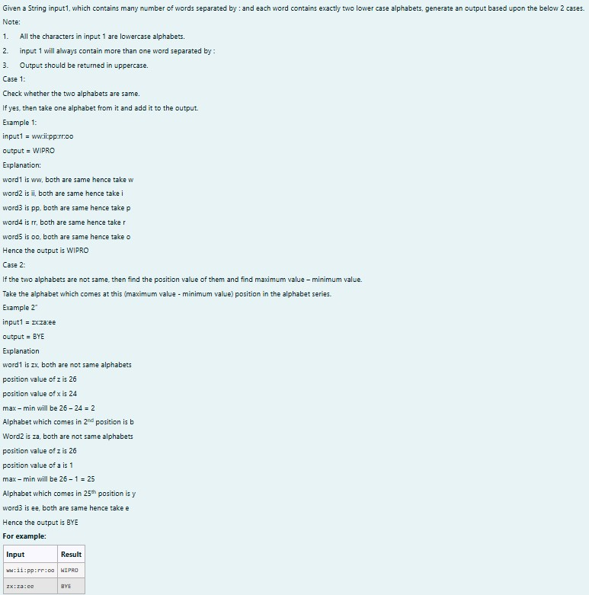

**SOLUTION :**

|  |
| --- |
| import java.util.*; class diff{ char different(char a, char b){ if ((int)a != (int)b) return (char)((int)'a' + ((int)a-(int)b) - 1);  return a;  }  }  public class Main{ public static void main(String[] args){  Scanner scan = new Scanner(System.in);  diff z = new diff();  String q = scan.nextLine();  StringBuffer ans = new StringBuffer(); StringBuffer temp = new StringBuffer();  for(int i = 0;i < q.length();i++){ if(q.charAt(i) == ':'){ temp.append(" ");  }  else{ temp.append(Character.toString(q.charAt(i))); |
| }  }  String h = temp.toString(); for(int i = 0;i < temp.length();i++){ if(i%3 == 0){ ans.append(Character.toString(z.different(h.charAt(i),h.charAt(i+1))));  }  }  System.out.print(ans.toString().toUpperCase());  }  } |

**OUTPUT :**

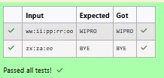

**3.**

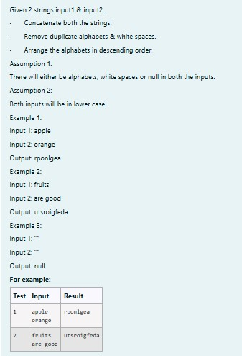

**SOLUTION :**

|  |
| --- |
| import java.util.*;  public class HelloWorld { public static void main(String[] args) {  Scanner scan = new Scanner(System.in);  String a = scan.nextLine();  String b = scan.nextLine();  StringBuffer ab = new StringBuffer(); if(a.trim().isEmpty() && b.trim().isEmpty()){ System.out.print("null");  }  else{  for(int i = 0;i < a.length();i++){ if (a.charAt(i) != ' ') { ab.append(Character.toString(a.charAt(i)));  }  }  for(int i = 0;i < b.length();i++){ if (b.charAt(i) != ' '){ ab.append(Character.toString(b.charAt(i)));  }  }  char[] d = ab.toString().toCharArray(); Arrays.sort(d);  for(int i = d.length - 1;i >= 1;i--){ if(d[i] != d[i-1])  System.out.print(d[i]); }  System.out.print(d[0]);  }  }  } |

**OUTPUT :**

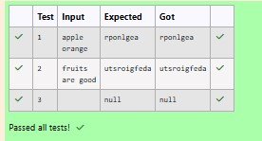

[**Lab-07-Interfaces**](http://www.rajalakshmicolleges.org/moodle/course/section.php?id=58)

**1.**

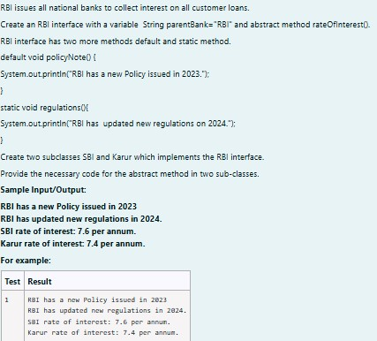

**SOLUTION :**

|  |
| --- |
| // Define the RBI interface interface RBI {  // Variable declaration  String parentBank = "RBI";  // Abstract method double rateOfInterest();  // Default method  default void policyNote() {  System.out.println("RBI has a new Policy issued in 2023");  }  // Static method  static void regulations() {  System.out.println("RBI has updated new regulations in 2024.");  }  }  // SBI class implementing RBI interface class SBI implements RBI {  // Implementing the abstract method public double rateOfInterest() { |
| return 7.6;  }  }  // Karur class implementing RBI interface class Karur implements RBI {  // Implementing the abstract method public double rateOfInterest() { return 7.4;  }  }  // Main class to test the functionality public class Main { public static void main(String[] args) {  // RBI policies and regulations  RBI rbi = new SBI(); // Can be any class implementing RBI  rbi.policyNote(); // Default method RBI.regulations(); // Static method  // SBI bank details  SBI sbi = new SBI();  System.out.println("SBI rate of interest: " + sbi.rateOfInterest() + " per annum.");  // Karur bank details  Karur karur = new Karur();  System.out.println("Karur rate of interest: " + karur.rateOfInterest() + " per annum.");  }  } |

**OUTPUT :**

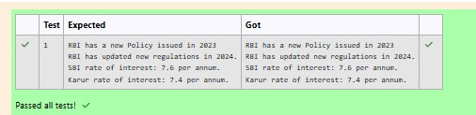

**2.**

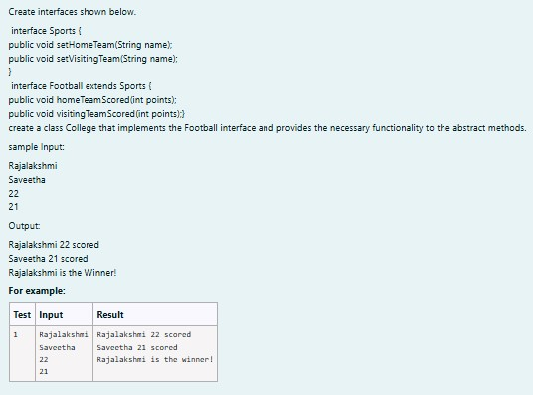

**SOLUTION :**

|  |
| --- |
| import java.util.Scanner;  interface Sports { void setHomeTeam(String name);  void setVisitingTeam(String name);  }  interface Football extends Sports { void homeTeamScored(int points);  void visitingTeamScored(int points);  }  class College implements Football { private String homeTeam; private String visitingTeam; private int homeTeamPoints = 0; private int visitingTeamPoints = 0;  public void setHomeTeam(String name) { this.homeTeam = name;  }  public void setVisitingTeam(String name) { this.visitingTeam = name;  } |

|  |
| --- |
| public void homeTeamScored(int points) { homeTeamPoints += points;  System.out.println(homeTeam + " " + points + " scored");  }  public void visitingTeamScored(int points) { visitingTeamPoints += points;  System.out.println(visitingTeam + " " + points + " scored");  }  public void winningTeam() { if (homeTeamPoints > visitingTeamPoints) {  System.out.println(homeTeam + " is the winner!");  } else if (homeTeamPoints < visitingTeamPoints) {  System.out.println(visitingTeam + " is the winner!");  } else {  System.out.println("It's a tie match.");  }  }  }  public class Main { public static void main(String[] args) {  Scanner sc = new Scanner(System.in);  // Get home team name  String hname = sc.nextLine();  // Get visiting team name  String vteam = sc.nextLine();  // Create College object College match = new College(); match.setHomeTeam(hname); match.setVisitingTeam(vteam);  // Get points scored by home team  int htpoints = sc.nextInt(); match.homeTeamScored(htpoints);  // Get points scored by visiting team int vtpoints = sc.nextInt();  match.visitingTeamScored(vtpoints);  // Determine and print the winning team match.winningTeam();  sc.close();  } |

}

**OUTPUT :**

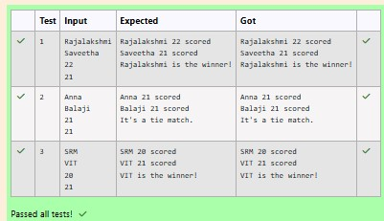

**3.**

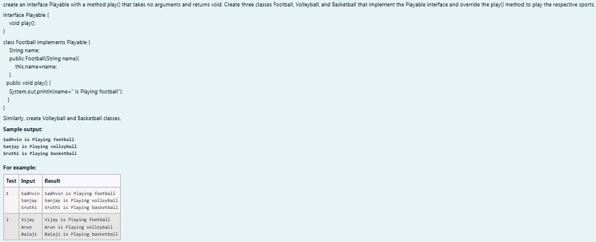

**SOLUTION :**

|  |
| --- |
| import java.util.Scanner;  // Define the Playable interface interface Playable {  // Abstract method to play the respective sport void play();  }  // Football class implementing Playable interface  class Football implements Playable {  String name;  // Constructor  public Football(String name) { this.name = name;  } |

|  |
| --- |
| // Override the play method  public void play() {  System.out.println(name + " is Playing football");  }  }  // Volleyball class implementing Playable interface  class Volleyball implements Playable {  String name;  // Constructor  public Volleyball(String name) { this.name = name;  }  // Override the play method  public void play() {  System.out.println(name + " is Playing volleyball");  }  }  // Basketball class implementing Playable interface  class Basketball implements Playable {  String name;  // Constructor  public Basketball(String name) { this.name = name;  }  // Override the play method  public void play() {  System.out.println(name + " is Playing basketball");  }  }  // Main class to test the functionality public class Main { public static void main(String[] args) {  Scanner scanner = new Scanner(System.in);  // Input for Football player  String footballPlayerName = scanner.nextLine();  Football footballPlayer = new Football(footballPlayerName);  // Input for Volleyball player |
| String volleyballPlayerName = scanner.nextLine();  Volleyball volleyballPlayer = new Volleyball(volleyballPlayerName);  // Input for Basketball player  String basketballPlayerName = scanner.nextLine();  Basketball basketballPlayer = new Basketball(basketballPlayerName);  // Call the play method for each player  footballPlayer.play(); volleyballPlayer.play(); basketballPlayer.play();  scanner.close();  }  } |

**OUTPUT :**

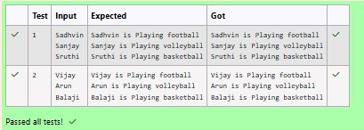

[**Lab-08**](http://www.rajalakshmicolleges.org/moodle/course/section.php?id=57)[**-**](http://www.rajalakshmicolleges.org/moodle/course/section.php?id=57)[**Polymorphism,**](http://www.rajalakshmicolleges.org/moodle/course/section.php?id=57)[**Abstract**](http://www.rajalakshmicolleges.org/moodle/course/section.php?id=57)[**Classes,**](http://www.rajalakshmicolleges.org/moodle/course/section.php?id=57)[**final**](http://www.rajalakshmicolleges.org/moodle/course/section.php?id=57)[**Keyword**](http://www.rajalakshmicolleges.org/moodle/course/section.php?id=57)

**1.**

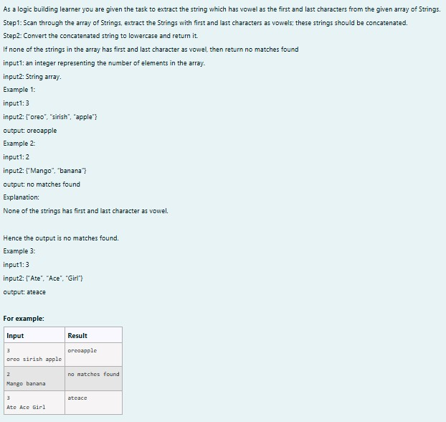

**SOLUTION :**

|  |
| --- |
| import java.util.Scanner; public class VowelStringExtractor {  // Method to extract strings with vowels as first and last characters public static String extractVowelStrings(String[] stringArray) {  StringBuilder result = new StringBuilder();  String vowels = "aeiouAEIOU"; // String containing all vowels  // Iterate through the array of strings for (String s : stringArray) {  // Check if the string is not empty and if both the first and last characters are vowels if (s.length() > 0 && vowels.indexOf(s.charAt(0)) != -1 && vowels.indexOf(s.charAt(s.length() - 1)) != -1) { result.append(s); // Append matching string to the result  }  }  // Return the concatenated string in lowercase or "no matches found" return result.length() > 0 ? result.toString().toLowerCase() : "no matches |
| found";  }  public static void main(String[] args) {  Scanner scanner = new Scanner(System.in);  // Input for the number of strings  int n = scanner.nextInt();  scanner.nextLine(); // Consume the newline character  // Input for the strings in one line  String input = scanner.nextLine();  String[] strings = input.split(" "); // Split input into an array  // Process and output the result  String result = extractVowelStrings(strings);  System.out.println(result);  scanner.close(); // Close the scanner  }  } |

**OUTPUT :**

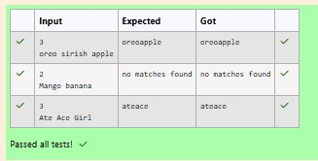

**2.**

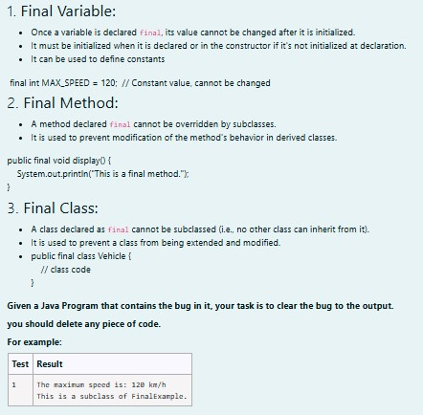

**SOLUTION :**

|  |
| --- |
| // Final class definition final class FinalExample {  // Final variable  final int MAX_SPEED = 120; // Constant value  // Final method  public final void display() {  System.out.println("The maximum speed is: " + MAX_SPEED + " km/h");  }  }  // Main class to test the final class public class Test { public static void main(String[] args) {  // Create an instance of FinalExample  FinalExample example = new FinalExample(); example.display();  // Uncommenting the following line will result in a compile-time error // because FinalExample is a final class and cannot be subclassed.  // class SubclassExample extends FinalExample { }  System.out.println("This is a subclass of FinalExample.");  }  } |

**OUTPUT :**

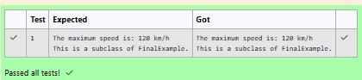

**3.**

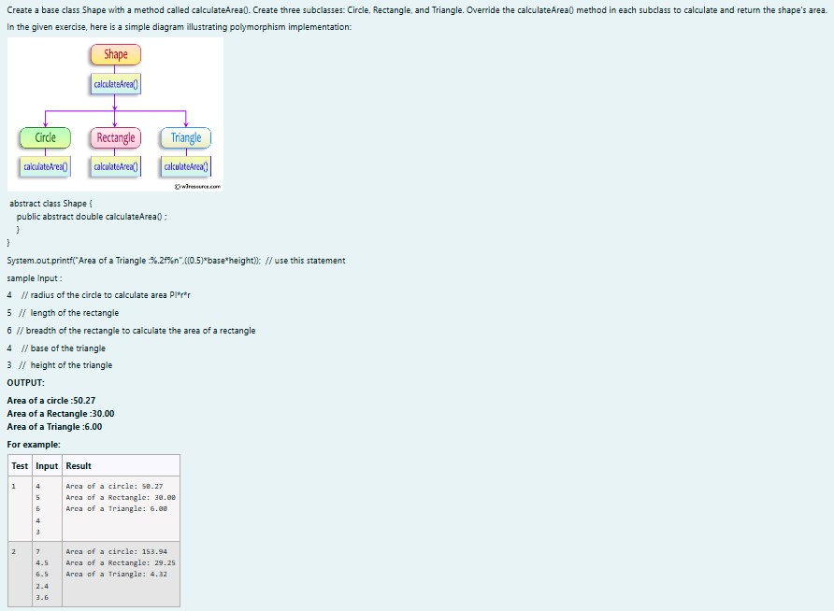

**SOLUTION :**

|  |
| --- |
| import java.util.Scanner;  // Abstract class Shape abstract class Shape { public abstract double calculateArea();  }  // Circle class  class Circle extends Shape { private double radius;  public Circle(double radius) { this.radius = radius;  }  @Override |

|  |
| --- |
| public double calculateArea() { return Math.PI * radius * radius; // Area of circle: πr²  }  }  // Rectangle class  class Rectangle extends Shape { private double length; private double breadth;  public Rectangle(double length, double breadth) { this.length = length;  this.breadth = breadth;  }  @Override  public double calculateArea() { return length * breadth; // Area of rectangle: length * breadth  }  }  // Triangle class  class Triangle extends Shape { private double base; private double height;  public Triangle(double base, double height) { this.base = base;  this.height = height;  }  @Override  public double calculateArea() { return 0.5 * base * height; // Area of triangle: 0.5 * base * height  }  }  // Main class to test the shapes public class ShapeTest { public static void main(String[] args) {  Scanner scanner = new Scanner(System.in);  // Input for Circle  double radius = scanner.nextDouble();  Circle circle = new Circle(radius);  System.out.printf("Area of a circle: %.2f%n", circle.calculateArea());  // Input for Rectangle |
| double length = scanner.nextDouble();  double breadth = scanner.nextDouble();  Rectangle rectangle = new Rectangle(length, breadth);  System.out.printf("Area of a Rectangle: %.2f%n", rectangle.calculateArea());  // Input for Triangle double base = scanner.nextDouble();  double height = scanner.nextDouble(); Triangle triangle = new Triangle(base, height);  System.out.printf("Area of a Triangle: %.2f%n", triangle.calculateArea());  scanner.close();  }  } |

**OUTPUT :**

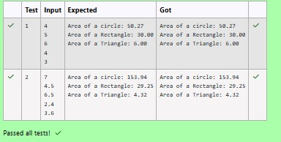

[**Lab-09-Exception**](http://www.rajalakshmicolleges.org/moodle/course/section.php?id=59)[**Handling**](http://www.rajalakshmicolleges.org/moodle/course/section.php?id=59)

**1.**

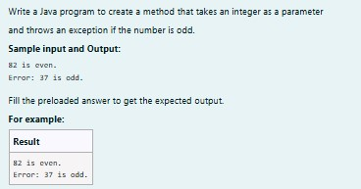

**SOLUTION :**

class prog {

public static void main(String[] args) {

|  |
| --- |
| int n = 82; trynumber(n); n = 37;  trynumber(n); // Call the trynumber(n);  }  public static void trynumber(int n) { try { checkEvenNumber(n); // Call the checkEvenNumber() System.out.println(n + " is even.");  } catch (Exception e) { // Catch the exception  System.out.println("Error: " + e.getMessage());  }  }  public static void checkEvenNumber(int number) { if (number % 2 != 0) { throw new RuntimeException(number + " is odd."); // Throw a RuntimeException  }  **}**  **}** |

**OUTPUT :**

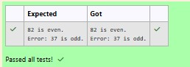

**2.**

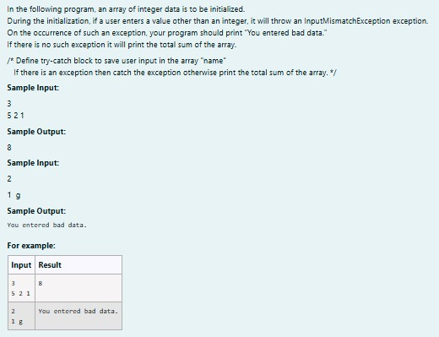

**SOLUTION :**

|  |
| --- |
| import java.util.Scanner;  import java.util.InputMismatchException;  class prog { public static void main(String[] args) {  Scanner sc = new Scanner(System.in); int length = sc.nextInt();  // create an array to save user input int[] name = new int[length]; int sum = 0; // save the total sum of the array.  /* Define try-catch block to save user input in the array "name" If there is an exception then catch the exception otherwise print the total sum of the array. */  try { for (int i = 0; i < length; i++) { name[i] = sc.nextInt(); // save user input in the array  }  // Calculate the total sum  for (int num : name) {  sum += num;  }  // Print the total sum  System.out.println(sum);  } catch (InputMismatchException e) {  System.out.println("You entered bad data.");  }  sc.close(); // Close the scanner  }  } |

**OUTPUT :**

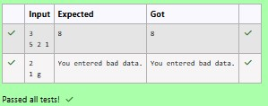

**3.**

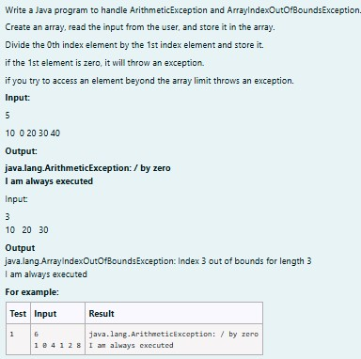

**SOLUTION :**

|  |
| --- |
| import java.util.Scanner;  public class ExceptionHandlingExample { public static void main(String[] args) {  Scanner scanner = new Scanner(System.in);  // Read the size of the array int size = scanner.nextInt();  // Initialize the array int[] numbers = new int[size];  // Read the elements into the array for (int i = 0; i < size; i++) { numbers[i] = scanner.nextInt();  }  try {  // Attempt to perform division  int result = numbers[0] / numbers[1]; // This may cause an  ArithmeticException  } catch (ArithmeticException e) {  System.out.println(e); // Catch division by zero  } catch (ArrayIndexOutOfBoundsException e) {  System.out.println(e); // Catch accessing out of bounds } catch (Exception e) { |
| System.out.println(e); // Catch any other exceptions  } finally {  // This block is always executed  }  try {  // Attempt to access an out-of-bounds index  int outOfBoundsValue = numbers[3]; // This will trigger  ArrayIndexOutOfBoundsException if size < 4  } catch (ArrayIndexOutOfBoundsException e) { System.out.println(e);  } finally {  // This block is always executed for the second try System.out.println("I am always executed");  }  scanner.close();  }  } |

**OUTPUT :**

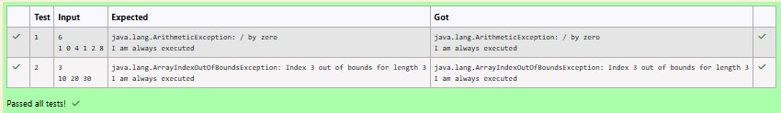

[**Lab-10-**](http://www.rajalakshmicolleges.org/moodle/course/section.php?id=60)[**Collection-**](http://www.rajalakshmicolleges.org/moodle/course/section.php?id=60)[**List**](http://www.rajalakshmicolleges.org/moodle/course/section.php?id=60)

**1.**

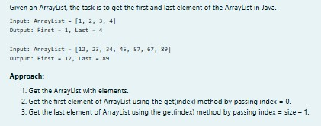

**SOLUTION :**

|  |
| --- |
| import java.util.ArrayList; import java.util.Scanner;  public class FirstAndLastElement { public static void main(String[] args) {  Scanner scanner = new Scanner(System.in);  // Create an ArrayList |
| ArrayList<Integer> numbers = new ArrayList<>(); int numElements = scanner.nextInt();  for (int i = 0; i < numElements; i++) { int number = scanner.nextInt(); numbers.add(number);  }  System.out.println("ArrayList: " + numbers);  // Get the first element int firstElement = numbers.get(0);  // Get the last element  int lastElement = numbers.get(numbers.size() - 1);  // Print the results  System.out.print("First : " + firstElement);  System.out.println(", Last : " + lastElement);  }  } |

**OUTPUT :**

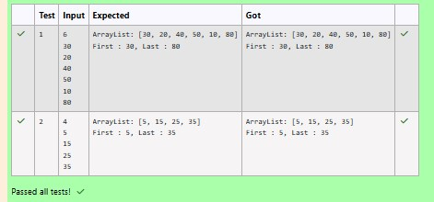

**2.**

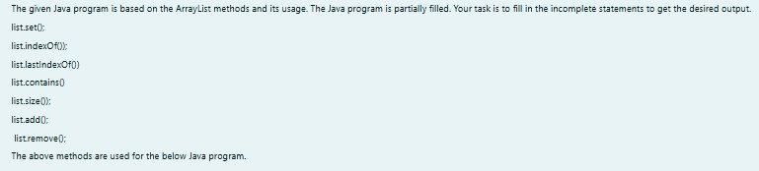

**SOLUTION :**

import java.util.ArrayList; import java.util.Scanner; public class Prog {

|  |
| --- |
| public static void main(String[] args)  {  Scanner sc= new Scanner(System.in); int n = sc.nextInt();  ArrayList<Integer> list = new ArrayList<Integer>();  for(int i = 0; i<n;i++) list.add(sc.nextInt());  // printing initial value ArrayList  System.out.println("ArrayList: " + list);  //Replacing the element at index 1 with 100  list.set(1,100);  //Getting the index of first occurrence of 100  System.out.println("Index of 100 = "+ list.indexOf(100) );  //Getting the index of last occurrence of 100  System.out.println("LastIndex of 100 = "+ list.lastIndexOf(100));  // Check whether 200 is in the list or not  System.out.println(list.contains(200)); //Output : false  // Print ArrayList size  System.out.println("Size Of ArrayList = "+list.size() );  //Inserting 500 at index 1  list.add(1,500); // code here  //Removing an element from position 3  list.remove(3); // code here  System.out.print("ArrayList: " + list);  }  } |

**OUTPUT :**

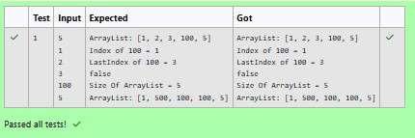

**3.**

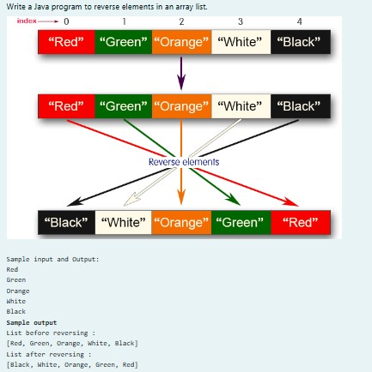

**SOLUTION :**

|  |
| --- |
| import java.util.ArrayList; import java.util.Collections; import java.util.Scanner;  public class ReverseArrayList { public static void main(String[] args) {  Scanner scanner = new Scanner(System.in);  ArrayList<String> list = new ArrayList<>(); int n = scanner.nextInt();  for (int i = 0; i < n; i++) {  String element = scanner.next();  list.add(element);  }  System.out.println("List before reversing : "); System.out.println(list);  Collections.reverse(list);  System.out.println("List after reversing : "); |
| System.out.println(list); }  } |

**OUTPUT :**

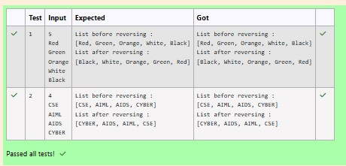

[**Lab-11-Set,**](http://www.rajalakshmicolleges.org/moodle/course/section.php?id=61)[**Map**](http://www.rajalakshmicolleges.org/moodle/course/section.php?id=61)

**1.**

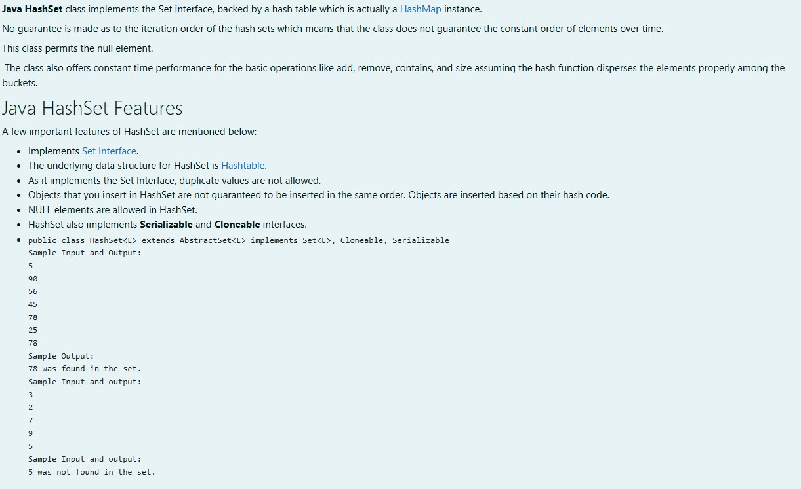

**SOLUTION :**

|  |
| --- |
| **import java.util.HashSet; import java.util.Scanner;**  **public class Prog { public static void main(String[] args) {**  **Scanner sc = new Scanner(System.in);**  **// Read the number of elements** |
| **int n = sc.nextInt();**  **// Create a HashSet object to store numbers**  **HashSet<Integer> numbers = new HashSet<>();**  **// Add numbers to the HashSet for (int i = 0; i < n; i++) { numbers.add(sc.nextInt());**  **}**  **// Read the search key int skey = sc.nextInt();**  **// Check if skey is present in the HashSet**  **if (numbers.contains(skey)) {**  **System.out.println(skey + " was found in the set.");**  **} else {**  **System.out.println(skey + " was not found in the set.");**  **}**  **// Close the scanner sc.close();**  **}**  **}** |

**OUTPUT :**

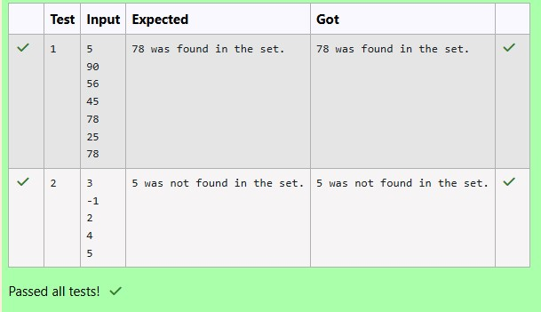

**2.**

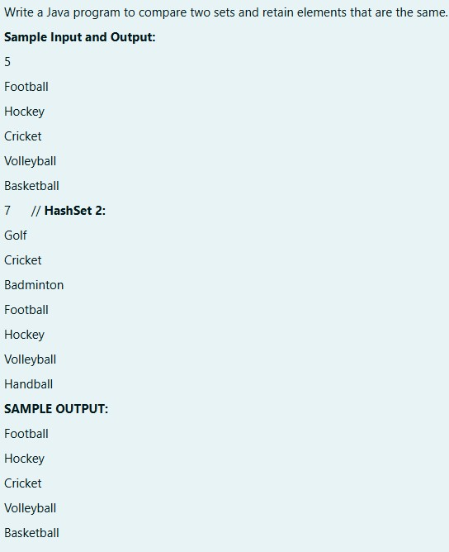

**SOLUTION :**

|  |
| --- |
| **import java.util.HashSet; import java.util.Scanner; import java.util.Set;**  **public class CompareSets { public static void main(String[] args) {**  **Scanner scanner = new Scanner(System.in);**  **// Read the size of the first set**  **int size1 = Integer.parseInt(scanner.nextLine());**  **// Create a HashSet to store the first set of elements**  **Set<String> set1 = new HashSet<>();**  **// Read elements for the first set for (int i = 0; i < size1; i++) { set1.add(scanner.nextLine()); }** |
| **// Read the size of the second set**  **int size2 = Integer.parseInt(scanner.nextLine());**  **// Create a HashSet to store the second set of elements**  **Set<String> set2 = new HashSet<>();**  **// Read elements for the second set for (int i = 0; i < size2; i++) { set2.add(scanner.nextLine());**  **}**  **// Retain common elements using the retainAll() method**  **set1.retainAll(set2);**  **// Print the common elements for (String element : set1) {**  **System.out.println(element);**  **}**  **scanner.close();**  **}**  **}** |

**OUTPUT :**

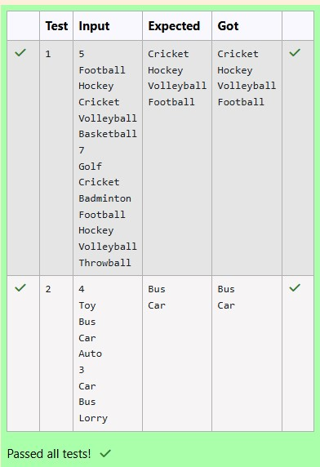

**3.**

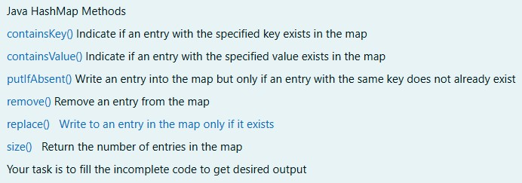

**SOLUTION :**

|  |
| --- |
| **import java.util.HashMap; import java.util.Map.Entry; import java.util.Scanner; import java.util.Set; public class Prog {**  **public static void main(String[] args) {**  **// Creating HashMap with default initial capacity and load factor**  **HashMap<String, Integer> map = new HashMap<String, Integer>();**  **String name; int num;**  **Scanner sc = new Scanner(System.in); int n = sc.nextInt();**  **for (int i = 0; i < n; i++) { name = sc.next(); num = sc.nextInt();**  **map.put(name, num);**  **}**  **// Printing key-value pairs**  **Set<Entry<String, Integer>> entrySet = map.entrySet();**  **for (Entry<String, Integer> entry : entrySet) {**  **System.out.println(entry.getKey() + " : " + entry.getValue());**  **}**  **System.out.println("----------");**  **// Creating another HashMap**  **HashMap<String, Integer> anotherMap = new HashMap<String,**  **Integer>();** |
| **// Inserting key-value pairs to anotherMap using put() method anotherMap.put("SIX", 6); anotherMap.put("SEVEN", 7);**  **// Inserting key-value pairs of map to anotherMap using putAll() method anotherMap.putAll(map); // This line fills in the missing code**  **// Printing key-value pairs of anotherMap entrySet = anotherMap.entrySet();**  **for (Entry<String, Integer> entry : entrySet) {**  **System.out.println(entry.getKey() + " : " + entry.getValue());**  **}**  **// Adds key-value pair 'FIVE-5' only if it is not present in map map.putIfAbsent("FIVE", 5);**  **// Retrieving a value associated with key 'TWO'**  **int value = map.get("TWO");**  **System.out.println(value); // Prints the value associated with key "TWO"**  **(if it exists)**  **// Checking whether key 'ONE' exists in map**  **System.out.println(map.containsKey("ONE")); // Prints true if "ONE" is a key, false otherwise**  **// Checking whether value '3' exists in map**  **boolean valueExists = map.containsValue(3); // You can use a variable to**  **store the result**  **System.out.println(valueExists); // Prints true if value 3 exists in the map, false otherwise**  **// Retrieving the number of key-value pairs present in map**  **System.out.println(map.size()); // Prints the number of entries in the map**  **}**  **}** |

**OUTPUT :**

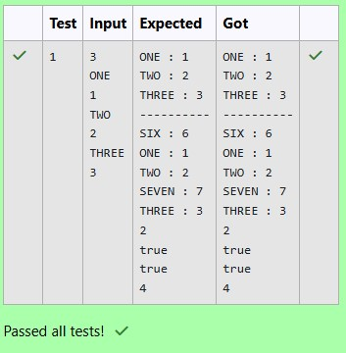

[**Lab-12-Introduction**](http://www.rajalakshmicolleges.org/moodle/course/section.php?id=56)[**to**](http://www.rajalakshmicolleges.org/moodle/course/section.php?id=56)[**I/O,**](http://www.rajalakshmicolleges.org/moodle/course/section.php?id=56)[**I/O**](http://www.rajalakshmicolleges.org/moodle/course/section.php?id=56)[**Operations,**](http://www.rajalakshmicolleges.org/moodle/course/section.php?id=56)[**Object Serialization**](http://www.rajalakshmicolleges.org/moodle/course/section.php?id=56)

**1.**

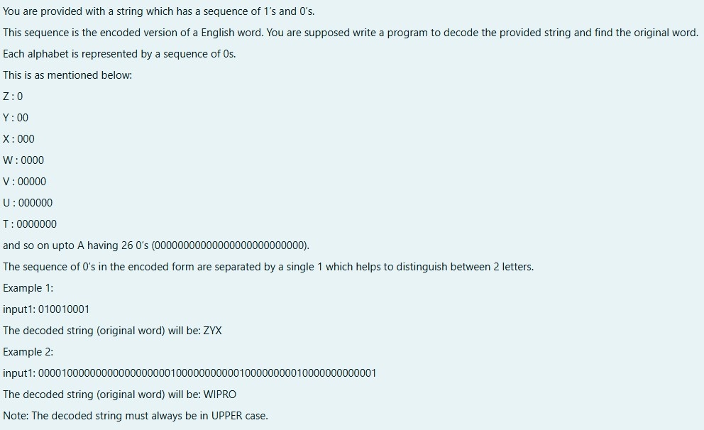

**SOLUTION :**

|  |
| --- |
| **import java.util.Scanner;**  **public class DecodeString { public static void main(String[] args) {**  **Scanner scanner = new Scanner(System.in);**  **String encodedString = scanner.nextLine();**  **StringBuilder decodedString = new StringBuilder(); int count = 0;**  **for (int i = 0; i < encodedString.length(); i++) { if (encodedString.charAt(i) == '0') { count++;**  **} else { char decodedChar = (char) ('Z' - count + 1); decodedString.append(decodedChar);**  **count = 0;**  **}**  **}**  **System.out.println(decodedString.toString()); }** |

**}**

**OUTPUT :**

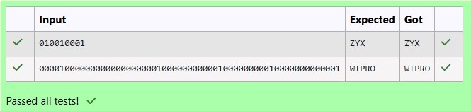

**2.**

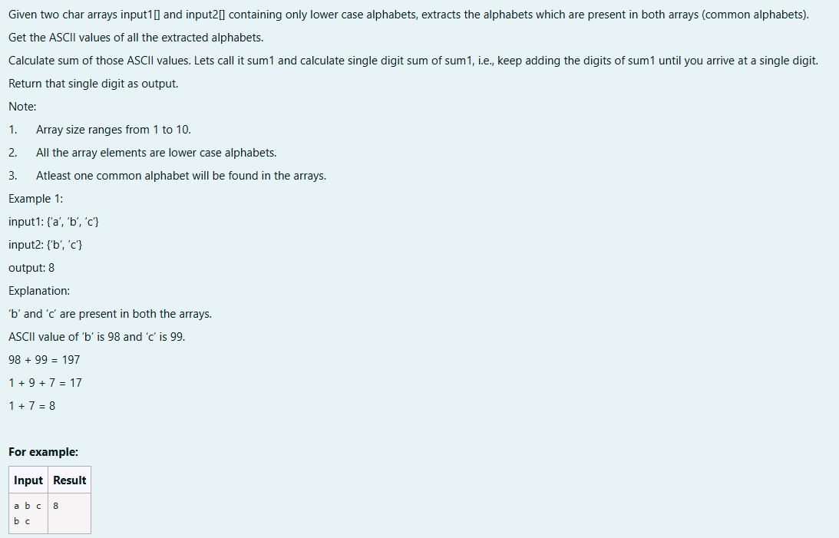

**SOLUTION :**

|  |
| --- |
| **import java.util.HashSet; import java.util.Set;**  **public class CommonAlphabetSum {**  **public static int singleDigitSum(int num) { int sum = 0;**  **while (num > 0) {**  **sum += num % 10;**  **num /= 10;**  **}**  **if (sum > 9) { return singleDigitSum(sum);**  **}** |
| **return sum;**  **}**  **public static int calculateCommonAlphabetSum(char[] input1, char[]**  **input2) {**  **Set<Character> set1 = new HashSet<>(); for (char c : input1) { set1.add(c);**  **}**  **int sum = 0; for (char c : input2) { if (set1.contains(c)) { sum += c;**  **}**  **}**  **return singleDigitSum(sum);**  **}**  **public static void main(String[] args) { char[] input1 = {'a', 'b', 'c'}; char[] input2 = {'b', 'c', 'd'};**  **int result = calculateCommonAlphabetSum(input1, input2); System.out.println(result); }**  **}** |

**OUTPUT :**

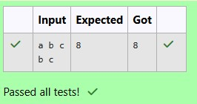

**3.**

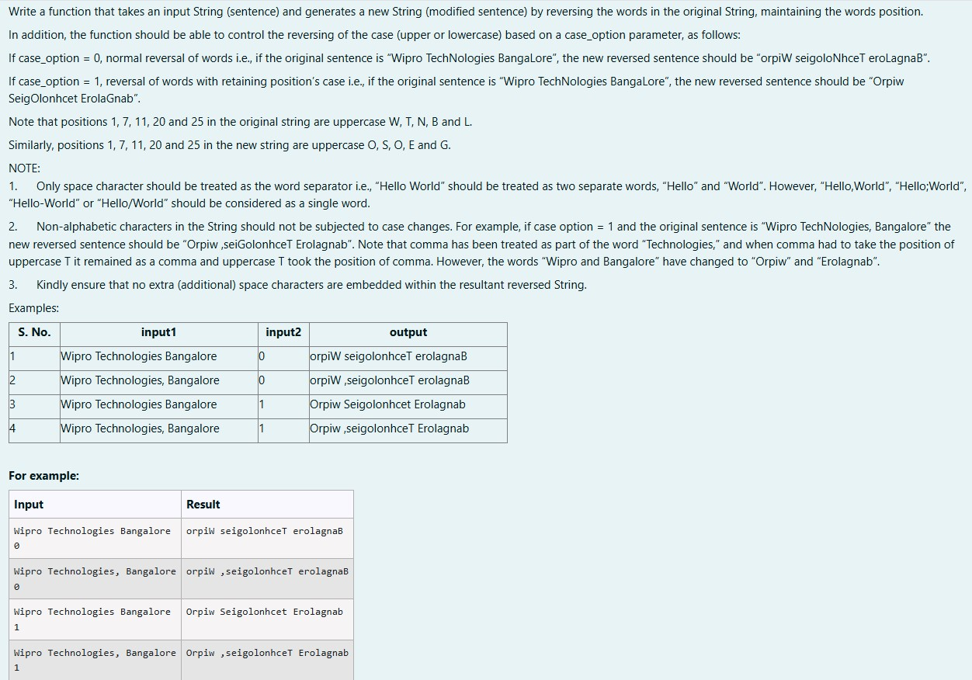

**SOLUTION :**

|  |
| --- |
| **import java.util.Scanner; public class WordReverser {**  **public static String reverseWordsWithCase(String sentence, int**  **caseOption) {**  **// Split the sentence into words based on spaces**  **String[] words = sentence.split(" ");**  **// StringBuilder to store the result**  **StringBuilder result = new StringBuilder();**  **// Process each word for (String word : words) {**  **// Reverse the word**  **String reversedWord = new StringBuilder(word).reverse().toString();**  **if (caseOption == 0) {**  **// If caseOption is 0, no case conversion, just reverse the word**  **result.append(reversedWord).append(" ");**  **} else if (caseOption == 1) {**  **// If caseOption is 1, adjust the case while maintaining original letter** |

|  |
| --- |
| **positions result.append(applyCaseConversion(reversedWord,**  **word)).append(" ");**  **}**  **}**  **// Remove the trailing space and return the result return result.toString().trim();**  **}**  **private static String applyCaseConversion(String reversedWord, String**  **originalWord) {**  **// StringBuilder to store the adjusted word**  **StringBuilder adjustedWord = new StringBuilder();**  **// Iterate over each character in the reversed word for (int i = 0; i < reversedWord.length(); i++) { char reversedChar = reversedWord.charAt(i); char originalChar = originalWord.charAt(i);**  **if (Character.isLowerCase(originalChar)) {**  **// If the original character was lowercase, the reversed character**  **should be uppercase adjustedWord.append(Character.toLowerCase(reversedChar));**  **} else if (Character.isUpperCase(originalChar)) {**  **// If the original character was uppercase, the reversed character**  **should be lowercase adjustedWord.append(Character.toUpperCase(reversedChar)); } else {**  **// Non-alphabetic characters remain unchanged adjustedWord.append(reversedChar);**  **}**  **}**  **return adjustedWord.toString();**  **}**  **public static void main(String[] args) {**  **// Create a Scanner object to get input from the user**  **Scanner scanner = new Scanner(System.in);**  **// Get sentence input from the user**  **String sentence = scanner.nextLine(); // Get case option input from the user int caseOption = scanner.nextInt();** |
| **// Validate the case option**  **if (caseOption != 0 && caseOption != 1) {**  **System.out.println("Invalid case option. Please enter 0 or 1."); } else {**  **// Call the function and print the result**  **String result = reverseWordsWithCase(sentence, caseOption); System.out.println(result);**  **}**  **// Close the scanner**  **scanner.close();**  **}**  **}** |

**OUTPUT :**

