**2.3 Brainstorming:**

**Brainstorm & Idea Prioritization Template**

| Date | 18 JUNE 2025 |
| --- | --- |
| Team ID | LTVIP2025TMID47771 |
| Project Name | Visualization Tool for Electric Vehicle Charge and Range Analysis |
| Maximum Marks | 4 Marks |

**Brainstorm & Idea Prioritization Template:**

"How might we design an intuitive and interactive visualization tool that helps electric vehicle users, fleet operators, and planners easily understand and analyze real-time charge levels, battery consumption, and range estimates, so they can make smarter, stress-free driving and planning decisions?"

**Step-1: Team Gathering, Collaboration and Select the Problem Statement**

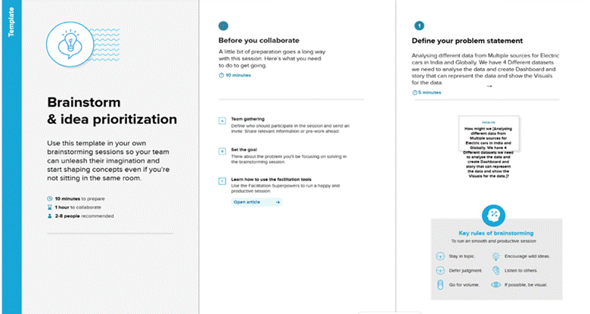

**Step-2: Brainstorm, Idea Listing and Grouping**

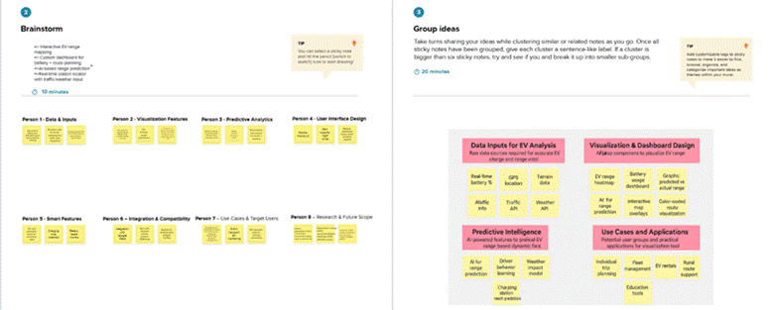

**Step-3: Idea Prioritization**

