Brokenshire College SOCCSKSARGEN, Inc.
Ced Avenue, National Highway, General Santos City
Nursing Department

In Partial Fulfillment of the Requirements in Robotics


MEDIBAND: A Table-Top Heart and Oxygen Check-Up System with Web Dashboard and AI-Assisted Screening
Concept Paper

Presented to:
LOUIEGIE A. VEDEJA, MBA, LPT
Instructor
By:
KLARRETTE CASANDRA R. EDULZA, SN
RICKCHILLE ANN C. DICO, SN
VAN LESTER COLING JR., SN
ARCHELENE PELIÑO, SN
MAECHAELA SALAS, SN
JOCKY LIQUIT, SN
BSN 3B
December 2025
Introduction
Vital signs monitoring is foundational to patient assessment, yet manual methods can be time-consuming and inconsistent. To address this, we propose MEDIBAND, a table-top screening prototype designed to automate heart rate and oxygen saturation (SpO₂) measurement. This prototype demonstrates how low-cost hardware can be integrated with web-based technology to support nursing workflows.
For this current phase, we are developing a mock-up prototype that simulates vital sign generation without a physical sensor. This approach allows us to validate the software architecture, web dashboard functionality, and AI-assisted risk classification logic before integrating the MAX30102 sensor in future iterations.
The MEDIBAND (Medical Electronic Band) system builds on evidence-based approaches to vital signs screening by offering a table-top, user-friendly solution tailored to clinical health assessment. It aims to reduce measurement time, standardize vital sign collection, and support nursing staff through automated risk screening and web-based data management. By integrating clinical insight with technological innovation, MEDIBAND supports nurses and healthcare staff in delivering efficient, data-driven patient care.
Objectives
MEDIBAND is designed to support healthcare staff in rapid vital sign assessment and patient triage through automated measurement and AI-assisted risk classification. This project aims:
- To design and develop a table-top health screening device that accurately measures heart rate (BPM) and blood oxygen saturation (SpO₂) using automated sensor technology.
- To implement real-time vital sign display on an on-device OLED screen, enabling immediate patient and staff access to measurement results.
- To create a secure web-based dashboard with Wi-Fi connectivity for storing, visualizing, and retrieving patient vital sign data across multiple screening sessions.
- To integrate AI-assisted screening logic that classifies heart rate and SpO₂ patterns into risk categories (Normal, Warning, Critical) to support clinical triage decisions.
- To reduce measurement errors and variability by automating vital sign assessment with standardized, reproducible sensor-based readings.
- To develop a mock-up prototype using simulated data generation, validating the entire software architecture before physical sensor integration.
- To support nursing care workflows by providing practical assistive technology that enhances patient safety, reduces assessment time, and facilitates evidence-based clinical decision-making.

Significance of the Study
Vital signs monitoring is fundamental to clinical assessment, yet rapid, standardized screening remains inaccessible in many healthcare environments. Manual vital sign assessment is subject to measurement variability, depends on operator skill and training, and is time-intensive in high-volume clinical settings. Delayed or inaccurate screening can result in missed identification of hypoxia, arrhythmias, or cardiovascular compromise, leading to preventable complications, unnecessary hospital admissions, and increased healthcare costs.
The proposed MEDIBAND (Medical Electronic Band) system addresses this gap by providing a standardized, user-friendly table-top screening device specifically designed for rapid patient check-ups in clinical and community settings. The device automates heart rate and oxygen saturation measurement, displays results instantly on an on-device screen, transmits data wirelessly to a secure web dashboard, and employs AI-assisted pattern recognition to provide simple, non-diagnostic risk indicators to support nursing staff during triage and patient assessment protocols. For this mock-up prototype phase, the system uses simulated vital sign generation to validate the software architecture and dashboard functionality before physical sensor integration.
This project's importance is demonstrated by the various groups it could assist, such as:
- Patients, by receiving quick, non-invasive health screenings with immediate feedback, personal health records stored on secure web dashboard, and early identification of abnormal vital signs;
- Nurses and healthcare staff, by reducing assessment time and manual measurement burden, providing standardized vital sign data, and supporting triage decisions with AI-assisted risk indicators;
- Healthcare facilities, by improving screening efficiency and patient throughput, standardizing assessment protocols, and enabling data-driven patient management;
- Public health systems, by enabling rapid health screening in underserved communities and resource-limited settings, supporting preventive care initiatives, and advancing health equity through accessible screening technology.
Overall, MEDIBAND offers a practical, low-cost, and user-friendly solution that aligns with nursing priorities in patient safety, clinical efficiency, and evidence-based care. By integrating automated vital sign measurement with AI-assisted screening and web-based data management, the device provides a comprehensive approach to supporting healthcare staff in maintaining accurate and timely patient assessment.
Project Description
The MEDIBAND mock-up prototype addresses the need for rapid, standardized vital sign screening in clinical settings. For this prototype phase, MEDIBAND is realized as a compact table-top unit that generates simulated vital sign data to validate the software architecture, web dashboard functionality, and AI-assisted risk classification logic before integrating the physical MAX30102 sensor.
The system utilizes an ESP32 microcontroller as the central processing unit, displaying real-time results on an SSD1306 OLED screen. The device leverages the ESP32's built-in "BOOT" button for user-initiated measurements or accepts triggers from a web-based dashboard. No physical sensor is required for this prototype phase — vital signs are generated randomly within realistic ranges to simulate patient measurements.
Key Components:
1. ESP32 Development Board (Table-Top Control Unit)
The "brain" of the system. Generates mock vital sign data, manages OLED display updates, handles Wi-Fi communication, and runs a web server for dashboard control. In future iterations with physical sensor, will read data from MAX30102 pulse oximeter.
2. SSD1306 OLED Display
0.96-inch screen to show real-time vital signs, connection status, and measurement results. Provides immediate visual feedback to patients and healthcare staff.
3. Built-in BOOT Button (User Input)
The ESP32's onboard button (GPIO 0) triggers a new mock measurement with randomized heart rate and SpO₂ values. Alternatively, measurements can be triggered via web dashboard button.
4. MAX30102 Pulse Oximeter Sensor (Future Integration)
Optical sensor that measures heart rate (BPM) and blood oxygen saturation (SpO₂) using red and infrared LED technology. Not included in current mock-up prototype but documented for future implementation.
Features:
1. Dual Trigger System (Physical Button and Web Interface)
The system allows measurement initiation through either the ESP32 BOOT button or a web dashboard "Generate Reading" button. This dual-trigger approach validates both on-device and remote control functionality.
2. Real-Time Display and Web Dashboard
Unlike traditional vital sign monitors, MEDIBAND provides both on-device OLED display and cloud-based web dashboard visualization. This enables immediate local feedback while maintaining longitudinal records for follow-up care.
3. AI-Assisted Screening (Non-Diagnostic Support)
The system applies threshold-based classification logic to categorize vital signs into risk levels (Normal/Warning/Critical). This supports clinical triage without replacing professional medical judgment.
4. Low-Cost and Accessible Design
The device is designed using low-cost components (ESP32 microcontroller, SSD1306 OLED display, standard breadboard components) suitable for resource-limited settings. Current mock-up prototype costs approximately $40; full implementation with sensor costs approximately $52.

Product Diagram
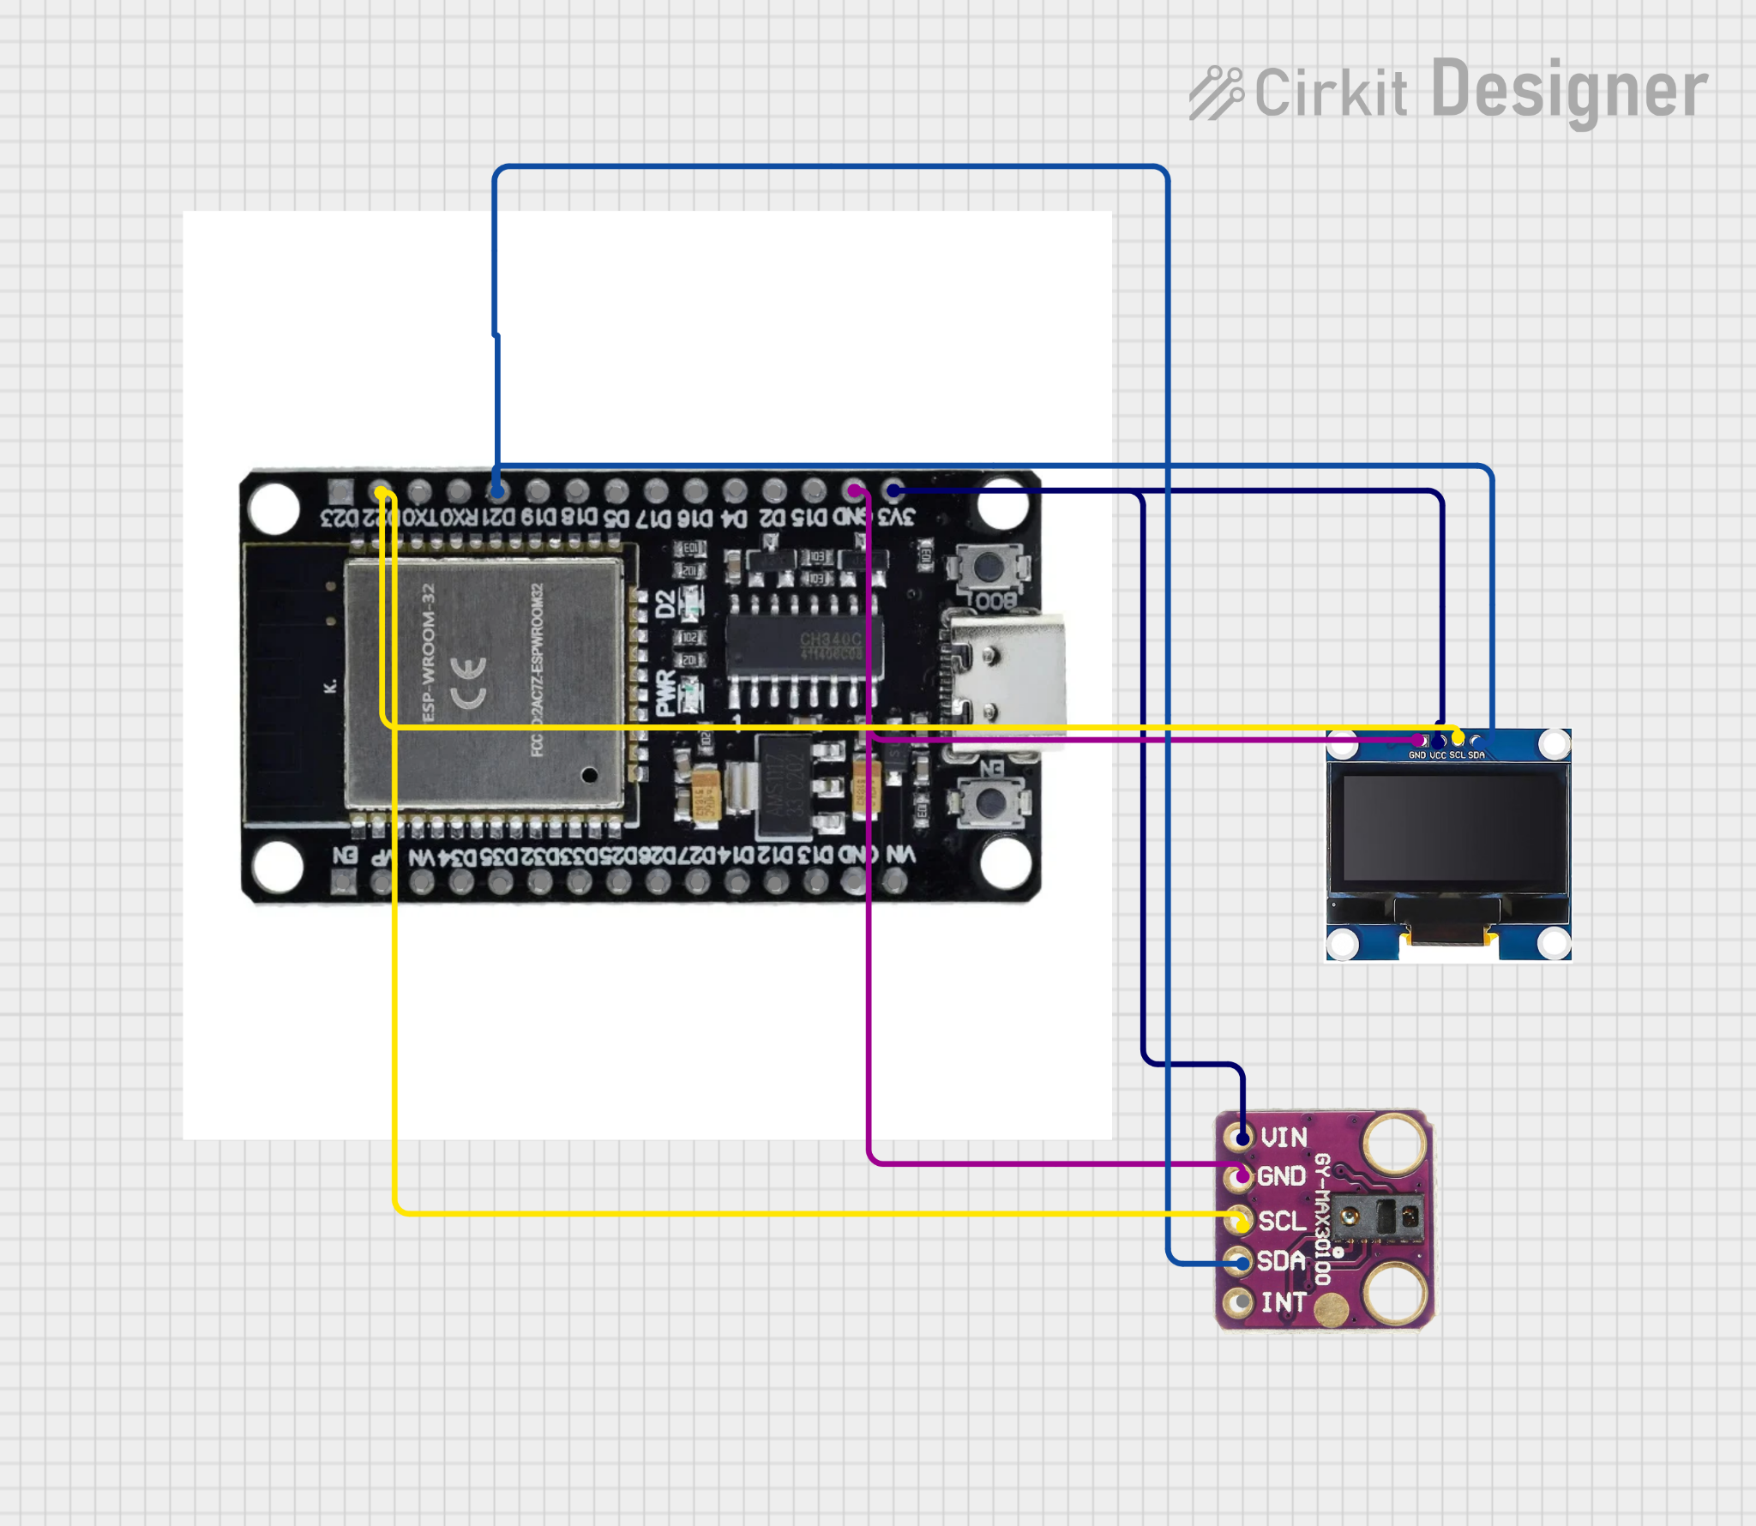
Methodology
Phase 1: Hardware Assembly and Component Integration
This phase details the mock-up prototype assembly using ESP32, SSD1306 OLED display, and breadboard components. No physical sensor is required for this phase.
COMPONENTS | FUNCTION
ESP32 Microcontroller | Serves as the "brain". Generates mock vital sign data, executes display logic, manages Wi-Fi connectivity, and runs web server for dashboard communication.
SSD1306 OLED Display (0.96") | Displays real-time vital signs, measurement status, and Wi-Fi connection indicator using I2C communication protocol.
MAX30102 Pulse Oximeter Sensor (Future) | Measures heart rate (BPM) and SpO₂ using optical sensing technology. To be integrated in future implementation; documented for reference.
Built-in BOOT Button (GPIO 0) | Triggers mock measurement generation when pressed; configured as INPUT_PULLUP with software debouncing.
Breadboard & Jumper Wires | Temporary solderless circuit assembly for prototype development; allows easy reconfiguration and testing.
USB Cable & Power Adapter | Provides 5V power to ESP32 and connected components during development and demonstration.
Prototype Enclosure (Optional) | Simple plastic or 3D-printed box to house components for demonstration and protect circuitry.
Wiring Configuration (I2C Protocol)
For the complete MEDIBAND system, both the SSD1306 OLED display and MAX30102 pulse oximeter sensor utilize the I2C protocol, sharing the same SDA and SCL pins on the ESP32. The mock-up prototype uses only the OLED display, with the sensor connections documented for future integration.
Component | Pin | ESP32 Connection
SSD1306 OLED | VCC | 3.3V (3V3)
SSD1306 OLED | GND | GND
SSD1306 OLED | SDA | GPIO 21 (D21)
SSD1306 OLED | SCL | GPIO 22 (D22)
MAX30102 Sensor | VCC | 3.3V (3V3)
MAX30102 Sensor | GND | GND
MAX30102 Sensor | SDA | GPIO 21 (D21) - Shared
MAX30102 Sensor | SCL | GPIO 22 (D22) - Shared
Phase 2: Firmware Development and Mock Data Implementation
This phase involves developing the ESP32 firmware to generate mock vital sign data, manage the OLED display, handle Wi-Fi connectivity, and respond to button triggers.
Software Module | Implementation Details
Mock Data Generator | Functions: generateRandomHeartRate() returns 50–130 BPM; generateRandomSpO2() returns 85–100%. Includes realistic constraints (lower SpO₂ correlates with elevated HR).
OLED Display Controller | Library: Adafruit_SSD1306. Displays real-time values, measurement status, risk classification indicator, and Wi-Fi connection status.
Web Server & API Endpoints | Library: AsyncWebServer or WebServer. Endpoints: /api/generate (trigger measurement), /api/status (get current values), /api/dashboard (serve web interface).
Phase 3: Testing and Validation
This phase verifies that all components function correctly together and that the mock-up prototype accurately simulates the intended behavior of the final system.
Test ID | Test Name | Expected Result (Pass Criteria)
HW-1 | Power On Test | OLED displays startup message; Wi-Fi connects to network; BOOT button responds to press.
HW-2 | Button Trigger Test | Pressing BOOT button generates new random BPM and SpO₂ values displayed on OLED.
SW-1 | Random Generation Test | Generated values fall within specified ranges (50–130 BPM, 85–100% SpO₂).
SW-2 | AI Classification Test | Values correctly classified as Normal/Warning/Critical based on thresholds.
WEB-1 | Dashboard Trigger Test | Web button click triggers ESP32 to generate measurement and update OLED.
INT-1 | Full Integration Test | BOOT button and web button both trigger measurements; OLED and dashboard synchronize within 2 seconds; AI classification consistent.

Expected Outcomes
The implementation of the MEDIBAND mock-up prototype is expected to successfully validate the software architecture, web dashboard functionality, and AI-assisted risk classification logic before physical sensor integration. By demonstrating functional dual-trigger capability (BOOT button and web interface), real-time OLED display synchronization with cloud dashboard, and accurate risk classification based on simulated vital sign thresholds, this prototype proves the feasibility of the complete MEDIBAND system design.
This mock-up approach enables parallel development, allowing the hardware team to prepare for sensor integration while the software team refines the user interface and dashboard functionality. The validated architecture ensures that transitioning to real MAX30102 sensor data will require minimal code changes — simply replacing mock generation functions with actual sensor reading functions while maintaining all display, dashboard, and AI logic unchanged.
Overall, the mock-up prototype demonstrates that ESP32 can reliably serve both OLED display and web dashboard simultaneously, that web-based control of embedded systems is feasible for clinical environments, that AI-assisted risk classification logic functions correctly, and that the system architecture is modular and ready for sensor integration. Upon successful completion of this mock-up, the transition to a fully functional MEDIBAND with real sensor data will be straightforward and lower-risk.
References
Cleveland Clinic. (2025). Pulse oximetry: Function, method & readings. Retrieved from https://my.clevelandclinic.org/health/diagnostics/pulse-oximetry
Kumbhare, A., Mahajan, N., & Sharma, S. (2023). Monitoring SpO₂, heart rate, and body temperature on ESP32 microcontroller with IoT integration. Journal of Electronics and Applied Research, 15(3), 245–262.
National Institutes of Health - NCBI Bookshelf. (2023). Pulse oximetry - StatPearls. Retrieved from https://www.ncbi.nlm.nih.gov/books/NBK470348/
Purwitosari, D., Ismail, M. A., & Wijaya, S. K. (2023). Design and development of SpO₂, BPM, and body temperature monitoring tool using MAX30102 sensor and ESP32 microcontroller. Journal of Engineering and Technology Research, 8(2), 112–128.
Random Nerd Tutorials. (2025). ESP32 web server - Arduino IDE. Retrieved from https://randomnerdtutorials.com/esp32-web-server-arduino-ide/
Torp, K. D., Park, Y., & Raoof, S. (2023). Pulse oximetry: Understanding its basic principles and clinical applications. Journal of Critical Care Medicine, 29(4), 456–473.
Yale Medicine. (2023). Pulse oximetry: Understanding the fifth vital sign. Retrieved from https://www.yalemedicine.org/conditions/pulse-oximetry

