WEEK 1 INTERNSHIP TASK
Data Acquisition, Cleaning, and Exploratory Data Analysis

Dataset | IBM HR Analytics Employee Attrition & Performance
Domain | Human Resources / Employee Attrition
Original dataset | 1,470 rows × 35 columns
Cleaned dataset | 1,470 rows × 31 columns

Tools: Python | Pandas | NumPy | Matplotlib | Seaborn | Google Colab
KORA AHLYA
Internship Week 1 Report

1. Introduction
This Week 1 internship task covers data acquisition, data cleaning, preprocessing, and exploratory data analysis (EDA). The IBM HR Analytics Employee Attrition & Performance dataset was selected to study employee attrition and workplace-related factors.

2. Task Objective
The objective is to simulate a real data-science data-preparation workflow by acquiring a public dataset, inspecting its quality, cleaning unnecessary information, exploring important patterns, and documenting the results with code and visualizations.

3. Dataset and Data Acquisition
The dataset was loaded in Google Colab using Pandas. The public source used in the notebook is Kaggle. The dataset contains 1,470 employee records and 35 columns.
df = pd.read_csv("/content/WA_Fn-UseC_-HR-Employee-Attrition.csv")

4. Data Cleaning and Preprocessing

4.1 Missing Values
Missing values were checked for every column. No missing values required imputation.
missing_values = df.isnull().sum()

4.2 Duplicate Records
Duplicate rows were checked using df.duplicated().sum(). The cleaned dataset contains no duplicate rows.
duplicate_count = df.duplicated().sum()

4.3 Removing Constant Columns
EmployeeCount, Over18, and StandardHours were removed because each contains only one unique value and therefore provides no useful variation.
df_clean = df_clean.drop(columns=["EmployeeCount", "Over18", "StandardHours"])

4.4 Removing Identifier Column
EmployeeNumber was removed because it is an identifier, not a meaningful analytical feature.
df_clean = df_clean.drop(columns=["EmployeeNumber"])

4.5 Final Validation
The cleaned dataset contains 1470 rows and 31 columns. Final validation found 0 missing values and 0 duplicate rows.

5. Exploratory Data Analysis
Seven visualizations were created to meet the internship requirement and examine the distribution of attrition and relationships with important employee variables.

5.1 Employee Attrition Distribution
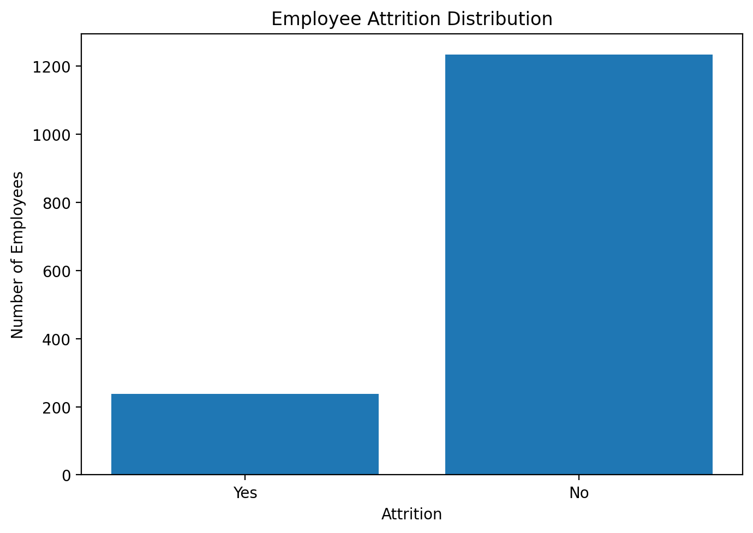
Figure: 5.1 Employee Attrition Distribution
The dataset has 1233 employees who stayed (83.88%) and 237 employees who left (16.12%). This shows a clear class imbalance in the Attrition outcome.

5.2 Employee Attrition by Department
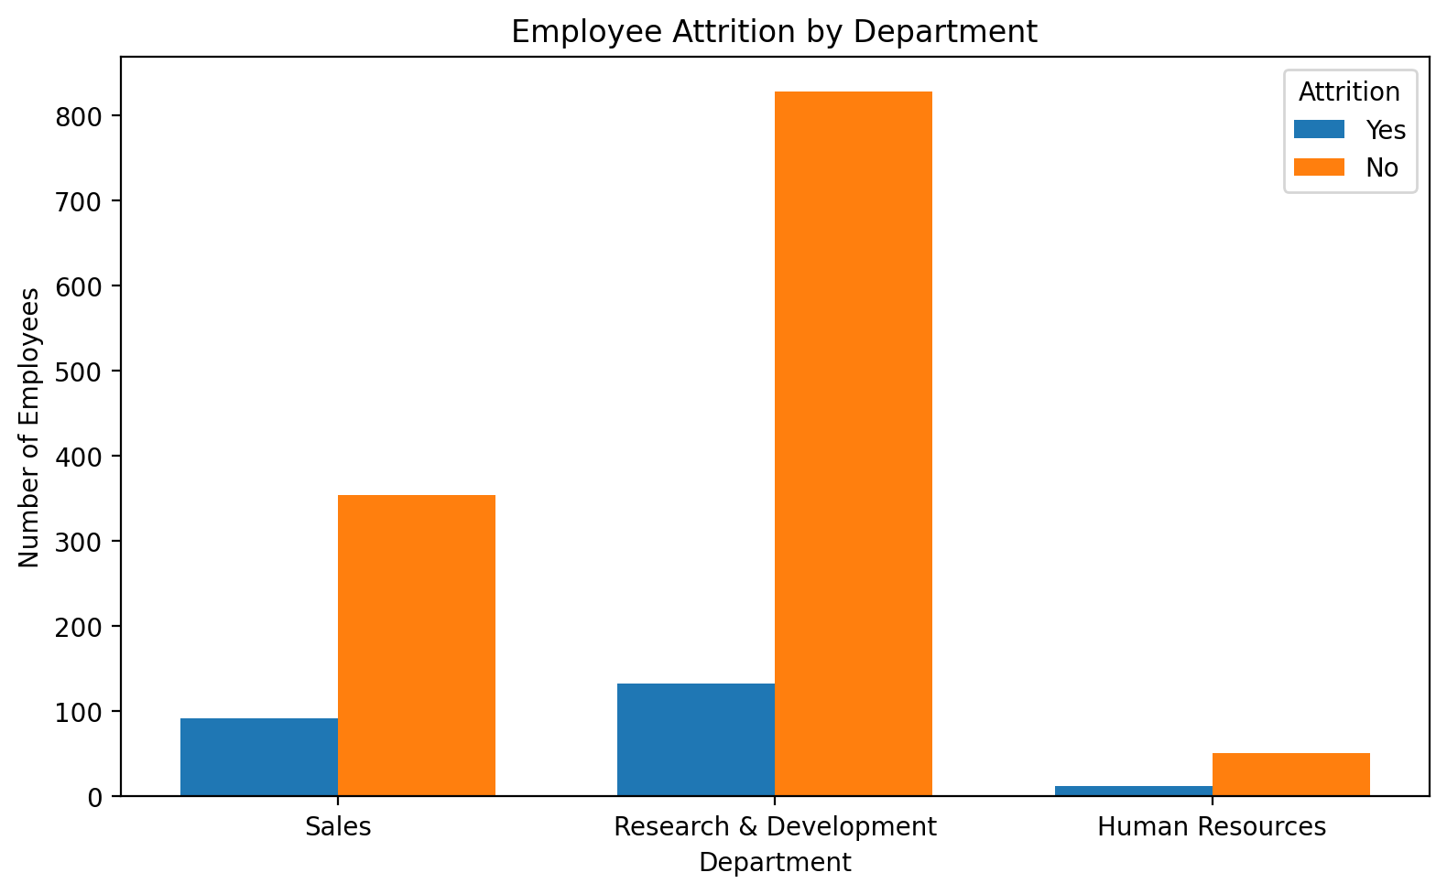
Figure: 5.2 Employee Attrition by Department
The chart compares employees who stayed and left within each department. Because department sizes differ, raw counts should be interpreted together with department-level proportions.

5.3 Employee Attrition by Overtime Status
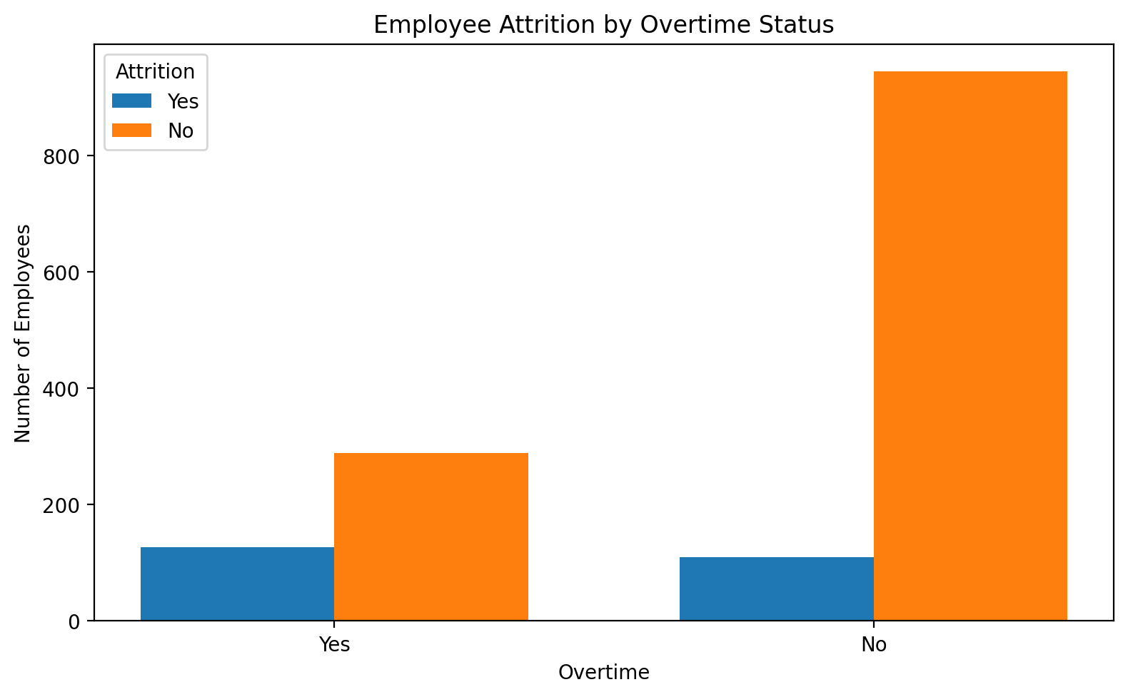
Figure: 5.3 Employee Attrition by Overtime Status
Employees who work overtime have an attrition rate of 30.53%, compared with 10.44% for employees who do not work overtime. This is an association, not proof of causation.

5.4 Monthly Income Distribution by Attrition
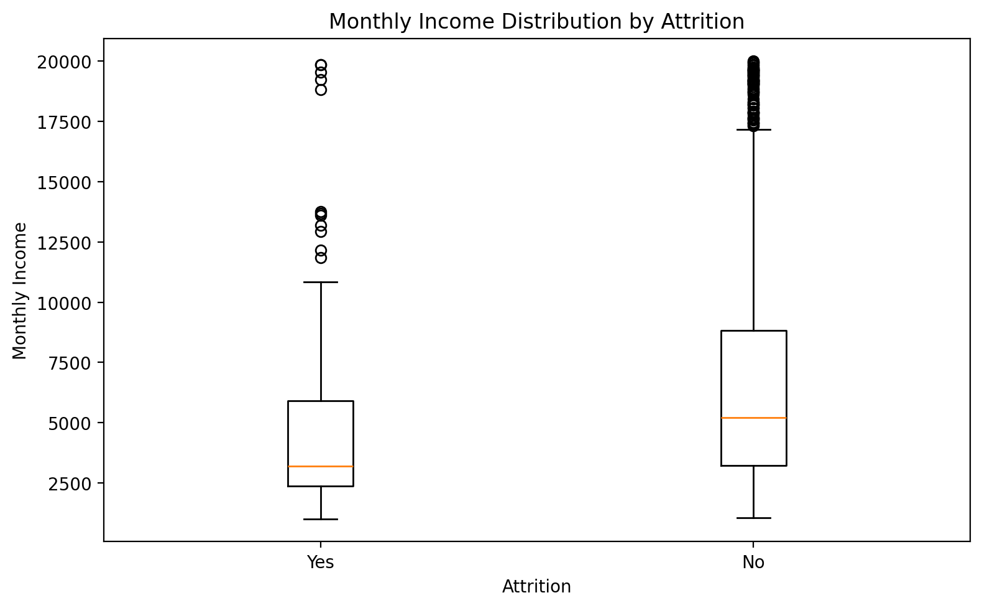
Figure: 5.4 Monthly Income Distribution by Attrition
The mean monthly income is 4787.09 for employees who left and 6832.74 for employees who stayed. The boxplot also shows the spread and outliers.

5.5 Correlation Heatmap
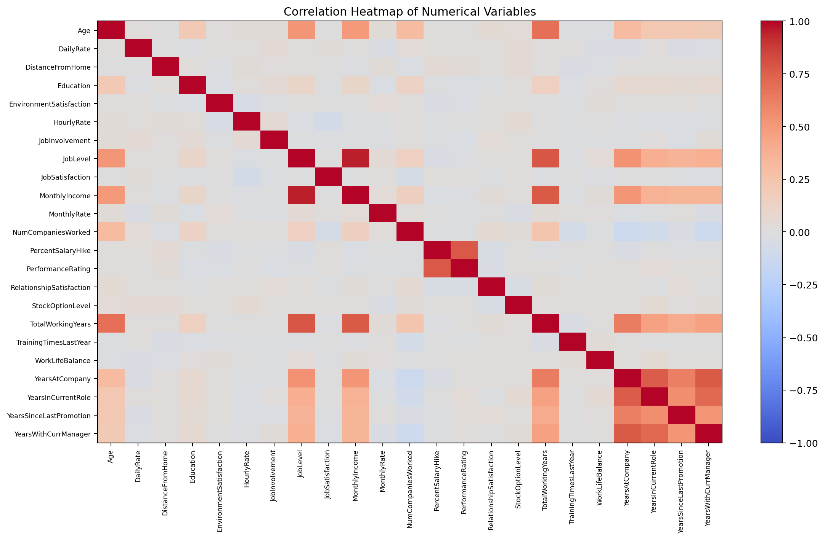
Figure: 5.5 Correlation Heatmap
The heatmap summarizes the direction and strength of relationships among numerical variables. Correlation indicates association and does not establish causation.

5.6 Employee Attrition by Job Satisfaction
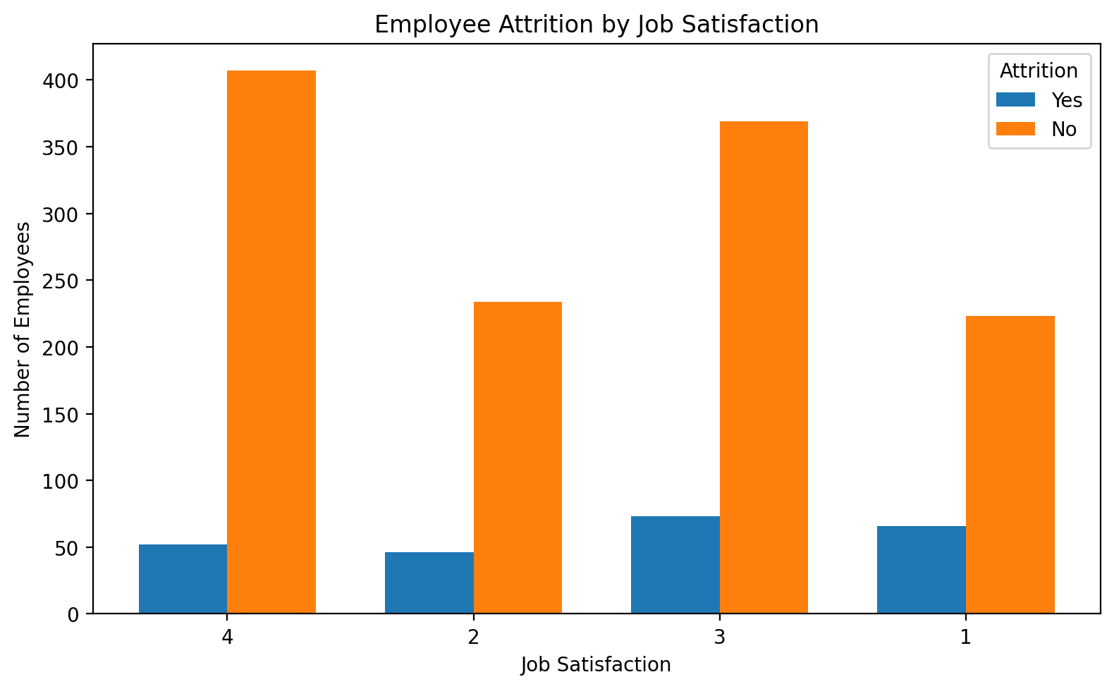
Figure: 5.6 Employee Attrition by Job Satisfaction
Attrition proportions vary across job-satisfaction levels. The highest observed attrition proportion is at level 1 (22.84%), while the lowest is at level 4 (11.33%).

5.7 Employee Attrition by Work-Life Balance
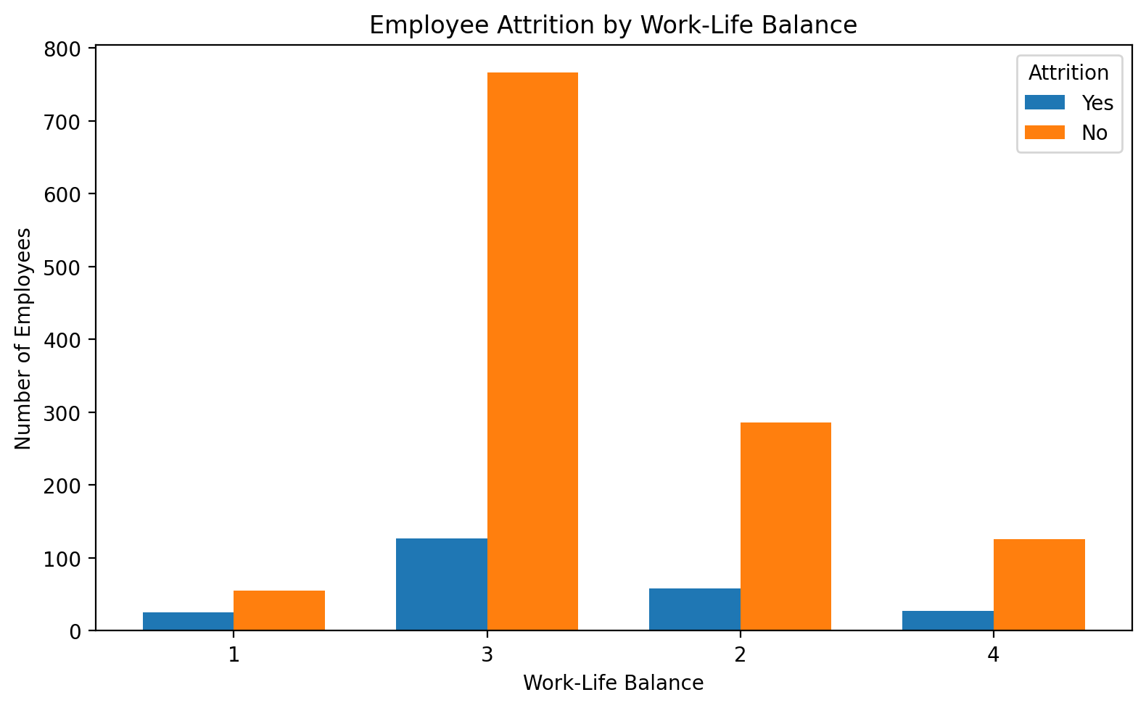
Figure: 5.7 Employee Attrition by Work-Life Balance
Attrition proportions vary across work-life-balance levels. The highest observed attrition proportion is at level 1 (31.25%), while the lowest is at level 3 (14.22%).

6. Key Insights
- The Attrition target is imbalanced, so future models should use appropriate evaluation metrics rather than accuracy alone.
- Overtime is associated with a higher attrition proportion in this dataset.
- Monthly income differs between employees who left and those who remained and should be interpreted together with job level, role, and experience.
- Job satisfaction and work-life balance show different attrition proportions and are suitable factors for further investigation.
- The numerical correlation heatmap shows relationships among several employee characteristics, especially among job level, income, and experience-related variables.

7. Limitations
- This is exploratory analysis and does not prove causal relationships.
- Department counts alone are not sufficient for comparing attrition risk because departments have different sizes.
- The dataset represents a specific employee population and should not automatically be generalized to every organization.

8. Future Scope
The cleaned dataset can be used for predictive modelling. Future steps include encoding categorical variables, feature selection, train-test splitting, model comparison, hyperparameter tuning, and evaluation using precision, recall, F1-score and ROC-AUC.

9. Conclusion
The Week 1 task completed the required data acquisition, cleaning, preprocessing, and exploratory analysis workflow. Seven relevant visualizations were produced and the cleaned dataset is ready for future machine-learning analysis.

10. Deliverables
- cleaned_employee_attrition.csv
- 01_attrition_distribution.png
- 02_attrition_by_department.png
- 03_overtime_vs_attrition.png
- 04_monthly_income_vs_attrition.png
- 05_correlation_heatmap.png
- 06_job_satisfaction_vs_attrition.png
- 07_worklife_balance_vs_attrition.png

Appendix: Core Code Snippets

Import Libraries
import pandas as pd
import numpy as np
import matplotlib.pyplot as plt
import seaborn as sns

Load Dataset
df = pd.read_csv("/content/WA_Fn-UseC_-HR-Employee-Attrition.csv")

Clean Dataset
df_clean = df.drop(columns=["EmployeeCount", "Over18", "StandardHours", "EmployeeNumber"])

Save Cleaned Dataset
df_clean.to_csv("cleaned_employee_attrition.csv", index=False)

