WEEK 5 INTERNSHIP REPORT
Comprehensive Data Science Project Reporting and Strategic Recommendations
Project: Employee Attrition Analysis, Statistical Validation, and Machine Learning Prediction
Dataset: IBM HR Analytics Employee Attrition & Performance
Domain: Human Resources / Employee Retention
Author: Kora Ahalya
Tools: Python, Pandas, NumPy, SciPy, Scikit-learn, Matplotlib, Seaborn, Google Colab

1. Executive Summary
This final-week project integrates the data science workflow completed during the internship, covering data preparation, exploratory analysis, advanced visualization, statistical validation, machine learning, model evaluation, and strategic recommendations. The project uses the IBM HR Analytics Employee Attrition & Performance dataset to understand employee attrition and provide evidence that can support HR decision-making.
The analysis examined attrition across overtime, job satisfaction, job role, monthly income, and other employee characteristics. A Chi-Square Test of Independence was used to formally test the relationship between overtime status and attrition. The test returned a Chi-Square statistic of 87.5643 with 1 degree of freedom and p < 0.001. Cramér's V was 0.2441, indicating a noticeable association. A Logistic Regression model was then developed to predict attrition. It achieved 86.05% accuracy, 61.54% precision, 34.04% recall, 43.84% F1-score, and AUC 0.8079.
The central practical finding is that overall accuracy does not tell the entire story. The model has useful discrimination but misses many actual attrition cases, as shown by its relatively low recall for the Attrition class. Therefore, the model should be treated as a screening and decision-support tool rather than an automated HR decision system.

2. Project Synthesis
Internship Week | Contribution
Week 1 | Data acquisition, cleaning, preprocessing, descriptive analysis, and exploratory visualizations.
Week 2 | Advanced visualizations and data storytelling to communicate patterns.
Week 3 | Hypothesis formulation, Chi-Square testing, p-value interpretation, and Cramér's V.
Week 4 | Logistic Regression development and evaluation using classification metrics, confusion matrix, and ROC/AUC.
Week 5 | Integration of findings, feature/risk analysis, business impact, and strategic recommendations.

3. Business Problem and Objectives
Employee attrition can increase recruitment and training requirements and can result in the loss of organizational experience. The project objective is to understand attrition patterns, validate an important relationship statistically, predict attrition using machine learning, and translate the evidence into practical recommendations.
- Identify important patterns associated with employee attrition.
- Use visual analysis to communicate these patterns.
- Statistically validate the association between overtime and attrition.
- Build and evaluate a machine learning model for attrition prediction.
- Identify areas that deserve additional HR investigation.
- Recommend practical and responsible actions for stakeholders.

4. Methodology
- Used the cleaned IBM HR Analytics Employee Attrition & Performance dataset.
- Performed descriptive and comparative analysis of employee attrition.
- Created visualizations for overall attrition, overtime, job satisfaction, job role, and income.
- Applied the Chi-Square Test of Independence to OverTime and Attrition.
- Calculated Cramér's V to quantify association strength.
- Encoded the binary target and categorical features for machine learning.
- Used an 80:20 stratified train-test split and StandardScaler.
- Trained Logistic Regression and evaluated accuracy, precision, recall, F1-score, and AUC.
- Analyzed model coefficients and predicted risk levels for the test set.

5. Exploratory and Visual Analysis

5.1 Overall Employee Attrition
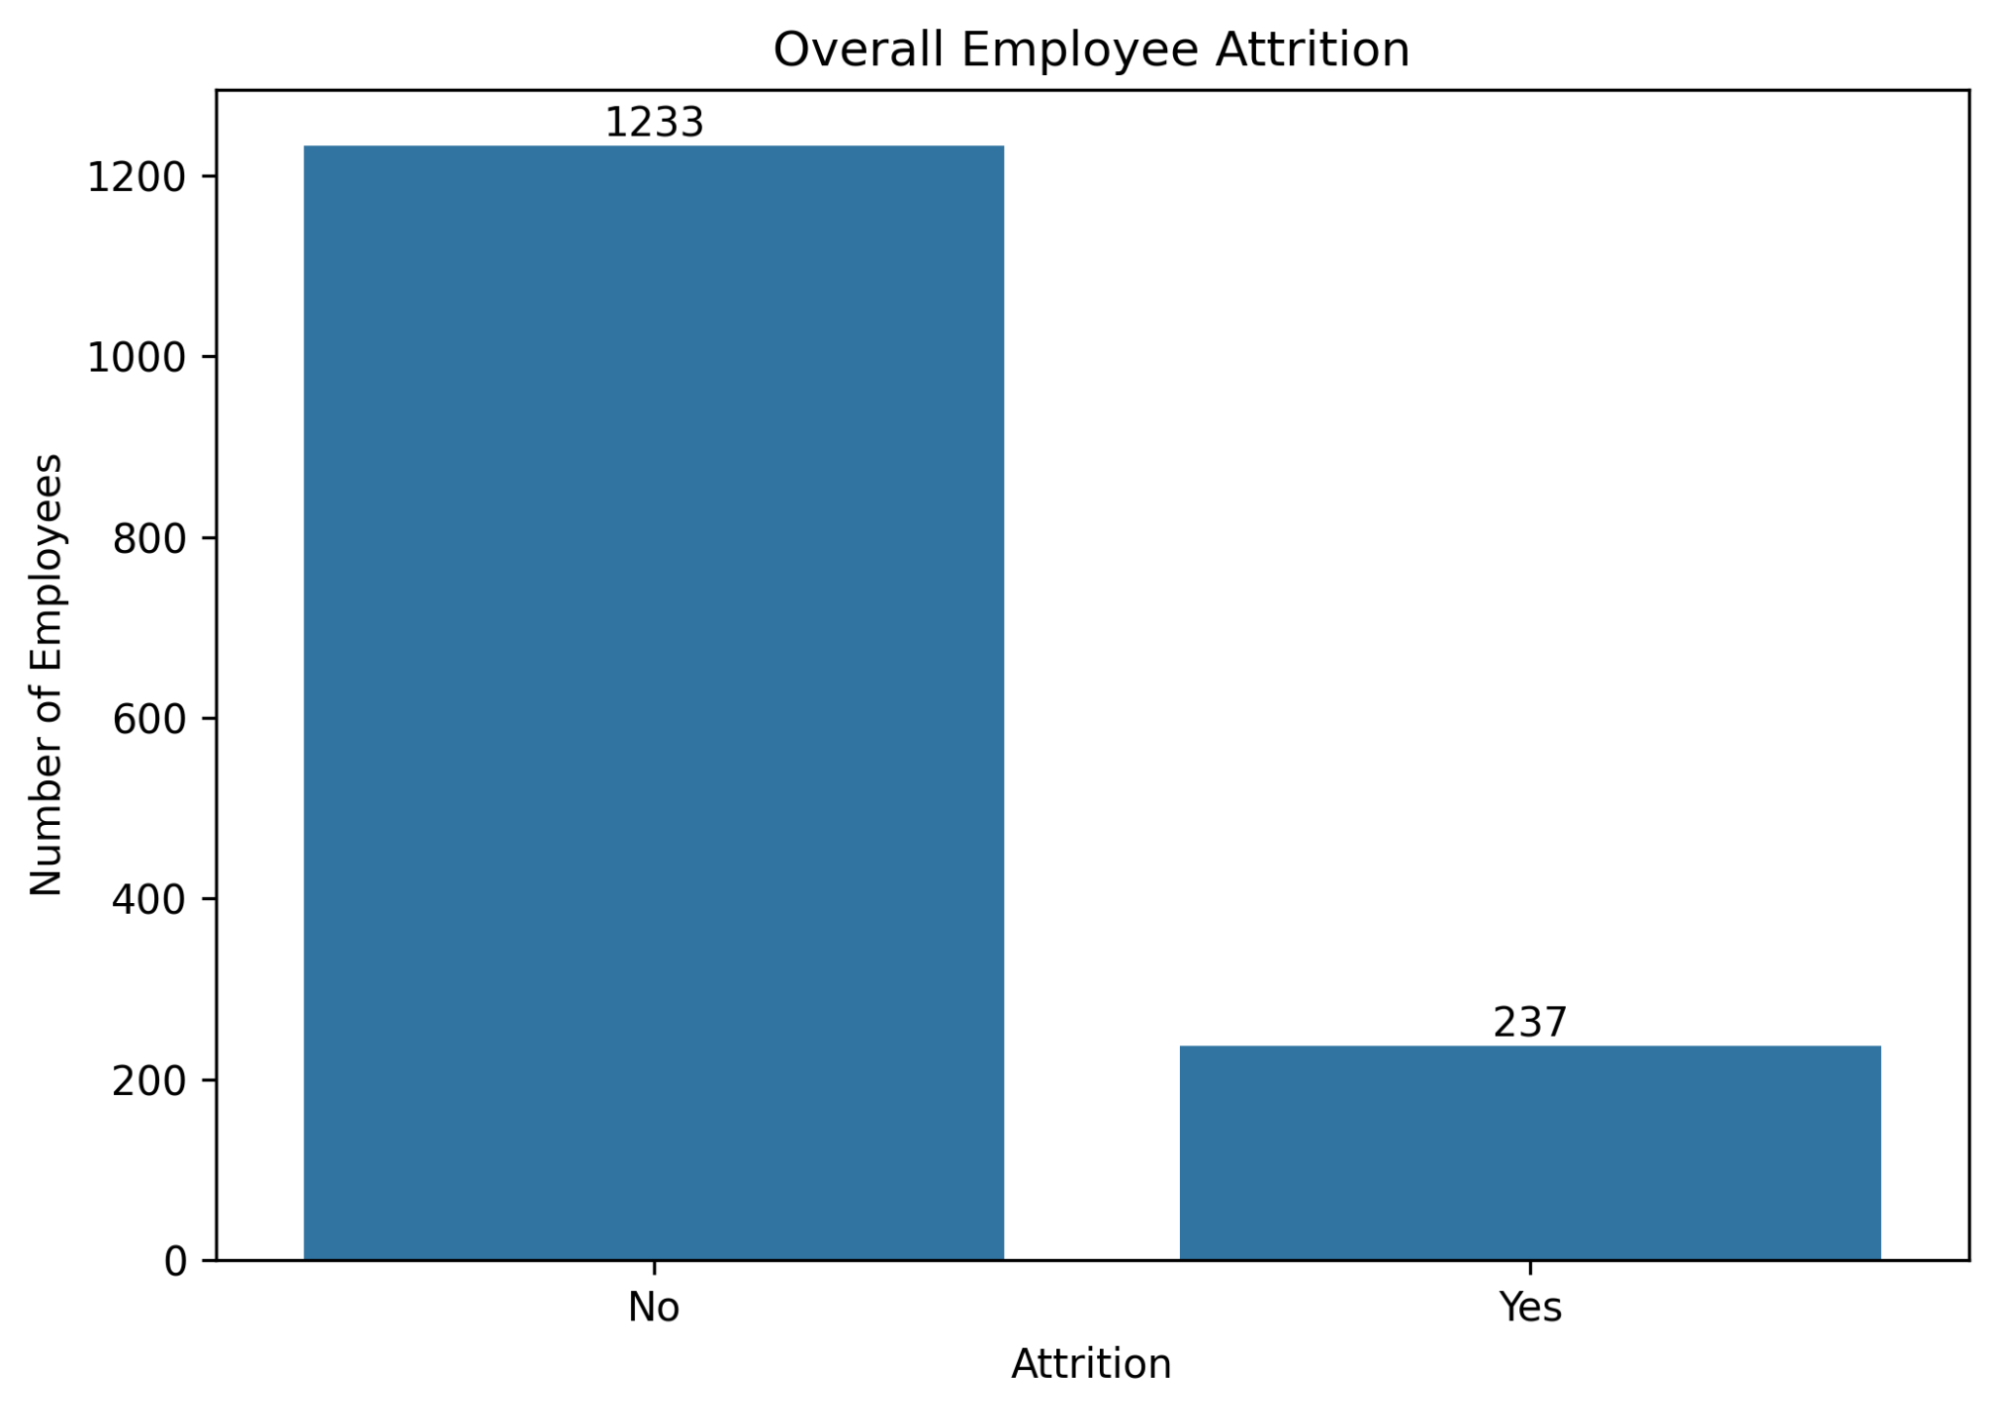
The overall attrition chart establishes the baseline distribution of employees who stayed versus employees who left. The imbalance between the classes is important because it affects how model performance should be interpreted.

5.2 Employee Attrition Rate by Overtime
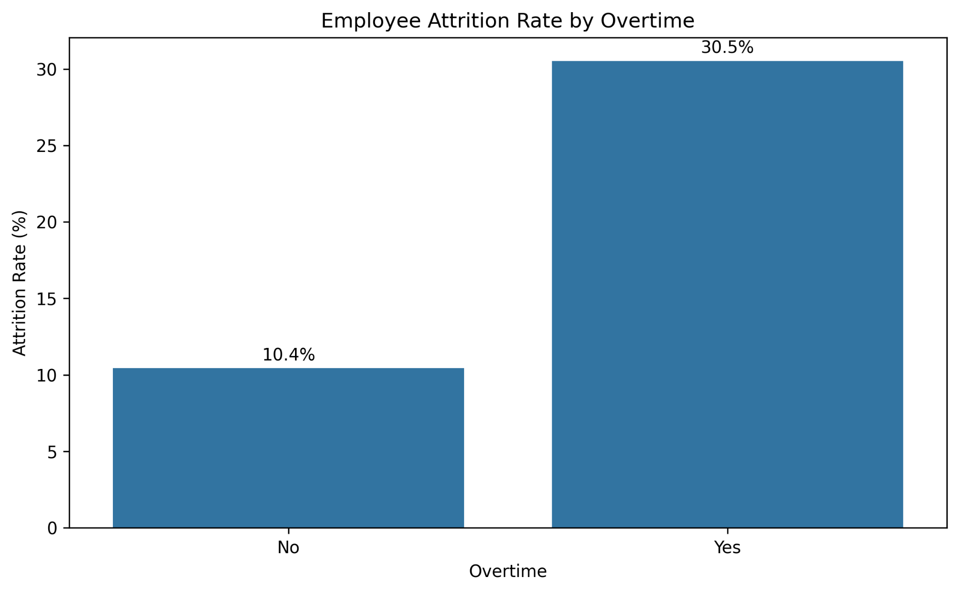
The overtime chart shows a much higher observed attrition rate among employees who work overtime. This visible difference motivated the formal hypothesis test performed later in the project.

5.3 Employee Attrition Rate by Job Satisfaction
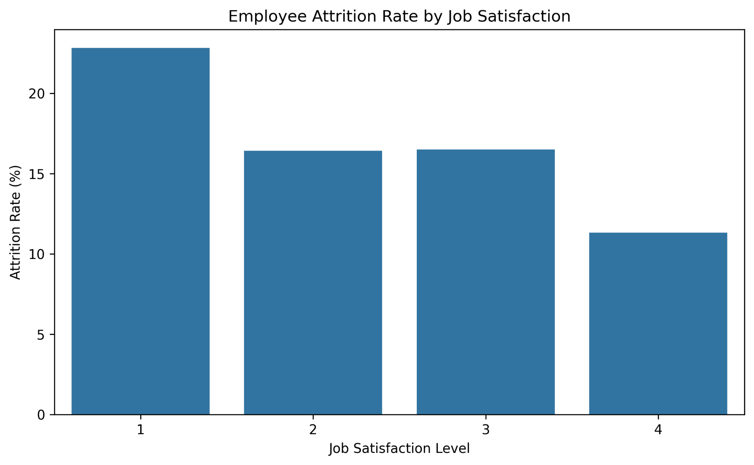
The chart compares attrition rates across job satisfaction levels. It provides a clear view of differences between satisfaction groups and supports further HR investigation.

5.4 Employee Attrition Rate by Job Role
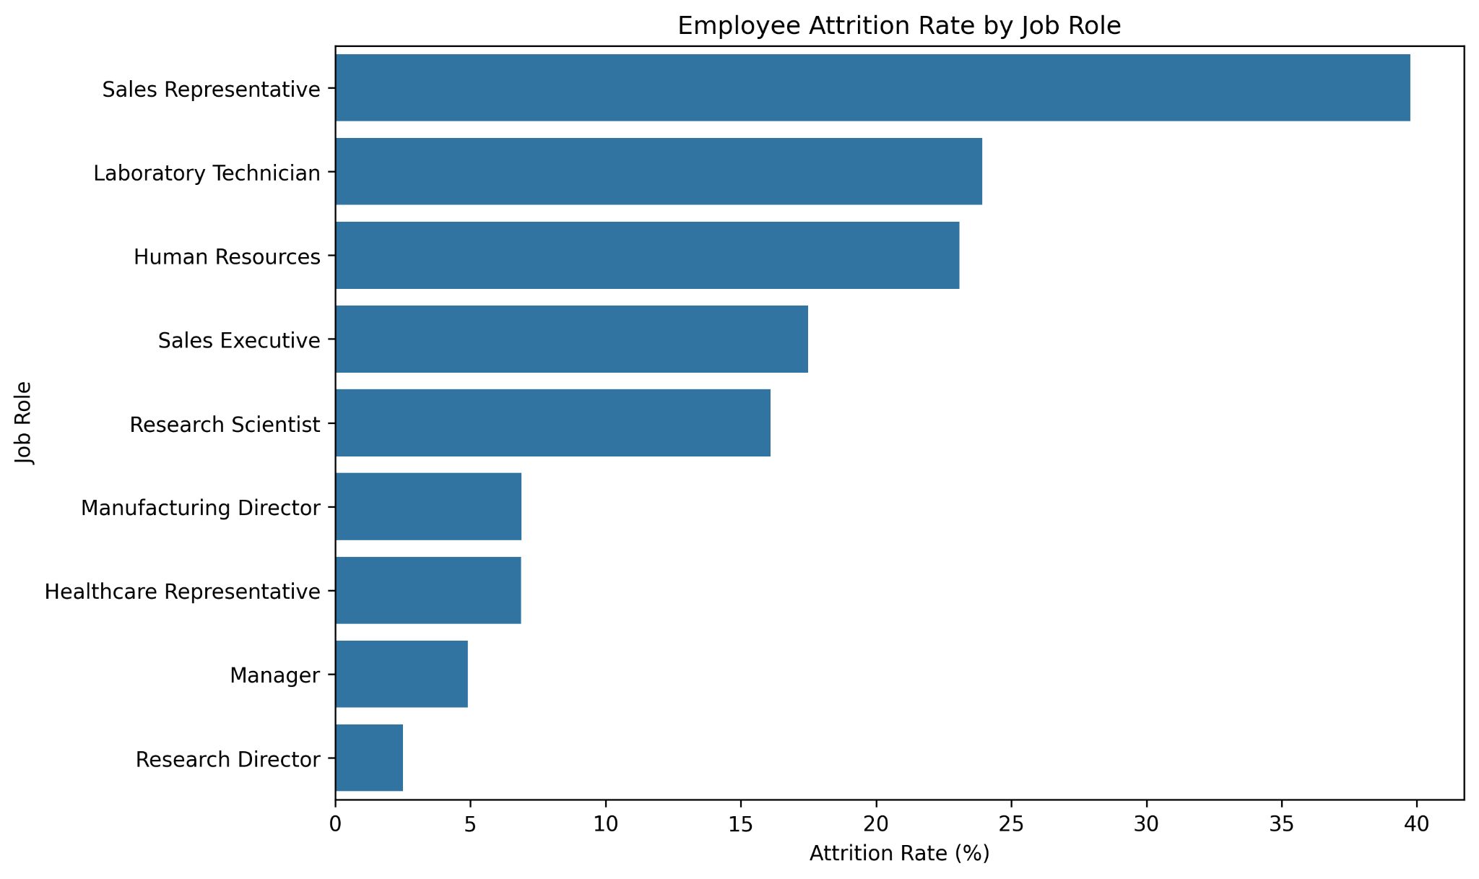
The job-role comparison shows that attrition rates differ considerably across roles. This indicates that retention strategies may need to be tailored to specific employee groups.

5.5 Monthly Income Distribution by Attrition
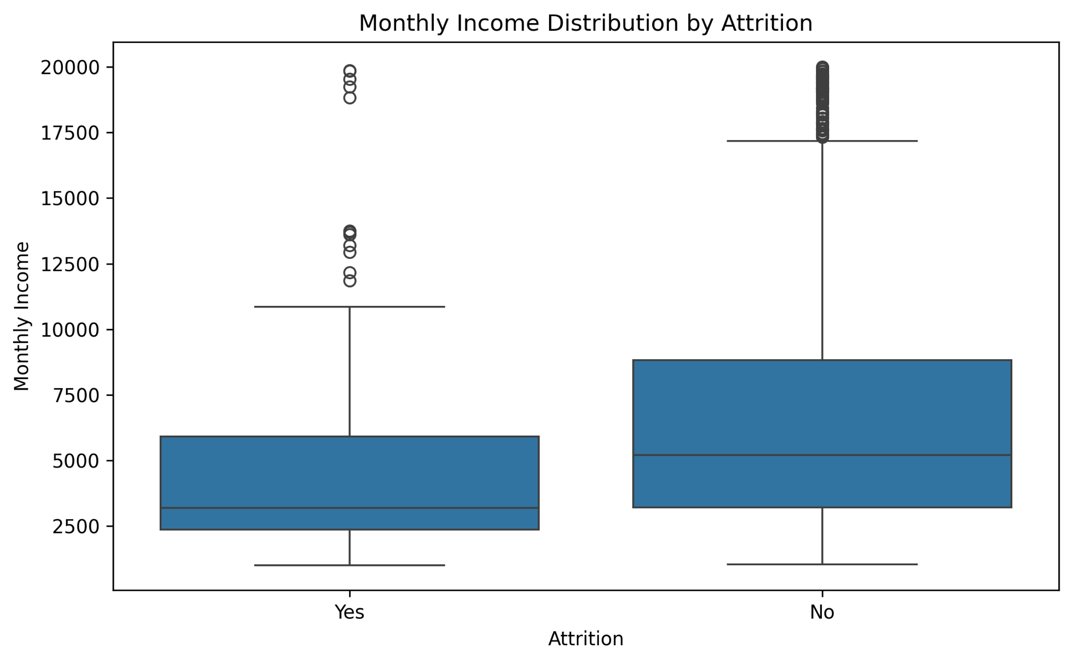
The box plot compares monthly income distributions between employees who stayed and those who left. It also shows variation and outliers that are not visible from averages alone.

6. Statistical Validation
The selected hypothesis was whether working overtime is significantly associated with employee attrition. Because both variables are categorical, the Chi-Square Test of Independence was used.
H₀: There is no significant association between overtime status and employee attrition.
H₁: There is a significant association between overtime status and employee attrition.
Measure | Result
Chi-Square Statistic | 87.5643
Degrees of Freedom | 1
P-value | p < 0.001
Significance Level | 0.05
Cramér's V | 0.2441
Decision | Reject H₀
The p-value is below 0.001 and therefore below the 0.05 significance level. The null hypothesis is rejected. This provides strong evidence of a statistically significant association between overtime status and attrition in the dataset. The effect size of 0.2441 indicates a noticeable association. This result establishes association, not causation.

7. Machine Learning Model Development and Evaluation
A Logistic Regression model was developed to predict employee attrition. The target was encoded as No = 0 and Yes = 1, categorical predictors were one-hot encoded, the data was split using an 80:20 stratified split, and standardization was applied using StandardScaler.
Model Metric | Result
Accuracy | 86.05%
Precision | 61.54%
Recall | 34.04%
F1-Score | 43.84%
AUC | 0.8079
The model provides useful overall discrimination, as indicated by the AUC of 0.8079. However, recall for the Attrition class is 34.04%, which means the model misses a substantial number of employees who actually left. This is more important for an HR retention use case than accuracy alone.

7.1 Final Model Confusion Matrix
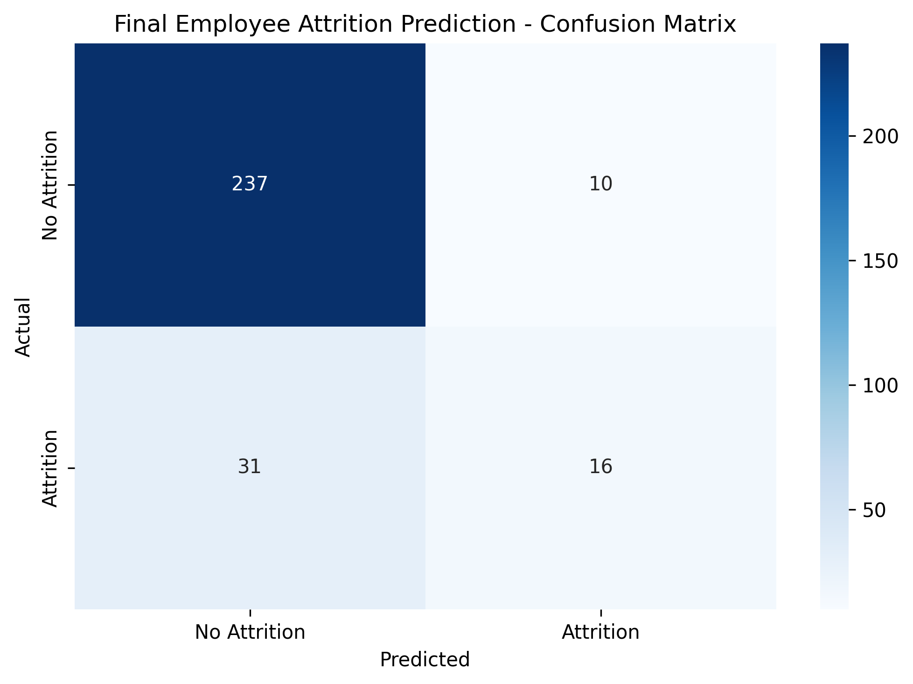
The confusion matrix displays 237 true negatives, 10 false positives, 31 false negatives, and 16 true positives. The 31 false negatives show the model's main weakness in detecting actual attrition cases.

7.2 Final Model ROC Curve
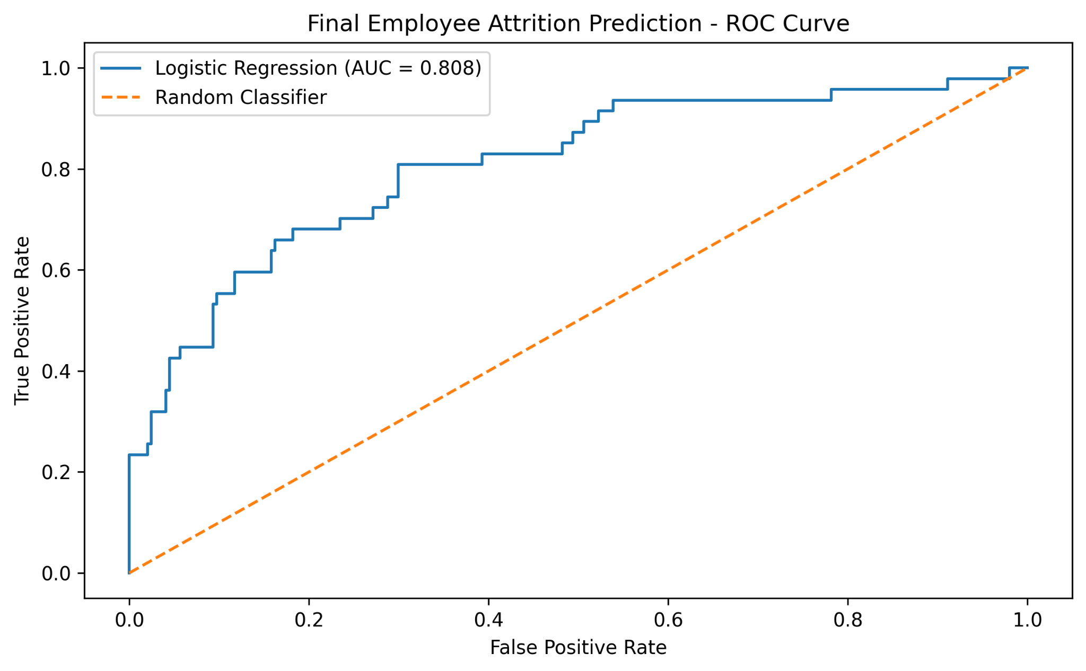
The ROC curve shows the trade-off between true positive and false positive rates. The AUC of 0.8079 indicates useful separation between the two classes above random classification.

7.3 Final Model Performance Metrics
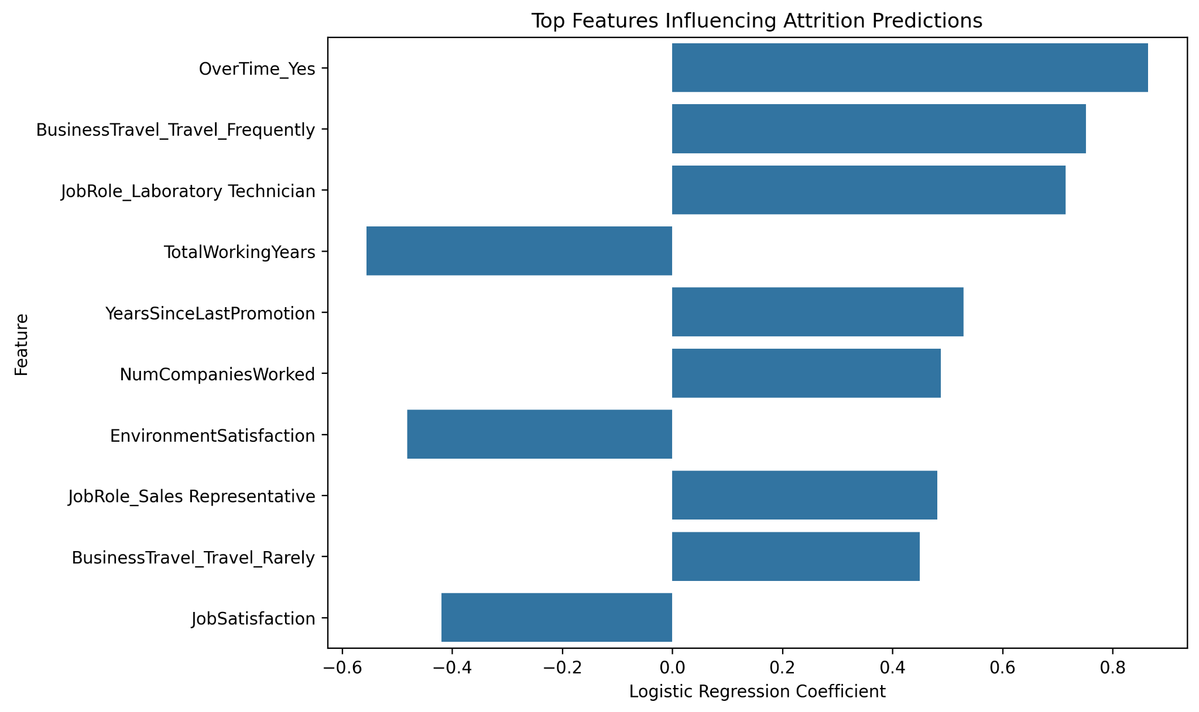
The feature-coefficient visualization identifies the variables with the largest absolute Logistic Regression coefficients in the final fitted model. Coefficient direction represents the model's contribution to the predicted class, not causal impact.

7.4 Predicted Employee Risk Levels
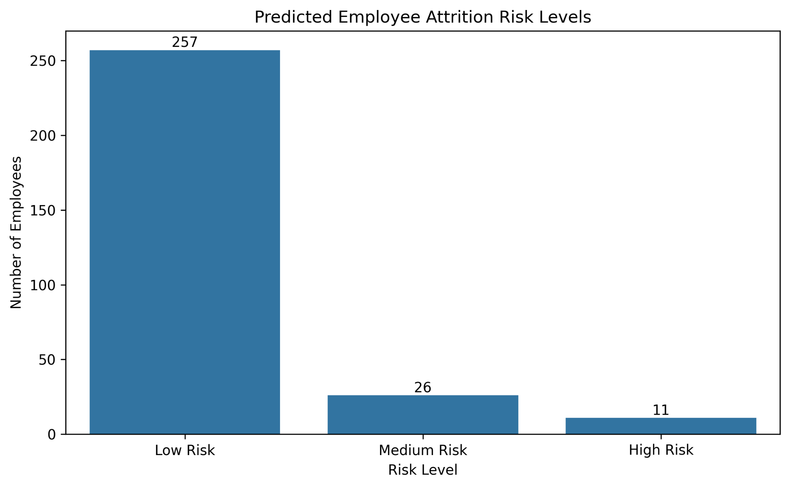
The risk chart groups test-set employees into low-, medium-, and high-risk categories using predicted attrition probabilities. In the generated test set, 257 employees were classified as low risk, 26 as medium risk, and 11 as high risk. These categories are useful for prioritization, but they should not be treated as definitive predictions of future employee behavior.

8. Strategic Recommendations
Monitor overtime exposure: The significant overtime-attrition association supports closer review of workload, staffing, scheduling, and sustained overtime patterns.
Prioritize retention review for high-risk groups: Use model outputs as a screening mechanism to identify cases for human review, not as automatic employment decisions.
Focus on employee satisfaction: Investigate lower-satisfaction groups and identify workplace issues that may be contributing to turnover.
Investigate high-attrition job roles: Roles with comparatively high observed attrition should be examined for workload, management, career progression, and compensation conditions.
Improve the predictive model: Address class imbalance, tune the probability threshold, perform cross-validation, and compare additional classification algorithms.
Track the findings over time: Repeat the analysis with updated employee data to determine whether the observed patterns remain stable.

9. Potential Business Impact
The integrated workflow provides HR stakeholders with a structured way to move from descriptive observations to statistically validated findings and predictive analysis. The significant overtime relationship can guide questions about workload and staffing, while the predictive model can help prioritize cases for deeper review.
The project also demonstrates why model evaluation must reflect business objectives. An accuracy of 86.05% may appear strong, but the low 34.04% attrition recall means the baseline model misses many actual attrition cases. Using recall, F1-score, and AUC alongside accuracy provides a more realistic assessment.

10. Limitations and Future Improvements
- The analysis is based on one dataset and may not generalize to every organization.
- The Chi-Square test identifies association, not causation.
- The baseline model has low recall for the Attrition class.
- No training-versus-test comparison or cross-validation was included in the reported baseline results, so overfitting cannot be diagnosed conclusively from these results alone.
- Class imbalance affects model interpretation.
- Future work should compare multiple models, address imbalance, tune thresholds, use cross-validation, and consider precision-recall analysis.
- Predicted risk categories should be treated as decision-support information and not used as automatic employment decisions.

11. Representative Code Snippets
# Hypothesis testing
contingency_table = pd.crosstab(df["OverTime"], df["Attrition"])
chi2, p_value, dfree, expected = chi2_contingency(contingency_table)
# Machine learning
df_model["Attrition"] = df_model["Attrition"].map({"No": 0, "Yes": 1})
X = pd.get_dummies(df_model.drop("Attrition", axis=1), drop_first=True)
y = df_model["Attrition"]
X_train, X_test, y_train, y_test = train_test_split(
X, y, test_size=0.20, random_state=42, stratify=y
)
scaler = StandardScaler()
X_train_scaled = scaler.fit_transform(X_train)
X_test_scaled = scaler.transform(X_test)
model = LogisticRegression(max_iter=1000, random_state=42)
model.fit(X_train_scaled, y_train)
y_pred = model.predict(X_test_scaled)
y_probability = model.predict_proba(X_test_scaled)[:, 1]

12. Conclusion
This final project integrates the major data science skills developed during the internship into one end-to-end employee attrition study. Exploratory and advanced visualizations were used to understand patterns in overtime, job satisfaction, job role, income, and overall attrition. The Chi-Square test provided strong statistical evidence of an association between overtime and attrition, with chi-square = 87.5643, df = 1, and p < 0.001.
The Logistic Regression model achieved 86.05% accuracy and AUC = 0.8079, demonstrating useful predictive ability. At the same time, the 34.04% recall for the Attrition class highlights a significant weakness. The most responsible use of the current model is as a screening tool that supports further HR investigation. Improving class handling, threshold selection, validation, and algorithm choice should be priorities for future work.

13. Internship Workflow and Workload
The final project consolidates data acquisition and cleaning, exploratory analysis, visualization and storytelling, statistical hypothesis testing, machine learning development, evaluation, risk analysis, and strategic recommendation. The internship specifies an estimated workload of 30–35 hours. This report documents the project activities and should be accompanied by the intern's actual time record if required.

