WEEK 3 INTERNSHIP REPORT
Statistical Analysis and Hypothesis Testing in Python

Dataset: IBM HR Analytics Employee Attrition & Performance
Domain: Human Resources / Employee Attrition
Author: Kora Ahalya
Tools: Python, Pandas, NumPy, SciPy, Matplotlib, Seaborn, Google Colab

Week 3 Task

1. Introduction
Week 3 focused on applying statistical analysis and hypothesis testing to a real-world business problem using the IBM HR Analytics Employee Attrition & Performance dataset. The analysis investigated whether employee overtime status is statistically associated with employee attrition. The purpose was to move beyond descriptive analysis and use a formal statistical test to determine whether the observed relationship was statistically significant at a 5% significance level.

2. Dataset Description
The analysis used the cleaned IBM HR Analytics Employee Attrition & Performance dataset prepared during the previous internship work. The dataset contains employee-level human resources information. For this hypothesis test, the two variables of interest were OverTime and Attrition.
Variable | Type | Role in Analysis
OverTime | Categorical | Independent variable
Attrition | Categorical | Outcome variable

3. Research Question
Does working overtime have a significant relationship with employee attrition?

4. Hypothesis Formulation
Null Hypothesis (H₀): There is no significant association between overtime status and employee attrition.
Alternative Hypothesis (H₁): There is a significant association between overtime status and employee attrition.
Significance level (α): 0.05

5. Methodology
Both OverTime and Attrition are categorical variables. Therefore, the Chi-Square Test of Independence was selected to test whether the distribution of attrition differs by overtime status. A contingency table was created from the observed frequencies, expected frequencies were computed under the assumption of independence, and the chi-square statistic and p-value were used for the hypothesis decision.
Cramér's V was also calculated to describe the strength of association. This complements the p-value because statistical significance alone does not indicate the practical magnitude of a relationship.

6. Python Code Used
import pandas as pd
import numpy as np
from scipy.stats import chi2_contingency
df_clean = pd.read_csv("cleaned_employee_attrition.csv")
contingency_table = pd.crosstab(
df_clean["OverTime"],
df_clean["Attrition"]
)
chi2, p_value, degrees_of_freedom, expected = chi2_contingency(
contingency_table
)
n = contingency_table.to_numpy().sum()
min_dimension = min(contingency_table.shape) - 1
cramers_v = np.sqrt(
chi2 / (n * min_dimension)
)
print("Chi-Square Statistic:", chi2)
print("Degrees of Freedom:", degrees_of_freedom)
print("P-value:", p_value)
print("Cramer's V:", cramers_v)

7. Statistical Test Results
Metric | Result
Chi-Square Statistic | 87.5643
Degrees of Freedom | 1
P-value | p < 0.001
Significance Level | 0.05
Cramér's V | 0.2441
Decision | Reject H₀
The Python output displayed the p-value as 0.0 because it was below the displayed numerical precision. For formal reporting, the result is correctly written as p < 0.001 rather than as an exact zero.

8. Interpretation of Results
The Chi-Square Test of Independence produced a chi-square statistic of 87.5643 with 1 degree of freedom and a p-value below 0.001. Since p < 0.001 is much smaller than the significance level of 0.05, the null hypothesis is rejected. The analysis therefore provides strong statistical evidence of an association between overtime status and employee attrition in this dataset.
The Cramér's V value of 0.2441 indicates a noticeable association between the two categorical variables. The analysis demonstrates statistical association, not causation, so the result does not prove that overtime alone causes employees to leave.

9. Visualizations Supporting the Statistical Test

Visualization 1: Employee Attrition Rate by Overtime Status
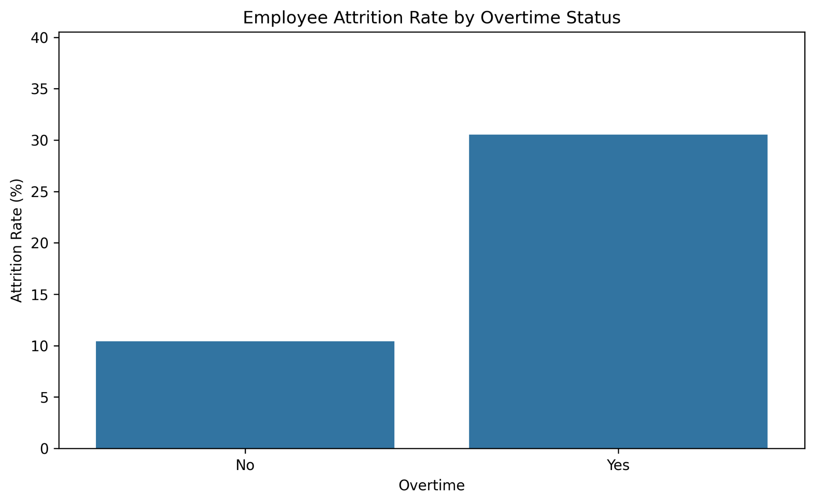
The chart compares the percentage of employees who left within each overtime category. It provides an intuitive view of the observed difference that is later tested statistically.

Visualization 2: Overtime Status vs Employee Attrition
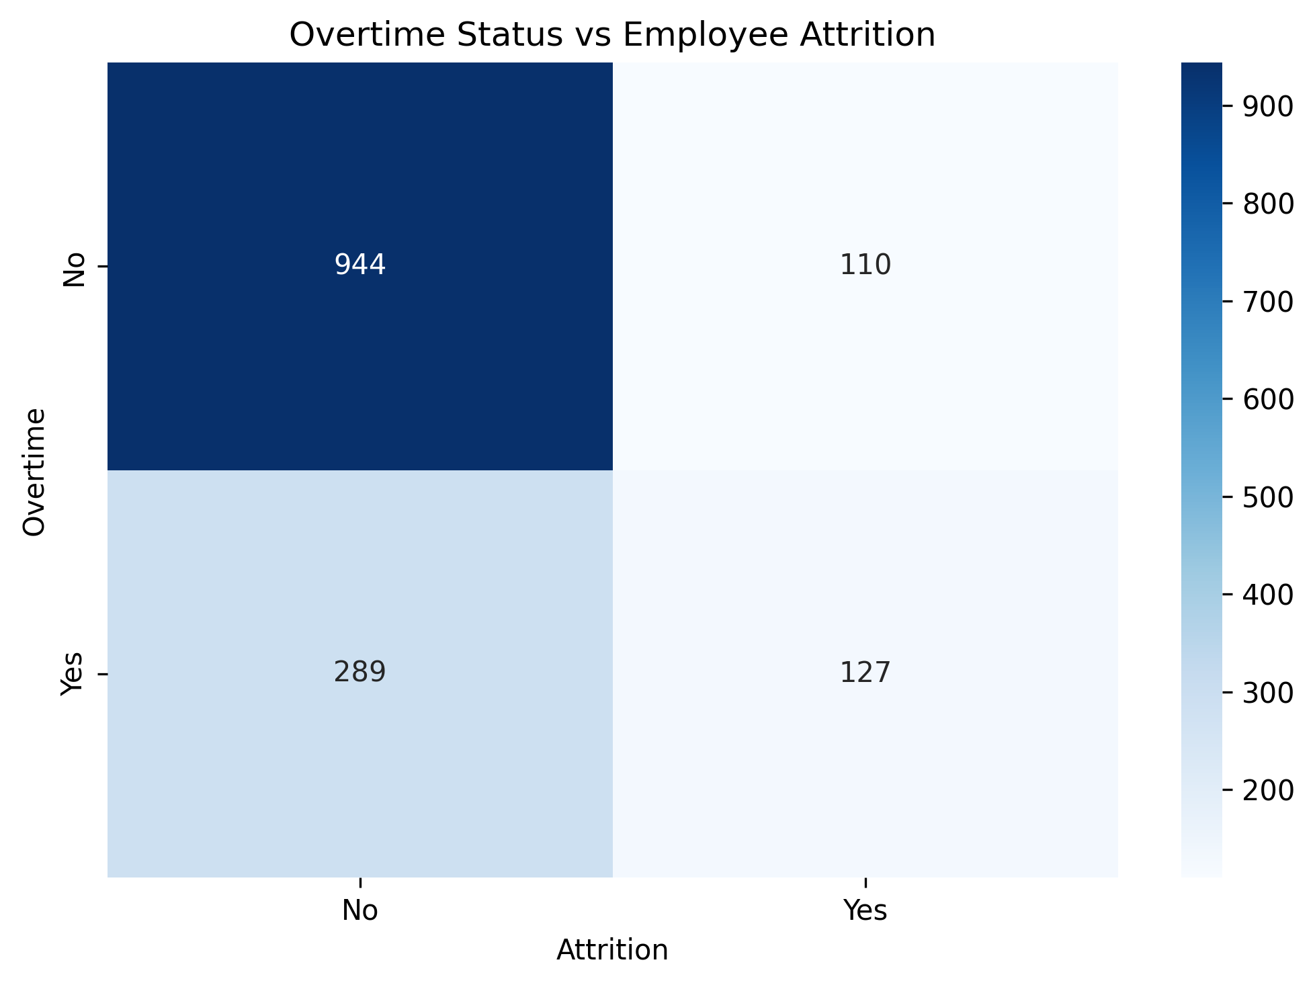
The heatmap shows the observed contingency-table counts. Employees who did not work overtime and employees who worked overtime can be compared directly across the attrition categories.

Visualization 3: Percentage of Employees Who Left by Overtime Status
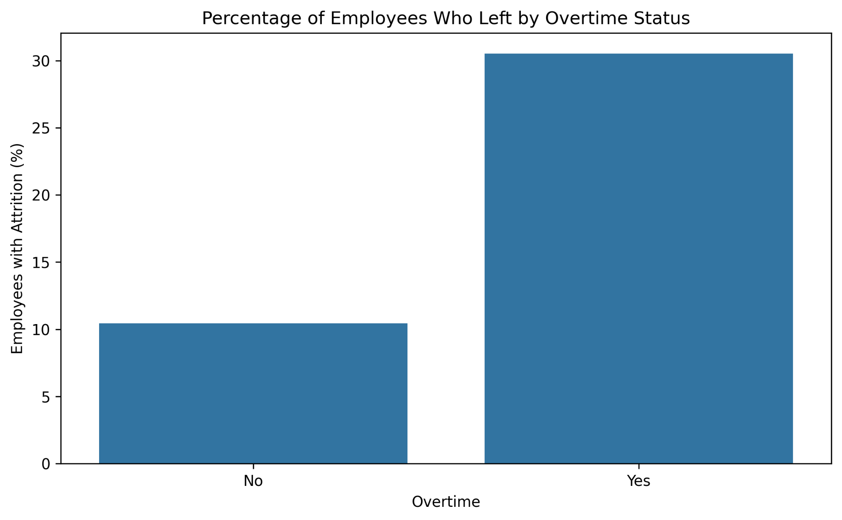
This visualization compares attrition percentages across overtime categories. It makes the difference in attrition rates especially clear for a non-technical audience.

10. Business Implications
The statistical evidence indicates that overtime status is associated with employee attrition in the analyzed HR dataset. From a business perspective, this result can be used as a signal for HR teams and managers to investigate workload, staffing, scheduling, employee well-being, and other workplace conditions affecting employees who work overtime.
The finding should not be used alone to claim that overtime causes turnover. Other factors such as job role, age, income, satisfaction, and career progression may also influence attrition. A broader analysis can help determine which combination of factors is most strongly related to employee retention.

11. Limitations
The Chi-Square Test of Independence evaluates association between categorical variables and does not establish causality. It also does not control for other potentially influential variables. Future work could use logistic regression or another multivariable technique to examine the relationship while controlling for additional employee characteristics.

12. Conclusion
This Week 3 analysis applied a Chi-Square Test of Independence to examine the relationship between overtime status and employee attrition. The test returned a chi-square statistic of 87.5643 with 1 degree of freedom and p < 0.001. Since the p-value is below 0.05, the null hypothesis was rejected. The Cramér's V value of 0.2441 indicates a noticeable association. The results provide statistical evidence that overtime status and attrition are associated in this dataset and provide a useful basis for deeper employee-retention analysis.

13. Workload and Process Summary
The Week 3 workflow covered formulation of a business hypothesis, selection of a suitable statistical test, contingency-table analysis, chi-square testing, p-value interpretation, effect-size calculation, supporting visualization, and documentation. The internship specifies an estimated workload of 30–35 hours; this report documents the required analytical workflow and should be paired with an actual time record if one was maintained.

