WEEK 4 INTERNSHIP REPORT
Machine Learning Model Development and Evaluation
Dataset: IBM HR Analytics Employee Attrition & Performance
Domain: Human Resources / Employee Attrition
Author: Kora Ahalya
Model: Logistic Regression
Tools: Python, Pandas, NumPy, Scikit-learn, Matplotlib, Seaborn, Google Colab

1. Introduction
Week 4 focused on developing and evaluating a basic machine learning classification model using Python. The objective was to build a model capable of predicting whether an employee would leave the organization based on available employee and workplace attributes. The IBM HR Analytics Employee Attrition & Performance dataset was used because Attrition is a binary target variable suitable for classification.

2. Problem Statement and Objective
The business problem is to identify employees who are likely to leave the organization. Early identification can help HR teams investigate relevant workplace factors and support employee-retention analysis.
Target variable: Attrition, where No = 0 and Yes = 1.
Machine learning approach: Binary classification using Logistic Regression.

3. Data Preparation and Preprocessing
The cleaned employee attrition dataset prepared in the earlier internship weeks was used. The Attrition column was converted to a binary numerical target. Categorical predictor variables were converted using one-hot encoding with drop_first=True. The data was split into training and testing sets using an 80:20 split with random_state=42 and stratification. StandardScaler was fitted on the training data and then applied to the test data.

4. Model Selection and Justification
Logistic Regression was selected because the target is binary. It is a standard classification algorithm that is relatively simple to interpret and produces class probabilities, making it appropriate for confusion-matrix, threshold, and ROC/AUC evaluation.

5. Key Python Code
df_model = df_clean.copy()
df_model["Attrition"] = df_model["Attrition"].map({"No": 0, "Yes": 1})
X = df_model.drop("Attrition", axis=1)
y = df_model["Attrition"]
X = pd.get_dummies(X, drop_first=True)
X_train, X_test, y_train, y_test = train_test_split(
X, y, test_size=0.20, random_state=42, stratify=y
)
scaler = StandardScaler()
X_train_scaled = scaler.fit_transform(X_train)
X_test_scaled = scaler.transform(X_test)
model = LogisticRegression(max_iter=1000, random_state=42)
model.fit(X_train_scaled, y_train)
y_pred = model.predict(X_test_scaled)
y_prob = model.predict_proba(X_test_scaled)[:, 1]

6. Model Evaluation Results
Metric | Result
Accuracy | 0.8605 (86.05%)
Precision | 0.6154 (61.54%)
Recall | 0.3404 (34.04%)
F1-Score | 0.4384 (43.84%)
AUC | 0.8079
The model achieved 86.05% accuracy and an AUC of 0.8079. However, performance on the positive Attrition class was weaker, with precision 0.62, recall 0.34, and F1-score 0.44.

7. Classification Report Interpretation
Class | Precision | Recall | F1-Score | Support
No Attrition | 0.88 | 0.96 | 0.92 | 247
Attrition | 0.62 | 0.34 | 0.44 | 47
The confusion matrix contains 237 true negatives, 10 false positives, 31 false negatives, and 16 true positives. The 31 false negatives are important because they represent employees who actually left but were not identified as attrition cases by the model.

8. Visualizations for Model Evaluation

Visualization 1: Confusion Matrix
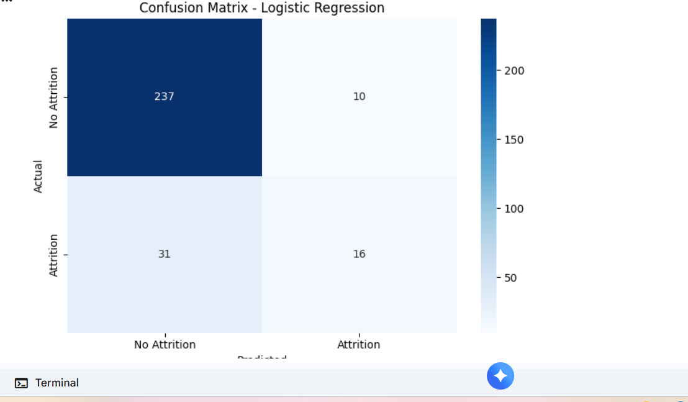
The confusion matrix summarizes correct and incorrect predictions. It shows that the model predicts No Attrition much more successfully than Attrition.

Visualization 2: ROC Curve
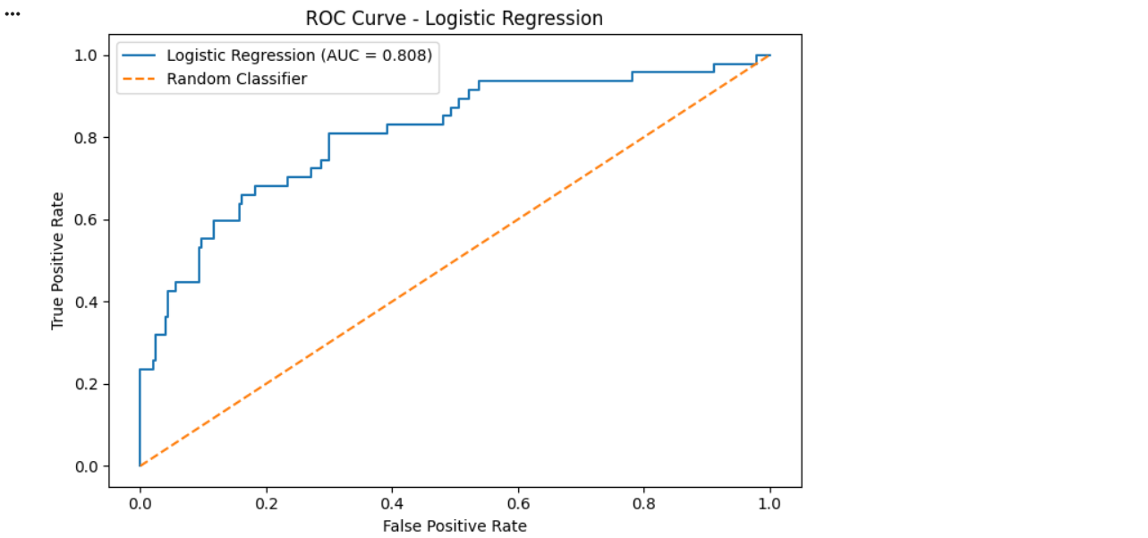
The ROC curve shows the trade-off between the true positive rate and false positive rate. The AUC of 0.8079 indicates useful discriminatory ability above random classification.

Visualization 3: Logistic Regression Performance Metrics
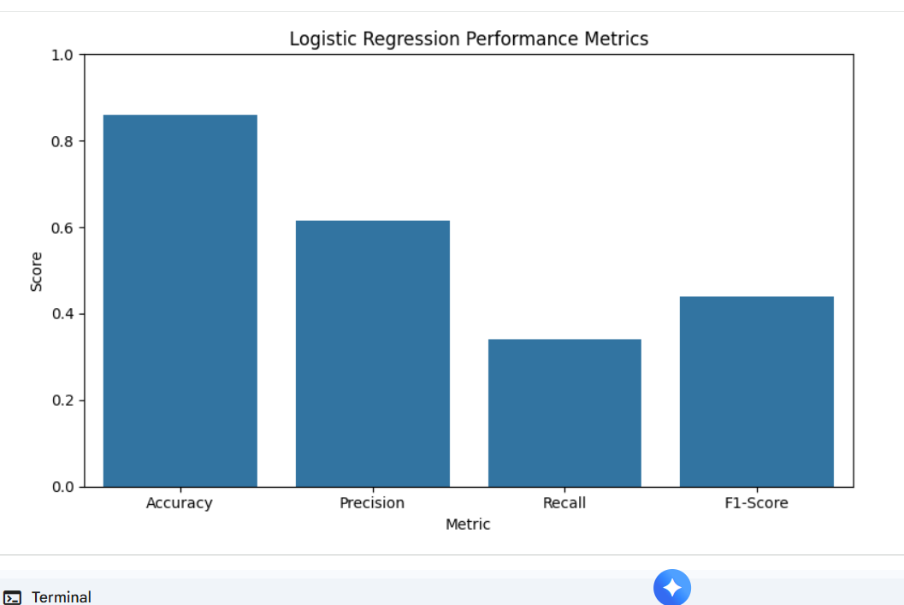
This chart compares accuracy, precision, recall, and F1-score. The lower recall compared with accuracy highlights the model's difficulty in identifying attrition cases.

9. Sources of Model Error
The main weakness is the low recall for the Attrition class. A recall of 0.3404 means that the model correctly identified only about 34% of employees who actually left. The confusion matrix shows 31 false negatives. The dataset also contains substantially more No Attrition cases than Attrition cases, so class imbalance can contribute to high overall accuracy while minority-class detection remains weak.

10. Overfitting and Underfitting Considerations
These results alone do not prove that the model is overfitting or underfitting because a training-set comparison or cross-validation result was not generated. A proper diagnosis would compare training and test performance and examine cross-validation scores. The AUC of 0.8079 suggests useful predictive separation, but the low attrition recall shows clear room for improvement.

11. Suggestions for Model Improvement
- Address class imbalance using class_weight='balanced' or appropriate resampling methods.
- Tune the classification threshold to improve recall when missing an attrition case is costly.
- Compare Logistic Regression with Decision Tree, Random Forest, SVM, or boosting models.
- Use cross-validation and hyperparameter tuning for more robust model selection.
- Perform feature selection and examine the most informative variables.
- Use additional metrics such as balanced accuracy and precision-recall curves.

12. Business Implications
The model demonstrates that employee attrition can be predicted to some extent from the available HR features. The AUC of 0.8079 indicates useful discrimination between employees who stay and those who leave. However, the low recall means the model should not be used as a standalone HR decision system. It is better treated as a screening or prioritization tool that can support further investigation.

13. Limitations
The analysis uses one dataset and one baseline classification algorithm. Results depend on the selected features, split, class distribution, and classification threshold. The model captures statistical patterns in the dataset and does not establish causal relationships.

14. Conclusion
A Logistic Regression model was developed to predict employee attrition using the IBM HR Analytics dataset. The model achieved 86.05% accuracy and an AUC of 0.8079. While performance was strong for employees who did not leave, recall for the Attrition class was only 34.04%, with an F1-score of 43.84%. This shows why accuracy alone is not sufficient for this business problem. Future work should focus on class imbalance, threshold tuning, cross-validation, feature selection, and comparison with additional machine learning algorithms.

15. Process Summary
The Week 4 workflow covered data preparation, target encoding, categorical-variable encoding, train-test splitting, feature scaling, Logistic Regression training, model evaluation, confusion-matrix and ROC visualizations, error analysis, and recommendations for improvement. The internship specifies an estimated workload of 30–35 hours; this report documents the required analytical workflow and should be paired with an actual time record if maintained.

