**Part A**

**I**

**A**

**B**

**C**

**D**

**E**

**F**

**G**

**Objective** : Name and decribe each component

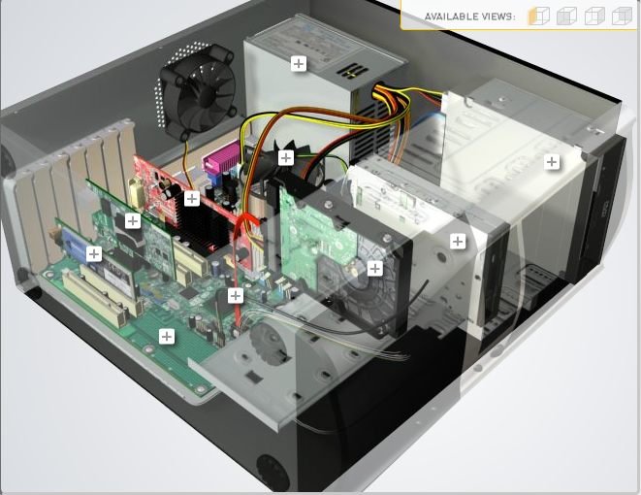

**H**

|  |  |  |
| --- | --- | --- |
| Download [**http://tinyurl.com/CW208-CAG-SIM**](http://tinyurl.com/CW208-CAG-SIM) PC Build Simulator.  Go through steps of building a PC, as you complete the simulation find and describe in detail components A to I. To run simulator first install <http://www.swffileplayer.com/> and open ***RootMovie.swf*** using SWF player. Alternatively install [Macromedia Flashplayer](https://fpdownload.macromedia.com/pub/flashplayer/updaters/32/flashplayer_32_sa.exe) . Ideally use a simulator as listed in class. | | |
| Label | Name each component | Description |
| A | Expansion card | Additional slots that fit into pci slot |
| B | GPU | Graphical processing unit |
| C | Cpu fan | Cooling unit for the processor |
| D | Power supply | Powers the components |
| E | Disk drive | Reads cd’s |
| F | Card/floppy disk reader | Reads memory cards and floppy disks |
| G | Hard drive | Storage device |
| H | Sata cable | Connects board to storage device |
| I | motherboard | Houses components |

**Part B**

**Objective**

Compare a pre-assembled system and the components that could be assembled to build a comparable system. After completing this practical, you should be able to:

1. Identify the components of a pre-assembled system
2. Locate prices for components needed to assemble a comparable system
3. Compare the cost of a pre-assembled system and a self-assembled system.

If you can’t find exact match for components, find the closest possible substitute. Use the Internet and available computer-related publications as your sources for information. Examples of websites for computer parts [www.komplett.ie](http://www.komplett.ie), [www.dell.ie](http://www.dell.ie), [www.custompc.ie](http://www.custompc.ie) [www.amazon.de](http://www.amazon.de)

MAKE SURE TO INCLUDE VALID LINKS TO WEB REFERENCES

[Pre Build](https://www.komplett.ie/paradigit-gaming-advanced-r5-gtx1660/80060887/product/9641#specificaties)

[Keyboard + mouse](https://www.amazon.com/Logitech-Desktop-Durable-Comfortable-keyboard/dp/B003NREDC8/ref=sr_1_5?dchild=1&keywords=keyboard&qid=1635346132&sr=8-5)

|  |  |  |
| --- | --- | --- |
|  | **Pre-Assembled Computer Package** | **Computer Package**  **Components** |
| **CPU** | AMD Ryzen 5 3600 | 250 $ |
| **Storage / Memory** | | |
| |  | | --- | |  | | RAM | | Hard Drive | |  | | |  | | --- | |  | | 8gb ddr4 3200mhz | |  | |  |   500gb ssd | 34 $  44$ |
| **Input/Output** | | |
| |  | | --- | | Keyboard | | Pointing Device | | Monitor | | Speakers | | Network Adapter | |  | |  | | Logitech mk120  Logitech optical wired | 26.88 $ bundle |
| **Bundled Software**  (Including Operating System) | Win 11 |  |
| **Total Cost** | 975.88 € | 930 $ |

**Part C**

**Objective**

You have been asked by a family friend to assist them with a computer purchase. They’re unfamiliar with technology and the terms used and have presented you with two alternatives machine choices. They would like to be able to write word documents, surf internet and play Minecraft © Mojang and Half-Life © Valve Software. They are considering playing Fortnight but are not sure yet, as it depends on machine cost and if they can extract some money from their Bitcoin wallet.

Compare Personal Computer Option A and B in relation to each of the side headings and recommend a system and any alterations.

|  |  |  |
| --- | --- | --- |
|  | Personal Computer  Option A | Personal Computer  Option B |
| CPU | 2.2 GHz Intel Celeron 450 | 3.2 GHz Intel Core i5 |
| Memory |  |  |
| |  | | --- | | Cache | | RAM | | Hard Drive | | CD-ROM/DVD | | |  | | --- | | 512 KB Cache | | 4 GB RAM | | 320 GB Hard Drive | | DVD+/-RW drive | | |  | | --- | | 4 MB Cache | | 8 GB RAM | | 1 TB Hard Drive | | DVD+/-RW drive | |
| Input/Output |  |  |
| |  | | --- | | Keyboard | | Pointing Device | | Screen | | Speakers | | Network Adapter | | |  | | --- | | USB multifunction keyboard | | USB optical mouse | | 20’’ HD flatscreen monitor | | Multimedia Speaker System | | Integrated 10/100/1000 Ethernet | | |  | | --- | | wireless multifunction keyboard | | wireless optical mouse | | 25’’ HD flatscreen monitor | | Dolby Surround Sound Speakers | | Integrated 10/100/1000 Ethernet | |

|  |
| --- |
| **Recommendations** |
| I would personally recommend going with option B for CPU and Memory however going with the input/output from options A, this is due to the fact that it would have the capabilities being able to handle the games that he wants to play but in the future it could handle games that the person would like to try in the future. The need for wireless option for mouse and keyboard can be more expensive than a usb, also usb more often has the faster response time to movements/keystrokes. In aspects of money wise majority of the money would be spent on the cpu/memory, the peripherals wouldn’t need as much for the games that he is already planning to play. I would also say that options for the motherboard be focused on doing more changes for the future for possible upgrades as in for a gpu for the system or for more ram upgrades. At the current time I see no need for having peripherals more expensive than what they need to be and will allow for the same experience/possibly better. |

**Your Recommend System**

|  |  |
| --- | --- |
|  | Personal Computer  Recommendation |
| **CPU** | AMD Ryzen 5 3600 3.6ghz 6 core processor |
| **Memory** | |
| |  | | --- | |  | | RAM | | Hard Drive | | SSD Drive | | |  | | --- | | 16gb (2x 8) ddr4 3200 mhz | | Western digital blue 2 tb hdd | | Samsung 970 evo 500gb nvme ssd | |  | |
| **Input/Output** | |
| |  | | --- | | Keyboard | | Pointing Device | | Screen | | Speakers | | Network Adapter  GPU |   Power Suply  MotherBoard  Case | |  | | --- | |  | |  | |  | | Msi geforce gtx 1650 4gb | | EVGA 650w 80+ gold certified Modular ATX |   MSI MAG B550 tomahawk atx am4 motherboard  Corsair 270r ATX mid tower |

Hand up this practical report at the end of session and ensure it has been checked

|  |  |  |  |
| --- | --- | --- | --- |
| **Student Name** | **Denis Inwood** | **Student Number** | **C00261277** |
| **Date** | **27/10/2021** | **Checked** |  |
| **Group** | **A / B** | **A** |  |