NOTE: Calculators are permitted, and your logbook must include worked solutions. Please check in with Tutor(s) if you have any questions. Marks for attendance and submission of completed work. Logbook should be submitted for review by external examiner at the end of academic year.

**Objective**

Complete exam questions

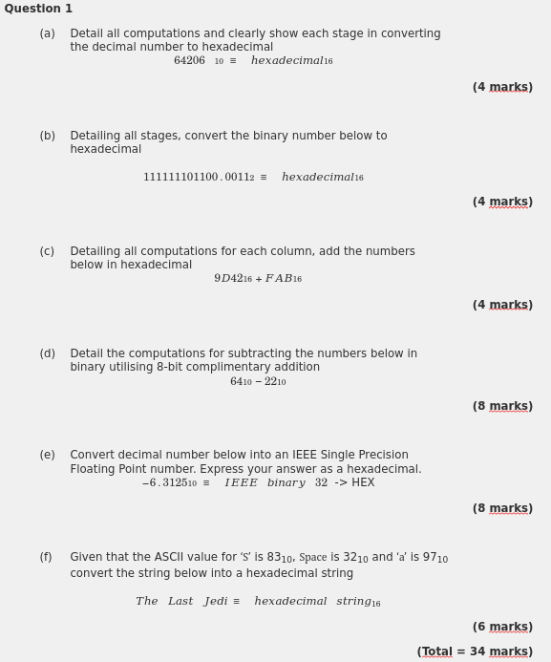

Photograph your progress at the end if this Tutorial and ensure it has been checked

|  |  |  |  |
| --- | --- | --- | --- |
| **Student Name** | **Denis inwood** | **Student Number** | **C00261277** |
| **Date** | **17/11** | **Checked** | **Y** |
| **Group** | **A / B** | **A** |  |

Answers A to F insert here (Photograph of Log Book)

|  |  |
| --- | --- |
| A | C:\Users\denis\AppData\Local\Temp\Rar$DRa8292.12253\IMG_20211117_155949.jpg |
| B | C:\Users\denis\AppData\Local\Temp\Rar$DRa8292.14738\IMG_20211117_160001.jpg |
| C | C:\Users\denis\AppData\Local\Temp\Rar$DRa8292.17819\IMG_20211117_160017.jpg |
| D | C:\Users\denis\AppData\Local\Temp\Rar$DRa8292.19398\IMG_20211117_160031.jpg |
| E |  |
| F |  |

Part 1

