Private Network Service Platform - Architecture Document
Computer Networks project, Phase 1 | Team: team07 | Kevish, Bhawana, Abhimaan | 4 October 2026
Domain: app.team07.test / api.team07.test. Network: Rishihood_Learner, 10.7.0.0/19, gateway 10.7.0.1. Three Macs: the DNS and edge roles are on separate Macs and both backends run on one Mac on ports 3001 and 3002.

1. Network topology
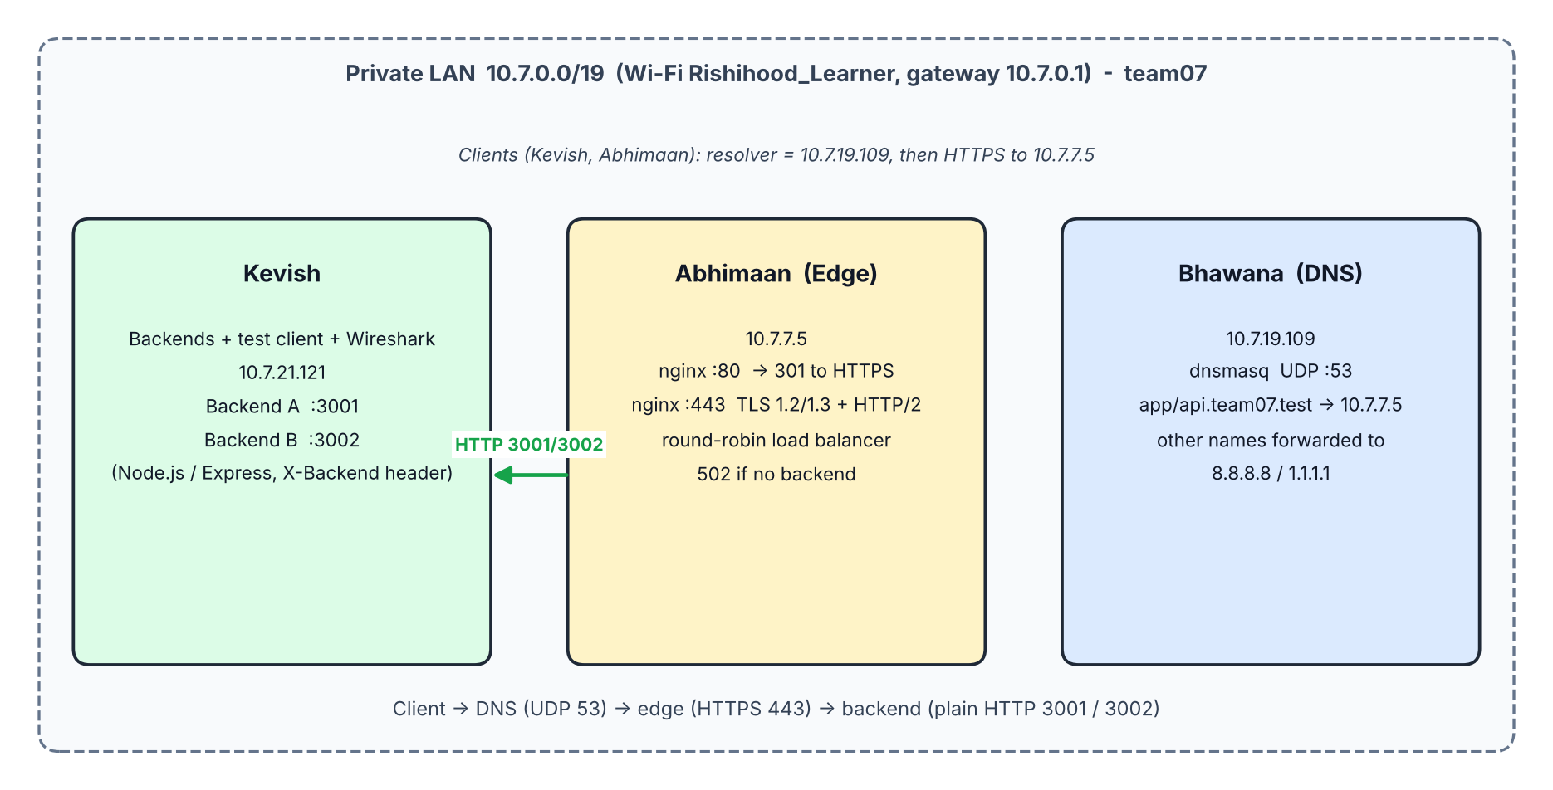

2. Machine roles and IP / service table
Owner | Role | IP | Services / ports
Bhawana | Private DNS | 10.7.19.109 | dnsmasq, UDP 53
Abhimaan | Edge: TLS terminator, reverse proxy, load balancer | 10.7.7.5 | nginx TCP 80 (redirect to HTTPS), TCP 443 (TLS, HTTP/2)
Kevish | Backends, test client, Wireshark | 10.7.21.121 | Backend A TCP 3001, Backend B TCP 3002

DNS records: app.team07.test and api.team07.test point to 10.7.7.5 (TTL 60 s). Other names are forwarded to 8.8.8.8 and 1.1.1.1. Clients on the private DNS: Kevish and Abhimaan (Wi-Fi DNS = 10.7.19.109).

3. Request flow, layer by layer
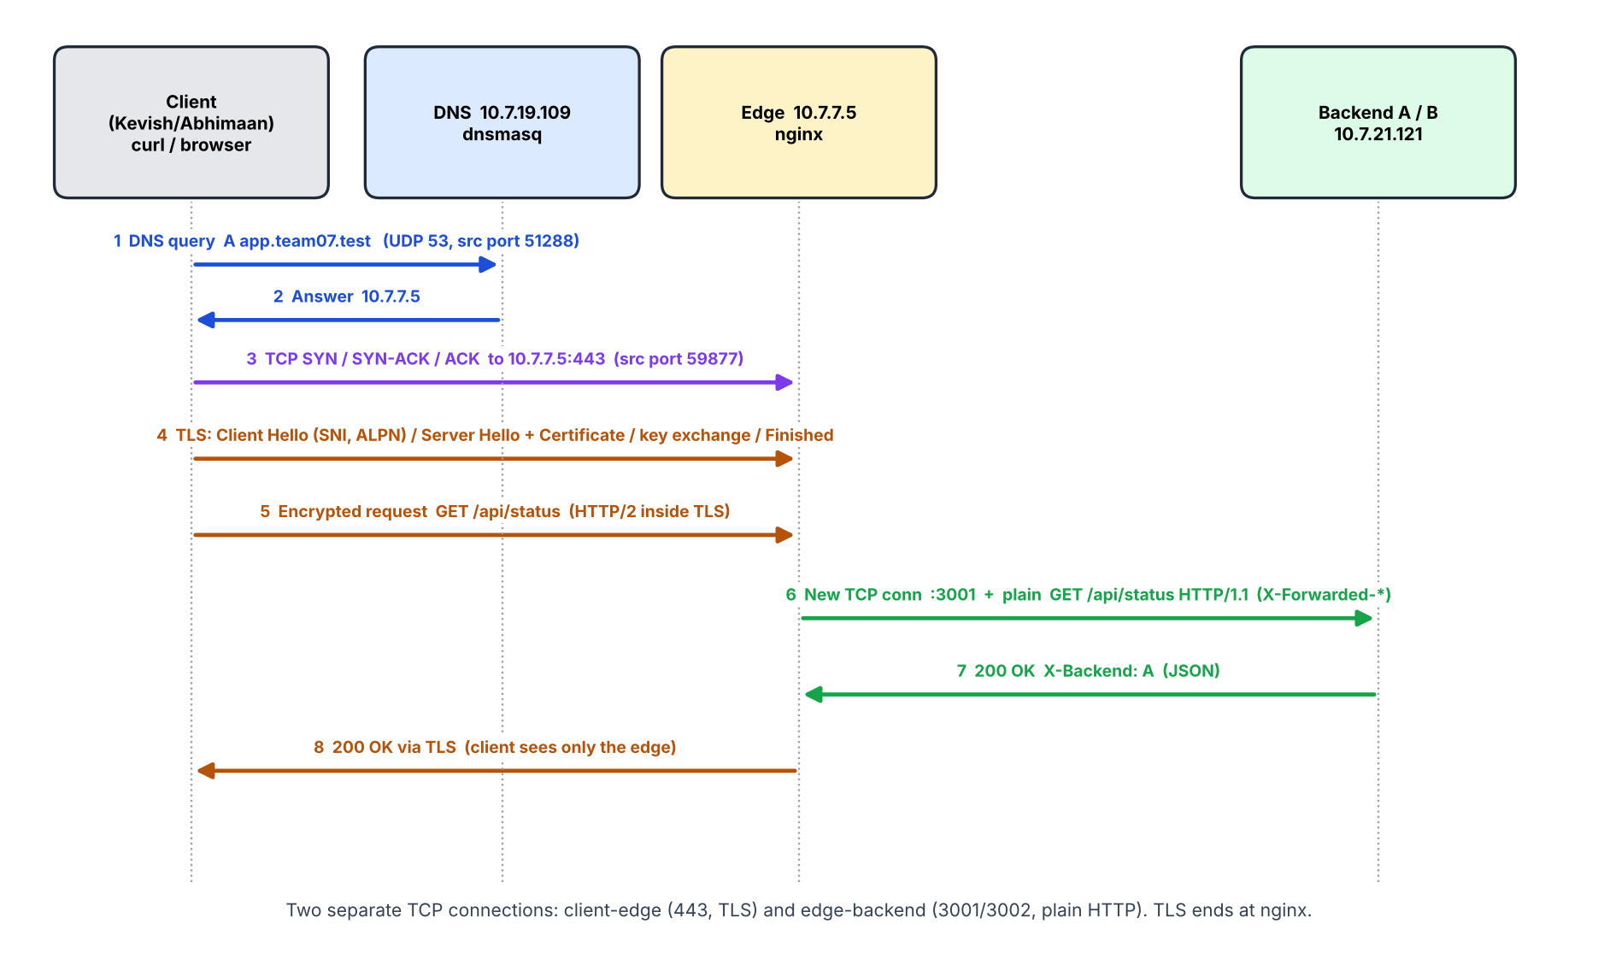
Step | Layer / protocol | Evidence (CN-phase-1.pcapng)
1-2 | DNS over UDP 53 | Frames 3-4: 10.7.21.121:51288 to 10.7.19.109:53; answer A 10.7.7.5
- | ARP / Ethernet | Frames 5, 7: who-has 10.7.7.5, reply 72:94:6f:7b:aa:c9; frames go directly to the host, not the gateway
3 | TCP three-way handshake | Frames 6, 8, 9: 59877 to 443, SYN, SYN-ACK, ACK
4 | TLS 1.2 handshake | Frames 10-17: Client Hello (SNI, ALPN), Server Hello and Certificate (issuer team07 Local Root CA), key exchange, Finished
5, 8 | HTTP/2 inside TLS | Frames 18-34: Application Data (encrypted)
6-7 | Plain HTTP/1.1, edge to backend | Frames 23-31: 10.7.7.5:52981 to 10.7.21.121:3001, GET /api/status with X-Forwarded-* headers

TLS terminates at nginx. The edge opens a second TCP connection to the chosen backend. Backends see the edge IP (from=10.7.7.5); the real client IP is only in X-Forwarded-For.

4. OSI / TCP-IP mapping
OSI | TCP/IP | In this project
7 Application | Application | HTTP/1.1, HTTP/2, DNS, Cache-Control, ETag, X-Backend
6 Presentation | Application | TLS encryption and certificates (OpenSSL CA, nginx ssl)
5 Session | Application | TLS session, ALPN negotiation
4 Transport | Transport | TCP 443, 3001, 3002 (handshake, Seq/Ack, Win, SACK); UDP 53
3 Network | Internet | IPv4 10.7.0.0/19, ICMP ping (ttl=64)
2 Data link | Link | Wi-Fi frames, MAC addresses, ARP
1 Physical | Link | Wi-Fi radio

5. Cloud equivalents
Our component | Cloud equivalent
dnsmasq host-records | Amazon Route 53 private hosted zone
nginx TLS termination, round-robin, retry | Application Load Balancer with ACM certificate and target-group health checks
Backend A / B | EC2 or ECS targets in a target group
Own root CA and server certificate | AWS Certificate Manager or a public CA
max_fails, fail_timeout, proxy_next_upstream | ALB health checks and automatic deregistration
nginx 502 when both backends are down | ALB 502/503 with no healthy target
Wireshark on a client | VPC Flow Logs, traffic mirroring

6. Design decisions
- .test is reserved for private use; public DNS returns NXDOMAIN from the root zone (.local belongs to mDNS).
- Caching uses backend Cache-Control and ETag, not nginx proxy_cache, so load-balancer alternation stays visible. Identical content gives identical ETags, so 304 works from either backend.
- Both names point at the edge; clients never learn backend IPs.
- Single points of failure: the DNS Mac and the edge Mac (addressed in Phase 2).

7. Failure demonstrations (summary)
# | Fault | Layer | Result | curl exit
H1 | Wrong resolver 8.8.8.8 | DNS | NXDOMAIN; ping by IP works | 6
H2 | DNS record points to wrong IP | TLS | TCP connects, certificate not trusted | 60
H3 | Backend A stopped | App tier | Answers only from B, error.log shows refused :3001 | 0
H4 | Both backends stopped | App tier | HTTP/2 502 from nginx | 0 (502)
H5 | Wrong port 8443 | TCP | Connection refused, host reachable | 7

8. Incidents and fixes
- No route to host toward Kevish (first ping round): an ARP failure, cleared by reconnecting Wi-Fi; all six ping directions then passed with ttl=64.
- nginx refused on port 80: a leftover nginx from an earlier project held ports 8080/443 and its configuration did not include servers/*. Fixed with a clean nginx.conf and a root-owned brew service.

9. Deliverables map
Configuration bundle: dns/, nginx/, certs/. Backend source: backend/. Evidence: evidence/A-lan to H-failures (see evidence/INDEX.md). Operations: docs/SETUP.md, docs/RUNBOOK.md, docs/VIVA.md.

