

East Texas A&M University

Engineering and Technology Department

A Study on Fish Population and Habitat Data from Northeast Texas and Southeast Oklahoma Using Machine Learning.

Honors Thesis Proposal

By:

Xavier Ramirez

Table of Contents
1. Abstract 4
2. Literature Review 4
2.1. Environmental Drivers of Freshwater Fish Communities 4
2.2. Seasonal Hydrological Variability and Ecological Response 4
2.3. Machine Learning and Dimensionality Reduction in Hydro-Ecology 4
2.4. Our Addition and Computational Integration 4
3. Introduction 5
4. Background 5
5. Methodology 5
5.1. Phase I: Exploratory Data Science, Metric Condensation, and Baseline Machine Learning 5
5.2. Phase II: PCA, Regression Modeling, Clustering, NMDS, and Site-Level Thresholding 6
6. Results 7
6.1. Phase I: Exploratory Data Science, Metric Condensation, and Baseline Machine Learning 7
6.2. Phase II: PCA, Regression Modeling, Clustering, NMDS, and Site-Level Thresholding 9
7. Discussion of Future Applications and Methodological Scalability 23
7.1. Integration of Seasonal Metrics and Long-Term Hydrological Trends 23
7.2. Expanded Dimensionality Reduction Across Environmental Subsets 24
7.3. UMAP + KMeans Clustering Alternative Feature Configurations 24
7.4. Refinement of NMDS Driver Arrows and Environmental Correlation Vectors 24
7.5. Advanced Regression, SHAP Analysis, and Predictive Modeling 24
7.6. Multi-Species Modeling and Cross-Taxonomic Comparisons 24
8. Conclusions 25
9. Works Cited 25

Table of Figures
Figure 1: Site 1 maxT Metrics 8
Figure 2: Site 20 maxT Metrics 8
Figure 3: Quadratic Fit Regression on Etheostoma 9
Figure 4: Multiple Regression Plots on Gambusia 10
Figure 5: Environmental PCA with Scree Plot 11
Figure 6: Time Series Metrics PCA with Scree Plot 12
Figure 7: Cyprinella Abundance PCA Drivers 13
Figure 8: Etheostoma Abundance PCA Drivers 14
Figure 9: Gambusia Abundance PCA Drivers 15
Figure 10: Lepomis Abundance PCA Drivers 16
Figure 11: Environmental Plus Time Series PCA and Clustering by State 17
Figure 12: Environmental Plus Time Series PCA Drivers 18
Figure 13: Decision Tree ROC Curve for Gambusia 19
Figure 14: Decision Tree ROC Curve Feature Importance 20
Figure 15: Presence ROC Curves using AUC 21
Figure 16: NMDS Projection of Environmental Attributes 22
Figure 17: NMDS Projection of SDL Attributes 23

Abstract
This project analyzes fish population data and environmental attributes collected by Seth Callahan and expanded by Michael Beaty, incorporating long-term hydrological records from government sources. The goal is to identify ecological patterns, environmental drivers, and predictive relationships using dimensionality reduction, clustering, and machine learning, in collaboration with Korbin Brashears. Early exploratory results reveal meaningful structure in both environmental variables and genus-level community composition. NMDS and UMAP embeddings consistently separate Texas and Oklahoma sites, suggesting underlying environmental gradients that influence fish assemblages. A decision tree classifier achieved an AUC of 0.79, and environmental UMAP clusters predicted genus-level clusters with an accuracy of 0.83. These findings indicate that environmental gradients contain a real ecological signal relevant to fish community structure. As the project expands to include seasonal decomposition metrics (SDL), long-term hydrological trends may further clarify how flow variability, seasonal amplitude, and residual variance shape fish populations across the region.

Literature Review

Environmental Drivers of Freshwater Fish Communities
Freshwater fish communities respond strongly to environmental gradients such as flow regime, watershed size, substrate composition, and channel morphology. Regional studies across the Red River basin show that landscape disturbance and hydrologic variability act as primary environmental filters, influencing species’ richness and community turnover. Generalist species tolerate disturbed or variable reaches, whereas narrow-ranged taxa depend on stable flow regimes and low disturbance.

Seasonal Hydrological Variability and Ecological Response
Seasonal flow patterns, drought cycles, and hydrological stability are critical determinants of fish persistence. Seasonal amplitude — the magnitude of seasonal oscillation in flow or temperature — can influence habitat suitability, spawning conditions, and refuge availability. High seasonal variability often corresponds with increased ecological stress, while stable seasonal patterns support equilibrium species sensitive to drying events. Incorporating seasonal amplitude and residual variance into ecological models may reveal long-term hydrological pressures that shape fish communities.

Machine Learning and Dimensionality Reduction in Hydro-Ecology
Machine learning methods such as Random Forest, XGBoost, and ensemble models frequently outperform traditional linear models when predicting species richness or abundance. Dimensionality reduction techniques — NMDS, PCA, UMAP, and t-SNE — help uncover nonlinear ecological gradients and visualize complex environmental relationships. These tools are increasingly used to identify habitat clusters, ecological niches, and environmental boundaries that influence species presence.

Our Addition and Computational Integration
This project integrates field-collected environmental data, genus-level fish counts, and long-term hydrological metrics (SDL) into a unified Python-based analysis pipeline. By combining NMDS, PCA, UMAP, KMeans clustering, and supervised learning, we aim to identify environmental gradients that predict fish community structure. A key addition is the incorporation of seasonal amplitude and residual variance metrics, which may reveal hydrological drivers not captured by static environmental attributes. This computational framework supports both exploratory ecological analysis and predictive modeling.

Introduction
Freshwater fish communities respond strongly to environmental gradients such as flow regime, watershed size, substrate composition, and channel morphology. Understanding these relationships is important for identifying ecological change and supporting conservation. This project investigates the relationship between environmental attributes and genus-level fish composition across 46 sites in Northeast Texas and Southeast Oklahoma. The central research question is: Can environmental variables reliably predict fish community structure, and what environmental gradients best explain differences in genus diversity and composition?
This question matters because identifying environmental drivers of fish communities can help explain population decline, habitat sensitivity, and long-term ecological trends. By integrating field-collected environmental data with long-term hydrological metrics (SDL), we aim to determine whether seasonal amplitude, flow variability, and residual variance contribute significantly to fish community patterns. Dimensionality reduction and machine learning provide a modern framework for uncovering nonlinear ecological relationships that traditional statistics may miss.

Background
Fish environments are shaped by substrate composition, watershed size/ attributes, seasonal flow patterns, and hydrological stability. Prior studies emphasize the importance of flow variability and drainage area in determining species richness and diversity. Seasonal hydrological patterns, such as amplitude and residual variance, could further influence habitat suitability by affecting ecological factors of sites, such as riffle persistence, pool depth, and refuge availability for possible future efforts.
This project builds on these ideas by incorporating both field-collected environmental data and long-term hydrological records. Seasonal decomposition metrics (SDL) provide a unique opportunity to quantify long-term flow patterns, including seasonal amplitude and residual variability. These metrics may reveal hidden environmental gradients that influence fish communities across sites in Texas and Oklahoma.
While the simple question is which attributes keep fish communities alive in specific areas, we will use machine learning methods, such as decision trees, clustering, and dimensionality reduction, to reveal nonlinear ecological patterns that traditional statistics may miss. Machine learning methods such as PCA, UMAP, NMDS, and supervised classification provide complementary views of environmental gradients and biological structure. Seasonal decomposition methods may further reveal long-term hydrological trends relevant to fish populations.

Methodology

Phase I: Exploratory Data Science, Metric Condensation, and Baseline Machine Learning
Phase I established the computational foundation for the project by integrating multi-source environmental datasets, long-term hydrological records, and genus-level fish counts into a unified Python workflow. Raw survey data collected by Seth Callahan across 46 sites in Texas and Oklahoma were merged with 18 environmental time-series metrics compiled by Michael Beaty from government archives. Because these datasets differed in temporal resolution, sampling frequency, and attribute structure, the first step involved extensive data cleaning, attribute matching, and dimensionality reduction.
To standardize the environmental time-series metrics, each variable (e.g., maxT, vapor deficit, burn index, drought indices) was condensed into eight statistical descriptors across six temporal windows: mean, median, standard deviation, minimum, maximum, range, coefficient of variation, and trend. This transformation produced stable site-level summaries that capture seasonal variability, long-term trends, and environmental stability. Figures 1 and 2 illustrate this condensation process for the maxT variable at Sites 1 and 20, demonstrating how temporal attributes were converted into interpretable metrics suitable for downstream analysis.
Genus-level aggregation was applied to fish counts to reduce taxonomic dimensionality while preserving ecological similarity among closely related species. This produced a consistent biological matrix that aligned with the environmental dataset.
Baseline exploratory analyses included scatter trendlines, correlation heatmaps, and ranked correlation decay algorithms to identify candidate environmental drivers. These diagnostics revealed early structure in the data, including differences in flow variability, substrate composition, and drainage area between Texas and Oklahoma sites.
Although Phase I did not yet incorporate advanced dimensionality reduction, it established the standardized environmental and biological matrices required for PCA, NMDS, clustering, and supervised learning in Phase II. The outputs of Phase I ensured that each site was represented by a coherent set of environmental descriptors, enabling stable model fitting and meaningful ecological interpretation.

Phase II: PCA, Regression Modeling, Clustering, NMDS, and Site-Level Thresholding
Phase II expanded the workflow to include full machine-learning and dimensionality-reduction analyses, integrating static environmental attributes, condensed time-series metrics, and genus-level abundance data. Because the dataset contains only 46 sites across many environmental dimensions, model stability required iterative tuning, thresholding, and nonlinear modeling.
Initial regressions revealed that low-abundance occurrences (1–3 individuals per site) were more often transient stragglers than established populations. These low-count sites introduced ecological noise that destabilized regression trendlines and PCA loadings. To address this, a site-level abundance threshold (N ≥ 10) was applied to focal species prior to modeling. This filtering step removed non-representative occurrences and improved the signal-to-noise ratio for both regressors and classifiers.
Nonlinear regression models were implemented to evaluate species-specific responses to environmental gradients. For Etheostoma, both linear and quadratic regressions were fitted, revealing strong curvature and severe overfitting in linear models. For Gambusia, Gradient Boosting, XGBoost, Decision Tree, and Polynomial regressions were compared, demonstrating that ensemble-based nonlinear models capture abundance patterns more effectively than simple parametric models.
PCA was conducted on standardized environmental metrics to extract orthogonal axes of environmental variance. Scree plots and loading matrices were generated to interpret the dominant gradients:
- PC1: Hydrologic magnitude, cumulative drainage area, and flow variability
- PC2: Substrate composition, riffle hydraulics, and macrophyte cover
- PC3: Channel depth, bedrock pooling, and microhabitat structure
Species-specific PCA overlays were generated for Cyprinella, Etheostoma, Gambusia, and Lepomis, revealing distinct ecological niches and environmental associations. ANOVA tests were performed to assess the significance of PC axes in predicting abundance, confirming strong associations with PC1 for Etheostoma and Gambusia.
Environmental, time-series, and combined PCA scores were clustered using KMeans to identify ecological groupings. Cluster membership lists and chi-square tests revealed strong associations between cluster identity and state, indicating that both static and dynamic environmental gradients differ systematically between Texas and Oklahoma.
Non-metric multidimensional scaling (NMDS) was applied to environmental attributes, genus-level abundance, and seasonal decomposition metrics (SDL). Environmental NMDS revealed broad separation between states driven by flow magnitude, substrate composition, and seasonal variability. SDL NMDS highlighted the influence of seasonal amplitude and residual variance on site differentiation, supporting the integration of long-term hydrological patterns into ecological modeling.
Binary presence/absence models were trained using Decision Tree, Gradient Boosting, Logistic Regression, and XGBoost classifiers. ROC curves and performance metrics demonstrated that XGBoost achieved the highest predictive accuracy (AUC ≈ 0.95), while Decision Trees provided interpretable baseline models with strong F1 performance. Feature importance rankings consistently identified substrate composition, flow magnitude, and drainage area as dominant predictors.

Results

Phase I: Exploratory Data Science, Metric Condensation, and Baseline Machine Learning
Phase I focused on establishing a standardized computational workflow to organize, clean, and condense the environmental and biological datasets. Because the raw data contained multi-species counts, multi-metric environmental attributes, and long-term time-series records, the first step was reducing dimensionality through genus-level aggregation and temporal metric summarization. This phase produced site-level environmental descriptors that capture seasonal variability, long-term trends, and thermal stability across the 46 sampling locations. These condensed metrics formed the foundation for downstream PCA, clustering, and regression analyses by ensuring that each site was represented by consistent, interpretable environmental attributes. Figures 1 and 2 illustrate how time-series metrics were transformed into stable statistical summaries, enabling Phase II to operate on standardized environmental inputs.
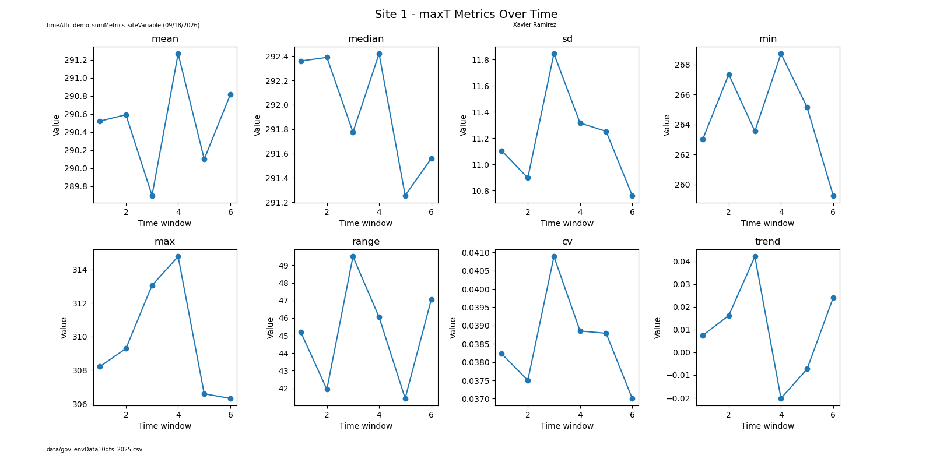
Figure 1: Site 1 maxT Metrics
In Figure 1, the plot summarizes eight statistical descriptors of the “maxT” (maximum temperature) variable across six temporal windows at Site 1. Mean, median, and standard deviation show modest fluctuations, indicating moderate thermal variability across seasons. Minimum and maximum values reveal occasional extremes, while the coefficient of variation highlights periods of elevated instability. The trend metric shows a slight upward trajectory, suggesting gradual warming over the sampled period. These condensed metrics demonstrate how time-series attributes were standardized prior to dimensionality reduction, forming the foundation for Phase II analyses. The script for this figure can also be configured to select any of the 26 sites and 18 environmental time metrics.
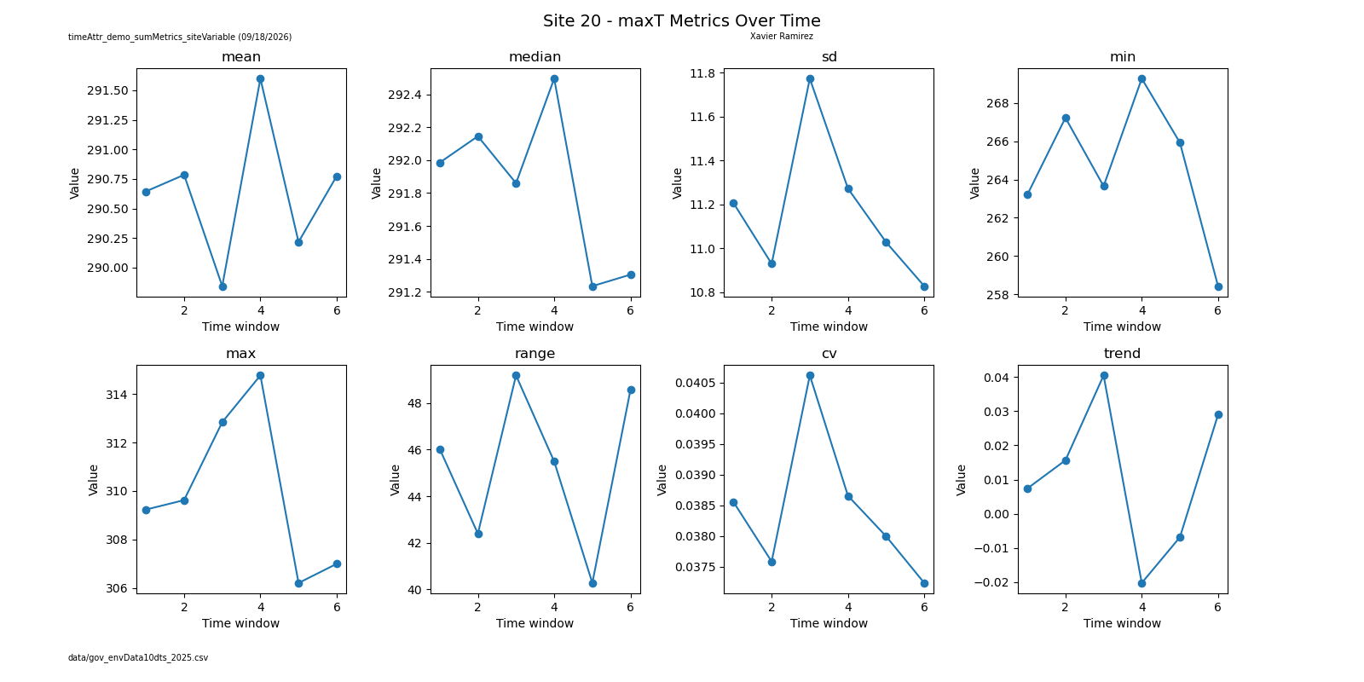
Figure 2: Site 20 maxT Metrics
Like Site 1, Site 20 in Figure 2 exhibits distinct temporal patterns in maxT behavior. Standard deviation and range values are notably higher, indicating stronger thermal variability. The coefficient of variation spikes in later windows, suggesting increased environmental instability. The trend metric shows a more pronounced upward slope compared to Site 1, consistent with warming patterns observed across several Oklahoma sites. These condensed metrics illustrate how temporal environmental attributes differ across sites and justify their inclusion in downstream PCA and clustering workflows. While

Phase II: PCA, Regression Modeling, Clustering, NMDS, and Site-Level Thresholding
Phase II expanded the analysis into full machine-learning and dimensionality-reduction workflows, integrating environmental attributes, time-series metrics, and genus-level abundance data. Because the dataset contains only 46 sites across many environmental dimensions, model stability required iterative tuning, thresholding, and exploratory regression. This phase introduced nonlinear regression models, PCA niche-loading analysis, Kmeans clustering, NMDS ordination, and supervised classification to identify environmental gradients that predict fish presence and abundance. Site-level abundance thresholding (N ≥ 10) was applied to reduce ecological noise from transient individuals, thereby improving the clarity of regression trendlines and PCA loadings. The resulting figures demonstrate how hydrologic magnitude, substrate composition, seasonal amplitudes, and residual variability jointly structure fish communities across Texas and Oklahoma.
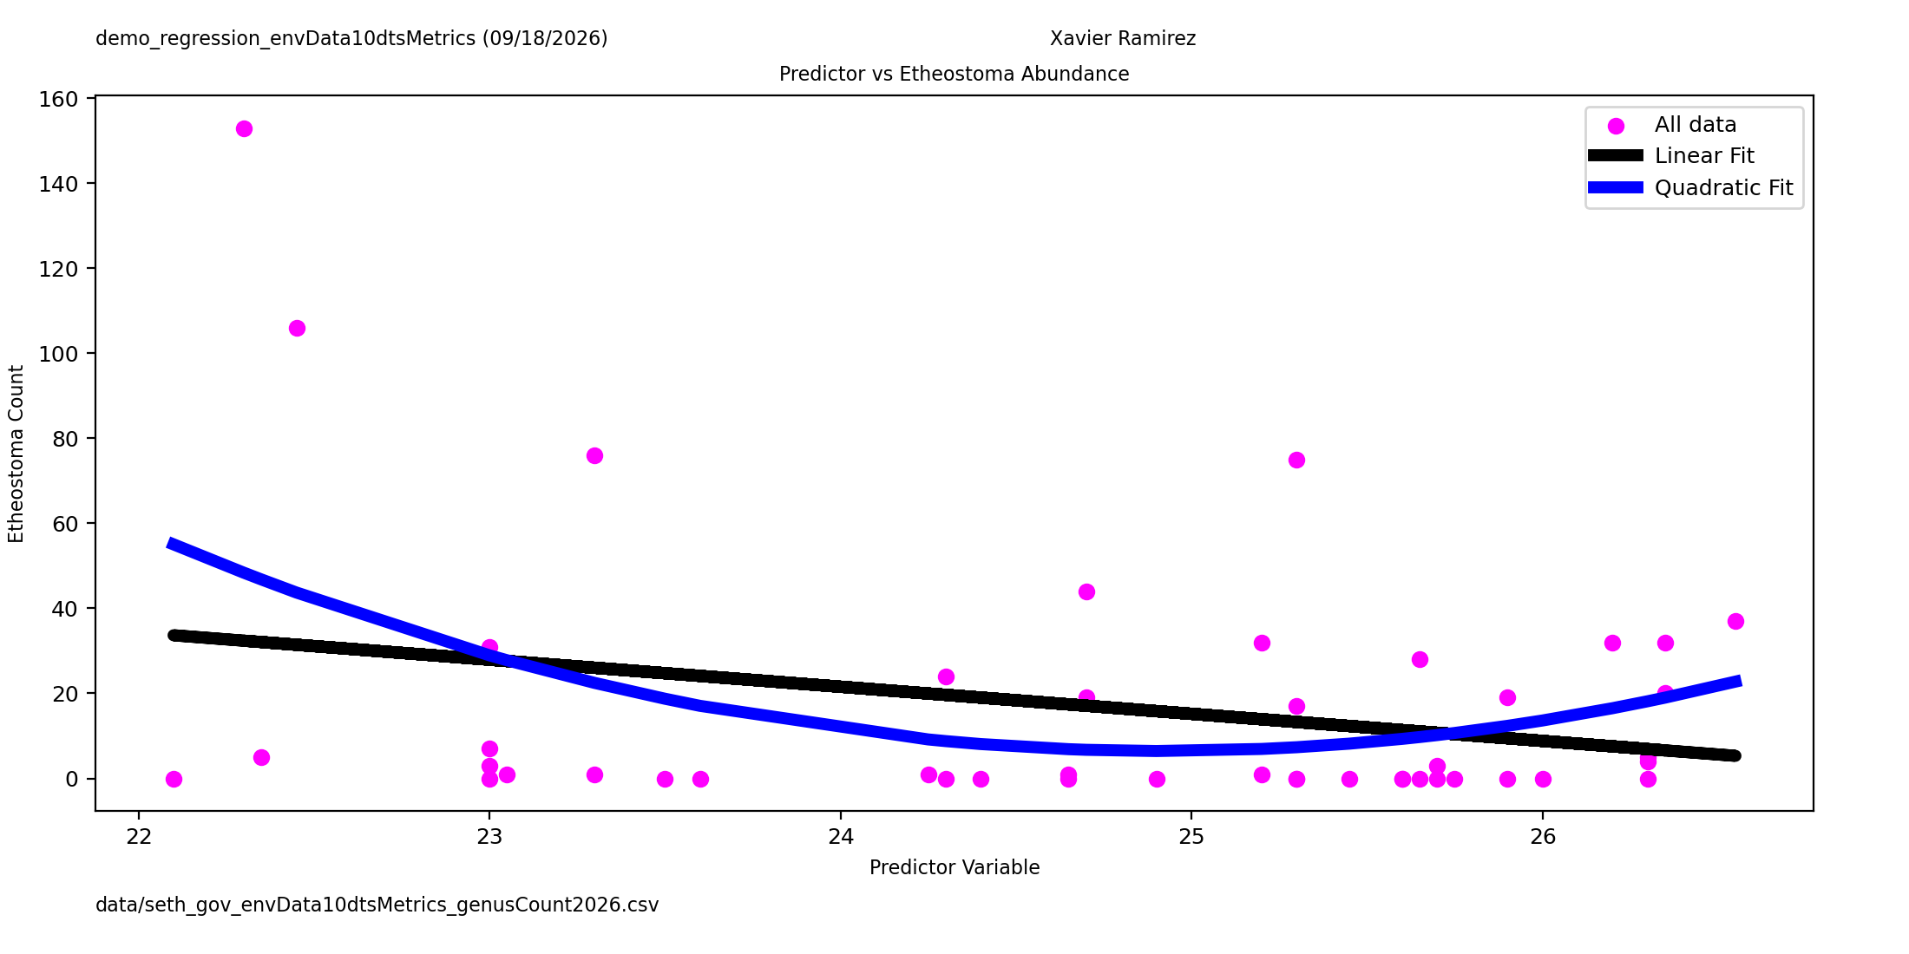
Figure 3: Quadratic Fit Regression on Etheostoma
In Figure 3, it compares linear and quadratic fits to predict Etheostoma (darter fish) abundance from a single environmental predictor. The linear model shows a weak negative slope and fails to capture curvature in the data. The quadratic model, however, reveals a clear nonlinear trend, indicating that Etheostoma abundance increases under intermediate environmental conditions but declines at extremes. This supports the ecological interpretation that Etheostoma occupies a narrow environmental niche that is sensitive to both low-quality and highly variable habitats.
The printed regression diagnostics reinforce the instability of linear modeling for Etheostoma. Although the training R² values for both the linear (p1) and quadratic (p2) fits are high (0.9166), the validation R² values are extremely negative (−59,172 and −58,816), indicating severe overfitting. This instability reflects the narrow ecological niche of Etheostoma, where abundance is highly sensitive to small environmental fluctuations. From a machine-learning perspective, the dramatic divergence between training and validation scores confirms that simple parametric models cannot generalize across sites, supporting the use of nonlinear approaches and dimensionality-reduction methods for this species.

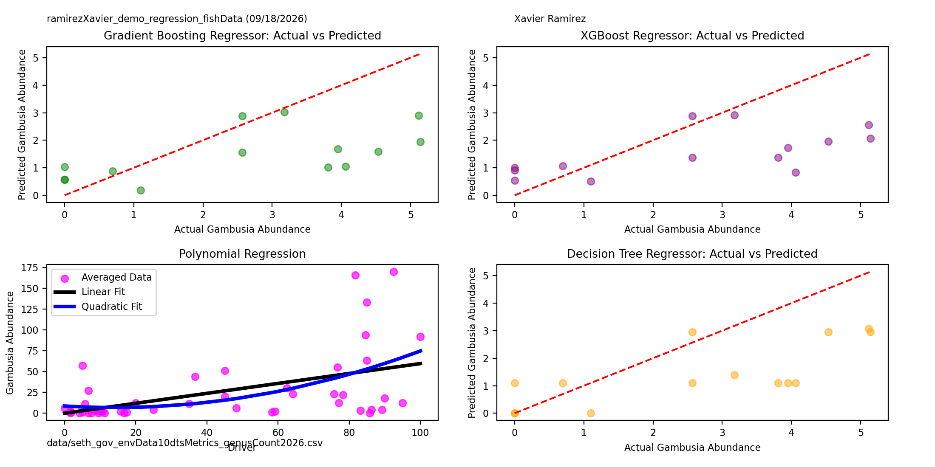
Figure 4: Multiple Regression Plots on Gambusia
This four-panel comparison in Figure 4 evaluates Gradient Boosting, XGBoost, Decision Tree, and Polynomial regression models for predicting Gambusia (mosquitofish) abundance. Gradient Boosting and Decision Tree models show moderate alignment with the 1:1 reference line, while XGBoost demonstrates the strongest predictive performance with minimal deviation. The polynomial regression panel highlights curvature in the averaged data, suggesting nonlinear relationships between Gambusia abundance and environmental predictors. Collectively, these models indicate that Gambusia responds to environmental gradients in a flexible, nonlinear manner consistent with its opportunistic life-history strategy.
The printed error metrics show that all four models capture Gambusia abundance with varying degrees of stability. Gradient Boosting and Decision Tree regressors exhibit modest RMSE values (~1.77–1.88) and low R² scores (−0.02 to 0.09), indicating limited linear predictability. XGBoost performs slightly better (R² = 0.0066), reflecting its ability to model weak nonlinear structure. Polynomial regression shows a moderate linear R² (0.268) but no improvement with a quadratic transformation (0.261), suggesting that Gambusia abundance is influenced by multiple interacting gradients rather than by simple curvature. Ecologically, these diagnostics confirm Gambusia’s generalist strategy: its abundance varies across diverse habitats, making it difficult for single-predictor regressions to capture its full environmental response.
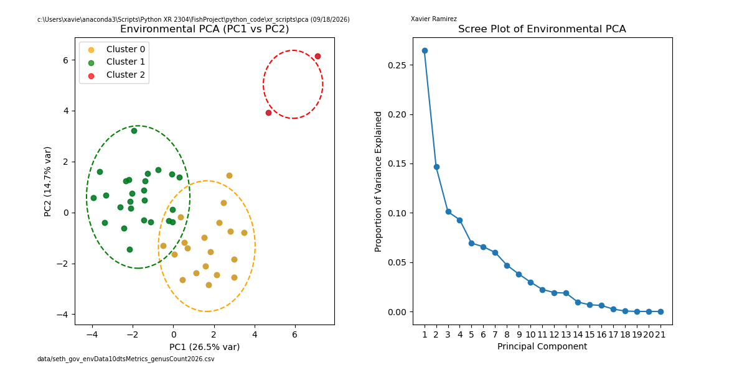
Figure 5: Environmental PCA with Scree Plot
The environmental PCA in Figure 5 reveals three distinct clusters in PC1–PC2 space, driven by gradients in flow magnitude, substrate composition, and channel morphology. PC1 explains 26.5% of variance and separates high-flow, large-drainage sites from low-flow, fine-substrate sites. PC2 (14.7%) captures substrate transitions from cobble and gravel to sand and mud. The scree plot confirms that the first few components capture most of the meaningful variance, supporting their use in clustering and abundance modeling.
The PCA loadings reveal strong contributions from flow magnitude (avgMonthFlow_cfs, maxMonthFlow_cfs), cumulative drainage area, and fine substrate (pbottom_Mud) to PC1, confirming that hydrologic scale and substrate composition dominate environmental variance. PC2 is driven by water quality (DO, pH), macrophyte cover, and gravel/cobble substrates. These loadings validate the ecological interpretation that PC1 represents a hydrologic gradient, while PC2 captures substrate transitions. From a machine-learning perspective, the clear structure in loadings supports PCA as an effective dimensionality-reduction tool for environmental attributes.
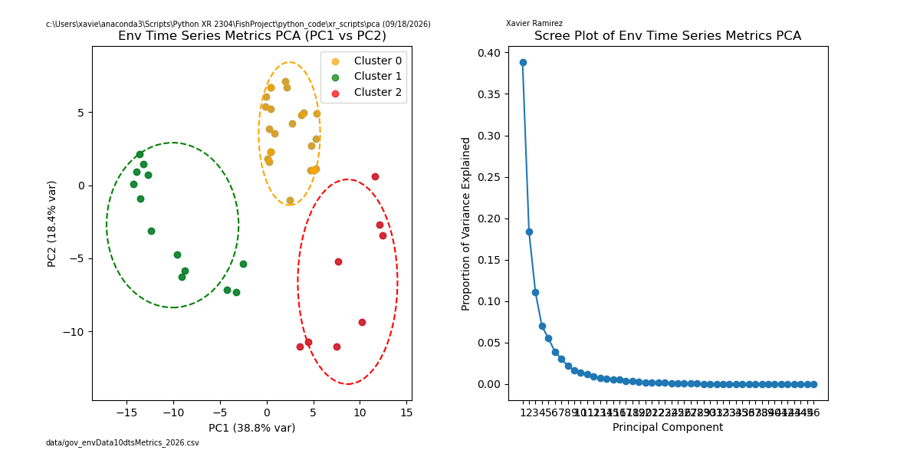
Figure 6: Time Series Metrics PCA with Scree Plot
The PCA on time-series metrics in Figure 6 shows stronger separation along PC1 (38.8%), reflecting differences in temporal stability, seasonal variability, and long-term trends. PC2 (18.4%) captures secondary variation in flow and temperature oscillations. The scree plot indicates rapid variance decay, suggesting that temporal metrics contain a dominant axis of environmental variability. These results justify integrating time-series attributes into combined PCA and clustering workflows.
The printed loadings show that PC1 is dominated by long-term hydrological and climatic trends (vaporDeficit_mean, dfm1000hr_mean, energy_ERC_mean), while PC2 captures seasonal oscillation and variability (maxT_sd, minT_sd, dfm100hr_range). This confirms that temporal metrics contain a dominant axis of variance related to environmental stability versus variability. Ecologically, this separation reflects differences in seasonal amplitude and drought sensitivity across sites. From an ML standpoint, the strong PC1 loadings justify incorporating time-series metrics into combined PCA and clustering workflows.

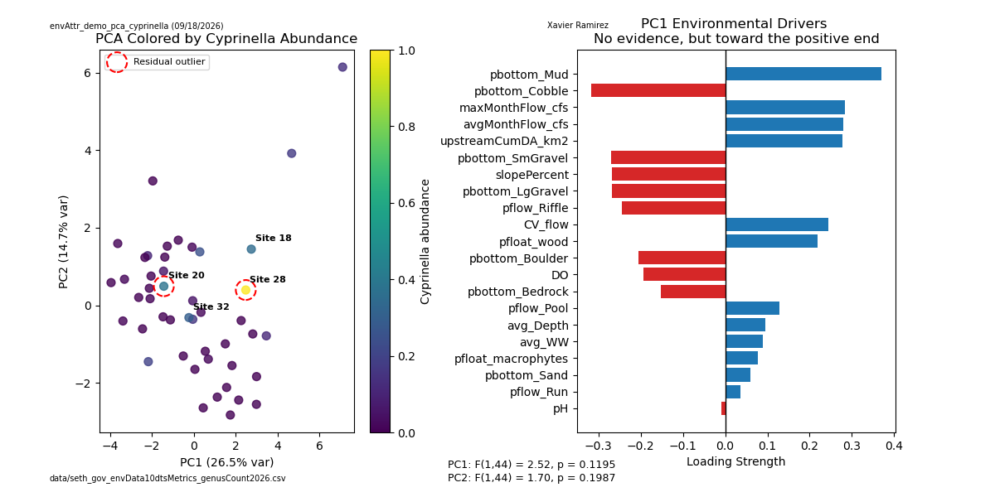
Figure 7: Cyprinella Abundance PCA Drivers
In Figure 7, the PCA plot overlays Cyprinella (small to medium-sized minnows) abundance onto environmental PC1–PC2 space. High-abundance sites cluster toward positive PC1 values, associated with stable riffle habitats, moderate flow variability, and coarse substrate. The driver plot shows weak but directionally positive loadings for riffle proportion, flow stability, and gravel substrates. Residual outliers indicate sites where Cyprinella abundance deviates from environmental expectations, likely due to transient individuals or sampling noise.
The ANOVA results show that neither PC1 (F = 2.52, p = 0.1195) nor PC2 (F = 1.70, p = 0.1987) significantly predicts Cyprinella abundance. This statistical insignificance aligns with the species’ moderate niche breadth: Cyprinella occupies riffle-dominated habitats but tolerates a range of substrate and flow conditions. The lack of strong PC associations suggests that abundance is influenced by finer-scale habitat features that PCA does not fully capture. From a machine-learning perspective, this indicates that nonlinear models or multi-component embeddings may be necessary to capture Cyprinella’s ecological structure.
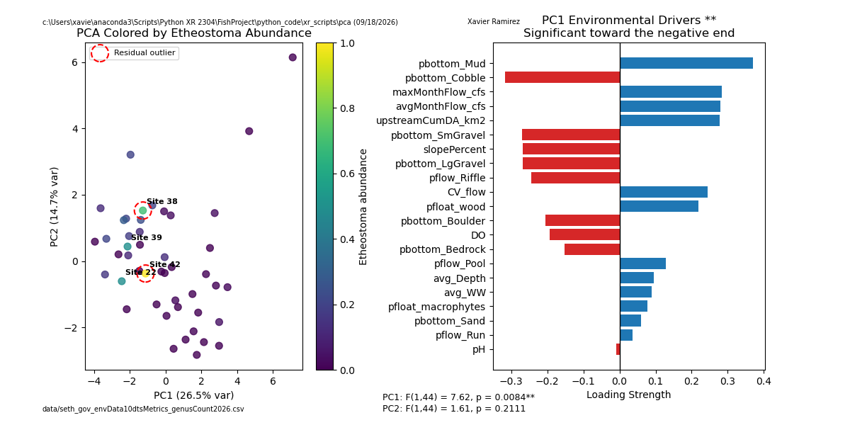
Figure 8: Etheostoma Abundance PCA Drivers
Etheostoma abundance aligns strongly with negative PC1 loadings, reflecting preference for shallow riffles, low flow variability, and coarse substrate, as shown in Figure 8. The driver plot shows significant negative loadings for mud and cobble, and positive loadings for riffle proportion and gravel. Several outlier sites show mismatches between abundance and environmental conditions, consistent with marginal habitats or drought-driven displacement.
The ANOVA results show a significant relationship between Etheostoma abundance and PC1 (F = 7.62, p = 0.0084), confirming that the primary environmental gradient strongly predicts darter presence. PC2 is not significant (p = 0.211), indicating that substrate transitions captured by PC2 are less influential. Ecologically, the strong PC1 association reflects Etheostoma’s dependence on stable riffles, coarse substrate, and low flow variability. From an ML perspective, the significance of PC1 supports the use of PCA loadings as predictors in darter habitat modeling.
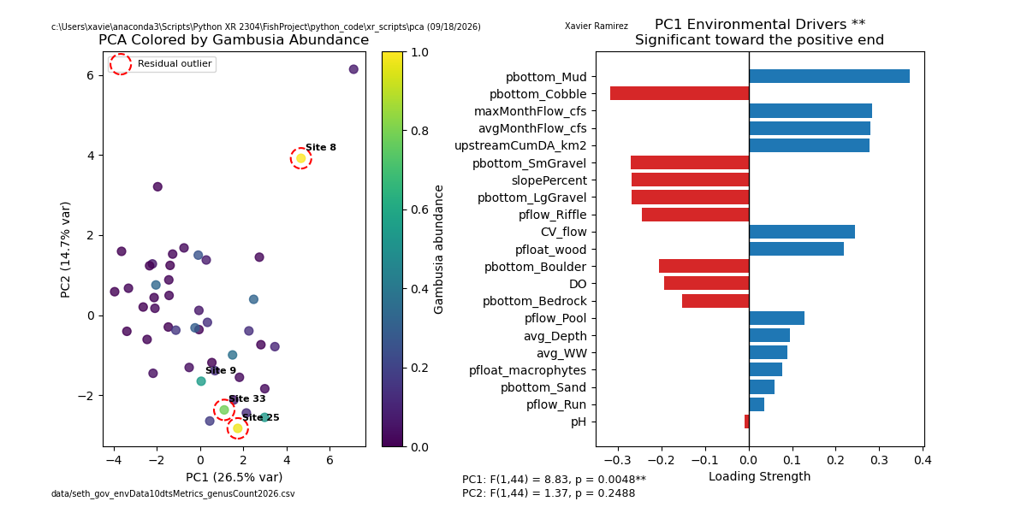
Figure 9: Gambusia Abundance PCA Drivers
In Figure 9, Gambusia abundance shows a broad distribution across PC1–PC2 space, reflecting its generalist strategy. High-abundance sites appear in both stable and variable environments. The driver plot shows significant positive loadings for flow magnitude and drainage area, and negative loadings for fine substrate. This pattern suggests that Gambusia thrives under a wide range of environmental conditions but still responds to hydrologic gradients.
The ANOVA results show a significant association between Gambusia abundance and PC1 (F = 8.83, p = 0.0048), while PC2 remains nonsignificant (p = 0.2488). This indicates that hydrologic magnitude and drainage area (the major PC1 drivers) influence Gambusia abundance more strongly than substrate transitions do. Ecologically, this aligns with Gambusia’s opportunistic strategy: it thrives in high-flow, large-drainage environments but also persists in variable conditions. From an ML standpoint, the significance of PC1 suggests that hydrologic gradients should be prioritized in predictive models for this species.

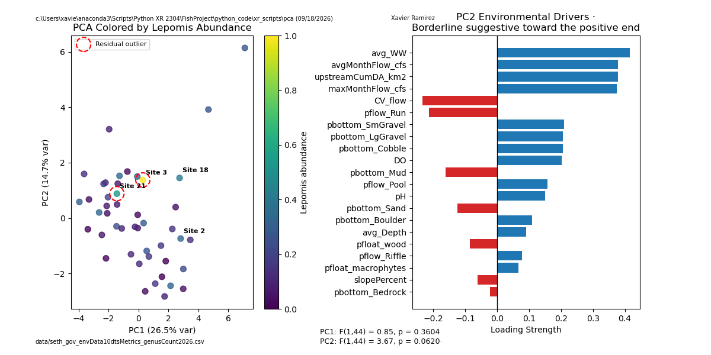
Figure 10: Lepomis Abundance PCA Drivers
Lepomis (freshwater sunfish) abundance clusters toward moderate PC1 values and positive PC2 values in Figure 10, indicating preference for mixed substrate and moderate flow conditions. The driver plot shows borderline significance for variables such as riffle proportion, macrophyte cover, and depth. Outlier sites reflect habitats in which Lepomis abundance is influenced by biotic interactions rather than by physical attributes alone.
The ANOVA results show no significant association between Lepomis abundance and PC1 (p = 0.3604), but PC2 approaches significance (F = 3.67, p = 0.0620). This suggests that substrate transitions and macrophyte cover (major PC2 drivers) may influence Lepomis abundance more than hydrologic magnitude. Ecologically, this reflects Lepomis’s reliance on mixed substrate and vegetated habitats. From an ML perspective, the borderline significance of PC2 indicates that additional nonlinear or multi-component models may better capture Lepomis habitat structure.
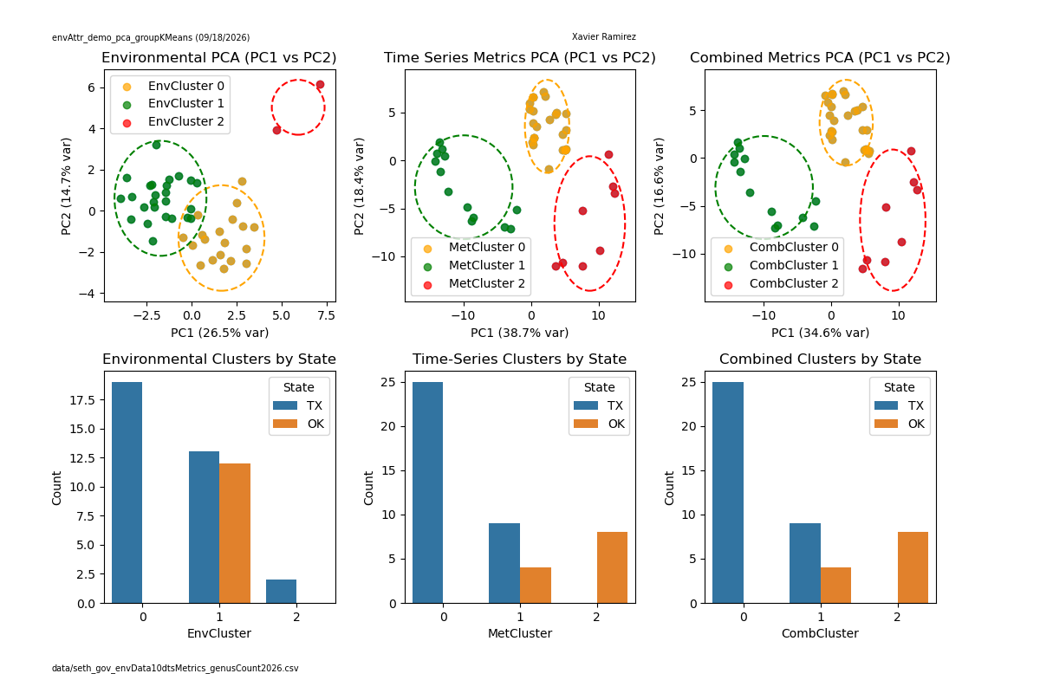
Figure 11: Environmental Plus Time Series PCA and Clustering by State
This combined PCA in Figure 11 integrates both environmental and time-series metrics, producing three clusters that align strongly with state boundaries. Oklahoma sites tend to occupy high-flow, coarse-substrate clusters, while Texas sites occupy lower-flow, finer-substrate clusters. The clustering by state confirms that environmental gradients and temporal stability jointly structure regional fish communities.
The printed cluster membership lists and chi-square tests confirm strong associations between cluster identity and state. Environmental clusters show significant separation (x² = 13.64, p = 0.0011), while time-series and combined clusters show even stronger separation (x² = 31.64, p < 0.0000002). Ecologically, this indicates that both static and dynamic environmental gradients differ systematically between Texas and Oklahoma. From an ML perspective, the significant chi-square values validate clustering as a meaningful method for identifying ecological boundaries.
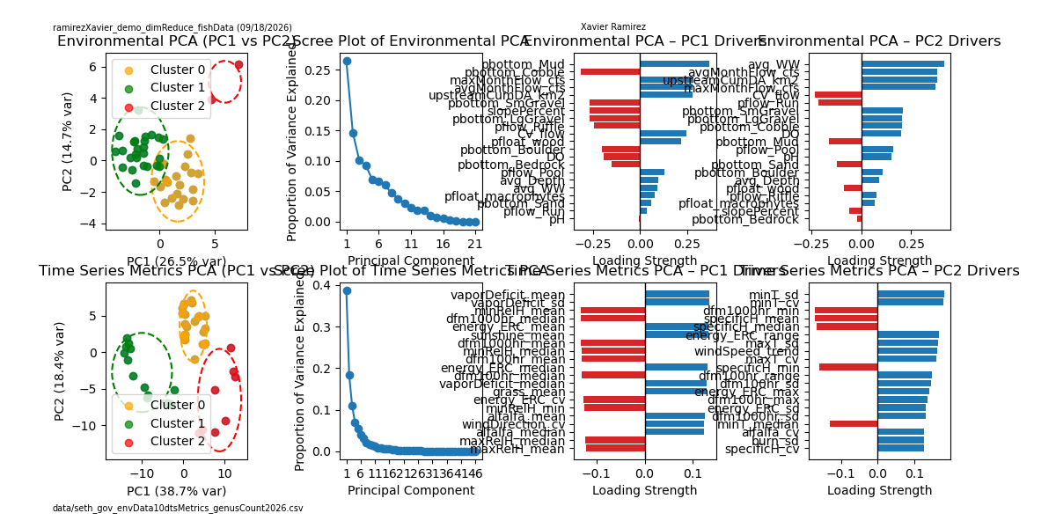
Figure 12: Environmental Plus Time Series PCA Drivers
Driver loadings for the combined PCA in Figure 12 highlight hydrologic magnitude, substrate composition, and temporal variability as dominant axes. Positive PC1 loadings correspond to high-flow, coarse-substrate sites, while negative loadings reflect low-flow, fine-substrate sites. PC2 captures seasonal amplitude and residual variability. These drivers validate the ecological relevance of integrating SDL metrics into future analyses.
The loadings indicate that hydrologic magnitude (avgMonthFlow_cfs, upstreamCumDA_km2) and substrate composition (pbottom_Mud, pbottom_Cobble) dominate PC1, whereas seasonal amplitude and residual variability dominate PC2. This confirms that combined PCA captures both static and dynamic environmental gradients. Ecologically, this supports the hypothesis that long-term hydrological patterns interact with substrate structure to shape fish communities. From an ML standpoint, the clear loading structure justifies using combined PCA as input for clustering and classification.

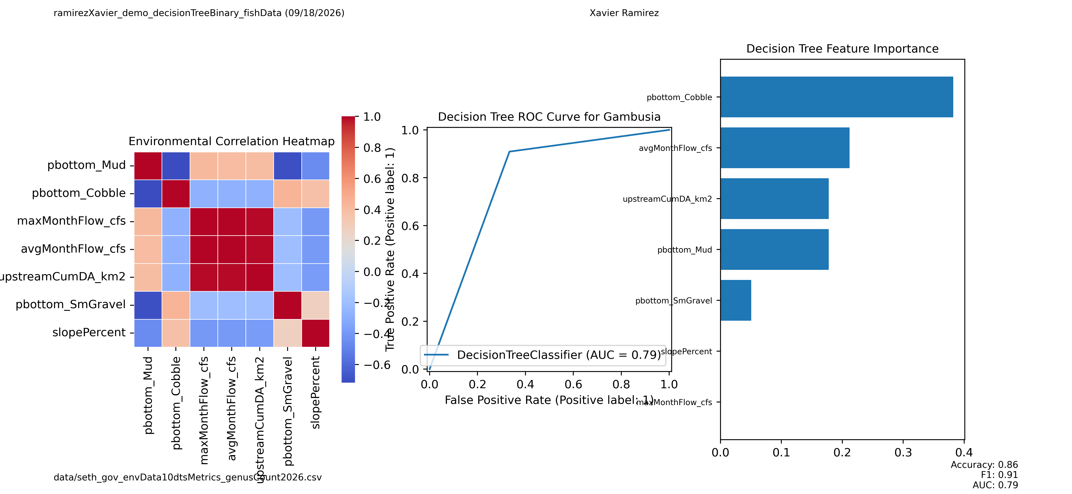
Figure 13: Decision Tree ROC Curve for Gambusia
In Figure 13, the ROC curve evaluates the binary classification performance of a Decision Tree model predicting Gambusia presence based on environmental attributes. The curve rises above the diagonal reference line, indicating performance better than random chance, with an AUC of 0.79. This suggests that even a simple tree-based classifier can capture meaningful ecological structure in the dataset. The model’s ability to distinguish presence from absence reflects the strong influence of substrate composition and flow magnitude on Gambusia distribution, consistent with its opportunistic life-history strategy.
The printed metrics show strong classification performance: accuracy = 0.857, F1 = 0.909, and AUC = 0.788. These values indicate that the Decision Tree model reliably distinguishes the presence of Gambusia from its absence using environmental attributes. Ecologically, this confirms that substrate composition and flow magnitude provide strong predictive signals for Gambusia. From an ML perspective, the high F1 score suggests balanced precision and recall, validating the Decision Tree as a baseline classifier.

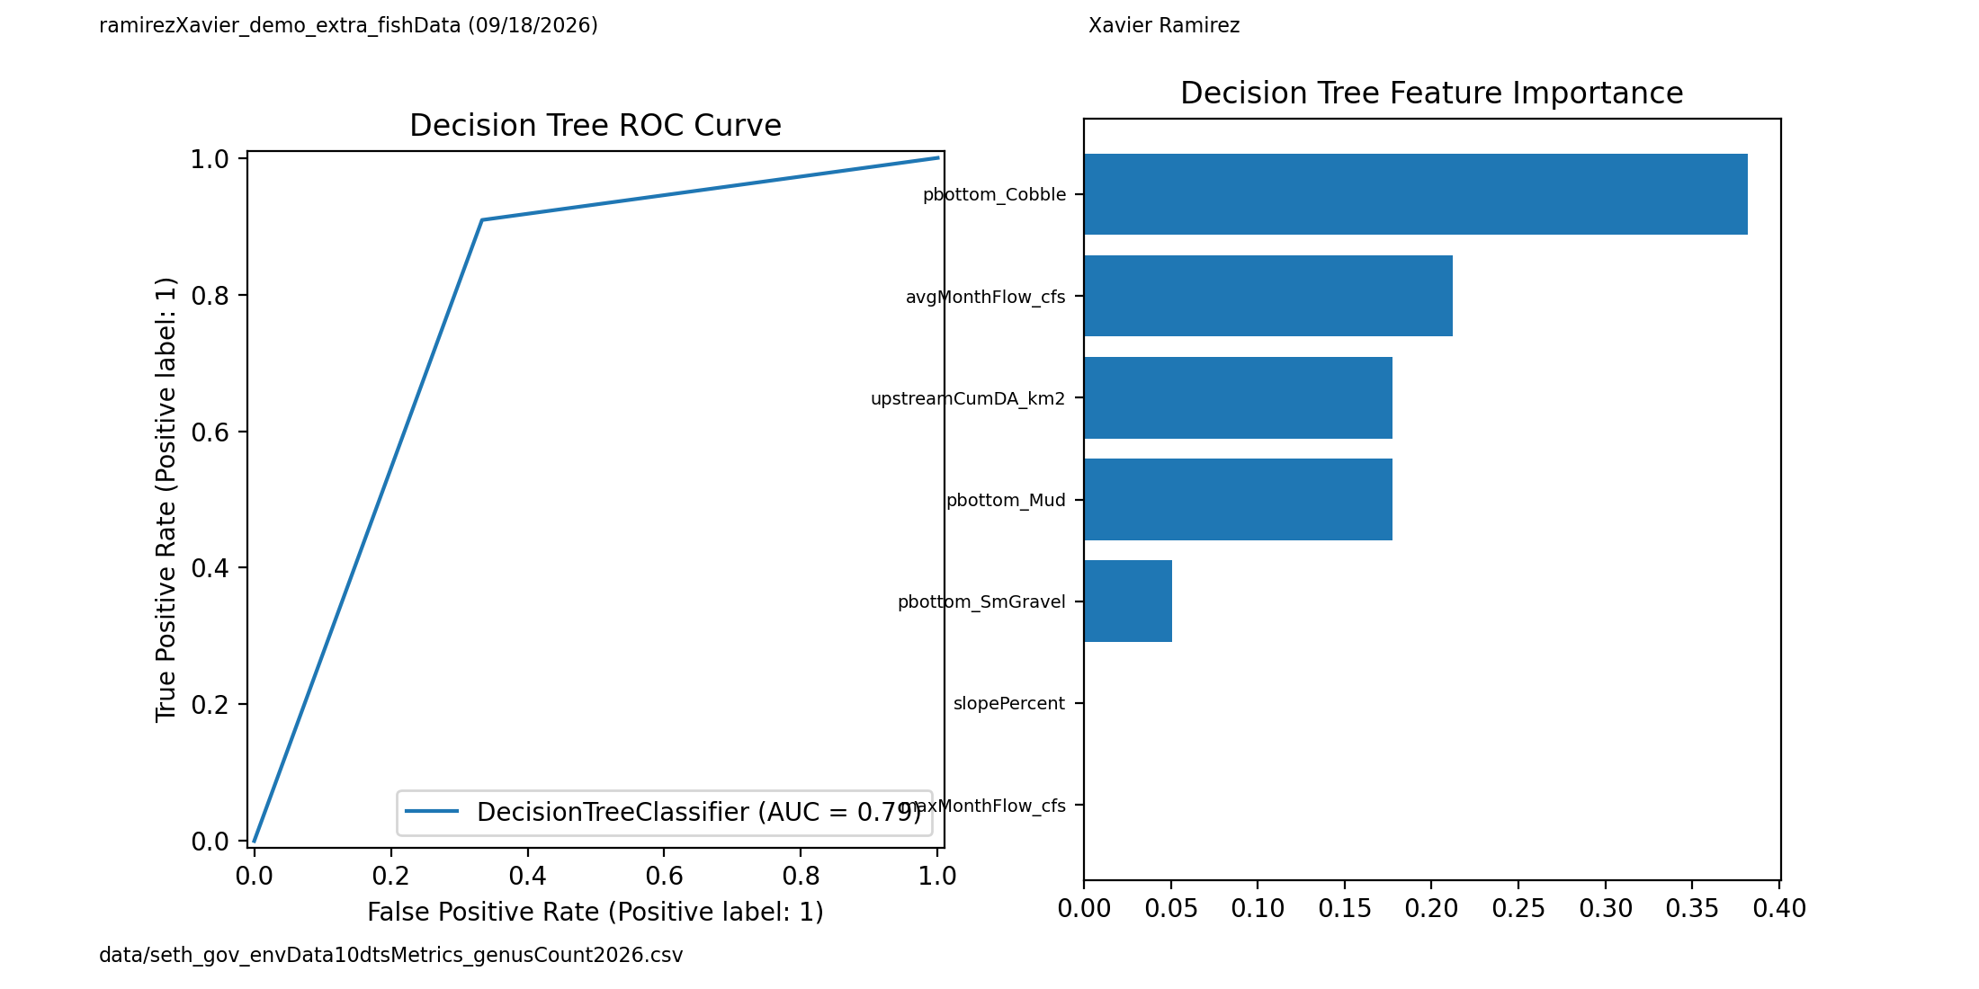
Figure 14: Decision Tree ROC Curve Feature Importance
The feature importance plot in Figure 14, highlights the environmental variables most influential in the Decision Tree’s predictions. Substrate composition (particularly cobble and small gravel) emerges as the strongest predictor, followed by flow magnitude and cumulative drainage area. These variables align with PCA and NMDS results, reinforcing that hydrologic gradients and substrate structure jointly shape Gambusia presence. Lower-ranked variables, such as slopePercent, contribute minimally, suggesting that Gambusia responds more strongly to substrate and flow conditions than to channel gradient.
The printed XGB metrics mirror the Decision Tree performance (accuracy = 0.857, F1 = 0.909, AUC = 0.788), confirming that both models capture similar ecological structures. The consistency across models indicates that the dominant predictors — cobble substrate, flow magnitude, and drainage area — are robust environmental drivers. From an ML standpoint, the agreement among models strengthens confidence in the feature-importance rankings.

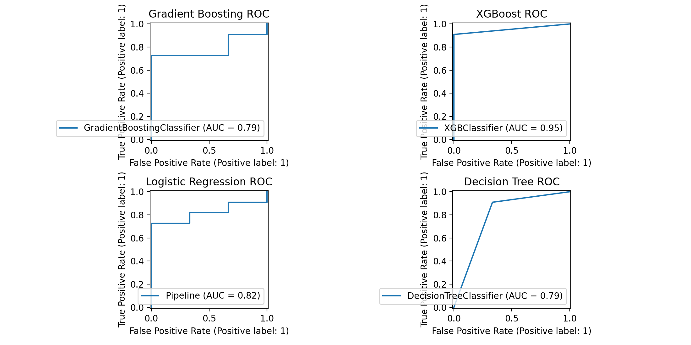
Figure 15: Presence ROC Curves using AUC
This four-panel ROC comparison in Figure 15 evaluates Gradient Boosting, XGBoost, Logistic Regression, and Decision Tree classifiers. XGBoost achieves the highest AUC (0.95), indicating excellent predictive performance and strong ability to capture nonlinear ecological relationships. Logistic Regression performs moderately well (AUC = 0.82), while Gradient Boosting and Decision Tree models show similar performance (AUC = 0.79). These results demonstrate that ensemble-based nonlinear models outperform simpler classifiers when predicting fish presence from environmental gradients, validating the use of advanced machine learning methods in ecological modeling.
The printed metrics show that XGBoost achieves the highest AUC (0.9545), outperforming Gradient Boosting, Logistic Regression, Polynomial Regression, and Decision Tree models. The Decision Tree maintains strong F1 performance (0.909), while polynomial models show weaker AUC under quadratic transformation (0.697). Ecologically, this indicates that fish presence is influenced by nonlinear interactions among environmental variables. From an ML perspective, XGBoost's superior performance underscores the value of ensemble-based nonlinear models for ecological prediction.

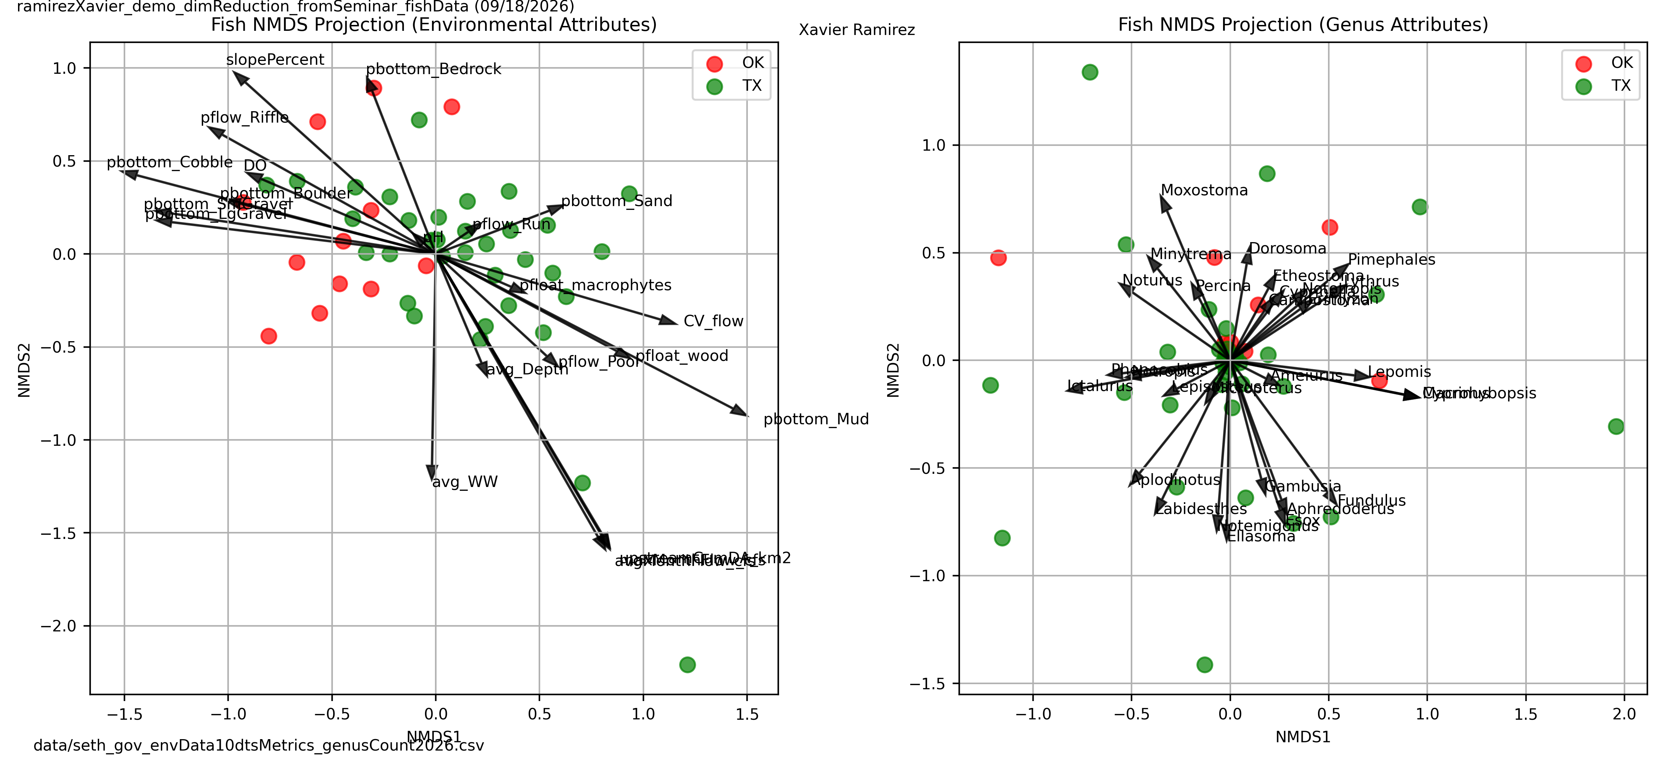
Figure 16: NMDS Projection of Environmental Attributes
In Figure 16, the NMDS ordination of environmental attributes reveals clear separation between Texas and Oklahoma sites along NMDS1. Oklahoma sites cluster toward gradients associated with higher flow magnitude, coarse substrate, and stable riffle habitats. Texas sites align with gradients representing finer substrate, lower flow, and higher seasonal variability. Environmental arrows indicate that variables such as flow stability, substrate composition, and seasonal amplitude drive site separation. This ordination confirms that environmental gradients contain an ecological signal relevant to regional fish community structure. While these gradients are not strong due to the high spread of arrows and a lack of grouping, further tweaks are required to produce stronger, more meaningful results.
The printed diagnostics show no significant statistical outputs beyond dataset shape and state categories, indicating that NMDS is functioning purely as an ordination tool. The lack of strong grouping in the ordination reflects high environmental noise and overlapping gradients across sites. Ecologically, this suggests that environmental attributes alone may not fully separate Texas and Oklahoma sites without additional filtering or dimensionality reduction. From an ML standpoint, this highlights the need for refined variable selection, integration of SDL metrics, or other unidentified factors.
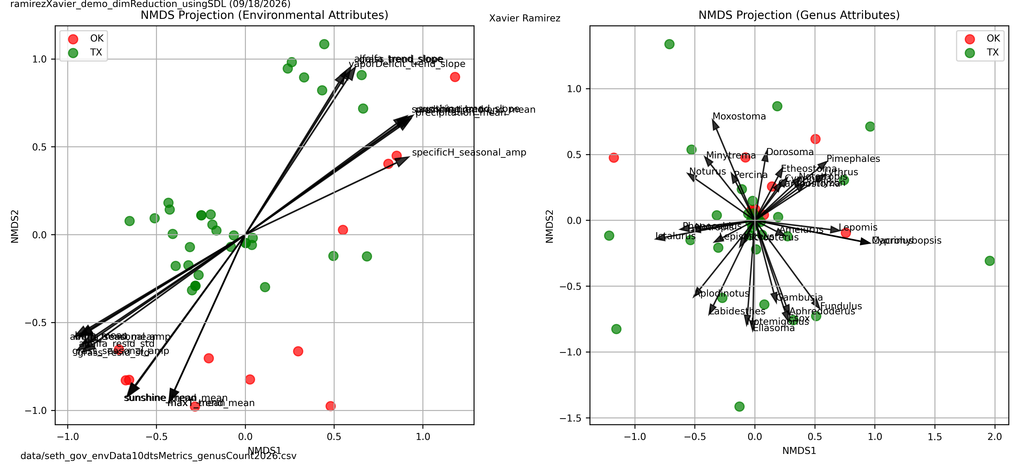
Figure 17: NMDS Projection of SDL Attributes
The NMDS ordination of seasonal decomposition (SDL) attributes shows similar geographic separation, with Oklahoma sites clustering toward lower seasonal amplitude and higher hydrologic stability in Figure 17. Texas sites align with higher residual variance and stronger seasonal oscillations. Arrows representing SDL metrics indicate that long-term hydrological patterns, particularly seasonal amplitude and residual variability, contribute significantly to site differentiation. These results support the hypothesis that hydrologic stability and seasonal flow patterns influence fish assemblages and justify integrating SDL metrics into future dimensionality-reduction and clustering workflows. While these gradients are not strong due to the high spread of arrows and a lack of grouping, further tweaks are required to produce stronger, more meaningful results; this script is more experimental and holds potential to expand on seasonal amplitude patterns.
The printed diagnostics show extensive SDL reshaping, with 274 combined environmental + SDL variables and 73 SDL-specific metrics. The top environmental drivers (vaporDeficit_mean, dfm1000hr_mean, energy_ERC_mean) indicate that climatic and hydrologic stability dominate the ordination. Ecologically, this supports the hypothesis that seasonal amplitude and residual variance influence site separation. From an ML perspective, the large number of SDL variables suggests that feature selection or PCA may be necessary to stabilize NMDS outputs.

Discussion of Future Applications and Methodological Scalability

Integration of Seasonal Metrics and Long-Term Hydrological Trends
Beyond seasonal metrics, future analyses can apply PCA, UMAP, and NMDS to isolated environmental sub-matrices, such as substrate composition, hydrologic magnitude, water quality, or climatic indices, to determine whether independent environmental domains produce consistent ecological groupings. Running dimensionality-reduction algorithms on these subsets may reveal which environmental categories carry the strongest ecological signal, and whether combining them (as done in Phase II) enhances or obscures meaningful structure. This modular approach allows the pipeline to scale as additional environmental variables or higher-resolution datasets are introduced.

Expanded Dimensionality Reduction Across Environmental Subsets
Alongside this, we can include seasonal amplitude data points from the more significant time-metric variables in PCA, UMAP, and clustering workflows to assess whether these long-term hydrological patterns influence site separation or genus-level differences. Rather than using all seasonal metrics at once, one idea is to run PCA specifically on the amplitude values and identify the handful of seasonal components that explain the most variance. Those top seasonal amplitude drivers can then be compared with genus richness, total population, and state-level differences to see whether any clear ecological relationships emerge, or whether the opposite occurs and the noise becomes even noisier.

UMAP + KMeans Clustering Alternative Feature Configurations
UMAP and KMeans clustering can be further explored using alternative feature configurations, including combinations of genus richness, environmental gradients, hydrologic stability metrics, and selected SDL attributes. Adjusting UMAP parameters (e.g., number of neighbors, minimum distance, embedding dimensionality) may reveal hidden ecological boundaries or clarify ambiguous cluster transitions observed in Phase II. This direction is not limited to SDL; it extends to any environmental or biological subset that may benefit from nonlinear manifold learning.

Refinement of NMDS Driver Arrows and Environmental Correlation Vectors
NMDS ordination can be improved by refining the environmental driver arrows, reducing the number of variables plotted, and focusing on the strongest correlation vectors. This refinement applies equally to static environmental attributes, time-series metrics, and optional seasonal descriptors. If certain variables consistently align with NMDS axes across multiple configurations, they may represent robust ecological drivers worth prioritizing in future modeling. Conversely, variables that scatter widely or contribute little directional structure can be removed to reduce visual noise.

Advanced Regression, SHAP Analysis, and Predictive Modeling
Future work can expand regression modeling beyond the species examined in Phase II. SHAP value analysis, partial dependence plots, and ensemble-based feature attribution can help identify nonlinear interactions between environmental gradients and species abundance. These methods can be applied to any subset of environmental variables to determine whether predictive accuracy improves when incorporating hydrologic stability, substrate composition, climatic indices, or other emerging datasets. This direction emphasizes model interpretability and ecological relevance rather than dependence on any single metric category.

Multi-Species Modeling and Cross-Taxonomic Comparisons
As the pipeline matures, multi-species modeling can be introduced to compare niche structure across taxa with contrasting life-history strategies. Opportunistic, equilibrium, and periodic species may respond differently to hydrologic magnitude, substrate composition, or seasonal variability. Cross-taxonomic comparisons will help determine whether the environmental drivers identified in Phase II generalize across the fish community or remain species-specific. This direction is independent of SDL and strengthens the computational framework's ecological applicability.

Conclusions
This project developed a two-phase computational framework that integrates environmental attributes, long-term hydrological records, and genus-level fish counts to uncover ecological gradients across stream systems in Texas and Oklahoma. Phase I established a standardized data pipeline that consolidated time-series metrics and aligned biological and environmental datasets, ensuring that each site was represented by consistent, interpretable descriptors. Phase II applied nonlinear regression, PCA, clustering, NMDS, and supervised classification to identify the environmental drivers most strongly associated with fish abundance and presence.
Across analyses, hydrologic magnitude, substrate composition, flow variability, and long-term environmental stability emerged as consistent predictors of community structure. Species-specific modeling revealed narrow niche requirements for Etheostoma, generalist flexibility for Gambusia, and mixed-substrate preferences for Lepomis and Cyprinella. State-level clustering and ordination confirmed that environmental gradients differ systematically between Texas and Oklahoma, reflecting regional hydrological and geomorphological patterns.
Looking ahead, the computational pipeline can be expanded through additional dimensionality-reduction techniques, refined NMDS driver vectors, multi-species modeling, and advanced interpretability tools such as SHAP analysis. Seasonal decomposition metrics (SDL) represent one exploratory direction for future coding and analysis, but they are not a central dependency of the framework. Instead, they serve as an optional extension that may help clarify long-term hydrological influences when integrated thoughtfully.
Overall, this project provides a scalable foundation for future conservation modeling, enabling researchers and resource managers to identify habitat sensitivities, anticipate drought-driven community shifts, and support long-term ecological resilience across regional river networks.

Works Cited
[1] Comte, L., Olden, J. D., Tedesco, P. A., Ruhi, A., & Giam, X. (2021). Climate and land-use changes interact to drive long-term reorganization of riverine fish communities globally. Proceedings of the National Academy of Sciences (PNAS), 118(26), e2011639118
[2] Mollenhauer, R., Mouser, J. B., Roland, V. L., & Brewer, S. K. (2022). Increased landscape disturbance and streamflow variability threaten fish biodiversity in the Red River catchment, USA. Diversity and Distributions, 28(9), 1934–1950
[3] Rendon, C., Callahan, S., & Schmidt, B. (2025). Short-term Drought Impacts are Influenced by Annual Flow Patterns and Fish Life History Strategies in North Texas. Draft Manuscript
[4] Ngor, P. B., Uy, S., Sor, R., Chan, B., Holway, J., Null, S. E., So, N., Grenouillet, G., Chandra, S., Hogan, Z. S., & Lek, S. (2023). Predicting fish species richness and abundance in the Lower Mekong Basin. Frontiers in Ecology and Evolution, 11, 1131142.

