Tutorial 6
BTJMAL001
LNGANG002
22 October 2021
Github link for part1 and part2: https://github.com/Kore-rep/eee-3096s-practical-work/tree/master/Tutorial-6

PART 1
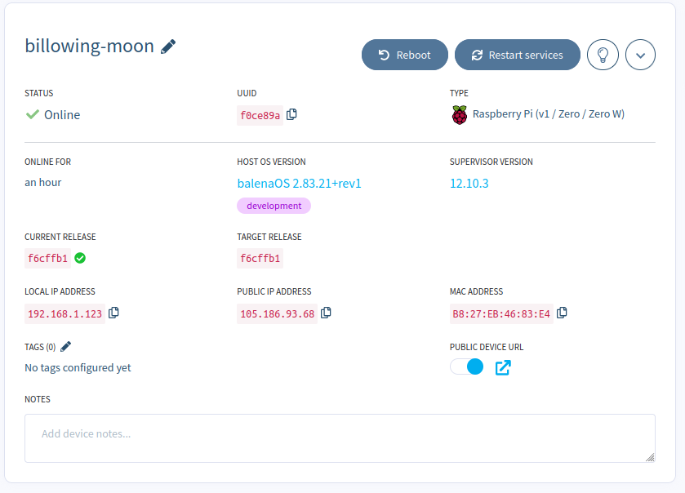
Server running with custom message
Waveform
PART 2
Balena Dashboard showing Raspberry Pi

