**TW Project Coster**

**Software Instruction Manual**

**Version 1.0**

**Release Date: 25/08/15**

**Contents**

1.0 Introduction 3

1.1 System Overview 3

1.2 Basic Concepts and Workflow 3

2.0 Initial Setup 4

2.1 Creating an Account / Logging in 4

2.2 User Profile and General Settings 4

3.0 Costing a Project 6

3.1 Create a new project 6

3.2 Adding/Editing Project Tasks 7

3.2.1 Adding Change Orders associated with extra costs 7

© 2015 KMS LLP. All product names, logos, brands and any other trademarks contained in this document are the property of their respective owners

# 1.0 Introduction

## 1.1 System Overview

Making use of a modern web UI, TW Project Coster is designed to enable you to keep track of and manage forecasted and actual time and costs for all your technical writing projects, so as to be able to confidently charge your customers for work you have done and report on and justify those charges in the process.

There are 3 deployment options for TW Project Coster:

1. As a **cloud-hosted** web app (at [www.twprojectcoster.com/login](http://www.twprojectcoster.com/login))
2. As a **self-hosted** web app for company intranet/private server installation (please contact your administrator for url and login details)
3. As a locally-installed **offline app** (making use of the same web UI)

## 1.2 Basic Concepts and Workflow

To use TW Project Coster, you first configure some common project variables such as project types, rates of cost, reasons for change etc.

Following this, usage is based on a 3-step workflow:

Add new project to list > Add/edit task details and costs > Report on final costs

Once a new project is added to the list, within a single page you can add and edit the different tasks (manual introduction, individual chapters, index etc.) associated with each project. From here you can make use of the pre-defined variables to track forecast and actual time and costs and note changes and the reasons for change.

The program will automatically calculate your actual and total costs. Once a project is complete you can export a report and invoice to pdf/doc/html format.

# 2.0 Initial Setup

## 2.1 Creating an Account / Logging in

1. **Cloud-hosted:** go to [www.twprojectcoster.com/login](http://www.twprojectcoster.com/login), click ‘register’ and fill in your details as prompted
2. **Self-hosted:** go to the url given by your company administrator and either fill in the login details as provided, or click ‘register’ to create your account, then fill in details as prompted
3. **Local app:** go to [www.twprojectcoster.com/download](http://www.twprojectcoster.com/download), select the version appropriate to your OS (Linux/Mac/Windows) and download and run the installer

In each case, the login/register dialog is the same:

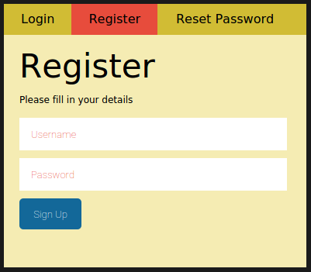

Once registered, you will receive a confirmation email to activate your account.

## 2.2 User Profile and General Settings

Once logged in, click on the **‘Settings’** button, and select the **‘Profile’** tab to edit your business details, which are used when exporting reports and invoices:

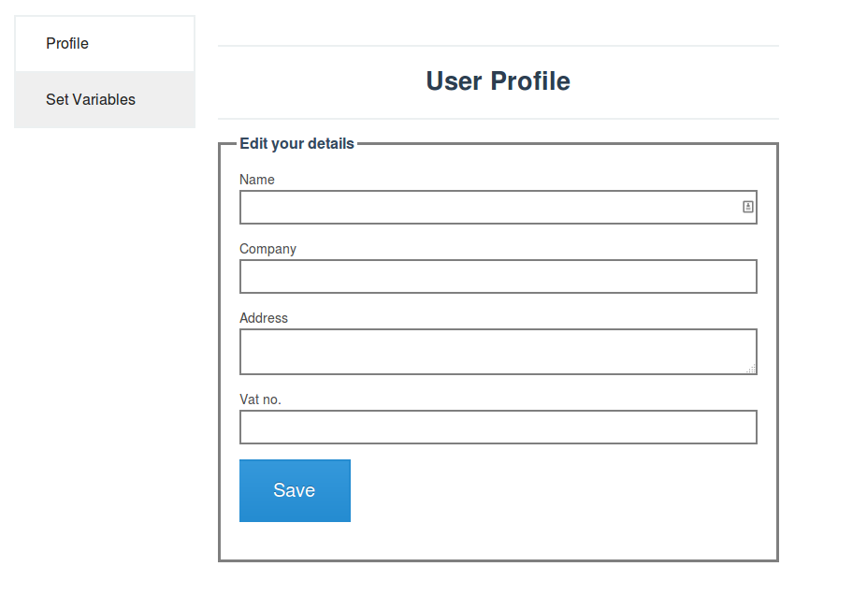

Next, click on the ‘Set Variables’ tab, to define the options that are available for all projects:

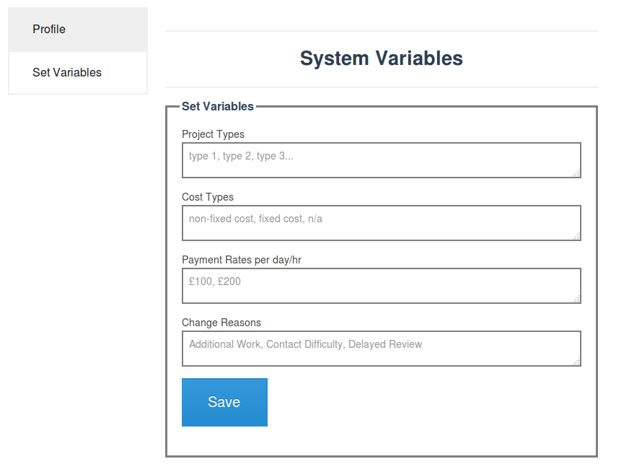

These variables will then be available as drop-downs for each section of your project. As in the above screenshot, use commas to separate each option. Note that ‘n/a’ can be set as an option for any of the variables.

Project Type: e.g. Software Manual, Appliance Handbook, etc.

Cost Type: default options are 'fixed cost' and 'non-fixed cost'. Can be used if you ever agree to doing a certain part of a project for a fixed price.

Payment Rates: you can set a specific payment rate for each section/task in a project. These can be per day or per hour and you can include both hourly and daily rates in the list (e.g. £100, £200, £250, £23, £26, £35)

Change Reason: enables you to specify the reasons that have led to extra charges on a particular task in a project. Default values are set as above.

# 3.0 Costing a Project

## 3.1 Create a new project

In the main screen you will be looking at an empty project list. To create your first project, click on 'Create New Project'. You will then be presented with the Project Overview of your new project, where you can fill in the basic details:

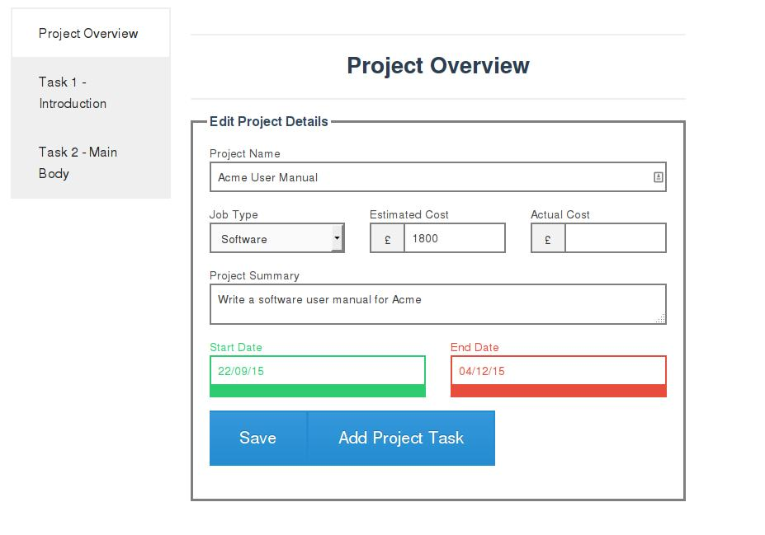

Note that the 'Job Type' drop down corresponds to the list you configured in the system variables.

The 'Actual Cost' figure is automatically updated as a running total of the 'Actual Cost' figures from each project task.

Once you have entered all the project overview details, click 'Save'. Then you can click on 'Add Project Task' to add your first task (note that the screenshot above shows two tasks already added)

## 3.2 Adding/Editing Project Tasks

From the Project Overview, you can click on 'Add Project Task' to add your first task (note that the screenshot below shows two tasks already added):

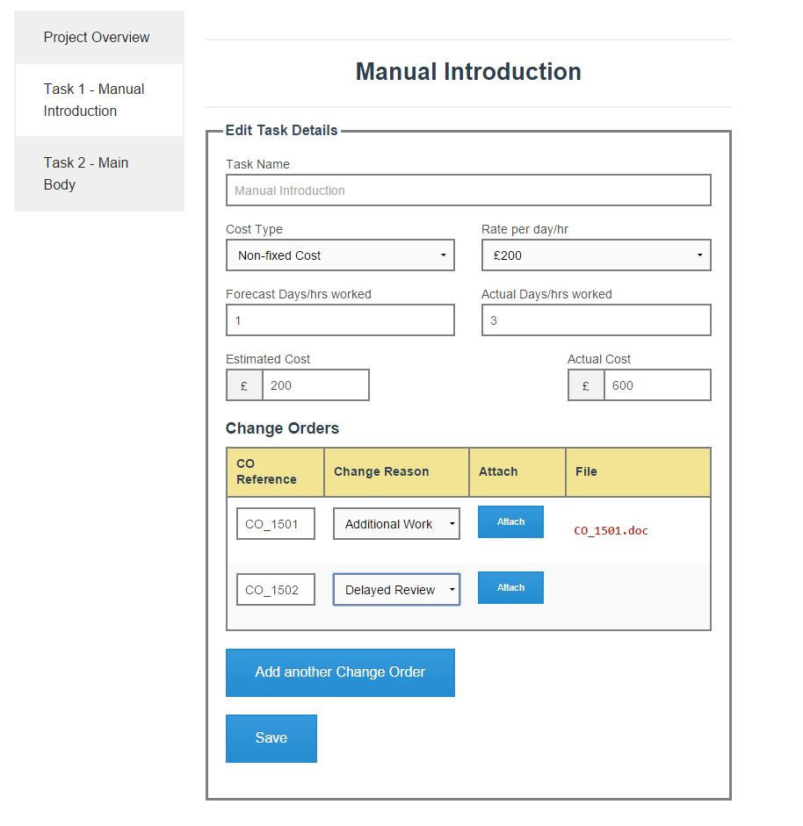

In the above 'Manual Introduction' task, the 'Cost Type' and 'Rate per day/hr' drop-downs correspond to the lists you configured in system variables.

'Estimated Cost' is calculated automatically by multiplying 'Rate per day/hr' and 'Forecast days/hrs worked'. Likewise, 'Actual Cost' by rate and 'Actual days/hrs worked'

### 3.2.1 Adding Change Orders associated with extra costs

You can keep track of your Change Orders associated with extra costs in each task.

The Change Orders table allows you, for each change, to **①** enter the reference, **②** specify the reason and **③** attach the original file associated with the change:

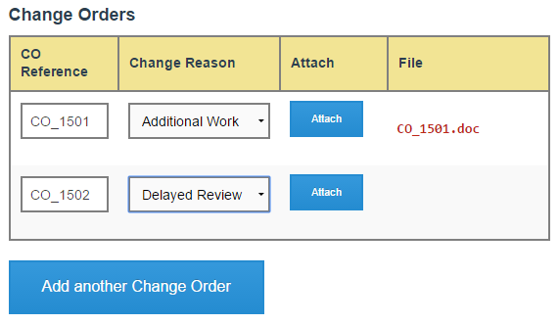

**②**

**③**

**①**

You will see from the above screenshot that no file has yet been attached to Change Order CO_1502.

Clicking to attach the original file will prompt a standard dialog to browse your local file system. When you attach the original file, it will be stored in the TW Project Coster file system, in the folder “twprojectcoster/projects/acmeproject/changeorders/”.

If you chose ‘yes’ for the ‘remove Change Order files from original location’ option in the System Variables, then it will be deleted from where you had originally saved it. This is to ensure that you do not have your change orders saved in more than one location.

You can view the file at any time by clicking on the file link, and you can upload a new version of the file by clicking ‘Attach’ again.