##### Input sanitization

###### Examples for just one file (entitites.csv)

* **The input quantity for each player’s battle participants (except ‘assisting monks’) must be >=1:**



* **The input quantity for each player’s battle participants must be < 100:**



* **The input quantity for each player’s battle participants must adhere to further rules:**



* **The input entity for each player’s battle participants must be recognized:**



* **Check for too much input:**

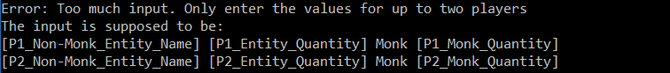

* **Check for too little input:**

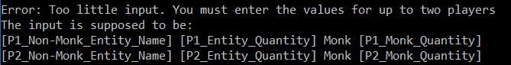

* **Check for excessive monk input:**



##### Test case 1

###### Input

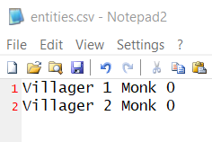

###### Processing

* Recognition that villagers have 4 HP and 3 SD
* Recognition that only up two rounds of combat can occur (there are no archers/monks)
* Checking whether any of the entities involved in the fight died, which ends the program.
* **Player 1 deaths:**

(P2_Villager_Quantity) * ((P2_Villager_Standard_Attack) / (P1_Villager_HP))

* **Player 2 deaths:**

(P1_Villager_Quantity) * ((P1_Villager_Standard_Attack) / (P2_Villager_HP))

###### Expected output

**Player 1 deaths:** one (rounded down from 1.5 damage)

**Player 2 deaths:** zero (rounded down from 0.75 damage)

###### Output

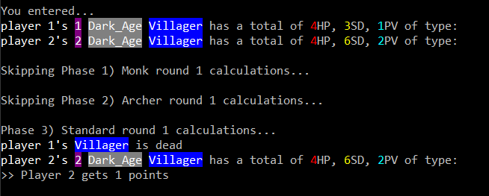

###### Outcome

Successful

##### Test case 2

###### Input

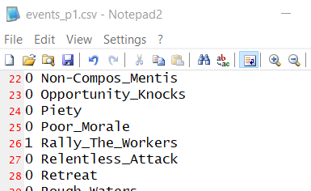 

###### Processing

* Recognition that player 1’s villager standard damage increased by 3 because of Rally the Workers
* Recognition that only up two rounds of combat can occur (there are no archers/monks)
* Checking whether any of the entities involved in the fight died, which ends the program.
* **Player 1 deaths:**

(P2_Villager_Quantity) * ((P2_Villager_Standard_Attack) / (P1_Villager_HP))

* **Player 2 deaths:**

(P1_Villager_Quantity) * ((P1_Villager_Standard_Attack) / (P2_Villager_HP))

###### Expected output

**Player 1 deaths:** one (rounded down from 1.5 damage)

**Player 2 deaths:** one (rounded down from 1.5 damage)

###### Output

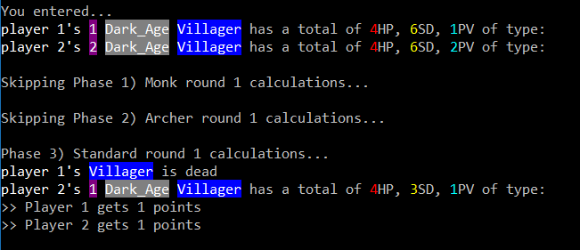

###### Outcome

Successful

##### Test case 3

###### Input

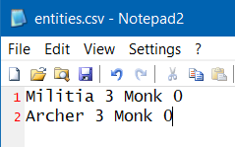

###### Processing

* Recognition that each Militia has 8 HP, 4 SD, and 2 PV
* Recognition that each Archer has 6 HP, four SD, five RD, and two PV.
* Recognition that up to 1 round of archer combat ought to occur (there are archers)
* Recognition that up two rounds of combat can occur afterward
* Checking whether the entities involved in the fight will retreat, which ends the program.
* Checking whether any of the entities involved in the fight died, which ends the program.
* **Player 1 deaths (archer round):**

(P2_Archer_Quantity) * ((P2_Archer_Ranged_Attack) / (P1_Militia_HP))

* **Player 1 deaths (standard attack rounds):**

(P2_Archer_Quantity) * ((P2_Archer_Standard_Attack) / (P1_Militia_HP))

* **Player 2 deaths (standard attack rounds):**

(P1_Militia_Quantity) * ((P1_Militia_Standard_Attack) / (P2_Archer_HP))

###### Expected output archer round 1

**Player 1 deaths:** one (rounded down from 1.875 damage)

###### Expected output standard combat round 1

**Player 1 deaths:** one (rounded down from 1.5 damage)

**Player 2 deaths:** one (rounded down from 1.333333333333333 damage)

###### Expected output standard combat round 2

**Player 1 deaths:** one (rounded down from 1 damage)

**Player 2 deaths:** zero (rounded down from 0.6666666666666667 damage)

###### Output

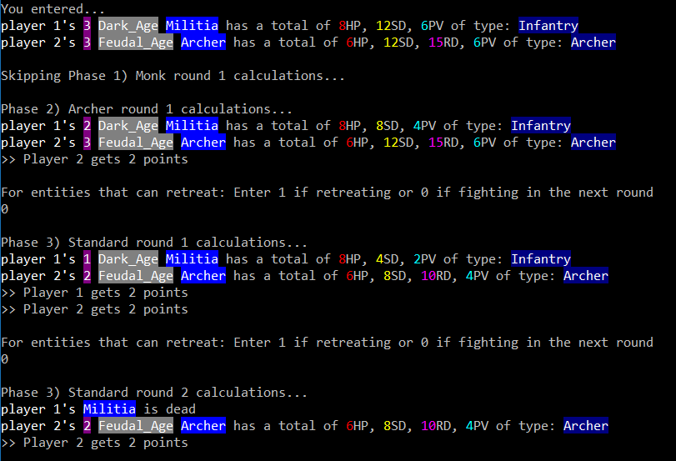

###### Outcome

Successful

##### Test case 4

###### Input

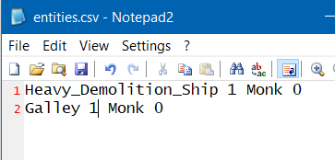

###### Processing

* Recognition that each Heavy Demolition Ship has 16 HP, 140 SD, and 6 PV.
* Recognition that each Galley has 30 HP, 14 SD, and 6 PV
* Recognition that up two rounds of standard combat can occur (there are no archers/monks)
* Recognition that the Demolition Ships only attacks in the second round of combat.
* Recognition that the Demolition Ship explodes upon attacking a target.
* Checking whether the entities involved in the fight will retreat, which ends the program.
* Checking whether any of the entities involved in the fight died, which ends the program.
* **Player 1 deaths (standard attack rounds):**

(P1_Galley_Quantity) * ((P1_Galley_Standard_Attack) / (P2_Heavy_Demolition_Ship_HP))

* **Player 2 deaths (standard attack round 2 only):**

(P1_Heavy_Demolition_Ship_Q) * ((P1_Heavy_Demolition_Ship_Standard_Attack) / (P2_Galley_HP))

###### Expected output standard combat round 1

**Player 1 deaths:** zero (rounded down from 0.875 damage)

**Player 2 deaths:** N/A

###### Expected output standard combat round 2

**Player 1 deaths:** zero from Galley. The Heavy Demolition Ship goes kamikaze and explodes itself.

**Player 2 deaths:** four (rounded down from 4.666666666666667 damage). In other words, the Galley most is annihilated by the Heavy Demolition Ship.

###### Output

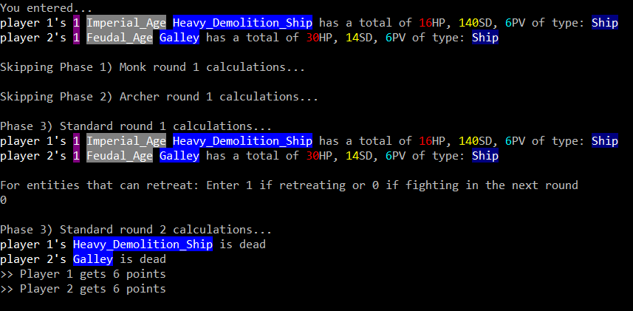

###### Outcome

Successful

##### Test case 5

###### Input

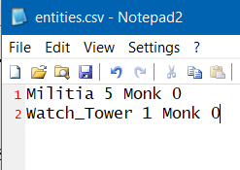

###### Processing

* Recognition that each Militia has 8 HP, 4 SD, and 2 PV
* Recognition that each Watch Tower has 80 HP, 15 SD, and 9 PV.
* Recognition that up two rounds of standard combat can occur (there are no archers/monks)
* Recognition that Watch Towers only attack once but participate in both rounds of combat.
* Checking whether the entities involved in the fight will retreat, which ends the program.
* Checking whether any of the entities involved in the fight died, which ends the program.
* **Player 1 deaths (standard attack round 1 only):**

(P2_Watch_Tower _Quantity) * (P2_Watch_Tower _Standard_Attack) / (P1_Militia_HP)

* **Player 2 deaths:** N/A (versing a building)
* **Player 2 damage (standard attack rounds):**

(P2_Watch_Tower_HP) – ((P1_Militia_Quantity) * (P1_Militia_Standard_Attack))

###### Expected output standard combat round 1

**Player 1 deaths:** one (rounded down from 1.875 damage)

**Player 2 damage:** 20 (100 – 80)

###### Expected output standard combat round 2

**Player 2 damage:** 20 (100 – 80)

###### Output

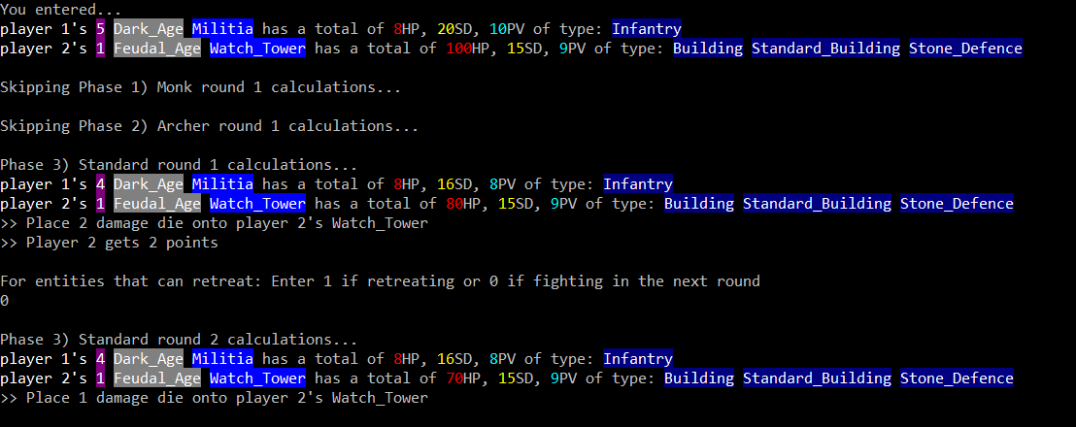

###### Outcome

Successful

##### Test case 6

###### Input

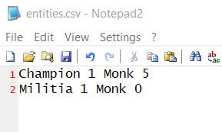



###### Processing

* Recognition that each Champion has 20 HP, 13 SD, and 2 PV.
* Recognition that each Monk has 3 HP and 15 PV.
* Differentiation between conversion and healing attempts.
* Checking whether the entities involved in the fight will retreat, which ends the program.
* Checking whether any of the entities involved in the fight died, which ends the program.
* **Player 1 deaths (standard attack round 1 only):**

(P2_Militia _Quantity) * (P2_Militia _Standard_Attack) / (P1_Champion_HP)

* **Player 2 deaths:**

If the Conversion attempt is successful then P1 loses a Militia in the monk round.

###### Expected output monk combat round 1

**Player 1 deaths:** zero (player 2 has no monks)

**Player 2 deaths:** one if the conversion attempt is successful. 0 if not successful

###### Output

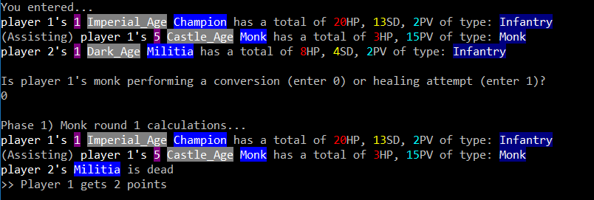

###### Outcome

Successful.