**Computer Organization 2019**

**HOMEWORK 6**

系級: 資訊111 學號: F74074122 姓名: 歐禮寬

**問題(Question)**

Q1. How do you know the number of block from input file?

Cache size * 1024 / block size

Q2. How do you know how many set in this cache?

如果associativity=0,set=1;associativity=1,set=4;associativity=2,set=Cache size * 1024 / block size

Q3. How do you know the bits of the width of the Tag ?

Tag = 32 – log2(block size) – log2(number of block) + log2(set)

Q4. Briefly describe your data structure of your cache.

Int 陣列Cache[cache_index][set] ,裡面存某個tag

Q5. Briefly describe your algorithm of LRU.

當read或存某個數進到cache時,讓對應的lru值設成最大set數,並將其他不為0的lru值-1,當要更新時找lru最小(也就是1)的那個，即要更新的cache;一開始每個lru都是0。

Q6. Briefly describe your algorithm of your policy.

要更新cache值時用random的方式，隨機更新某個cache

Q7. Run trace2.txt, trace3.txt and then makefile to get the miss rate and put it in your report.

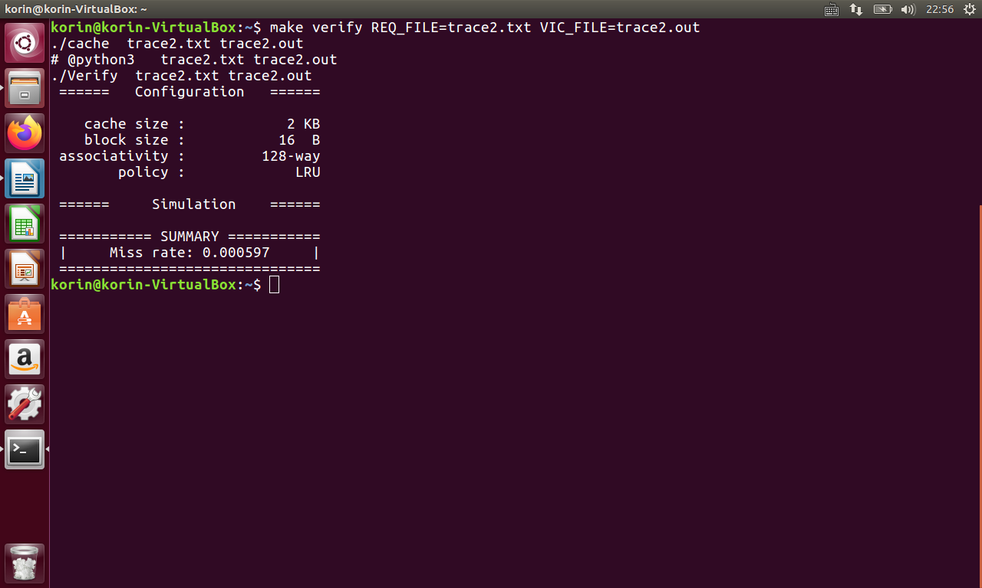

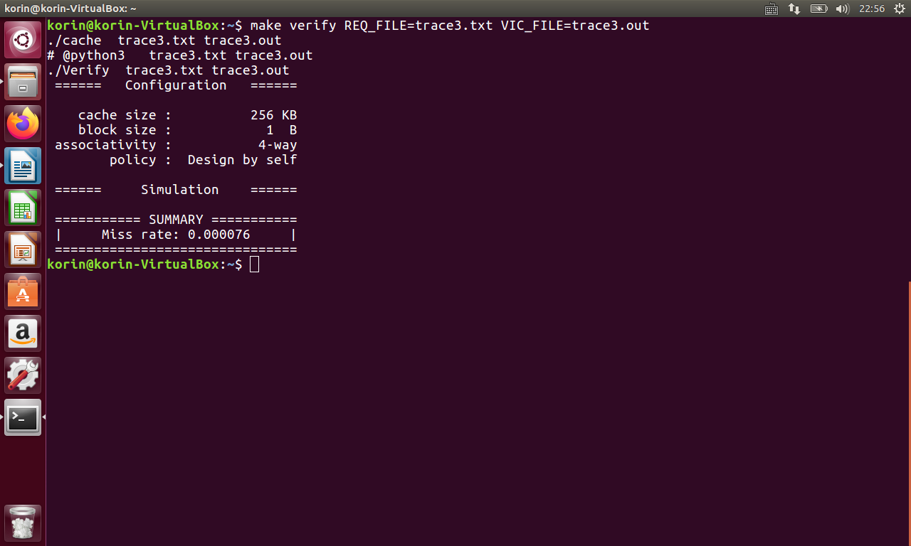

**心得(Report)**

跟上次的cpu比起來好寫多了 : )，一開始makefile時不知為啥verify檔案都會出現拒絕不符權限的操作，上網找了一夏解決方法，透過 chmod 777 Verify 就可以解決了XD，最後，這次作業也蠻好玩的，也讓我對cache進一步的了解ㄌ。