HSBOX

Lab Objective
The objective of this practical lab is to understand and demonstrate the basic penetration-testing methodology in an authorized, controlled HSBox lab environment.
The lab covers the complete process from network reconnaissance and target identification to vulnerability assessment, exploitation, and gaining root-level access. The practical exercise helps develop hands-on skills in identifying open ports and services, analyzing potential vulnerabilities, using security tools such as Nmap and Metasploit, and understanding how vulnerabilities can be exploited in a controlled environment.

Key Learning Objectives
- Identify the target machine and determine its IP address.
- Perform network scanning and identify open ports and running services.
- Analyze exposed services to identify potential security weaknesses.
- Identify SMB-related vulnerabilities, including MS17-010, where applicable.
- Use Metasploit to understand vulnerability assessment and exploitation in a controlled lab.
- Configure the required target and local host parameters.
- Execute the appropriate exploitation steps against the authorized HSBox target.
- Understand the difference between initial access and privilege escalation.
- Verify successful access and identify the level of privileges obtained.
- Obtain and verify root-level access within the lab environment.
- Document each step, command, output, and observation for security assessment purposes.
- Understand how exposed services and unpatched vulnerabilities can lead to unauthorized system access.

Expected Outcome
By completing this lab, I should be able to understand a basic end-to-end penetration-testing workflow: Reconnaissance → Scanning → Enumeration → Vulnerability Identification → Exploitation → Privilege Escalation → Root Access → Documentation.

2. Lab Environment
The HSBox practical penetration-testing lab was performed in an isolated and authorized virtual lab environment. The purpose of this environment was to safely practice reconnaissance, scanning, vulnerability identification, exploitation, and privilege escalation without affecting production systems.

Attacker Machine
- Operating System: Kali Linux
- Purpose: Used as the penetration-testing/attacker machine
- Tools Used:
  - Nmap
  - Metasploit Framework
  - Netcat and other Linux security utilities, as required
- Role: Network scanning, service enumeration, vulnerability assessment, and authorized exploitation

Target Machine
- Target: HSBox-1
- Operating System: Windows/Linux lab target, according to the provided HSBox environment
- Purpose: Vulnerable target machine used for security testing
- Role: Target for network scanning, vulnerability identification, exploitation, and privilege-escalation exercises
- Newtwork scan
Performed a network scan using Nmap to identify active hosts and locate the HSBox target machine within the authorized lab network.
Command : ip a

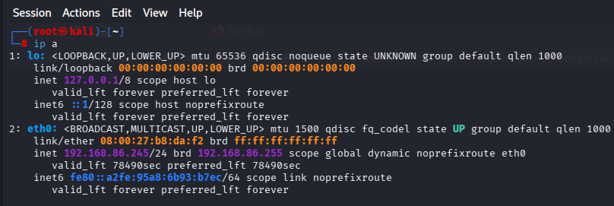

- Performed a network scan using Nmap to identify active hosts and locate the HSBox target machine within the authorized lab network.

HACKERSCHOOL.lan :- 192.168.86.249
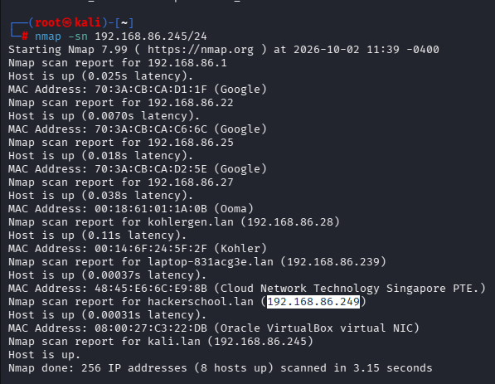
Step 3:
Performed a port scan using Nmap against the identified HSBox target IP address to determine which TCP ports were open and which services were accessible.
The discovered open ports were analyzed to identify the services running on the target and to determine potential areas for further security assessment.
Command : nmap target ip address

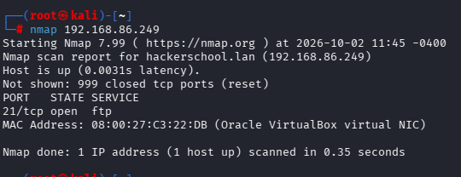

Step 4:
I performed FTP enumeration on the target IP using Nmap to check whether port 21 was open and identify information about the running FTP service using Nmap's default scripts.

Command : Nmap traget ip -p 21 -sC

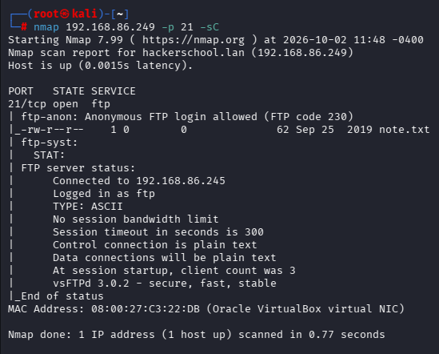

Step 5 :

The goal is to determine whether FTP is running on the target and collect basic information about the FTP service for further security assessment.
Command : ftp traget ip address

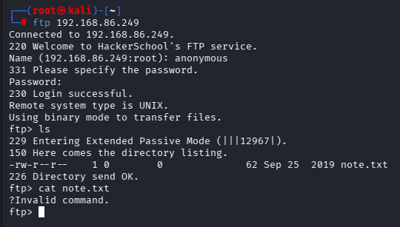

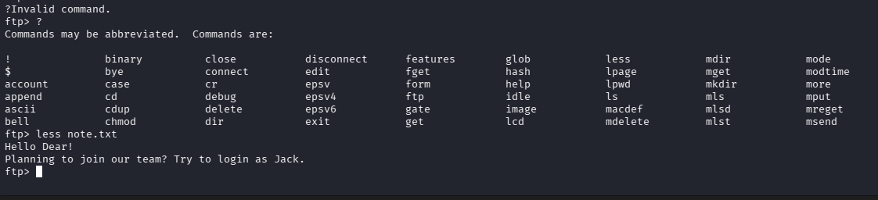
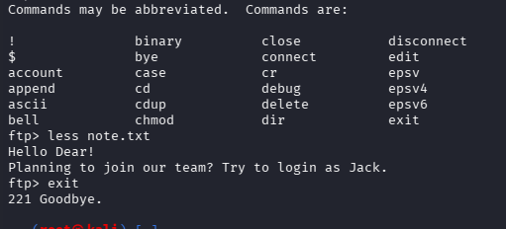

Step 6:
What I did:
I performed a full TCP port scan on the target IP address to identify any additional open ports that were not discovered during the earlier FTP-specific scan.
Why I performed this step:
Since I needed to investigate the jack user and did not yet know which service or port could be associated with it, I scanned all TCP ports to find additional services running on the target.

Command : namp tragetipaddress -p-

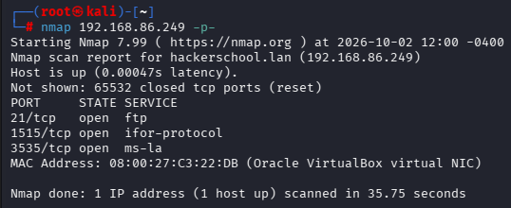

Step 7 :
After performing the full TCP port scan, I identified additional open ports such as 1515 and 3535. Since I did not know which services were running on these ports, I performed a service version detection scan to identify the services and their versions.

Command : Nmap tragetip address -p21,1515,3535 sV

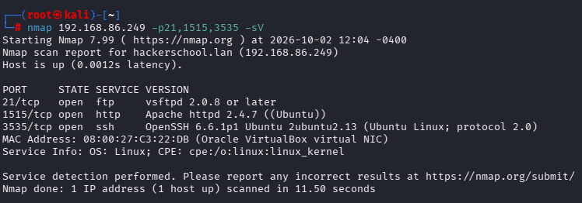

Step 8:
I used the identified SSH service on port 3535 to attempt authentication with the jack user. This step was performed to verify whether the discovered user credentials could be used to access the SSH service on the target machine.
Command : Shh jack@tragetip address -p 3535

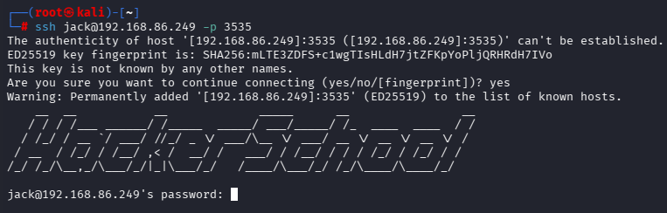

Step 9:
I identified that SSH was running on port 3535 and that the username jack could potentially be used for SSH login. However, I did not know the password for the jack account. Therefore, I needed to perform password-cracking against the lab service to identify the valid password.

Command :-
http://192.168.86.249:1515/

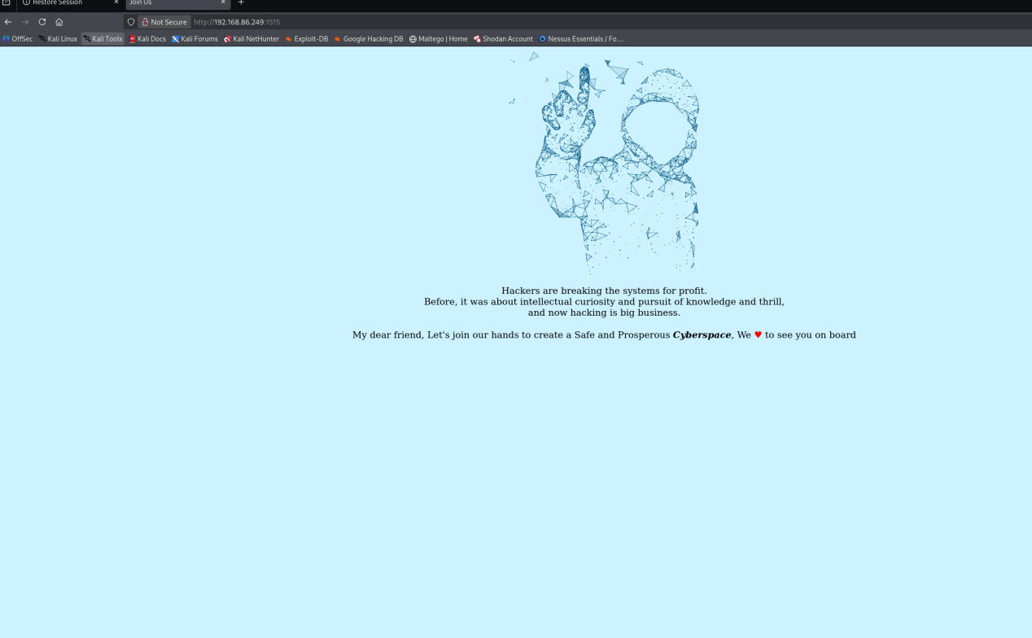

Step 10:
I used Cewl to crawl the target web application and extract relevant words from its content. I saved these words into password.txt to create a customized password wordlist for the next stage of the authorized lab exercise.
Command : cewl -d 1 -m 8 http://192.168.86.249:1515/ -w password.txt

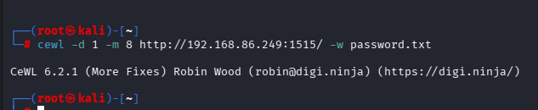

Step 11:

After generating the custom wordlist using Cewl, I reviewed the password.txt file to verify the words that were collected from the target web application.

Command : Cat password.txt

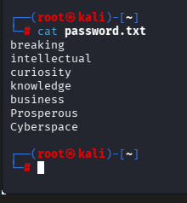

Step 12:
Password Cracking with Hydra
I used Hydra with the custom password.txt wordlist to test password candidates for the jack user against the SSH service running on port 3535. This step followed the Nmap enumeration and CeWL wordlist-generation stages and was performed as part of the authorized HSBOX1 lab assessment.

Command : Hydra -l jack -P password.txt targetip ssh -s 3535 -t 4 -e nsr

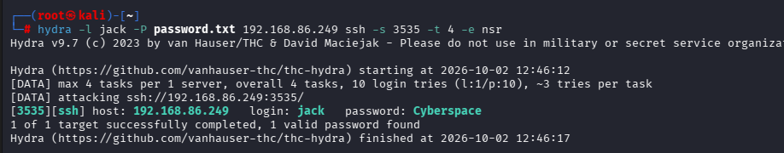

Step 13:
After completing the password-cracking step, I identified the valid credentials for the jack user: username = jack and password = Cyberspace. I then used these credentials to log in to the target HackerSchool machine through SSH on port 3535

Command :- ssh jack@targetid -p 3535

Enetr password and now you are able to access to jack@hackerschool

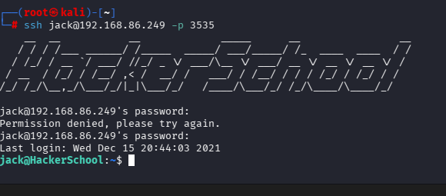

Step 14:

Next, I checked the target machine to see whether there were any additional notes or files available. I found one more note inside the system that needed to be reviewed.

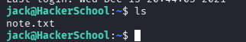

Step 15:

Next, I opened the .txt note to review its contents and understand what information it contained.
Command : cat note.txt

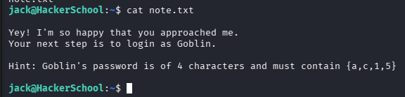

Step 16:
In the next step, I needed to log in to the goblin account using the hint provided in the note. Since the exact password was unknown, I used the Crunch tool to generate a customized password wordlist based on the information provided in the hint. This wordlist could then be used to test possible passwords during the authorized lab exercise.

Command : crunch 4 4 ac15 > gob.txt

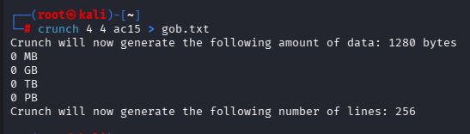

Step 16 :

After identifying the goblin username and generating a customized password wordlist with Crunch based on the provided hint, I used Hydra to test the generated password candidates against the appropriate login service.
The purpose of this step was to determine whether any password from the generated wordlist could successfully authenticate the goblin account in the authorized lab environment.
Command : Hydra -l goblin -P gob.txt targetip ssh -s 3535 -t 4 -e nsr

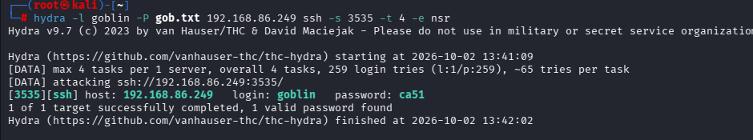

Step 17:

Now we got password for goblin account now we need to login to account using command as
Command : ssh goblin@targetip -p 3535
I entered password as “ca51” for goblin username and now I logged into goblin account
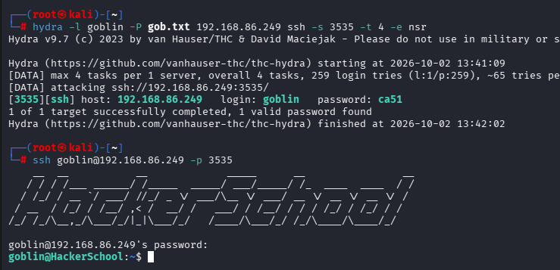

Step 18:
Check note
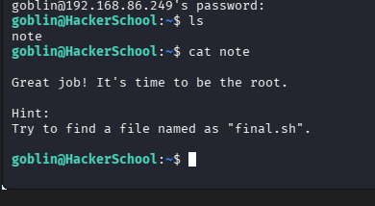

Step 19:
Find command to check final.sh
To check final.sh file

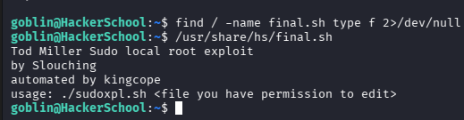

Step 19 :
In this step, I checked the final.sh file but found that I did not have sufficient permissions to edit it. Therefore, I needed to identify the appropriate method to obtain the required permissions before making any changes to the file.

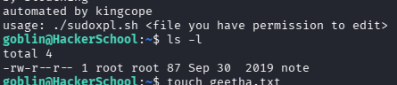

Step 20:

I first created a new text file using the touch command. After creating the file, I used ls -l to view the file details and check its permissions.
The ls -l command displays detailed information about files, including their owner, group, permissions, size, and modification time.

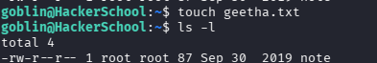

Step 21:

I checked /usr/share/hs/final.sh and geetha.txt to verify their permissions and configuration. After confirming the required access, I proceeded to the temporary root environment on the HackerSchool machine.

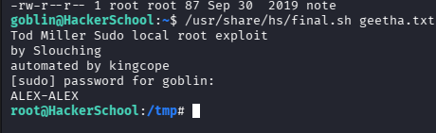

Conclusion

Successfully completed the HSBOX1 lab and practiced a complete basic penetration-testing workflow, including network scanning, service enumeration, FTP/SSH investigation, password testing, Linux file permissions, and post-access enumeration using tools such as Nmap, CeWL, Hydra, and Crunch.

