**Project Title:** Real-Time Twitter Analytics Dashboard using Power BI  
**Intern Name:** Koritala Bhargavi  
**Internship Duration:** 25-03-2025 to 25-04-2025  
**Organization:** NullClass

**1. Introduction**

The internship aimed to equip me with real-time data analysis and visualization skills using Power BI. The primary objective was to build a dynamic and interactive dashboard using Twitter data to gain insights into engagement metrics such as likes, retweets, replies, impressions, and clicks.

**2. Background**

As a student with a background in Artificial Intelligence and Machine Learning, I wanted to gain hands-on experience in data visualization tools. This internship provided a platform to work with real-world datasets, apply DAX functions, and build meaningful business intelligence dashboards.

**3. Learning Objectives**

* To analyze and visualize Twitter social media data.
* To implement complex filters and dynamic conditions using DAX.
* To gain proficiency in Power BI reporting and dashboard creation.
* To simulate real-time business reporting scenarios.

**4. Activities and Tasks**

I performed the following tasks as part of the project:

**Basic Dashboard Visuals:**

1. Card showing the **sum of media views**
2. Card showing **overall impressions on the post**
3. Card for **Engagement Rate**
4. Card showing the **count of tweets engaged**
5. Gauge chart for **sum of likes**
6. Gauge chart for **maximum retweets**

**Click Analysis:**

1. Clustered bar chart showing **sum of URL clicks by tweet**
2. Pie chart for **sum of hashtag clicks, URL clicks, and user profile clicks**
3. Line chart for **sum of impressions by week**
4. Bar chart for **count of tweets by week**
5. Clustered bar chart for **media engagements and media views by week**
6. Line chart showing **count of tweets by week**
7. Matrix for **sum of total clicks by click type and tweet**
8. Clustered bar chart for **click types by tweet**
9. Clustered column chart for **replies, retweets, and likes by Tweet Category**

**Internship Task Implementations:**

* **Pie chart** with drill-down for total clicks on tweets with >500 impressions.
* **Clustered bar chart** showing click types by tweet category, filtered by:
  + Clicks > 0
  + Word count > 40
  + Even dates
  + Time window: 3 PM to 5 PM IST
* **Clustered column chart** for replies, retweets, and likes:
  + Media engagements > median
  + Posted from June to August 2020
  + Time windows: 7 AM to 11 AM & 3 PM to 5 PM IST
  + Tweet length > 20 characters
  + Media views even
  + Date odd
  + Excludes tweets containing the letter "S"

**5. Skills and Competencies Gained**

* Power BI dashboard design and layout
* Advanced DAX calculations and measures
* Time-based and value-based conditional filters
* Data transformation and modeling
* Drill-down and interactive visual implementation

**6. Challenges and Solutions**

* **Challenge:** Filtering tweets without the letter “s” significantly reduced results. **Solution:** Added logic to display a message indicating no matching data.
* **Challenge:** Time conversion between UTC and IST. **Solution:** Created custom columns to extract hours in 12-hour format and identify AM/PM.
* **Challenge:** Multiple complex filter conditions causing visuals to return blank values. **Solution:** Broke down complex DAX logic into stepwise variables and tested incrementally.

**7. Outcomes and Impact**

The dashboard provided an interactive experience that could help marketing teams monitor Twitter performance in real-time. It offers actionable insights through well-designed visuals, filters, and conditional logic.

**8. Feedback and Evidence**

All visuals were built with the provided dataset:  
🔗 [Dataset (CSV)](https://github.com/KoritalaBhargavi/PowerBIProject/blob/main/SocialMedia.csv)

Screenshot of the completed dashboard:

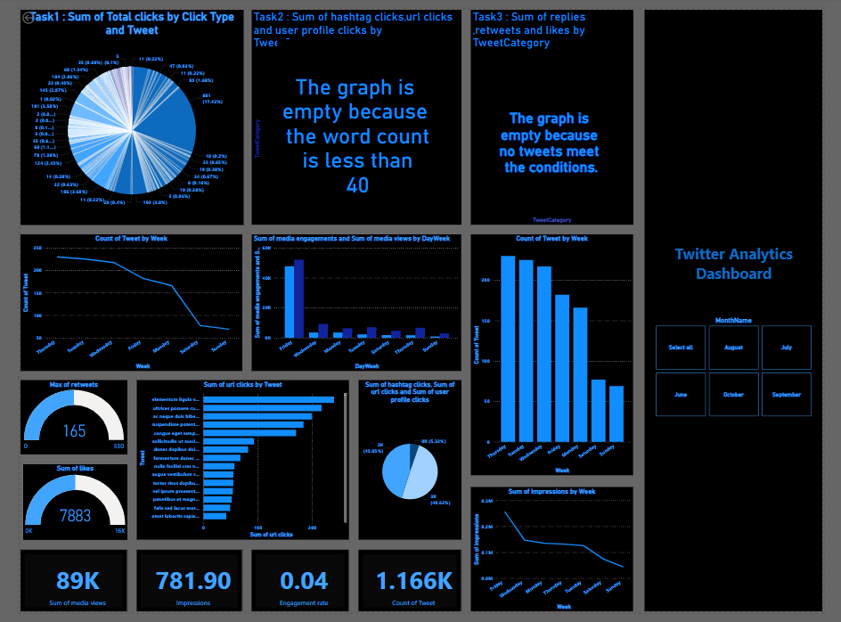

GitHub repository with all files:  
🔗 [GitHub Repo](https://github.com/KoritalaBhargavi/PowerBIProject)

**9. Conclusion**

This internship offered a rich learning experience in real-time data analysis, data modeling, and business reporting. The hands-on project has strengthened my skills in Power BI and prepared me for future data-driven roles.