DOKUZ EYLÜL UNIVERSITY
ENGINEERING FACULTY
DEPARTMENT OF COMPUTER ENGINEERING

CME 4434
DATA WAREHOUSES AND BUSINESS INTELLIGENCE

CLASSIFIERS FOR RICE SEED

by
2014510054 Mahmud KORKMAZ

Izmır(turkey)

INTRODUCTION

In this project, the use of pre-process operations and classification algorithms on the continuous data set, which we learned in the DATA WAREHOUSES AND BUSINESS INTELLIGENCE course, and then the accuracy scores we obtained from these algorithms were compared.
The general idea behind classification in Data mining is to predict the target class from analyzing the training dataset (Haghanikhameneh et al., 2012). Certainly, it is the most significant task that can be applied in different field of human life (A. Murua et al., 2008; Haghanikhameneh et al., 2012). Absolutely, plenty of classification algorithms has increasingly developed in the past couple of years; such as decision trees (Tibebe Beshah et al., 2013), support vector machines (Mu et al., 2017), neural networks and so on.
In this project, I used classification algorithms such as Naive Bayes, Nearest Neighborhood, and Decision Tree.

RElated work
OnlineShoppersIntention-EDA-Classification-Clustering[1]:
The dataset consists of feature vectors belonging to 12,330 sessions. The dataset was formed so that each session would belong to a different user in a 1-year period to avoidany tendency to a specific campaign, special day, user profile, or period.
The Online Shopping Dataset gives them some of the attributes shown in the Project and the item sold or not sold. So it's basically guessing whether it's sold with features or not. Forecast is provided for new sessions that will or will not buy the item. This can be important information for e-commerce companies that receive similar features from their customers. Three different classification algorithms were used for this step.
Another aim of the project is clustering. They applied pca for dimension reduction to 2d or 3d for features. After that, they want to cluster them on the plot. They show how the behavior of these customers differs.

In classification step, they have choosen sgdclassifier, mlpclassifier and k-NN for classification algorithms.

Accuracy Scores:
SGDClassifier: 83.29
MLPClassifier: 81.47
k-NN: 80.12

Three different algorithms were used for classification algorithms. These were; SGDClassifier, MLPClassifier and kNN algorithms. The best score among them was obtained from SGDClassifier.
For the cluster, dimension reduction with PCA was performed first. It has been made suitable for plotting. The explained variance ratios of PC1-PC2 were enough to explain the dataset. After PCA, clustering was applied with kmeans algorithm. Since optimum k is 2 according to the elbow method, it was applied with first 2 and then 3 and 4.

Price classification on Massachusetts housing data[2]:
In this project the Class property is PRICE, which is a continuous dollar value variable. To convert this to categorical ordinal data, they binned list prices using an equal-width grouping operation. The widths of the boxes have not yet been determined. The application of this classification will be the recommended list prices for sellers.
The group decided to switch from WEKA to Python to automate the process. This decision provides greater efficiency and scalability, as 25 different models have to be tested. Thanks to the Python code, the group can test multiple models with multiple feature selections for further analysis.
What didn't go well:
The raw dataset contains many columns that are not significant for PRICE classification. Therefore, many columns had to be discarded.
The PRICE class attribute is quite skewed, which makes grouping more difficult. Classification of logarithmic PRICE values ​​may lead to better results.

EXPERIMENTEL DESİNG AND METHODOLOGY
The data in the dataset was extracted from two kinds of rice (Gonen, Jasmine).
Range Index: 18185 entries. Data columns (total 12 columns): All the attributes are continuous real valued while the class is binary (categorical).
[8 rows x 11 columns]
id 18185 non-null int64
Area 18185 non-null float64
MajorAxisLength 18185 non-null float64
MinorAxisLength 18185 non-null float64
Eccentricity 18185 non-null float64
ConvexArea 18185 non-null float64
EquivDiameter 18185 non-null float64
Extent 18185 non-null float64
Perimeter 18185 non-null float64
Roundness 18185 non-null float64
AspectRation 18185 non-null float64
Class 18185 non-null object
I counted the number of missing values ​​in each column of the data.
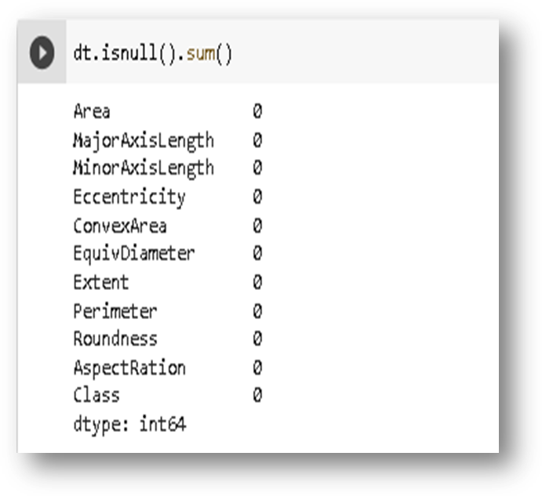
Figure. 1 Missing value

I drew boxplots to identify the columns in the table that contain the outliers.
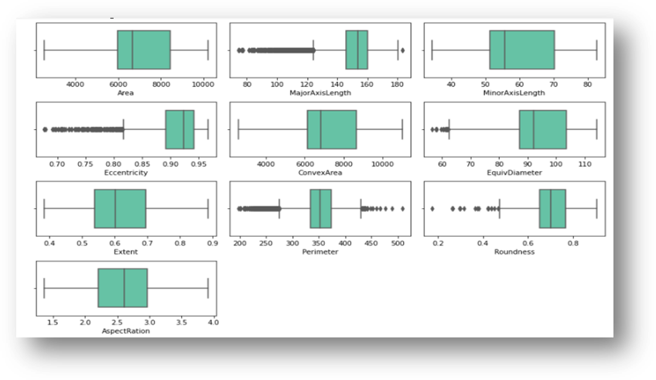
Figure. 2 Boxplots for outliers
First I checked for duplicate samples in the dataset. The results show that there are no duplicate rows in the online retail dataset. So, I didn't need to remove any lines.
Since all the attributes are continuous and our class is binary, I used supervised discretization on the continuous attribute to calculate the correlation with the class.
For supervised discretization, I will use the target class information to generate boxes with the help of decision trees. First I have to find some optimal parameters, for example the depth of the tree.
From the results, I chose the optimal depth for each feature as follows.
- Area: 4
- MajorAxisLength: 3
- MinorAxisLength: 4
- Ecentricity: 2
- ConvexArea: 4
- EquivDiameter: 4
- Extent: 4
- Perimeter: 4
- Roundness: 4
- AspectRatio: 2
I calculated the correlation between the attribute pairs and between the attribute and the class and plotted them on a heatmap for visualization to aid in size reduction.

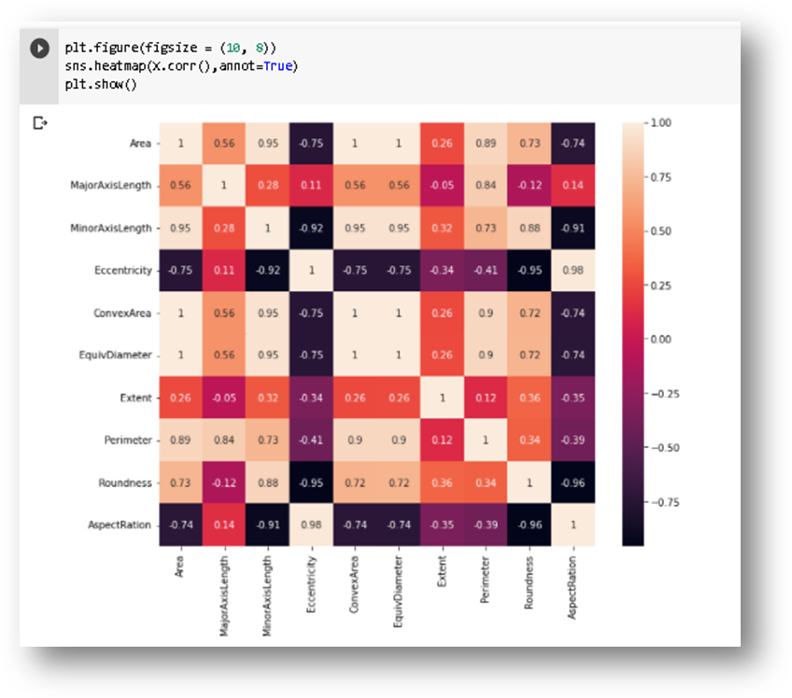
Figure. 3 Coorelation heatmap

Based on these findings, I used MinorAxisLength, Ecentricity, Extent, and Perimeter as our attributes.
I tried to make the distribution of continuous numerical data as Normal (Gaussian). I first plotted the data to visualize the distribution type. I applied data transformation, dimension reduction and data standardarziation for the attributes I will use.

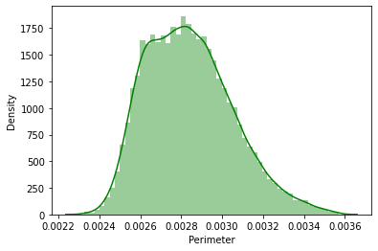
Figure. 4 1/x transformation on Perimeter Attribute

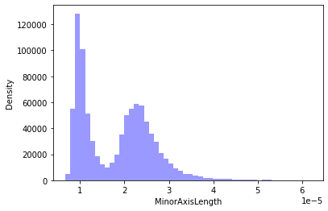
Figure. 5 Transforming MinorAxisLength Attribute

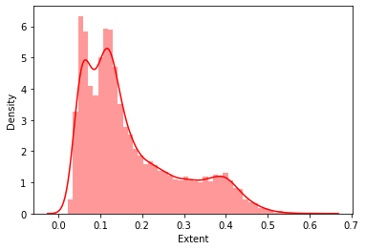
Figure. 6 Transforming Extent Attribute

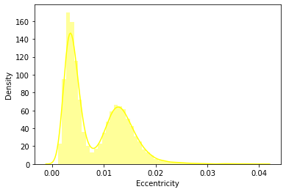
Figure. 7 Transforming Eccentricity Attribute

I then used the 5x5 fold validation technique for cross validation with stratified sampling for all of our classification models
Assuming that our sample is drawn independent of the model and each other and since the number of training examples in all the cases will be n greater than 30, we can say that with N% probability, the error of the entire distribution (true error) lies in the interval:
where errorS(h) is the training error achieved with sample S for our model h, ZN=1.64 for N=90 and ZN=1.28 for N=80.
So, we use the average test accuracies and average lengths of the splittted sets to calculate an average of true errors on the test data.

EXPERIMENTAL RESULT

I apply ID3- a decision tree classifier to the rice dataset obtained after preprocessing. For this purpose, I divided the data into 75% train and 25% test.
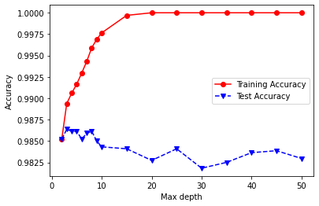
Figure. 8 Max test accuracy value is 0.9864 for depth 3.

Accuracy over Test Data: 98.61
Error with 90 percent confidence is: 1.392 ± 0.324
Error with 80 percent confidence is: 1.392 ± 0.253

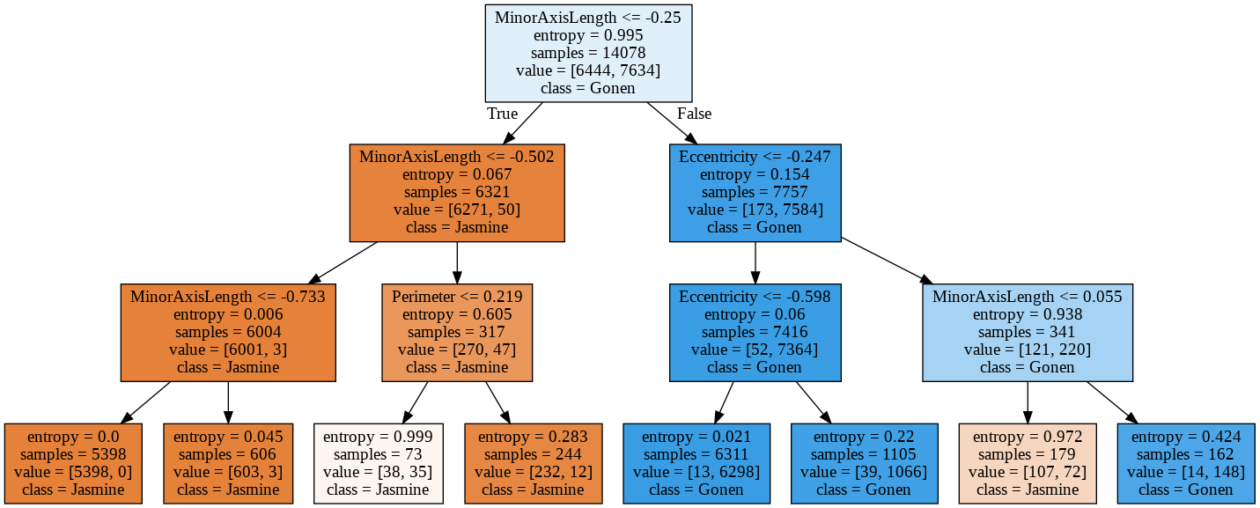
Figure. 9 Generated tree

Then I train the data and then plot the test accuracies obtained for the 5 rounds of my 5x5 fold cross validation with stratified sampling for our naive bayes classifier.

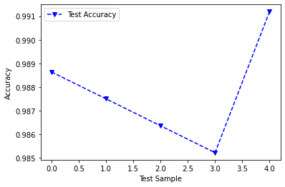
Figure. 10 Test accuracies lie in the range of 0.985 to 0.991.

Accuracy over Test Data: 98.78
Error with 90 percent confidence is: 1.222 ± 0.304
Error with 80 percent confidence is: 1.222 ± 0.237

Classification with KNN
I take k=5 for this project and use Minkowski distance as our metric, then split the data as 75% train and 25% test .
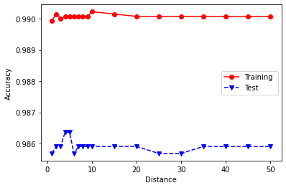
Figure. 11 Maximum test accuracy value is 0.9863for distance 4

Accuracy over Test Data: 98.73
Error with 90 percent confidence is: 1.267 ± 0.309
Error with 80 percent confidence is: 1.267 ± 0.241

CONCLUSION
Here is a comparison for how various models compare, scored by accuracy:

Model Accuracy Score
Naive Bayes 98.78
5 Nearest Neighbour 98.73
Decision Tree 98.61
We can still make a relative comparision on these models based on their accuracy score as: Naive Bayes > 5 Nearest Neighbour > Decision Tree. All these accuracy values are acceptable and thus the models perform well.

Based on their true error scores, we can say that besides Naive Bayes has the least true error for both the considered intervals followed by KNN. Decision Tree has a relatively high true error rate. This point to the same ordering of preference as above.

REFERENCES
[1] github.com/onur-duman/OnlineShoppersIntention-EDA-Classification-Clustering

[2] github.com/myz540/cs699_project_classification

[3] www.kaggle.com/seymasa/rice-dataset-gonenjasmine

[4] https://www.tutorialspoint.com/data_mining/dm_classification_prediction.htm

[5] Lung-Cheng Huang, Sen-Yen Hsu and Eugene Lin, “A Comparison of classification methods for predicting Chronic Fatigue Syndrome based on genetic data”

2009, “A Comparison of classification methods for predicting Chronic Fatigue Syndrome based on genetic
data”, Journal of Translational Medicine.

data”, Journal of Translational Medicine

