**Availity’s Full Stack Homework Questions**

**1.** **Tell me about your proudest professional achievement. It can also be a personal or school project.**

As a game developer, I have had the privilege of working on many incredibly unique and fun projects. On one of my previous teams, we were working on a game called ‘RoCitizens,’ a life-simulator roleplaying game centered around the idea of living in an immersive world, owning your own house, and living whatever type of lifestyle suits you. We had just launched our most extensive update ever, which expanded the world by around 400%. This update proved challenging for our existing player base, and we quickly learned that players could not figure out how to navigate the new world.

To solve this problem, I came up with the idea of a GPS minimap that players could use to orient themself and navigate to a variety of landmarks in the game. The GPS was a surprisingly complex feature to implement. I ended up creating a custom minimap renderer and a custom raycasting map renderer. I then created a directed and weighted graph of the existing road system and used Dijkstra’s algorithm for pathfinding. On top of that, I had no assistance with this specific feature, so I created everything from front-end to back-end. In the end, I am very proud of how it turned out, and the players seemed to enjoy using the GPS to find their friends, house, and any other landmark on the map.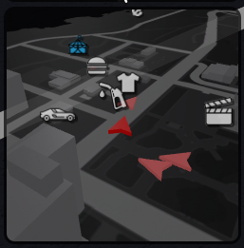

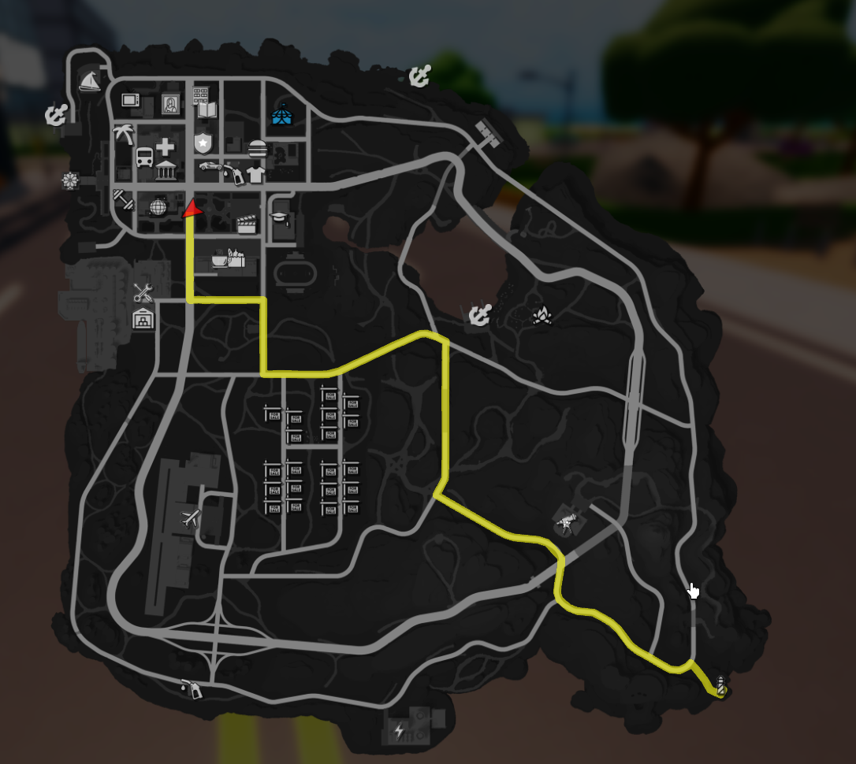

**2.** **Tell me about something you have read recently that you would recommend and why. (Can be a GitHub Repo, Article, Blog, Book, etc.).** I recently read an interesting article relating to AI predictions (<https://news.mit.edu/2022/ai-predictions-human-trust-0119>). In short, the article discussed methods that researchers have developed to build trust between a person and artificial intelligence. There are many things that AI can do better than humans, but knowing when to trust the AI is equally as important as the AI being accurate and precise. To help users trust their ‘AI Assistants,’ researchers have defined methods to gradually introduce their AI model so that they can understand its strengths and weaknesses. I recommend this article because it is fascinating to think about how much the world will change (and is changing!) with the influx of AI in our everyday lives. Inevitably, there will eventually be some sort of AI in most individuals’ workplaces. This article provides some good insight into the importance of onboarding this process and can help us better prepare for the future of AI.

**3.** **How would you explain to your grandmother what Availity does?** Availity creates software solutions that make it easier for insurance companies and healthcare providers to communicate and solve problems. Instead of relying on a slow phone call between your doctor, pharmacy, and your insurance provider, Availity creates software on the internet that makes those processes faster for everyone.