Project Progress
Nowcasting Inflation via Daily Web Scraping Price

1. Objective
- Build an Automated Data Infrastructure and Monitoring System: Set up an automated data pipeline and database to collect, store, and continuously monitor price.
- Calculate CPI for inflation nowcasting using machine learning model: Apply an economic formula to compute daily price relatives, and use regularized Ridge regression modeling to nowcast inflation ahead of the official monthly release.
- Build a decision-support dashboard: Develop an interactive dashboard that presents daily CPI results and inflation for easy monitoring.

2. Architecture

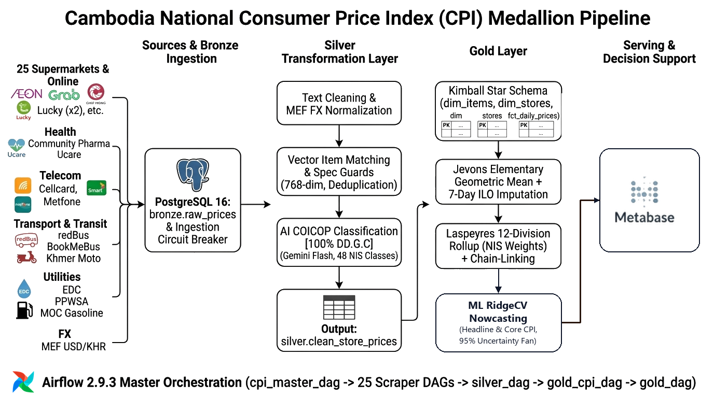
Figure 1: End-to-End System Architecture: Web Scraping, Medallion Pipeline & Dashboard.

Technology Stack
Component / Layer | Technology Stack
Data Ingestion & Scraping | Python
Database and Storage | Postgres 16
Orchestration | Apache Airflow
Data Transformation | dbt Core
AI Product Classifications | Gemini AI
Dashboard and Monitoring | Metabase
System Container | Docker

3. Data Collection
Data Source | Description
AEON Online Cambodia | Supermarket
DeliShop Asia Phnom Penh | Supermarket
GrabMart (Lucky Supermarket, Chip Mong) | Supermarket
L192 Online Marketplace | Footwear & Homeware
Community Pharmacy & Ucare Pharmacy | Healthcare & Pharmaceutical Goods
Khmer24 & Realestate.com.kh | Urban Residential Apartment, House Rentals
redBus & BookMeBus Transit | Bus & Travel Transport
Cellcard, Smart Axiata, Metfone | Mobile plan and Wi-Fi
Tela Khmer | Gasoline
dataEF API | Exchange rate
Sokha, Hyatt, Bayon BKK | Restaurant and hotel

4. Methodology

Stage 1: Web Scraping Layer
Protocols & Methods:
- REST / GraphQL APIs: Reverse-proxy APIs for supermarkets (AEON, DeliShop) and marketplaces (L192).
- HTTP Requests with TLS Fingerprinting: curl_cffi using Chrome TLS fingerprint impersonation to bypass anti-bot defenses.
- Headless Playwright: Dynamic browser escalation if Cloudflare or 403 Forbidden is met.

Stage 2: Bronze Layer (Raw Lake Ingestion)
Database Table: bronze.raw_prices
- What it does: Acts as an immutable, append-only raw data repository preserving the exact raw data as fetched from the web.
- Stored Fields: store_id, source_name, item_description_raw, price, currency, source_url, scraped_at, batch_id.

Stage 3: Silver Layer (Standardization, AI Classification & Quality Control)
Database Table: silver.standardized_prices
The Silver Layer has 3 main jobs:
[Raw Scrape] ──► 1. Clean Data ──► 2. Match Product ──► 3. Classify Basket ──► [Clean Silver Item]

1. Clean the Data (Standardize)
- Removes noise: Deletes marketing words (SALE, HOT DEAL, 50% OFF) and old price tags.
- Normalizes units: Converts volumes and weights into standard sizes (500ml, 1kg) to calculate price per liter/kg.
- Handles dual currency: Converts USD and Khmer Riel using the daily MEF exchange rate.
- Fixes Khmer text: Segments unspaced Khmer words and translates digits (០-៩ → 0-9).

2. Match the Product (Find the Same Item)
Connects identical products across different stores (e.g., AEON vs. DeliShop) using a 5-step waterfall:
- Barcode (GTIN): Exact match.
- Store SKU: Match with past days' catalog.
- Clean Name & Size: Exact text match with size protection (prevents 330ml matching 1.5L).
- AI Vector (pgvector): Matches English and Khmer equivalents (≥95% similarity).
- Fuzzy Spelling: Catches small typos.

3. Classify into Official Baskets (UN COICOP)
- Uses Google Gemini AI in batches to assign the official 4-digit government code (e.g., 01.1.1 for Rice/Bread).
Strict Guardrails prevent AI mistakes:
- Pet Food: Goes to Pets (09.3.1), never human food.
- Shampoo / Soap: Goes to Personal Care (12.1.3), never food.
- Beer / Wine: Goes to Alcohol (02.1), isolated from soft drinks.

The Gold Layer in Brief: From Clean Products to Official CPI
The Gold Layer applies official international standards (ILO / UN guidelines) to turn thousands of clean daily prices into national economic indicators.
It does this in 3 main steps:
[Clean Silver Items] ──► 1. Jevons Index ──► 2. Laspeyres Aggregation ──► 3. Core CPI & Marts

1. Elementary Index Calculation (Jevons Formula)
- (Jevons Geometric Mean): Instead of a simple average (which gets distorted by expensive luxury items), the system uses the geometric mean:
I_rice,t = ( (P_1,t / P_1,0) × (P_2,t / P_2,0) × ... × (P_n,t / P_n,0) )^(1/n)
- Missing Price Imputation: If an item is temporarily out-of-stock, a 7-day carry-forward rule fills in the price so the index doesn't jump wildly.

2. Official National Aggregation (Laspeyres Formula)
Cambodians spend more money on food than on furniture. To reflect real life, the 12 COICOP divisions are combined using official government survey expenditure weights (CSES 2020):
Headline CPI = ∑ ( Weight × Division Index )
- Food & Drinks (01): 44.775% (Highest weight in Cambodia)
- Housing & Electricity (04): 17.062%
- Transport & Fuel (07): 12.203%
- All other 9 Divisions: Remaining 25.960% (Clothing, Health, Telecom, etc.)

3. Central Bank Metric: Core CPI
For central bankers at the National Bank of Cambodia (NBC), temporary global oil spikes or seasonal vegetable floods distort the real picture:
- Refined Core CPI: The system calculates a second official index that removes Food (01) and Energy (04):
Core CPI = ( ∑_{ex-Food, ex-Energy} w_j · I_j ) / ( ∑ w_j )
This shows the underlying, long-term price stability of the economy.

Stage 4: Nowcasting
Methodology (Two-Tier Hybrid Approach): Rather than using a black-box AI model, we use a hybrid economic approach:
- Tier 1 (Official Aggregation): We use fixed CSES expenditure weights across all 12 COICOP divisions following official NIS/ILO Laspeyres standards. We calculate both Headline CPI and Core CPI (excluding volatile food and energy).
- Tier 2 (Forward Econometric Projection): For past observed days, we compute the realized daily average from scraped prices. For the unobserved remaining days of the month, we nowcast daily drift rates using regularized Ridge Regression (RidgeCV) with Bayesian prior shrinkage.
- Blending: We combine realized days and projected days using a time-weighted formula that smoothly converges onto actual data as the month ends.
Cambodia-Specific Market Features:
- 5 Core Baskets: We model the 5 high-velocity categories (~81.6% of Cambodia's basket): Food (44.8%), Housing/Utilities (17.1%), Transport (12.2%), Restaurants (3.1%), and Alcohol (1.6%).
- Freight Spillover: Fuel price momentum (Transport) is selectively fed into Food and Restaurant catering to model logistics cost pass-through.
- Holiday Handling: We built an exponential decay kernel for Khmer holidays (Khmer New Year, Pchum Ben, Water Festival) so temporary ceremonial spikes are not misread as permanent inflation.
- FX Pass-Through: Ingests daily USD/KHR commercial exchange rates.

