Visual Computing Assignment 1

Kornidesz Máté

26th of September 2025 (Deadline)

Content

Tasks and Overview 1

Tasks 2

1. Task: Dataset and Capture 2

2. Task: Feature Detection and Matching 2

3. Task: Homography Estimation Experiments 3

Experiments 3

Key point counts vs Match quality 3

Threshold vs Panorama alignment error 3

Discussion 3

Sources 3

## Tasks and Overview

The objective of this project is to create a panorama stitching system using feature detection, matching and Homography estimation to create the desired panorama. The description of the task required an input image source of 3 sets of images (each containing at least 2, which 2 images must be around 20%-60% overlapping for the desired results). The description of these images can be viewed later in this document (1. Task Dataset and Capture). Each dataset is captured to test the limits of the used methodologies in terms of number of matches, number of detected key points by varying the light conditions and texture richness throughout the images. The dataset was made with a phone camera in a standing position in high resolution (that is why the images made smaller in the “process pipeline” and that’s why they have their specified ratio (∽15:27). The pipeline was made in C++ and used the OpenCV library for the rest of the calculations and methods and for simple diagrams as well. The used methodologies were SIFT and AKAZE where the program prints the details specified in Task 2., there is also a possibility to visualize the matchings (not recommended, very dense for the rich input). For RANSAC the threshold was varying between 1.0, 3.0, 5.0 and 10.0, so from use a strict approach where inliers significantly drop, to a more permissive threshold where almost all matches count as inliers. The good balance is around 3 or 5 as the too small threshold can lead to visually unpleasant result if the images not aligned well, and the too big threshold also can lead to stretching in the result, so there may be a “sweet spot”. For the last part of the tasks, the images were blended using 2 different techniques: simple overlay and feathering. The 2 methods are compared to each other in terms of speed and result quality.

## Tasks

### Task: Dataset and Capture

The Images can be found on the GitHub repository ([Link to Repository](https://github.com/Kornimate/visual-computing-au)). The following details were observed about these pictures:

|  |  |  |  |
| --- | --- | --- | --- |
| Source Name | Pictures with *-s1-* | Pictures with *-s2-* | Pictures with *-s3-* |
| Title | Indoor Set 1 | Indoor Set 2 | Outdoor Set 3 |
| Short Description | Indoor picture set which contains a wall a curtain and some light behind the curtain | Indoor picture set which contains a corridor and stairs with mailboxes and a door | Outdoor picture set which contains a street with trees and houses and some parked cars |
| Lighting | Poor Lighting | Moderately Good Lighting | Good Lighting |
| Motion Blur | Moderately Sharp Image | Sharp Image | Sharp Image |
| Texture Richness | Lower Texture richness | Moderately High Texture Richness | High Texture Richness |

### Task: Feature Detection and Matching

These pieces of information were also logged to the console in the C++ program: (The images were scaled to 15% of their original size on both axes for better runtime and better viewability of matches on my device)

|  |  |  |  |  |  |
| --- | --- | --- | --- | --- | --- |
| Dataset | Method | Key point 1 | Key point 2 | Matches | Elapsed Time |
| s1 | SIFT | 50 | 40 | 14 | 1.2653 ms |
| s1 | AKAZE | 64 | 62 | 28 | 2.8425 ms |
| s2 | SIFT | 486 | 534 | 87 | 73.0941 ms |
| s2 | AKAZE | 496 | 312 | 109 | 8.6341 ms |
| s3 | SIFT | 478 | 708 | 76 | 92.2921 ms |
| s3 | AKAZE | 265 | 421 | 94 | 7.3694 ms |

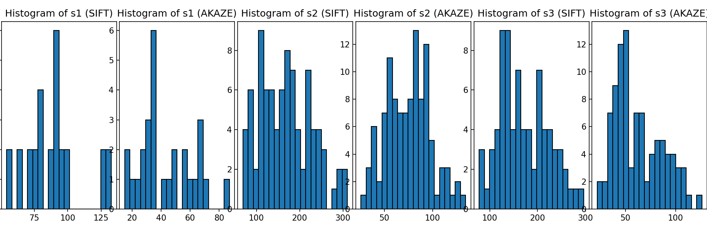

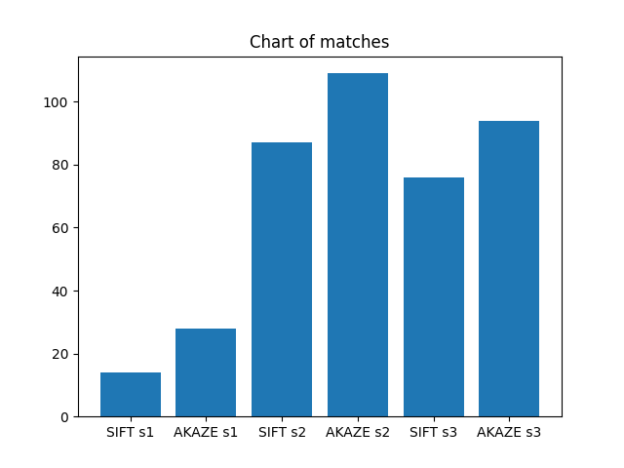

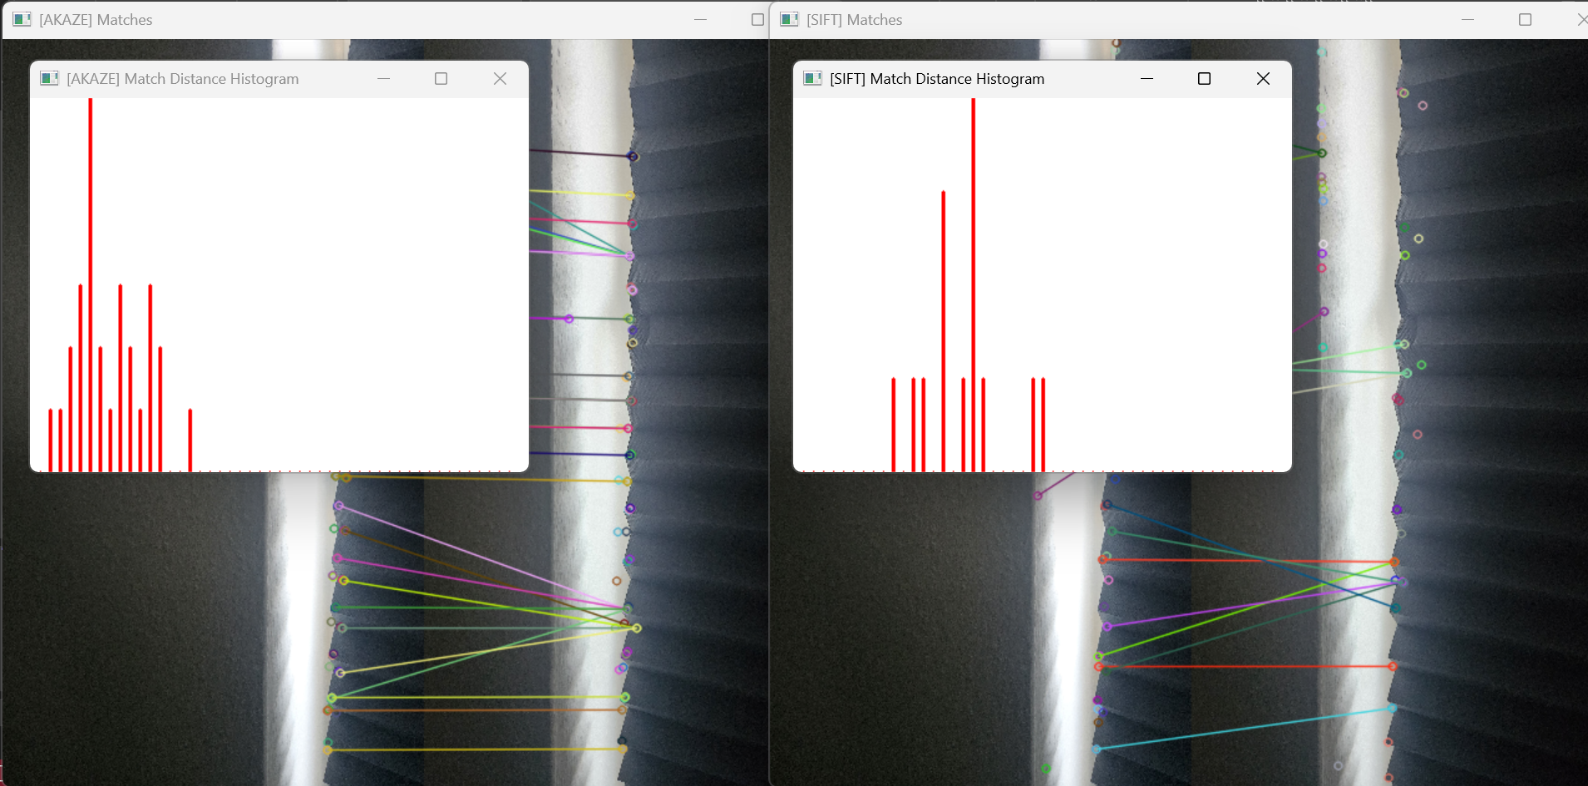

### Task: Homography Estimation Experiments

These pieces of information were also logged to the console in the C++ program: (The images were scaled to 15% of their original size on both axes for better runtime and better viewability of matches on my device) Images used for the experiments: **outdoor-s3-2.jpg** and **outdoor-s3-3.jpg**

|  |  |  |  |  |
| --- | --- | --- | --- | --- |
|  | Threshold = 1 | Threshold = 3 | Threshold = 5 | Threshold = 10 |
| Inliers | 17 | 69 | 91 | 100 |
| Visual Quality | Good | Good | Good | Good |
| Runtime | 191.69 ms | 172.254 ms | 177.881 ms | 177.737 ms |

## Experiments

### Key point counts vs Match quality

### Threshold vs Panorama alignment error

## Discussion

## Sources

The link to the GitHub repository: [GitHub Repository](https://github.com/Kornimate/visual-computing-au), this contains the short video and the source images as well.