* Introduction
* How to Use Cronometer to Track Nutrition
  + Getting / Setting the App
  + When to Record
  + How to Record
  + Review the Data
  + Learn from Tracking
  + Use App Features to Meet Nutrition Requirements and Be Efficient
* Conclusion

# Introduction

This article explains the mechanics of tracking nutrition using a mobile/web app. It is written for someone who already believes that tracking nutrition in order to eat purposefully is a valuable approach.

It turns out that tracking nutrition is difficult. What did you eat two days ago? How much carbohydrate, fat, and protein did you eat? How much zinc did you consume? We’ll never know. If you want to answer questions like these, it’s essential to track your nutrition. My preferred app for doing so is [Cronometer](https://cronometer.com/).

**A word on the *purposeful* approach:** *There are other approaches. One can go by hunger, craving, intuition, pre-fabricated diet-plan, or convenience. Depending on the situation, one of those options might be the best choice. But, I believe that eating with purpose is essential to achieving any goal that relies on proper nutrition, including living a long healthy life. Furthermore, by choosing to eat with purpose and reason most of the time, one’s subconscious mechanisms (i.e. hunger, craving, etc.) will be more likely to produce beneficial results when tracking and analyzing nutrition is not ideal. To be explicit, if you consciously understand that certain foods are nutritious, and therefore life-giving, and that others are superfluous, harmful, or life-taking, then you’ll be more likely to crave fish or vegetables than potato chips. You can automatize proper nutrition, or not.*

# How to Use Cronometer to Track Nutrition

## Getting / Setting the App

This should be pretty straight-forward. Download the app on your mobile, or access the webpage from a desktop/laptop. Make an account and set up your profile. You’re ready to track.

## When to Record

My personal experience is that tracking in real-time throughout the day is easier, more accurate, and will be done more reliably than trying to record everything at the end of the day. If you wait until the end of the day, you’re more likely to forget items, or to forget to track completely. Also, any nutrition plan that depends on changing *when* you eat, will be easier to execute if time-stamps are accurate - i.e. if you understand when you eat, you can intentionally change this more easily. Real-time tracking seem cumbersome at first, but once you enter a couple items, it becomes second nature and goes quickly. Even for a complex meal, you’ll spend only 3-5 minutes entering data. If the meal is simple, or it’s a product or recipe that you’ve previously entered, it may take only a few seconds.

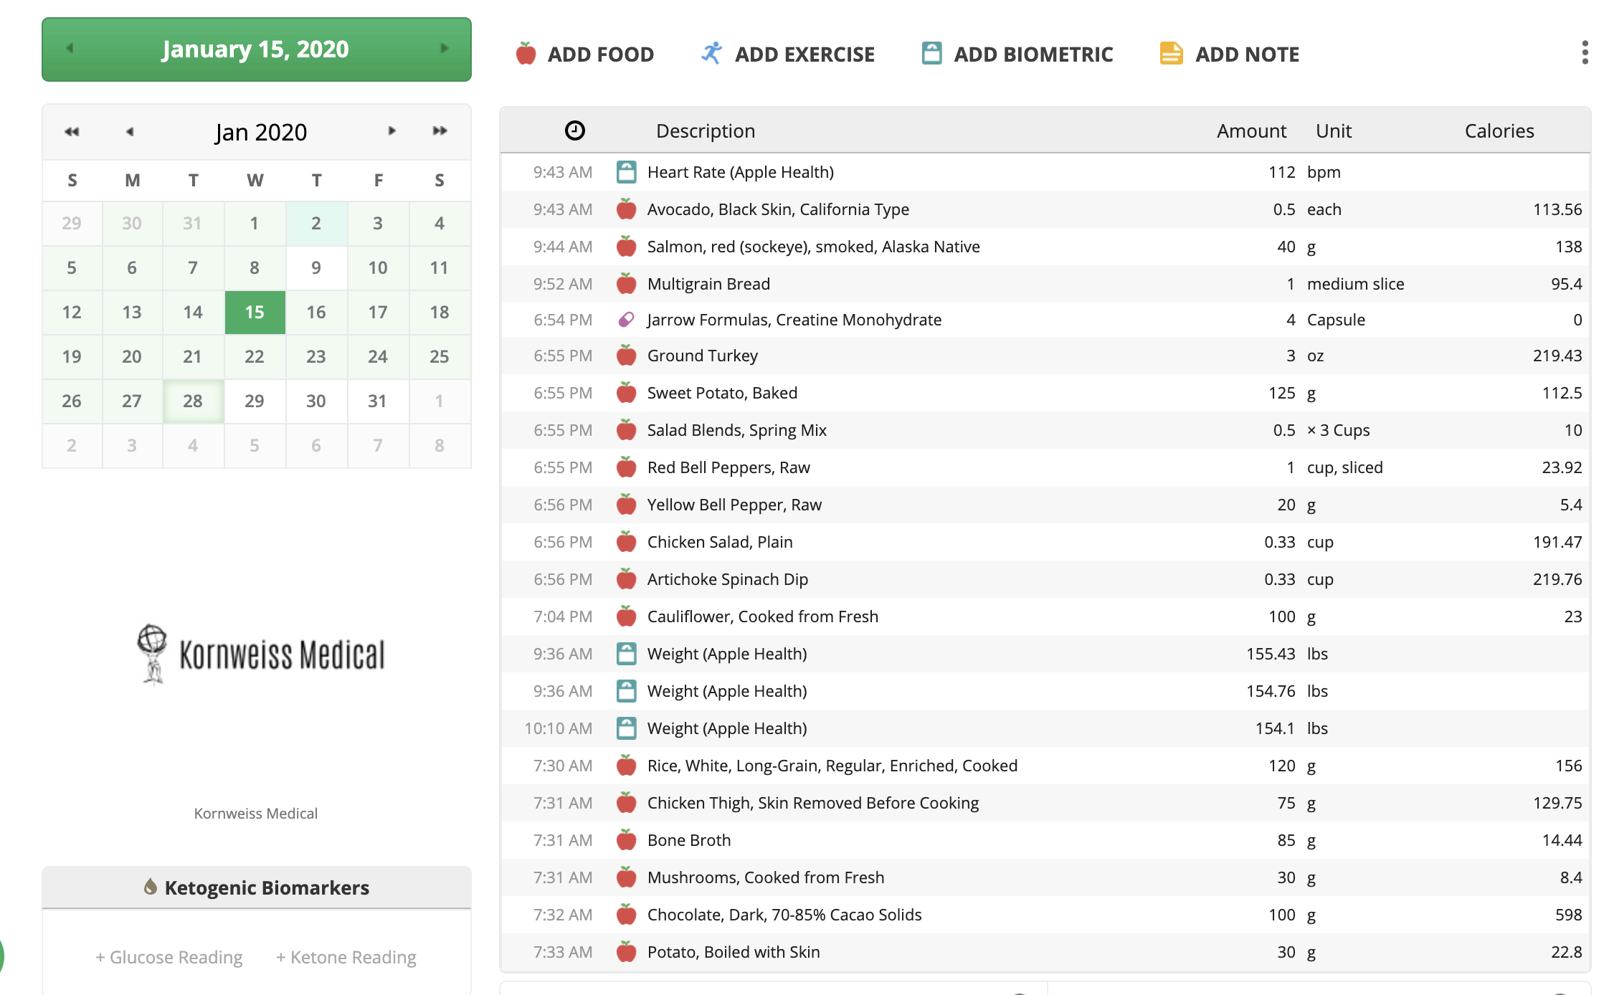 *A Day’s Worth of Entries*

## How to Record

### Weigh Your Food

Get a kitchen scale. I have [this one](https://www.amazon.com/Hario-Drip-Coffee-Scale-Timer/dp/B009GPJMOU/ref=sr_1_3?dchild=1&keywords=haribo+coffee+scale&qid=1589559848&sr=8-3) which I use for weighing coffee and food. There are less expensive options. When you eat at home, put your plate on the scale and add one item at a time, noting the weight in grams. In between items, use the “tare” button to reset the scale. Record each item and its weight in Cronometer as you add it to the plate.

### Choose Generics, Not Brands

Enter generic food items for the richest nutritional data. (e.g. choose “almonds” rather than “Trader Joe’s almonds.” The nutrition databases have more nutritional info stored for the generic item than for most brand items. You can see how many “listed nutrients” are available for a certain selection in the app.

### Learn From Other Experts

Check out [Chris Masterjohn’s recommendations](https://chrismasterjohnphd.com/lite-videos/2018/07/24/track-vitamin-mineral-intake) on how to use Cronometer for tracking vitamins and minerals.

## Review the Data

As you enter foods throughout the day, you’ll receive feedback from the graphs. The bars fill up based on the daily requirements. The app comes preloaded with daily requirements based on [RDAs (recommended daily allowances)](https://ods.od.nih.gov/Health_Information/Dietary_Reference_Intakes.aspx) for adults. These targets can be customized. When you’re using the app or the website, clicking or hovering over a particular macro or micronutrient display will reveal which foods contributed towards your intake of a particular nutrient and to what degree.

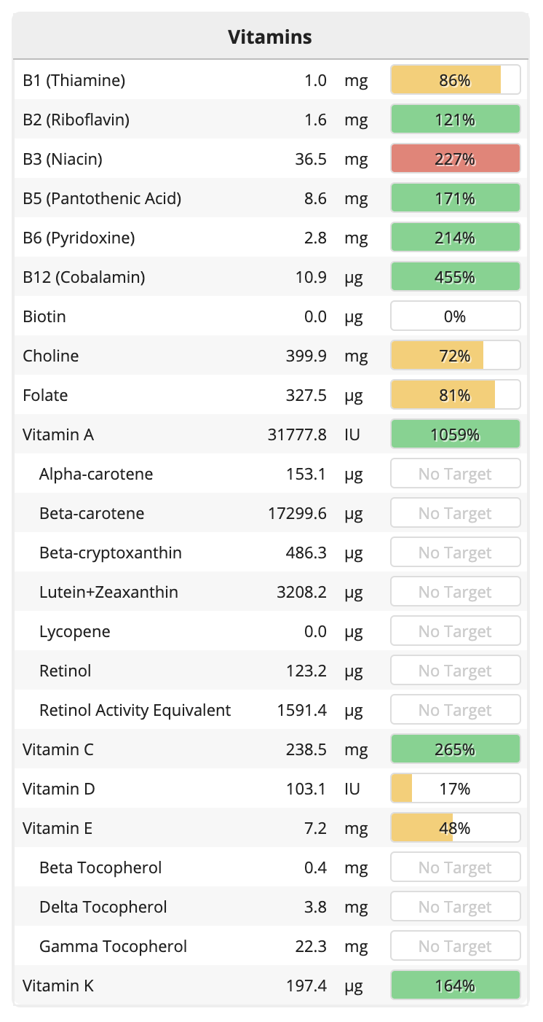

## Learn from Tracking

Pay attention to the nutrition information and target values as you enter items for the day. After a few days of doing this, you’ll see which foods contain which nutrients and in what amounts. After a few weeks, you’ll start to naturally remember this without much extra effort on your part. You might also notice that some of your foods contain a lot of energy (measured in calories) but very few nutrients (e.g. rice, candy, ice-cream). You’ll notice that some are the opposite (e.g. peppers, spinach, fish). You’ll be getting a nutrition education while you track.

## Use App Features to Meet Nutrition Requirements and Be Efficient

### Use The Oracle Button

Use the Oracle button to receive suggestions for foods that could complete your remaining nutrition requirements for the day. In the mid-afternoon, if my micronutrient graphs are coming up short, I will use this button to help come up with some creative ideas of foods that could round out my daily nutrition. Common deficiencies include Zinc, Vitamin A, Vitamin C, Selenium, and Vitamin D – and thus, the Oracle might often suggest foods rich in these nutrients - fish, organ meats, and dark green leafy vegetables for example.

### Use Trends

Trends matter more than individual days. Unless you are treating a specific deficiency or medical problem, you likely don’t need to worry too much about missing a target here or there. There are storage-depots for many nutrients in the body (e.g. B12, iron), so a healthy person won’t become depleted in a few days. Instead, use the Trends –> Nutrition Report tab to look at averages for weeks or months to see if there is a pattern of a deficiency across longer periods of time.

### Use Recipes

Create custom recipes to save time and to meet targets. Recipes can be actual recipes for cooking, or they can just be combinations of pre-prepared foods that you often eat together. Most people have some dietary staples that they eat repeatedly. For example - if you eat oatmeal with raisins and a coffee for breakfast every morning, you could put these three items into a recipe. This makes your morning tracking trivial. If you don’t have staples, developing some nutrient-dense staples is an efficient method of ensuring adequate nutrition. By doing this, you remove a lot of the “activation energy,” that’s usually required to eat well consistently. An effective staple is a food(s) that you know you like, that’s easy to prepare, with known nutritional value. Once you settle on a staple, save it in Cronometer by using the “Custom Recipe” feature. This allows you to track accurately and quickly. You can see in the screenshot a custom recipe that I saved - quick oats, pecans, berries, chia seeds, and a hard-boiled egg.

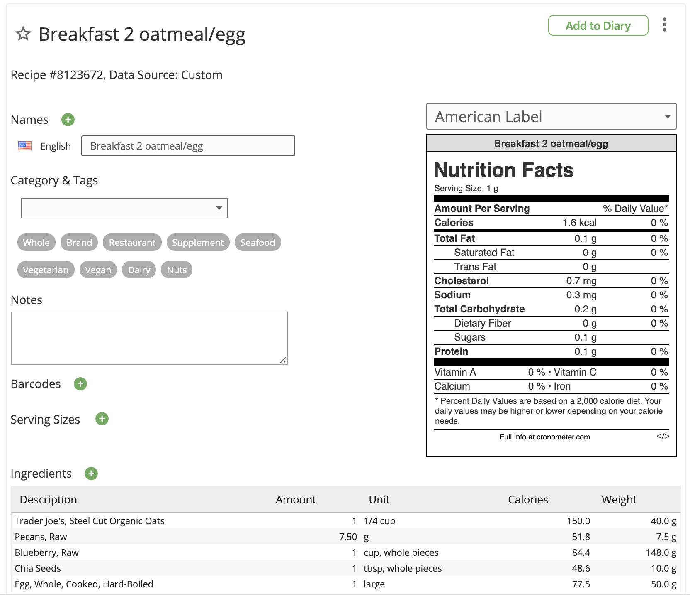

#### 2 Tips for Recipes / Staples

##### 1. Simplicity is Key.

The simpler your staple, the more likely it is that you can reliably have access to this food. It needs to be cheap, convenient, and easy to prepare. Making it easy to track by saving it in Cronometer is the final step.

##### 2. New Staples Can Replete Deficiencies

Fill in the gaps. Use specific staples/recipes to fill in specific gaps. If you know that your usual diet is extremely deficient in Omega-3 fatty acids, for instance, create a staple that you know will give you a periodic complement of omega-3 fatty acids - salmon, mackerel, herring, fish-oil supplement, pharma grade omega-3, etc.

# Conclusion

Tracking your nutrition is the first step to purposeful eating. If you find out what, when, and how much you’re eating now, you’ll be able to make informed adjustments to your nutrition plan. When you do make adjustments, you’ll be able to see how those are working. Some people, when they first start tracking, find out that they’re eating far better or worse than they expected. My experience with my own tracking and with my friends, family, and clients, is that it’s really difficult to get a feel for what you’re eating. People who believe they have a firm grasp on their nutrition often find out they’re consuming 5 or 10 times the carbohydrate as they predicted. Others who thought that massive changes were in order were pleased to find out that they were actually eating a diverse, complete, nutritive diet, and that only a few small changes were necessary.

Eating is a very automated, habitual process. After decades of eating a certain way, it’s not a surprise that most people struggle to make long-lasting significant changes to the way they eat. Tracking brings the process of eating into the conscious mind where it can be manipulated, re-learned, and sent back to the subconscious - new and improved.