**CV**  
**Dmytro Kornylo**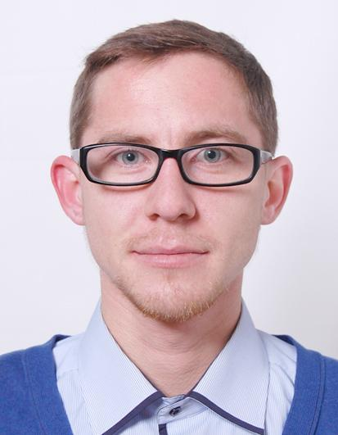

**PERSONAL DETAILS**

Full Name: Dmytro Kornylo   
Nationality: Ukrainian  
 D.O.B. 15.05.1991  
  
Marital Status: Unmarried  
Address: 3 Yaponska Str, Apt.10, Lviv, Ukraine  
Mob. (+38) 063 0603051   
 E-Mail: [kornulo@gmail.com](mailto:kornulo@gmail.com)  
 Facebook: https://www.facebook.com/kornulo

**EDUCATION**

* 2015 - ”SoftServe” courses HTML5 App Development Fundamentals
* 2014 – Software testing courses “Logos”.
* 2008 – 2014 – Lviv National University of Veterinary and Biotechnologies, Department of Food Technologies.
* 1998 – 2008 – Secondary school №3, Chervonograd, Lviv region.

**WORK EXPERIENCE**

* May 2014 – January 2015 – Lutsk, QА/QC engineer at “ItemBridge”.
* 2013 – 2014 – Lutsk, Sales manager at "Obnova" Internet Store.
* 2010 – 2012 – Lviv, Electoral advertisement distributor.

**SKILLS**

* HTML/CSS/JavaScript/Bootstrap
* ( <http://kornylo.github.io/my_temlete/index.html> )
* Jira
* GitHub + Clode9
* Operating Systems – Ubuntu, Microsoft Windows XP / 7 / 8;   
  Browsers – Mozilla, Opera, Google Chrome, Internet Explorer; Firefox (firebug)
* MS Office – Word, Excel
* MySQL Server, visual studio
* Selenium – initial level
* Types of tests, Test Case

**ADDITIONAL SKILLS**

Good planning skills, creative thinking, perfect communication and presentation skills.   
High level of self-organization and ability to achieve goals effectively.

**LANGUAGES**

Ukrainian – native,

Russian – fluently,

English – intermediate.

**PERSONAL QUALITIES**

Goals oriented, excellent team player, fast-learning.