**CV**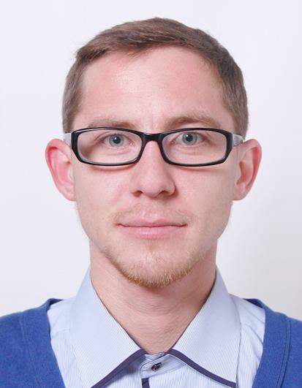

**Kornylo Dmytro**

**PERSONAL DETAILS**

Full Name: Dmytro Kornylo  
Nationality: Ukrainian  
D.O.B. 15.05.1991  
Marital Status: Unmarried  
Address: 3 Yaponska Str, Apt.10, Lviv, Ukraine  
Mob. (+38) 063 0603051   
E-Mail: kornulo@gmail.com

**EDUCATION**

* 2015- "SoftServe" courses Fundamentals of HTML5 App
* .2014 – Software testing courses “Logos”
* 2008 – 2014 – Lviv National University of Veterinary and Biotechnologies, Department of Food Technologies.
* 1998 – 2008 – Secondary school №3, Chervonograd, Lviv region.

**WORK EXPERIENCE**

* May 2014 – January 2015 – Lutsk, QА//QC engineer at “ItemBridge”.
* January 2015 – Present (freelance)– Lutsk, QА//QC engineer at “ItemBridge”.
* 2013 – 2014 – Lutsk, Sales manager at "Obnova" Internet Store.
* 2010 – 2012 – Lviv, Electoral advertisement distributor.
* 2008 – 2010 – Lviv, Assistant at the construction, advertisement distributor. ﻿

**SKILLS**

* Github + Cloud9
* HTML/CSS /JavaScript/Bootstrap
* The project is currently in development ( <http://kornylo.github.io/weather/> )
* CMS- Drupal, WordPress
* Operating Systems – Ubuntu, Microsoft Windows XP / 7 / 8;   
  Browsers – Mozilla, Opera, Google Chrome, Internet Explorer; Firefox (firebug)
* MS Office – Word, Excel
* MySQL Server, visual studio
* Selenium – initial level
* Types of tests, Test Case

**ADDITIONAL SKILLS**

Good planning skills, creative thinking, perfect communication and presentation skills.   
High level of self-organization and ability to achieve goals effectively.

**LANGUAGES**

Ukrainian – native,

Russian – fluently,

English – intermediate.

**PERSONAL QUALITIES**

Goals oriented, excellent team player, fast-learning.