108820027 電資三 周世昊 Homework4

2.2

Q1.

The counter return to zero, but the contents of the EditText is preserved

Q2.

Android shuts down your Activity by calling onPause(), onStop(), and onDestroy(), and then starts it over again, calling onCreate(), onStart(), and onResume()

Q3.

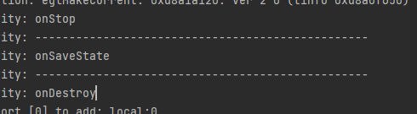

onSaveInstanceState() is called before the onDestroy() method.

Q4.

onPause() or onStop()

2.3

Q1.

new Intent(String action)

Q2.

All of the above.

Q3.

Intent takePicture = new Intent(MediaStore.ACTION_IMAGE_CAPTURE);