Secure API for LLM using FastAPI, JWT and OpenRouter
LLM Proxy API
A REST API service for interacting with Large Language Models (LLMs) via OpenRouter, with user authentication, chat history storage, and session management.
The project is built with FastAPI and uses JWT authentication, SQLite, and a layered architecture inspired by Clean Architecture principles.

Features
- User registration and authentication
- JWT-based authorization
- Sending prompts to a Large Language Model
- Chat history storage in database
- Retrieving chat history
- Clearing chat history
- Health check endpoint

Technologies
- Python 3.11+
- FastAPI
- SQLAlchemy
- SQLite
- OpenRouter API
- Pydantic
- Uvicorn
- Ruff (linter)

Project Structure
app
├── api
│ ├── deps.py
│ ├── routes_auth.py
│ └── routes_chat.py
│
├── core
│ ├── config.py
│ ├── errors.py
│ └── security.py
│
├── db
│ ├── base.py
│ ├── models.py
│ └── session.py
│
├── repositories
│ ├── chat_messages.py
│ └── users.py
│
├── schemas
│ ├── auth.py
│ ├── chat.py
│ └── user.py
│
├── services
│ └── openrouter_client.py
│
├── usecases
│ ├── auth.py
│ └── chat.py
│
└── main.py
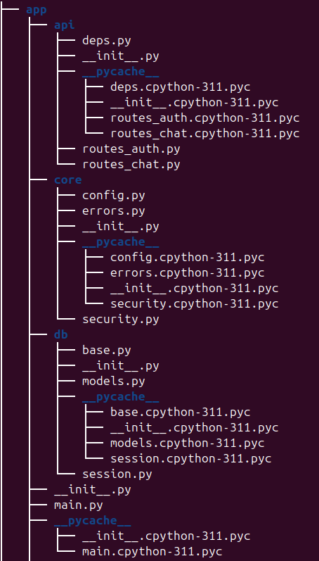
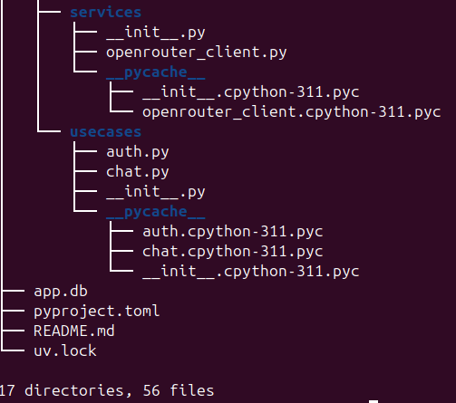
Installation and Setup
Extract the project archive
Download and extract the ZIP archive containing the project.
Example:
llm-p.zip → extract → llm-p/
Open the project directory in the terminal.

Create a virtual environment
uv venv
Activate it:
MacOS / Linux
source .venv/bin/activate
Windows
.venv\Scripts\activate

Install dependencies
uv pip install -e .

Environment Variables
Create a .env file in the project root:
APP_NAME=llm-proxy
ENV=dev
JWT_SECRET=supersecret
JWT_ALG=HS256
ACCESS_TOKEN_EXPIRE_MINUTES=60
SQLITE_PATH=./app.db
OPENROUTER_API_KEY=your_api_key_here
OPENROUTER_BASE_URL=https://openrouter.ai/api/v1
OPENROUTER_MODEL=mistralai/mistral-7b-instruct
OPENROUTER_SITE_URL=http://localhost:8000
OPENROUTER_APP_NAME=llm-proxy
You can generate an API key at:
https://openrouter.ai/keys

Running the Server
Start the server:
uv run uvicorn app.main:app --reload
The API will be available at:
http://127.0.0.1:8000
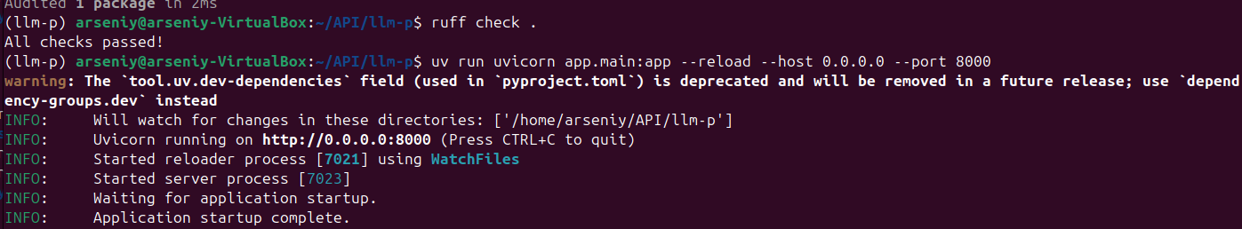
API Documentation (Swagger)
Interactive API documentation is available at:
http://127.0.0.1:8000/docs
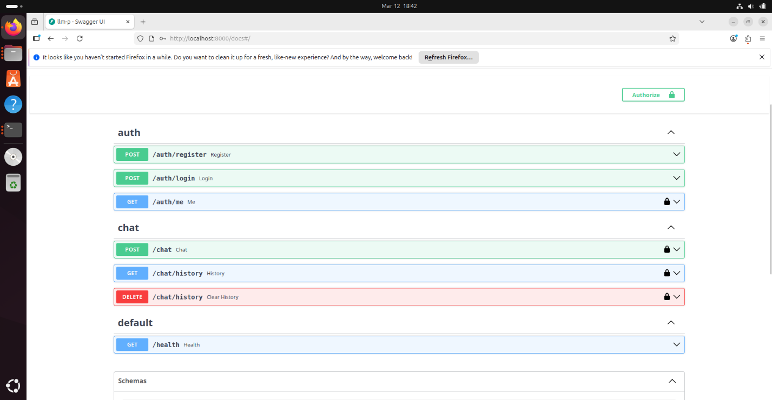
Authentication
Register User
POST /auth/register
Example request:
{
"email": "student_surname@email.com",
"password": "password123"
}
⚠️ Important
The email must follow the format:
student_surname@email.com
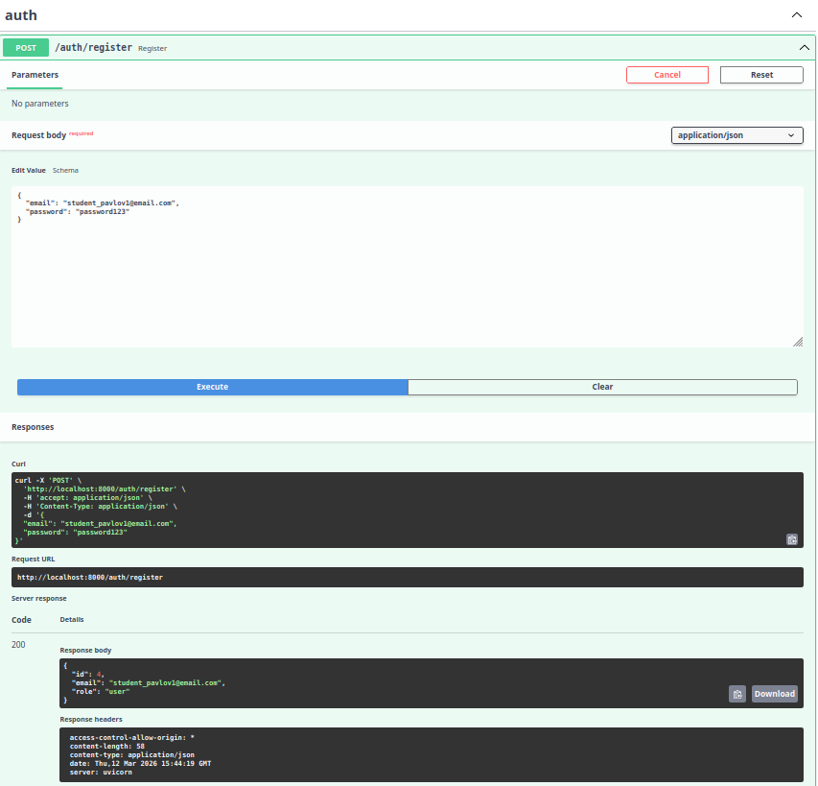
Login
POST /auth/login
Uses OAuth2 password flow.
Example credentials:
username: student_surname@email.com
password: password123
Response example:
{
"access_token": "JWT_TOKEN",
"token_type": "bearer"
}
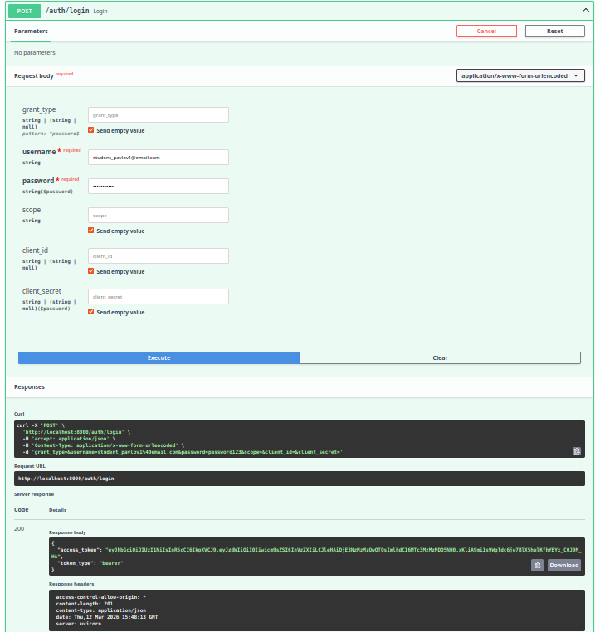
Swagger Authorization
To access protected endpoints:
- Click Authorize in Swagger
- Insert the token
Bearer <JWT_TOKEN>
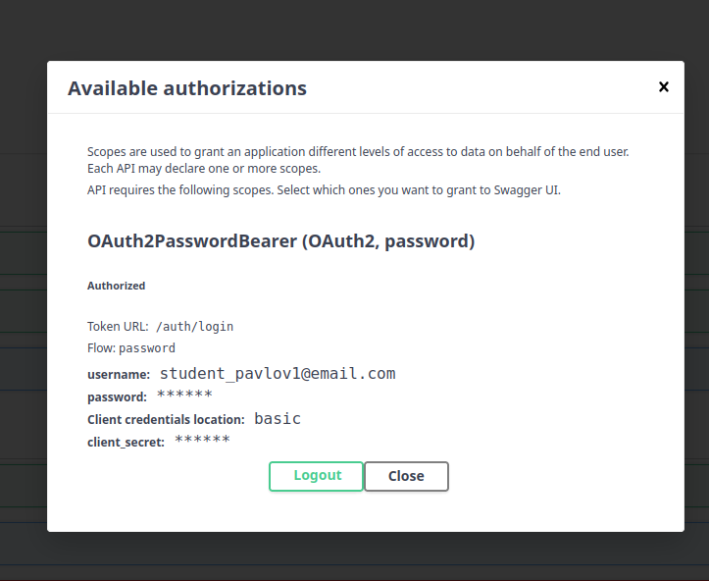
Chat API
Send Message to LLM
POST /chat
Example request:
{
"prompt": "Explain FastAPI simply",
"temperature": 0.7
}
Response example:
{
"answer": "FastAPI is a modern Python web framework..."
}
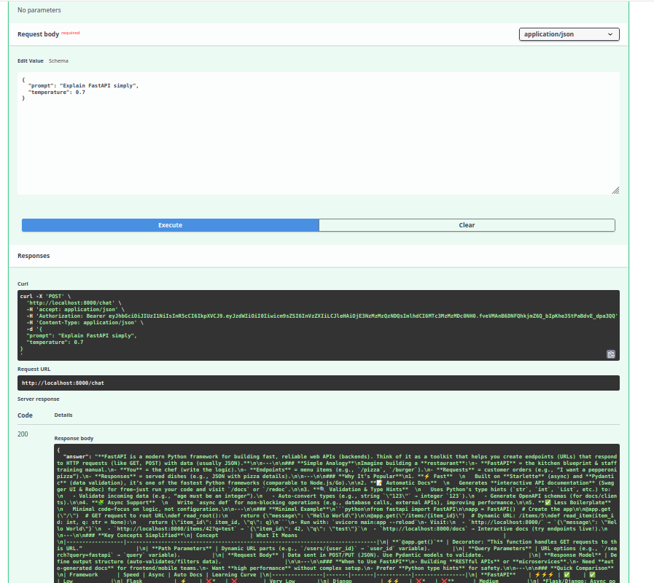
Chat History
GET /chat/history
Returns the conversation history stored in the database.
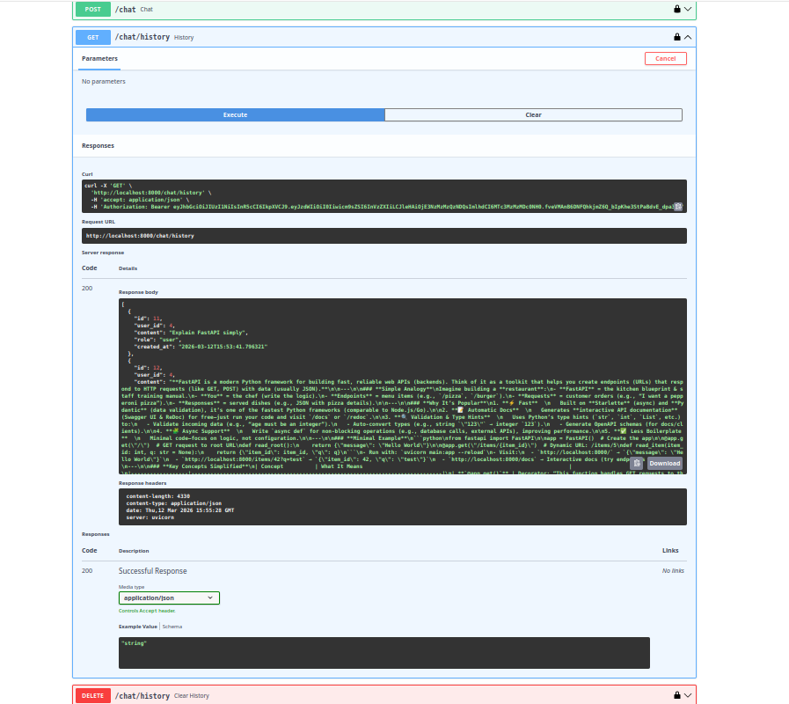
Delete Chat History
DELETE /chat/history
Deletes all stored messages for the current user.
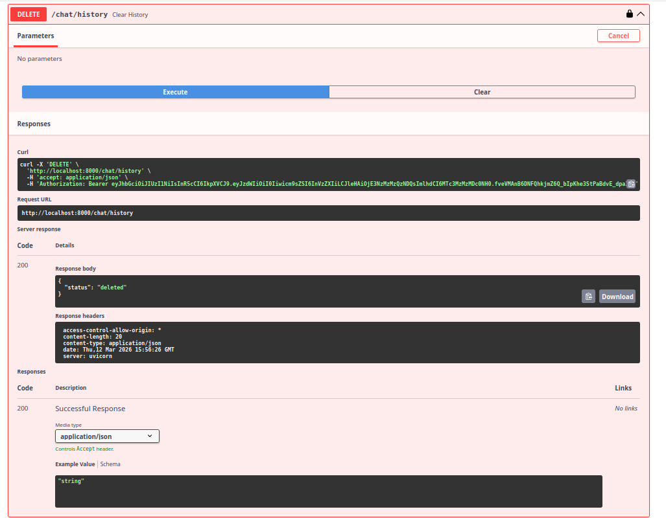
Health Check
GET /health
Example response:
{
"status": "ok"
}

Database
The project uses SQLite.
The database file is created automatically:
app.db
To inspect the database:
sqlite3 app.db
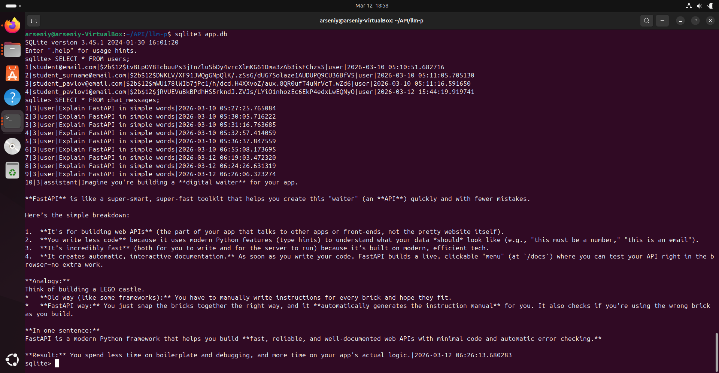
Code Quality
Run linter:
ruff check .
Format code:
ruff format .
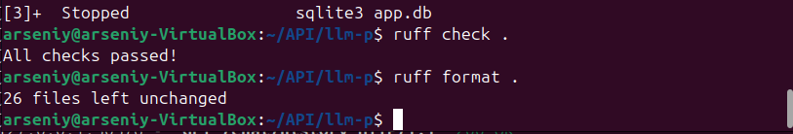
Example Workflow
1 Register a new user
2 Login using /auth/login
3 Receive a JWT token
4 Authorize in Swagger
5 Send prompts to /chat
6 Check stored messages using /chat/history

Architecture
The project is organized into multiple layers:
API layer
Handles HTTP requests and responses.
UseCases layer
Contains business logic of the application.
Repositories layer
Handles database interactions.
Services layer
Responsible for external API integrations (OpenRouter).
Core layer
Contains configuration, security utilities, and shared components.
This structure follows simplified Clean Architecture principles.

