Svetlana Koroteeva ID: 300432399

Assignment 3 – Individual part

AIML 427 - Big Data

2023 T1

***(a) Describe the task including the details of the input data***

***(data source, data size, the original number of features and instances,***

***feature types, whether missing values exist, etc.) and the expected output of the system;***

The main goal of the project to make classifier to diagnose 14 personal disorders based on existing NESARC dataset. As there are several label columns the final pipeline is going to be elaborated during the process.

NESARC was a survey of 43,093 participants that covered alcohol, drug and psychiatric disorders, risk factors, and consequences. Wave 1 of the NESARC was conducted in 2001-2002 in a frame of the National Epidemiologic Survey on Alcohol and Related Conditions (NESARC) was conducted to provide information from 43,093 American adults on the common mental substance and psychiatric disorders as defined in DSM-IV [1]. It was used since in multiple projects. The row dataset was loaded from a github project[2].

"nesarc_pds.csv" is a raw dataset and does not specifically have class labels. For the project columns of interest were selected as class labels. Original data has 3008 features and 43094 instances and should be reduced for the assignment purpose.

In the assignment we will use this data to predict DSM-IV diagnosis [3] indicated in the last part of the data description as different types of personality disorders.

Some of the diagnoses are represented by several columns. Diagnoses part of the data is fully populated. However, the set contains poorly populated columns. It was checked on the initial stage of the project if some columns and rows have high percent of missing data. Simple analysis with pandas methods



showed that.

Number of rows with >= 50.0% missing data: 41933

Number of columns with >= 50.0% missing data: 2183

All the features have categorical values.

***(b) Describe all the pre-processing steps applied to the download***

***data file(s) to obtain the dataset that is used as input of your program,***

First of all, we will assign the features of interest as potential labels. Some of the columns should be joined later.

As our goal is to use massive data and not required to research specifical feature we can remove all the columns with missing data more than 30%.( Recommended maximum percent of missing data is 25-30%. ). This reduced the dataset in 5 times. After deletion the set size was reduced to 65 MB.

In the dataset unknown values set as 9 ,99,999,9999. We replace them to Nan as well as the “white spaces”.

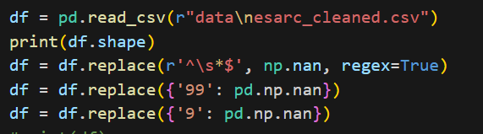

As the next step the most frequent value was imputed to all Nan cells with SimpleImputer method of sklearn library. (Other option “mean” is only suitable for continuous data).

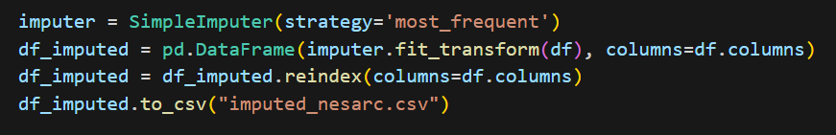

Next, we prepare diagnoses class labels, joining some of them by most often value. After a simple modification we will have 652 columns which include 14 label columns. This dataset was saved as “nesarc_final.csv” dataset. The first fit to a basic Logistic Regression model showed 100% of accuracy. It might happen that some of the features are fully correlated with the corresponding diagnose labels. However , we are more interested to discover less obvious patterns in the data via this research, so removal was required. To find them feature selection technique based on Pearson’s correlation was conducted.

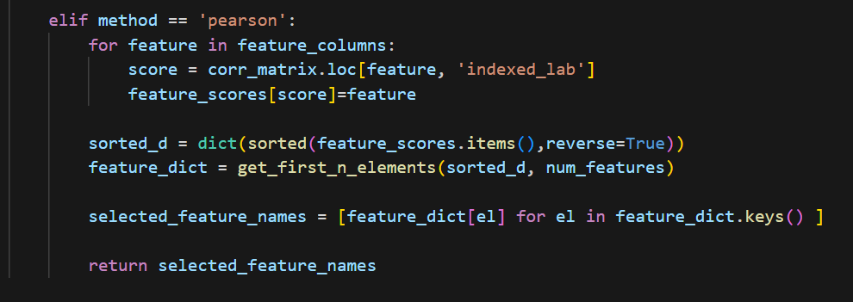

|  |  |
| --- | --- |
| Class | Features |
| AVOIDPDX2 | DEPPDDX2, S1Q211, S1Q212, S1Q16, DOBY, S1Q20, MARITAL, S1Q14C4, S1Q7A9, SPOUSE |
| DEPPDDX2 | AVOIDPDX2, S1Q16, S1Q212, S1Q211, S1Q14C4, S1Q20, S1Q7A1, S1Q8A, S3EQ8B, S3EQ8C |
| OBCOMDX2 | S1Q211, S1Q212, S1Q6A, S1Q7A9, DOBY, S4BQ11, S1Q20, S1Q14C1, S1Q131, S4BQ7C |
| DEP | S1Q211, S1Q212, S1Q16, S1Q20, SEX, S4BQ11, S4BQ7C, S1Q7A1, S4BQ12, S4BQ7B |
| PAN | S1Q211, S1Q212, S1Q16, S1Q20, SEX, S1Q7A9, S1Q1D3, S1Q7A1, S4BQ11, S11BQ11 |
| AGORA | S1Q211, S1Q212, S1Q16, S1Q20, SEX, S1Q7A9, S1Q7A1, S2AQ16B, S4BQ11, S4BQ7C |
| SPECPHOB | SEX, S1Q211, S1Q212, S1Q16, S1Q20, S4BQ11, S1Q7A9, DOBY, S4BQ7C, S1Q14C1 |
| ANX | DEP, PARADX2, S1Q211, S1Q212, S1Q20, S1Q16, SEX, S1Q1C, S1Q7A1, S1Q7A9 |

The analysis based of ranking confirmed that several groups of features are highly correlated to labels .They were discovered and for the purpose of investigation removed.

The a3_correlation.py script was run on the dataset to identify covariant features. This dataset was saved as “nesarc_final_lack.csv” which contains 348 features and 14 label columns.

The names of label columns refer to the following diagnoses:

Depression - DEP,

Panic disorder - PAN,

Anxiety -ANX,

Dependent personality - DEPPDDX2 ,

Obsessive-Compulsive - OBCOMDX2,

Paranoid personality - PARADX2 ,

Histrionic personality disorder - HISTDX2,

Agoraphobia - AGORA,

Social phobia- SOCPHOB,

Conduct disorder - CONDUCTONLY ,

Antisocial personality disorder - ANTISOCDX2,

Schizoid personality disorder - SCHIZDX2

Avoidant personality disorder - AVOIDPDX2

***(c) (15 marks) Describe the program using UML class diagrams and/or***

***pseudo-code;***

**Base model pseudo-code:**

The pseudocode is suitable for each classifier model and does not include pre-processing steps. However, ideally preprocessing script should be written in a single function called “clean_and_impute” and applied to train and test data inside of model function.

Import necessary libraries:

*pyspark.ml.feature.VectorAssembler/StandardScaler,*

*pyspark.ml.classification.LogisticRegression/RandomForestClassifier/NaiveBayes*

*pyspark.ml import Pipeline*

*pyspark.sql import SparkSession*

*and time*

Start SparkSession

Read CSV file to RDD

**Define functions**

Average calculator

T***rain and evaluate*** ***the model***.

Set label list:

*list_of_labels = [*

*"CONDUCTONLY",*

*"ANTISOCDX2",*

*"AVOIDPDX2",*

*"DEPPDDX2",*

*"OBCOMDX2",*

*"PARADX2",*

*"SCHIZDX2",*

*"HISTDX2",*

*"DEP",*

*"PAN",*

*"AGORA",*

*"SOCPHOB",*

*"SPECPHOB",*

*"ANX"*

*]*

Set list of classifiers

*classifiers = [*

*"LogisticRegression",*

*"RandomForestClassifier",*

*"NaiveBayes"*

*]*

Set seeds

*seeds = [987, 1052, 777]*

Initialize empty results list

For each label in list_of_labels

For each classifier in classifiers

Initialize lists for storing results

For each seed in seeds

Read the data from the CSV file

Prepare the feature columns

***Train and evaluate the model***

Start measuring the time.

Split the dataset into training and test sets.

(Clean and impute test and train data) #not implemented yet

Create an instance of classifier

Create a pipeline and add the classifier.

Create Vector assembler object

Transform training and test data

Create a Scaler object #this part is for normalizing script only

Fit a scaler on the training data

Transform training and test data with scaler

Fit the pipeline on the training data

Use the trained model to make predictions.

Calculate the accuracy of the training predictions

Use the trained model to make predictions on test data.

Calculate the accuracy of the test predictions

Stop measuring time and calculate the running time.

Return the training accuracy, test accuracy, and running time.

Append the results to corresponded lists

Calculate average results

Add the average results to the results list

Create the Spark DataFrame from the results list

Save the DataFrame as a CSV file

**Base model UML class diagram:**

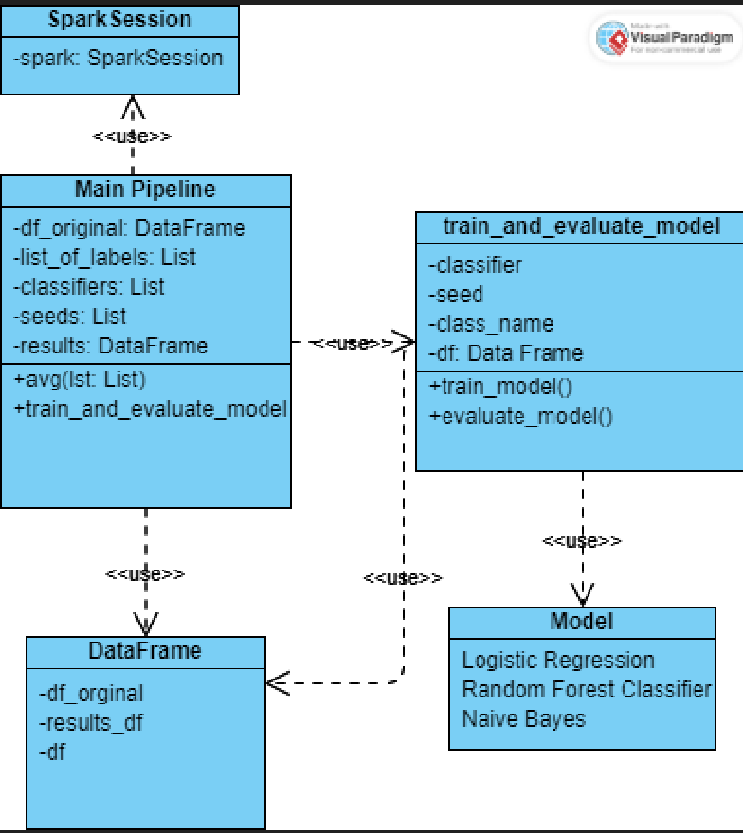

***Fig 1. Baseline Model UML class diagram***

***(d) Describe how to install and run the program step by step in***

***a Readme.txt file.***

Please look at **README.txt** file.

(***e) Compare and discuss the results (including the training and***

***test accuracy, the running time, the model, etc. depending on the program) of the program with and without normalising/scaling data.***

The basic classifier was run on cluster and results were written as csv file.

As it was indicated in pseudocode and UML diagram 3 Classifiers: LogisticRegression,

RandomForestClassifier and NaiveBayes are used inside the model.

In order to use other type, you can just add other model name as it is imported to the “classifiers” list.

Besides, the data for the model was split with different seeds and average values from each run populated the table. Diagnose codes are listed in the column called “class”. The model was run 9 times for each class with 3 different seeds and 3 different classifier.

Table1. Baseline model results

|  |  |  |  |  |
| --- | --- | --- | --- | --- |
| Classifier | Class | Training Accuracy | Test Accuracy | Running Time |
| LogisticRegression | CONDUCTONLY | 0.990667586 | 0.989592767 | 112.1902 |
| RandomForestClassifier | CONDUCTONLY | 0.99051317 | 0.990032873 | 5.487722 |
| NaiveBayes | CONDUCTONLY | 0.656224096 | 0.655213452 | 1.641517 |
| LogisticRegression | ANTISOCDX2 | 0.969575959 | 0.967224738 | 6.093356 |
| RandomForestClassifier | ANTISOCDX2 | 0.967115992 | 0.967691178 | 5.507843 |
| NaiveBayes | ANTISOCDX2 | 0.377409928 | 0.377975363 | 1.567013 |
| LogisticRegression | AVOIDPDX2 | 0.981357332 | 0.978460826 | 5.791655 |
| RandomForestClassifier | AVOIDPDX2 | 0.976702169 | 0.978020777 | 5.373419 |
| NaiveBayes | AVOIDPDX2 | 0.48252516 | 0.478837491 | 1.602829 |
| LogisticRegression | DEPPDDX2 | 0.997473886 | 0.993372754 | 5.482821 |
| RandomForestClassifier | DEPPDDX2 | 0.995102155 | 0.995391874 | 5.322338 |
| NaiveBayes | DEPPDDX2 | 0.579333386 | 0.573646909 | 1.564391 |
| LogisticRegression | OBCOMDX2 | 0.929256918 | 0.928884067 | 63.72542 |
| RandomForestClassifier | OBCOMDX2 | 0.924017117 | 0.925880876 | 5.896053 |
| NaiveBayes | OBCOMDX2 | 0.566107277 | 0.568573574 | 1.557272 |
| LogisticRegression | PARADX2 | 0.960453252 | 0.956274904 | 31.97484 |
| RandomForestClassifier | PARADX2 | 0.952003334 | 0.95205446 | 5.555039 |
| NaiveBayes | PARADX2 | 0.468847952 | 0.465787744 | 1.55604 |
| LogisticRegression | SCHIZDX2 | 0.969013407 | 0.96574947 | 11.88612 |
| RandomForestClassifier | SCHIZDX2 | 0.966818199 | 0.967354737 | 5.785848 |
| NaiveBayes | SCHIZDX2 | 0.443474276 | 0.442387207 | 1.530819 |
| LogisticRegression | HISTDX2 | 0.98184267 | 0.979470615 | 8.140685 |
| RandomForestClassifier | HISTDX2 | 0.981114557 | 0.981567106 | 5.388974 |
| NaiveBayes | HISTDX2 | 0.440072916 | 0.438513734 | 1.679145 |
| LogisticRegression | DEP | 0.96430306 | 0.962487361 | 5.547238 |
| RandomForestClassifier | DEP | 0.960861411 | 0.961271192 | 5.809699 |
| NaiveBayes | DEP | 0.454409618 | 0.452656348 | 1.606098 |
| LogisticRegression | PAN | 0.961103948 | 0.961373783 | 91.32235 |
| RandomForestClassifier | PAN | 0.960398003 | 0.962798029 | 5.433159 |
| NaiveBayes | PAN | 0.5795131 | 0.574596789 | 1.53932 |
| LogisticRegression | AGORA | 0.991483888 | 0.988350137 | 5.757849 |
| RandomForestClassifier | AGORA | 0.989046047 | 0.989126913 | 5.768109 |
| NaiveBayes | AGORA | 0.497957224 | 0.495926297 | 1.556853 |
| LogisticRegression | SOCPHOB | 0.958489535 | 0.956687832 | 5.668611 |
| RandomForestClassifier | SOCPHOB | 0.9539558 | 0.954202907 | 5.426215 |
| NaiveBayes | SOCPHOB | 0.57103262 | 0.565116502 | 1.57947 |
| LogisticRegression | SPECPHOB | 0.91044881 | 0.911124845 | 6.091499 |
| RandomForestClassifier | SPECPHOB | 0.906179735 | 0.907966538 | 5.711357 |
| NaiveBayes | SPECPHOB | 0.609364059 | 0.604160556 | 1.673929 |
| LogisticRegression | ANX | 0.959923758 | 0.960572018 | 100.5981 |
| RandomForestClassifier | ANX | 0.957529998 | 0.959536721 | 5.635833 |
| NaiveBayes | ANX | 0.40817785 | 0.407871796 | 1.699034 |

The basic model shows good performance for most classes. Logistic Regression and RandomForest perform without big difference. From the other hand, Naive Bayes shows lower accuracies compared to the other classifiers. It might happened that features are dependant from each other. Logistic Regression shows quite high running time for some of the features as ANX ,PAN, CONDUCTONLY. Some of the diagnoses were predicted with a higher accuracy for example depression (DEP), panic disorder (PAN), anxiety (ANX), and others.

For normaliziation the following code added after features to vectors transformation



The model was run on cluster the same way as previous. And showed absolutely the same accuracies. From the other hand running time increased. It might happen due to additional scaling step in the script. The reason why scaling did not impact on accuracy might be that all values in similar scale and as we know categorical. Normalization is normally applied to continuous numerical features to ensure that they are on a similar scale.

Table 2. Baseline model with scaling results

|  |  |  |  |  |
| --- | --- | --- | --- | --- |
| Classifier | Class | Training Accuracy | Test Accuracy | Running Time |
| LogisticRegression | CONDUCTONLY | 0.990667586 | 0.989592767 | 218.5083 |
| RandomForestClassifier | CONDUCTONLY | 0.99051317 | 0.990032873 | 7.837038 |
| NaiveBayes | CONDUCTONLY | 0.656224096 | 0.655213452 | 1.776618 |
| LogisticRegression | ANTISOCDX2 | 0.969575959 | 0.967224738 | 130.0013 |
| RandomForestClassifier | ANTISOCDX2 | 0.967082938 | 0.967794684 | 6.647616 |
| NaiveBayes | ANTISOCDX2 | 0.377409928 | 0.377975363 | 1.734752 |
| LogisticRegression | AVOIDPDX2 | 0.981357332 | 0.978460826 | 195.757 |
| RandomForestClassifier | AVOIDPDX2 | 0.976735232 | 0.977968997 | 5.920451 |
| NaiveBayes | AVOIDPDX2 | 0.48252516 | 0.478837491 | 1.904354 |
| LogisticRegression | DEPPDDX2 | 0.997473886 | 0.993372754 | 128.5787 |
| RandomForestClassifier | DEPPDDX2 | 0.995080095 | 0.995391874 | 5.969145 |
| NaiveBayes | DEPPDDX2 | 0.579333386 | 0.573646909 | 1.989378 |
| LogisticRegression | OBCOMDX2 | 0.929256918 | 0.928884067 | 91.06342 |
| RandomForestClassifier | OBCOMDX2 | 0.923939894 | 0.925803164 | 7.3722 |
| NaiveBayes | OBCOMDX2 | 0.566107277 | 0.568573574 | 2.175725 |
| LogisticRegression | PARADX2 | 0.960453252 | 0.956274904 | 62.034 |
| RandomForestClassifier | PARADX2 | 0.951694414 | 0.952028674 | 6.980798 |
| NaiveBayes | PARADX2 | 0.468847952 | 0.465787744 | 1.920981 |
| LogisticRegression | SCHIZDX2 | 0.969013407 | 0.96574947 | 95.91298 |
| RandomForestClassifier | SCHIZDX2 | 0.966785116 | 0.967354737 | 6.470842 |
| NaiveBayes | SCHIZDX2 | 0.443474276 | 0.442387207 | 1.728125 |
| LogisticRegression | HISTDX2 | 0.98184267 | 0.979470615 | 10.65026 |
| RandomForestClassifier | HISTDX2 | 0.981114557 | 0.981567106 | 5.805281 |
| NaiveBayes | HISTDX2 | 0.440072916 | 0.438513734 | 1.633691 |
| LogisticRegression | DEP | 0.96430306 | 0.962487361 | 5.789421 |
| RandomForestClassifier | DEP | 0.960971696 | 0.961530076 | 5.865344 |
| NaiveBayes | DEP | 0.454409618 | 0.452656348 | 1.630901 |
| LogisticRegression | PAN | 0.961103948 | 0.961373783 | 85.92358 |
| RandomForestClassifier | PAN | 0.960386972 | 0.962798029 | 5.9271 |
| NaiveBayes | PAN | 0.5795131 | 0.574596789 | 1.626236 |
| LogisticRegression | AGORA | 0.991483888 | 0.988350137 | 5.668263 |
| RandomForestClassifier | AGORA | 0.989046047 | 0.989126913 | 5.793369 |
| NaiveBayes | AGORA | 0.497957224 | 0.495926297 | 1.725305 |
| LogisticRegression | SOCPHOB | 0.958489535 | 0.956687832 | 6.325853 |
| RandomForestClassifier | SOCPHOB | 0.953691041 | 0.954202972 | 5.873572 |
| NaiveBayes | SOCPHOB | 0.57103262 | 0.565116502 | 1.682777 |
| LogisticRegression | SPECPHOB | 0.91044881 | 0.911124845 | 6.528693 |
| RandomForestClassifier | SPECPHOB | 0.905870878 | 0.907811096 | 5.763771 |
| NaiveBayes | SPECPHOB | 0.609364059 | 0.604160556 | 1.650015 |
| LogisticRegression | ANX | 0.959923758 | 0.960572018 | 86.57909 |
| RandomForestClassifier | ANX | 0.957375568 | 0.959510781 | 5.860768 |
| NaiveBayes | ANX | 0.40817785 | 0.407871796 | 1.632331 |

***(f) Compare and discuss the results (including the training and test accuracy, the running time, the model, etc. depending on the program) of the program with and without transforming data using PCA***

For this model “train and evaluate” class replaced by PCA model, which includes both PCA and one of the classifiers used for previous part.

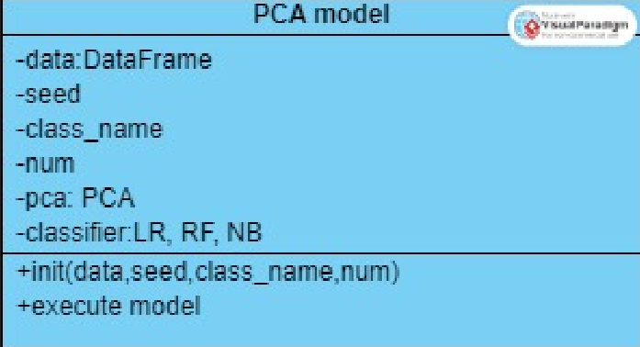

Fig. 2 PCA embedded model

PCA was used along with Logistic regression for the assignment as embedded method . The results are also extracted for different seeds and different numbers of classes. Besides, PCA is also taking the number of components as a parameter. For our model 3,10,20,30 components were used to obtain the results (see Table 3 in the Appendix)

We can observe that test accuracy is very low, and it is much lower then training accuracy overall, which can indicate significant overfitting. Testing accuracy increase with increasing of number of components from 3 to 20 significantly and to 30 slightly. We can also notice that this tendency is not always true. For some of the classes (e.g., "ANTISOCDX2"), increasing the number of PCA components does not significantly improve test accuracy. Optimal number of PCA components may vary depending on the class and the data distribution.

The runtime is increasing slightly with the number of PCA components increases. It is quite good in general however we cannot compare the runtime with other assignment models as this PCA-Logistic regression model was not run on cluster (due to cluster technical issues)

The poor results of the model can occur by the several issues. First is the fact that values are categorical as PCA is more suitable for numerical data. Second reason could be caused by non-linear relationship between features as PCA is linear method. And third are outliers: PCA is sensitive to outliers as it maximizes the variance in the data.

To summarize, PCA can help reduce the dimensionality of the data, but it might not capture all the relevant information for the classification task, other feature selection as lasso techniques could be considered. Besides it worth to check how non-linear dimensionality reduction techniques such as manifold learning algorithms (t-SNE, Isomap) are performing on this data, as they can capture non-linear relationships. To improve existing model the outliers could be investigated and cut as well.

**Other trials: LASSO**

To compare with baseline model and PCA with other model and following recommendations from PCA part, Lasso dimensionality reduction method was applied to the existing data. Lasso does not require other “co-model” as both reduce features and output the trained model in the same time.

From the lasso model results (Table 3) we can see that accuracy is good overall, however running time is quite high from 100 to 200 seconds per model run. Training accuracy is slightly higher than test which indicate slight overfitting. We can observe a negative correlation between accuracy and running time when run with different class labels: accuracy and running time both declined for some of the class labels. It might happen by a couple of reasons. First some classes, which show better results are more balanced. Second, feature distribution could vary across the label and some of them can have more complex data patterns which require longer time to converge. We can improve the results for the lasso model by preparing data for each class label and balance the number of positive and negative instances inside of each class. Approximately 250 features were selected by this model.

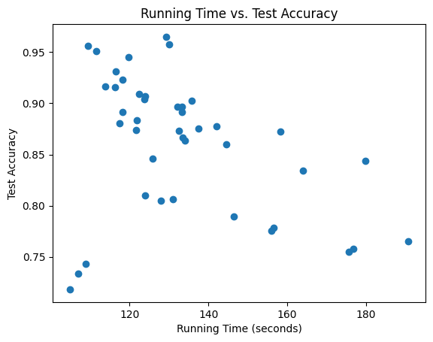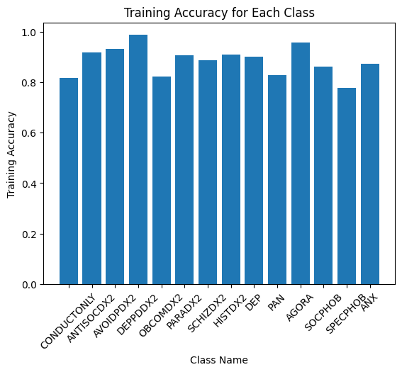

Fig.3 Lasso model viz

Table 3. Lasso model results

|  |  |  |  |  |
| --- | --- | --- | --- | --- |
| Classifier | Class | Training Accuracy | Test Accuracy | Running Time |
| LassoModel | CONDUCTONLY | 0.822943 | 0.669563 | 2178.175 |
| LassoModel | CONDUCTONLY | 0.819701 | 0.702053 | 816.4868 |
| LassoModel | CONDUCTONLY | 0.8054 | 0.741755 | 67.62742 |
| LassoModel | ANTISOCDX2 | 0.92088 | 0.89089 | 54.61191 |
| LassoModel | ANTISOCDX2 | 0.921784 | 0.897888 | 96.69292 |
| LassoModel | ANTISOCDX2 | 0.919783 | 0.894333 | 213.7744 |
| LassoModel | AVOIDPDX2 | 0.937045 | 0.904231 | 2640.55 |
| LassoModel | AVOIDPDX2 | 0.926154 | 0.93131 | 1902.463 |
| LassoModel | AVOIDPDX2 | 0.926006 | 0.933031 | 2425.387 |
| LassoModel | DEPPDDX2 | 0.973404 | 0.968524 | 611.2313 |
| LassoModel | DEPPDDX2 | 0.97205 | 0.977754 | 126.0041 |
| LassoModel | DEPPDDX2 | 0.982945 | 0.974614 | 52.99104 |
| LassoModel | OBCOMDX2 | 0.8196 | 0.815061 | 60.30946 |
| LassoModel | OBCOMDX2 | 0.820118 | 0.814153 | 585.0147 |
| LassoModel | OBCOMDX2 | 0.822259 | 0.803384 | 53.29897 |
| LassoModel | PARADX2 | 0.908832 | 0.888895 | 50.89624 |
| LassoModel | PARADX2 | 0.900406 | 0.909279 | 55.01105 |
| LassoModel | PARADX2 | 0.903902 | 0.900569 | 55.01244 |
| LassoModel | SCHIZDX2 | 0.879759 | 0.875474 | 460.267 |
| LassoModel | SCHIZDX2 | 0.884901 | 0.859646 | 51.04546 |
| LassoModel | SCHIZDX2 | 0.881882 | 0.85929 | 49.91426 |
| LassoModel | HISTDX2 | 0.906157 | 0.888968 | 47.93953 |
| LassoModel | HISTDX2 | 0.903338 | 0.889588 | 47.15973 |
| LassoModel | HISTDX2 | 0.905929 | 0.887631 | 455.1718 |
| LassoModel | DEP | 0.897137 | 0.885678 | 54.16138 |
| LassoModel | DEP | 0.89962 | 0.879657 | 50.81025 |
| LassoModel | DEP | 0.901487 | 0.874257 | 509.4852 |
| LassoModel | PAN | 0.822515 | 0.784747 | 50.23395 |
| LassoModel | PAN | 0.798135 | 0.790759 | 48.82116 |
| LassoModel | PAN | 0.82491 | 0.779445 | 50.2057 |
| LassoModel | AGORA | 0.955502 | 0.945943 | 46.36825 |
| LassoModel | AGORA | 0.953192 | 0.941195 | 482.6968 |
| LassoModel | AGORA | 0.9616 | 0.924161 | 45.74782 |
| LassoModel | SOCPHOB | 0.864406 | 0.830926 | 49.63039 |
| LassoModel | SOCPHOB | 0.858642 | 0.844606 | 49.82849 |
| LassoModel | SOCPHOB | 0.858638 | 0.842761 | 181.8951 |
| LassoModel | SPECPHOB | 0.774298 | 0.759591 | 991.9275 |
| LassoModel | SPECPHOB | 0.77233 | 0.763994 | 113.9712 |
| LassoModel | SPECPHOB | 0.771198 | 0.768571 | 554.5387 |
| LassoModel | ANX | 0.874162 | 0.863877 | 827.2188 |
| LassoModel | ANX | 0.872603 | 0.872251 | 746.81 |
| LassoModel | ANX | 0.873543 | 0.87066 | 620.4173 |

### Conclusion and future work.

### 

In the frame of the assignment several binary classifiers were built – Basic classifier, Classifier with normalized data, PCA+Logistic Regression Classifier and LASSO regression classifier The best performance was shown by baseline model with Logistic Regression and Random Forest. Feature selection with Pearson correlation was applied on data cleaning stage to investigate highly correlated features issue.

The possible directions for future work:

1. Implement “clean_and_impute function” (instead of several scripts);
2. Ballance data;
3. Investigate and remove outliers;
4. Parameters tuning;
5. Investigate non-linearity and apply non-linear manifold learning algorithms;
6. Build multiclass classifier instead of 14 binary classifiers.

### References

1. [National Epidemiologic Survey on Alcohol and Related Conditions-III (NESARC-III) | National Institute on Alcohol Abuse and Alcoholism (NIAAA) (nih.gov)](https://www.niaaa.nih.gov/research/nesarc-iii) - about NESARC dataset for the Q1
2. [wesleyan-machine-learning/data at master · radumas/wesleyan-machine-learning (github.com)](https://github.com/radumas/wesleyan-machine-learning/tree/master/data) – source for download nesarc_pds.csv dataset for Q1
3. [DSM-IV codes - Wikipedia](https://en.wikipedia.org/wiki/DSM-IV_codes) - Diagnostic and Statistical Manual of Mental Disorders, 4th Edition
4. [PySpark Lasso Regression – Building, Tuning, and Evaluating Lasso Regression with PySpark MLlib - Machine Learning Plus](https://www.machinelearningplus.com/pyspark/pyspark-lasso-regression/) – Lasso regression with pyspark, making vector from features
5. [Correlation — PySpark 3.4.0 documentation (apache.org)](https://spark.apache.org/docs/latest/api/python/reference/api/pyspark.ml.stat.Correlation.html) – Ranking with correlation: chi-square
6. [PCA — PySpark 3.4.0 documentation (apache.org)](https://spark.apache.org/docs/latest/api/python/reference/api/pyspark.ml.feature.PCA.html) -PCA
7. [Visual Paradigm Online (visual-paradigm.com)](https://online.visual-paradigm.com/app/diagrams/)

Appendix

Fig 4. PCA Number of component vs Running time/Test and Train accuracy visualisation

Table 4. PCA results

|  |  |  |  |  |  |  |
| --- | --- | --- | --- | --- | --- | --- |
| Classifier | Class | Seed | Num PCA Comp | Train Accuracy | Test Accuracy | RunTime |
| PCA_model | CONDUCTONLY | 987 | 3 | 0.990304 | 0.540806 | 15.59032 |
| PCA_model | CONDUCTONLY | 987 | 10 | 0.990304 | 0.57854 | 9.47362 |
| PCA_model | CONDUCTONLY | 1052 | 3 | 0.990637 | 0.536487 | 7.497615 |
| PCA_model | CONDUCTONLY | 1052 | 10 | 0.990637 | 0.53302 | 8.667549 |
| PCA_model | CONDUCTONLY | 777 | 3 | 0.990599 | 0.515133 | 6.93837 |
| PCA_model | CONDUCTONLY | 777 | 10 | 0.990599 | 0.535507 | 7.700324 |
| PCA_model | ANTISOCDX2 | 987 | 3 | 0.966675 | 0.543612 | 8.508811 |
| PCA_model | ANTISOCDX2 | 987 | 10 | 0.966675 | 0.59933 | 8.084162 |
| PCA_model | ANTISOCDX2 | 1052 | 3 | 0.966584 | 0.549993 | 7.352689 |
| PCA_model | ANTISOCDX2 | 1052 | 10 | 0.966584 | 0.607995 | 8.820627 |
| PCA_model | ANTISOCDX2 | 777 | 3 | 0.966864 | 0.547999 | 8.090194 |
| PCA_model | ANTISOCDX2 | 777 | 10 | 0.966864 | 0.589064 | 7.368196 |
| PCA_model | AVOIDPDX2 | 987 | 3 | 0.976206 | 0.609357 | 7.426095 |
| PCA_model | AVOIDPDX2 | 987 | 10 | 0.976206 | 0.663202 | 7.662394 |
| PCA_model | AVOIDPDX2 | 1052 | 3 | 0.976377 | 0.600268 | 8.552086 |
| PCA_model | AVOIDPDX2 | 1052 | 10 | 0.976377 | 0.650561 | 6.594305 |
| PCA_model | AVOIDPDX2 | 777 | 3 | 0.976795 | 0.622738 | 5.66799 |
| PCA_model | AVOIDPDX2 | 777 | 10 | 0.976795 | 0.66813 | 6.088605 |
| PCA_model | DEPPDDX2 | 987 | 3 | 0.995301 | 0.702621 | 5.933207 |
| PCA_model | DEPPDDX2 | 987 | 10 | 0.995301 | 0.741292 | 6.497824 |
| PCA_model | DEPPDDX2 | 1052 | 3 | 0.994905 | 0.719222 | 5.998199 |
| PCA_model | DEPPDDX2 | 1052 | 10 | 0.994905 | 0.74084 | 7.113749 |
| PCA_model | DEPPDDX2 | 777 | 3 | 0.995035 | 0.752889 | 5.436584 |
| PCA_model | DEPPDDX2 | 777 | 10 | 0.995035 | 0.767163 | 7.134051 |
| PCA_model | OBCOMDX2 | 987 | 3 | 0.922629 | 0.536461 | 9.577986 |
| PCA_model | OBCOMDX2 | 987 | 10 | 0.922629 | 0.589467 | 8.446723 |
| PCA_model | OBCOMDX2 | 1052 | 3 | 0.924334 | 0.523848 | 7.110282 |
| PCA_model | OBCOMDX2 | 1052 | 10 | 0.924334 | 0.600085 | 8.414352 |
| PCA_model | OBCOMDX2 | 777 | 3 | 0.924195 | 0.497731 | 7.833553 |
| PCA_model | OBCOMDX2 | 777 | 10 | 0.924195 | 0.595712 | 7.771842 |
| PCA_model | PARADX2 | 987 | 3 | 0.950361 | 0.61737 | 9.430489 |
| PCA_model | PARADX2 | 987 | 10 | 0.950361 | 0.643966 | 8.652737 |
| PCA_model | PARADX2 | 1052 | 3 | 0.951034 | 0.605743 | 7.387407 |
| PCA_model | PARADX2 | 1052 | 10 | 0.951034 | 0.639137 | 8.129591 |
| PCA_model | PARADX2 | 777 | 3 | 0.951471 | 0.611276 | 8.566049 |
| PCA_model | PARADX2 | 777 | 10 | 0.951471 | 0.651134 | 8.98711 |
| PCA_model | SCHIZDX2 | 987 | 3 | 0.96651 | 0.573769 | 7.678497 |
| PCA_model | SCHIZDX2 | 987 | 10 | 0.96651 | 0.615003 | 7.970901 |
| PCA_model | SCHIZDX2 | 1052 | 3 | 0.966584 | 0.558939 | 9.436449 |
| PCA_model | SCHIZDX2 | 1052 | 10 | 0.966584 | 0.615554 | 6.597362 |
| PCA_model | SCHIZDX2 | 777 | 3 | 0.967162 | 0.567773 | 5.572774 |
| PCA_model | SCHIZDX2 | 777 | 10 | 0.967162 | 0.600495 | 5.983799 |
| PCA_model | HISTDX2 | 987 | 3 | 0.981005 | 0.543771 | 6.016602 |
| PCA_model | HISTDX2 | 987 | 10 | 0.981005 | 0.609795 | 6.461125 |
| PCA_model | HISTDX2 | 1052 | 3 | 0.981373 | 0.531759 | 5.378772 |
| PCA_model | HISTDX2 | 1052 | 10 | 0.981373 | 0.604378 | 6.430977 |
| PCA_model | HISTDX2 | 777 | 3 | 0.980966 | 0.540519 | 6.043427 |
| PCA_model | HISTDX2 | 777 | 10 | 0.980966 | 0.592284 | 6.05591 |
| PCA_model | DEP | 987 | 3 | 0.959858 | 0.565726 | 5.81741 |
| PCA_model | DEP | 987 | 10 | 0.959858 | 0.680735 | 5.840774 |
| PCA_model | DEP | 1052 | 3 | 0.960265 | 0.555997 | 5.278391 |
| PCA_model | DEP | 1052 | 10 | 0.960265 | 0.687422 | 6.111811 |
| PCA_model | DEP | 777 | 3 | 0.961369 | 0.593235 | 5.584575 |
| PCA_model | DEP | 777 | 10 | 0.961369 | 0.689541 | 6.144098 |
| PCA_model | PAN | 987 | 3 | 0.959395 | 0.557673 | 6.05492 |
| PCA_model | PAN | 987 | 10 | 0.959395 | 0.636464 | 6.149977 |
| PCA_model | PAN | 1052 | 3 | 0.960959 | 0.551398 | 6.413141 |
| PCA_model | PAN | 1052 | 10 | 0.960959 | 0.611741 | 6.295065 |
| PCA_model | PAN | 777 | 3 | 0.960806 | 0.562289 | 5.757803 |
| PCA_model | PAN | 777 | 10 | 0.960806 | 0.602771 | 6.197093 |
| PCA_model | AGORA | 987 | 3 | 0.989146 | 0.556229 | 5.704956 |
| PCA_model | AGORA | 987 | 10 | 0.989146 | 0.676798 | 6.006685 |
| PCA_model | AGORA | 1052 | 3 | 0.98885 | 0.542542 | 5.506873 |
| PCA_model | AGORA | 1052 | 10 | 0.98885 | 0.64244 | 6.319165 |
| PCA_model | AGORA | 777 | 3 | 0.989142 | 0.604606 | 5.672971 |
| PCA_model | AGORA | 777 | 10 | 0.989142 | 0.69598 | 6.166184 |
| PCA_model | SOCPHOB | 987 | 3 | 0.952346 | 0.511911 | 5.772828 |
| PCA_model | SOCPHOB | 987 | 10 | 0.952346 | 0.619489 | 5.930435 |
| PCA_model | SOCPHOB | 1052 | 3 | 0.954012 | 0.533724 | 5.626266 |
| PCA_model | SOCPHOB | 1052 | 10 | 0.954012 | 0.613623 | 5.946704 |
| PCA_model | SOCPHOB | 777 | 3 | 0.953722 | 0.53394 | 5.762829 |
| PCA_model | SOCPHOB | 777 | 10 | 0.953722 | 0.620327 | 6.080694 |
| PCA_model | SPECPHOB | 987 | 3 | 0.904792 | 0.55639 | 5.874079 |
| PCA_model | SPECPHOB | 987 | 10 | 0.904759 | 0.604162 | 5.837915 |
| PCA_model | SPECPHOB | 1052 | 3 | 0.904715 | 0.54972 | 5.346164 |
| PCA_model | SPECPHOB | 1052 | 10 | 0.904715 | 0.60154 | 5.646935 |
| PCA_model | SPECPHOB | 777 | 3 | 0.905757 | 0.558024 | 5.546048 |
| PCA_model | SPECPHOB | 777 | 10 | 0.905757 | 0.594391 | 5.836307 |
| PCA_model | ANX | 987 | 3 | 0.957443 | 0.531793 | 5.931154 |
| PCA_model | ANX | 987 | 10 | 0.957443 | 0.667927 | 5.810253 |
| PCA_model | ANX | 1052 | 3 | 0.956228 | 0.535006 | 5.526748 |
| PCA_model | ANX | 1052 | 10 | 0.956228 | 0.678581 | 5.590827 |
| PCA_model | ANX | 777 | 3 | 0.957562 | 0.544375 | 5.557214 |
| PCA_model | ANX | 777 | 10 | 0.957562 | 0.666809 | 6.047026 |
| PCA_model | CONDUCTONLY | 987 | 20 | 0.990304 | 0.65387 | 6.462421 |
| PCA_model | CONDUCTONLY | 987 | 30 | 0.990304 | 0.645327 | 6.274596 |
| PCA_model | CONDUCTONLY | 1052 | 20 | 0.990637 | 0.648574 | 6.068475 |
| PCA_model | CONDUCTONLY | 1052 | 30 | 0.990637 | 0.646135 | 6.093417 |
| PCA_model | CONDUCTONLY | 777 | 20 | 0.990599 | 0.635532 | 6.241112 |
| PCA_model | CONDUCTONLY | 777 | 30 | 0.990599 | 0.638272 | 6.634392 |
| PCA_model | ANTISOCDX2 | 987 | 20 | 0.966709 | 0.765204 | 6.934179 |
| PCA_model | ANTISOCDX2 | 987 | 30 | 0.966675 | 0.764749 | 7.042283 |
| PCA_model | ANTISOCDX2 | 1052 | 20 | 0.966584 | 0.77157 | 6.553179 |
| PCA_model | ANTISOCDX2 | 1052 | 30 | 0.966617 | 0.77742 | 6.915148 |
| PCA_model | ANTISOCDX2 | 777 | 20 | 0.966963 | 0.76702 | 6.830005 |
| PCA_model | ANTISOCDX2 | 777 | 30 | 0.966963 | 0.76811 | 6.900295 |
| PCA_model | AVOIDPDX2 | 987 | 20 | 0.97614 | 0.749729 | 7.181622 |
| PCA_model | AVOIDPDX2 | 987 | 30 | 0.976008 | 0.783141 | 6.769742 |
| PCA_model | AVOIDPDX2 | 1052 | 20 | 0.976278 | 0.773263 | 6.928752 |
| PCA_model | AVOIDPDX2 | 1052 | 30 | 0.976212 | 0.801328 | 6.965388 |
| PCA_model | AVOIDPDX2 | 777 | 20 | 0.976762 | 0.775243 | 6.706599 |
| PCA_model | AVOIDPDX2 | 777 | 30 | 0.976596 | 0.791975 | 6.704781 |
| PCA_model | DEPPDDX2 | 987 | 20 | 0.995301 | 0.807481 | 7.00138 |
| PCA_model | DEPPDDX2 | 987 | 30 | 0.995268 | 0.834399 | 7.433594 |
| PCA_model | DEPPDDX2 | 1052 | 20 | 0.994905 | 0.841856 | 7.602314 |
| PCA_model | DEPPDDX2 | 1052 | 30 | 0.994872 | 0.860465 | 8.00275 |
| PCA_model | DEPPDDX2 | 777 | 20 | 0.995035 | 0.833182 | 7.139795 |
| PCA_model | DEPPDDX2 | 777 | 30 | 0.995068 | 0.845912 | 7.927685 |
| PCA_model | OBCOMDX2 | 987 | 20 | 0.922629 | 0.651398 | 6.371972 |
| PCA_model | OBCOMDX2 | 987 | 30 | 0.922629 | 0.663745 | 6.399841 |
| PCA_model | OBCOMDX2 | 1052 | 20 | 0.924301 | 0.661869 | 6.032484 |
| PCA_model | OBCOMDX2 | 1052 | 30 | 0.924334 | 0.667552 | 6.087562 |
| PCA_model | OBCOMDX2 | 777 | 20 | 0.924228 | 0.650642 | 6.272153 |
| PCA_model | OBCOMDX2 | 777 | 30 | 0.924228 | 0.658078 | 6.360448 |
| PCA_model | PARADX2 | 987 | 20 | 0.950295 | 0.74737 | 6.68001 |
| PCA_model | PARADX2 | 987 | 30 | 0.95046 | 0.761981 | 6.228797 |
| PCA_model | PARADX2 | 1052 | 20 | 0.950935 | 0.754694 | 6.308718 |
| PCA_model | PARADX2 | 1052 | 30 | 0.951067 | 0.767385 | 5.888793 |
| PCA_model | PARADX2 | 777 | 20 | 0.951405 | 0.747723 | 6.229868 |
| PCA_model | PARADX2 | 777 | 30 | 0.951471 | 0.76318 | 5.889138 |
| PCA_model | SCHIZDX2 | 987 | 20 | 0.96651 | 0.7262 | 5.827717 |
| PCA_model | SCHIZDX2 | 987 | 30 | 0.966444 | 0.731974 | 6.564595 |
| PCA_model | SCHIZDX2 | 1052 | 20 | 0.966584 | 0.738313 | 5.822592 |
| PCA_model | SCHIZDX2 | 1052 | 30 | 0.966551 | 0.739382 | 6.305201 |
| PCA_model | SCHIZDX2 | 777 | 20 | 0.967162 | 0.726799 | 5.778846 |
| PCA_model | SCHIZDX2 | 777 | 30 | 0.967129 | 0.72944 | 6.682925 |
| PCA_model | HISTDX2 | 987 | 20 | 0.981005 | 0.734029 | 6.145646 |
| PCA_model | HISTDX2 | 987 | 30 | 0.981005 | 0.739466 | 5.917073 |
| PCA_model | HISTDX2 | 1052 | 20 | 0.981373 | 0.744146 | 6.20704 |
| PCA_model | HISTDX2 | 1052 | 30 | 0.981373 | 0.750143 | 6.60971 |
| PCA_model | HISTDX2 | 777 | 20 | 0.980966 | 0.734693 | 6.112098 |
| PCA_model | HISTDX2 | 777 | 30 | 0.980966 | 0.739589 | 5.917947 |
| PCA_model | DEP | 987 | 20 | 0.96009 | 0.772218 | 6.317398 |
| PCA_model | DEP | 987 | 30 | 0.960322 | 0.77485 | 5.83541 |
| PCA_model | DEP | 1052 | 20 | 0.960265 | 0.766792 | 5.876925 |
| PCA_model | DEP | 1052 | 30 | 0.960132 | 0.780106 | 5.563653 |
| PCA_model | DEP | 777 | 20 | 0.961336 | 0.785314 | 6.116076 |
| PCA_model | DEP | 777 | 30 | 0.961336 | 0.791439 | 6.324153 |
| PCA_model | PAN | 987 | 20 | 0.959395 | 0.686906 | 6.256224 |
| PCA_model | PAN | 987 | 30 | 0.959395 | 0.692813 | 6.097251 |
| PCA_model | PAN | 1052 | 20 | 0.960959 | 0.673536 | 6.341356 |
| PCA_model | PAN | 1052 | 30 | 0.960959 | 0.676355 | 6.007098 |
| PCA_model | PAN | 777 | 20 | 0.960806 | 0.668704 | 6.36648 |
| PCA_model | PAN | 777 | 30 | 0.960806 | 0.67422 | 5.764261 |
| PCA_model | AGORA | 987 | 20 | 0.989146 | 0.766655 | 6.522008 |
| PCA_model | AGORA | 987 | 30 | 0.989146 | 0.77537 | 6.31117 |
| PCA_model | AGORA | 1052 | 20 | 0.988817 | 0.731643 | 6.531336 |
| PCA_model | AGORA | 1052 | 30 | 0.98885 | 0.74232 | 6.713827 |
| PCA_model | AGORA | 777 | 20 | 0.989142 | 0.786672 | 6.382995 |
| PCA_model | AGORA | 777 | 30 | 0.989175 | 0.788735 | 6.333509 |
| PCA_model | SOCPHOB | 987 | 20 | 0.952346 | 0.677264 | 6.048652 |
| PCA_model | SOCPHOB | 987 | 30 | 0.952346 | 0.681218 | 5.657836 |
| PCA_model | SOCPHOB | 1052 | 20 | 0.954012 | 0.662657 | 5.966885 |
| PCA_model | SOCPHOB | 1052 | 30 | 0.954012 | 0.670501 | 6.256663 |
| PCA_model | SOCPHOB | 777 | 20 | 0.953722 | 0.683228 | 5.656594 |
| PCA_model | SOCPHOB | 777 | 30 | 0.953756 | 0.691595 | 5.975084 |
| PCA_model | SPECPHOB | 987 | 20 | 0.904759 | 0.635032 | 6.333269 |
| PCA_model | SPECPHOB | 987 | 30 | 0.904825 | 0.63812 | 5.765323 |
| PCA_model | SPECPHOB | 1052 | 20 | 0.904781 | 0.632093 | 6.248156 |
| PCA_model | SPECPHOB | 1052 | 30 | 0.904748 | 0.637603 | 5.805026 |
| PCA_model | SPECPHOB | 777 | 20 | 0.90579 | 0.638784 | 5.861352 |
| PCA_model | SPECPHOB | 777 | 30 | 0.905823 | 0.644847 | 5.820113 |
| PCA_model | ANX | 987 | 20 | 0.957409 | 0.723833 | 6.54101 |
| PCA_model | ANX | 987 | 30 | 0.957409 | 0.739574 | 6.177893 |
| PCA_model | ANX | 1052 | 20 | 0.956195 | 0.748236 | 6.092988 |
| PCA_model | ANX | 1052 | 30 | 0.956063 | 0.759937 | 5.956755 |
| PCA_model | ANX | 777 | 20 | 0.957463 | 0.739784 | 6.217742 |
| PCA_model | ANX | 777 | 30 | 0.957397 | 0.748179 | 5.886543 |