**Project_ Spreadsheet (20220813)**

1. **Vlookup (Lesson 11)**

1. **Project ID Card Parser (Lesson 16)**

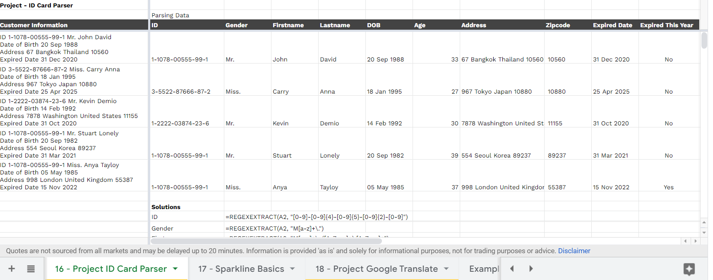

1. **Project Convert TH to EN Date (Lesson 14)**

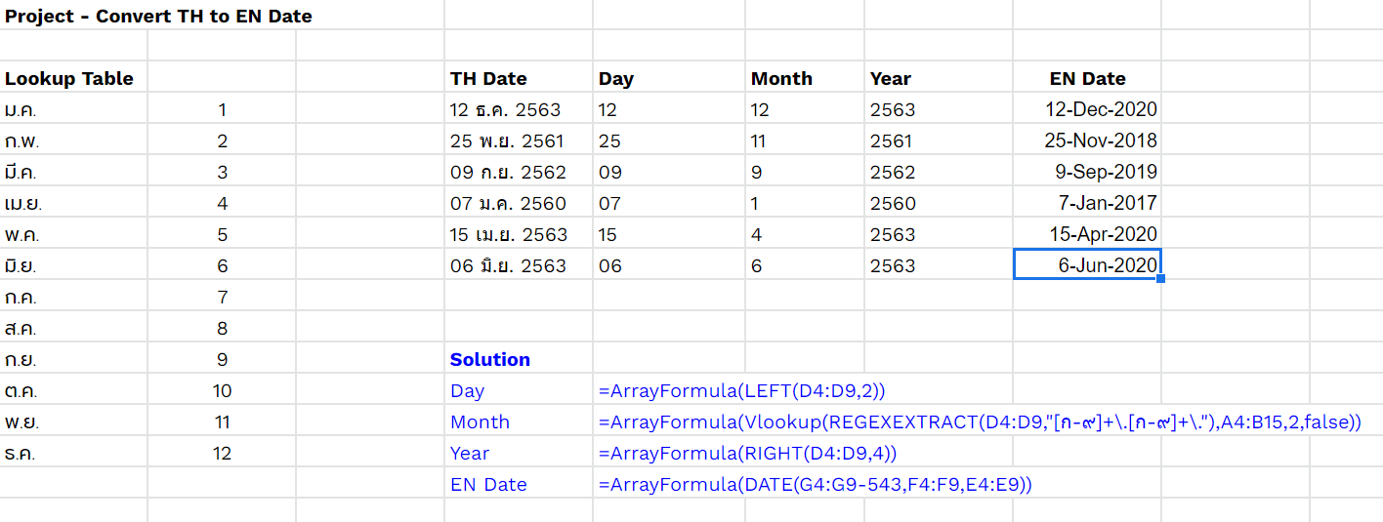

1. **Project** Dy**namic Query (Lesson10)**

