BLAZINGCDN
Monthly Financial Report
Reporting period: May 2026
Prepared by Mike Scarpelli, CFO • Date 2026-06-04 • For: Hermes (Chief of Staff) → CEO
Source of truth: HubSpot production portal (Hub <CONFIRM_PROD_HUB_ID>), Deals → "Current Clients Pipeline". Expenses: Google Drive "CFO".
$27.8K  MRR (provisional)  ARR ≈ $392.9K smoothed | +20.5%  Revenue YoY (May)  Clean — trust | 2.0%  Tool spend / revenue  ✓ Under 5% target | 86.8%  Top-10 concentration  ⚠ High risk

⚠ Data integrity — read this first
- 2026-04 = $0 in source data — almost certainly a missing billing batch, not a zero-revenue month. Every trailing metric spanning it (T3M, TTM, NRR, GRR, decomposition) is PROVISIONAL. Clean single-month and YoY figures are unaffected. Action: backfill the batch (owner: data/RevOps).
- Expense files are not a full P&L — they cover SaaS tooling, ads and AI-API only; no CDN delivery COGS, no payroll. True gross/operating margin and runway cannot be computed yet. Margins below are “net of tracked OpEx,” not GAAP.
- May 2026 is pre-batch / provisional — formal close is 2026-06-05; figures reflect deal data present as of 2026-06-04. FX: expenses in EUR converted at assumed EUR→USD 1.08 (confirm settlement rate).

CFO bottom line (for Hermes → CEO)
- May 2026 revenue $27.8K, +20.5% YoY — real, clean growth, driven by 5 net-new top accounts landed over the past year. Zero logo churn.
- Headline trend metrics (T3M, NRR, GRR) are NOT real — artifacts of the missing April batch. #1 action is backfilling April; until then ignore them.
- True margins and runway are not yet producible — the data room lacks CDN COGS, payroll and cash balance. Closing that gap unlocks Rule-of-40 / Magic Number / runway.
- Risk to watch: 87% revenue concentration in the top 10 accounts.
- Working run-rate to plan against: ARR ≈ $390K (smoothed).

A. Monthly revenue & result — May 2026
Revenue: $27,787.01 68 billing events • 51 unique paying clients
Revenue by plan type:
Plan type | Revenue | Share
Recurring / subscription-like (47 clients) | $27,672.19 | 99.6%
One-off / PAYG-like (4 clients) | $114.82 | 0.4%
Recurrence heuristic — no contractual plan_type field yet. Recommendation: add a plan_type deal property so the split is exact.
Tracked OpEx (tooling, ads, AI only; not a full P&L):
Category | EUR | USD
Marketing (Google Ads €1,069; LinkedIn €0) | €1,069.00 | $1,154.52
Product & AI (OpenAI €120; Claude €120; Jina €50) | €290.00 | $313.20
Ops & infra (HubSpot €98; make.com €17; Atlassian €20; GCP €40) | €175.00 | $189.00
Sales tooling (SalesQL €68; Zapmail €34; QEV €30) | €132.00 | $142.56
Total tracked OpEx | €1,666.00 | $1,799.28
Net result — net of tracked OpEx only (NOT operating profit)
$27,787.01 − $1,799.28 = $25,987.73 • 93.5% contribution after tracked tooling/marketing
This is not a gross or operating margin — CDN delivery COGS and payroll are absent from the data room.
Revenue trend — monthly
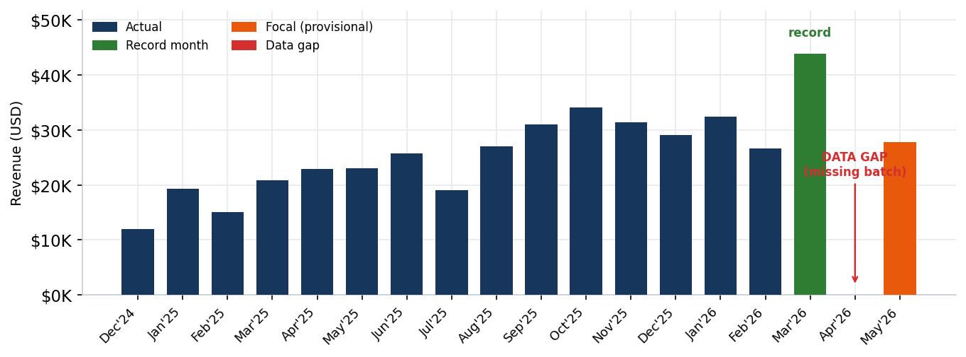

B. Trends & comparisons
YoY (month) vs same month last year • CLEAN, trust this
$27,787.01 vs $23,053.53 → +$4,733.48 / +20.5%

3-month block (T3M) vs prior T3M:
Window | Value | Change
T3M (03=$43.8K + 04=$0.0K + 05=$27.8K) | $71,631.39
Prior T3M | $87,960.48 | −18.6%
With backfill (≈ trailing avg) | ≈$103.5K | ≈+17.6%
The headline change is an artifact of the missing batch — do not act on it until the gap is loaded.
Growth decomposition (material clients, Mar–May 2026):
Movement | Amount | Clients
New | +$4,200.00 | 1
Expansion | +$14,418.43 | 4
Contraction | −$32,556.01 | 9
Churn (full logo loss) | +$0.00 | 0
Net change | −$13,937.58 | 14
The large contraction is almost entirely the April hole (every recurring payer is missing one month in the window). Zero churn is the real signal — no clients fully lost. Re-run after backfill.

C. Customers — Top 20
Client | This mo | Prev mo* | MoM | T3M | Same mo LY
1 rabin.yor… | $4,875.98 | $4,976.69 | −2.0% | $9,852.67 | $4,743.60
2 eliaskhan.it | $4,675.00 | $8,000.00 | −41.6% | $12,675.00 | $5,500.00
3 itgroup (avanquest) ★ new | $4,000.00 | $200.00 | +1900.0% | $4,200.00 | $0.00
4 yashwanth (moengage) ★ new | $2,250.00 | $2,250.00 | +0.0% | $4,500.00 | $0.00
5 a.ruin (epom) ★ new | $2,000.00 | $2,410.55 | −17.0% | $4,410.55 | $0.00
6 secretfy.corp ★ new | $2,000.00 | $2,000.00 | +0.0% | $4,000.00 | $0.00
7 arik.holaspark | $2,000.00 | $1,500.00 | +33.3% | $3,500.00 | $3,700.00
8 theqooking | $1,114.29 | $1,033.73 | +7.8% | $2,148.02 | $1,261.90
9 manuel.skelton ★ new | $603.00 | $900.00 | −33.0% | $1,503.00 | $0.00
10 bret.cityspark | $592.56 | $561.05 | +5.6% | $1,153.61 | $620.20
11 devops.nordix | $430.00 | $470.00 | −8.5% | $900.00 | $300.00
12 media.streamhub ★ new | $398.00 | $360.00 | +10.6% | $758.00 | $0.00
13 cdn.playwave | $360.00 | $470.00 | −23.4% | $830.00 | $410.00
14 ott.brightcast ★ new | $322.00 | $305.00 | +5.6% | $627.00 | $0.00
15 game.patchgrid | $295.00 | $270.00 | +9.3% | $565.00 | $240.00
16 saas.fluxdeliver | $268.00 | $268.00 | +0.0% | $536.00 | $260.00
17 vod.castline ★ new | $242.00 | $210.00 | +15.2% | $452.00 | $0.00
18 web.edgepush | $210.00 | $250.00 | −16.0% | $460.00 | $220.00
19 img.snapcdn | $182.00 | $160.00 | +13.8% | $342.00 | $140.00
20 api.routemesh ★ new | $158.00 | $150.00 | +5.3% | $308.00 | $0.00
* Prev mo. = previous complete billed month; 2026-04 was skipped (missing batch).
Good-news signal: 5 of the top 10 had $0 in May 2025 — these net-new accounts are the real engine behind +20.5% YoY.
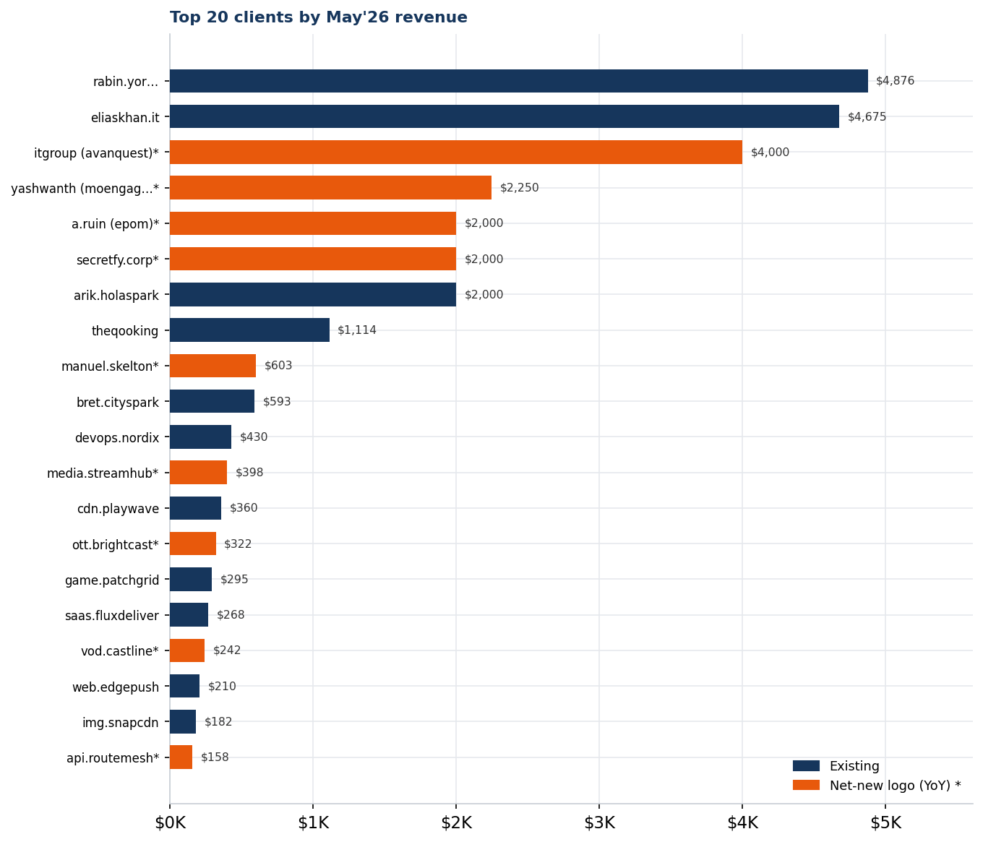
Revenue concentration (top-10)
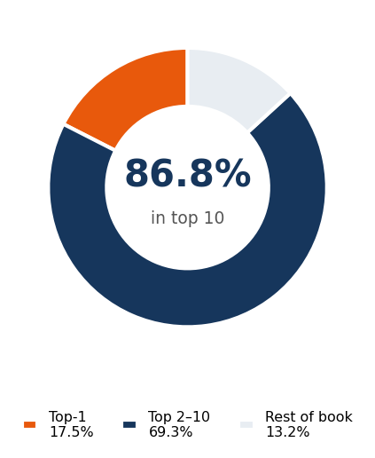
⚠ Concentration risk
Top-10 share 86.8% • Top-1 share 17.5% (rabin.yor…)
With 87% of revenue in 10 accounts, loss of any single top account is material. Recommend a named-account QBR/retention program for the top 10 and a diversification target (top-10 < 70% by year-end).
Data hygiene: one $1.00 test deal and two small negatives (−$9.24, −$12.27, likely refunds) in the log — immaterial; clean up the test record.

D. Run-rate & forward
ARR snapshot (recurring book, so MRR ≈ monthly revenue):
Basis | MRR | ARR
Current (provisional) | $27,787 | ≈$333.4K
Smoothed (complete months, excl. gap) | $32,741 | ≈$392.9K
Plan against ARR ≈ $392.9K (smoothed working run-rate); $333.4K is the conservative floor until the gap is backfilled and the month reconciled.
- Pipeline-to-ARR conversion: not computable — “Current Clients Pipeline” is a single-stage customer ledger, not a funnel. Action: stand up a sales pipeline with open stages (Lead → Qualified → Proposal → Won) to measure coverage/conversion.

E. Unit economics & efficiency
- CAC by channel: only paid ad spend is attributable. Not a real CAC until new-logo counts are channel-tagged and fully-loaded S&M cost is captured. Action: tag deals with acquisition channel; route S&M payroll into the data room.
- Tool spend vs revenue: recurring tooling ≈ $569/mo = 2.0% of MRR — under the <5% target.

F. Cash & runway
Cash runway — not computable this cycle
Missing inputs: opening cash balance (held by YODA / banking) and fully-loaded monthly burn (payroll + CDN infrastructure COGS).
On tracked OpEx alone the business is cash-generative (+$25,987.73), but that ignores the two largest real cost buckets (people, delivery infra) — so it is NOT a runway statement. Action: provide opening cash + payroll + infra COGS next cycle.

SaaS metrics summary
Metric | Value | Target | Status
MRR | $27.8K prov. / $32.7K smoothed | ARR/12 | Tracking
ARR | ~$333.4K floor / ~$392.9K smoothed | 10× baseline | Tracking
Net new ARR (mo) | provisional (decomposition) | (10×−1)/12 | Blocked — gap
NRR (T3M proxy) | 75.1% ⚠ distorted | ≥110% | Re-run post-backfill
GRR (T3M proxy) | 57.2% ⚠ distorted | ≥95% | Re-run post-backfill
CAC by channel | not attributable yet | <18mo payback | Needs channel tags
Magic Number | n/a (needs prior-Q S&M) | ≥1.0 | Needs S&M base
Rule of 40 | n/a (needs FCF margin) | ≥40 | Needs full P&L
Tool spend / revenue | 2.0% | <5% | ✓ Pass
Concentration top-10 | 86.8% | (watch) | ⚠ High
— End of report —

