BLAZINGCDN
Monthly Financial Report
Reporting period: May 2026
Prepared by Mike Scarpelli, CFO • Date 2026-06-04 • For: Hermes (Chief of Staff) → CEO
Source of truth: HubSpot production portal (Hub 143144902), Deals → “Current Clients Pipeline”. Expenses: Google Drive “CFO” (PayG + Subscriptions).
$27.8K  MRR (provisional)  ARR ≈ $390K smoothed | +20.5%  Revenue YoY (May)  Clean — trust | 2.05%  Tool spend / revenue  ✓ Under 5% target | 86.8%  Top-10 concentration  ⚠ High risk

⚠ Data integrity — read this first (baseline report)
- April 2026 = $0 in source data — almost certainly a missing billing batch, not a zero-revenue month. Every trailing metric spanning April (T3M, TTM, NRR, GRR, decomposition) is PROVISIONAL. Clean single-month and YoY figures are unaffected. Action: backfill April (owner: data/RevOps — Vadym).
- Expense files are not a full P&L — they cover SaaS tooling, ads and AI-API only; no CDN delivery COGS, no payroll. True gross/operating margin and runway cannot be computed yet. Margins below are “net of tracked OpEx,” not GAAP.
- May 2026 is pre-batch / provisional — formal close is 2026-06-05; figures reflect deal data present as of 2026-06-04. FX: expenses in EUR converted at assumed EUR→USD 1.08 (confirm settlement rate).

CFO bottom line (for Hermes → CEO)
- May 2026 revenue $27.8K, +20.5% YoY — real, clean growth, driven by 5 net-new top accounts landed over the past year. Zero logo churn.
- Headline trend metrics (T3M −18.6%, NRR 75%, GRR 57%) are NOT real — artifacts of the missing April batch. #1 action is backfilling April; until then ignore them.
- True margins and runway are not yet producible — the data room lacks CDN COGS, payroll and cash balance. Closing that gap unlocks Rule-of-40 / Magic Number / runway.
- Risk to watch: 87% revenue concentration in the top 10 accounts.
- Working run-rate to plan against: ARR ≈ $390K (smoothed).

A. Monthly revenue & result — May 2026 (provisional)
Revenue: $27,787.01 68 billing events • 51 unique paying clients
Revenue by plan type (recurrence heuristic — no contractual plan_type field yet):
Plan type | Revenue | Share
Recurring / subscription-like (47 clients) | $27,672.19 | 99.6%
One-off / PAYG-like (4 clients) | $114.82 | 0.4%
Recommendation: add a plan_type deal property so the split is exact, not heuristic.
Tracked OpEx — May 2026 (tooling, ads, AI only; not a full P&L):
Category | EUR | USD @1.08
Marketing (Google Ads €1,069) | €1,069.00 | $1,154.52
Product & AI (OpenAI, Claude, Jina) | €290.00 | $313.20
Ops & infra (HubSpot, make, Atlassian, GCP) | €175.00 | $189.00
Sales tooling (SalesQL, Zapmail, QEV) | €132.00 | $142.56
Total tracked OpEx | €1,666.00 | $1,799.28
Net result — net of tracked OpEx only (NOT operating profit)
$27,787.01 − $1,799.28 = $25,987.73 • 93.5% contribution after tracked tooling/marketing
This is not a gross or operating margin — CDN delivery COGS and payroll are absent from the data room.

Revenue trend — monthly (Dec 2024 – May 2026)
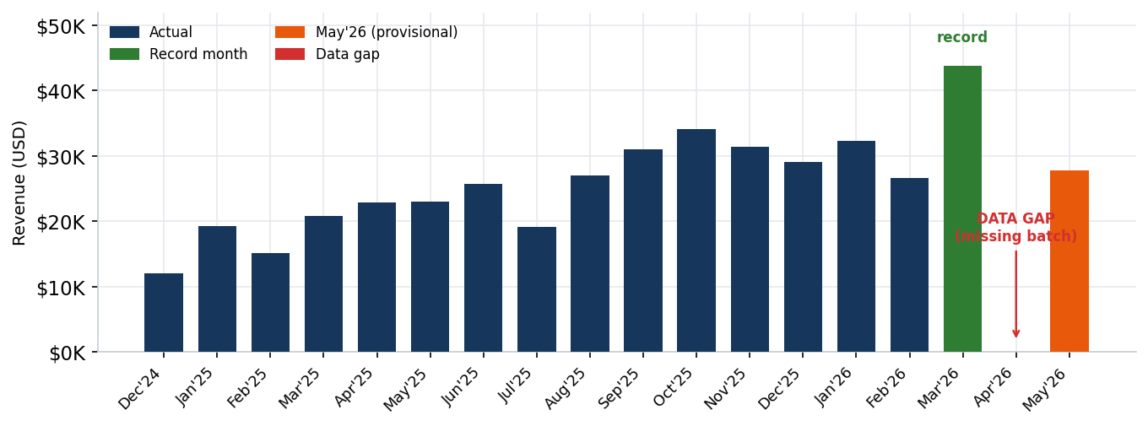

B. Trends & comparisons
YoY (month) — May 2026 vs May 2025 • CLEAN, trust this
$27,787.01 vs $23,053.53 → +$4,733.48 / +20.5%

3-month block (T3M) — Mar+Apr+May 2026 vs Dec–Feb • PROVISIONAL (corrupted by April gap):
Window | Value | Change
T3M (Mar $43.8K + Apr $0 + May $27.8K) | $71,631.39
Prior T3M (Dec+Jan+Feb) | $87,960.48 | −18.6%
With April backfilled (≈$31K) | ≈$102.6K | ≈+17%
The −18.6% headline is an artifact of the missing April batch — do not act on it until April is loaded.
Growth decomposition (material clients >$500/mo) • PROVISIONAL:
Movement | Amount | Clients
New | +$4,200.00 | 1
Expansion | +$14,418.43 | 4
Contraction | −$32,556.01 | 9
Churn (full logo loss) | −$0.00 | 0
Net change | −$13,937.58 | 14
The large contraction is almost entirely the April hole (every recurring payer is missing one month in the window). Zero churn is the real signal — no clients fully lost. Re-run after backfill.

C. Customers
Client | May 2026 | T3M (Mar–May) | May 2025
1 rabin.yor… | $4,875.98 | $9,852.67 | $4,743.60
2 eliaskhan.it | $4,675.00 | $12,675.00 | $5,500.00
3 itgroup (avanquest) ★ new | $4,000.00 | $4,200.00 | $0.00
4 yashwanth (moengage) ★ new | $2,250.00 | $4,500.00 | $0.00
5 a.ruin (epom) ★ new | $2,000.00 | $4,410.55 | $0.00
6 secretfy.corp ★ new | $2,000.00 | $4,000.00 | $0.00
7 arik.holaspark | $2,000.00 | $3,500.00 | $3,700.00
8 theqooking | $1,114.29 | $2,148.02 | $1,261.90
9 manuel.skelton ★ new | $603.00 | $1,503.00 | $0.00
10 bret.cityspark | $592.56 | $1,153.61 | $620.20
Good-news signal: 5 of the top 10 had $0 in May 2025 — these net-new accounts are the real engine behind +20.5% YoY.
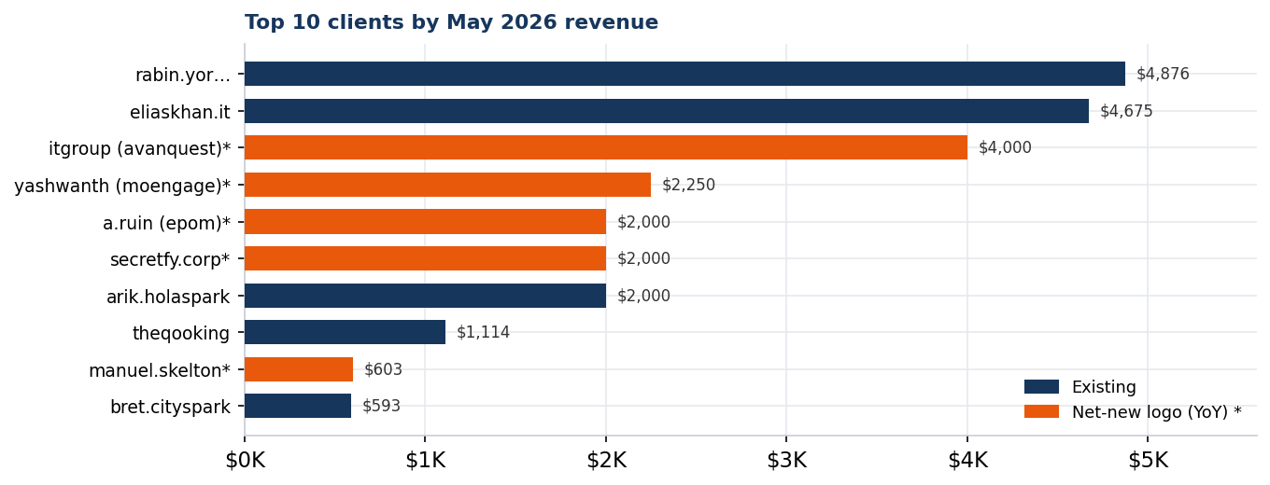
Revenue concentration (May 2026)
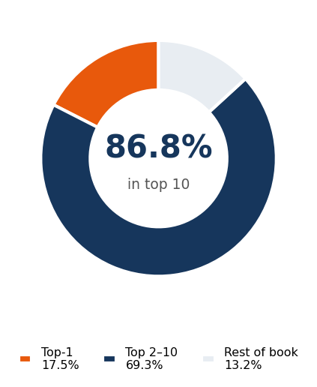
⚠ Concentration risk
Top-10 share 86.8% • Top-1 share 17.5% (rabin.yor…)
With 87% of revenue in 10 accounts, loss of any single top account is material. Recommend a named-account QBR/retention program for the top 10 and a diversification target (top-10 < 70% by year-end).
Data hygiene: one $1.00 test deal and two small negatives (−$9.24, −$12.27, likely refunds) in the log — immaterial; clean up the test record.

D. Run-rate & forward
ARR snapshot (recurring ≈ 99.6% of book, so MRR ≈ monthly revenue):
Basis | MRR | ARR
Current (May 2026, provisional) | $27,787 | ≈$333.4K
Smoothed (Jan/Feb/Mar/May, excl. April gap) | $32,640 | ≈$391.7K
Plan against ARR ≈ $390K (smoothed working run-rate); $333K is the conservative floor until April is backfilled and May reconciled.
- Pipeline-to-ARR conversion: not computable — “Current Clients Pipeline” is a single-stage customer ledger, not a funnel. Action: stand up a sales pipeline with open stages (Lead → Qualified → Proposal → Won) to measure coverage/conversion.

E. Unit economics & efficiency
- CAC by channel: only paid ad spend is attributable ($1,154.52 in May). Not a real CAC until new-logo counts are channel-tagged and fully-loaded S&M cost (outbound tooling + people) is captured. Action: tag deals with acquisition channel; route S&M payroll into the data room.
- Tool spend vs revenue: recurring tooling ≈ $569/mo = 2.05% of MRR — under the <5% target. Largest controllable line is Google Ads ($1,155); tie its continuation to attributable new-logo ARR.

F. Cash & runway
Cash runway — not computable this cycle
Missing inputs: opening cash balance (held by YODA / banking) and fully-loaded monthly burn (payroll + CDN infrastructure COGS).
On tracked OpEx alone the business is cash-generative in May (+$25,988), but that ignores the two largest real cost buckets (people, delivery infra) — so it is NOT a runway statement. Action: provide opening cash + payroll + infra COGS next cycle.

SaaS metrics summary (May 2026)
Metric | Value | Target | Status
MRR | $27.8K prov. / $32.6K smoothed | ARR/12 | Tracking
ARR | ~$333K floor / ~$390K smoothed | 10× baseline | Tracking
Net new ARR (mo) | provisional (decomposition) | (10×−1)/12 | Blocked — April gap
NRR (T3M proxy) | 75.1% ⚠ distorted | ≥110% | Re-run post-backfill
GRR (T3M proxy) | 57.2% ⚠ distorted | ≥95% | Re-run post-backfill
CAC by channel | not attributable yet | <18mo payback | Needs channel tags
Magic Number | n/a (needs prior-Q S&M) | ≥1.0 | Needs S&M base
Rule of 40 | n/a (needs FCF margin) | ≥40 | Needs full P&L
Tool spend / revenue | 2.05% | <5% | ✓ Pass
Concentration top-10 | 86.8% | (watch) | ⚠ High
— End of report —

