Ознакомиться с использованием информационных сетей для решения задач структурного подразделения. Наличие локальных вычислительных сетей и задачи, решаемые с их помощью. Связь с глобальными сетями (Internet).

309 аудитория  
  
**Компьютер:**

Имя устройства DESKTOP-PCABQ3P

Процессор Intel(R) Core(TM) i7-10700 CPU @ 2.90GHz 2.90 GHz

Оперативная память 16,0 ГБ (доступно: 15,8 ГБ)

Код устройства D8C54E3B-BE73-4CA0-B725-482B0A1AF815

Код продукта 00331-10000-00001-AA016

Тип системы 64-разрядная операционная система, процессор x64

Выпуск Windows 10 Pro

Версия 22H2

Дата установки ‎03.‎09.‎2024

Сборка ОС 19045.5247

Взаимодействие Windows Feature Experience Pack 1000.19060.1000.0

**Проверка ip устройства**

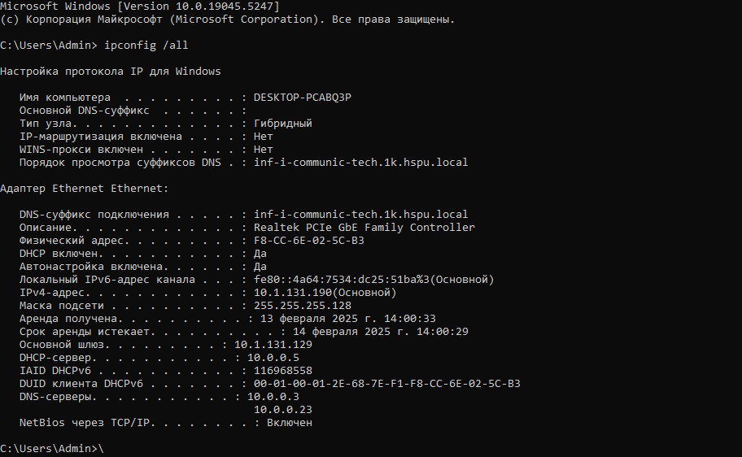

**Проверка соединения с локальным сервисом:**  
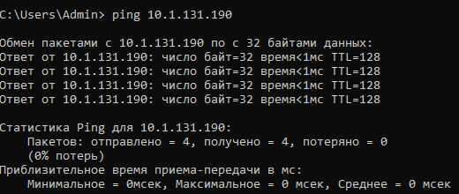

**Проверка таблиц маршрутизации:**  
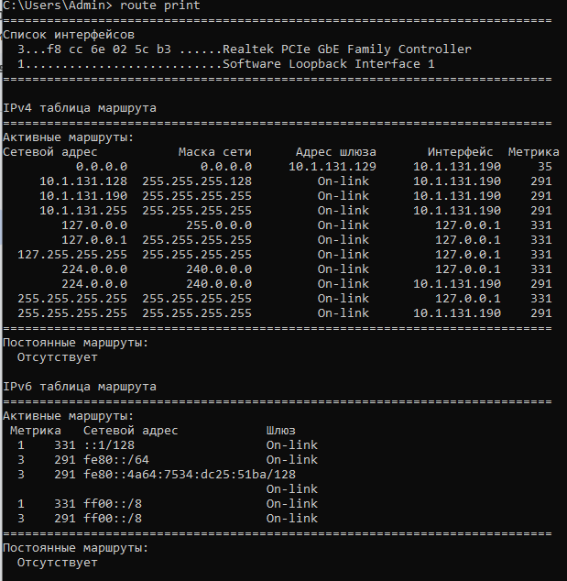

**Проверка соединения с интернетом:**  
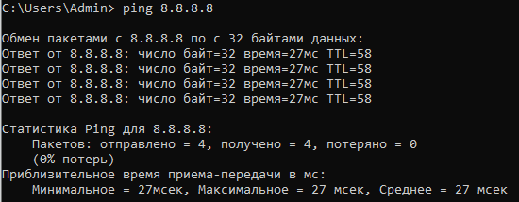

**Просмотр списка сетевых устройств:**  
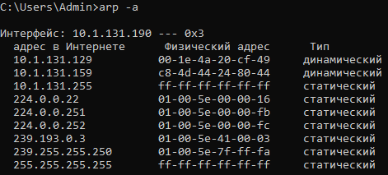

**Проверка работы DNS, позволяющее получать ip-адреса по доменам:**

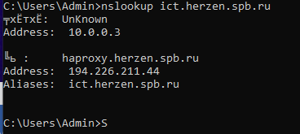

**Исследование открытых соединений с помощью netstat:**  
  
‘

C:\Users\Admin> netstat

Активные подключения

Имя Локальный адрес Внешний адрес Состояние

TCP 10.1.131.190:7680 10.1.24.133:51866 TIME_WAIT

TCP 10.1.131.190:7680 10.1.106.142:51479 TIME_WAIT

TCP 10.1.131.190:7680 10.1.106.221:50357 TIME_WAIT

TCP 10.1.131.190:7680 10.1.106.228:60658 TIME_WAIT

TCP 10.1.131.190:7680 10.1.142.151:51016 TIME_WAIT

TCP 10.1.131.190:7680 10.1.142.157:49676 TIME_WAIT

TCP 10.1.131.190:7680 10.3.14.62:51955 TIME_WAIT

TCP 10.1.131.190:7680 10.3.14.68:49798 TIME_WAIT

TCP 10.1.131.190:7680 10.3.122.62:50266 TIME_WAIT

TCP 10.1.131.190:7680 10.3.122.75:50148 TIME_WAIT

TCP 10.1.131.190:7680 10.5.1.244:55462 TIME_WAIT

TCP 10.1.131.190:7680 10.6.12.85:50947 TIME_WAIT

TCP 10.1.131.190:7680 10.6.12.181:64210 TIME_WAIT

TCP 10.1.131.190:7680 10.6.13.86:50386 TIME_WAIT

TCP 10.1.131.190:7680 10.6.13.86:50452 TIME_WAIT

TCP 10.1.131.190:7680 10.6.13.185:62158 TIME_WAIT

TCP 10.1.131.190:7680 10.11.38.84:61421 TIME_WAIT

TCP 10.1.131.190:7680 10.11.38.188:51815 TIME_WAIT

TCP 10.1.131.190:7680 10.12.45.164:54677 TIME_WAIT

TCP 10.1.131.190:7680 10.12.45.164:54682 TIME_WAIT

TCP 10.1.131.190:7680 10.14.142.31:49858 TIME_WAIT

TCP 10.1.131.190:7680 10.14.142.64:49982 TIME_WAIT

TCP 10.1.131.190:7680 10.16.67.86:64494 TIME_WAIT

TCP 10.1.131.190:7680 10.16.67.103:60324 TIME_WAIT

TCP 10.1.131.190:7680 10.16.67.196:59030 TIME_WAIT

TCP 10.1.131.190:7680 10.20.25.101:61349 TIME_WAIT

TCP 10.1.131.190:7680 10.20.25.124:52268 TIME_WAIT

TCP 10.1.131.190:7680 10.20.57.100:54188 TIME_WAIT

TCP 10.1.131.190:7680 10.20.122.96:51335 TIME_WAIT

TCP 10.1.131.190:7680 10.21.96.47:51667 TIME_WAIT

TCP 10.1.131.190:7680 10.31.41.202:54579 TIME_WAIT

TCP 10.1.131.190:7680 10.31.41.202:54597 TIME_WAIT

TCP 10.1.131.190:7680 10.31.56.71:59005 TIME_WAIT

TCP 10.1.131.190:7680 10.31.111.105:55801 TIME_WAIT

TCP 10.1.131.190:7680 10.32.37.70:52815 TIME_WAIT

TCP 10.1.131.190:7680 10.33.47.239:50489 TIME_WAIT

TCP 10.1.131.190:7680 10.35.96.15:54229 TIME_WAIT

TCP 10.1.131.190:7680 10.35.96.154:53346 TIME_WAIT

TCP 10.1.131.190:7680 10.35.97.122:53776 TIME_WAIT

TCP 10.1.131.190:7680 10.36.50.46:58086 TIME_WAIT

TCP 10.1.131.190:7680 10.36.205.250:65169 TIME_WAIT

TCP 10.1.131.190:7680 10.39.87.27:57873 TIME_WAIT

TCP 10.1.131.190:7680 10.39.87.33:51043 TIME_WAIT

TCP 10.1.131.190:52987 151.101.38.172:http CLOSE_WAIT

TCP 10.1.131.190:52990 62.128.100.47:https CLOSE_WAIT

TCP 10.1.131.190:52992 62.128.100.92:https CLOSE_WAIT

TCP 10.1.131.190:53006 4.207.247.137:https ESTABLISHED

TCP 10.1.131.190:53017 77.74.181.141:https CLOSE_WAIT

TCP 10.1.131.190:53225 arn11s12-in-f3:https ESTABLISHED

TCP 10.1.131.190:53247 arn11s10-in-f10:https ESTABLISHED

TCP 10.1.131.190:53251 arn09s23-in-f10:https ESTABLISHED

TCP 10.1.131.190:53254 arn11s11-in-f10:https ESTABLISHED

TCP 10.1.131.190:53267 lu-in-f194:https ESTABLISHED

TCP 10.1.131.190:53271 arn11s11-in-f10:https ESTABLISHED

TCP 10.1.131.190:53353 10.5.62.22:ms-do ESTABLISHED

TCP 10.1.131.190:53447 a92-123-189-97:https CLOSE_WAIT

TCP 10.1.131.190:53503 82.202.184.184:https CLOSE_WAIT

TCP 10.1.131.190:53510 lu-in-f84:https ESTABLISHED

TCP 10.1.131.190:53521 store:https ESTABLISHED

TCP 10.1.131.190:53542 104.18.21.226:http TIME_WAIT

TCP 10.1.131.190:53551 10.1.142.165:ms-do ESTABLISHED

TCP 10.1.131.190:53612 10.0.15.115:13111 TIME_WAIT

TCP 10.1.131.190:53623 10.0.15.115:13111 TIME_WAIT

TCP 10.1.131.190:53631 arn11s12-in-f4:https ESTABLISHED

TCP 10.1.131.190:53632 arn11s04-in-f14:https ESTABLISHED

TCP 10.1.131.190:53633 lh-in-f95:https ESTABLISHED

TCP 10.1.131.190:53634 le-in-f132:https ESTABLISHED

TCP 10.1.131.190:53635 arn11s10-in-f14:https ESTABLISHED

TCP 10.1.131.190:53637 arn11s11-in-f14:https ESTABLISHED

TCP 10.1.131.190:53638 20.44.10.122:https TIME_WAIT

TCP 10.1.131.190:53639 arn11s12-in-f14:https ESTABLISHED

TCP 10.1.131.190:53640 arn11s11-in-f3:https ESTABLISHED

TCP 10.1.131.190:53641 lr-in-f100:https ESTABLISHED

TCP 10.1.131.190:53642 arn11s10-in-f1:https ESTABLISHED

TCP 10.1.131.190:53643 10.0.15.115:13000 TIME_WAIT

TCP 10.1.131.190:53644 arn11s04-in-f1:https ESTABLISHED

TCP 10.1.131.190:53645 arn09s22-in-f14:https ESTABLISHED

TCP 10.1.131.190:53646 la-in-f113:https ESTABLISHED

TCP 10.1.131.190:53647 10.0.15.115:13111 TIME_WAIT

TCP 10.1.131.190:53651 10.0.15.115:13000 TIME_WAIT

TCP 10.1.131.190:53654 10.1.24.142:ms-do ESTABLISHED

TCP 10.1.131.190:53655 194.226.211.29:https ESTABLISHED

TCP 10.1.131.190:53656 151.101.205.91:https ESTABLISHED

TCP 10.1.131.190:53657 arn11s12-in-f10:https ESTABLISHED

TCP 10.1.131.190:53658 194.226.211.26:https TIME_WAIT

TCP 10.1.131.190:53659 194.226.211.26:https TIME_WAIT

TCP 10.1.131.190:53660 a23-59-85-67:http ESTABLISHED

TCP 10.1.131.190:53662 194.226.211.26:https TIME_WAIT

TCP 10.1.131.190:53664 194.226.211.26:https TIME_WAIT

TCP 10.1.131.190:53665 arn11s10-in-f3:https ESTABLISHED

TCP 10.1.131.190:53666 a23-64-12-35:http ESTABLISHED

TCP 10.1.131.190:53667 10.0.15.115:13111 TIME_WAIT

TCP 10.1.131.190:53668 arn09s23-in-f3:https ESTABLISHED

TCP 10.1.131.190:53669 arn11s12-in-f3:https ESTABLISHED

TCP 10.1.131.190:53670 arn11s10-in-f3:https ESTABLISHED

TCP 10.1.131.190:53675 10.31.56.66:ms-do TIME_WAIT

TCP 10.1.131.190:53677 10.1.106.149:ms-do SYN_SENT

TCP 10.1.131.190:53681 10.31.111.105:ms-do TIME_WAIT

TCP 10.1.131.190:53682 10.39.122.240:ms-do SYN_SENT

**Трассировка:**

