# Package Diagram

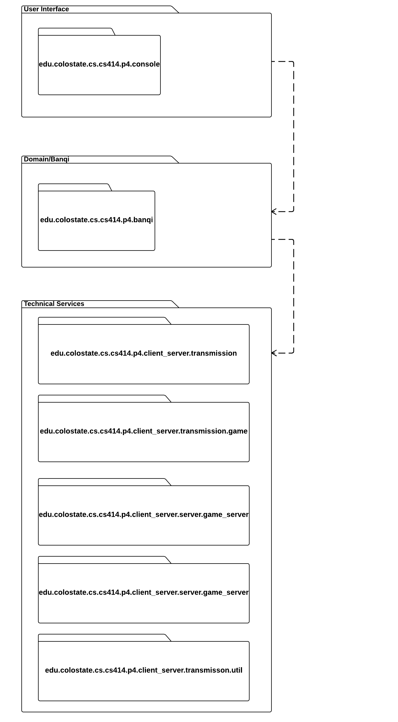

# Design Class Diagram

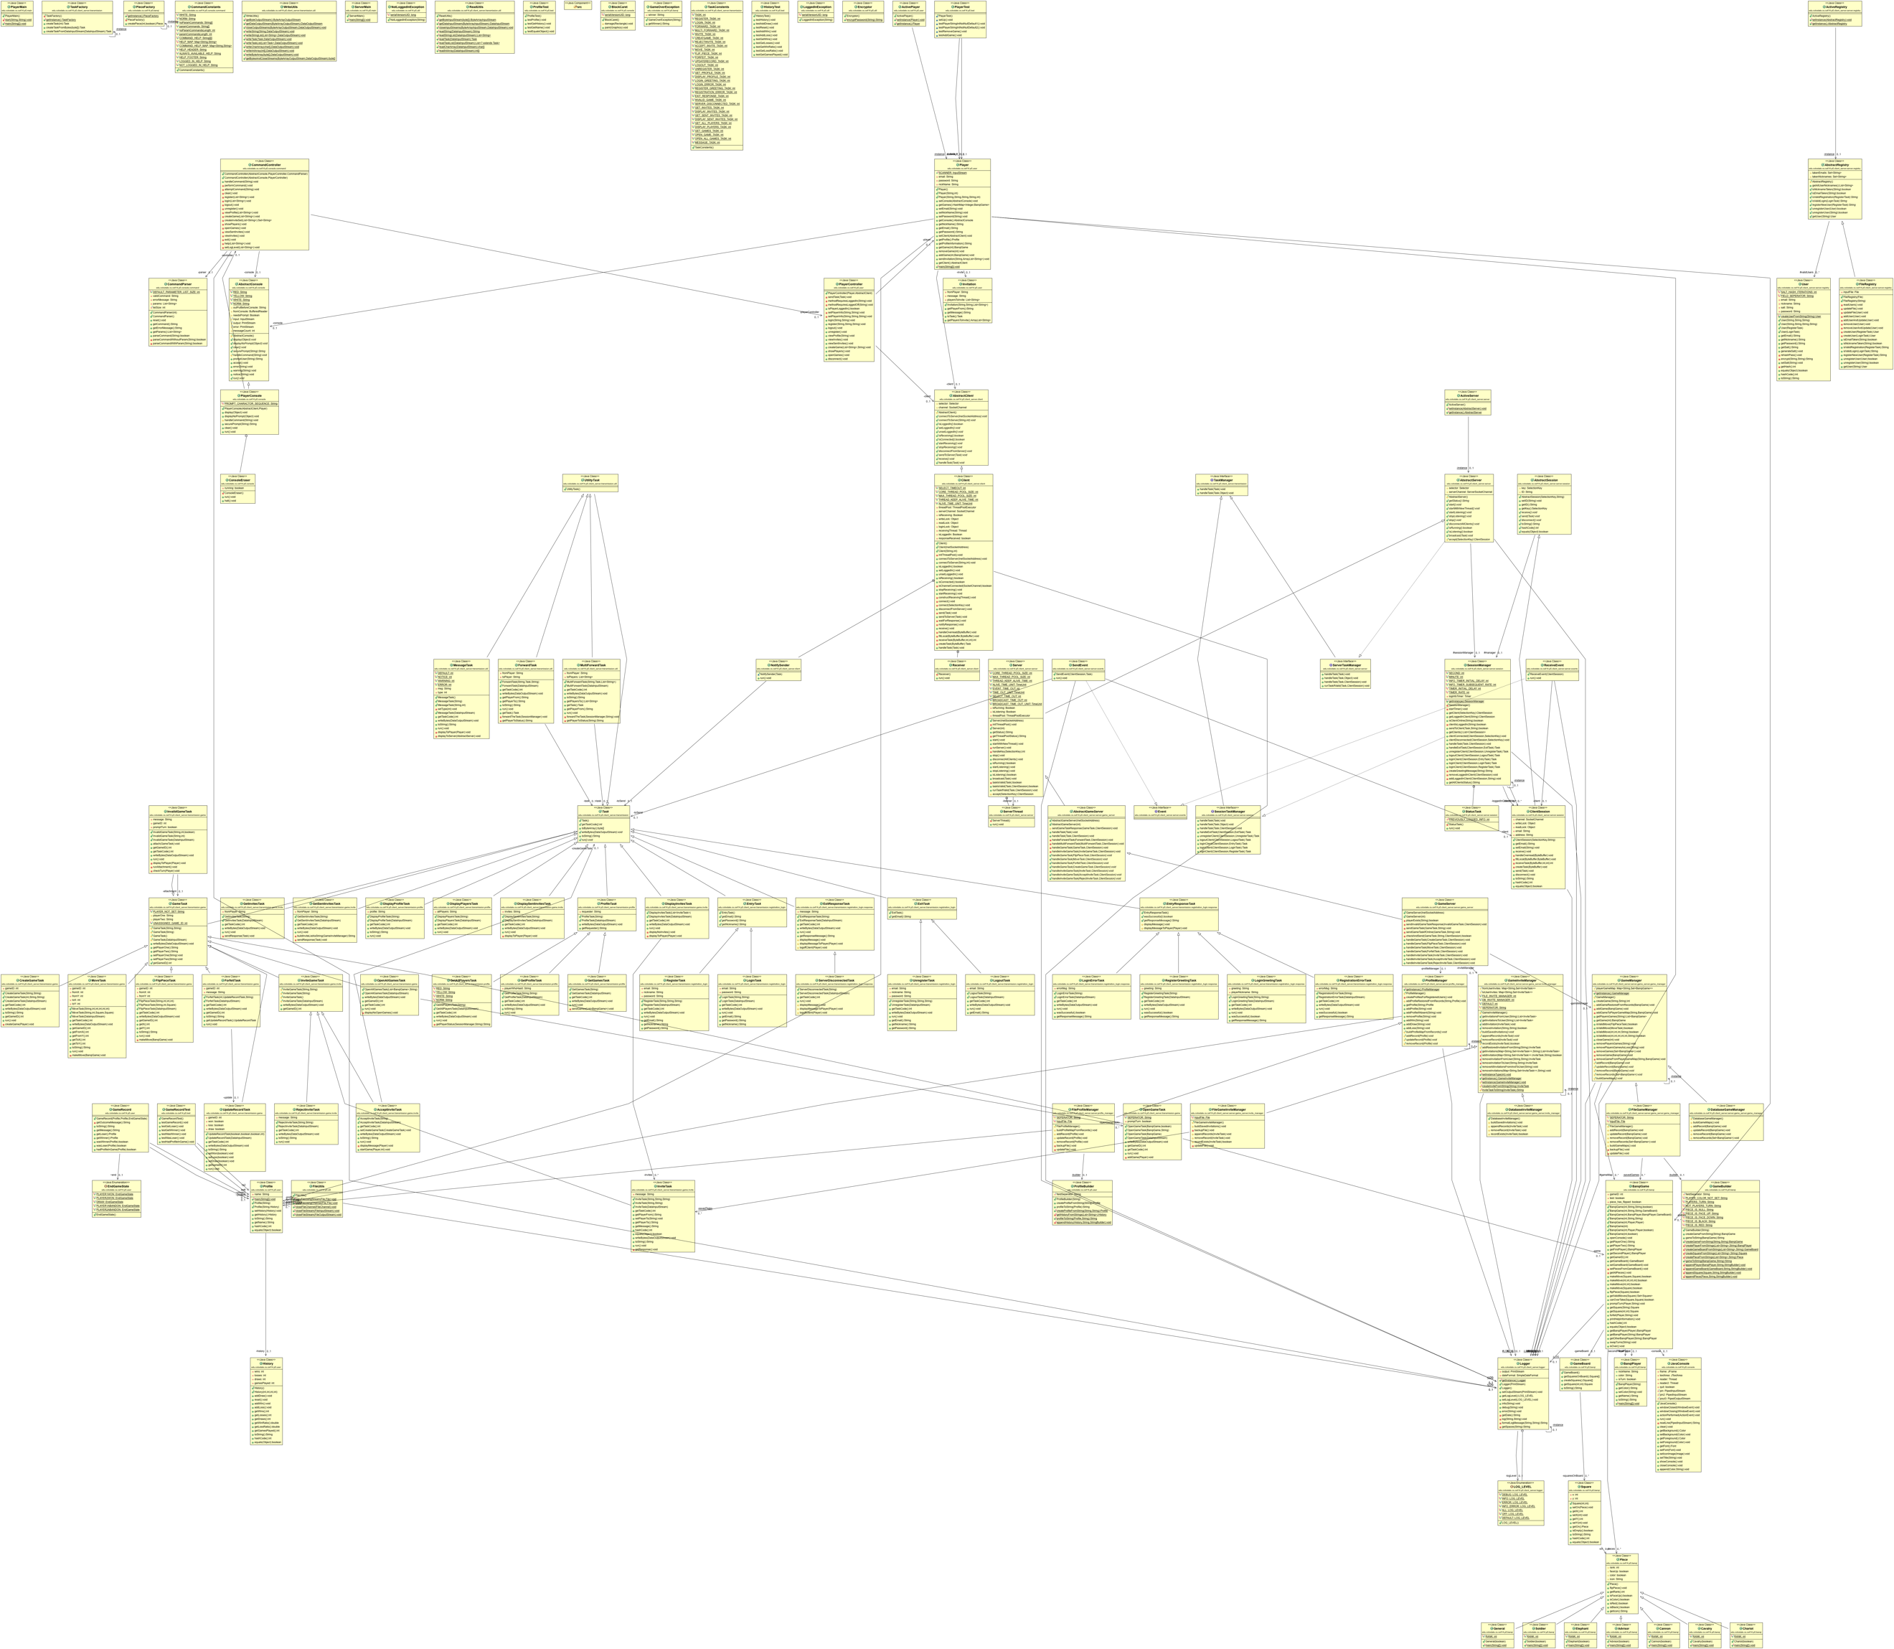

# Sequence Diagrams

1. SD showcasing how a client communicates with the server:

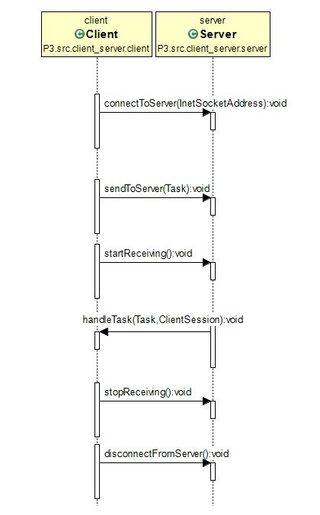

1. SD showcasing low coupling between profile and history

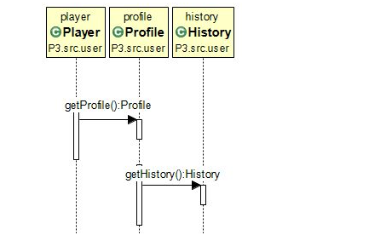

1. SD showcasing how a game is created

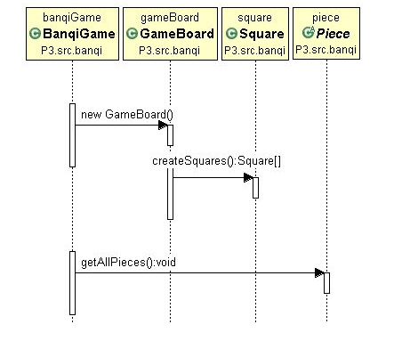

1. SD showcasing the registering of a user

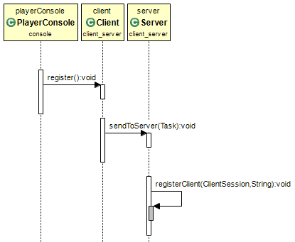

1. SD showing how a game is played:

