Domain Model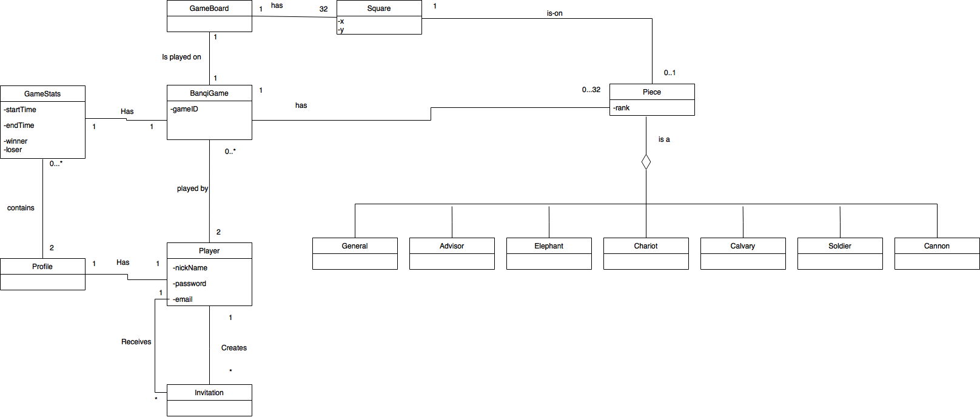

**Glossary**

|  |  |
| --- | --- |
| **Term:** | **Definition:** |
| Advisor | Advisor is a subclass of Piece. This class represents the Advisor piece in Banqi. There will only be a total of four Advisor’s during a game of Banqi (two per side). |
| BanqiGame | BanqiGame is a class that controls the game.It determines whose turn it is, if the game is over, and who the winner is.  *gameID*, a unique id for each game. |
| Calvary | Calvary is a subclass of Piece. This class represents the Calvary piece in Banqi. There will only be a total of four Calvary pieces during a game of Banqi (two per side). |
| Cannon | Cannon is a subclass of Piece. This class represents the Cannon piece in Banqi. There will only be four Cannon pieces during a game of Banqi (two per side). |
| Chariot | Chariot is a subclass of Piece. This class represents the Chariot piece in Banqi. There will only be a total of four Chariots (two per side). |
| Elephant | Elephant is a subclass of Piece. This class represents the Elephant piece in Banqi. There will only be a total of four Elephant’s during a game of Banqi (two per side). |
| GameBoard | GameBoard is a class that represents the real world game board of the Banqi game. The GameBoard is made up of 32 Squares. |
| GameStats | GameStats is a class that keeps track of statistics of a Banqi Game.  *startTime*, the date/time that a banqi game started.  *endTime*, the date/time that a banqi game ended.  *winner*, the Player that won the game.  *loser*, the Player that lost the game. |
| General | General is a subclass of Piece. This class represents the General piece in Banqi. There will only be a total of two General’s during a game of Banqi (one per side). |
| Piece | Piece is a superclass (will be inherited by other classes).  *Rank,* Each piece is associated with a rank that determines which pieces they can collect/overtake. |
| Player | Player is a class that represents a real life player/opponent in Banqii. This class maintains a user’s password, nickname, and email address.  *nickname*, the nickname a user chooses when registering their account.  *email*, the email address a user entered when they registered their account.  *password*, the password a user chooses when they register their account. |
| Profile | Profile is a class that represents a real life player of banqi. |
| Soldier | Soldier is a subclass of Piece. This class represents the Solider piece in Banqi. There will only be a total of 10 pieces during a game of Banqi (5 per side). |
| Square | Square is a class that represents a square tile on a real life Banqi game board.  *X,* the x axis of the Square’s location on the board.  *Y,* the y axis of the Square’s location on the board.  (X,Y) will be unique for each Square and will represent a physical location of a square tile on a GameBoard. |