**Index**

|  |  |  |
| --- | --- | --- |
| **Use Case** | **Use Case ID** | **Page #** |
| *Register* | ID: 01 | Page 1 |
| *Create Game* | ID: 02 | Page 2 |
| *Invite User* | ID: 03 | Page 3 |
| *Respond Invitation* | ID: 04 | Page 4 |
| *Quit Game* | ID: 05 | Page 5 |
| *Unregister* | ID: 06 | Page 6 |
| *Record History* | ID: 07 | Page 7 |
| *View Profile* | ID: 08 | Page 8 |
| *Start Game* | ID: 09 | Page 9 |
| *Play Game* | ID: 10 | Page 10 |
| *Save Game* | ID: 11 | Page 11 |
| *Login* | ID: 12 | Page 12 |
| *Show Players* | ID: 13 | Page 13 |
| *View Invites* | ID: 14 | Page 14 |
| *View Sent Invites* | ID: 15 | Page 15 |
| *Open Games* | ID: 16 | Page 16 |

ID: 01

|  |  |
| --- | --- |
| **Use Case Section** | **Comment** |
| Use Case Name | Register |
| Scope | Banqi Application |
| Level | User-goal |
| Primary Actor | User (The person registering) |
| Stakeholders and Interests | Person registering: Wants to register and log in to play games. |
| Preconditions | 1. A person is not registered to the system. 2. Person has unique email, password, and nickname |
| Success Guarantee | User is registered |
| Main Success Scenario | 1. User enters unique email, password, and nickname 2. User presses the submit button 3. System checks to see if user already exists 4. If user does not already exist, user will be registered as new user 5. System will then notify the user that they succesfully registered |
| Extensions | 1. A registration attempt may fail if the person registering entered a email or nickname that is not unique. 2. System will then notify the user that they unsuccessfully registered. |
| Special Requirements | None |
| Technology and Data Variations List | 1. Information entered w/ keyboard 2. Submit button clicked by mouse 3. User needs an adequate internet connection |
| Frequency of Occurrence | Occurs often |
| Miscellaneous | Once a user has registered, they won’t have to register again. |

ID: 02

|  |  |
| --- | --- |
| **Use Case Section** | **Comment** |
| Use Case Name | Create Game |
| Scope | Banqi Application |
| Level | User-goal |
| Primary Actor | User |
| Stakeholders and Interests | Registered users who want to create a game. |
| Preconditions | A user must be registered to the system and has a connection to the game server. |
| Success Guarantee | A new game is created and the user is added as a player to the newly created game. |
| Main Success Scenario | 1. Registered user creates a new game 2. A “create game” request is transmitted to the game server. 3. The game server sends a success or fail response back to the user. 4. User is prompted with success message. 5. System adds the user to the newly created game. |
| Extensions | 1. User is prompted with a failure message 2. System does not add the user to the newly created game |
| Special Requirements | The game server must be available. |
| Technology and Data Variations List | Menu options clicked by mouse. |
| Frequency of Occurrence | Often |
| Miscellaneous | 1. The system must assign unique identifiers for each game that is created by users. |

ID: 03

|  |  |
| --- | --- |
| **Use Case Section** | **Comment** |
| Use Case Name | Invite User |
| Scope | Banqi Application |
| Level | User-goal |
| Primary Actor | Registered User |
| Stakeholders and Interests | Registered Users: Users are interested in playing with either a singular or a set of other users. |
| Preconditions | 1. Both the invitee and the invited players must be a registered user. 2. A game must be created before inviting other users to play |
| Success Guarantee | 1. A user is invited to a game 2. The user accepts the invite and is added to the game. |
| Main Success Scenario | 1. User creates a new game. 2. User invites player(s) to join newly created game. 3. Invited user receives invitation |
| Extensions | 1. A user is invited to a game 2. The user declines the invite 3. The user is not added to the game |
| Special Requirements | None |
| Technology and Data Variations List | 1. User types invited users username w/ keyboard 2. Send button clicked by mouse 3. User needs an adequate internet connection |
| Frequency of Occurrence | Often |
| Miscellaneous | A user can only invite another user once at a time (one-to-one relationship) |

ID: 04

|  |  |
| --- | --- |
| **Use Case Section** | **Comment** |
| Use Case Name | Respond Invitation |
| Scope | Banqi Application |
| Level | User-goal |
| Primary Actor | User |
| Stakeholders and Interests | User 1: Sends invite to play game with other player  User 2: Plays a game that he/she is invited to |
| Preconditions | Both users are registered, Game invitation has been extended |
| Success Guarantee | 1. User accepts invitation and a game is successfully created |
| Main Success Scenario | 1. User 2 receives invite 2. User 2 accepts invite 3. User 1 (user that sent the invite) is notified that the invited user (User 2) has accepted the invitation 4. Both users start game |
| Extensions | 1. User 2 rejects the invitation 2. User 1 is notified |
| Special Requirements | None |
| Technology and Data Variations List | None |
| Frequency of Occurrence | Often |
| Miscellaneous | None |

ID: 05

|  |  |
| --- | --- |
| **Use Case Section** | **Comment** |
| Use Case Name | Quit game |
| Scope | Banqi Application |
| Level | User-goal |
| Primary Actor | User |
| Stakeholders and Interests | User 1: In game, is playing  User 2: In game, wants to quit |
| Preconditions | Both users are registered, and in game |
| Success Guarantee | Game is stopped, stats are recorded, both users are notified |
| Main Success Scenario | 1. User selects to quit 2. Both users are notified of the intention to quit 3. The game stops, the stats are recorded, and both players can no longer play |
| Extensions | Nones |
| Special Requirements | None |
| Technology and Data Variations List | None |
| Frequency of Occurrence | Often |
| Miscellaneous | None |

ID: 06

|  |  |
| --- | --- |
| **Use Case Section** | **Comment** |
| Use Case Name | Unregister |
| Scope | Banqi Application |
| Level | User-goal |
| Primary Actor | User |
| Stakeholders and Interests | User: wants to unregister |
| Preconditions | User is registered |
| Success Guarantee | User is unregistered |
| Main Success Scenario | 1. User clicks unregister button 2. System removes user login information, nickname, and profile for user 3. User is notified that they have been unregistered |
| Extensions | 1. User clicks unregister button 2. System fails to remove user login information, nickname, and profile for user 3. User is notified that they have not been unregistered |
| Special Requirements | None |
| Technology and Data Variations List | Unregistered button is clicked with mouse |
| Frequency of Occurrence | Often |
| Miscellaneous | None |

ID: 07

|  |  |
| --- | --- |
| **Use Case Section** | **Comment** |
| Use Case Name | Record History |
| Scope | Banqi Application |
| Level | subfunction-level |
| Primary Actor | System |
| Stakeholders and Interests | User: Wants to be able to see their record (wins,losses,ties,draw,etc.) |
| Preconditions | A user must be registered to have a record |
| Success Guarantee | System logs record for a game and inserts the information for the specified user.  Information that is logged: (Opponent, start date/time, end date/time, result of game) |
| Main Success Scenario | 1. Users play a game 2. Once the game is finished the system logs the proper information for both users playing. 3. Each users record is updated with the opponents nickname, start/end date of time, and the end result of the game (i.e., win, loss, tie, draw, abandoned) |
| Extensions | None |
| Special Requirements | None |
| Technology and Data Variations List | None |
| Frequency of Occurrence | Often |
| Miscellaneous | System will keep track of all records and display a rankings list |

ID: 08

|  |  |
| --- | --- |
| **Use Case Section** | **Comment** |
| Use Case Name | View Profile |
| Scope | Banqi Application |
| Level | User-goal |
| Primary Actor | User |
| Stakeholders and Interests | User: wants to see their or another user’s profile information. |
| Preconditions | User is registered and logged in. |
| Success Guarantee | User sees their or another user’s profile with information such as wins, losses, ties, and games played. |
| Main Success Scenario | 1. User requests to view profile 2. User sees their profile information |
| Extensions | 1. User requests to view profile under another user’s nickname 2. User see's profile information for the associated nickname. |
| Special Requirements | None |
| Technology and Data Variations List | None |
| Frequency of Occurrence | Often |
| Miscellaneous | None |

ID: 09

|  |  |
| --- | --- |
| **Use Case Section** | **Comment** |
| Use Case Name | Start Game |
| Scope | Banqi Application |
| Level | User-goal |
| Primary Actor | Users |
| Stakeholders and Interests | Registered users who are apart of the game that will start. |
| Preconditions | The game has not already started. Two users are registered and have either accepted an invitation to the game or created the game. |
| Success Guarantee | The game starts and players begin. |
| Main Success Scenario | 1. A registered user creates a game. 2. The same user invites another registered user to the game. 3. When / if the invited user accepts the invite, the system starts the game. 4. The users are notified the game has started. 5. The system marks the game as active, and no other users can join the game. |
| Extensions | 1. A joined player leaves the game before the game is started 2. The game does not start |
| Special Requirements | Two users must have joined the game. |
| Technology and Data Variations List | None |
| Frequency of Occurrence | Often |
| Miscellaneous | None |

ID: 10

|  |  |
| --- | --- |
| **Use Case Section** | **Comment** |
| Use Case Name | Play Game |
| Scope | Banqi Application |
| Level | User-goal |
| Primary Actor | User |
| Stakeholders and Interests | Users: Playing the game |
| Preconditions | Users must be registered and in an active game |
| Success Guarantee | Users take turns making legal moves. |
| Main Success Scenario | 1. User starts a new game 2. The user that invited another user to play gets to take his/her turn first 3. Both users take turns making moves 4. Users finish the game 5. System logs information specified in the Record History (ID 7) use case |
| Extensions | 1. User starts a new game 2. The invited users gets to take his/her turn first 3. Both users take turns making moves 4. Users finish the game 5. System logs information specified in the Record History (ID 7) use case |
| Special Requirements | The game server must be available. |
| Technology and Data Variations List | Menu options clicked by mouse. |
| Frequency of Occurrence | Often |
| Miscellaneous | None |

ID: 11

|  |  |
| --- | --- |
| **Use Case Section** | **Comment** |
| Use Case Name | Save game |
| Scope | Banqi Application |
| Level | System-goal |
| Primary Actor | System |
| Stakeholders and Interests | User: Wants to be able to return to a game between logins without having to create a new game. |
| Preconditions | A game is created and has been started (aka a player has taken a turn).  Game state must have changed since last save. |
| Success Guarantee | A game is properly saved with the right information |
| Main Success Scenario | 1. System saves game state |
| Extensions | 1. When game is finished system removes the last saved game state |
| Special Requirements | None |
| Technology and Data Variations List | None |
| Frequency of Occurrence | Often |
| Miscellaneous | None |

ID: 12

|  |  |
| --- | --- |
| **Use Case Section** | **Comment** |
| Use Case Name | Login |
| Scope | Banqi Application |
| Level | User-goal |
| Primary Actor | User |
| Stakeholders and Interests | User: Wants to be able to login to the game so he/she can play the Banqi game. |
| Preconditions | A user must be registered to the system. |
| Success Guarantee | User is sucessfully logged in to Banqi game. |
| Main Success Scenario | 1. A registered user logins into the Banqi game system 2. User is notified that login was successfull |
| Extensions | 1. A registered user attempts to login to the Banqi game system 2. After a failed attemp they will be notified that the login was unsuccessful |
| Special Requirements | None |
| Technology and Data Variations List | 1. Information entered with keyboard 2. Submit button cliicked by mouse 3. User needs an adequate internet connection |
| Frequency of Occurrence | Often |
| Miscellaneous | None |

ID: 13

|  |  |
| --- | --- |
| **Use Case Section** | **Comment** |
| Use Case Name | Show Player |
| Scope | Banqi Application |
| Level | User-goal |
| Primary Actor | User |
| Stakeholders and Interests | User: Wants to be able to see a list of all the players (online/offline). |
| Preconditions | A user must be registered and logged into the system. |
| Success Guarantee | User is successfully shown a list of all players. |
| Main Success Scenario | 1. A registered user logs into the Banqi game system 2. User is shown a list of all players (offline and online) |
| Extensions | 1. User is shown a list that contains no players |
| Special Requirements | None |
| Technology and Data Variations List | 1. Information entered with keyboard 2. User needs an adequate internet connection |
| Frequency of Occurrence | Somewhat often |
| Miscellaneous | None |

ID: 14

|  |  |
| --- | --- |
| **Use Case Section** | **Comment** |
| Use Case Name | View Invites |
| Scope | Banqi Application |
| Level | User-goal |
| Primary Actor | User |
| Stakeholders and Interests | User: Wants to be able to see a list of all the invitations they have recieved to play a banqi game. |
| Preconditions | A user must be registered and logged into the system. |
| Success Guarantee | User is successfully shown a list of all the invitations they have received. |
| Main Success Scenario | 1. A registered user logs into the Banqi game system 2. User is shown a list of all the invitations that they have recieved |
| Extensions | 1. User is shown a list that contains no invitations |
| Special Requirements | None |
| Technology and Data Variations List | 1. Information entered with keyboard 2. User needs an adequate internet connection |
| Frequency of Occurrence | Often |
| Miscellaneous | None |

ID: 15

|  |  |
| --- | --- |
| **Use Case Section** | **Comment** |
| Use Case Name | View Sent Invites |
| Scope | Banqi Application |
| Level | User-goal |
| Primary Actor | User |
| Stakeholders and Interests | User: Wants to be able to see a list of all the invitations they have sent to other players. |
| Preconditions | A user must be registered and logged into the system. |
| Success Guarantee | User is successfully shown a list of all the invitations they have sent. |
| Main Success Scenario | 1. A registered user logs into the Banqi game system 2. User is shown a list of all the invitations that they have sent to others |
| Extensions | 1. User is shown a list that contains no sent invitations |
| Special Requirements | None |
| Technology and Data Variations List | 1. Information entered with keyboard 2. User needs an adequate internet connection |
| Frequency of Occurrence | Often |
| Miscellaneous | None |

ID: 16

|  |  |
| --- | --- |
| **Use Case Section** | **Comment** |
| Use Case Name | Open Games |
| Scope | Banqi Application |
| Level | User-goal |
| Primary Actor | User |
| Stakeholders and Interests | User: Wants to be able to open games they have not yet finished. |
| Preconditions | A user must be registered and logged into the system.  The user must have played a game and exited out of the game before it was ended/forfeited. |
| Success Guarantee | Users games succesfully open on a new game console |
| Main Success Scenario | 1. A registered user logs into the Banqi game system 2. Users game consoles open up with the proper game state the user left off with. |
| Extensions | 1. Users game console opens in a finished state |
| Special Requirements | None |
| Technology and Data Variations List | 1. Information entered with keyboard 2. User needs an adequate internet connection |
| Frequency of Occurrence | Often |
| Miscellaneous | None |

OLD USE CASE DIAGRAM 1:

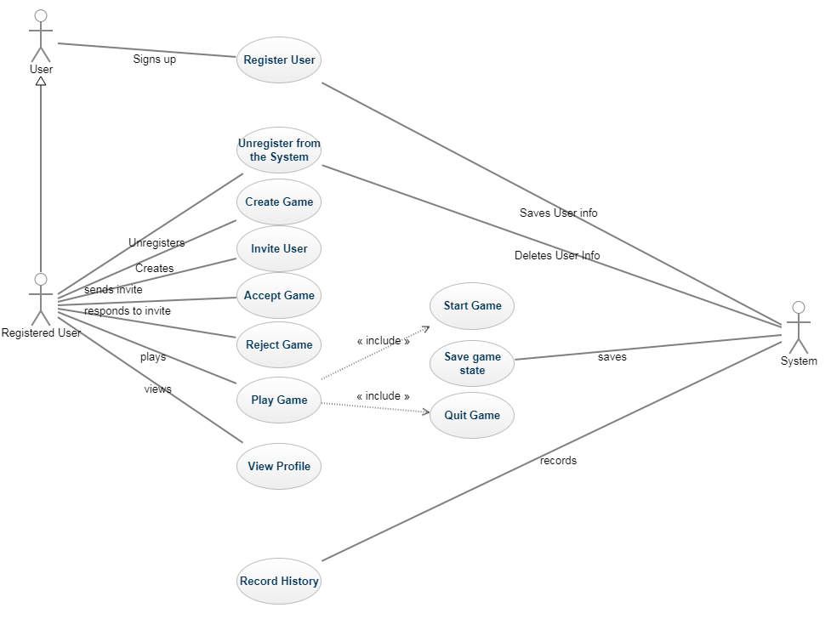

OLD USE CASE DIAGRAM 2:

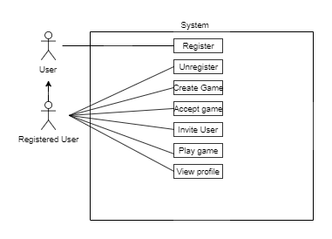

UPDATED USE CASE DIAGRAM:

