Коржилов Максим ПР23/1

Лабораторная работа №7
Тема: Отладка отдельных модулей программного проекта.
Организация обработки исключений.
Цель: создать программный проект в среде Visual Studio на языке C#, реализовать организацию обработки исключений для обеспечения надежной работы приложения, а также разработать функционал для оформления предзаказов с использованием базы данных MS SQL Server.
Ход работы
Добавим столбец для цены за предзаказ в таблицу изданий (рис. 1).

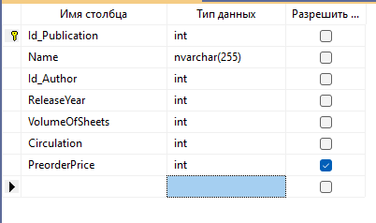
Рис. 1 – Столбец с ценой

Заполним цену во всех изданиях (рис. 2).

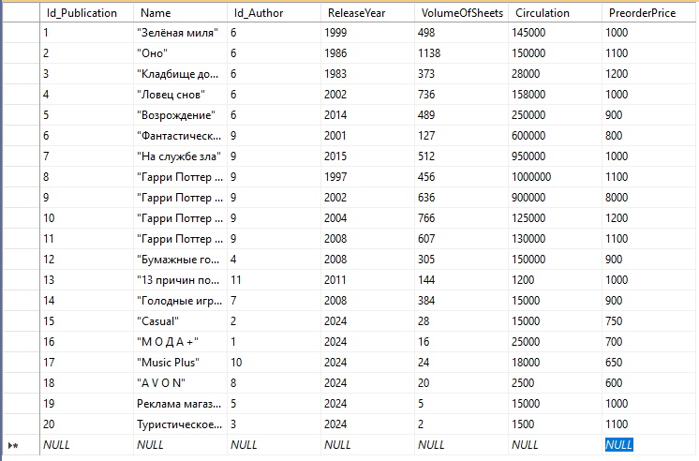
Рис. 2 – Цены за издания

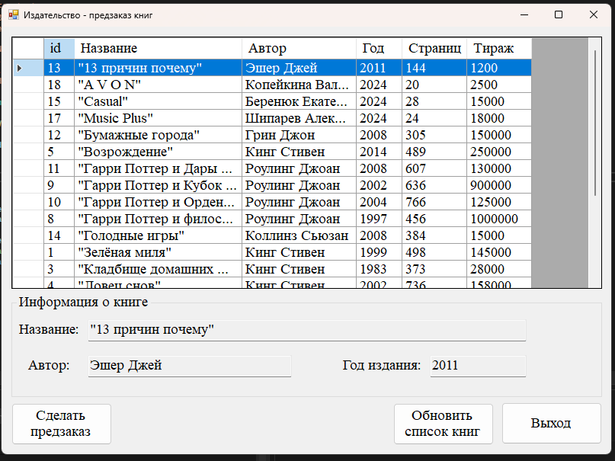
Рис. 3 – Форма выбора книги
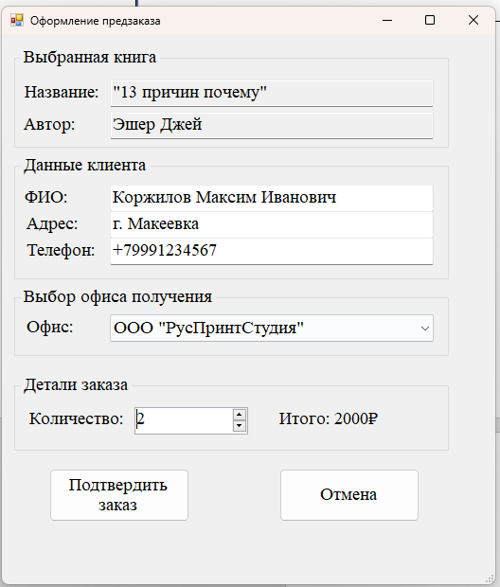
Рис. 4 – Форма оформления предзаказа

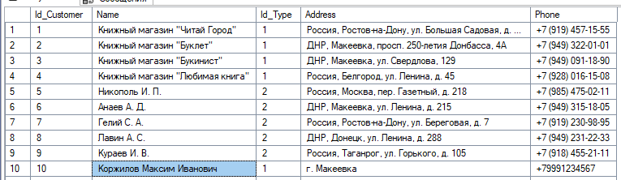
Рис. 5 – Новый пользователь создан

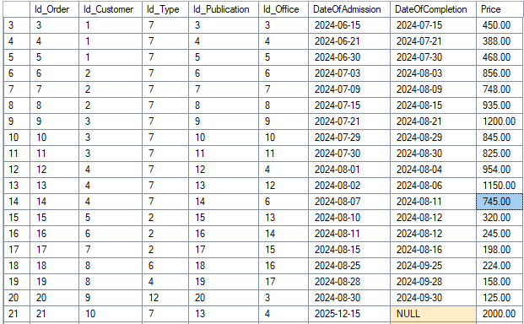
Рис. 6 – Новый заказ создан

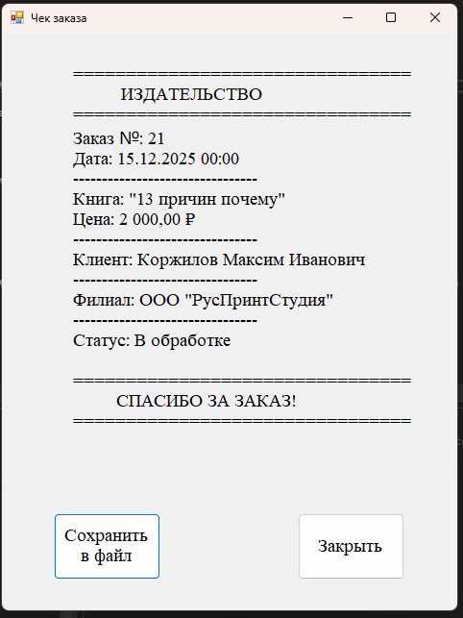
Рис. 7 – Форма с чеком

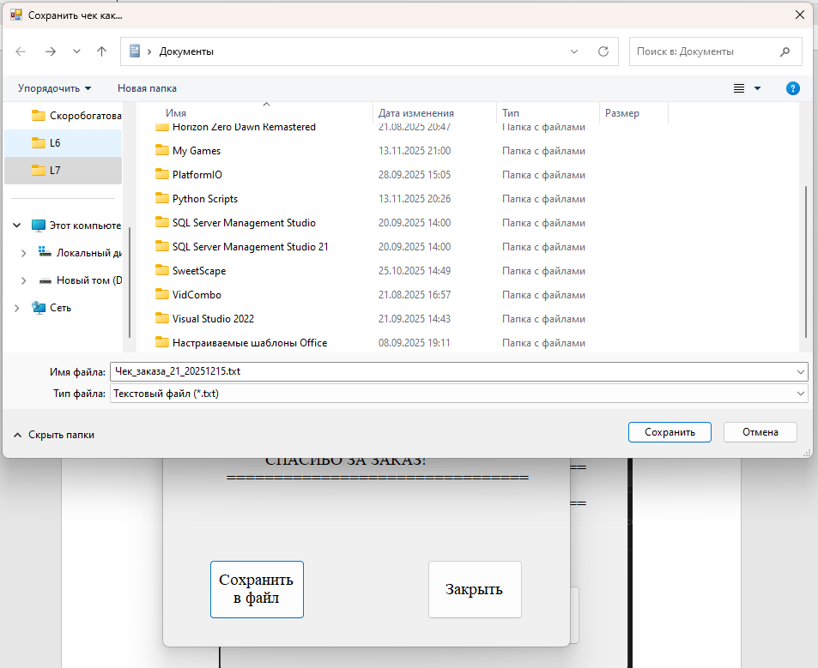
Рис. 8 – Сохранение чека в файл

Код формы FormMain:
using PublishingApp.Models;
using System;
using System.Collections.Generic;
using System.ComponentModel;
using System.Data;
using System.Drawing;
using System.Linq;
using System.Text;
using System.Threading.Tasks;
using System.Windows.Forms;

namespace PublishingApp
{
public partial class FormMain : Form
{
DatabaseHelper databaseHelper = new DatabaseHelper();
Dictionary<string, Book> books = new Dictionary<string, Book>();
string selectedBook = "";

public FormMain()
{
InitializeComponent();
refreshBooks();
}

private void refreshBooks()
{
dgvBooks.Rows.Clear();
books.Clear();
foreach (Book book in databaseHelper.GetBooks())
{
dgvBooks.Rows.Add(book.Id, book.Title, book.AuthorName, book.ReleaseYear, book.Pages, book.Circulation);
books.Add(book.Id.ToString(), book);
}
}

private void dgvBooks_SelectionChanged(object sender, EventArgs e)
{
try // срабатывает ошибка при нажатии "обновить". выделение меняется после очистки, а строчек ещё нет
{
int rowN = ((DataGridView)sender).SelectedRows[0].Index;
Book book = books[dgvBooks.Rows[rowN].Cells[0].Value.ToString()];
txtAuthor.Text = book.AuthorName;
txtTitle.Text = book.Title;
txtYear.Text = book.ReleaseYear.ToString();
selectedBook = book.Id.ToString();
}
catch { }
}

private void btnExit_Click(object sender, EventArgs e)
{
if (MessageBox.Show("Вы действительно хотите выйти?", "Подтверждение выхода", MessageBoxButtons.OKCancel, MessageBoxIcon.Question).Equals(DialogResult.OK))
{
Close();
}
}

private void btnReload_Click(object sender, EventArgs e)
{
txtAuthor.Text = txtTitle.Text = txtYear.Text = "";
refreshBooks();
dgvBooks_SelectionChanged(dgvBooks, null); // выбираем книгу вручную. автоматический переход срабатывает после очистки, но не после заполнения
}

private void btnPreorder_Click(object sender, EventArgs e)
{
Form form = new FormOrder(books[selectedBook]);
this.Hide();
form.ShowDialog();
this.Show();
}
}
}

Код формы FormOrder:
using PublishingApp.Models;
using System;
using System.Collections.Generic;
using System.Windows.Forms;

namespace PublishingApp
{
public partial class FormOrder : Form
{
Book _book;
List<Office> offices;
DatabaseHelper dbHelper = new DatabaseHelper();

public FormOrder(Book book)
{
InitializeComponent();
txtAuthor.Text = book.AuthorName;
txtTitle.Text = book.Title;
_book = book;
nudCantidad_ValueChanged(this, EventArgs.Empty);
refreshOffices();
}

private void nudCantidad_ValueChanged(object sender, EventArgs e)
{
lblResultPrice.Text = $"Итого: {_book.Price * nudCantidad.Value}₽";
}

private void btnCancel_Click(object sender, EventArgs e)
{
if (MessageBox.Show("Вы действительно хотите отменить заказ?", "Подтверждение отмены", MessageBoxButtons.OKCancel, MessageBoxIcon.Question).Equals(DialogResult.OK))
{
Close();
}
}

private void refreshOffices()
{
offices = dbHelper.GetOffices();
foreach (Office office in offices)
{
cbxOffices.Items.Add(office.Name);
}
}

private void btnConfirm_Click(object sender, EventArgs e)
{
if (cbxOffices.SelectedIndex == -1)
{
MessageBox.Show("Выберите офис получения!", "Ошибка ввода", MessageBoxButtons.OK, MessageBoxIcon.Error);
return;
}
if (txtClientName.Text.Length == 0 || txtPhoneNumber.Text.Length == 0 || txtAddress.Text.Length == 0)
{
MessageBox.Show("Заполните данные клиента!", "Ошибка ввода", MessageBoxButtons.OK, MessageBoxIcon.Error);
return;
}
int id = dbHelper.CreateCustomer(new Customer { Name = txtClientName.Text, Address = txtAddress.Text, Phone = txtPhoneNumber.Text });
Office office = offices[cbxOffices.SelectedIndex];
Order order = new Order
{
CustomerId = id,
CustomerName = txtClientName.Text,
BookId = _book.Id,
BookTitle = _book.Title,
OfficeId = office.Id,
OfficeName = office.Name,
OrderDate = DateTime.Now,
Price = _book.Price * nudCantidad.Value,
CompletionDate = null
};
order.Id = dbHelper.CreateOrder(order);
MessageBox.Show("Заказ успешно создан!", "Успех", MessageBoxButtons.OK, MessageBoxIcon.Information);
Form form = new FormReceipt(order.Id);
this.Hide();
form.ShowDialog();
Close();
}
}
}

Код формы FormReceipt:
using PublishingApp.Models;
using System;
using System.IO;
using System.Windows.Forms;

namespace PublishingApp
{
public partial class FormReceipt : Form
{
private Order _order;
DatabaseHelper databaseHelper = new DatabaseHelper();

public FormReceipt(int orderId)
{
_order = databaseHelper.GetOrderDetails(orderId);
InitializeComponent();
BuildReceipt();
}

private void BuildReceipt()
{
var receipt = $@"
================================
ИЗДАТЕЛЬСТВО
================================
Заказ №: {_order.Id}
Дата: {_order.OrderDate:dd.MM.yyyy HH:mm}
--------------------------------
Книга: {_order.BookTitle}
Цена: {_order.Price:C2}
--------------------------------
Клиент: {_order.CustomerName}
--------------------------------
Филиал: {_order.OfficeName}
--------------------------------
Статус: {(_order.CompletionDate.HasValue ? "Выполнен" : "В обработке")}
" + (_order.CompletionDate.HasValue ? $"Дата выполнения: {_order.CompletionDate:dd.MM.yyyy}\n" : "") + @"
================================
СПАСИБО ЗА ЗАКАЗ!
================================
";
rtbReceiptText.Text = receipt;
}

private void btnPrint_Click(object sender, EventArgs e)
{
using (SaveFileDialog saveFileDialog = new SaveFileDialog())
{
saveFileDialog.Filter = "Текстовый файл (*.txt)|*.txt";
saveFileDialog.FileName = $"Чек_заказа_{_order.Id}_{_order.OrderDate:yyyyMMdd}.txt";
saveFileDialog.Title = "Сохранить чек как...";
saveFileDialog.InitialDirectory = Environment.GetFolderPath(Environment.SpecialFolder.MyDocuments);
if (saveFileDialog.ShowDialog() == DialogResult.OK)
{
string filePath = saveFileDialog.FileName;
File.WriteAllText(filePath, rtbReceiptText.Text);
MessageBox.Show($"Чек успешно сохранен!", "Сохранение завершено", MessageBoxButtons.OK, MessageBoxIcon.Information);
}
}
}

private void btnClose_Click(object sender, EventArgs e)
{
if (MessageBox.Show("Вы действительно хотите выйти?", "Подтверждение выхода", MessageBoxButtons.OKCancel, MessageBoxIcon.Question).Equals(DialogResult.OK))
{
Close();
}
}
}
}

Код класса DatabaseHelper:
using PublishingApp.Models;
using System;
using System.Collections.Generic;
using System.Data.SqlClient;

namespace PublishingApp
{
public class DatabaseHelper : IDisposable
{
private string connectionString = @"Data Source=DESKTOP-33V95C9\SQLEXPRESS;Initial Catalog=Publishing;Integrated Security=True;Connect Timeout=30";

public List<Book> GetBooks()
{
var books = new List<Book>();

using (var connection = new SqlConnection(connectionString))
{
connection.Open();
string query = @"
SELECT p.Id_Publication, p.Name, p.Id_Author,
p.PreorderPrice,
a.Surname + ' ' + a.Name as AuthorName,
p.ReleaseYear, p.VolumeOfSheets, p.Circulation
FROM Publications p
LEFT JOIN Authors a ON p.Id_Author = a.Id_Author
ORDER BY p.Name";

using (var command = new SqlCommand(query, connection))
using (var reader = command.ExecuteReader())
{
while (reader.Read())
{
books.Add(new Book
{
Id = (int)reader["Id_Publication"],
Title = reader["Name"].ToString(),
AuthorId = reader["Id_Author"] != DBNull.Value ? (int)reader["Id_Author"] : 0,
AuthorName = reader["AuthorName"].ToString(),
ReleaseYear = (int)reader["ReleaseYear"],
Pages = (int)reader["VolumeOfSheets"],
Circulation = (int)reader["Circulation"],
Price = (int)reader["PreorderPrice"]
});
}
}
}

return books;
}

public List<Office> GetOffices()
{
var offices = new List<Office>();

using (var connection = new SqlConnection(connectionString))
{
connection.Open();
string query = "SELECT Id_Office, Office, Address, Phone FROM Offices ORDER BY Office";

using (var command = new SqlCommand(query, connection))
using (var reader = command.ExecuteReader())
{
while (reader.Read())
{
offices.Add(new Office
{
Id = (int)reader["Id_Office"],
Name = reader["Office"].ToString(),
Address = reader["Address"].ToString(),
Phone = reader["Phone"].ToString()
});
}
}
}

return offices;
}

public int CreateOrder(Order order)
{
using (var connection = new SqlConnection(connectionString))
{
connection.Open();

string query = @"
INSERT INTO Orders (Id_Type, Id_Publication, Id_Office, Id_Customer,
DateOfAdmission, DateOfCompletion, Price)
VALUES (7, @Publication, @Office, @Customer,
@DateOfAdmission, @DateOfCompletion, @Price);
SELECT SCOPE_IDENTITY();";

using (var command = new SqlCommand(query, connection))
{
command.Parameters.AddWithValue("@Publication", order.BookId);
command.Parameters.AddWithValue("@Office", order.OfficeId);
command.Parameters.AddWithValue("@Customer", order.CustomerId);
command.Parameters.AddWithValue("@DateOfAdmission", order.OrderDate);

if (order.CompletionDate.HasValue)
command.Parameters.AddWithValue("@DateOfCompletion", order.CompletionDate.Value);
else
command.Parameters.AddWithValue("@DateOfCompletion", DBNull.Value);

command.Parameters.AddWithValue("@Price", order.Price);

return Convert.ToInt32(command.ExecuteScalar());
}
}
}

public int CreateCustomer(Customer customer)
{
using (var connection = new SqlConnection(connectionString))
{
connection.Open();

string query = @"
INSERT INTO Customers (Name, Id_Type, Address, Phone)
VALUES (@Name, 1, @Address, @Phone);
SELECT SCOPE_IDENTITY();";

using (var command = new SqlCommand(query, connection))
{
command.Parameters.AddWithValue("@Name", customer.Name);
command.Parameters.AddWithValue("@Address",
string.IsNullOrEmpty(customer.Address) ? (object)DBNull.Value : customer.Address);
command.Parameters.AddWithValue("@Phone",
string.IsNullOrEmpty(customer.Phone) ? (object)DBNull.Value : customer.Phone);

return Convert.ToInt32(command.ExecuteScalar());
}
}
}

public Order GetOrderDetails(int orderId)
{
using (var connection = new SqlConnection(connectionString))
{
connection.Open();

string query = @"
SELECT o.Id_Order, o.DateOfAdmission,
o.Price, p.Name as BookTitle, c.Name as CustomerName,
ofc.Office as OfficeName
FROM Orders o
LEFT JOIN Publications p ON o.Id_Publication = p.Id_Publication
LEFT JOIN Customers c ON o.Id_Customer = c.Id_Customer
LEFT JOIN Offices ofc ON o.Id_Office = ofc.Id_Office
WHERE o.Id_Order = @OrderId";

using (var command = new SqlCommand(query, connection))
{
command.Parameters.AddWithValue("@OrderId", orderId);

using (var reader = command.ExecuteReader())
{
if (reader.Read())
{
return new Order
{
Id = (int)reader["Id_Order"],
BookTitle = reader["BookTitle"].ToString(),
CustomerName = reader["CustomerName"].ToString(),
OfficeName = reader["OfficeName"].ToString(),
OrderDate = (DateTime)reader["DateOfAdmission"],
Price = (decimal)reader["Price"]
};
}
}
}
}

return null;
}

public bool TestConnection()
{
try
{
using (var connection = new SqlConnection(connectionString))
{
connection.Open();
return connection.State == System.Data.ConnectionState.Open;
}
}
catch (Exception ex)
{
Console.WriteLine($"Connection test failed: {ex.Message}");
return false;
}
}

public void Dispose()
{
}
}

}

Код класса Author:
using System;
using System.Collections.Generic;
using System.Linq;
using System.Text;
using System.Threading.Tasks;

namespace PublishingApp.Models
{
internal class Author
{
public int Id { get; set; }
public string Surname { get; set; }
public string Name { get; set; }
public string FullName => $"{Surname} {Name}";
}
}

Код класса Book:
using System;
using System.Collections.Generic;
using System.Linq;
using System.Text;
using System.Threading.Tasks;

namespace PublishingApp.Models
{
public class Book
{
public int Id { get; set; }
public string Title { get; set; }
public int AuthorId { get; set; }
public string AuthorName { get; set; }
public int ReleaseYear { get; set; }
public int Pages { get; set; }
public int Circulation { get; set; }
public int Price { get; set; }
}
}

Код класса Customer:
using System;
using System.Collections.Generic;
using System.Linq;
using System.Text;
using System.Threading.Tasks;

namespace PublishingApp.Models
{
public class Customer
{
public string Name { get; set; }
public string Address { get; set; }
public string Phone { get; set; }
}
}

Код класса Office:
using System;
using System.Collections.Generic;
using System.Linq;
using System.Text;
using System.Threading.Tasks;

namespace PublishingApp.Models
{
public class Office
{
public int Id { get; set; }
public string Name { get; set; }
public string Address { get; set; }
public string Phone { get; set; }
}
}

Код класса Order:
using System;

namespace PublishingApp.Models
{
public class Order
{
public int Id { get; set; }
public int BookId { get; set; }
public int OfficeId { get; set; }
public int CustomerId { get; set; }
public string BookTitle { get; set; }
public string CustomerName { get; set; }
public string OfficeName { get; set; }
public DateTime OrderDate { get; set; }
public Nullable<DateTime> CompletionDate { get; set; }
public decimal Price { get; set; }
}
}

