Лабораторная работа №5
Тема: Настройка работы системы контроля версий (типов импортируемых файлов, путей, фильтров и др. параметров импорта в репозиторий).
Цель: освоить методы конфигурирования системы контроля версий для определения типов импортируемых файлов, настройки путей и фильтров, а также параметров импорта, что обеспечивает правильную организацию и управление проектом.
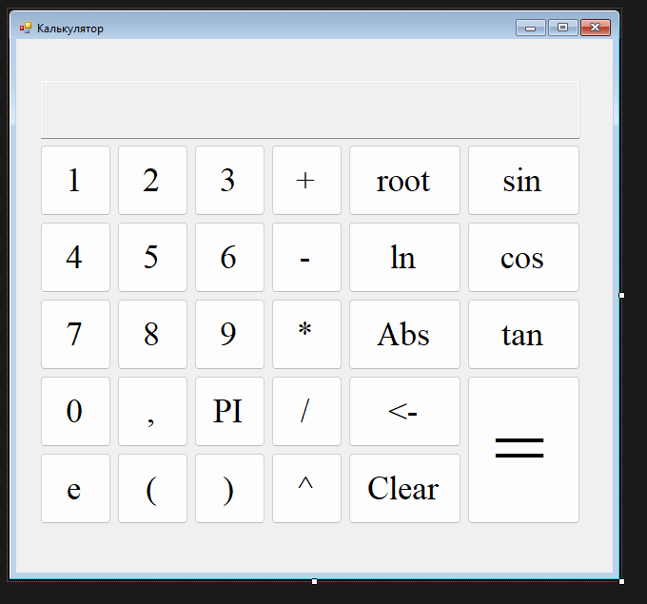
Рис 1 – макет приложения

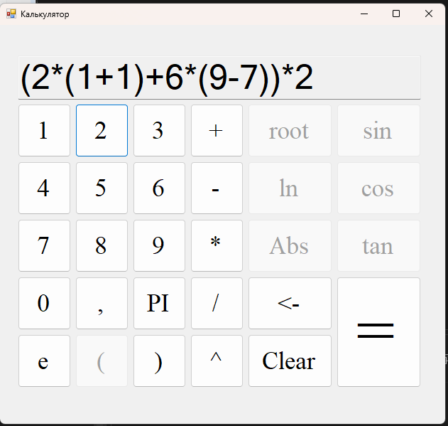
Рис 2 – результат работы

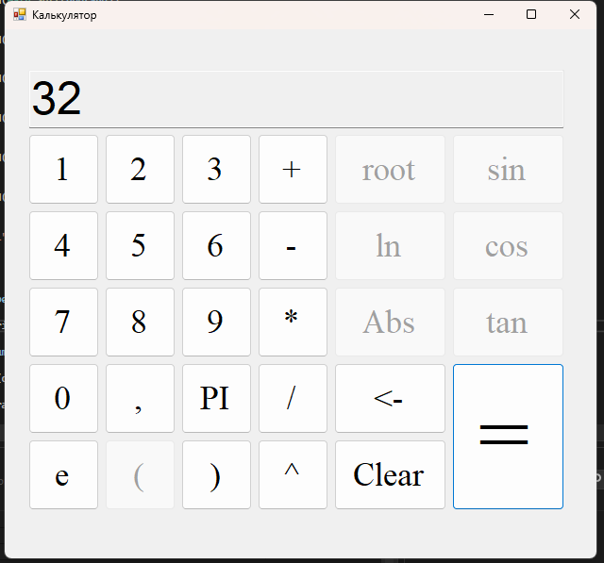
Рис 3 – вывод результата

Код приложения:
using System;
using System.Collections.Generic;
using System.ComponentModel;
using System.Data;
using System.Drawing;
using System.Linq;
using System.Text;
using System.Threading.Tasks;
using System.Windows.Forms;
using static System.Net.Mime.MediaTypeNames;

namespace Calculator
{
public partial class MainForm : Form
{
string input_number = "";
bool bracketOpen = false;
List<double> operands = new List<double>();
List<string> operations = new List<string>();
string[] priorities = { "^", "*/", "+-" };
string mathFunction = "null";
List<int> brackets = new List<int>();

public MainForm()
{
InitializeComponent();
}

private void btnNumber_Click(object sender, EventArgs e)
{
changeFunctionsAvailability(false);
string text = ((Button)sender).Text;
switch (text)
{
case "PI":
input_number += "3,141592";
txtConsole.Text += "3,141592";
break;
case "e":
input_number += "2,718281828";
txtConsole.Text += "2,718281828";
break;
default:
input_number += text;
txtConsole.Text += text;
break;
}

if (text == ",")
{
btnPoint.Enabled = false;
}
}

private void btnMathFunction_Click(object sender, EventArgs e)
{
changeFunctionsAvailability(true);
string text = ((Button)sender).Text;
txtConsole.Text += $"{text}(";
brackets.Add(operands.Count);
bracketOpen = true;
mathFunction = text;
}

private void btnMathOperation_Click(object sender, EventArgs e)
{
string text = ((Button)sender).Text;
changeFunctionsAvailability(true);
txtConsole.Text += text;
operations.Add(text);
addOperand();
}

private void changeFunctionsAvailability(bool state)
{
btnRoot.Enabled = btnLn.Enabled = btnAbs.Enabled = btnSin.Enabled = btnCos.Enabled = btnTan.Enabled = btnOpenBracket.Enabled = state;
}

private void addOperand()
{
if (input_number == "")
{
return;
}
double operand = Convert.ToDouble(input_number);
if (mathFunction == "null")
{
operands.Add(operand);
btnPoint.Enabled = true;
input_number = "";
}
else
{
switch (mathFunction)
{
case "root":
operands.Add(Math.Sqrt(operand));
break;
case "ln":
operands.Add(Math.Log(operand));
break;
case "Abs":
operands.Add(Math.Abs(operand));
break;
case "sin":
operands.Add(Math.Sin(operand));
break;
case "cos":
operands.Add(Math.Cos(operand));
break;
case "tan":
operands.Add(Math.Tan(operand));
break;
}
mathFunction = "null";
}
}

void calculate(int firstNumber, int lastNumber)
{
foreach (string op in priorities)
{
for (int i = firstNumber; i < lastNumber; i++)
{
if (op.Contains(operations[i]))
{
switch (operations[i])
{
case "^":
operands[i + 1] = Math.Pow(operands[i], operands[i + 1]);
break;
case "*":
operands[i + 1] = operands[i] * operands[i + 1];
break;
case "/":
operands[i + 1] = operands[i] / operands[i + 1];
break;
case "+":
operands[i + 1] = operands[i] + operands[i + 1];
break;
case "-":
operands[i + 1] = operands[i] - operands[i + 1];
break;
}
operands.RemoveAt(i);
operations.RemoveAt(i);
calculate(firstNumber, lastNumber - 1);
return;
}
}
}
}

private void btnCalculate_Click(object sender, EventArgs e)
{
addOperand();
while (brackets.Count > 0)
{
calculate(brackets[brackets.Count - 1], operations.Count);
brackets.RemoveAt(brackets.Count - 1);
}
calculate(0, operations.Count);
txtConsole.Text = Math.Round(operands[0], 4).ToString();
input_number = txtConsole.Text;
operands.Clear();
operations.Clear();
}

private void btnClear_Click(object sender, EventArgs e)
{
txtConsole.Text = "";
operands.Clear();
operations.Clear();
input_number = "";
changeFunctionsAvailability(true);
}

private void btnReverse_Click(object sender, EventArgs e)
{
txtConsole.Text = txtConsole.Text.Substring(0, txtConsole.Text.Length - input_number.Length + 1);
changeFunctionsAvailability(true);
input_number = "";
}

private void btnOpenBracket_Click(object sender, EventArgs e)
{
txtConsole.Text += "(";
brackets.Add(operands.Count);
bracketOpen = true;
}

private void btnCloseBracket_Click(object sender, EventArgs e)
{
if (bracketOpen)
{
txtConsole.Text += ")";
addOperand();
calculate(brackets[brackets.Count - 1], operations.Count);
brackets.RemoveAt(brackets.Count - 1);
bracketOpen = brackets.Count != 0;
}
}
}
}

