**Kosai Al Ghanom**

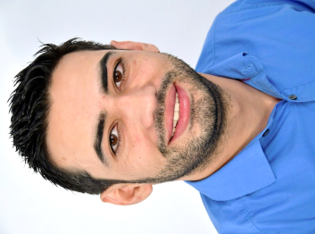Junior Web Developer

Altikofenstr. 4, 3048 Worblaufen

Kosai.alghanom@powercoders.org | +41 779 23 05 87

[GitHub](https://github.com/kosai-Al-Ghanom) | [Learning Blog](http://kosai-alghanom.netlify.com/) |

Languages: English (B1), German (B2), Arabic (mother tongue)

IT skills: ★☆☆☆☆   
★★☆☆☆ HTML, CSS

★☆☆☆☆ JS

**WORK EXPERIENCE**

10/2013 – 06/2017 Cashier at supermarket, Jordan.

* Set up the checkout area.
* Operate the cash register.
* Serving customers.
* Ensure the flow of money.
* Creation of the cash accounting.
* Responsible for order in the work area.

06/2010 – 01/2013 Accountant / import, Cement Company, Damascus, Syria

* Accounts and preparation of financial statements.
* Preparing sales and purchases reports

**EDUCATION**

03/2020 – 06 / 2020 Powercoders – Coding Academy for Refugees, Zurich, Switzerland

* Foundations in HTML, CSS, JavaScript; specialization tracks upcoming
* Weekly business & social skills trainings (time mgt., communication, etc.)

01/2019 – 01 / 2020 Professional integration course co-opera, SAH Bern, Liebefeld.

* Expansion of language, basic and action skills.
* Advice on professional interests and opportunities.
* Professional orientation and insight into the world of work through short internships.

09/2009 – 01/2011 Institute of Finance and Banking Sciences, Damascus, Syria.

* Accounting science and markets

**EXTRACURRICULAR ACTIVITIES**

02/2020 – today - Volunteer family companion, Swiss Red Cross, Bern, Switzerland.

- Volunteer Accountant, Syria-Switzerland association, Bern, Switzerland.